E/ECE/TRANS/505/Rev.3/Add.148/Amend.5
25 November 2022
Agreement
Concerning the Adoption of Harmonized Technical United Nations Regulations for Wheeled Vehicles, Equipment and Parts which can be Fitted and/or be Used on Wheeled Vehicles and the Conditions for Reciprocal Recognition of Approvals Granted on the Basis of these United Nations Regulations*
(Revision 3, including the amendments which entered into force on 14 September 2017)
_________
Addendum 148 – UN Regulation No. 149
Amendment 5
Supplement 5 to the original version of the Regulation – Date of entry into force:
8 October 2022
Uniform provisions concerning the approval of road illumination devices (lamps) and systems for power-driven vehicles
This document is meant purely as documentation tool. The authentic and legal binding text is: ECE/TRANS/WP.29/2022/38.
_________
UNITED NATIONS
Paragraph 3.3.2.4., amend to read:

“3.3.2.4. Symbol(s), according to Table 1, and additional symbol(s), if any”
Paragraph 3.3.2.4.4., amend to read:

“3.3.2.4.4. In the case of front fog lamps, headlamps and AFS installation units incorporating an outer lens of plastic material, the group of letters "PL" to be affixed near the symbols identifying the function(s);”

Add a new paragraph 3.3.2.4.8., to read:

“3.3.2.4.8. In the case of AFS, in addition the symbol "T", after the symbol(s) of all lighting function(s) and/or class(es) designed to comply with the respective bend lighting provisions, with said symbol(s) arranged together and leftmost to the symbol "T". ”

Paragraph 4.5.2.6., amend to read:
“4.5.2.6. Except for AFS and cornering lamps, in case of a lamp incorporating one or more light source(s) or LED module(s) producing the principal passing-beam or the front fog beam and having a total objective luminous flux which exceeds 2,000 lumens, a reference shall be made in the communication form in Annex 1.
In case of an AFS incorporating light sources and/or LED module(s) producing the basic passing beam and having a total objective luminous flux of the lighting units as indicated under item 9.3.3. (a) of the communication form which exceeds 2,000 lumen per side, a reference shall be made in the communication form in Annex 1.
The objective luminous flux of LED modules shall be measured as described in paragraph 5. of Annex 9.”

Figure A4-V, amend to read:
“Figure A4-V
Passing-beam for right-hand traffic
V
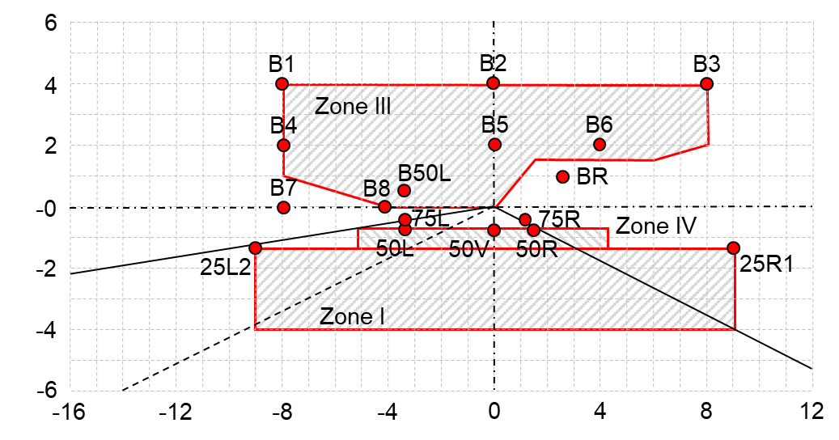
V
The test point locations for left-hand traffic are mirrored about the VV line”

Figure A4-VII, amend to reads:
“Figure A4-VII

AFS Passing-beam for right-hand traffic*

* Note: The measurement procedure is prescribed in Annex 4
For the purpose of this Annex:
"above it" means vertically above, only;
"below it" means vertically below, only.
Angular positions of passing-beam photometric requirements are indicated for right-hand traffic and are expressed in degrees up (U) or down (D) from H-H respectively right (R) or left (L) from V-V.

The test point locations for left-hand traffic are mirrored about the V-V line
V
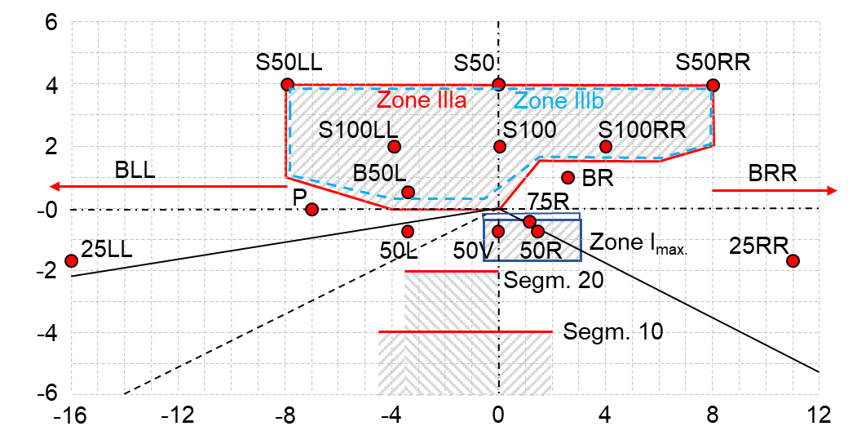
H
H
V
”

* Former titles of the Agreement: Agreement concerning the Adoption of Uniform Conditions of Approval and Reciprocal Recognition of Approval for Motor Vehicle Equipment and Parts, done at Geneva on 20 March 1958 (original version); Agreement concerning the Adoption of Uniform Technical Prescriptions for Wheeled Vehicles, Equipment and Parts which can be Fitted and/or be Used on Wheeled Vehicles and the Conditions for Reciprocal Recognition of Approvals Granted on the Basis of these Prescriptions, done at Geneva on 5 October 1995 (Revision 2).

