E/ECE/324/Rev.1/Add.62/Rev.1/Amend.5−E/ECE/TRANS/505/Rev.1/Add.62/Rev.1/Amend.5
11 November 2022
Agreement
Concerning the Adoption of Harmonized Technical United Nations Regulations for Wheeled Vehicles, Equipment and Parts which can be Fitted and/or be Used on Wheeled Vehicles and the Conditions for Reciprocal Recognition of Approvals Granted on the Basis of these United Nations Regulations*
(Revision 3, including the amendments which entered into force on 14 September 2017)
_________
Addendum 62 – UN Regulation No. 63
Revision 1 - Amendment 5
Supplement 5 to the 02 series of amendments – Date of entry into force: 8 October 2022
Uniform provisions concerning the approval of L1 category vehicles with regard to sound emission
This document is meant purely as documentation tool. The authentic and legal binding texts is: ECE/TRANS/WP.29/2022/5.

_________
UNITED NATIONS

Table of Contents, Annexes, amend to read:
"5 Test track layout"
Paragraph 10.3., amend to read:
"10.3. Notwithstanding the transitional provisions above, Contracting Parties applying this Regulation may grant type approvals according to any preceding series of amendments to this Regulation. However, the specification of the test track may conform to ISO 10844:2014."
Insert a new paragraph 10.4. to read:
"10.4. Contracting Parties applying this Regulation shall continue to grant extensions of existing approvals to any preceding series of amendments to this Regulation. However, the specification of the test track may conform to ISO 10844:2014."
Paragraphs 10.4. (former) to 10.6., renumber as 10.5. to 10.7., respectively.
Paragraphs 10.7. (former) and 10.8., delete.
Annex 3,
Paragraph 2.1.1., amend to read:
"2.1.1. Test site
The test site shall consist of a central acceleration track surrounded by a substantially level test area. The test track shall be level; the track surface shall be dry and so designed that rolling sound remains low.
On the test site, free sound field conditions shall be maintained to within ±1 dB between the sound source placed in the middle of the acceleration section and the microphone. This condition shall be deemed to be met if there are no large sound reflecting objects such as hedges, rocks, bridges or buildings within 50 m of the centre of the acceleration section.
No obstacle likely to affect the sound field shall be close to the microphone and no one shall come between the microphone and the sound source. The observer taking the measurements shall take up position so as to avoid influencing the metre readings.
The surface of the test track shall conform to ISO 10844:2014."
Annex 5,
Title, amend to read:
"Test track layout"

Footnote 1 to the title, delete.

Footnote 2 to paragraph 1., delete.

Paragraphs 1., 2., and 2.1. to 2.5., delete.

Paragraphs 3., 3.1., 3.2., 3.2.1., 3.2.1.1. to 3.2.1.4., and 3.2.2., delete.

Figure 1, amend to read:
"Figure 1
Test track layout with dimensions in meters
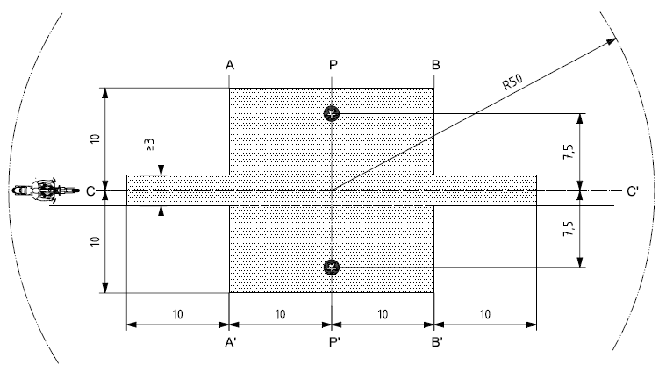

Key

Minimum area covered with test road surface, i.e. test area

Microphone positions (height 1,2m)

Source: ISO 10844:1994, with modifications."

Figure 2 and Table 1, delete.

Paragraphs 4., 4.1. to 4.3., 5. and 5.1. to 5.3., delete.

Paragraphs 6., 6.1., 6.1.1. to 6.1.6., 6.1.6.1. to 6.1.6.7. and 6.2., delete.

* Former titles of the Agreement: Agreement concerning the Adoption of Uniform Conditions of Approval and Reciprocal Recognition of Approval for Motor Vehicle Equipment and Parts, done at Geneva on 20 March 1958 (original version); Agreement concerning the Adoption of Uniform Technical Prescriptions for Wheeled Vehicles, Equipment and Parts which can be Fitted and/or be Used on Wheeled Vehicles and the Conditions for Reciprocal Recognition of Approvals Granted on the Basis of these Prescriptions, done at Geneva on 5 October 1995 (Revision 2).

