|  |  |  |  |
| --- | --- | --- | --- |
|  | United Nations | ECE/TRANS/WP.29/2022/128 | |
| _unlogo | **Economic and Social Council** | | Distr.: General  30 August 2022  Original: English |

**Economic Commission for Europe**

Inland Transport Committee

**World Forum for Harmonization of Vehicle Regulations**

**188th session**

Geneva, 14-16 November 2022

Item 4.8.1 of the provisional agenda

**1958 Agreement:  
Consideration of draft amendments to existing UN Regulations submitted by GRSP**

Proposal for Supplement 8 to the 03 series of amendments to UN Regulation No. 129 (Enhanced Child Restraint systems)

Submitted by the Working Party on Passive Safety [[1]](#footnote-2)\*

The text reproduced below was adopted by the Working Party on Passive Safety (GRSP) at its seventy-first session (ECE/TRANS/WP.29/GRSP/71, para. 25). It is based on ECE/TRANS/WP.29/GRSP/2022/7 as amended by annex III to the report, ECE/TRANS/WP.29/GRSP/2022/8 and ECE/TRANS/WP.29/GRSP/2022/9 both not amended. It is submitted to the World Forum for Harmonization of Vehicle Regulations (WP.29) and to the Administrative Committee (AC.1) for consideration at their November 2022 sessions.

.

*Paragraph 6.1.3.6.,* amend to read:

"6.1.3.6. For booster cushions, type approval shall not be granted for a stature below 125 cm. Booster cushions shall not be declared for use below a stature of 125 cm.

Booster cushions shall ensure that the top of the child's head is at or above a horizontal plane at 770 mm vertically from the Cr axis when seated on the test bench described in Annex 6.

The procedure to check if a booster cushion fulfils this requirement is outlined as follows (See figure 1 below):

Figure 1  
**Measurement Device to Check the Sitting Height**

**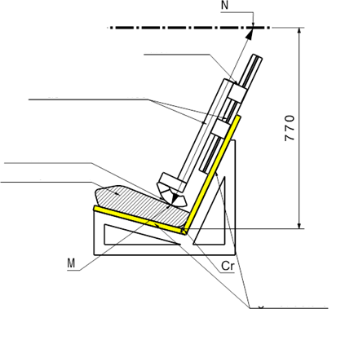**

Contact surface

Rigid structure

Ruler

Measurement device

Booster cushion

(a) A simulated test bench shall be used for the assessment. The simulated bench shall have the same geometry as the test bench defined in Annex 6 of this Regulation, including the seat cushions. However, the width of the simulated bench may be reduced, if the width is between 500 and 800 mm,as shown in Annex 25. The simulated test bench shall be of rigid construction and shall not deform when using the measuring device defined in Annex 25.

(b) A rigid structure is attached to the simulated test bench and holds a sliding part.

(c) The booster cushion shall be placed on the simulated test bench with its centreline aligned with the centreline of the test bench and the rear surface of the booster cushion contacting the backrest of the test bench.

(d) If ISOFIX attachments are present these shall be latched with the test bench lower ISOFIX anchorages. An additional force of 135 +/-15N shall be applied in a plane parallel to the surface of the simulated test bench. The force shall be applied along the centreline of the Enhanced Child Restraint System and at a height of no more than 100 mm above the simulated test bench seat surface.

(e) The measurement device is extended downwards parallel to the simulated test bench backrest, until it is stopped by the booster seat cushion.

Figure 2  
**Ruler of Measurement Device**

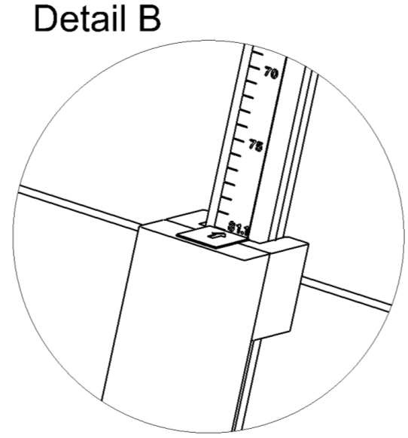

**75**

**70**

Ruler showing sitting height of child

(f) The corresponding value of the sitting height is displayed by a ruler that is provided with the device as shown in Figure 2.

(g) Using the data in Table 3, the sitting height is utilized to determine the corresponding minimum stature of the child that can be accommodated by the booster cushion. Example: A sitting height of 66.2 cm shall correspond to a child minimum stature of 125 cm; a sitting height of 75.9 cm shall correspond to 150 cm.

In case the value obtained for the sitting height is between two integer values always round up to the next integer value (e.g. Measured sitting height = 70.1 cm ► resulting stature = 136.05 cm ► Smallest stature allowed = 137 cm).

(h) The stature determined in this procedure shall be compared to the lower limit of the approval stature range. The requirement is fulfilled if the lower approval stature is greater or equal than the obtained minimum stature.

Table 3  
**Sitting Heights with Corresponding Minimum Statures**

| *Minimum Sitting Height 50th percentile[[2]](#footnote-3)3 (cm)* | *Stature (cm)* |
| --- | --- |
| 66.2 | 125 |
| 67.9 | 130 |
| 69.7 | 135 |
| 71.6 | 140 |
| 73.6 | 145 |
| 75.9 | 150 |

*Note*: For statures in between the displayed values the respective sitting height needs to be calculated by means of a linear interpolation."

*Paragraph 6.6.4.3.1.,* amend to read:

"6.6.4.3.1. Injury assessment criteria for frontal and rear impact as in Table 4.

# Table 4

| *Criterion* | *Abbreviation* | *Unit* | *Q0* | *Q1* | *Q1.5* | *Q3* | *Q6* | *Q10* |
| --- | --- | --- | --- | --- | --- | --- | --- | --- |
| Head performance criterion (only in case of contact during in-vehicle testing) | HPC\* (15) |  | 600 | 600 | 600 | 800 | 800 | 800 |
| Resultant head acceleration 3 ms | A head Cum 3 ms \*\*\* | g | 75 | 75 | 75 | 80 | 80 | 80 |
| Upper neck tension Force | Fz | N | For monitoring purpose only\*\* | | | | |  |
| Upper neck flexion moment | My | Nm |  | | | | |  |
| Resultant chest acceleration 3 ms | A chest Cum 3 ms \*\*\* | g | 55 | 55 | 55 | 55 | 55 | 55\*\*\*\*\*\* |
| Chest deflection**\*\*\*\*\*** | TBC | mm | NA | For monitoring purpose only\*\* | | | | |
| Abdominal pressure\*\*\*\* | P | Bar | NA | NA | 1.2 | 1.0 | 1.0 | 1.2 |

\* HPC: see Annex 17.

\*\* To be reviewed within three years following entry into force of the series 01 of this Regulation.

\*\*\* Cum 3ms means cumulative 3 ms value.

\*\*\*\* Abdominal pressure, the highest recorded value is applicable for injury assessment (i.e. when the right-handed sensors record 1.3 bar and the left-handed sensor 1.0 bar, the recorded 1.3 bar is to be used for injury assessment).

\*\*\*\*\* For the Q10 dummy, the upper and lower chest deflection shall be measured. The chest displacement X shall be used

\*\*\*\*\*\* Thoracic Spine at location T4 according to ISO/TS 13499:2019"

*Paragraph 6.7.2.7.,* amend to read*:*

"6.7.2.7. An adjuster mounted directly on the Enhanced Child Restraint System shall be capable of withstanding repeated operation and shall, before the dynamic test prescribed in paragraph 7.1.3. undergo a test comprising 5,000 ± 5 cycles as specified in paragraph 7.2.6.1.

An adjuster mounted on a strap shall be capable of withstanding repeated operation and shall, before the dynamic test prescribed in paragraph 7.1.3. undergo a test comprising 5,000 ± 5 cycles as specified in paragraph 7.2.6.2."

*Paragraph 8.1.*, amend to read:

"8.1. The information defined in Annex 27 shall be provided in the test reports that are included in the Type Approval Application.

For a new Type Approval all information shall be provided.

For a Type Approval Extension, the applicant may limit this information to cover the changes to the ECRS."

*Paragraph 14.1.*, amend to read:

"14.1. Each Enhanced Child Restraint System shall be accompanied by information for its use. The information can be provided to the user, either:

(a) In a paper form fulfilling requirements 14.2. and 14.3.; or

(b) In a paper form fulfilling requirements 14.2. and 14.4. and in a digital form fulfilling requirements 14.3."

*Annex 15,* amend to read:

"**Annex 15**

**Description of Conditioning for Adjusters**

Figure 1

**Conditioning for adjusters mounted directly on Enhanced Child Restraint Systems**

**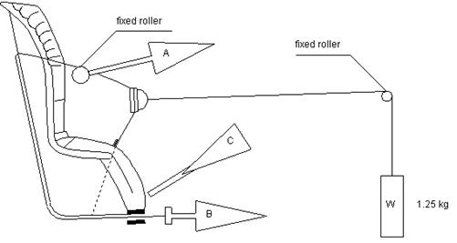**

1. Conditioning for adjusters mounted directly on Enhanced Child Restraint Systems (Figure 1)

1.1. Method

1.1.1. With the webbing set at the reference position described in paragraph 7.2.6.1., withdraw at least 50 mm of webbing from the integral harness by pulling on the free end of the webbing.

1.1.2. Attach the adjusted part of the integral harness to the pulling device A.

1.1.3. Activate the adjuster and pull at least 150 mm of webbing into the integral harness. This represents half of one cycle and puts pulling device A to the maximum webbing extraction position.

1.1.4. Connect free end of webbing to pulling device B.

1.2. The procedure of the cycle is:

1.2.1. Pull B at least 150 mm while A exerts no tension on the integral harness.

1.2.2. Activate the adjusters (C) and pull A while B exerts no tension on the free end of the webbing.

1.2.3. At the end of stroke, de-activate the adjuster.

1.2.4. Repeat cycle as specified in paragraph 6.7.2.7. of this UN Regulation.

Figure 2

**Conditioning for adjusters connected to a strap (not directly mounted on Enhanced Child Restraint Systems)**

Adjuster (rigidly clamped)

Strap

Strap end clamped or fixed to ECRS

2. Conditioning for adjusters connected to a strap (not directly mounted on Enhanced Child Restraint Systems) (Figure 2)

2.1. Method

2.1.1. Rigidly clamp the adjuster

2.1.2. With the strap set at the reference position described in paragraph 7.2.6.2., withdraw at least 50 mm of strap from the adjuster by pulling on the free end of the strap.

2.1.3. Attach the adjuster part of the strap to the pulling device A.

2.1.4. Activate the adjuster (C) and pull at least 150 mm of strap through the adjuster. This represents half of one cycle and puts pulling device A to the maximum strap extraction position.

2.1.5. Connect the free end of the strap to pulling device B.

2.2. The cycle is:

2.2.1. Pull B at least 150 mm while A does not exert tension on the strap.

2.2.2. Activate the adjuster (C) and pull A while B does not exert tension on the free end of the strap.

2.2.3. At the end of the stroke, de-activate the adjuster.

2.2.4. Repeat the cycle as specified in paragraph 6.7.2.7. of this Regulation."

*Annex 25.,* amend to read:

"Annex 25

Device to measure the booster cushion height

**

500-800 mm

The mass of the device shall be 15kg +/-1kg

[all dimensions in mm]

Calibration of the measurement scale

To calibrate the ruler of the measurement device, its structure shall contact the supporting surface (Detail A). In this configuration, the scale shall show the calibration value of 79.7 cm (Detail B).

The calibration of the ruler is based on the sitting height of the Hybrid III 5th percentile dummy seated on the test bench defined in Annex 6 of this Regulation. When this dummy is seated on the test bench, the top of the head is 77.0 cm from the Cr axis. The nominal sitting height of the dummy is 78.7 cm. Taking this value as a reference, when translating the value to the 80 mm distance from the test bench backrest where the sitting height of the child is measured, and taking into account the different angles in between the backrest, the horizontal plane and the head position, a value of 79.7 cm is used as the calibration value.

|  |  |
| --- | --- |
|  |  |
| Detail B |
|  |

"

*Annex 27, amend to read:*

"Annex 27

List of Minimum Contents for The Test Reports included in the Type Approval Application

This Annex contains a list of the minimum content and information that shall be provided in the test reports that are included for a new Type Approval Application. For Type Approval Extensions only the information related to the changes to the ECRS shall be provided.

How this information is presented in the Type Approval Application shall be the choice of the Technical Service, i.e. the layout, format, order of the information may be changed.

…"

1. \* In accordance with the programme of work of the Inland Transport Committee for 2022 as outlined in proposed programme budget for 2022 (A/76/6 (part V sect. 20) para 20.76), the World Forum will develop, harmonize and update UN Regulations in order to enhance the performance of vehicles. The present document is submitted in conformity with that mandate. [↑](#footnote-ref-2)
2. 3 Anthropometric Reference Database France, Volume III: Statistical Results for 0 to 17-year old Children, Children equipment and Accessories. IFTH, Cholet, France, page 525 [↑](#footnote-ref-3)