|  |  |  |  |
| --- | --- | --- | --- |
|  | United Nations | ECE/TRANS/2022/26 | |
| _unlogo | **Economic and Social Council** | | Distr.: General  14 December 2021  Original: English |

**Economic Commission for Europe**

Inland Transport Committee

**Eighty-fourth session**

Geneva, 22-25 February 2022  
Item 9 (v) of the provisional agenda  
**Strategic questions of a horizontal and cross-sectoral   
policy or regulatory nature:  
Transport statistics and data**

Transport Statistics Activities

Note by the secretariat

|  |
| --- |
| *Summary* |
| This document highlights the efforts made by the Working Party on Transport Statistics to modernise transport statistics data dissemination, focussing on the new interactive version of the Transport Statistics Infocards. |
|  |

I. Background

1. The Working Party on Transport Statistics (WP.6) continues its activities in providing key data to inform the Inland Transport Committee (ITC) on developments in the inland transport sector, as well as to facilitate the work of other Working Parties and individual member States through evidence-based policy making. In line with the Inland Transport Committee Strategy until 2030, part of this is to modernize data dissemination activities. Transport Statistics Infocards have, since 2017, provided country profiles containing main transport indicators for each member State. This document describes the new interactive version of the Transport Statistics Infocards.

II. Previous Transport Statistics Infocards

2. A set of transport statistics country profiles - Transport Statistics Infocards - have been prepared since 2017 by the secretariat, based on information available in the ECE transport statistics database (http://w3.unece.org/PXWeb/en), to provide annual country-by-country overviews of key transport indicators, including passenger and freight volumes, modal split and road safety related data for ECE member States. The original idea behind the Infocards was to complement the formal publications on transport and road safety statistics that were organized around themes, towards organizing the data around countries. The Infocards produced between 2017 and 2021 are available at <https://unece.org/transport/transport-statistics/infocards>. From September 2021 onwards, this product has been modernised from a PDF format towards an interactive data dashboard.

III. New Interactive Version

3. The new version of the Transport Statistics Infocards offers dynamic and interactive country overviews of key transport indicators in the form of a data dashboard. All individual Country profiles are available in the three ECE official languages, English, French and Russian. They can be viewed at <https://stats.unece.org/infocard/>. In contrast with the previously static PDF, users can hover over graphs to find out exact figures, can click through to maps for some of the indicators, and can toggle between countries and languages easily.

4. The Infocard dashboard country of choice is selected from the drop-menu on the top-right of the webpage. The top section of a country Infocard dashboard contains information on its status as a Contracting Party to UN Transport Conventions and Agreements, as well as a set of more statistics of key importance for inland transport; the size and population of the country, as well as its number of passenger cars, motorization rate, and length of railway lines.

# Figure

# **Top-level data shown in the Infocards dashboard**

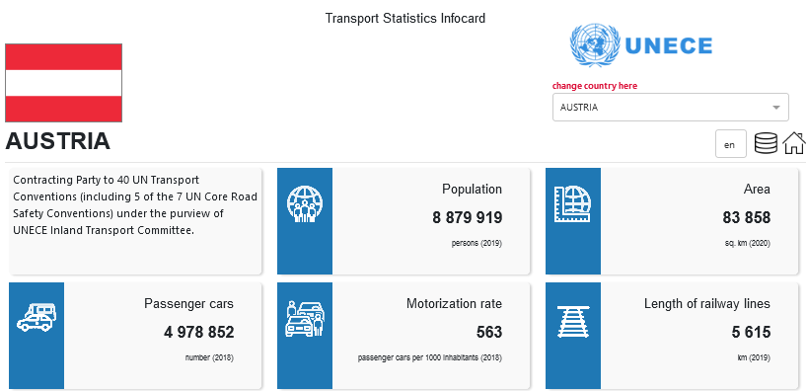

5. When scrolling further down through the country dashboard the user can view a series of graphs, charts and maps for visualising key country transport statistics. In the first row, the “Road fatality score”, visualised as a ECE region map, assigns a score to each country based on their relative position in relation to all ECE member States in terms of road traffic fatalities per million inhabitants, with approximately the same number of countries assigned to each rating band. A low score indicates less road fatalities per million inhabitants relative to other countries. The adjacent chart can be toggled between visualising a longitudinal overview of the total number of road traffic fatalities, and the road traffic fatality rate per 100 000 cars for the country. Both charts can be switched to an ECE region map enabling quick country comparisons for the two indicators.

# Figure

# **Road traffic fatality score, map and line graphs**

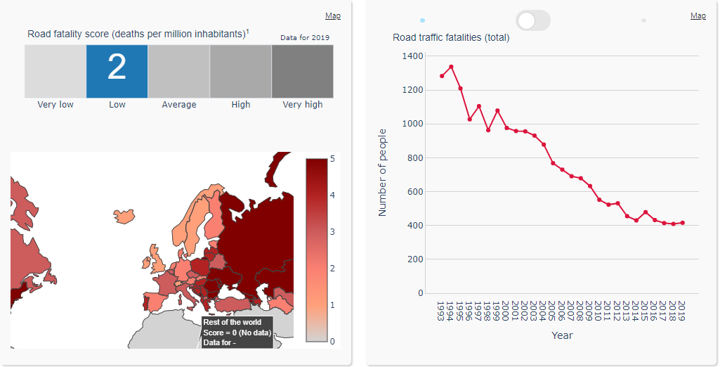

6. The subsequent section contains two bar charts showing ECE wide comparisons, in both of which the bar representing the country currently being viewed is highlighted in red, and both of which can be converted to display the respective statistics as a rating-based ECE region map, further enabling country comparison. The left one can be toggled between road traffic fatalities per million inhabitants (as shown below) and the rate per 100,000 passenger cars. The right bar chart shows country percentages of new passenger car registrations that are alternative fuel types, with a fuel type of either electricity, compressed natural gas, liquefied natural gas, liquefied petroleum gas, bioethanol, biodiesel, bi-fuel or hydrogen and fuel cells. This excludes hybrid and plug-in hybrid petrol and diesel cars.

# Figure

# **Country comparison charts for road fatalities per million inhabitants, and new registrations of alternative fuel passenger cars**

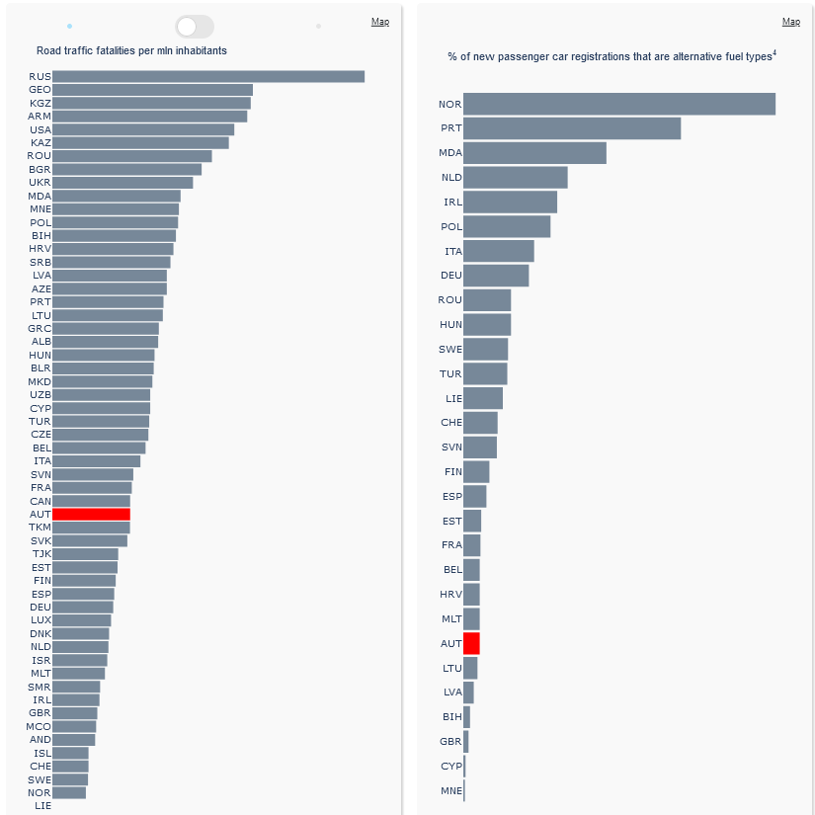

7. The next row on the left contains the percentage of the country’s road fatalities that are pedestrians and cyclists, or motorcyclists respectively, and compares these figures with the ECE average. The ECE average is calculated for countries with available data only. These data too can be visualised as a regional map. The bar chart on the right side of this row visualises country data on road traffic fatalities disaggregated by age group and sex.

# Figure

# **Road fatality victim breakdowns**

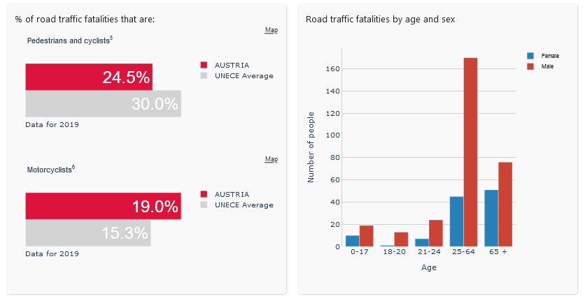

8. The final row of the country dashboard contains two charts. The left graphic shows a twenty-year evolution of freight transport inland modal split by rail, road and inland waterways in tonne kilometres (left side). An important methodological note is that the rail and inland waterway freight data are typically compiled on a territorial basis, whereas the road freight data are based upon the residency of the vehicles, which should be taken into account for comparison purposes. The second shows modal split on the passenger side, but only covering public transport. Data for rail and bus and coaches come from the common questionnaire collected together with Eurostat and the International Transport Forum, whereas data for trams and metro systems come from the new ECE tram and metro data collection, where data are only available from 2010 onwards or later.

# Figure

# **Freight and passenger modal split comparisons**

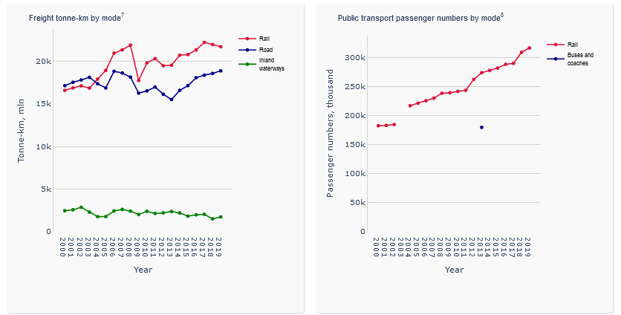

9. Finally, the country Infocard dashboard contains a series of footnotes referencing data sources and containing comments on the datasets used to generate the charts and graphs, which provide guidance for the user on how to interpret and understand the data.

10. It should be noted that the Infocard in some places highlights certain data gaps or breaks in time series for some countries and series. These gaps are present in the underlying database, and so no additional efforts have been made to mask them. It is hoped that this dashboard can be used to highlight inconsistent or missing data with country contacts to improve data availability and quality in the future.

IV. Concluding remarks

11. It is hoped that the new Infocards will improve access of member States and the general public to the transport statistics collected by WP.6. Member States are encouraged to provide any feedback on this data product. Suggestions for improvements and additions are welcome. With the guidance of member States, the secretariat will continue to modernise data dissemination practices.