|  |  |  |  |
| --- | --- | --- | --- |
|  | United Nations | ECE/TRANS/2022/18 | |
| _unlogo | **Economic and Social Council** | | Distr.: General  14 December 2021  Original: English |

**Economic Commission for Europe**

Inland Transport Committee

**Eighty-fourth session**

Geneva, 22–25 February 2022  
Item 9 (g) of the provisional agenda  
**Strategic questions of a horizontal and cross-sectoral**

**policy or regulatory nature:**

**Analytical work on transport**

Analytical work of the sustainable transport division

Note by the secretariat

|  |
| --- |
| *Summary* |
| This note summarizes the work undertaken in the framework of the Working Party on Transport Trends and Economics (WP.5), which serves as the transport think tank in the framework of the Inland Transport Committee (ITC). The note also provides a brief overview of the analytical work assumed in 2021 by the United Nations Economic Commission for Europe (ECE) Sustainable Transport Division. This work comprised publications on specific transport issues, analytical work conducted in the framework of designated Groups of Experts and Multidisciplinary Task Forces, analytical papers to support activities related to the United Nations transport conventions, capacity-building workshops, the operationalization of a GIS-based International Transport Infrastructure Observatory (ITIO), as well as the development of knowledge tools and indicators enabling Governments to measure their degree of economic connectivity in terms of transport, trade and border crossing processes. |
| The Committee is invited to **provide guidance** on future directions of the analytical work in the field of transport. |
|  |

I. Analytical work undertaken by the Working Party on Transport Trends and Economics

1. The Working Party on Transport Trends and Economics (WP.5) provides an interregional forum for the exchange of experiences and ideas, in particular, on challenges relating to the development sustainable inland transport systems. Its mandate allows it to assume the unique role of a transport “think tank” in the framework of the Inland Transport Committee (ITC).

2. Following the request of ITC at its eighty-first session inviting its subsidiary bodies to take follow-up actions to align their work with the ITC Strategy (ECE/TRANS/288, paras. 15 (a) and (c)) the WP.5 mandates and programme of work have been fully aligned with the priority actions of the Strategy included under the fourth role of ITC as a “United Nations Platform for promoting sustainable regional and interregional inland transport connectivity and mobility”.

3. In view of its past activities, and considering the ITC Strategy until 2030, WP.5 at its thirty-second session in 2019 agreed on six key clusters of work and long-term (2020–2030) programme of work on the basis of which the present document has been structured:

(a) Development of transport networks and/ or links;

(b) Transport and climate change;

(c) Sustainable urban mobility;

(d) Transport infrastructure data;

(e) Review and monitoring of emerging issues and sustainable development goals; and

(f) Inland transport security.

II. Overview of Working Party on Transport Trends and Economics activities per cluster

A. Development of transport networks and/ or links

1. Euro-Asian Transport Links operationalization



4. In the framework of WP.5, in November 2020, a round of virtual consultations on the next steps in the operationalization of Euro-Asian transport corridors took place. On that occasion, the Governments of Azerbaijan, Georgia, Kazakhstan, Turkey and Ukraine expressed their interest to provide feedback on and contribute towards the development of a corridor management mechanism on EATL route 3. This proposal was then repeated at the eighty-third session of the Inland Transport Committee in February 2021 which took note of it and encouraged WP.5 to continue the activities on the operationalization of EATL and report back to the Inland Transport Committee (ITC). At the thirty-fourth session of WP.5 in September 2021, representatives from Azerbaijan and Georgia took the floor under this agenda item and reiterated their interest to launch such an initiative aimed at elaborating an EATL route 3 Corridor Coordination and Performance Review Mechanism together with the other three Governments with the support of the secretariat.

5. WP.5 took note of the efforts supported by the secretariat to fulfil the mandate provided by ITC on operationalization of international corridors and enhancing interregional connectivity. In this regard, WP.5 invited the five Governments to report back on its progress at the forthcoming thirty-fifth session of the Working Party in September 2022.

2. Interregional transport connectivity

  



 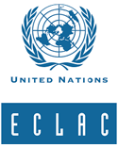

6. As part of the WP.5 thirty-fourth session, the secretariat organized a discussion on interregional connectivity which benefited from the participation of representatives from all five United Nations regional commissions (ECE, ECA, ESCAP, ECLAC and ESCWA) as well as the following member States of the United Nations: Azerbaijan, Egypt, Turkey, Russian Federation and Paraguay. Presentations focused on national and region-specific efforts to establish stronger interregional transport connectivity. Inter alia, the representative of Azerbaijan spoke about efforts of his Government to contribute to Euro-Asian connectivity, including through the implementation of designated road and rail transport infrastructure projects (i.e. Baku-Tbilisi-Kars) and the establishment of a Coordinating Council on Transit Freight. The Representative of Egypt spoke on the role of his country role as a junction point connecting countries on the African continent from West to East along the Mediterranean coastline and from North to South. The representative of Turkey provided information informed about its corridor-oriented approach with a focus on infrastructure projects addressing missing links, elimination of bottlenecks at border crossings, improving non-physical inter-operability as well as digitalization. The representative of Paraguay focused on the efforts of its Government and of ECLAC in developing the bi-oceanic transport corridor connecting maritime ports on the Atlantic and the Pacific oceans. A representative of the Russian Federation presented on the role and contributions of the Directorate of International Transport Corridors (non-profit organization) in providing expert, analytical and information support to federal executive bodies, development institutions and businesses on the development and effective use of international transport corridors.

7. WP.5 welcomed the interregional consultations that were held on sustainable transport connectivity which assist in the implementation of the ITC strategy and in particular its pillar on interregional connectivity. WP.5 also invited the secretariat to continue holding and facilitating such consultations on targeted topics of interregional interest, in cooperation if possible, with the other United Nations regional commissions as well as other regional / interregional organizations and relevant projects.

8. All presentations delivered under this agenda item are available on the website of the WP.5 thirty-fourth session which is accessible here: unece.org/transport/events/wp5-working-party-transport-trends-and-economics-34th-session

B. Transport and climate change

9. A Group of Experts on Assessment of Climate Change Impacts and Adaptation for Inland Transport (GE.4) operating under WP.5 auspices commenced its activities in 2020 focusing on: (a) raising awareness, building capacity and integrating knowledge from countries and scientific community on climate change impact assessment and adaption for transport, and (b) further advancing the state of knowledge, the analysis of climate change impacts on inland transport and identification of suitable and costs-effective adaptation measures. This work is a continuation and further expansion of activities of a preceding Group of Experts who presented the results of its work in the report available at <https://unece.org/transport/publications/climate-change-impacts-and-adaptation-international-transport-networks-0>.

|  |  |
| --- | --- |
| Map I | Map II |
| **Change in the warm spell duration index (WSDI) under a) RCP8.5 and b) RCP2.6 for period 2051-2080 with respect to the 1971-2000 baseline period** | **the E-roads network/ combined with Map I, routes that are prone to climate change impact can be identified** |

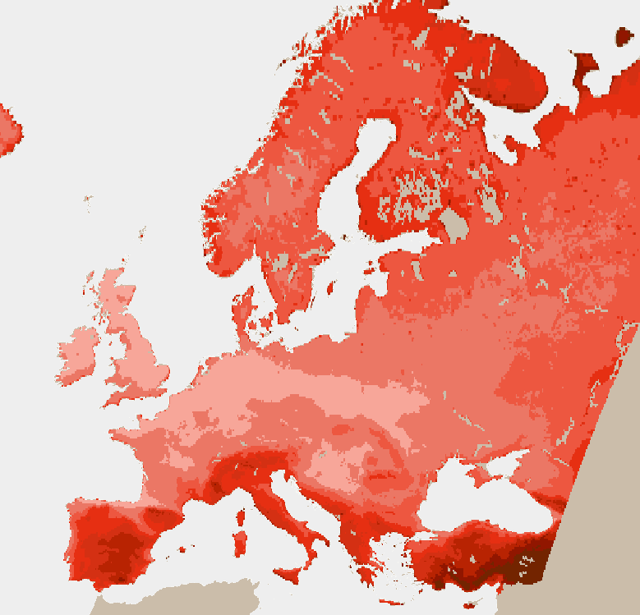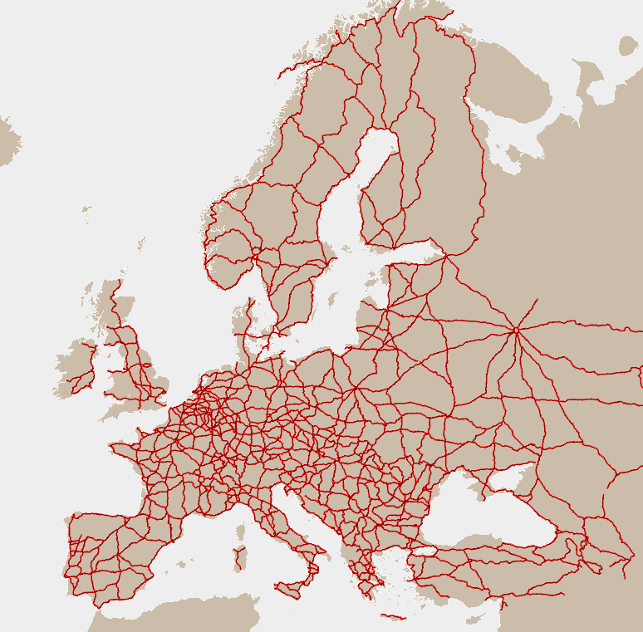

*Source*: ECE

10. In order to successfully deliver on its main tasks, the group of experts works to advance on specific topics. It discusses the impacts from climate change on transport of interest to transport professionals so that it can produce a dedicated analysis on these impacts for ECE region and some more detailed analysis for selected transport corridors in the ECE region. It further looks into collection of damage and disruption costs and indirect costs from extreme weather events which affected transport infrastructure or operations. The group would also like to use this cost analysis to establish business cases for transport adaptation to climate change. Furthermore, the group explores possibilities and needs for setting up a database on adaptation measures.



11. The group also supports its members in organizing conferences to raise awareness on the need to adapt transport to climate change. Such conference was held in Moscow hosted by ROSDORNII – the Russian Road Research Institute – on 15 and 16 November 2021 for countries of Eastern Europe, Caucasus and Central Asia. The Conference facilitated sharing of knowledge and promoted the work done to analyse future impacts from climate change on transport. It was attended by more than 150 participants joining it in-person or through an online conference platform.

C. Sustainable urban mobility, public transport, and cycling

1. Adoption of the THE PEP European Cycling Master Plan – Infrastructure Module



12. At the WP.5 thirty-fourth session, the secretariat and the Transport, Health and Environment Pan-European Programme (THE PEP) Chair reported on the adoption of THE PEP Pan-European Cycling Master Plan at the THE PEP High-level Ministerial Meeting which was held in May 2021 in Vienna and shed light on the role that the infrastructure module for cycling would play in implementing the Master Plan. In this regard, WP.5 was updated on the work done on the infrastructure module in the run-up to the THE PEP High-level Ministerial Meeting.

13. The secretariat further presented a proposal (as contained in annex to the report of the WP.5 thirty-fourth session ECE/TRANS/WP.5/70) for a 2022–2024 mandate and the terms of reference for a group of experts on the development of a cycling infrastructure module. The group was proposed in order to systematize and accelerate the work on the infrastructure module. WP.5 approved the establishment of a new group of experts and adopted the terms of reference.

14. According to its Terms of Reference, the group of experts on cycling infrastructure module is tasked to advance the elaboration of the infrastructure module in close liaison with THE PEP Partnership on Cycling Promotion/Active Mobility as contribution to the implementation of the Pan-European Master Plan for Cycling Promotion.

15. The mandate of the group, proposed for the period 2022–2024, to be endorsed by ITC at its eighty-fourth annual session, encompasses tasks focused on:

(a) Collection of data on national cycling networks, data analysis and proposal of ECE routes based on national routes forming an ECE cycling network; and

(b) Elaboration of acceptable definitions for various types of cycling infrastructure as well as new road signs which in addition to existing signs of the United Nations Convention on Road Signs and Signals of 1968 should be used for signposting the routes.

16. In line with the adopted master plan for cycling promotion, the group of experts will be expected to:

(a) Serve as a platform to collect, integrate, and analyse data on national cycling networks from ECE member States;

(b) Propose international cycling routes which will form the ECE cycling network; the routes will be proposed based on the national networks data and analysis done, and taking into consideration the Eurovelo network;

(c) Work with the draft definitions elaborated so far and made available in ECE/TRANS/WP.5/2021/6 and improve them further as appropriate;

(d) Discuss road signs introduced recently in some of the ECE countries to facilitate cycling and propose road signs that should be considered for inclusion in the United Nations Convention on Road Signs and Signals of 1968, and

(e) Prepare a final report on its achievements.

17. As part of its tasks the group of experts will be expected to discuss road signs introduced recently in some of the ECE countries to facilitate cycling and propose road signs that should be considered for inclusion in the United Nations Convention on Road Signs and Signals of 1968.

# Figure 1

# **Examples of different signs denoting a cycle lane**

|  |
| --- |
|  |

# Figure 2

# **Examples of different roadside signs denoting a traffic-light exemption for cyclists**

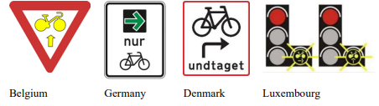

2. Expert Round Table on Economic Analysis of the Transformation of Urban Transport Systems

18. On 17 September 2021, further to a request of the Working Party at its thirty-third session (September 2020) a Workshop on Green Urban Transport was organized as part of the WP.5 cluster of work on "sustainable urban mobility, public transport, and cycling". The workshop which was co-organized by the ECE Sustainable Transport Division and the Urban Development, Housing and Land Management section at the ECE secretariat drew upon policy recommendations put forward in the ECE Nexus publication entitled [“People-Smart Sustainable Cities – Sustainable and Smart Cities for All Ages”](https://unece.org/sites/default/files/2021-01/SSC%20nexus_web_opt_ENG.pdf) (April 2021). Furthermore, the workshop built further on the momentum generated by the adoption at the fifth THE PEP High-level Meeting (Vienna, May 2021) of the first-ever [Pan-European Master Plan for Cycling Promotion](https://thepep.unece.org/sites/default/files/2021-05/MASTERPLAN_2021-05-16_BF.pdf) (Master Plan).

19. Inter alia, the workshop discussed the applicability of the Master Plan in an urban context and identified opportunities to further strengthen the infrastructure component of the Master Plan through the development of internationally agreed minimum standards and harmonized traffic signs. The workshop featured speakers from a varied group of countries, including Austria, Netherlands, Russian Federation, Switzerland and benefited from contributions by the Delft University of Technology, the Russian University of Transport, the International Association of Public Electric Enterprises and the European Cities and Regions for Transport Innovation (POLIS).

20. Further to the important role of bicycling in an urban mobility context, participants in the workshop agreed on the high relevance of several related aspects, including:

• The importance of redesigning existing urban transport infrastructure and services (which includes maximizing the availability of safe and spacious sidewalks for pedestrians and maximizing public transport networks that are accessible, affordable, and easy to use). In this regard, the significance of accommodating new modes of urban mobility, including electric scooters and steps, car ridesharing, bike-sharing with well-planned parking spaces and charging stations was also recognized.

• The important role of developing a sound regulatory framework surrounding urban mobility and its impact on health and the environment as well as the need for effective enforcement, including through the introduction and enforcement of a set of coherent road safety rules, including speed limitations as well as actively deterring and enforcing limitations related to greenhouse gas emissions (e.g. through banning older cars from urban centres).

21. WP.5 welcomed the workshop organized on green urban transport, thanked the co-organizers for their contribution and support and appreciated all presentations made by the experts. In particular, the Working Party noted the importance in terms of safety of sustainable urban mobility measures as well as the development of a sound regulatory framework on national and local level surrounding urban mobility and its impact on health and environment. It noted that this should entail both passenger and freight mobility. WP.5 also reiterated its interest to continue efforts on promoting and presenting trends and good practices under this topic as part of its cluster of work on sustainable urban transport.

22. The proceedings of the workshop, presentations and all workshop materials are available on the website of the WP.5 thirty-fourth session which is accessible here: www.unece.org/transport/events/wp5-working-party-transport-trends-and-economics-34th-session.

D. Transport infrastructure data

1. Establishment of the Geographic Information System based International Transport Infrastructure Observatory



*Source:* ECE

# Figure 3

# **Illustration of the ITIO interface and visualization of the four user groups**

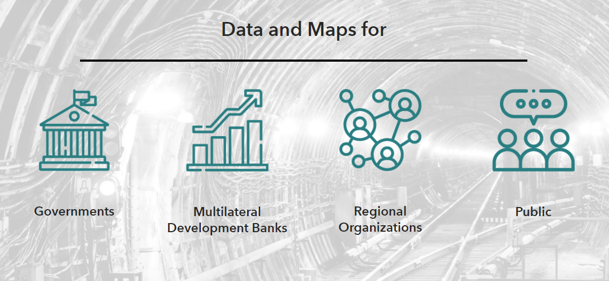

*Source:* ECE

# Figure 4

# **ITIO Government user dashboard**



*Source*: ECE

23. On the occasion of the WP.5 thirty-fourth session, the ECE secretariat, jointly with the secretariats of the Economic and Social Commission for Western Asia (ESCWA) and the Economic Cooperation Organization (ECO) held a joint presentation of the GIS based ITIO.

24. ITIO, funded through the Islamic Development Bank (IsDB) in the framework of an extrabudgetary project, offers a multi-stakeholder, web-based GIS platform which hosts data on a large variety of transport infrastructure networks and nodes across different modes including road, rail, inland waterways, ports, airports, intermodal terminals, logistics centres and border crossing points. Core ITIO user categories include Governments, Multilateral Development Banks (MDBs), Regional Cooperation Organizations (RCOs), and the broader public.

25. Core functionalities of ITIO can be summarized as follows:

(a) Offering an electronic repository of ECE inland transport conventions, project outputs, and deliverables of designated groups of experts:

• ITIO offers a digital environment that helps visualize specific outputs and deliverables, such as the work done in the framework of the TEM[[1]](#footnote-2), TER[[2]](#footnote-3) and EATL[[3]](#footnote-4) projects but also the tangible outputs produced by the Group of Experts on Assessment of Climate Change Impacts and Adaptation for Inland (GE.3) and the Group of Experts on Benchmarking Transport Infrastructure Construction Costs (GE.4).

• ITIO provides an electronic platform that will be catalytical for the ongoing digitalization of different United Nations inland transport agreements and conventions, especially those covering infrastructure (AGR[[4]](#footnote-5), AGC[[5]](#footnote-6), AGTC[[6]](#footnote-7) and AGN[[7]](#footnote-8)) but also border crossing facilitation instruments such as TIR[[8]](#footnote-9)/eTIR (customs systems location).

(b) Financing transport infrastructure:

• ITIO operates as a virtual marketplace for financing transport infrastructure by providing an electronic interface between Multilateral Development Banks (MDBs) and Governments. Governments can upload their transport infrastructure projects in need of funding as well as select which MDBs they wish to reach out to. By adding or removing GIS layers, data on transport infrastructure networks can be combined with data about the national and/or regional ratification and implementation rate of specific transport legal instruments or with the impact that climate change may have on planned infrastructure projects. For MDBs, the ITIO functions as a clearing house granting them direct access to a centralized information platform assisting them to decide which projects to consider for funding. A secured electronic communication platform will be provided enabling all users to reach out to each other and exchange information.

(c) Promoting sustainable regional and interregional connectivity:

• The observatory provides the possibility to all regional and interregional organizations to create their own maps illustrating their transport infrastructure initiatives, corridors, projects, reports and studies and anything else they consider useful for the purpose of further enhancing regional connectivity. This will enhance cooperation among the different transport infrastructure initiatives in Europe, Asia, and Africa.

26. At its thirty-fourth session, WP.5 took note of the information concerning the further development of ITIO and invited interested stakeholders (including national Governments and Multilateral Development Banks) to participate in a test phase. WP.5 also invited the secretariat to provide necessary assistance to national delegates and representatives of other stakeholder entities in conducting these tests, including through providing dedicated accounts for testing. It also requested the secretariat to inform the ITC Bureau and the Committee on the development of the Observatory and possible outcomes of the tests once they are completed.

27. As requested by WP.5 at its thirty-third session in September 2020, the secretariat issued working document ECE/TRANS/WP.5/2021/4 which provides a detailed description of the Observatory, its purpose, functions, user groups and operational modalities.

# Map III **Visualization of the transport networks and nodes application via the Governments user interface**

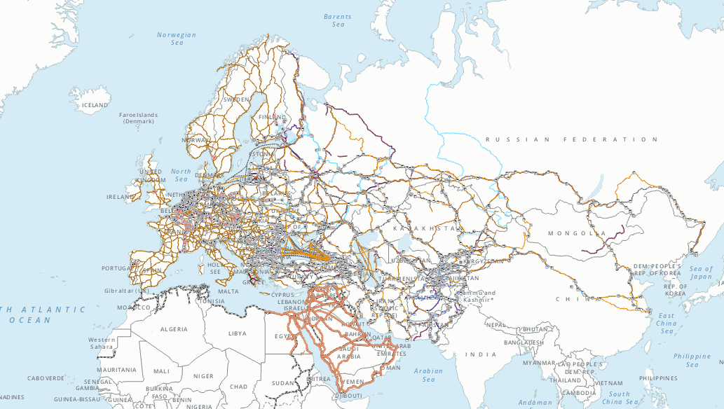

# Map IV **Pop-up window with technical data per network segment**

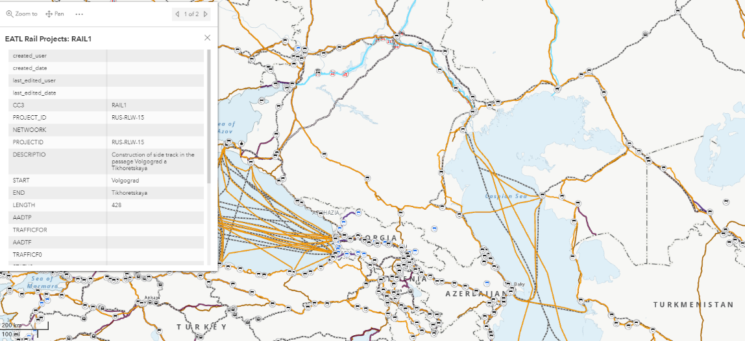

*Source:* ECE

2. Group of Experts on Benchmarking of Transport Infrastructure Construction Costs

28. The mandate of the Group, which was established in October 2016 under WP.5 auspices, stipulated that the final report of the group which is due by September 2022 should:

• Identify models, methodologies, tools, and good practices for evaluating, calculating, and analysing inland transport Infrastructure costs

• Identify and list terminologies used for costing inland transport Infrastructure

• Collect and analyse data for benchmarking inland transport construction costs

29. At the WP.5 thirty-fourth session, the GE.4 Chair informed the Working Party that following the request put forward at its session last year, ITC at its eighty-third session in February 2021 had agreed to extend the mandate of the Group for one more year until 2022. The purpose of the extension as defined by ITC is to continue and revamp the data collection efforts of the Group across all modes resulting in a more data rich final report as well as to prepare an additional benchmarking analysis of transport infrastructure maintenance and operation costs.

30. At its eleventh session which took place in April 2021, GE.4/WP.5 produced a number of new deliverables (revisions of previously prepared documents) including a compilation of good practices at national levels for evaluating and calculating transport infrastructure construction costs ECE/TRANS/WP.5/2020/7/Rev.1 and a revised consolidated terminology list for related road, rail and inland waterway infrastructure, maintenance and operation costs as contained in ECE/TRANS/WP.5/GE.4/2019/1/Rev.3. Furthermore, it also prepared and submitted two new questionnaires on maintenance and operation costs for road and rail infrastructure (ECE/TRANS/WP.5/2021/5).

31. WP.5 took note of the progress made by the group of experts, in particular regarding the additional questionnaires on transport maintenance and operation costs it had prepared. WP.5 then supported the idea that these questionnaires be submitted to mode-specific Working Parties SC.1, SC.2 and SC.3/WP.3 for data collection purposes.WP.5 finally agreed to take a more proactive role in supporting the data collection efforts and to raise awareness about the Group’s activities and try to support geographical expansion of the Group and its data findings leading to a more data rich final report to be presented by the Group at the 2022 WP.5 session.

E. Review and monitoring of emerging issues and sustainable development goals

1. Continuous work of the Informal Multidisciplinary Advisory Group on Transport Responses to the COVID-19 Crisis

# 

32. At its eighty-second annual session (Geneva, 25–28 February 2020), ITC requested the secretariat, in close cooperation with the Bureau, with the support of interested governments and key stakeholders to conduct necessary research on provisions in existing frameworks and new needed areas of work to promote cooperation between transport authorities in the field of counteracting the effects of emergency situations of cross-country nature, including epidemics and pandemics, and present this information to WP.5for consideration of further steps and for inclusion to its programme of work.

33. In response to this tasking, and as the pandemic further evolved, the secretariat established an Informal Multidisciplinary Advisory Group on Transport Responses to the COVID-19 Crisis which had its first virtual meeting in June 2020 followed by a second one in 8 September 2020 as part of the thirty-third session of WP.5. Based on inputs received from Governments and other stakeholders during these Multidisciplinary Advisory Group sessions and based on guidance received from WP.5 in September 2020 and the ITC Bureau at its session in November 2020, a working document (ECE/TRANS/2021/4) has been prepared by the secretariat and submitted to ITC at its eighty-third session for consideration and possible endorsement of next steps.

34. ITC at its eighty-third session considered the document and decided “to prolong the work of the Advisory Group for one more year until February 2022” and “to enhance cooperation between working parties, and between the ITC and other specialized agencies of the UN System, including IMO and ICAO contributing to a better coordinated delivery of programme of work and increased interoperability”.

35. In response to the above ITC request, the WP.5 Chair decided to host an informal meeting with mode specific Working Party Chairs and Vice-Chairs (SC.1, SC.3/WP.3, WP.5, WP.24, WP.30) in late May 2021 followed by a third session of the Multidisciplinary Advisory Group in June 2021 with participation of the IMO and ICAO. Deliberations focused on the identification of commonalities and lessons learned in the way that the maritime, aviation and inland transport (sub-)sectors responded the COVID-19 pandemic. Additional information received and a revised set of recommendations were incorporated in ECE/TRANS/WP.5/2020/10/Rev.1. and submitted to WP.5 for further guidance.

36. The revised set of recommendations identify the following key pillars for possible further action:

(a) At international transport regulatory level

• Prioritize a human centred approach/ recognize the essential role of transport workers.

• Evaluate how COVID-19 induced “temporary” measures (temporary extension of validity of permits and documents or temporary exemptions and facilitations measures) can be turned into emergency protocols.

(b) At the level of existing international legal instruments

• Assess how infrastructure agreements AGTC, AGR, AGC and AGN could serve as the backbone for the identification of critically important routes and nodes that need to remain open under any circumstances.

• Assess how in the framework of the Harmonization Convention for instance criteria could be defined for land border crossings that need to stay open at any time to enable the international transport of essential cargo and supplies.

(c) At the level of continued sectoral and inter-sectoral dialogue on pandemic preparedness:

• Have pandemic / emergency preparedness as a recurrent agenda item for the forthcoming sessions of mode-specific WPs (SC.1, SC.2, SC.3, WP.24 and WP.30).

• Build further on the work done by the informal Advisory Group so far and continue to explore specific measures/ tools that could be developed aimed at increasing the resilience of the inland transport system to future pandemics such as for instance the development of a contingency planning concept for rail, road and inland waterway sectors.

37. At its thirty-fourth session, WP.5 considered the recommendations provided and requested the secretariat to prepare an official document including the recommendations developed so far as well as a proposed action plan for their implementation and to develop a concept note for further information exchange and possible contingency planning for rail as well as road and inland waterways for the forthcoming ITC session. WP.5 also requested the secretariat to raise awareness about the important role that transport workers play in keeping supply chains operational at times of pandemics and other emergency situations and to enable their prioritized access to healthcare systems.

38. In response to this request, the secretariat prepared Working Document 20 (ECE/TRANS/2022/20) to be considered by ITC at its forthcoming session.

2. Development of Sustainable Inland Transport Connectivity Indicators



*Source:* ECE

39. The thirty-fourth session of WP.5 featured the launch of a set of 215 Sustainable Inland Transport Connectivity Indicators (SITCIN) which had been developed in the framework of a United Nations Development Account (UNDA) project entitled “Sustainable transport connectivity and implementation of transport related SDGs in selected landlocked and transit/bridging countries” implemented by ECE in cooperation with ESCWA and ECLAC.

40. The main objective of the indicators, which have been tested and validated in five pilot countries, (including Georgia, Jordan, Kazakhstan, Paraguay, and Serbia) is to offer a tool to Governments to measure and qualify their degree of transport connectivity, both domestically and bilaterally/subregionally as well as in terms of soft and hard infrastructure. The indicators also offer Governments the possibility to measure the extent to which they implement the relevant United Nations legal instruments, agreements, and conventions and the degree to which their inland transport systems are inter-operable with the systems within their respective subregions.

41. The indicators are structured within three pillars of sustainability and applied across the four inland transport sectors including, road, rail, inland waterways, and inter-modal transport. The Economic Sustainability pillar contains a set of specific indicators aimed at validating border crossing efficiency, time, and costs as well as quality of (inter-modal) infrastructure and the use of Internet Communication Technology (ICT) and intelligent transport solutions. Within the pillar on Social Sustainability a set of clusters has been developed aimed at assessing adequacy of road traffic rules enforcement, road traffic infrastructure, vehicle regulations and administrative frameworks surrounding cross border transport of perishable foodstuffs and of dangerous goods. As part of the Environmental Sustainability pillar indicators were designed to evaluate measures aimed at reduction of greenhouse gas emissions, air pollutants and noise emissions.

42. In order to promote the use of the SITCIN assessment and make it as user-friendly and accessible as possible, an automated SITCIN user and data collection platform as well as an interactive e-learning course on how to use the indicators have been developed. Both tools would be made available towards the beginning of 2022 in English, French, Russian, Arabic and Spanish.

Figure 5:

# **Three central user dashboards on the Sustainable Inland Transport Connectivity Indicators user platform**

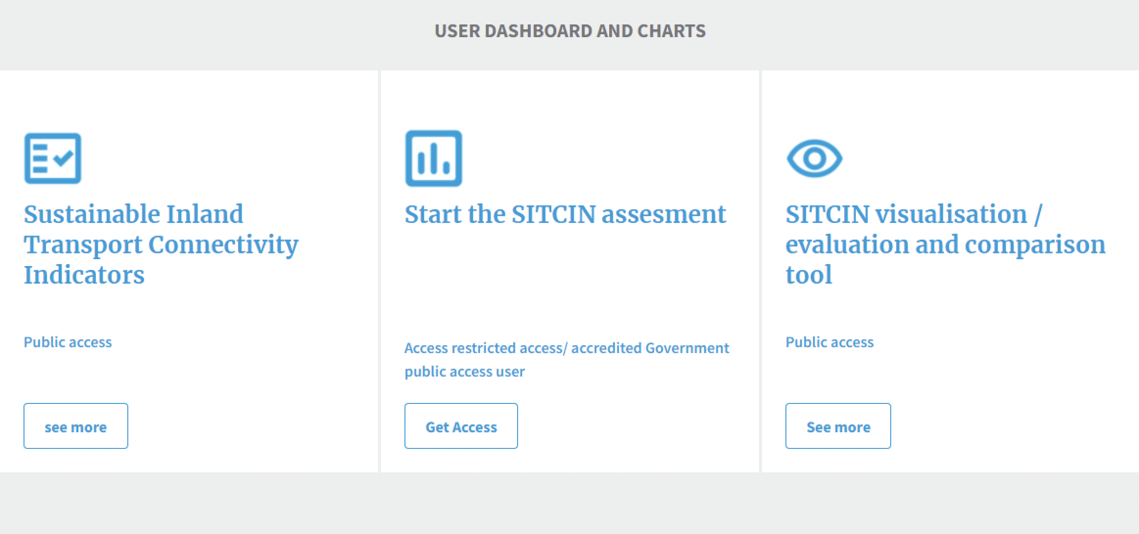

*Source:* ECE

43. As requested by WP.5 at its thirty-fourth session, the secretariat will publish in early 2022 the full set of indicators and the experiences of the five pilot countries that have used them as an official United Nations publication in the three ECE working languages.

F. Inland transport security

44. On 16 September 2021, in conjunction with WP.5, a Workshop on Security Aspects of Dangerous Goods Transportation was held in the framework of the annual 2021 ECE Inland Transport Security Forum. The event was co-organized by the WP.5 secretariat and the secretariat of the Committee and Sub-Committee of Experts on the Transport of Dangerous Goods, the RID/ADR/ADN Joint Meeting and the ADN Safety and Administrative Committees. It was moderated by a representative of France in his capacity as Chair of the RID/ ADR/ ADN Joint Meeting and featured keynote speakers from a range of organizations and national agencies including from the United Nations Counter-Terrorism Centre (UNCTC)/ Section on Preventing and Responding to Weapons of Mass Destruction (WMP) Chemical, Biological, Radiological and Nuclear (CBRN) Terrorism; International Union of Railways (UIC) Security Division and a national representative from the Federal Agency for Nuclear Control of Belgium. The workshop gathered transport of dangerous goods safety and security experts from Ministries of Transport and other relevant, road, rail and inland waterway authorities as well as from private sector, academia, research institutions and independent experts engaged in this field from a broad range of member States including many from outside the ECE region.

45. Panellists and participants recognized that transport of dangerous goods brings with it both safety and security risks and that due attention should be paid to potential risks posed by the theft and misuse of the most hazardous goods by ill-intentioned individuals against people, property, the economy, or the environment. This category of hazardous goods is known as “high consequence dangerous goods” and are defined as those which have the potential for misuse in a terrorist event. As a result, of such misuse, severe consequences might ensue mass casualties, mass destruction or mass socioeconomic disruption. Examples of high consequence dangerous goods referred to include most explosives, specific toxic substances, infectious substances, and toxic gases as well as desensitized explosives, and radioactive material above a certain transport security threshold. It was noted that other substances and objects might also be considered high consequence dangerous goods depending on the mode of transportation, hazardous properties, packing group and quantities that are shipped.

46. Participants agreed that while safety aspects of the transport of dangerous goods are well-governed by national and international regulations based on the United Nations Recommendations for the Transport of Dangerous Goods, Model Regulations, security aspects are beyond the scope of these regulations.  It was noted that these Model Regulations, which are prepared by the Subcommittee of Experts on the Transport of Dangerous Goods of the United Nations Economic and Social Council (ECOSOC) serviced by ECE, are updated every two years and implemented worldwide in modal regulations such as the Agreement concerning the International Carriage of Dangerous Goods by Road (ADR) for road transport and the European Agreement concerning the International Carriage of Dangerous Goods by Inland Waterways (ADN) for inland waterways as well as the Regulation concerning the International Carriage of Dangerous Goods by Rail (RID) administered by the Intergovernmental Organisation for International Carriage by Rail (OTIF).  It was emphasised that, to ensure consistency between these different regulatory systems, the United Nations has developed mechanisms for the harmonization of hazard classification criteria and communication tools, and for transport conditions for all modes of transport. It was noted that in spite of not being the main objective, these regulations have defined a minimal set of binding requirements concerning security and that it could be checked if an extension of that framework would benefit from future consideration at inter-governmental level. Finally, participants in the workshop agreed that pending the possible development of an internationally agreeable, more extensive security framework surrounding the transport of dangerous goods, it is of key importance that national authorities develop and implement their own national security plans for such transports as well as raise awareness of and train their staff on the associated risks to complete the minimal frame offered by the above-mentioned Model Regulations.

47. The Working Party appreciated the workshop on security aspects of dangerous goods transportation under its cluster of work on transport security. It agreed on the importance of implementation of the available regulatory framework surrounding dangerous goods, awareness raising and training of personnel and keeping up to date with the latest trends in this field. Finally, the Working Party, upon a proposal by the Russian Federation, requested the secretariat to hold as part of its next session a seminar on protection of inland transport infrastructure from acts of unlawful interferences at the stages of design, construction, and operation.

48. The concept note, programme and full set of presentations delivered at the workshop are available on the webpage of the WP.5 thirty-fourth session: www.unece.org/transport/events/wp5-working-party-transport-trends-and-economics-34th-session.

III. Analytical work: publications by the Working Party on Transport Trends and Economics

Inter-modal transport in the age of COVID-19: Practices, Initiatives and Responses – Building Pandemic-resilient transport systems (February 2021)

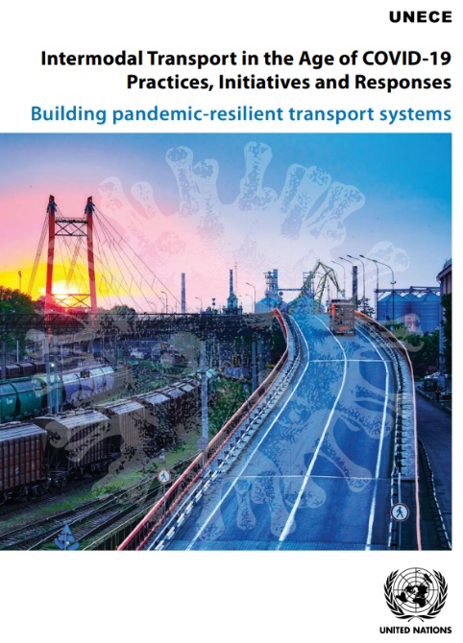The Coronavirus (COVID-19) pandemic has placed our increasingly interconnected world in an unprecedented situation. This crisis has generated human distress and an economic downturn that is impacting global efforts to improve livelihoods and achieve the United Nations Sustainable Development Goals As the early response to restraining the spread of the COVID-19 pandemic has shown, limited coordinated action undertaken in countries which included curtailing travel and closing borders, has negatively impacted our intensely interconnected world. By these actions, transport operations have been affected which has led to disruption of supply chains and trade flows. As a result, the delivery and availability of essential products such as food or medicines became a common challenge undermining countries’ capacity to respond to COVID-19 and begin to sustainably recover. This publication provides a comprehensive overview of the efforts made by the ECE Sustainable Transport Division through the various Working Parties it administers in the field of inland transport to support member States in their responses to this crisis. Inter alia, the publication touches on issues relating to border crossing facilitation, road, rail and inter-modal transport, transport of dangerous goods and transport statistics. A comprehensive overview is provided of national, regional, international, and sectoral transport policy responses and various ECE transport legal instruments of significance in the context of cross-border emergency situations and pandemics are being presented and examined in more detail. The publication is available here: <https://unece.org/transport/publications/intermodal-transport-age-covid-19-practices-initiatives-and-responses>.

IV. Analytical work: publications by the Economic Commission for Europe Sustainable Transport Division

A. Handbook for national master plans for freight transport and logistics (May 2021)

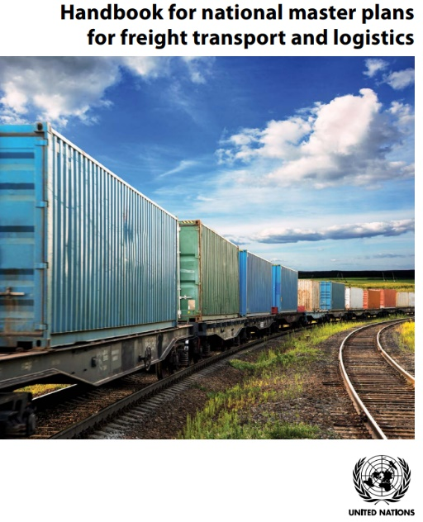This Handbook for national master plans for freight transport and logistics has been elaborated with the aim to showcase the importance of the freight sector for the national economic development, and more importantly to assist national authorities in charge of freight transport and logistics with potential actions in accompanying the sector development to follow a sustainable path in support of national economic development. The path to sustainable development of freight transport and logistics sector as presented in this Handbook can be applicable at any times. The transformation of the sector may however be very timely in circumstances such as the aftermath to COVID-19 when governments take various measures to revive national and regional economies. The publication is available here: <https://unece.org/transport/publications/handbook-national-master-plans-freight-transport-and-logistics>.

B. The development of international passenger rail transport (March 2021)

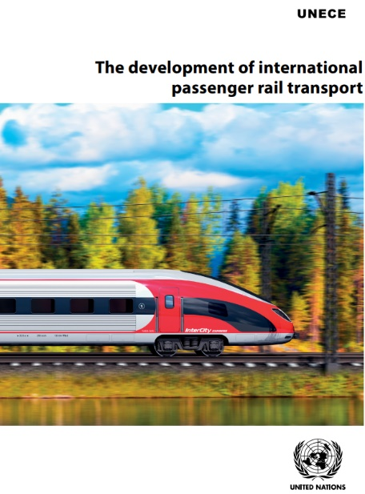International rail passenger transport is of fundamental importance to the movement of people across borders in the ECE region. Its central role was highlighted in Inland Transport Committee resolution No. 264. The COVID-19 pandemic offers, beyond its negative economic impacts that remain to be recovered from, the opportunity to reconsider the role of rail transport in the ECE region and further promote it in the post-pandemic recovery. The workshop dedicated to “The development of international passenger rail transport in the context of ITC Resolution No.264”, held during the seventy-fourth session of the Working Party on Rail Transport on the 18 November 2020, provided an overview of the situation of international passenger rail transport in the ECE region and the impact of the COVID-19 pandemic. It showed that joint efforts are necessary at several levels and in various fields: at the national level where investment in infrastructure and rolling stock, improvement of passenger services are necessary, and at the regional and international level, where border crossing formalities often need to be harmonized and simplified.

The workshop concluded that in the ECE region, the current focus on sustainability in the transport sector may offer the opportunity to national, international and private stakeholders to participate in the development of international passengers rail transport by giving a special attention to intermodality, with the aim to get a seamless network, more efficient and attractive. It was agreed that international rail passenger transport needs to be developed further and facilitated by the creation and implementation of appropriate legal instruments at a Pan-European level. The current publication provides a compilation of workshop deliberations and is available here: <https://unece.org/info/Transport/pub/354591>.

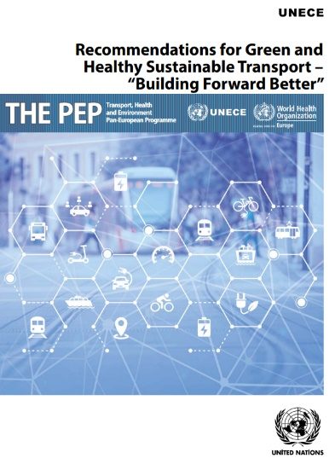 C. Recommendations for Green and Healthy Sustainable Transport – “Building Forward Better” (April 2021)

In April 2020, a United Nations Task Force was set up to develop recommendations for green and healthy sustainable transport to assist member States in the post COVID-19 recovery.  Bringing together over 50 experts from member States, international institutions, academia, public transport operators and industry experts, the Task Force set up under THE PEP has developed a set of key recommendations that member States can implement to support these recovery efforts. The publication is available here: <https://unece.org/transport/publications/recommendations-green-and-healthy-sustainable-transport-building-forward>.

D. Tools for asset management: Trans-European Motorways recommendations for road operators (May 2021)

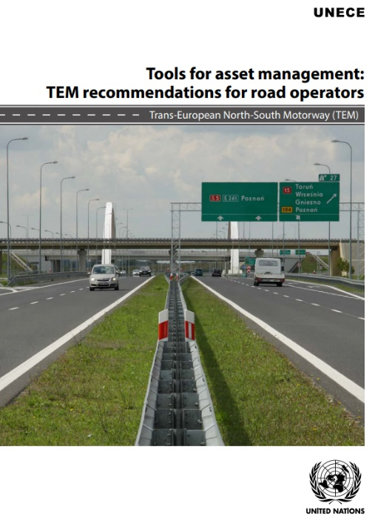The Trans-European North-South Motorway (TEM) Project was initiated to facilitate road traffic in Central, Eastern and South-Eastern Europe and to assist with the process of integrating European transport infrastructure systems.

In order to improve management of the road network, the Project provides TEM member countries with benchmarking of the current capacities of asset management, with up-to-date information on how to address the value creation process in their procedures, competencies and supporting information systems. Asset management is understood as an ongoing value creation process that can be exercised with greater or lesser situational awareness on the part of the asset’s owner and manager. The level of awareness is reflected in the maturity of existing asset management systems within TEM Project member countries. This high-level benchmarking of TEM member countries’ management capacities and tools can improve the asset management process both for individual project members and for the TEM network as a whole. The publication is available here: <https://unece.org/transport/publications/tools-asset-management-tem-recommendations-road-operators>.

E. Business Models for the road sector/ Trans-European Motorways Network: Considerations and recommendations (May 2021)

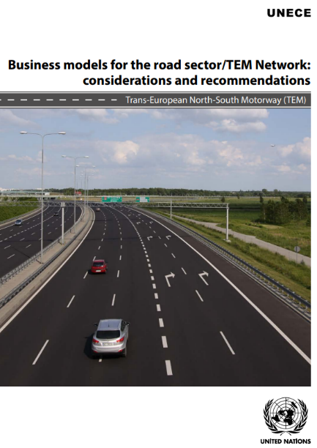This report aims to provide TEM member countries with up-to-date information about how to organize service delivery models as well as benchmarking of existing and alternative business models to ensure the greater effectiveness and efficiency of the road sector. The business models described in this publication cover all relevant activities of road authorities from appropriate understanding of customer and stakeholder needs and expectations, to aligning the value proposition with key internal processes and resources (including outsourcing and partnerships in the supply chain). This approach also accounts for road authorities’ costs of revenue and revenue sources and streams. Benchmarking of existing business models in TEM member countries creates a sound basis for further detailed analytical work focused on road asset management, data management and Building Information Modelling, and sources and types of financing for funding road infrastructure development and maintenance (as defined in the TEM Project Strategy). The full report is available here: <https://unece.org/transport/publications/business-models-road-sectortem-network-considerations-and-recommendations>.

F. Trans-European Railway High-Speed Master Plan Study (July 2021)

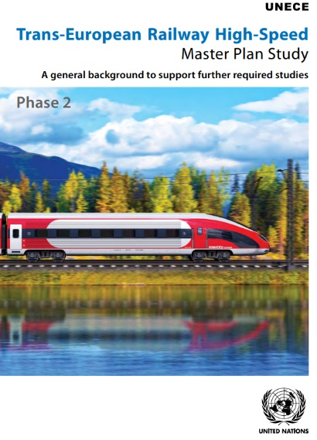The rapid development of high-speed rail (HSR) networks has been observed worldwide in recent years. The experience of states operating these systems demonstrates that they are setting new standards of quality and contributing to the renaissance of railway as a mode of transport. The development of a HSR network in the TER region would significantly improve the competitiveness of rail, increasing the sustainability of the transport sectors in TER countries.

The TER HSR Master Plan Phase 2 is a continuation of the work undertaken in Phase 1, and extends its analysis to the following areas:

• Technical and legislative aspects

• Socioeconomic analysis

• Conditions for the establishment of national and international networks

• Financial and planning elements of HSR.

Currently, there are few railway lines in TER member States that allow high speed operation. This creates a unique opportunity for developing HSR systems in individual TER member States to ensure that this development is integrated across the wider TER region through adequate international connectivity. This study aims to provide decision makers with the necessary tools to define what, if any, HSR network should be developed in their respective states. The publication is available here: <https://unece.org/info/publications/pub/358568>.

1. Trans-European Motorways project. [↑](#footnote-ref-2)
2. Trans-European Railways project. [↑](#footnote-ref-3)
3. Euro-Asian Transport Links. [↑](#footnote-ref-4)
4. European Agreement on Main International Traffic Arteries. [↑](#footnote-ref-5)
5. European Agreement on Main International Railway Lines. [↑](#footnote-ref-6)
6. European Agreement on Important International Combined Transport Lines and Related Installations. [↑](#footnote-ref-7)
7. European Agreement on Main. Inland Waterways of International. Importance. [↑](#footnote-ref-8)
8. Convention on International Transport of Goods Under Cover of TIR Carnets. [↑](#footnote-ref-9)