|  |  |  |  |
| --- | --- | --- | --- |
|  | United Nations | ECE/TRANS/2022/12 | |
| _unlogo | **Economic and Social Council** | | Distr.: General  13 December 2021  Original: English |

**Economic Commission for Europe**

Inland Transport Committee

**Eighty-fourth session**

Geneva, 22-25 February 2022  
Item 9 (a) of the provisional agenda  
**Strategic questions of a horizontal and cross-sectoral**

**policy or regulatory nature:**

**Status of accession to international United Nations**

**inland transport conventions and agreements**

Status of accession to international United Nations inland transport conventions and agreements

Note by the secretariat[[1]](#footnote-2)

|  |
| --- |
| *Summary* |
| This document presents the status of accessions by ECE and non-ECE member States to the United Nations transport agreements and conventions administered by ECE. |
| On 6 December 2021, the total number of contracting parties to the 59 United Nations legal instruments in the field of transport administered by ECE was 1,807, with six new contracting parties to six legal instruments. |
| The Committee may wish to **invite countries**, which have not yet done so, to accede to the United Nations conventions and other legal instruments in inland transport administered by the Committee and its subsidiary bodies. |
|  |

I. Overview

1. Figure I below shows the growth of the total number of contracting parties to legal instruments on inland transport concluded under the purview of the Inland Transport Committee (ITC). On 6 December 2021, the total number of contracting parties to the 59 United Nations legal instruments in the field of transport administered by the United Nations Economic Commission for Europe (ECE) was 1,807, with six new contracting parties to six legal instruments (see annex for details). Out of these 59 legal instruments, ten have not yet entered into force. The summary tables on the status of signatures, ratifications and accessions for all legal instruments are available at www.unece.org/trans/conventn/intro.html.

Figure I

**Annual Growth of Contracting Parties to Legal Instruments on inland transport under the purview of the ITC**

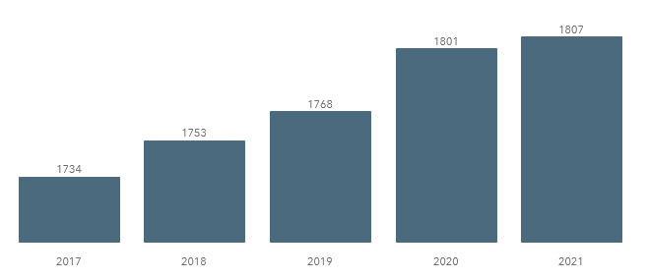

*Source*: ECE

2. Figure II below illustrates the evolution of accessions by ECE and non-ECE contracting parties since 1950.

Figure II

**Accession of ECE and non-ECE Contracting Parties (1950**–**2021)**

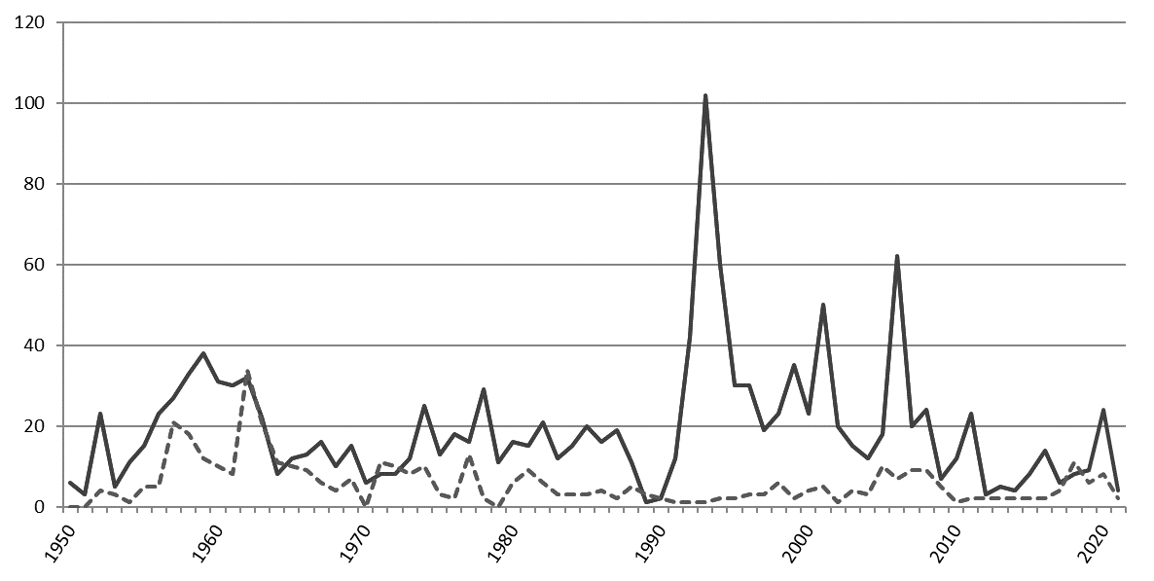

*Legend:* Solid line: ECE member States - Dotted line: non-ECE member States

*Source*: ECE

3. Of the 193 United Nations Member States, 151 States (78 per cent) are contracting parties to at least one legal instrument on inland transport, in addition to two Permanent Observers to the United Nations and one non-State contracting party. Eleven per cent of the United Nations Member States are contracting parties to at least 30 legal instruments.

II. Geographical Distribution of Contracting Parties

4. The total number of contracting parties to the 59 transport conventions is 1,807 (as of 6 December 2021). Of these, 1,390 are ECE member States and 417 are non-ECE States.

5. Of the 151 United Nations Member States that are contracting parties, 95 (63 per cent) are non-ECE member States.

6. Out of the 59 legal instruments under the purview of ITC, 49 are in force. Non-ECE United Nations Member States are contracting parties to 32 transport conventions, representing 30 per cent of the total number of accessions to these conventions. This also means that about 60 per cent of United Nations transport conventions serviced by ECE and in force, have a geographical coverage beyond the territory of ECE. On average, each ECE member State is party to 25 legal instruments, while each non-ECE member State is party to 4.3 legal instruments.

Figure III

**ECE and non-ECE member States Contracting Parties to at least one United Nations Transport Convention**

*Legend:* Dark grey: contracting parties - Light grey: non-contracting parties

*Source:* ECE

7. The European Union is currently the only non-State contracting party to United Nations legal instruments under the purview of the Committee. It is party to seven legal instruments.

8. Ethiopia became in 2021 the 151st United Nations Member State to accede to one of the conventions under the purview of the Committee. Forty-two United Nations Member States are not yet contracting parties to any legal instruments on inland transport under the purview of ITC: Angola, Belize, Bhutan, Bolivia (Plurinational State of), Chad, Colombia, Comoros, Democratic People's Republic of Korea, Djibouti, Dominica, Equatorial Guinea, Eritrea, Gabon, Gambia, Grenada, Guinea, Guinea-Bissau, Kiribati, Libya, Maldives, Marshall Islands, Mauritania, Micronesia (Federated States of), Mozambique, Nauru, Nicaragua, Palau, Panama, Saint Kitts and Nevis, Saint Lucia, Saint Vincent and the Grenadines, Samoa, Sao Tome and Principe, Somalia, South Sudan, Suriname, Swaziland, Timor-Leste, Tuvalu, Vanuatu, Yemen and Zambia.

9. The Committee may wish to consider this information and provide guidance on ways to increase the number of new accessions to the legal instruments under its purview.

Annex

Accessions registered from 1 January – 6 December 2021

| *Date* | *Contracting party* | *Convention* |
| --- | --- | --- |
| 02/12/2021 | Iran (Islamic Republic of) | Agreement on the International Carriage of Perishable Foodstuffs and on the Special Equipment to be Used for such Carriage (ATP), of 1 September 1970 |
| 25/08/2021 | Ethiopia | Convention on Road Traffic, of 8 November 1968 |
| 24/08/2021 | Kyrgyzstan | European Agreement concerning the Work of Crews of Vehicles Engaged in International Road Transport (AETR), 1970 |
| 14/06/2021 | Turkmenistan | Customs Convention on Containers, 1972 |
| 14/06/2021 | Turkmenistan | Convention on Customs Treatment of Pool Containers Used in International Transport, 1994 |
| 01/04/2021 | Estonia | Convention on Road Traffic, 1949 |

1. This document was scheduled for publication after the standard publication date owing to circumstances beyond the submitter's control. [↑](#footnote-ref-2)