E/ECE/TRANS/505/Rev.3/Add.148/Amend.3
17 December 2021
Agreement
Concerning the Adoption of Harmonized Technical United Nations Regulations for Wheeled Vehicles, Equipment and Parts which can be Fitted and/or be Used on Wheeled Vehicles and the Conditions for Reciprocal Recognition of Approvals Granted on the Basis of these United Nations Regulations*
(Revision 3, including the amendments which entered into force on 14 September 2017)
_________
Addendum 148 – UN Regulation No. 149
Amendment 3
Supplement 3 to the original version of the Regulation – Date of entry into force:
30 September 2021
Uniform provisions concerning the approval of road illumination devices (lamps) and systems for power-driven vehicles
This document is meant purely as documentation tool. The authentic and legal binding text is: ECE/TRANS/WP.29/2020/46.
_________
UNITED NATIONS

Paragraph 4.13., amend to read:
"4.13. If applicable, the lamp shall be so made that, if a light source and/or a LED module has failed, a failure signal in order to comply with the relevant provisions of UN Regulation No. 48 is provided."
Table 8, part A, amend to read:

"Table 8

Luminous intensities of passing-beam (all intensities expressed in cd)
Headlamps for RH traffic***, Passing beam of |  |  |  |  |  | Class A |  | Class B |  | Class D
 |  | See beam pattern in Annex 4 |  |  |  | Figure A4-V |  | Figure A4-V |  | Figure A4-VI
 |  |  | Position in degrees
 |  |  | horizontal |  | vertical
Part A | No. | Element | at/from | to | at | min | max | min | max | min | max
 | 1 | B50L | 3.43 L |  | 0.57 U |  | 350 |  | 350 |  | 350
 | 2 | BR | 2.50 R |  | 1.00 U |  | 1,750 |  | 1,750
 | 3 | Zone III (see Part C) |  |  |  |  | 625 |  | 625 |  | 625
 | 4 | 50R | 1.72 R |  | 0.86 D | 5,100 |  | 10,100 |  | 12,500
 | 5 | 75R | 1.15 R |  | 0.57 D | 5,100 |  | 10,100 |  | 12,500
 | 6 | 50V | V |  | 0.86 D |  |  | 5,100 |  | 7,500
 | 7 | 50L | 3.43 L |  | 0.86 D |  | 13,200* |  | 13,200* |  | 18,480
 | 8 | 75L | 3.43 L |  | 0.57 D |  | 10,600 |  | 10,600
 | 9 | 25L1 | 3.43L |  | 1.72 D |  |  |  |  |  | 18,800
 | 10 | 25L2 | 9.00 L |  | 1.72 D | 1,250 |  | 1,700 |  | 2,500
 | 11 | 25R1 | 9.00 R |  | 1.72 D | 1,250 |  | 1,700 |  | 2,500
 | 12 | 25L3 | 15.00 L |  | 1.72 D |  |  |  |  | 1,250
 | 13 | 25R2 | 15.00 R |  | 1.72 D |  |  |  |  | 1,250
 | 14 | 15L | 20.00 L |  | 2.86 D |  |  |  |  | 625
 | 15 | 15R | 20.00 R |  | 2.86 D |  |  |  |  | 625
 |  | Segment I A to B | 5.15 L | 5.15 R | 0.86 D |  |  |  |  | 3,750
 |  | C-D | 2.50 R |  | 1.00 U |  |  |  |  |  | 1,750
 |  | Segment III and under | 9.37 L | 8.50 R | 4.29 D |  |  |  |  |  | 12,500
 |  | Zone IV | 5.15 L to 5.15 R –  0.86D to 1.72D |  |  | 1,700 |  | 2,500
 |  | Zone I | 9.00 L to 9.00 R –  1.72 D to 4.00 D |  |  |  | 17,600 |  | < 2I**
 |  | I_{max} R | Vertical above 1.72D,  right of V-V line |  |  |  |  |  |  |  | 43,800
 |  | I_{max} L | Left of V-V line |  |  |  |  |  |  |  | 31,300
…"

Table 9, part B, amend to read:

"Table 9

Passing-beam photometric requirements in conjunction with Figure A4-VII
…
Part B (bending mode): Table 9 applies, however with the lines Nos. 1, 7, 13 and 18 being replaced by those listed hereunder
Part B | 1 | B50L | L 3.43 | - | U 0.57 | 50⁴ | 530 |  | 530 |  |  |  | 790
 | 7 | Zone III | As specified in Table 11 |  |  | - | 880 | - | 880 | - | 880 | - | 880
 | 13 | 50 L | L 3.43 | - | D 0.86 | 1,700 | - | 1,700 | - | 3,400 | - | 3,400 | -
 | 18 | I_{max} | - | - | - | 10,100 | 44,100 | 5,100 | 44,100 | 10,100 | 79,300⁷ | 20,300 | 70,500²
…"
Annex 4
Figure A4-IX; amend to read:

"Figure A4-IX

Passing beam test points and zones for Class BS headlamp(s)
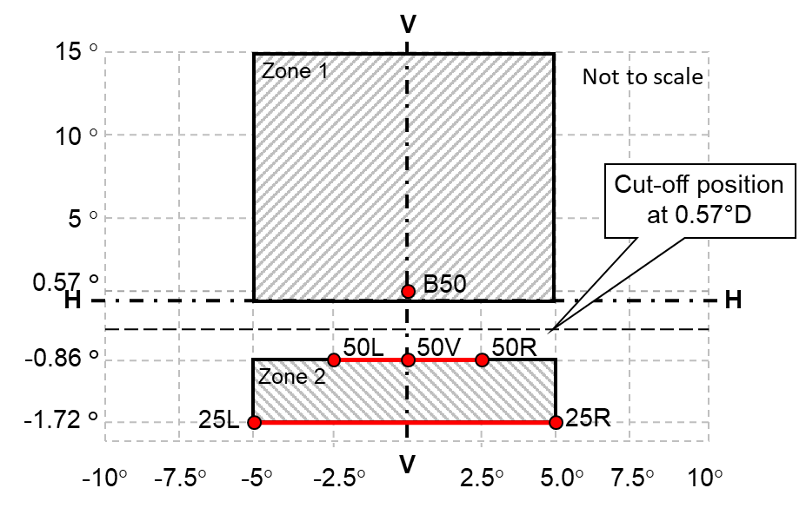
…"
Annex 7
Paragraph 1. (a), amend to read:
"(a) In the case of a headlamp with an asymmetrical passing-beam pattern:
at the point for I_{max} for driving-beam and in points 25L2, 50 R, B 50 L for passing-beam (or 25R2, 50 L, B 50 R for headlamps designed for left-hand traffic);"
Paragraph 1. (d), amend to read:
"(d) In the case of an AFS:
at the point for I_{max} for driving-beam and in points 25LL, 50V, B 50 L (or 25RR, 50V, B 50 R for AFS designed for left-hand traffic) for passing-beam;"
Paragraph 2.1.2.2.1. (a) and (b), amend to read:
"(a) Passing-beam, except for AFS system:
- 50 R - B 50 L – 25L2 for headlamps designed for right-hand traffic;
- 50 L - B 50 R – 25R2 for headlamps designed for left-hand traffic.
(b) Passing-beam, for AFS system:
Class C passing beam and each specified other passing beam class:
50V, B50L and 25LL, if applicable"
Annex 13, amend to read:
"Arrangement of approval marks
The following approval mark arrangements are given merely as examples and any other arrangement made in accordance with paragraph 3.3. of this Regulation is acceptable.
1. Approval mark of a single road illumination device
Figure A13-I - Marking example 1  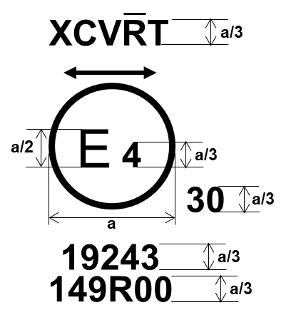  a = see para. 3.3.1.2.1. of this Regulation | The device bearing the approval mark shown on the left is an installation unit of an AFS approved in the Netherlands (E4) under approval number 19243 pursuant to this Regulation.  The number after 149R indicates that approval was granted in accordance with the requirements of this Regulation in its original form (00).  The functions identification symbols show that the approval was granted in respect of the driving-beam (R) and the Class C and Class V passing-beam. The double pointed arrow shows that the passing beam is suitable for both traffic systems by means of an appropriate adjustment of the setting of the optical element or the light source on the vehicle. Class C passing-beam, Class V passing-beam and driving-beam comply to bending lighting provisions, as indicated by the letter "T". The score above the letter "R" indicates that the driving-beam function is provided by more than one installation unit on that side of the system.  Number 30 indicates that the maximum luminous intensity of the driving-beam is between 123,625 and 145,125 candelas.
Figure A13-II - Marking example 2  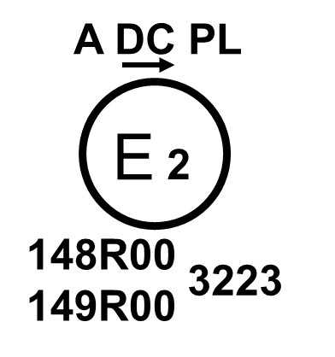 | The lamp bearing the approval mark shown on the left is a gas-discharge passing beam headlamp (DC) for left-hand traffic only (arrow) using a plastic lens (PL) approved in France (E2) pursuant to this Regulation 149R as set in the original series of amendments (00) combined with a front position lamp (A) as set in the original series of amendments (00) of the Regulation on Light Signalling Devices 148R. Both lamps (functions) are approved under approval number 3223.
2. Approval mark of grouped, combined or reciprocally incorporated lamps
Note: The vertical and horizontal lines schematize the shape of the light-signalling lamp. These lines are not part of the approval mark.
Figure A13-III
Marking example 3
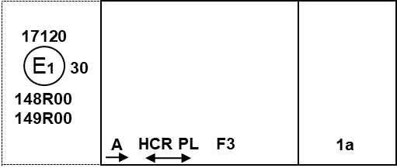
Figure A13-IV
Marking example 4-a
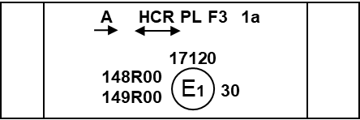
Note: The examples in Figures A13-III and A13-IV correspond to a lighting device bearing an approval mark comprising:
(a) A front position lamp approved in accordance with the 00 series of amendments to UN Regulation No. 148. The horizontal arrow indicates the side on which the required photometric specifications are met up to an angle of 80° H;
(b) A headlamp, Class B, with a passing-beam designed for right-hand traffic only and a driving-beam with a maximum intensity comprised between 123,625 and 145,125 candelas (as indicated by the number 30), approved in accordance with the requirements of this Regulation, as amended by the 00 series of amendments and incorporating a lens of plastic material;
(c) A front fog lamp approved in accordance with the 00 series of amendments of this Regulation and incorporating a lens of plastic material;
(d) A front direction indicator lamp of category 1a approved in accordance with the 00 series of amendments to UN Regulation No. 148.
Figure A13-V
Marking example 4-b
This example corresponds to an adaptive front-lighting system composed of two installation units for the left side of the vehicle and one installation unit for the right side.
Right side of the system /vehicle
_
1a
A
XCETR
E2
E2
30
149R00
148R00

45678

1a
A
XCETWR
45678

149R00
148R00

30
Left side of the system /vehicle
Installation unit 1 of the system
Installation unit 3 of the system

Installation unit 2 of the system

_
149R00
45678

XCW

The system bearing the above approval marks meets the requirements of this Regulation (original version of the Regulation) in respect of both a passing-beam for left-hand traffic and a driving-beam with a maximum intensity comprised between 123,625 and 145,125 candelas (as indicated by the number 30) grouped with a front direction indicator lamp of category 1a and a front position lamp approved in accordance with the 00 series of amendments of UN Regulation No. 148.
The installation unit 1 of the system (left side) is designed to contribute to the Class C passing-beam and the Class E passing-beam. The score above the letter "C" indicates that on that side more than one installation unit contributes to the Class C passing-beam. The letter "T" to the right following the listed symbols indicates that each, the Class C passing-beam and the Class E passing-beam are providing a bending mode.
The installation unit 3 of the system (left side) is designed to provide the second part of the Class C passing-beam of that side (as indicated by the score above the letter "C") and a Class W passing-beam. For this additional lighting unit, a circle surrounding the letter "E" followed by the distinguishing number of the country is not necessary.
The installation unit 2 of the system (right side) is designed to contribute to the Class C passing-beam, a Class E passing-beam, both with bending mode and a Class W passing-beam.
Note: In the above example, the different installation units of the system shall bear the same approval number.
3. Identification code of light source modules
Figure A13-VI
Light source module marking
MD E3 17325
The light source module bearing the identification code shown in Figure A13-VI has been approved together with a lamp approved in Italy (E3) under approval number 17325.
4. Additional lighting units designed to provide bend lighting
Figure A13-VII
Lighting unit marking
ALU E43 1234
The additional lighting unit bearing the identification code shown in Figure A13-VII has been approved together with a headlamp initially approved in Japan (E43) under approval number 1234.
…"

* Former titles of the Agreement: Agreement concerning the Adoption of Uniform Conditions of Approval and Reciprocal Recognition of Approval for Motor Vehicle Equipment and Parts, done at Geneva on 20 March 1958 (original version); Agreement concerning the Adoption of Uniform Technical Prescriptions for Wheeled Vehicles, Equipment and Parts which can be Fitted and/or be Used on Wheeled Vehicles and the Conditions for Reciprocal Recognition of Approvals Granted on the Basis of these Prescriptions, done at Geneva on 5 October 1995 (Revision 2).

