E/ECE/324/Rev.2/Add.106/Rev.8/Amend.4−E/ECE/TRANS/505/Rev.2/Add.106/Rev.8/Amend.4
8 December 2021
Agreement
Concerning the Adoption of Harmonized Technical United Nations Regulations for Wheeled Vehicles, Equipment and Parts which can be Fitted and/or be Used on Wheeled Vehicles and the Conditions for Reciprocal Recognition of Approvals Granted on the Basis of these United Nations Regulations*
(Revision 3, including the amendments which entered into force on 14 September 2017)
_________
Addendum 106 – UN Regulation No. 107
Revision 8 - Amendment 4
09 series of amendments – Date of entry into force: 30 September 2021
Uniform provisions concerning the approval of category M₂ and M₃ vehicles with regard to their general construction
This document is meant purely as documentation tool. The authentic and legal binding text is: ECE/TRANS/WP.29/2021/26.
_________
UNITED NATIONS

Insert new paragraphs 10.25. to 10.29., to read:
"10.25. As from the official date of entry into force of the 09 series of amendments, no Contracting Party applying this Regulation shall refuse to grant or refuse to accept type-approvals under this Regulation as amended by the 09 series of amendments.
10.26. As from 1 September 2023, Contracting Parties applying this Regulation shall not be obliged to accept type-approvals to the preceding series of amendments, first issued after 1 September 2023.
10.27. Until 1 September 2025, Contracting Parties applying this Regulation shall accept type-approvals to the preceding series of amendments, first issued before 1 September 2023.
10.28. As from 1 September 2025, Contracting Parties applying this Regulation shall not be obliged to accept type-approvals issued to the preceding series of amendments to this Regulation.
10.29. Notwithstanding paragraphs 10.26. and 10.28., Contracting Parties applying this Regulation shall continue to accept type approvals granted to the 06, 07 or 08 series of amendments to vehicles which are not affected by the 09 series of amendments."
Annex 1, part 1, Appendix 1, insert a new paragraph 4.4. to read:
"4.4. Reference temperature for the detection system (per paragraph 7.5.1.5.1.) : …"
Annex 1, part 1, Appendix 3, insert a new paragraph 5. to read:
"5. Reference temperature for the detection system (per paragraph 7.5.1.5.1.) : …"
Annex 2, amend to read:
"Annex 2
Arrangements of approval marks

Model A
(See paragraph 4.4. of this Regulation)
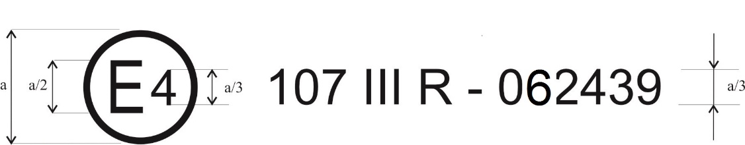
092439
a = 8 mm min

The above approval mark affixed to a vehicle shows that the vehicle type concerned has, with regard to its constructional features, been approved in the Netherlands (E 4) for Class III, pursuant to UN Regulation No. 107 under approval number 092439. The approval number indicates that the approval was granted according to the requirements of UN Regulation No. 107 as amended by the 09 series of amendments.

Model B
(See paragraph 4.5. of this Regulation)

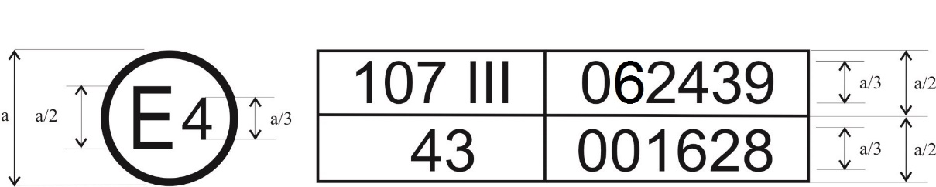
a = 8 mm min

The above approval mark affixed to a vehicle shows that the vehicle type concerned has been approved in the Netherlands (E 4) pursuant to UN Regulations Nos. 107 and 43*. The first two digits of the approval numbers indicate that, on the dates on which these approvals were granted UN Regulation No. 107 included the 09 series of amendments and UN Regulation No. 43 was in its original form.

Model C
(See paragraph 4.4.3. of this Regulation)

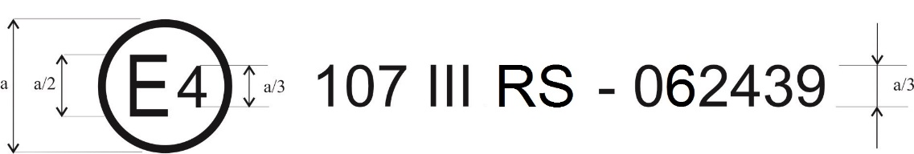
a = 8 mm min

The above approval mark affixed to a vehicle bodywork shows that the bodywork type concerned has, with regard to its constructional features, been approved separately in the Netherlands (E 4) for Class III as a separate bodywork (letter S), pursuant to UN Regulation No. 107 under approval number 092439. The approval number indicates that the approval was granted according to the requirements of UN Regulation No. 107 as amended by the 09 series of amendments."
Annex 3
Paragraph 7.5.1.5.1. amend to read:
"7.5.1.5.1. The alarm system and the fire suppression system, if fitted, shall be automatically activated through a fire detection system. The detection system shall be designed so as to detect a temperature, in the engine compartment, and in each compartment where a combustion heater is located, in excess of the reference temperature occurring during normal operation as declared by the manufacturer.
At the time of Type Approval, this temperature detection shall be verified by the Technical Service, in accordance with the manufacturer’s recommendations.
The fire suppression system may alternatively be activated automatically by other means, as long as it activates the alarm system."
Insert a new paragraph 7.5.7. and 7.5.7.1., to read:
"7.5.7. Fire event
7.5.7.1 In the case of vehicles of Classes I, II, III and B, having the engine located to the rear of the driver’s compartment, in the event of activation of an alarm system:
(a) The emergency lighting system according to paragraph 7.8.3., if fitted, shall automatically activate and,
(b) After a single positive action of the driver on any of the door controls in the driver’s compartment, all power-operated doors situated on the side of the vehicle that is nearer of the side of the road corresponding to the direction of traffic for which the vehicle is designed shall open and shall remain in the opened position.
This is applicable when the vehicle is stationary or driving at a speed less than or equal to 3 km/h.
A repeated use of the opening control shall not reverse the opening movement of the door, in order to avoid unintended re-closing in an emergency situation."
Insert a new paragraph 7.19., to read:
"7.19. Safety information:
In the case of vehicles of Classes II non low floor, III and B, means to transmit safety information, which permit the operator, driver and/or crew to easily inform the passengers of the safety instructions as e.g. the location of the emergency exits, the location of the fire extinguishers, safety sign, shall be specified by the manufacturer in the application for approval.
These means shall be adapted to the design and architecture of the vehicle with the aim of making the safety instructions easily accessible and intelligible by any passenger."
Annex 8
Paragraph 3.11.3.1.1., amend to read:
"3.11.3.1.1. Lifts shall only be capable of operation when the vehicle is at standstill. The vehicle shall have a starting prevention device that remains active until the lift is in its stowed position. If the lift gives access to the vehicle through a door referred to in paragraph 3.6 of this Annex, the starting prevention device shall remain active until the door is fully closed Any movement of the platform shall be prevented unless a device preventing the wheelchair from rolling off has been activated or has automatically come into operation."
Paragraph 3.11.4.1.1., amend to read:
"3.11.4.1.1. The ramp shall only be capable of operation when the vehicle is at standstill. The vehicle shall have a starting prevention device that remains active until the ramp is in its stowed position or completely disconnected from the vehicle. "

* Former titles of the Agreement: Agreement concerning the Adoption of Uniform Conditions of Approval and Reciprocal Recognition of Approval for Motor Vehicle Equipment and Parts, done at Geneva on 20 March 1958 (original version); Agreement concerning the Adoption of Uniform Technical Prescriptions for Wheeled Vehicles, Equipment and Parts which can be Fitted and/or be Used on Wheeled Vehicles and the Conditions for Reciprocal Recognition of Approvals Granted on the Basis of these Prescriptions, done at Geneva on 5 October 1995 (Revision 2).
* This number is given merely as an example.

