E/ECE/324/Rev.1/Add.66/Rev.6/Amend.1−E/ECE/TRANS/505/Rev.1/Add.66/Rev.6/Amend.1
3 December 2021
Agreement
Concerning the Adoption of Harmonized Technical United Nations Regulations for Wheeled Vehicles, Equipment and Parts which can be Fitted and/or be Used on Wheeled Vehicles and the Conditions for Reciprocal Recognition of Approvals Granted on the Basis of these United Nations Regulations*
(Revision 3, including the amendments which entered into force on 14 September 2017)
_________
Addendum 66 – UN Regulation No. 67
Revision 6 - Amendment 1
Supplement 1 to the 03 series of amendments – Date of entry into force: 30 September 2021
Uniform provisions concerning the approval of:
I. Specific equipment of vehicles of category M and N using liquefied petroleum gases in their propulsion system
II. Vehicles of category M and N fitted with specific equipment for the use of liquefied petroleum gases in their propulsion system with regard to the installation of such equipment
This document is meant purely as documentation tool. The authentic and legal binding text is: ECE/TRANS/WP.29/2021/20.
_________
UNITED NATIONS
Paragraph. 6.17.10.6., amend to read:
"6.17.10.6. Specific provisions regarding the K15 filling unit (Annex 9 – Figure 3):"
Paragraph 6.17.10.7.3., renumber as paragraph 6.17.10.8 and amend to read:
"6.17.10.8. The J15, K15 and heavy-duty vehicle Euro filling units shall comply with the impact test as described in Annex 9, paragraph 7."
Annex 9
Paragraph 7, amend to read:
"7. Impact test requirements for the J15, K15 and heavy-duty vehicle Euro filling units"
Figure 3, amend the figure title to read:
"Figure 3
Connecting area of the K15 filling unit"
After Figure 5, insert a new Figure 6:
"Figure 6
Connecting area of the J15 filling unit
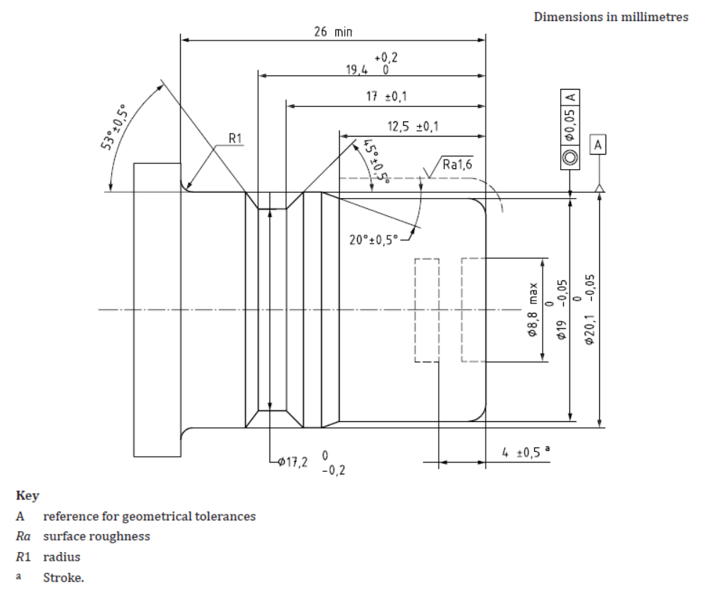"

* Former titles of the Agreement: Agreement concerning the Adoption of Uniform Conditions of Approval and Reciprocal Recognition of Approval for Motor Vehicle Equipment and Parts, done at Geneva on 20 March 1958 (original version); Agreement concerning the Adoption of Uniform Technical Prescriptions for Wheeled Vehicles, Equipment and Parts which can be Fitted and/or be Used on Wheeled Vehicles and the Conditions for Reciprocal Recognition of Approvals Granted on the Basis of these Prescriptions, done at Geneva on 5 October 1995 (Revision 2).

