|  |  |  |  |
| --- | --- | --- | --- |
|  | United Nations | ECE/TRANS/WP.29/2021/51/Corr.1 | |
| _unlogo | **Economic and Social Council** | | Distr.: General  5 March 2021  Original: English  English and Russian only |

**Economic Commission for Europe**

Inland Transport Committee

**World Forum for Harmonization of Vehicle Regulations**

**183rd session**

Geneva, 9-11 March 2021

Item 4.14.1 of the provisional agenda

**1958 Agreement**

**Proposal for amendments to the Consolidated Resolution**

**on the common specification of light source categories (R.E.5)**

Proposal for amendment 6 to the Consolidated Resolution on the common specification of light source categories (R.E.5)

Note by the secretariat

Corrigendum

*Page 19, Sheet Lx5/1, figure 1* should be read as below:

a

d

e

c

b

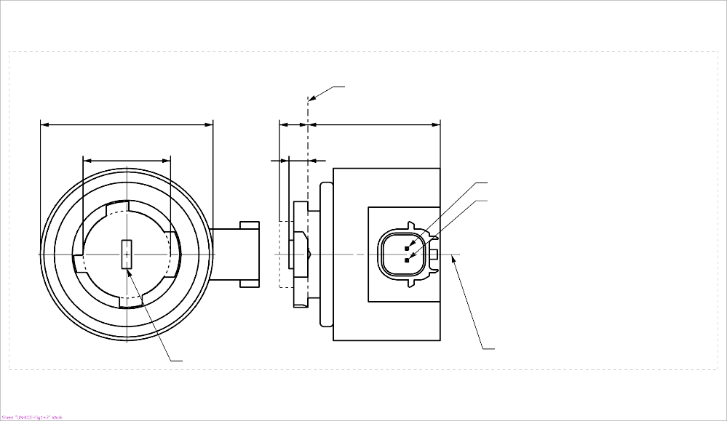

b

c

a

d

e

Reference plane1

V+

Light emitting area3

Reference axis2

Ground

4

**LR5A, LW5A, LY5A**

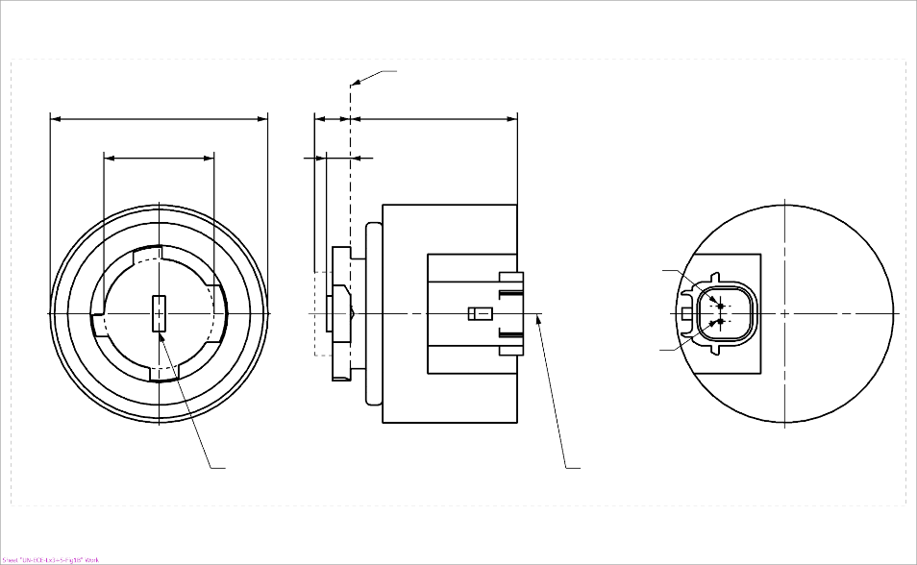

V+

Light emitting area3

Reference axis2

Ground

Reference plane1

4

**LR5B, LW5B, LY5B**

*Page 20, Sheet Lx5/5, figure 3* should be read as below:

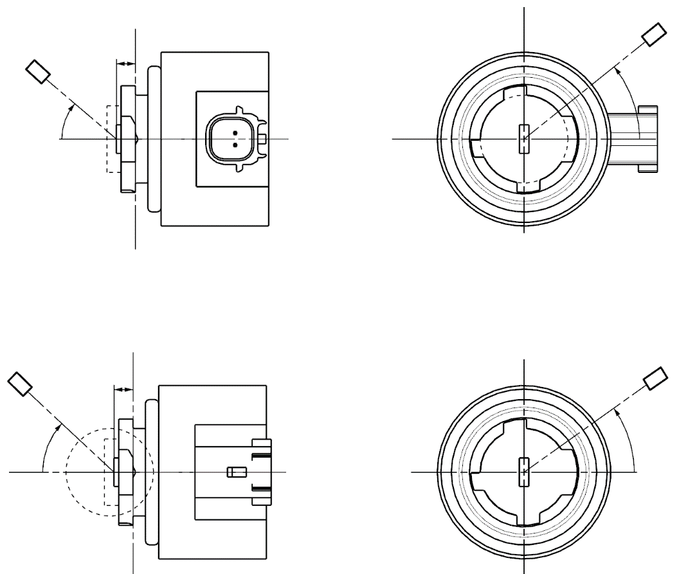

C

γ

e

C0

Reference axis

Reference plane

C-plane definition

Viewing direction along reference axis

Photo-Detector of Goniometer

**LR5A, LW5A, LY5A**

C

γ

e

C0

Reference axis

Reference plane

Photo-Detector of Goniometer

C-plane definition

Viewing direction along reference axis

**LR5B, LW5B, LY5B**