|  |  |  |  |
| --- | --- | --- | --- |
|  | United Nations | ECE/TRANS/WP.29/2021/51 | |
| _unlogo | **Economic and Social Council** | | Distr.: General  22 December 2020  Original: English |

**Economic Commission for Europe**

Inland Transport Committee

**World Forum for Harmonization of Vehicle Regulations**

**183rd session**

Geneva, 9-11 March 2021

Item 4.14.1 of the provisional agenda

**1958 Agreement**

**Proposal for amendments to the Consolidated Resolution**

**on the common specification of light source categories (R.E.5)**

Proposal for amendment 6 to the Consolidated Resolution on the common specification of light source categories (R.E.5)

Submitted by the Working Party on Lighting and Light-Signalling[[1]](#footnote-2)\*, [[2]](#footnote-3)\*\*

The text reproduced below was adopted by the Working Party on Lighting and Light-Signalling (GRE) at its eighty-third session (ECE/TRANS/WP.29/GRE/83, paras. 17 and 19). It is based on ECE/TRANS/WP.29/GRE/2020/6 and ECE/TRANS/WP.29/GRE/2020/22. It is submitted to the World Forum for Harmonization of Vehicle Regulations (WP.29) and to the Administrative Committee (AC.1) for consideration at their March 2021 sessions.

*The Status table*, amend to read:

"**Status table**

This consolidated version of this Resolution contains all provisions and amendments adopted so far by the World Forum for Harmonization of Vehicle Regulations (WP.29) and is valid from the date as indicated in the following table until the date on which the next revision of this Resolution becomes valid:

|  |  |  |  |  |
| --- | --- | --- | --- | --- |
| *Version of the Resolution* | *Date \* as from which the version is valid* | *Adopted by WP.29* | | *Clarification* |
| *Session No.* | *Amendment document No.* |
| … | … | … | … | … |
| 6 | 2021-03-09 | 183 | ECE/TRANS/WP.29/2021/51 | Amended details concerning measuring luminous flux and internal shield in paragraph 3.1, and sheets H4/2, H15/1, H15/5, H17/1, H17/6, H19/1, H19/5, HS1/2  Amend the definition for light centre and associated amended detail in sheet LR4/2  Introduction of use restriction for LED light source categories LW2, LW3, and LW5  Amended detail in filament light source sheets H7/3, H8/3, H11/3, H14/2, H16/3, H18/3, H19/2, H20/3, H27W/1, P21/5W/2, S1/S2/1 and WY21W/1  Amended detail in LED light source sheets L1/2, L1/4, L1/5, LR1/2, LR1/4, LW2/1, Lx3/1, Lx3/2, Lx3/5, LR4/1, LR4/2, LR4/4, Lx5/1, Lx5/2 and Lx5/5  Introduction of a new LED substitute light source category H11/LED/6 |

\* This date is the date of adoption of the amendment to the Resolution by WP.29 or the date of entering into force of an amendment to UN Regulation No. 37, 99 or 128 adopted by AC.1 as a package with the amendment to the Resolution in the same session of WP.29.

"

*Paragraph 2.2.3.,* amendto read:

"2.2.3. "*Light centre*" means a point that represents the apparent (virtual) origin of the light emitted."

*Paragraph 3.1., note \*,* amend to read:

"\* Tables, Electrical and Photometric characteristics:

Voltage is expressed in V;

Wattage is expressed in W;

Luminous flux is expressed in lm.

In a case of a category of filament light source where more than one value of reference luminous flux is specified, the value at approximately 12 V or 13.2 V for a lighting device and 13.5 V for a light-signalling device shall be applied unless otherwise specified by the regulation used for the device. "

*Paragraph 3.1., notes \*4 and \*5,* amend to read*:*

"\*4 Not for use in UN Regulation No. 112 headlamps and not for use in headlamps of Class A and Class B of UN Regulation No. 149.

\*5 Not for use in headlamps other than UN Regulation No. 113 class C and UN Regulation No. 149 Class CS headlamps."

*Paragraph 3.3.,*

*Group 2,* amend to read:

"

| *Group 2* | | | | |
| --- | --- | --- | --- | --- |
| *LED light source categories only for use in signalling lamps, cornering lamps, reversing lamps and rear registration plate lamps:* | | | | |
|  | *Category* |  | *Sheet number(s)* |  |
|  | LR1 |  | LR1/1 to 5 |  |
|  | LW2 | 2 | LW2/1 to 5 |  |
|  | LR3A |  | L3/1 to 6 |  |
|  | LR3B |  | L3/1 to 6 |  |
|  | LW3A | 2 | L3/1 to 6 |  |
|  | LW3B | 2 | L3/1 to 6 |  |
|  | LY3A |  | L3/1 to 6 |  |
|  | LY3B |  | L3/1 to 6 |  |
|  | LR4A |  | LR4/1 to 5 |  |
|  | LR4B |  | LR4/1 to 5 |  |
|  | LR5A |  | L5/1 to 6 |  |
|  | LR5B |  | L5/1 to 6 |  |
|  | LW5A | 2 | L5/1 to 6 |  |
|  | LW5B | 2 | L5/1 to 6 |  |
|  | LY5A |  | L5/1 to 6 |  |
|  | LY5B |  | L5/1 to 6 |  |

1 Not for use in conformity of production control of lamps.

2 Not for use behind red and amber lenses"

*Group 4,* amend to read:

"

|  |  |  |  |  |
| --- | --- | --- | --- | --- |
| *Group 4* | | | | |
| *LED substitute light source categories1 only for use in lamps approved with filament light source(s) of its counterpart light source category* | | | | |
|  | *Category* |  | *Counterpart filament light source category* | *Sheet number(s)* |
|  | C5W/LEDK | 2 | C5W | C5W/LED/1 to 4 |
|  | H11/LED/6 |  | H11 | H11/LED/1 to 7 |
|  | PY21W/LED |  | PY21W | PY21W/LED/1 to 4 |
|  | R5W/LED |  | R5W | R5W/LED/1 to 4 |
|  | W5W/LEDK | 2 | W5W | W5W/LED/1 to 4 |
|  | WY5W/LED |  | WY5W | W5W/LED/1 to 4 |

"

*Annex 1,*

*Sheet H4/2*, *table*, amend to read:

"

| *Dimensions in mm* | | | *Filament light sources of normal production* | | | | | *Standard filament light source* | | |
| --- | --- | --- | --- | --- | --- | --- | --- | --- | --- | --- |
| *12 V* | | *24 V* | | | *12 V* | | |
| e | | | 28.5 +0.35/-0.25 | | 29.0 ± 0.35 | | | 28.5 + 0.20 / -0.00 | | |
| p | | | 28.95 | | 29.25 | | | 28.95 | | |
| α | | | max. 40° | | | | | max. 40° | | |
| Cap P43t in accordance with IEC Publication 60061 (sheet 7004-39-6) | | | | | | | | | | |
| Electrical and photometric characteristics | | | | | | | | | | |
| Rated values | | Volts | 12 6/ | | 24 6/ | | | 12 6/ | | |
| Watts | 60 | 55 | 75 | | 70 | 60 | 55 | |
| Test voltage | | Volts | 13.2 | | 28.0 | | | 13.2 | | |
| Objective  values | Watts | | 75 max. | 68 max. | 85 max. | | 80 max. | 75 max. | 68 max. | |
| Luminous flux  ± % | | 1,650 | 1,000 | 1,900 | | 1,200 |  | | |
| 15 | | | | |  | | |
| Measuring flux 7/ lm | | | - | 1,000 | - | | 1,200 |  | | |
| Reference luminous flux at approximately | | | | | | 12 V | | 1,250 | | 750 |
| 13.2 V | | 1,650 | | 1,000 |

"

*Sheet H7/3, table,* amend to read:

"…

| *Dimensions in mm* | *Filament light sources of normal production* | | *Standard filament light source* |
| --- | --- | --- | --- |
| *12 V* | *24 V* | *12 V* |
| … | … | | … |
| … | … | … | … |
| g 12/ | 0.5 min. | | 0.5 min. |
| … | … | | … |

"

*Sheet H8/3, table,* amend to read:

"…

| *Dimensions in mm* | *Filament light sources of normal production* | *Standard filament light source* |
| --- | --- | --- |
| *12 V* | *12 V* |
| … | … | … |
| … | … | … |
| g | 0.5 min. | 0.5 min. |
| … | … | … |

"

*Sheet H11/3, table,* amend to read:

"…

| *Dimensions in mm* | *Filament light sources of normal production* | | *Standard filament light source* |
| --- | --- | --- | --- |
| *12 V* | *24 V* | *12 V* |
| … | … | | … |
| … | … | … | … |
| g | 0.5 min. | | 0.5 min. |
| … | … | | … |

"

*Sheet H14/2, figures 3, 4 and 5,* amend to read:

"

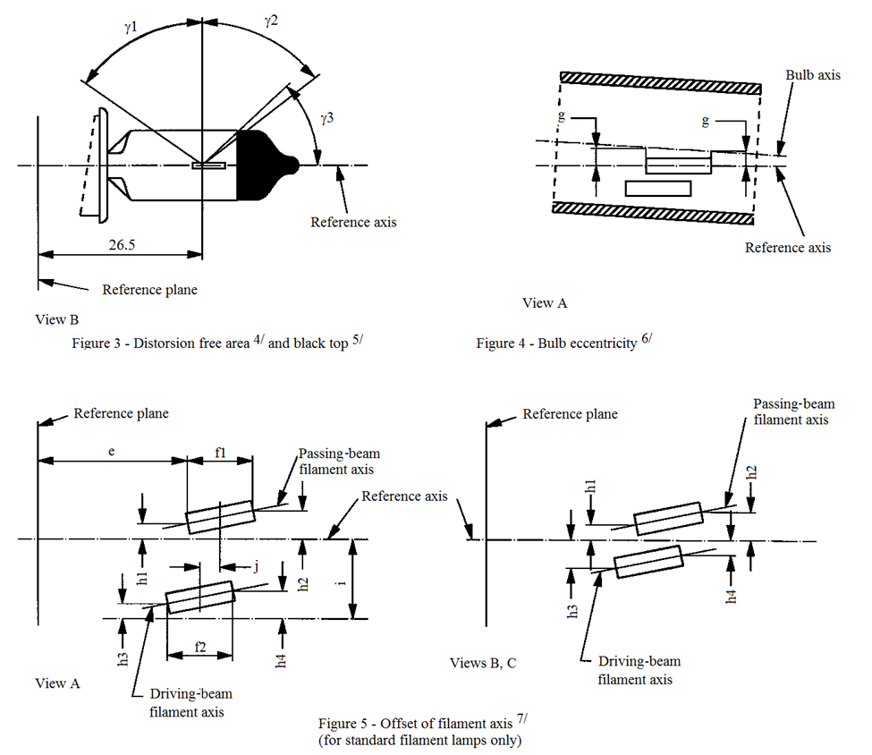

Reference axis

View B

Reference plane

View A

Reference axis

Bulb axis

Reference plane

Figure 3 – Distortion free area4/ and black top5/

Figure 4 – Bulb eccentricity6/

Passing-beam

filament axis

Passing-beam

filament axis

Driving-beam

filament axis

Driving-beam

filament axis

View A

Views B, C

Reference axis

Reference plane

Figure 5 – Offset of filament axis7/

(for standard filament light sources only)

ɣ1

ɣ2

ɣ3

g

g

e

f1

h1

h1

h3

h4

h2

h3

h2

h4

i

j

26.5

f2

"

*Sheet H15/1, figure 1*, amend to read (insert an arrow to the inner shield labelled with a footnote 14):

"

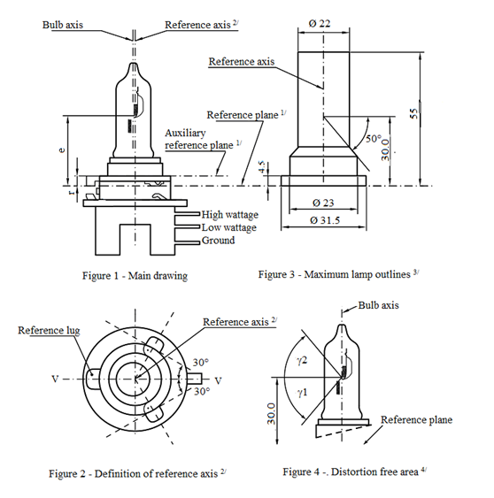

Reference axis2/

Reference plane1/

Bulb axis

Reference axis

Auxiliary

reference plane1/

High wattage

Low wattage

Ground

Figure 1 – Main drawing

Figure 3 - Maximum filament light source outlines3/

Ø 22

Bulb axis

Reference axis2/

Reference lug

Ø 31.5

Ø 23

50°

30.0

55

4.5

e

r

30°

30°

30.0

ɣ1

ɣ2

Reference plane

V

V

Figure 2 – Definition of reference axis7/

Figure 4 - Distortion free area4/

14/

"

*Sheet H15/5*, insert a new footnote 14:

"…

14/ Internal shield, not intended for producing the cut-off-line."

*Sheet H16/3, table,* amend to read:

"…

| *Dimensions in mm* | *Filament light sources of normal production* | *Standard filament light source* |
| --- | --- | --- |
| *12 V* | *12 V* |
| … | … | … |
| … | … | … |
| g | 0.5 min. | 0.5 min. |
| … | … | … |

"

*Sheet H17/1, figure 1*, amend to read (insert an arrow to the inner shield labelled with a new footnote 13):

"

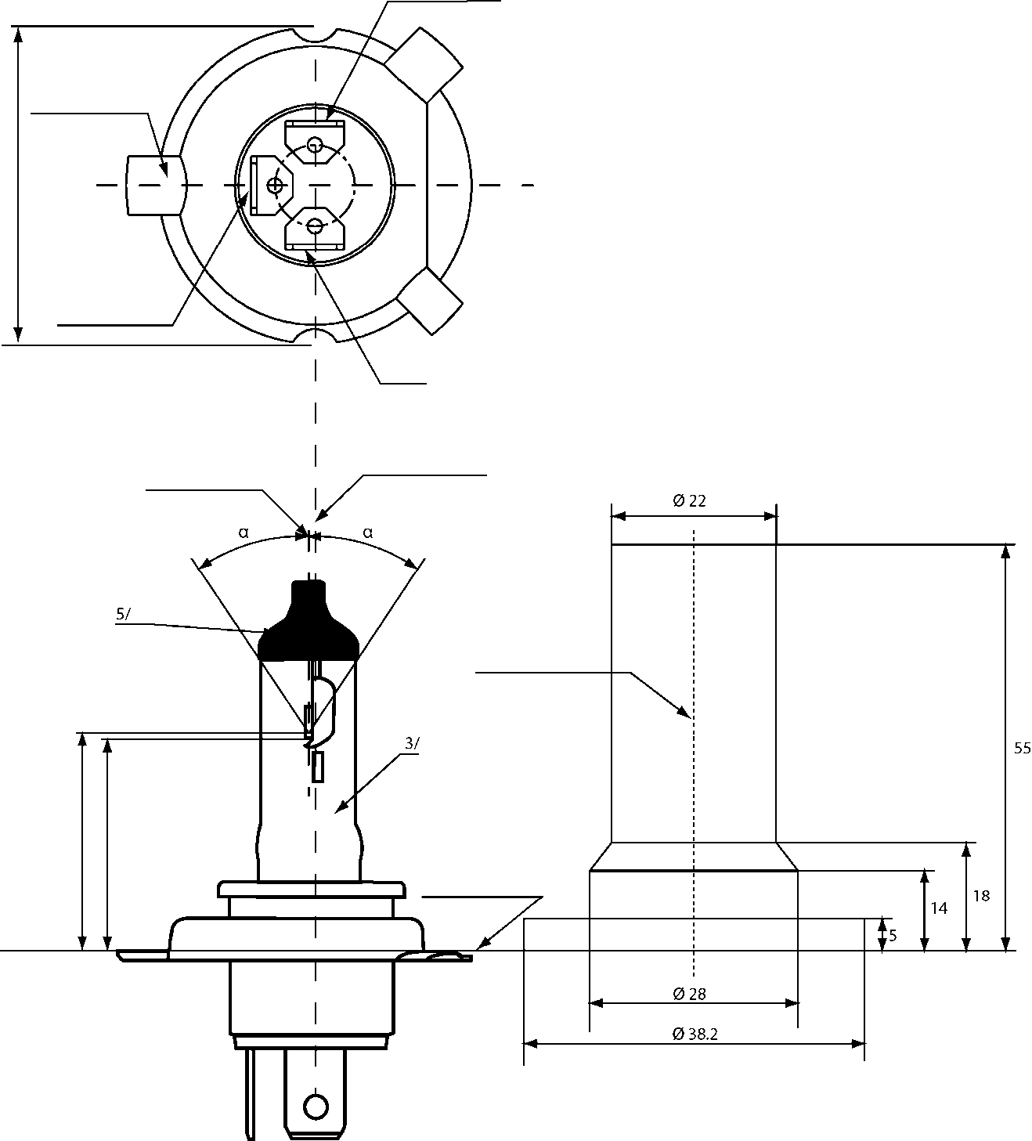

Driving-beam

Reference lug

Passing-beam

M

Earth

Axis of the bulb

Reference axis2/

Reference axis

Reference plane1/

Figure 1 –

Maindrawing

Figure 2 - Maximum filament light source outlines4/

Ø 38.2

Ø 28

Ø 22

5/

3/

55

18

14

5

α

α

e

p

13/

"

*Sheet H17/6*, insert a new footnote 13:

"…

13/ Internal shield, not intended for producing the cut-off-line."

*Sheet H18/3, table,* amend to read:

"…

|  |  |  |
| --- | --- | --- |
|  | *Filaments light sources of normal production* | *Standard filament light source* |
| *12 V* | *12 V* |
| … | … | … |
| … | … | … |
| g 12/ | 0.5 min. | 0.5 min. |
| … | … | … |

"

*Sheet H19/1, figure 1*, amend to read insert an arrow to the inner shield labelled with a new footnote 13):

"



13

"

*Sheet H19/2, table,* amend to read:

"…

|  |  |  |  |  |  |
| --- | --- | --- | --- | --- | --- |
| *Dimensions in mm* | | *Filament lamps of normal production* | | *Standard filament lamps* | |
| *12 V* | | *12 V* | |
| e | | 28.5 + 0.35 / - 0.15 | | 28.5 + 0.20 / - 0.0 | |
| p | | 28.95 | | 28.95 | |
| α | | max. 45° | | max. 45° | |
| Cap PU43t-3 in accordance with IEC Publication 60061 (sheet 7004-171-2) | | | | | |
| Electrical and photometric characteristics | | | | | |
| Rated values | Volts | 126 | | 126 | |
| Watts | 60 | 55 | 60 | 55 |
| Test voltage | Volts | 13.2 | 13.2 | 13.2 | 13.2 |
| Objective values | Watts | 72 max | 68 max. | 72 max. | 68 max. |
| Luminous flux | 1**,**750 ± 10% | 1**,**200 ± 10% |  |  |
| Reference luminous flux at approximately | | | 13.2 V | 1**,**750 | 1**,**200 |

"

*Sheet H19/5*, insert a new footnote 13:

"…

13 Internal shield, not intended for producing the cut-off-line."

*Sheet H20/3, table,* amend to read:

"

|  |  |  |  |  |  |
| --- | --- | --- | --- | --- | --- |
| … | | … | | … | … |
| … | | … | … |
| … | | … | | … | … |
| Objective values | | Watts | | 75 max. | 75 max. |
| Luminous flux | | 1**,**250 ± 10 % |  |
| Reference luminous flux at approximately | | | | 12 V | 900 |
| 13.2 V | 1**,**250 |
| … | … | | | … | … |
| … | | … | … | … |
| … | … |
| … | … | … |
| … | … |
| … | … |
| … | … |

"

*Sheet H21W/2,* insert a page break after paragraph 3.2. and start sheet H27W/1at the next page.

*Sheet HS1/2, table,* amend to read:

"

| *Dimensions in mm* | | | *Filament light sources of normal production* | | | | | *Standard filament light source* | |
| --- | --- | --- | --- | --- | --- | --- | --- | --- | --- |
| *6 V* | | *12 V* | | | *12 V* | |
| e | | | 28.5 + 0.45 / -0.25 | | | | | 28.5 + 0.20 / -0.00 | |
| p | | | 28.95 | | | | | 28.95 | |
| α | | | max. 40° | | | | | max. 40° | |
| Cap PX43t in accordance with IEC Publication 60061 (sheet 7004-34-2) | | | | | | | | | |
| Electrical and photometric characteristics | | | | | | | | | |
| Rated values | | Volts | 6 6/ | | 12 6/ | | | 12 6/ | |
| Watts | 35 | 35 | 35 | | 35 | 35 | 35 |
| Test voltage | | Volts | 6.3 | | 13.2 | | | 13.2 | |
| Objective values | Watts | | 35 | 35 | 35 | | 35 | 35 | 35 |
| ± % | | 5 | | | | | 5 | |
| Luminous flux | | 700 | 440 | 825 | | 525 |  | |
| ± % | | 15 | | | | |  | |
| Measuring flux 7/ lm | | | - |  | - | | 525 |  | |
| Reference luminous flux at approximately | | | | | | 12 V | | 700 | 450 |
| 13.2 V | | 825 | 525 |

"

*Sheet P21/5W/1,* insert a page break after the table and start sheet P21/5W/1 at the next page.

*Sheet S1/S2/1,* *the introductory text above the figures,* amend to read:

"The drawings are intended only to illustrate the essential dimensions (in mm) of the filament light source."

*Sheet WY21W/1, table*, amend to read:

"…

| *Dimensions in mm* | *Filament light sources of normal production* | | | *Standard filament light source* |
| --- | --- | --- | --- | --- |
| *Min.* | *Nom.* | *Max.* |
| e |  | 29.0 3/ |  | 29.0 ± 0.3 |
| f |  |  | 7.5 | 7.5 + 0 / -2 |
| Lateral deviation 1/ |  |  | 3/ | 0.5 max. |
| … | … | … | … | … |

"

*Annex 3,*

*List of sheets for LED light sources and their sequence,* amend to read:

"

|  | *Sheet number(s)* |  |
| --- | --- | --- |
|  | C5W/LED/1 to 4  H11/LED/1 to 7  L1/1 to 5 |  |
|  | LR1/1 to 5 |  |
|  | LW2/1 to 5 |  |
|  | Lx3/1 to 6 |  |
|  | LR4/1 to 5 |  |
|  | Lx5/1 to 6 |  |
|  | PY21W/LED/1 to 4  R5W/LED/1 to 4  W5W/LED/1 to 4 |  |

"

*Sheet L1/2, table 1,* amend to read:

"

|  |  |  |  |  |  |  |  |  |  |
| --- | --- | --- | --- | --- | --- | --- | --- | --- | --- |
| *Dimensions* | | | *Production*  *LED light sources* | | | *Standard*  *LED light sources* | | | |
| a | | mm | 6.0 max. | | | | | | |
| b | | mm | c + 10.0 min.  38.0 max. | | | | | | |
| c | | mm | 18.60 | | | | | | |
| d | | mm | 28.0 max. | | | | | | |
| e | | mm | 3.00 ± 0.30 | | | 3.00 ± 0.10 | | | |
| h8 | | mm | 4.88 | | | | | | |
| k9 | | mm | 7 min. | | | | | | |
| m9 | | mm | 4.5 max. | | | | | | |
| Cap PGJ18.5d-29 in accordance with IEC Publication 60061 (sheet 7004-185-~~[~~2~~]~~) 10 | | | | | | | | | |
| *Electrical and photometric characteristics5* | | | | | | | | | |
| Rated Values | Voltage (in Volts) | | 12 | | | | | | |
| Power (in Watts) |  | 4.0 | | | | | | |
|  |  |  |  | | | | | | |
| Test voltage | Volts (DC) |  | 13.2 | | 13.5 | | 13.2 | | 13.5 |
| Objective values 6 | Power (in Watts) at test voltage |  | 6.0 max | | | | | | |
| Luminous Flux (in lumen)  at test voltage |  | 350 ± 20% | 355 ± 20% | | 350 ± 10%7 | | 355 ± 10% | |
| Luminous Flux (in lumen)  at 9V DC |  | 70 min. | | | | | | |
| *Characteristics of the light-emitting area* | | | | | | | | | |
| Contrast | | | 200 min. | | | 200 min.  400 max. | | | |
| Size of light emitting area in relation to size of nominal emitter box 3 | | | 75% min. | | | 75% min. | | | |
| Uniformity R0.1 – surface ratio with luminance exceeding 10% of average luminance | | | 75% min. | | | 85% min. | | | |
| Uniformity R0.7 – surface ratio with luminance exceeding 70% of average luminance | | | 55% min. | | | 65% min. | | | |
| *Specific thermal test conditions* | | | | | | | | | |
| Maximum test temperature | | | 65 °C | | | 65 °C | | | |

"

*Sheet L1/4, the introductory text above Figure 4,* amend to read:

"…

The following test is intended to determine the normalized luminous intensity distribution of the light source in an arbitrary plane containing the reference axis. The intersection of the reference axis and the upper edge of the box is used as the coordinate system origin.

The light source is mounted on a flat plate with the corresponding mounting lug features. The plate is mounted to the goniometer table by a bracket, so that the reference axis of the light source lines up with one of the rotating axis of the goniometer. The corresponding measurement set-up is described in Figure 4.

Luminous intensity data is recorded with a standard photo-goniometer. The measurement distance should be chosen appropriately, to make sure that the detector is located in the far field of the light distribution.

The measurements shall be performed in C-planes C0, C90, C180 and C270, which contain the reference axis of the light source. The test points for each plane for multiple polar angles γ are specified in Table 3.

After measurement the data shall be normalized to 1000 lm according to paragraph 2.4.4. using the luminous flux of the individual light source under test. The data shall comply with the tolerance band as defined in Table 3.

The drawings are intended only to illustrate the essential set-up for measurement of the LED light source.…"

*Sheet L1/5, the text above table 3*, amend to read:

" The light pattern as described in Table 3 shall be substantially uniform, i.e. in between two adjacent grid points the relative luminous intensity requirement is calculated by linear interpolation using the two adjacent grid points. In case of doubt this may be checked in addition to verification of the grid points given in Table 3."

*Sheet L1/5, table 3*, *title,* amend to read:

"Test point values of normalized intensities of normal production and standard light sources, respectively"

*Sheet LR1/2, table,* amend to read:

"…

|  |  |  |  |  |  |
| --- | --- | --- | --- | --- | --- |
| *Dimensions in mm* | | *Tolerance* | | | |
| *LED light sources of normal production* | | *Standard LED light source* | |
| e 3/ 7/ | 24.0 | 0.2 | | 0.1 | |
| Cap PGJ21t-1 in accordance with IEC Publication 60061 (sheet 7004-165-1) | | | | | |
| Electrical and photometric characteristics 5/ | | | | | |
| Rated values |  | *Minor function* | *Major function* | *Minor function* | *Major function* |
| Volts | 12 | | 12 | |
| Test voltage | Volts (DC) | 13.5 | | 13.5 | |
| Objective  Values 6/ | Watts  (at test voltage) | 0.75 max. | 3.5 max. 1.4 min. | 0.75 max. | 3.5 max. 1.4 min. |
| Luminous flux  (in lm at test voltage) |  |  | 3.5 ± 10% | 47 ± 10% |
| Luminous flux  (in lm at 10-16 V DC) | 3.5 ± 20% | 47 ± 20% |  |  |

"

*Sheet LR1/4, penultimate paragraph*, amend to read:

"After measurement the data shall be normalized to 1,000 lm according to paragraph 2.4.4. using the luminous flux of the individual light source under test. The data shall comply with the tolerance band as defined in Table 3.

…"

*Sheet LW2/1, table,* amend to read:

"…

|  |  |  |  |  |  |  |  |
| --- | --- | --- | --- | --- | --- | --- | --- |
| *Dimensions in mm* | | *Tolerances* | | | | | |
| *LED light sources of normal production* | | *Standard LED light sources* | | | |
| e 8/ | 26.4 | 0.2 | | 0.1 | | | |
| Cap PGJY50 in accordance with IEC Publication 60061 (sheet 7004-182-1) | | | | | | | |
| Electrical and photometric characteristics 5/ | | | | | | | |
| Rated values |  | *Minor function* | *Major function* | | *Minor function* | *Major function* | |
| Volts | 12 | | | 12 | | |
| Test voltage | Volts (DC) | 13.5 | | | 13.5 | | |
| Objective  Values 6/ 7/ | Watts  (at test voltage) | 1 max. | 12 max. 4 min. | | 1 max. | | 12 max. 4 min. |
| Luminous flux  (in lm at test voltage) |  |  | | 50 ± 10% | | 725 ± 10% |
| Luminous flux  (in lm at 10-16 V DC) | 50 ± 15% | 725 ± 15% | |  | |  |
| Corresponding base temperature Tb in °C | | 30 ± 2 | 55 ± 2 | | 30 ± 0.5 | | 55 ± 0.5 |

"

*Sheet Lx3/1, figure 1,* amend to read:

"

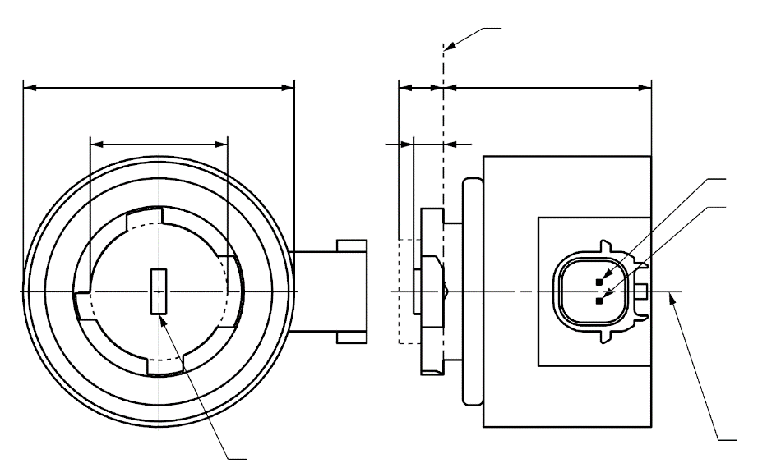

b

c

a

d

e

4

Reference plane1

V+

Light emitting area3

Reference axis2

Ground

**LR3A, LW3A, LY3A**

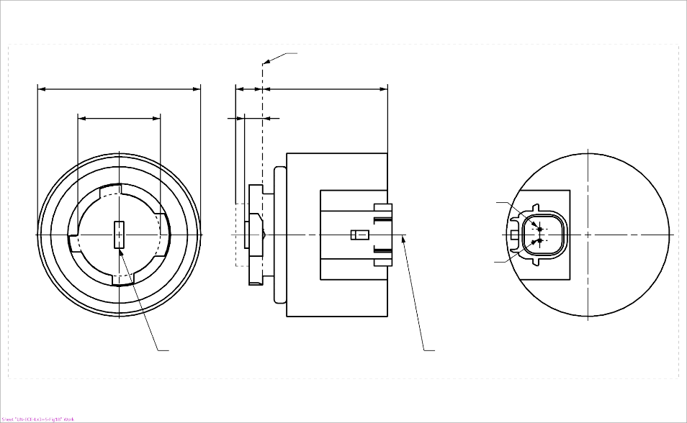

4

b

c

a

e

d

Light emitting area3

Reference axis2

Reference plane1

**LR3B, LW3B, LY3B**

Ground

V+

"

*Sheet Lx3/2, table 1 and footnote 4*, amend to read:

"….….

|  |  |  |  |  |  |  |  |
| --- | --- | --- | --- | --- | --- | --- | --- |
| *Dimensions* | | | | | | *Production LED light sources* | *Standard LED light sources* |
| a | | | | | mm | 6.0 max. | |
| b | | | | | mm | c + 10.0 min.  38.0 max. | |
| c | | | | | mm | 18.5 ± 0.1 | |
| d | | | | | mm | 28.0 max. | |
| e 13/ | | | | | mm | 3.0 ± 0.30 | 3.0 ± 0.15 |
| Cap | LR3A, LR3B  LW3A, LW3B  LY3A, LY3B | | PGJ18**.**5d-1  PGJ18.5d-24 PGJ18.5d-15 | | in accordance with IEC Publication 60061 (sheet 7004-185-2) | | |
| *Electrical and photometric characteristics* | | | | | | | |
| Rated values | | Volts | |  | | 12 | |
| Watts | |  | LR3A, LR3B | 3 | |
|  | LW3A, LW3B  LY3A, LY3B | 4 | |
| Test voltage | | Volts (DC) | | | | 13.5 | |
| Objective Values8 | | Watts  (at test voltage) | |  | LR3A, LR3B | 3.5 max. | |
|  | LW3A, LW3B | 5 max. | |
| 12 | LY3A, LY3B |
| Luminous flux  (in lm at test voltage) | | 5 | LR3A, LR3B | 80 ± 20%9 | 80 ± 10%10 |
| 6 | LW3A, LW3B | 250 ± 20% | 250 ± 10%11 |
| 7, 12 | LY3A, LY3B | 150 ± 20%9 | 150 ± 10%10 |
| Luminous flux  (in lm at 9 V DC) | | 5 | LR3A, LR3B | 19 min |  |
| 6 | LW3A, LW3B | 50 min. |  |
| 7, 12 | LY3A, LY3B | 30 min |  |

1/ …

2/ …

3/ …

4/ A minimum free air space of 5 mm around the light source shall be respected for convection; the connector interface can be neglected.

5/ …

6/ …

…"

*Sheet Lx3/5, fifth indent*, amend to read:

" After measurement the data shall be normalized to 1,000 lm according to paragraph 2.4.4. using the luminous flux of the individual light source under test. The data shall comply with the tolerance band as defined in Tables 4a and 4b.…"

*Sheet Lx3/5, figure 3,* amend to read:

"

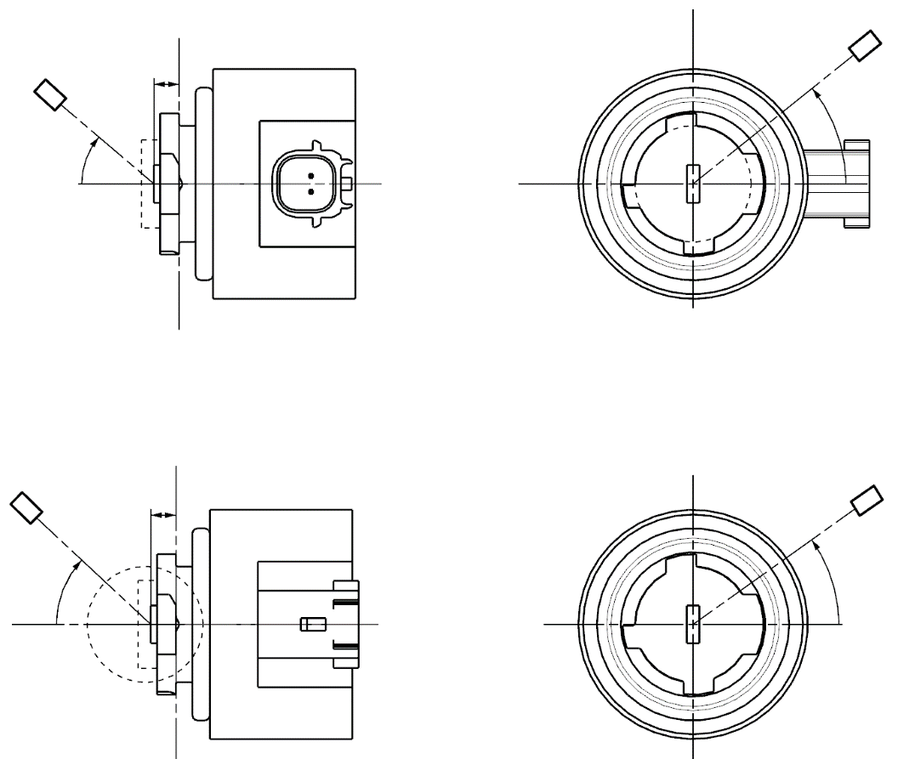

C

γ

e

C0

Reference axis

Reference plane

C-plane definition

Viewing direction along reference axis

Photo-Detector of Goniometer

**LR3A, LW3A, LY3A**

C

γ

e

C0

Reference axis

Reference plane

Photo-Detector of Goniometer

C-plane definition

Viewing direction along reference axis

**LR3B, LW3B, LY3B**

"

*Sheet LR4/1, figure 1,* amend to read:

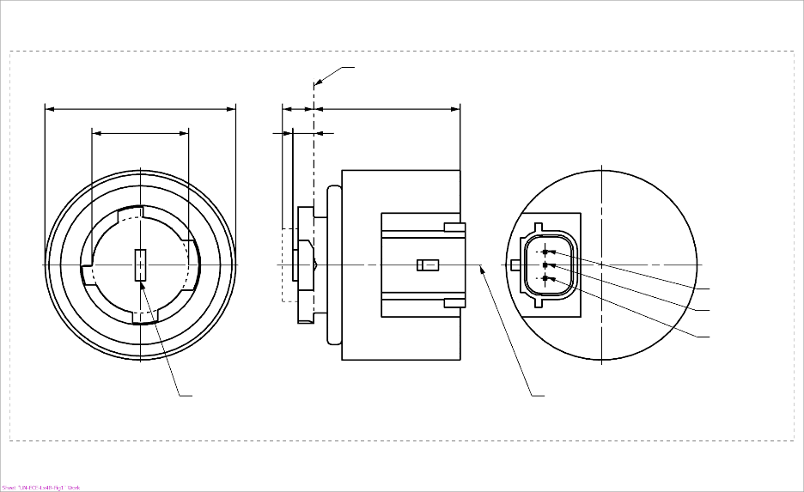

b

c

d

e

a

**LR4B**

Major Function

Reference axis2

Ground

Minor Function

Reference plane1

Light emitting area3

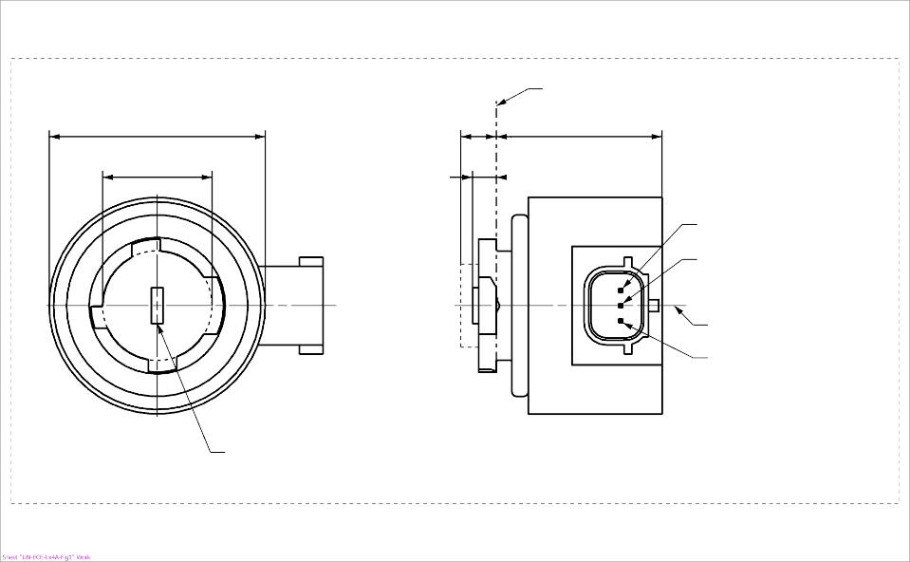

c

a

e

d

Reference plane1

Major Function

Minor Function

Reference axis2

Ground

b

Light emitting area3

**LR4A**

4

4

"

*Sheet LR4/2, table 1* *and footnotes 4 and 9*, amend to read:

"…

|  |  |  |  |  |  |  |
| --- | --- | --- | --- | --- | --- | --- |
| *Dimensions* | |  | *Production LED light sources* | | *Standard LED light sources* | |
| a | | mm | 6.0 max. | | | |
| b | | mm | c + 10.0 min.  38.0 max. | | | |
| c | | mm | 18.5 ± 0.1 | | | |
| d | | mm | 28.0 max. | | | |
| e 9/ | | mm | 3.0 ± 0.30 | | 3.0 ± 0.15 | |
| Cap PGJ18.5t-5 in accordance with IEC Publication 60061 (sheet 7004-185-2) | | | | | | |
| Electrical and photometric characteristics 5 | | | | | | |
| Rated values |  | | *Minor function* | *Major function* | *Minor function* | *Major function* |
| Volts | | 12 | | 12 | |
| Watts | | 0.75 | 3 | 0.75 | 3 |
| Test voltage | Volts (DC) | | 13.5 | | 13.5 | |
| Objective  Values 6 | Watts  (at test voltage) | | 1.0 max. | 3.5 max. | 1.0 max. | 3.5 max. |
| Luminous flux  (in lm at test voltage) | | 6 ± 20% | 80 ± 20% 7 | 6 ± 10% | 80 ± 10% 8 |
| Luminous flux  (in lm at 9 V DC) | | 1.5 min. | 19 min. |  |  |

1/ The reference plane is the plane defined by the contact points of the cap-holder fit.

2/ The reference axis is perpendicular to the reference plane and passing through the centre of the Bayonet core.

3/ Light emitting area: to be checked by means of the box system in Figure 2

4/ A minimum free air space of 5 mm around the LEDlight source shall be respected for convection; the connector interface can be neglected.

5/ The emitted light shall be red.

6/ After continuous operation for 30 minutes at 23 ± 2.5° C.

7/ The measured value shall be in between 100 per cent and 70 per cent of the value measured after 1 minute.

8/ The measured value shall be in between 85 per cent and 75 per cent of the value measured after 1 minute.

9/ Light centre length, both functions are operated at the same time during the measurement; for the method of measurement, see Annex K of IEC Publication 60809, Edition 3.3.

10/ The measured value shall be in between 100 per cent and 80 per cent of the value measured after 1 minute"

*Sheet LR4/4, fifth indent,* amend to read:

" After measurement the data shall be normalized to 1,000 lm according to paragraph 2.4.4. using the luminous flux of the individual light source under test. The data shall comply with the tolerance band as defined in Table 4."

*Sheet LR4/4, figure 3,* amend to read:

"

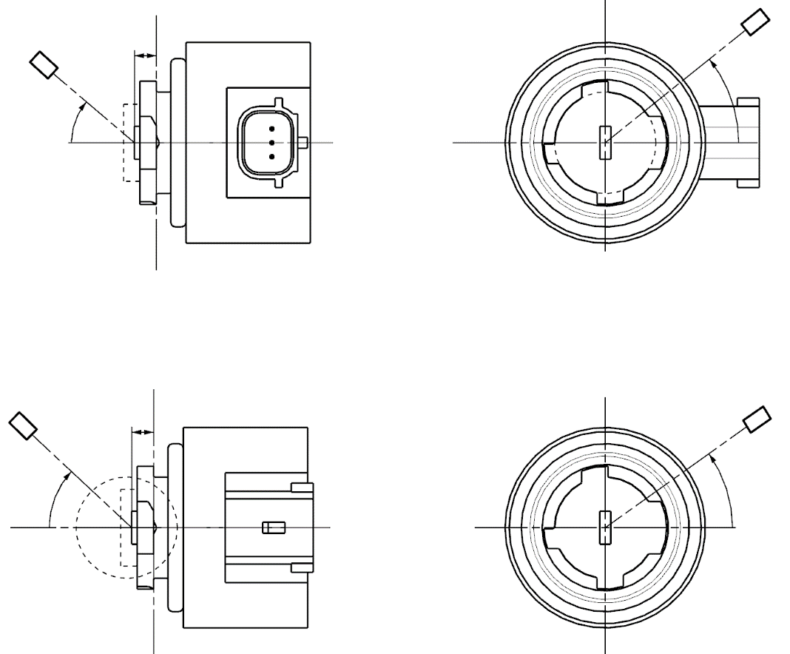

Reference axis

Reference plane

Photo-Detector of Goniometer

C-plane definition

Viewing direction along reference axis

**LR4B**

Reference axis

Reference plane

C-plane definition

Viewing direction along reference axis

Photo-Detector of Goniometer

**LR4A**

C

γ

e

C0

C

γ

e

C0

"

*Sheet Lx5/1, figure 1,* amend to read:

"

a

d

e

c

b

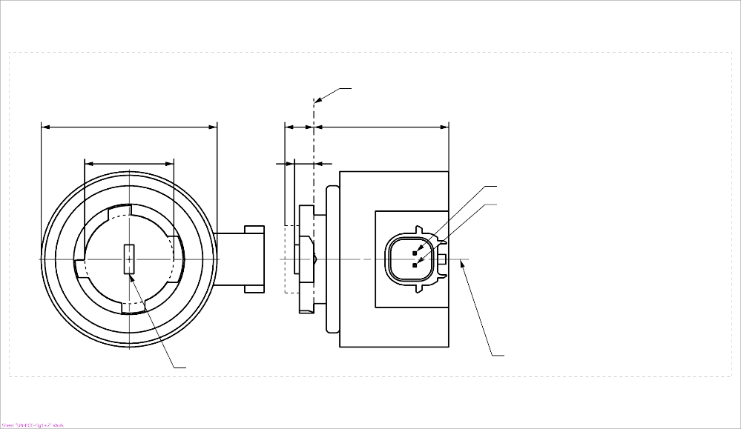

b

c

a

d

e

Reference plane1

V+

Light emitting area3

Reference axis2

Ground

4

**LR5A, LW5A, LY5A**



V+

Light emitting area3

Reference axis2

Ground

Reference plane1

4

**LR5B, LW5B, LY5B**

"

*Sheet Lx5/2, table 1 and footnote 4*, amend to read:

"…

|  |  |  |  |  |  |  |  |
| --- | --- | --- | --- | --- | --- | --- | --- |
| *Dimensions* | | | | | | *Production LED light sources* | *Standard LED light sources* |
| a | | | | | mm | 6.0 max. | |
| b | | | | | mm | c + 10.0 min.  38.0 max. | |
| c | | | | | mm | 18.5 ± 0.1 | |
| d | | | | | mm | 28.0 max. | |
| e 11/ | | | | | mm | 3.0 ± 0.30 | 3.0 ± 0.15 |
| Cap | LR5A, LR5B  LW5A, LW5B  LY5A, LY5B | | PGJ18.5d-10  PGJ18.5d-28  PGJ18.5d-19 | | in accordance with IEC Publication 60061 (sheet 7004-185-~~1~~**2**) | | |
| *Electrical and photometric characteristics* | | | | | | | |
| Rated values | | Volts | |  | | 12 | |
| Watts | |  | LR5A, LR5B | 3 | |
|  | LW5A, LW5B  LY5A, LY5B | 6 | |
| Test voltage | | Volts (DC) | | | | 13.5 | |
| Objective Values8 | | Watts  (at test voltage) | |  | LR5A, LR5B | 3.5 max. | |
|  | LW5A, LW5B | 8 max. | |
| 10 | LY5A, LY5B |
| Luminous flux  (in lm at test voltage) | | 5 | LR5A, LR5B | 120 ± 15% | 120 ± 5% 9 |
| 6 | LW5A, LW5B | 350 ± 20% | 350 ± 10% 9 |
| 7, 10 | LY5A, LY5B | 280 ± 20% | 280 ± 10% 9 |
| Luminous flux  (in lm at 9 V DC) | | 5 | LR5A, LR5B | 28 min. |  |
| 6 | LW5A, LW5B | 65 min. |  |
| 7, 10 | LY5A, LY5B | 55 min. |  |

1/ …

2/ …

3/ …

4/ A minimum free air space of 5 mm around the light source shall be respected for convection; the connector interface can be neglected.

5/ …

6/ …

…"

*Sheet Lx5/5, fifth indent,* amend to read:

" After measurement the data shall be normalized to 1,000 lm according to paragraph 2.4.4. using the luminous flux of the individual light source under test. The data shall comply with the tolerance band as defined in Table 4.…"

*Sheet Lx5/5, figure 3,* amend to read:

"

"



C

γ

e

C0

Reference axis

Reference plane

C-plane definition

Viewing direction along reference axis

Photo-Detector of Goniometer

**LR5A, LW5A, LY5A**

C

γ

e

C0

Reference axis

Reference plane

Photo-Detector of Goniometer

C-plane definition

Viewing direction along reference axis

**LR5B, LW5B, LY5B**

*After sheet C5W/LED/4*, insert new sheets H11/LED/1 to 7, to read:

(see following pages; one page per sheet)

"

**Category H11/LED/6 Sheet H11/LED/1**

The drawings are intended only to illustrate the essential dimensions (in mm) of the LED light source.

Figure 1

**Main drawing**

# 

Reference plane 1/

Reference axis 2/

A

B

e

f

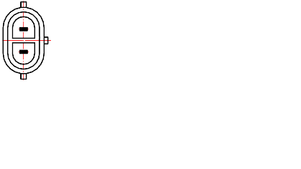

V+

Ground

View C

View A

Figure 2

**Maximum LED light source outline3/**

35

**∅**15.0

25.0

4

44.0

**∅**19.0

**∅**25.0

**∅** 50

50°

Reference plane

Reference axis

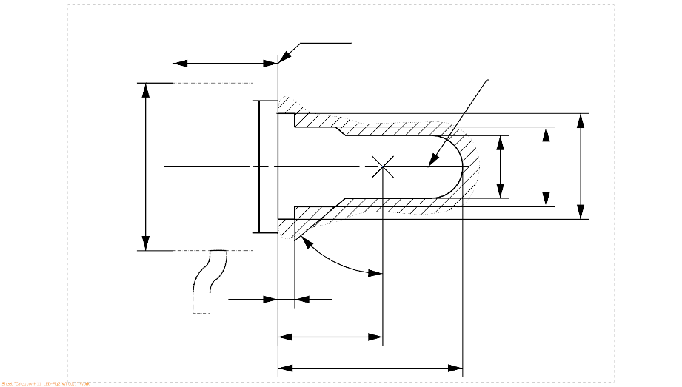

1/ The reference plane is the plane formed by the underside of the bevelled lead-in flange of the cap.

2/ The reference axis is perpendicular to the reference plane and passing through the centre of the 19 mm cap diameter.

3/ The LED light source shall not exceed the envelope as indicated in Figure 2.

**Category H11/LED/6 Sheet H11/LED/2**

Table 1

**Essential electrical and photometrical characteristics of the LED light source**

| *Dimensions in mm* | | | *LED light sources of normal production* | | *Standard LED light sources* |
| --- | --- | --- | --- | --- | --- |
| *12V* | *24V* |
| e 2/ | | | 25.0 nom. | | |
| f 2/ | | | 4.5 nom | | |
| Contrast 6/ | | | 100 min. | | |
| Elevated ambient air temperature 3/ | | | 60°C for H11/LED/6 | | |
| Cap H11/LED/6 PGJX19-2 in accordance with IEC Publication 60061 (sheet 7004-110A-1) | | | | | |
| *Electrical and photometric characteristics* | | | *4/* | *5/* | *4/* |
| Rated values | | Volts | 12 | 24 | 12 |
| Watts | 18 | 18 | 18 |
| Test voltage | | Volts (DC) | 13.2 | 28.0 | 13.2 |
| Objective values | Power | Watts | 21 max. | 21 max. | 21 max. |
| Electrical current | mA | 350 min.  1750 max.  (at 9-16 V DC) | 175 min.  875 max.  (at 16-32 V DC) | 350 min.  1750 max.  (at 9-16 V DC) |
| Luminous flux 1/  (at test voltage) | lm | 1,350 ± 10% | 1,350 ± 10% | 1,350 ± 10 % |
| Luminous flux 1/ | lm | 270 min.  (at 9 V DC) | 150 min.  (at 16 V DC) | 270 min.  (at 9 V DC) |

1/ The light emitted shall be white without a correlated colour temperature restriction.

2/ To be checked by means of a "box system", sheet H11/LED/3

3/ The luminous flux measured at the elevated ambient air temperature shall be at least 70% of the objective luminous flux (both measured at test voltage)

4/ In case of a failure of any of the light emitting elements (open circuit failure), the LED light source shall either still comply to the requirements concerning luminous flux and luminous intensity distribution or stop emitting light whereby, in the latter case, the electrical current draw, when operated between 12 V and 14 V, shall be less than 100 mA

5/ In case of a failure of any of the light emitting elements (open circuit failure), the LED light source shall either still comply to the requirements concerning luminous flux and luminous intensity distribution or stop emitting light whereby, in the latter case, the electrical current draw, when operated between 24 V and 28 V, shall be less than 50 mA

6/ The contrast is the proportion of luminous flux originating from two different areas, see details in sheet H11/LED/3

**Category H11/LED/6 Sheet H11/LED/3**

Screen projection requirements

The following test is intended to define the requirements for the apparent light emitting area of the LED light source and to determine whether the light emitting area is correctly positioned relative to the reference axis and reference plane in order to check compliance with the requirements.

The position of the light emitting area is checked by a box system defined in Figure 4 when operated at test voltage, which shows the projections when viewing from B (see sheet H11/LED/1, Figure 1) and from A and –A (see sheet H11/LED/1, Figure 1), i.e. along the C-planes C0, C90 and C270 (as defined in Figure 6).

The proportion of the total luminous flux emitted into these viewing directions from the area(s) as defined in Figure 4:

• Total box area: (A+B+C) / E shall be not less than 90%  
(for standard light sources a minimum of 95% applies)

• Area A: A / (A+B+C) shall be not more than 10%

• Areas B1, B2 and B3: B1/B, B2/B, B3/B shall each be not less than 15%

• Area B: B / (A+B+C) shall be not less than 72 %  
(for standard light sources a minimum of 75% and a maximum of 85% applies)

• Area C: C / (A+B+C) shall be not more than 22%

Figure 4

**Box definition of the light emitting area (dimensions given in Table 2)**

c1

x1

x2

c2

b1

b2

y1

y1

e

a1/2

a2

**E**

**B1**

**B2**

**B3**

**C**

**B**

**A**

Reference axis

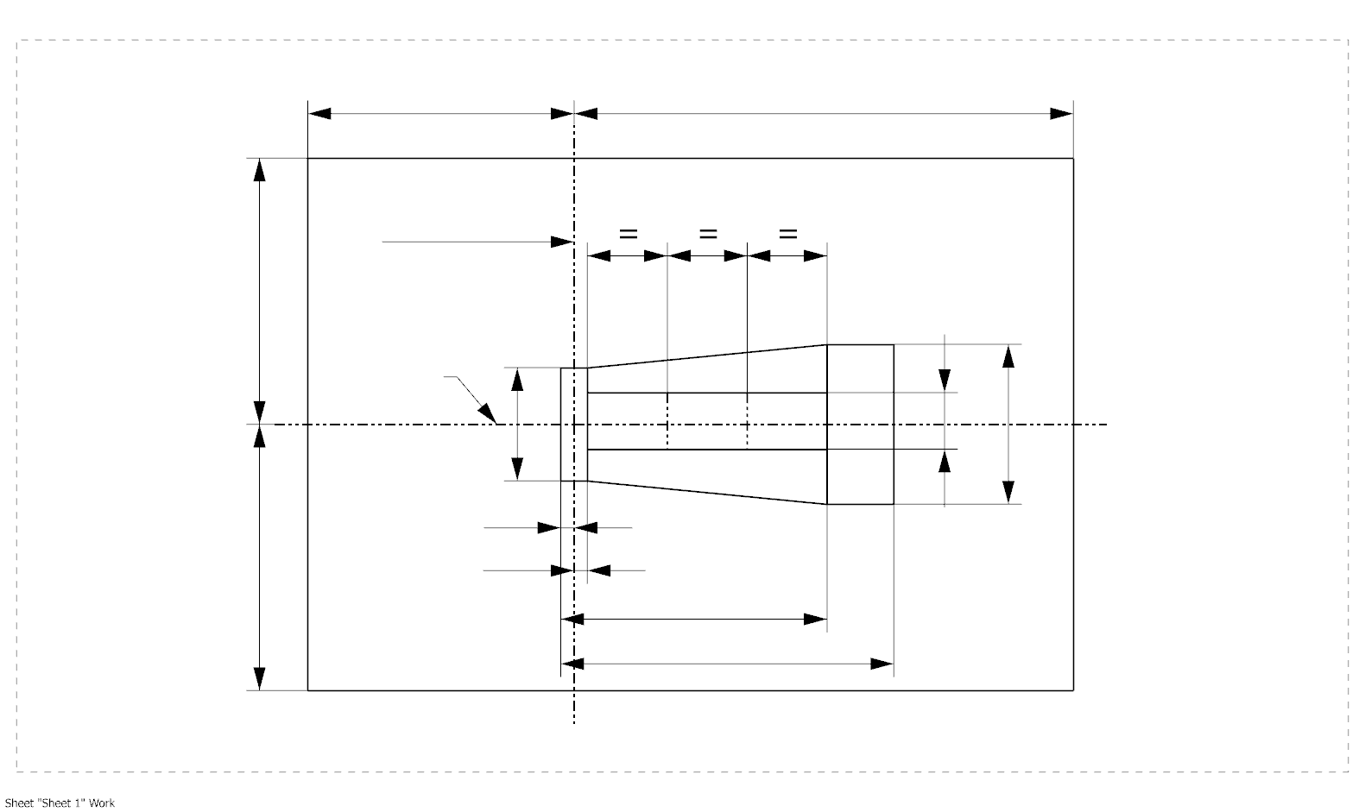

a1

The contrast is checked by a box system defined in Figure 5 when operated at test voltage, which shows the projections when viewing from A and –A (see sheet H11/LED/1, Figure 1), i.e. along the C-planes C90 and C270 (as defined in Figure 6).

The contrast is the proportion of the total luminous flux values emitted into these viewing directions from the corresponding areas (A+B+C) and D. The value of the contrast (A+B+C) / D shall be within the limits given in Table 1 (see Figure 5 for the definition of the area D).

**Category H11/LED/6 Sheet H11/LED/4**

Figure 5

**Box definition of the area D (dimensions given in Table 2)**

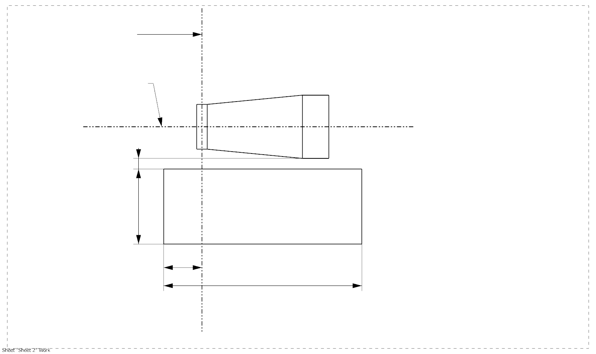

g2

g3

d

g1

**A**

**D**

**C**

**B**

e

Reference axis

Table 2

**Dimensions of the box definitions in Figure 4 and Figure 5**

|  |  |  |  |
| --- | --- | --- | --- |
| All views  (as specified above) | *Dimensions in mm* | All views  (as specified above) | *Dimensions in mm* |
| a1 | 1.7 | x1 | 25 |
| a2 | 1.9 | x2 | 19 |
| b1 | 0.2 | y1 | 12.5 |
| b2 | 0.2 | g1 | 2.85 |
| c1 | 5.0 | g2 | 7.5 |
| c2 | 4.0 | g3 | 1.45 |
| d | 0.4 |  | |

**Category H11/LED/6 Sheet H11/LED/5**

Normalized luminous intensity distribution

The following test is intended to determine the normalized luminous intensity distribution of the light source in the C-planes as described in Figure 6 when operated at test voltage. The intersection of the reference axis and the plane parallel to the reference plane at distance e = 25.0 mm is used as the coordinate system origin.

The light source is mounted on a flat plate with the corresponding holder features. The plate is fixed to the goniometer table by a bracket, so that the reference axis of the light source lines up with one of the rotating axis of the goniometer. The corresponding measurement set-up is described in Figure 6.

Luminous intensity data is recorded with a standard photo-goniometer. The measurement distance should be chosen appropriately in order to make sure that the detector is located in the far field of the light distribution.

The measurements shall be performed in C-planes for which the line of intersection coincides with the reference axis of the light source. The test points for each plane and polar angles γ are specified in Table 3.

The measured luminous intensity values, normalised to the measured luminous flux of the individual light source under test, shall be converted to normalised luminous intensity values of a 1000 lm light source. These data shall comply with the limits as defined in Table 3.

Figure 6

**Setup to measure the luminous intensity distribution and the definition of C-Planes and angle **

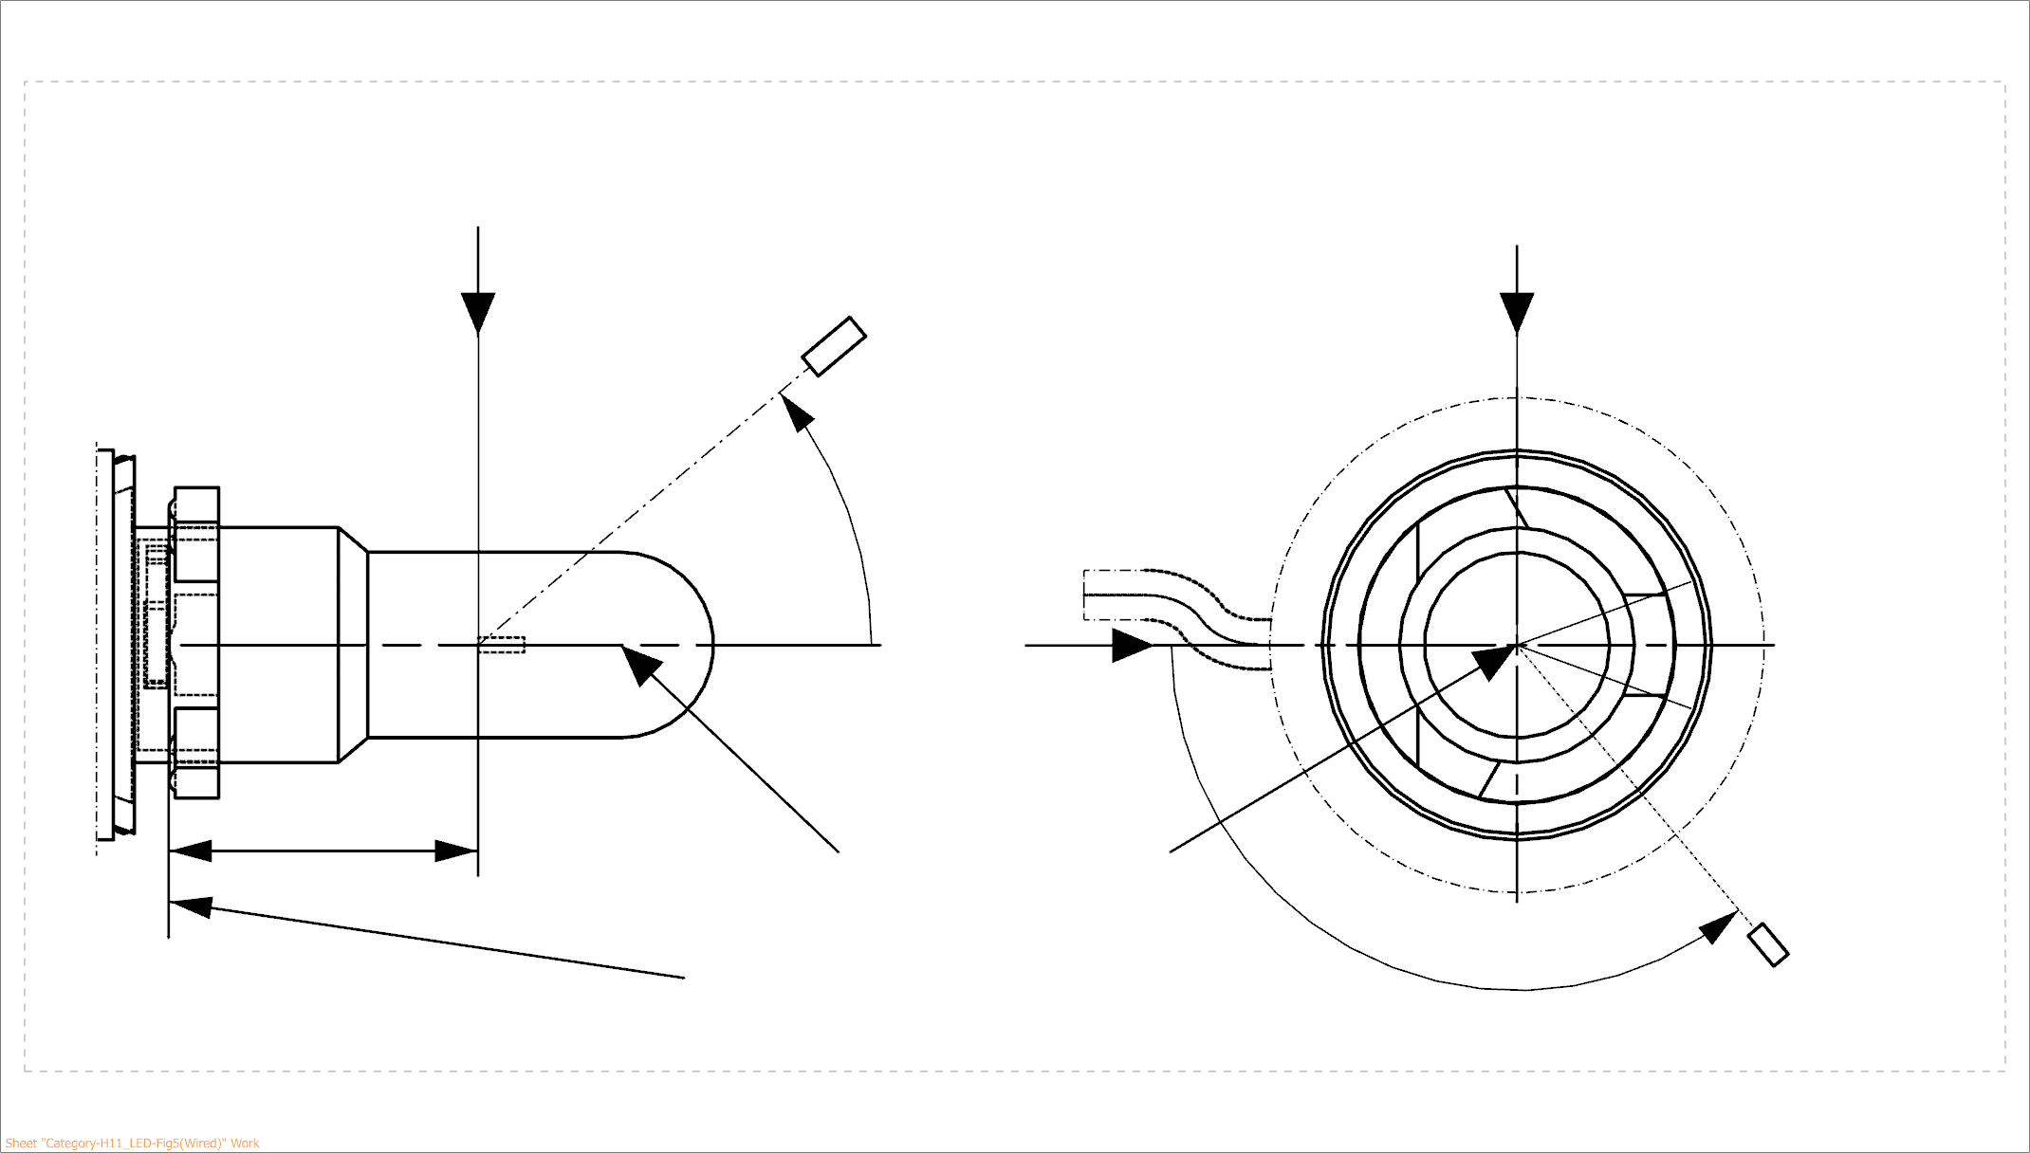

25,0

***View from B***

***View from C***

Reference plane

Reference axis

**B**

**A**

C = 270°

C = 90°

C = 180°

**C**

C = 0°

****

**A**

Photo-Detector of Goniometer

C-planes: see CIE publication 70-1987, "The measurement of absolute intensity distributions".

**Category H11/LED/6 Sheet H11/LED/6**

Table 3 – Part 1

**Test point values of normalized intensity (Black top area)**

|  |  |  |
| --- | --- | --- |
| *LED light source of normal production and standard LED light source* | | |
|  | *Minimum intensity (cd/klm)* | *Maximum intensity (cd/klm)* |
|  | C0, C90, C180, C270 | C0, C90, C180, C270 |
| 0° | n/a | 10 |
| 10° | n/a | 10 |
| 20° | n/a | 10 |
| 30° | n/a | 10 |

The light pattern as described in Table 3 – part 1 shall be substantially uniform, i.e. in between two adjacent grid points the relative luminous intensity requirement is calculated by linear interpolation using the two adjacent grid points. In case of doubt this may be checked in addition to verification of the grid points given in Table 3 – part 1.

*Note: The angular range in Table 3 – Part 1 is equivalent to the black top of its counterpart H11 filament light source specified by 3 in sheet H11/3.*

Table 3 – Part 2

**Test point values of normalized intensity (Distortion free area)**

|  |  |  |
| --- | --- | --- |
|  | *LED light source of normal production and standard LED light source* | |
|  | *Minimum intensity (cd/klm)* | *Maximum intensity (cd/klm)* |
|  | *C0, C90, C270* | *C0, C90, C270* |
| 50° | 80 | 130 |
| 60° | 80 | 130 |
| 70° | 80 | 130 |
| 80° | 80 | 130 |
| 90° | 80 | 130 |
| 100° | 80 | 130 |
| 110° | 80 | 130 |
| 120° | 80 | 130 |
| 130° | 80 | 130 |
| 140° | 80 | 130 |

The light pattern as described in Table 3 – part 2 (excluding the section between C90 and C270) shall be substantially uniform, i.e. in between two adjacent grid points the relative luminous intensity requirement is calculated by linear interpolation using the two adjacent grid points. In case of doubt this may be checked in addition to verification of the grid points given in Table 3 – part 2.

*Note:* *The angular range in Table 3 – Part 2 is equivalent to the distortion free area of its counterpart H11 filament light source specified by* 2 *and* 1 *in sheet H11/3.*

**Category H11/LED/6 Sheet H11/LED/7**

Table 3 – Part 3

**Test point values of normalized intensity (Shading area of the lead-in wire of the counterpart filament light source)**

|  |  |  |
| --- | --- | --- |
|  | *LED light source of normal production and standard LED light source* | |
| ** | *Minimum intensity (cd/klm)* | *Maximum intensity (cd/klm)* |
| *C-plane* | * = 90°* | * = 90°* |
| C0 | 80 | 130 |
| C30 | 80 | 130 |
| C60 | 80 | 130 |
| C90 | 80 | 130 |
| C120 | 80 | 130 |
| C150 | 80 | 130 |
| C180 | n/a | n/a |
| C210 | 80 | 130 |
| C240 | 80 | 130 |
| C270 | 80 | 130 |
| C330 | 80 | 130 |
| C330 | 80 | 130 |
| C360 (= C0) | 80 | 130 |

The light pattern as described in Table 3 – part 3 (excluding the section between C150 and C210) shall be substantially uniform, i.e. in between two adjacent grid points the relative luminous intensity requirement is calculated by linear interpolation using the two adjacent grid points. In case of doubt this may be checked in addition to verification of the grid points given in Table 3 – part 3.

*Note: Due to the shading area created by the lead-in wire of its counterpart H11 filament light source (opposite to the metal-free zone; see Figure 4 on sheet H11/2) there is no requirement in the C180-plane.*"

1. \* In accordance with the programme of work of the Inland Transport Committee for 2020 as outlined in proposed programme budget for 2020 (A/74/6 (part V sect. 20) para 20.37), the World Forum will develop, harmonize and update UN Regulations in order to enhance the performance of vehicles. The present document is submitted in conformity with that mandate. [↑](#footnote-ref-2)
2. \*\* This document was scheduled for publication after the standard publication date owing to circumstances beyond the submitter's control. [↑](#footnote-ref-3)