|  |  |  |  |
| --- | --- | --- | --- |
|  | United Nations | ECE/TRANS/WP.29/2021/20 | |
| _unlogo | **Economic and Social Council** | | Distr.: General  21 December 2020  Original: English |

**Economic Commission for Europe**

Inland Transport Committee

**World Forum for Harmonization of Vehicle Regulations**

**183rd session**

Geneva, 9-11 March 2021

Item 4.8.2 of the provisional agenda

**1958 Agreement:  
Consideration of draft amendments to existing   
UN Regulations submitted by GRSG**

Proposal for Supplement 1 to the 03 series of amendments to UN Regulation No. 67 (LPG vehicles)

Submitted by the Working Party on General Safety Provisions [[1]](#footnote-2)\*

The text reproduced below was adopted by the Working Party on General Safety Provisions at its 119th session, held in October 2020 (ECE/TRANS/WP.29/GRSG/98, para. 41). It is based on ECE/TRANS/WP.29/GRSG/2020/9. It is submitted to World Forum for Harmonization of Vehicle Regulations (WP.29) and the Administrative Committee of the 1958 Agreement (AC.1) for consideration and vote at their March 2021 sessions.

*Paragraph. 6.17.10.6.,* amend to read:

"6.17.10.6. Specific provisions regarding the K15 filling unit (Annex 9 – Figure 3):"

*Paragraph 6.17.10.7.3*., renumber as paragraph 6.17.10.8 and amend to read:

"6.17.10.8. The J15, K15 and heavy-duty vehicle Euro filling units shall comply with the impact test as described in Annex 9, paragraph 7."

*Annex 9*

*Paragraph 7,* amend to read:

"7. Impact test requirements for the J15, K15 and heavy-duty vehicle Euro filling units"

*Figure 3,* amend the figure title to read:

"Figure 3

**Connecting area of the K15 filling unit"**

*After Figure 5,* insert a new Figure 6:

"Figure 6

**Connecting area of the J15 filling unit**

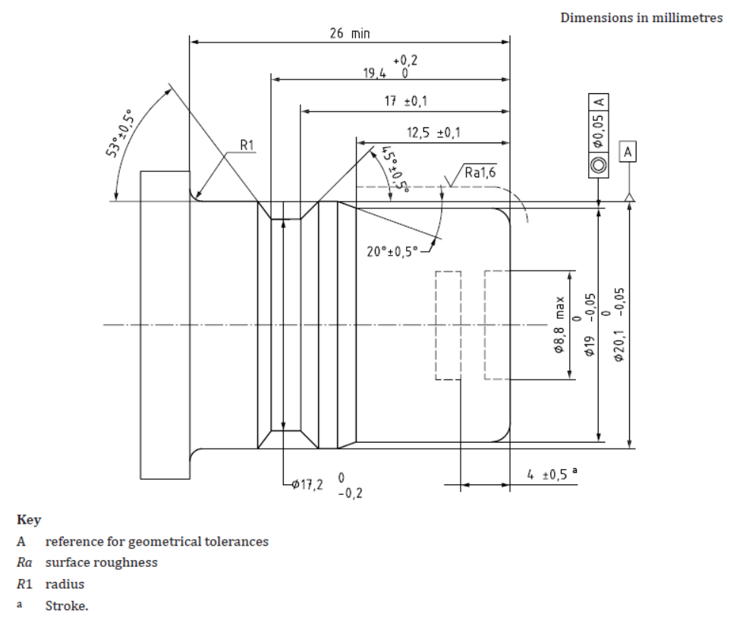"

1. \* In accordance with the programme of work of the Inland Transport Committee for 2020 as outlined in proposed programme budget for 2020 (A/74/6 (part V sect. 20) para 20.37), the World Forum will develop, harmonize and update UN Regulations in order to enhance the performance of vehicles. The present document is submitted in conformity with that mandate. [↑](#footnote-ref-2)