|  |  |  |  |
| --- | --- | --- | --- |
|  | United Nations | ECE/TRANS/WP.29/2021/4 | |
| _unlogo | **Economic and Social Council** | | Distr.: General  17 December 2020  Original: English |

**Economic Commission for Europe**

Inland Transport Committee

**World Forum for Harmonization of Vehicle Regulations**

**183rd session**

Geneva, 9-11 March 2021

Item 4.6.2 of the provisional agenda

**1958 Agreement:  
Consideration of draft amendments to existing   
UN Regulations submitted by GRBP**

Proposal for Supplement 9 to the 04 series of amendments to UN Regulation No. 41 (Noise emissions of motorcycles)

Submitted by the Working Party on Noise and Tyres[[1]](#footnote-2)\*

The text reproduced below was adopted by the Working Party on Noise and Tyres (GRBP) at its seventy-second session (ECE/TRANS/WP.29/GRBP/70, para. 5). It is based on ECE/TRANS/WP.29/GRBP/2020/18. It is submitted to the World Forum for Harmonization of Vehicle Regulations (WP.29) and to the Administrative Committee (AC.1) for consideration at their March 2021 sessions.

*Table of Contents, Annexes, 4,* amend to read:

"4 Test track layout"

*Paragraph 12.3.,* amend to read:

"12.3. Contracting Parties applying this Regulation may grant type approvals according to any preceding series of amendments to this Regulation.[[2]](#footnote-3) However, the specification of the test track may conform to ISO10844:2014."

*Insert a new paragraph 12.4.* to read:

"12.4. Contracting Parties applying this Regulation shall continue to grant extensions of existing approvals to any preceding series of amendments to this Regulation.1 However, the specification of the test track may conform to ISO10844:2014."

Paragraphs 12.4. (former) to 12.9., renumber as 12.5. to 12.10., respectively.

*Annex 3*

*Paragraph 1.2.1.*, third indent, delete "to the requirements of Annex 4 or".

*Annex 4*

*Title,* delete *footnote 1* and amend to read:

"Test track layout"

*Paragraphs 1. (including footnote 2), 2., and 2.1. to 2.5.,* delete.

*Paragraph 2.2., footnote 3,* delete.

*Paragraphs 3., 3.1., 3.2., 3.2.1., 3.2.1.1. to 3.2.1.4., and 3.2.2.,* delete.

*Figure 1*, amend to read:

"Figure 1

**Test track layout with dimensions in meters**

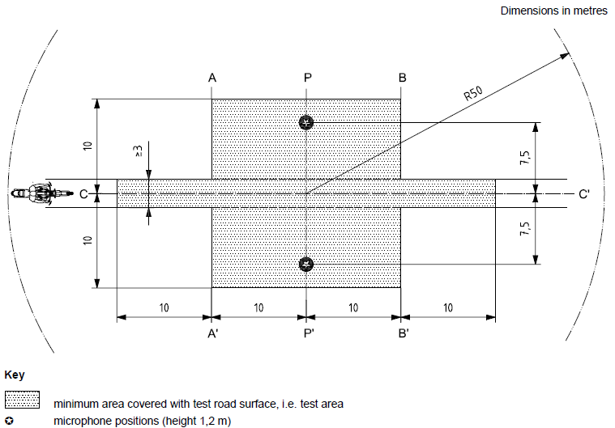

Key

|  |  |
| --- | --- |
|  | Minimum area covered with test road surface, i.e. test area |
|  | Microphone positions (height 1,2m) |

"

*Figure 2 and Table 1,* delete.

*Paragraphs 4., 4.1. to 4.3., 5. and 5.1. to 5.3.,* delete.

*Paragraphs 6., 6.1., 6.1.1. to 6.1.6., 6.1.6.1. to 6.1.6.7. and 6.2.,* delete.

1. \* In accordance with the programme of work of the Inland Transport Committee for 2020 as outlined in proposed programme budget for 2020 (A/74/6 (part V sect. 20) para 20.37), the World Forum will develop, harmonize and update UN Regulations in order to enhance the performance of vehicles. The present document is submitted in conformity with that mandate. [↑](#footnote-ref-2)
2. Note by the secretariat: the wording was adjusted in line with the decision of WP.29 at its November 2020 session (ECE/TRANS/WP.29/1155, paras. 92 and 93, and informal document WP.29-182-11). [↑](#footnote-ref-3)