Template for Case Studies
Regional Forum on Sustainable Development (21-22 March 2019, Geneva)
Governments and other stakeholders are kindly asked to provide concrete case studies and examples of practical solutions from their experience in SDG implementation. The case studies will be compiled in a document and shared with participants in advance of the Forum (please see last year’s case study compilation). A selection of case studies will be presented during the peer learning segment.

The Regional Forum on Sustainable Development (21-22 March 2019, Geneva) creates a regional space for peer learning and sharing of practical solutions in implementing the SDGs. Governments and other stakeholders will mutually learn from sharing concrete experiences, best practices and challenges. Case studies will form the basis of the peer learning segment.

When?

Why?

How?
Please submit the case study by 31 January 2019 to regionalforumunece@un.org.

SDG addressed
The case study must address one of the themes discussed at the round tables (see below). Please tick the relevant box.
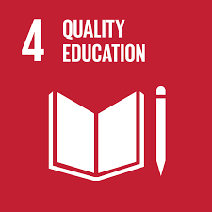
☐ Learning without Limits: Lifelong Learning and Inclusive Education
☐ The Power of Knowledge for Change: Education and Learning as Drivers of
Sustainable Development
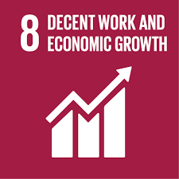
☐ The Growth We Want: Solutions for Sustained, Inclusive and Sustainable
Economic Growth
☐ The Future of Work: Productive Employment and Decent Work for All
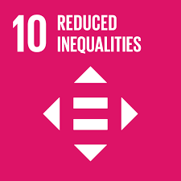
☐ Bridging the Gap: Achieving Greater Income and Economic Equality ☐ Towards a World of Equal Opportunity: Tackling inequality caused by exclusion
and discrimination
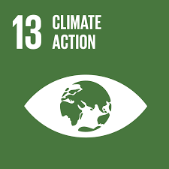
☐ Acting for Climate: Stepping Up Climate Change Policies, Action and
Awareness in the Region
☐ Coping with Climate Change: Strengthening Resilience and Adaptation
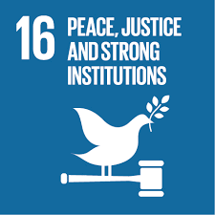
☐ Strengthening Institutions for Change: Fostering Effective and Inclusive
Governance for Sustainable Development
☐ Empowering People to Protect the Planet: The Environmental Dimension of SDG 16

Please fill in the template below.

Title
Please provide a title that reflects the core issues addressed in your case study.
Title: Click or tap here to enter text.

Summary
Please briefly summarise the objective of the case study/ practical solution (max 100 words).
Click or tap here to enter text.

Situation
Please elaborate on the specific situation/ context. Where possible, draw on statistics and data (max 150 words).
Click or tap here to enter text.

Strategy
Please describe the approach chosen (max 100 words).
Click or tap here to enter text.

Results and lessons learned
Please elaborate on the specific results, challenges encountered and lessons learned. If possible, briefly elaborate whether the concrete experience could be replicated in other contexts. Preferably, summarise your answer in bullet points (max 100 words).
Click or tap here to enter text.

Contact
Name:
Organisation:
E-Mail:
☐ Please tick this box if you do not wish your contact details to be published in the compiled document. The document will be published on our website. Please bear in mind that other stakeholders might wish to contact you in regard to the case study.

