E/ECE/324/Rev.2/Add.111/Rev.2/Amend.1−E/ECE/TRANS/505/Rev.2/Add.111/Rev.2/Amend.1
27 January 2011

Agreement
Concerning the Adoption of Uniform Technical Prescriptions for Wheeled Vehicles, Equipment and Parts which can be Fitted and/or be Used on Wheeled Vehicles and the Conditions for Reciprocal Recognition of Approvals Granted on the Basis of these Prescriptions*
(Revision 2, including the amendments which entered into force on 16 October 1995)

Addendum 111: Regulation No. 112
Revision 2 – Amendment 1
01 series of amendments - Date of entry into force: 9 December 2010
Uniform provisions concerning the approval of motor vehicle headlamps emitting an asymmetrical passing beam or a driving beam or both and equipped with filament lamps and/or light-emitting diode (LED) modules


UNITED NATIONS
In the list of Annexes, the title of Annex 3,amend to read:
"3 The spherical coordinate measuring system and test point locations"
In the whole text of the Regulation, replace all the references to the original version of the Regulation by the 01 series of amendments.
Paragraph 4.1.3., amend to read:
"4.1.3. An approval number shall be assigned to each type approved. Its first two digits shall indicate the series of amendments incorporating the most recent major technical amendments made to the Regulation at the time of issue of the approval. The same Contracting Party may not assign the same number to another type of headlamp covered by this Regulation."
Paragraph 4.2.3.1., amend to read:
"4.2.3.1. On headlamps meeting the requirements of this Regulation which are so designed that the filament or LED module(s) producing the principal passing beam shall not be lit simultaneously with that of any other lighting function with which it may be reciprocally incorporated: an oblique stroke (/) shall be placed behind the symbol indicating the headlamp producing the passing beam in the approval mark."
Paragraph 4.2.4., amend to read:
"4.2.4. The two digits of the approval number which indicate the series of amendments incorporating the most recent major technical amendments made to the Regulation at the time of issue of the approval and, if necessary, the required arrow may be marked close to the above additional symbols."
Paragraph 5.7.2., amend to read:
"5.7.2. In the case of failure, the luminous intensity above the line H-H shall not exceed the values of a passing beam according to paragraph 6.2.5.; in addition, on headlamps designed to provide a passing and/or a driving beam to become a bend lighting, a minimum luminous intensity of at least 2,500 cd. shall be fulfilled in test point 25 V (VV line, 1.72D).
…"
Paragraph 5.8.2., amend to read:
"5.8.2. Following the application of this (these) measure(s) the following requirements regarding the luminous intensity of the headlamp shall be met with the adjustment left unchanged compared to that for the original traffic direction:
5.8.2.1. Passing beam designed for right-hand traffic and adapted to left-hand traffic:
at 0.86D-1.72L at least 2500 cd
at 0.57U-3.43R not more than 880 cd
5.8.2.2. Passing beam designed for left-hand traffic and adapted to right-hand traffic:
at 0.86D-1.72R at least 2500 cd
at 0.57U-3.43L not more than 880 cd"
Paragraph 6.1.2., amend to read:
"6.1.2. The luminous intensity produced by the headlamp shall be measured at 25 m distance by means of a photoelectric cell having a useful area comprised within a square of 65 mm side. The point HV is the centre-point of the coordinate system with a vertical polar axis. Line h is the horizontal through HV (see Annex 3 to this Regulation)."
Paragraph 6.1.3., amend to read:
"6.1.3. Apart from LED module(s), the headlamps shall be checked by means of an uncoloured standard (étalon) filament lamp designed for a rated voltage
of 12 V. During the checking of the headlamp, the voltage at the terminals of the filament lamp shall be regulated so as to obtain the reference luminous flux at 13.2V as indicated at the relevant data sheet of Regulation No. 37. The headlamp shall be considered acceptable if it meets the requirements of paragraph 6. with at least one standard (étalon) filament lamp, which may be submitted with the headlamp.
For the measurements, the flux of this filament lamp may differ from the reference luminous flux at 13.2V specified in Regulation No. 37. In this case, the luminous intensity shall be corrected accordingly by the individual factor of the standard (étalon) filament lamp (F = Φ _{obj}. / Φ(Voltage))."
Paragraph 6.1.4., amend to read:
"6.1.4. LED module(s) shall be measured at 6.3 V, 13.2 V or 28.0 V respectively, if not otherwise specified within this Regulation. LED module(s) operated by an electronic light source control gear, shall be measured as specified by the applicant."
Paragraph 6.2.2., amend to read:
"6.2.2. The headlamp shall be visually aimed by means of the "cut-off" (see figure 1) as follows. The aiming shall be carried out using a flat vertical screen set up at a distance of 10 m or 25 m (as indicated in section 9 of Annex 1) forward of the headlamp and at right angles to the H-V axis as shown in Annex 3 to this Regulation. The screen shall be sufficiently wide to allow examination and adjustment of the "cut-off" of the passing beam over at least 5° on either side of the V-V line."
Paragraph 6.2.2.1., amend to read:
"6.2.2.1. For vertical adjustment: the horizontal part of the "cut-off" is moved upward from below line B and adjusted to its nominal position one per cent (0.57 degrees) below the H-H line;
………."
Paragraph 6.2.2.2., amend to read:
"6.2.2.2. …
(c) The kink of the "elbow" is basically located within +/-0.5 degrees to the left or right of the V-V line; .…"
Paragraph 6.2.4, amend to read:
"6.2.4. The passing beam shall meet the luminous intensities at the test points referred to in the tables below and in Annex 3 figure B (or mirrored about the VV line for left-hand traffic):
Headlamps for RH Traffic** |  | Class A Headlamp |  | Class B Headlamp
Test Point Designation | Test Point  Angular Coordinates - Degrees | Required luminous intensity  cd |  | Required luminous intensity  cd
Test Point Designation | Test Point  Angular Coordinates - Degrees | Max | Min | Max | Min
B 50 L | 0.57U, 3.43L | 350 |  | 350
BR | 1.0 U, 2.5R | 1,750 |  | 1,750
75 R | 0.57D, 1.15R |  | 5,100 |  | 10,100
75 L | 0.57D, 3.43L | 10,600 |  | 10,600
50 L | 0.86D, 3.43L | 13,200 |  | 13,200
50 R | 0.86D, 1.15R |  | 5,100 |  | 10,100
50 V | 0.86D, 0 |  |  |  | 5,100
25 L | 1.72D, 9.0L |  | 1,250 |  | 1,700
25 R | 1.72D, 9.0R |  | 1,250 |  | 1,700
Any point in zone III  (bounded by the following coordinates in degrees) |  | 625 |  | 625
  8 L | 8 L | 8 R | 8 R | 6 R | 1.5 R | V-V | 4 L
  1 U | 4 U | 4 U | 2 U | 1.5 U | 1.5 U | H-H | H-H
Any point in zone IV  (0.86D to 1.72D, 5.15 L to 5.15 R) |  |  | 1,700 |  | 2,500
Any point in zone I  (1.72D to 4D, 9 L to 9 R) |  | 17,600 |  | < 2I*
Note: In the table:
Letter L means that the point is located on the left of VV line.
Letter R means that the point is located on the right of VV line.
Letter U means the point is located above HH line
Letter D means the point or segment is located below HH line
* Actual measured value at points 50R / 50L respectively
** For left-hand traffic, the letter R shall be replaced by letter L and vice versa.

Headlamps for RH Traffic**
Test Point | Angular Coordinates  Degrees | Required luminous intensity- cd  Min
1 | 4U, 8L | Points 1+2+3  190
2 | 4U, 0 | Points 1+2+3  190
3 | 4U, 8R | Points 1+2+3  190
4 | 2U, 4L | Points 4+5+6  375
5 | 2U, 0 | Points 4+5+6  375
6 | 2U, 4R | Points 4+5+6  375
7 | 0, 8L | 65
8 | 0, 4L | 125
"
Paragraph 6.2.6., shall be deleted (including the reference to footnote 8 and footnote 8)
Paragraphs 6.2.7. to 6.2.9.3.(former), renumber as paragraphs 6.2.6 to 6.2.8.3 respectively.
Paragraph 6.3.1., amend to read:
"6.3.1. In the case of a headlamp designed to provide a driving beam and a passing beam, measurements of the luminous intensity of the driving beam shall be taken with the same headlamp alignment as for measurements under paragraphs 6.2.4. to 6.2.6. above; in the case of a headlamp providing a driving beam only, it shall be so adjusted that the area of maximum luminous intensity is centred on the point of intersection of lines H-H and V-V; such a headlamp need meet only the requirements referred to in paragraph 6.3. Where more than one light source is used to provide the driving beam, the combined functions shall be used to determine the maximum value of the luminous intensity (I_{M})."
Paragraphs 6.3.3. to 6.3.3.2., amend to read:
"6.3.3. Referring to Annex 3 Figure C and the table below, the luminous intensity distribution of the driving beam shall meet the following requirements:
 |  | Class A Headlamp | Class B Headlamp
Test Point | Angular Coordinates  Degrees | Required luminous intensity  cd | Required luminous intensity  cd
 |  | Min | Min
I_{max} |  | 27,000 | 40,500
H-5L | 0.0 , 5.0 L | 3,400 | 5,100
H-2.5L | 0.0 , 2.5 L | 13,500 | 20,300
H-2.5R | 0.0 , 2.5 R | 12,500 | 20,300
H-5R | 0.0 , 5.0 R | 3,400 | 5,100

6.3.3.1. The point of intersection (HV) of lines h h and v v shall be situated within the isolux 80 per cent of maximum luminous intensity (I_{max})
6.3.3.2. The maximum value (I_{M}) shall in no circumstances exceed 215,000 cd.
6.3.4. The reference mark (I'_{M}) of the maximum luminous intensity, referred to in paragraph 6.3.3.2. above, shall be obtained by the ratio:
I′_{M} = I_{M} /4,300
This value shall be rounded off to the value 7.5 - 10 - 12.5 - 17.5 - 20 - 25 - 27.5 - 30 - 37.5 - 40 - 45 - 50."
Paragraph 6.4.3., amend to read:
"6.4.3. Additional tests are made after the reflector has been moved vertically ±2° or at least into the maximum position, if less than 2°, from its initial position by means of the headlamps adjusting device. Having re-aimed the headlamp as a whole (by means of the goniometer for example) in the corresponding opposite direction the light output in the following directions shall be controlled and lie within the required limits:
passing beam : points HV and 75 R (75 L respectively);
driving beam : I_{M} and point HV (percentage of I_{M})."
Paragraph 6.5., shall be deleted
Paragraph 8, the reference to footnote 9 and footnote 9 renumber as footnote 8.
Paragraphs 14. to 14.4., amend to read:
"14. Transitional provisions
14.1. From the date of entry into force of the 01 series of amendments to this Regulation, no Contracting Party applying it shall refuse to grant approvals under this Regulation as amended by the 01 series of amendments.
14.2. As from 60 months after the date of entry into force of the 01 series of amendments, Contracting Parties applying this Regulation shall grant approvals only if the headlamp meets the requirements of this Regulation as amended by the 01 series of amendments.
14.3. Existing approvals for headlamps already granted under this Regulation before the date of entry into force of the 01 series of amendments shall remain valid indefinitely."
14.4. Contracting Parties applying this Regulation shall not refuse to grant extensions of approvals to the preceding series to this Regulation."
Paragraph 14.5. shall be deleted.
Annex 2,
The first paragraph, amend to read:
"The headlamp … indicate that it concerns a Class B passing and driving beam.
The figure 30 indicates that the maximum luminous intensity of the driving beam is between 123,625 and 145,125 candelas.
…
The use of Roman numerals as approval numbers should be avoided so as to prevent any confusion with other symbols."
Figure 11, the note, amend to read:
"Note: The four examples above correspond to a lighting device bearing an approval mark comprising:
…
A headlamp, Class B, with a passing beam designed for right- and left-hand traffic and a driving beam with a maximum intensity comprised between 123,625 and 145,125 candelas (as indicated by the number 30), approved in accordance with the requirements of this Regulation in its original form (00) and incorporating a lens of plastic material,
…"
Figure 12, the note, amend to read:
"The above example corresponds to the marking of a lens of plastic material intended to be used in different types of headlamps, namely:
Either A headlamp, Class B, with a passing beam designed for both traffic systems and a driving beam with a maximum luminous intensity comprised between 123,625 and 145,125 candelas (as indicated by the number 30), approved in Germany (E1) in accordance wit the requirements of this Regulation in its original form (00),
which is reciprocally incorporated with
A front position lamp approved in accordance with the 02 series of amendments to Regulation No. 7;
Or A headlamp, Class A, with a passing beam designed for both traffic systems and a driving beam with a maximum luminous intensity comprised between 33,750 cd and 41,250 cd (as indicated by the number 12.5), approved in Germany (E1) in accordance with the requirements of this Regulation in its original form (00),
which is reciprocally incorporated with
The same front position lamp as above;
Or Even either of the above-mentioned-headlamps approved as a single lamp.
The main body of the headlamp shall bear the only valid approval number, for instance:…"
Figure 12, the text of Example 2, amend to read:
"The above example corresponds to the marking of a lens of plastic material used in a unit of two headlamps approved in France (E2) under approval number 81151, consisting of:
A headlamp, Class B, emitting a passing beam and a driving beam with a maximum luminous intensity between x and y candelas, meeting the requirements of this Regulation, and
A headlamp, Class B, emitting a driving beam designed for both traffic systems with a maximum luminous intensity between w and z candelas, meeting the requirements of this Regulation, the maximum luminous intensities of the driving beams as a whole being comprised between 123,625 and 145,125 candelas."
Annex 3, amend to read:
"Annex 3
Spherical coordinate measuring system and test point locations

Figure A

Spherical coordinate measuring system
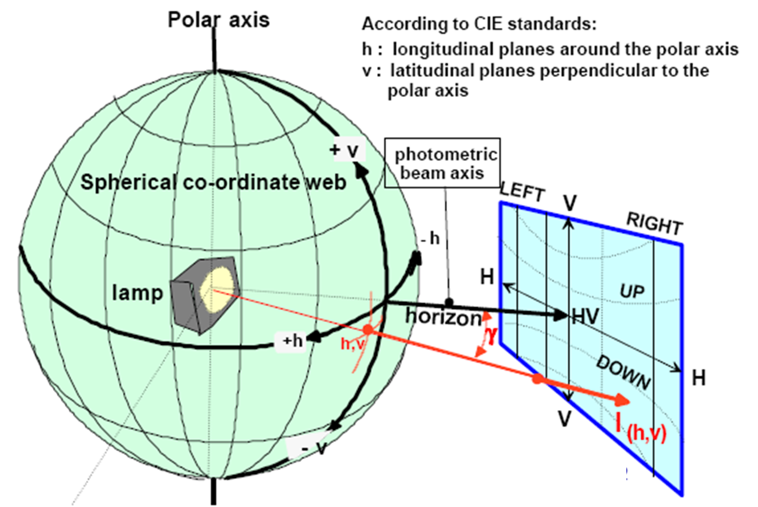
Polar Axis
Spherical Co-ordinate web
Lamp
Photometric Beam axis
UP
DOWN
Horizon
According to CIE standards:
h: longitudinal planes around the polar axis
v: latitudinal planes perpendicular to the polar axis
ECE projection screen at 25 meter distance
E_{25m}= l_{(h,v)}x cos γ/r²

Figure B

Passing beam for right-hand traffic
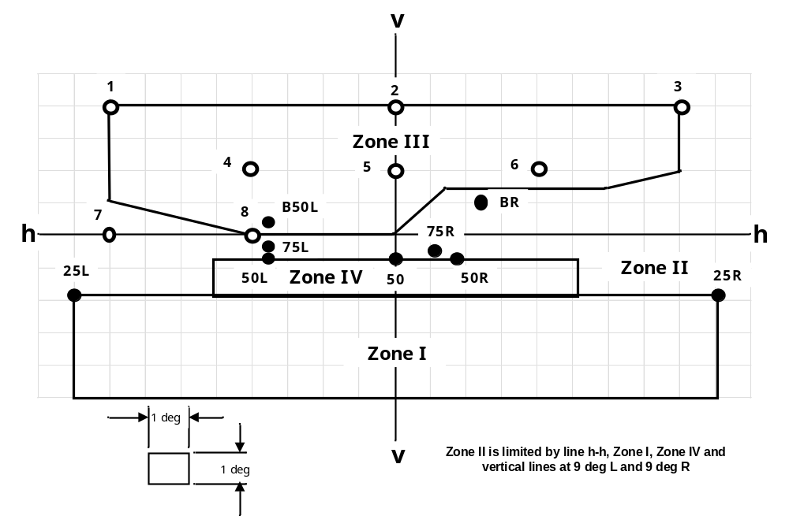
h-h = horizontal plane , v-v = vertical plane passing through the optical axis of the headlamp
The test point locations for left-hand traffic are mirrored about the VV line

Figure C

Driving beam test points
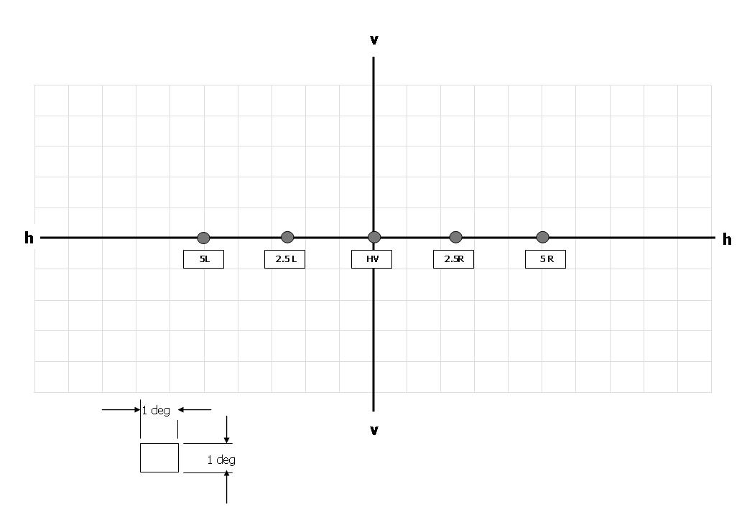

"
Annex 4,
The first paragraph, amend to read:
"Test for stability of…in operation
Tests on complete headlamps
Once the photometric values have been measured according to the prescriptions of this Regulation, in the point for I_{max} for driving beam and in points HV, 50 R, B 50 L for passing beam (or HV, 50 L, B 50 R for headlamps designed for left-hand traffic) a complete headlamp...
…"
Paragraph 1.1.2.2., amend to read:
"1.1.2.2. Photometric test
…
Driving beam: Point I_{max}
…"
Paragraph 1.2.1.2., amend to read:
"1.2.1.2. Application of the test mixture to the headlamp
…
Point of E_{max} in passing beam/driving beam and in driving beam only,
50 R and 50 V⁶ for a headlamp producing only a passing beam, designed for right-hand traffic,
50 L and 50 V⁶ for a headlamp producing only a passing beam, designed for left-hand traffic."
Paragraph 2, amend to read:
"2. Test for change in vertical position of the cut-off line under the influence of heat
This test consists of verifying that the vertical drift of the cut-off line under the influence of heat does not exceed a specified value for an operating headlamp producing a passing beam.
…."
Paragraph 2.2.1., amend to read:
"2.2.1. The result in milliradians (mrad) shall be considered as acceptable for a headlamp producing a passing beam, only when the absolute value Δr_{I} = | r₃ - r₆₀ | recorded on the headlamp is not more than 1.0 mrad (Δr_{I} < 1.0 mrad)."
Annex 5,
Paragraph 1.2.1., amend to read:
"1.2.1. No measured value deviates unfavourably by more than 20 per cent from the value prescribed in this Regulation. For values B 50 L (or R) and zone III, the maximum unfavourable deviation may be respectively:
B 50 L (or R): 170 cd equivalent 20 per cent
255 cd equivalent 30 per cent
Zone III 255 cd equivalent 20 per cent
380 cd equivalent 30 per cent"
Paragraph 1.2.2., amend to read:
"1.2.2. Or if
1.2.2.1. For the passing beam, the values prescribed in this Regulation are met at HV (with a tolerance of + 170 cd) and related to that aiming at least one point within a circle of 0.35 degrees around points B 50 L (or R)¹ (with a tolerance of 85 cd), 75 R (or L), 50 V, 25 R, 25 L, and in the entire area of zone IV which is not more than 0.52 degrees above line 25 R and 25 L;
1.2.2.2. And if, for the driving beam, HV being situated within the isolux 0.75 I_{max} a tolerance of +20 per cent …"
Paragraph 2.4. and footnote 4, amend to read:
"2.4. Measured and recorded photometric characteristics
The sampled headlamps shall be subjected to photometric measurements at the points provided for in the Regulation, the reading being limited at the points I_{max}, HV³, HL, HR⁴ in the case of a driving beam, and to points B 50 L (or R), HV, 50 V, 75 R (or L) and 25 L (or R) in the case of the passing beam (see figure in Annex 3).
____________
⁴ HL and HR: points "hh" located at 2.5 degrees to the left and to the right of point HV respectively.
Annex 6,
Paragraph 2.1.2.1., amend to read:
"2.1.2.1. Method
Photometric measurements shall be carried out on the samples before and after the test.
These measurements shall be made using a standard (étalon) lamp and/or LED module(s), as present in the headlamp, at the following points:
B 50 L and 50 R for the passing beam (B 50 R and 50 L in the case of headlamps intended for left-hand traffic);
I_{max} for the driving beam."
Annex 7,
Paragraphs 1.2.1. to 1.2.2.2., amend to read:
"1.2.1. No measured value …may be respectively:
B 50 L (or R): 170 cd equivalent 20 per cent
255 cd equivalent 30 per cent
Zone III 255 cd equivalent 20 per cent
380 cd equivalent 30 per cent"
1.2.2. Or if
1.2.2.1. For the passing beam, the values prescribed in this Regulation are met at HV (with a tolerance of + 170 cd) and related to that aiming at least one point of each area delimited on the measuring screen (at 25 m) by a circle 15 cm in radius around points B 50 L (or R)¹ (with a tolerance of 85 cd), 75 R (or L), 50 V, 25 R, 25 L, and in the entire area of zone IV which is not more than 22.5 cm above line 25 R and 25 L;
1.2.2.2. And if, for the driving beam, HV being situated within the isolux 0.75 I_{max}, a tolerance of +20 per cent for maximum values and -20 per cent for minimum values is observed for the photometric values at any measuring point specified in paragraph 6.3.2. of this Regulation. The reference mark is disregarded."
Annex 10,
Paragraph 4.3.1.5., amend to read:
"4.3.1.5. The luminous intensity values, measured after one minute and after photometric stability has occurred, shall comply with the minimum and maximum requirements."

* * Former title of the Agreement: Agreement Concerning the Adoption of Uniform Conditions of Approval and Reciprocal Recognition of Approval for Motor Vehicle Equipment and Parts, done at Geneva on 20 March 1958.

