E/ECE/324/Rev.1/Add.86/Rev.2/Corr.3−E/ECE/TRANS/505/Rev.1/Add.86/Rev.2/Corr.3
7 June 2011

Agreement
Concerning the Adoption of Uniform Technical Prescriptions for Wheeled Vehicles, Equipment and Parts which can be Fitted and/or be Used on Wheeled Vehicles and the Conditions for Reciprocal Recognition of Approvals Granted on the Basis of these Prescriptions*
(Revision 2, including the amendments which entered into force on 16 October 1995)

Addendum 86: Regulation No. 87
Revision 2 – Corrigendum 3
Corrigendum 2 to Revision 2 of the Regulation, subject of Depositary Notification C.N.159.2011.TREATIES-1 dated 28 April 2011
Uniform provisions concerning the approval of daytime running lamps for power-driven vehicles


UNITED NATIONS

Annex 2,
Figure 1, amend to read:

"Figure 1
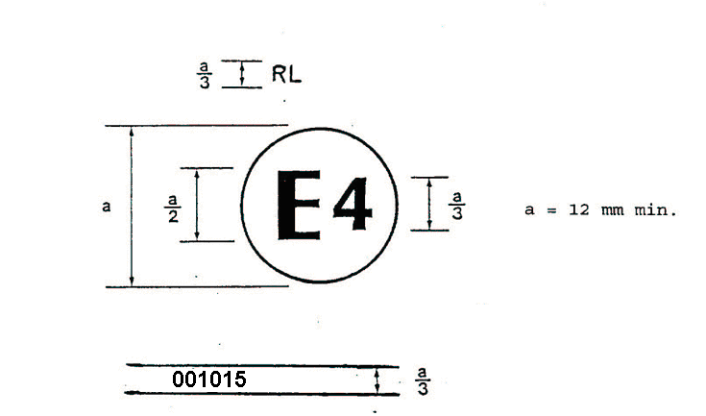"
a = 5 mm min.
a = 5 mm min.

* * Former title of the Agreement: Agreement Concerning the Adoption of Uniform Conditions of Approval and Reciprocal Recognition of Approval for Motor Vehicle Equipment and Parts, done at Geneva on 20 March 1958.

