E/ECE/324/Rev.2/Add.128/Amend.10−E/ECE/TRANS/505/Rev.2/Add.128/Amend.10
29 January 2020
Agreement
Concerning the Adoption of Harmonized Technical United Nations Regulations for Wheeled Vehicles, Equipment and Parts which can be Fitted and/or be Used on Wheeled Vehicles and the Conditions for Reciprocal Recognition of Approvals Granted on the Basis of these United Nations Regulations*
(Revision 3, including the amendments which entered into force on 14 September 2017)
_________
Addendum 128 – UN Regulation No. 129
Amendment 10
Supplement 9 to the original version of the Regulation – Date of entry into force: 11 January 2020
Uniform provisions concerning the approval of Enhanced Child Restraint Systems used on board of motor vehicles
This document is meant purely as documentation tool. The authentic and legal binding text is: ECE/TRANS/WP.29/2019/37.
_________
UNITED NATIONS

Paragraph 4.5., amend to read:
"4.5. Integral Enhanced Child Restraint Systems that can be used forward and rearward facing, shall have the following label permanently attached on the part hosting the child and visible to the person installing an Enhanced Child Restraint System in the vehicle:
The manufacturer shall be permitted to include the word "months" to explain the symbol "M" in the label. The word "months" should be in a language commonly spoken in the country or countries where the product is sold. More than one language is allowed.
Minimum label size 40 x 40 mm

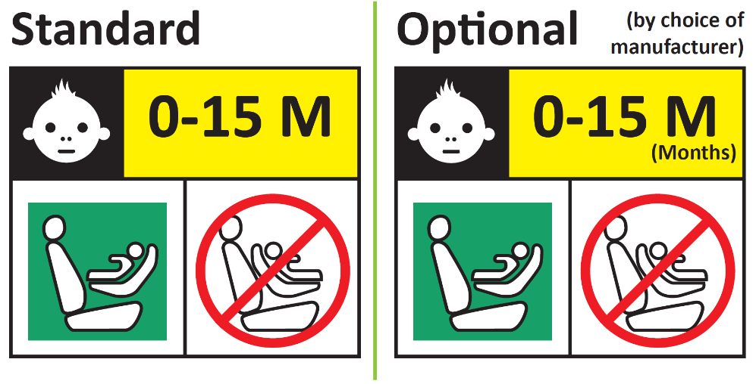
Forbidden sign – red
Label outline, vertical and horizontal lines black
Square – green
Background white
Top symbol white on black background
All text black on yellow or amber background
Background white

Integral Enhanced Child Restraint Systems that can be used forward facing only shall have the following label permanently attached on the part hosting the child and visible to the person installing an Enhanced Child Restraint System in the vehicle:
The manufacturer shall be permitted to include the word "months" to explain the symbol "M" in the label. The word "months" should be in a language commonly spoken in the country or countries where the product is sold. More than one language is allowed.
Minimum label size 40 x 40 mm
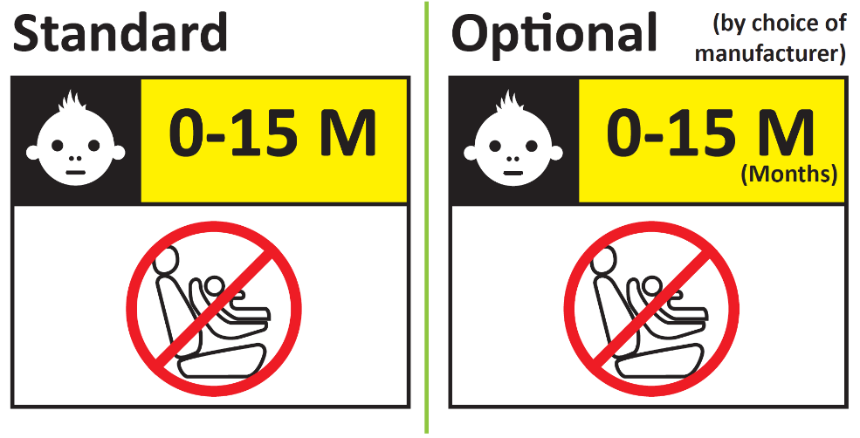"
Paragraph 6.6.4.4.1.1., amend to read:
"6.6.4.4.1.1. Forward facing Enhanced Child Restraint Systems
Head excursion: No part of the head of the dummy shall pass beyond the planes BA, DA and DE as defined in Figure 1 below. However, the head of the dummy may pass beyond the DE plane, if there is part of the child restraint structure, i.e. head pad or backrest, behind the head of the dummy, at the point the head passes the DE plane.
This shall be judged up to 300 ms or the moment that the dummy has come to a definitive standstill whatever occurs first."
Paragraph 14.3.3., amend to read:
"14.3.3. For integral forward facing Enhanced Child Restraint Systems, the following information shall be clearly visible on the exterior of the packing:
"IMPORTANT – DO NOT USE BEFORE THE CHILD’S AGE EXCEEDS 15 MONTHS (Refer to instruction)".
For integral Enhanced Child Restraint Systems that can be used forward and rearward facing, the following information shall be clearly visible on the exterior of the packing:
"IMPORTANT – DO NOT USE FORWARD FACING BEFORE THE CHILD’S AGE EXCEEDS 15 MONTHS (Refer to instruction)".
"

* Former titles of the Agreement: Agreement concerning the Adoption of Uniform Conditions of Approval and Reciprocal Recognition of Approval for Motor Vehicle Equipment and Parts, done at Geneva on 20 March 1958 (original version); Agreement concerning the Adoption of Uniform Technical Prescriptions for Wheeled Vehicles, Equipment and Parts which can be Fitted and/or be Used on Wheeled Vehicles and the Conditions for Reciprocal Recognition of Approvals Granted on the Basis of these Prescriptions, done at Geneva on 5 October 1995 (Revision 2).

