E/ECE/324/Rev.1/Add.57/Rev.3/Amend.2−E/ECE/TRANS/505/Rev.1/Add.57/Rev.3/Amend.2
2 November 2020
Agreement
Concerning the Adoption of Harmonized Technical United Nations Regulations for Wheeled Vehicles, Equipment and Parts which can be Fitted and/or be Used on Wheeled Vehicles and the Conditions for Reciprocal Recognition of Approvals Granted on the Basis of these United Nations Regulations*
(Revision 3, including the amendments which entered into force on 14 September 2017)
_________
Addendum 57 – UN Regulation No. 58
Revision 3 - Amendment 2
Supplement 2 to the 03 series of amendments – Date of entry into force: 25 September 2020
Uniform provisions concerning the approval of:
I. Rear underrun protective devices (RUPDs)
II. Vehicles with regard to the installation of an RUPD of an
approved type
III. Vehicles with regard to their rear underrun protection (RUP)
This document is meant purely as documentation tool. The authentic and legal binding text is: ECE/TRANS/WP.29/2020/19 (as amended by paragraph 88 of the report ECE/TRANS/WP.29/1151).
_______________
UNITED NATIONS
Insert new paragraph 3.1.5., to read:
"3.1.5. "Aerodynamic devices and equipment" mean devices that are designed to reduce the aerodynamic drag of road vehicles."
Paragraph 16.4., amend to read:
"16.4. For vehicles of categories M, N₁, N₂ with a maximum mass not exceeding 8 t, O₁ and O₂, the device shall be so fitted that the horizontal distance between the rear of the cross-member of the device and the most rearward point at the rear extremity of the vehicle, including any platform lift system, does not exceed 400 mm diminished by the largest total deformation including both plastic and elastic deformation (paragraph 7.3. of Part I) measured and recorded during the test at any of the points where the test forces are applied (Annex 1, item 8) during the type approval of the rear underrun protective device in conformity with the provisions of Part I of this Regulation and recorded in the type approval communication form. In measuring this distance, any part of the vehicle which is more than 2 m above the ground for every loading condition of the vehicle shall be excluded.
For vehicles of categories N₂ with a maximum mass exceeding 8 t, N₃, and vehicles of categories O₃ and O₄, equipped with a platform lift or being designed as a tipping trailer, the same requirement as above applies; however, for vehicles of these categories, the horizontal distance shall not exceed 300 mm measured to the rear of the cross-member before the test forces are applied.
For vehicles of categories O₃ and O₄, without any platform lift system and not being designed as a tipping-trailer, the maximum horizontal distances are reduced to 200 mm before the test forces have been applied and 300 mm diminished by the largest total deformation including both plastic and elastic deformation (paragraph 7.3. of Part I) measured and recorded during the test at any of the points where the test forces are applied (Annex 1, item 8).
In any case non-structural protrusions such as tail lamps and those of less than 50 mm of size in any direction, such as rubber bumpers, resilient buffers, hinges and latches shall be excluded from the determination of the most rearward point at the rear extremity.
In any case aerodynamic devices that comply with the provisions in annex 8 shall be excluded from the determination of the most rearward point at the rear extremity.
Before the application of the test forces, the maximum allowed horizontal distance of a single, a segmented or an inclined cross-member of a RUPD is 100 mm between the rear of the cross-member measured at the most forward point and the rear of the cross-member measured at the most rearward point, measured in the longitudinal plane of the vehicle."
Paragraph 25.3., amend to read:
"25.3. For vehicles of categories M, N₁, N₂ with a maximum mass not exceeding 8 t, O₁ and O₂, the RUP shall be situated as close to the rear of the vehicle as possible. The maximum horizontal distance between the rear of the device and the most rearward point at the rear extremity of the vehicle, including any platform lift system, does not exceed 400 mm measured to the rear of the cross-member and recorded during the test when the test forces are applied.
For vehicles of categories N₂ with a maximum mass exceeding 8 t, N₃, and vehicles of categories O₃ and O₄, equipped with a platform lift or being designed as a tipping trailer, the same requirement as above applies; however, for vehicles of these categories, the horizontal distance shall not exceed 300 mm measured to the rear of the cross-member before the test forces are applied.
For RUP for vehicles of categories O₃ and O₄, without any platform lift system and not being designed as a tipping-trailer, the maximum horizontal distance is reduced to 200 mm before and 300 mm during the test when the test forces are applied.
In any case non-structural protrusions such as tail lamps and those of less than 50 mm of size in any direction, such as rubber bumpers, resilient buffers, hinges and latches shall be excluded from the determination of the most rearward point at the rear extremity.
In any case aerodynamic devices that comply with the provisions in Annex 8 shall be excluded from the determination of the most rearward point at the rear extremity.
Before the application of the test forces the maximum allowed horizontal distance of a single, a segmented or an inclined cross-member of a RUPD is 100 mm between the rear of the cross-member measured at the most forward point and the rear of the cross-member measured at the most rearward point, measured in the longitudinal plane of the vehicle."
Insert a new Annex 8., to read:
"Annex 8
Aerodynamic devices
1. Purpose
The purpose of this test is to verify whether the aerodynamic device in the event of a collision with the rear of the vehicle or the vehicle combination is compromising the rear underrun protection.
2. General specifications
2.1. The external surface of aerodynamic devices shall not exhibit, directed outwards, any pointed or sharp parts or any projections of such shape, dimensions, direction or hardness as to be likely to increase the risk or seriousness of bodily injury to a person hit by the external surface or brushing against it in the event of a collision.
2.2. The external surface of vehicles shall not exhibit, directed outwards, any part likely to catch on pedestrians, cyclists or motor cyclists.
2.3. Protruding parts of the external surface of an aerodynamic device shall not have a radius of curvature less than 2.5 mm. Those parts of the external surface of an aerodynamic device which are so located that, in their folded or retracted condition as well as when in operation, they cannot be contacted by a sphere 100 mm in diameter, may have a radius of curvature less than 2.5 mm. This requirement shall not apply to parts of the external surface which protrude less than 5 mm, but the outward facing angles of such parts shall be blunted, save where such parts protrude less than 1.5 mm.
2.4. Protruding parts of the external surface, made of a material of hardness not exceeding 60 shore A, may have a radius of curvature less than 2.5 mm. The hardness measurement shall be taken with the component as installed on the vehicle. Where it is impossible to carry out a hardness measurement by the Shore A procedure, comparable measurements shall be used for evaluation.
3. Test conditions for aerodynamic devices
3.1. At the request of the manufacturer the test may be conducted either:
3.1.1. On a vehicle of the type for which an aerodynamic device is intended; in this case the test conditions set out in paragraph 4. below shall be observed; or
3.1.2. On a part of the body of the vehicle type for which the aerodynamic device is intended; this part shall be representative of the vehicle type(s) in question; or
3.1.3. On a rigid wall.
3.2. In the case of paragraph 3.1.2. and 3.1.3., the parts used to connect the aerodynamic devices to a part of the vehicle body or to a rigid wall shall be equivalent to those which are used to secure the aerodynamic devices when it is installed on the vehicle. Every device shall be accompanied by installation and operating instructions giving sufficient information for any competent person to install it correctly.
3.3. At the request of the manufacturer the test procedure described in paragraph 5. may be simulated by calculation.
The mathematical model shall be validated in comparison with the actual test conditions. To that effect, a physical test shall be conducted for the purposes of comparing the results obtained when using the mathematical model with the results of a physical test. Comparability of the test results shall be proven. A validation report shall be drafted by the manufacturer.
Any change made to the mathematical model or to the software likely to invalidate the validation report shall require a new validation process to be conducted.
4. Test conditions for vehicles
4.1. The vehicle shall be at rest on a level, flat, rigid and smooth surface.
4.2. The front wheels shall be in the straight-ahead position.
4.3. The tyres shall be inflated to the pressure recommended by the vehicle manufacturer.
4.4. The vehicle is unladen.
4.5. The vehicle may, if necessary to achieve the test force required in paragraph 5.1.2. below, be restrained by any method. This method is to be specified by the vehicle manufacturer.
4.6. Vehicles equipped with hydropneumatic, hydraulic or pneumatic suspension or a device for automatic levelling according to load shall be tested with the suspension or device in the normal running condition specified by the manufacturer.
5. Test procedure
5.1. The aerodynamic device shall offer a certain level of deformation to forces applied parallel to the longitudinal axis of the vehicle. Alternatively, the device may also be folded or retracted under the influence of force. The test shall be verified by means of suitable test mandrels. The device used to distribute the test force over the stated flat surface shall be connected to the force actuator through a swivel joint. In cases of geometric incompatibilities, it is recommended to use an adaptor instead of a device with a flat surface.
5.1.1. A force shall be applied parallel to the longitudinal axis of the vehicle via a surface not more than 250 mm in height and 200 mm wide with a radius of curvature of 5 ± 1 mm at the vertical edges or an adaptor. The surface or adaptor shall not be rigidly fixed to the aerodynamic device and shall be articulated in all directions. When the test is carried out on a vehicle the height of the centre of the surface or adaptor shall be defined by the manufacturer in an area between the lowest edge of the aerodynamic device and a point no more than 2.0 meters above the ground in vehicle-mounted condition (see figure 1). This point is to be defined on a laden vehicle with the technically permissible maximum laden mass.
When the test is carried out on a part of the body of the vehicle type or on a rigid wall the height of the centre of the surface or adaptor shall be defined by the manufacturer in an area between the lowest edge of the aerodynamic device and the point that represents the height of no more than 2.0 meters above the ground in vehicle-mounted condition on a laden vehicle with the technically permissible maximum laden mass (see figure 2).
The exact location of the centre of the surface or adaptor in the area of application of forces shall be specified by the manufacturer. In cases there the aerodynamic device has different stiffness’s in the area of application of forces (e.g. due to reinforcements, different materials or thicknesses etc.) the location of centre of the surface or adaptor is to be defined in the area with the highest resistance against external forces in longitudinal direction of the vehicle.

Figure 1
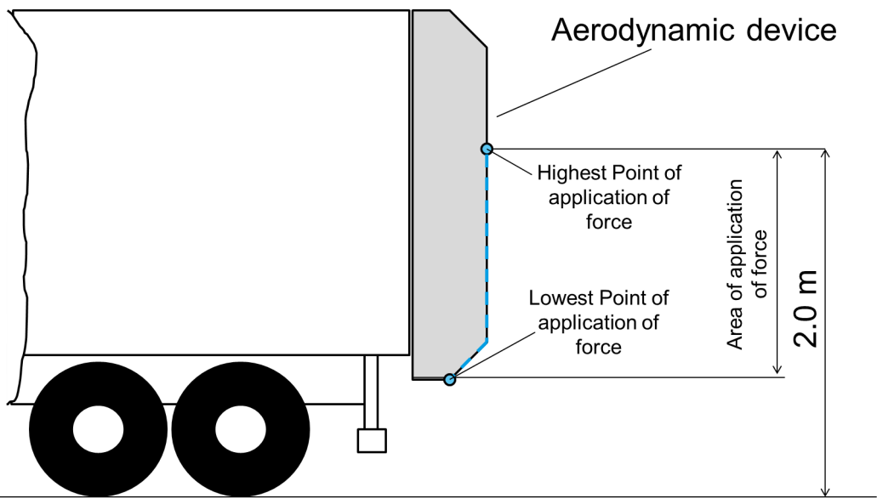

Figure 2
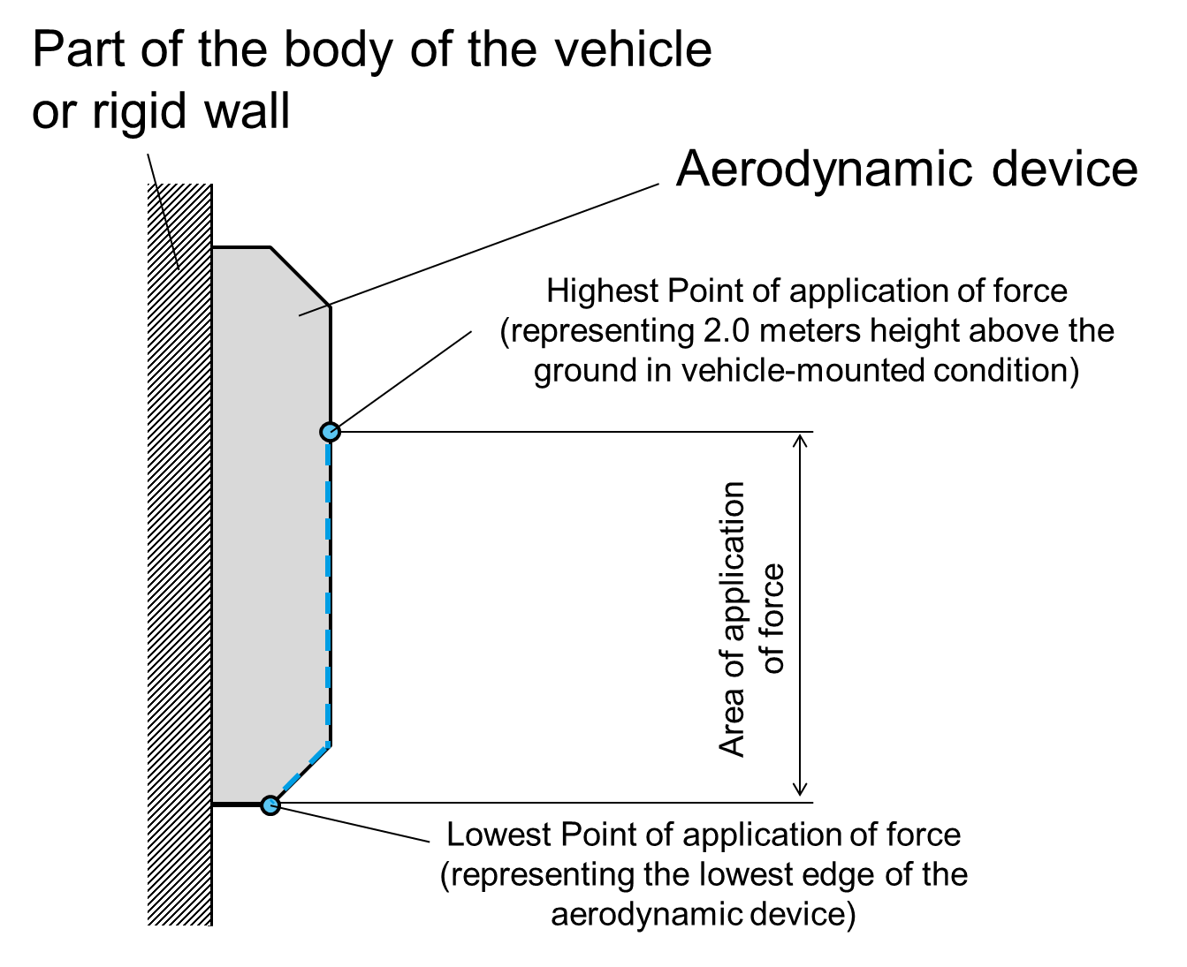
5.1.2. A horizontal force of maximum 4000 N ± 400 N shall be applied consecutively to two points situated symmetrically about the centre line of the vehicle or the centre line of the device on the rearmost outer edge of the aerodynamic device in completely unfolded or not retracted condition (see figure 3). The order in which the forces are applied may be specified by the manufacturer.

Figure 3
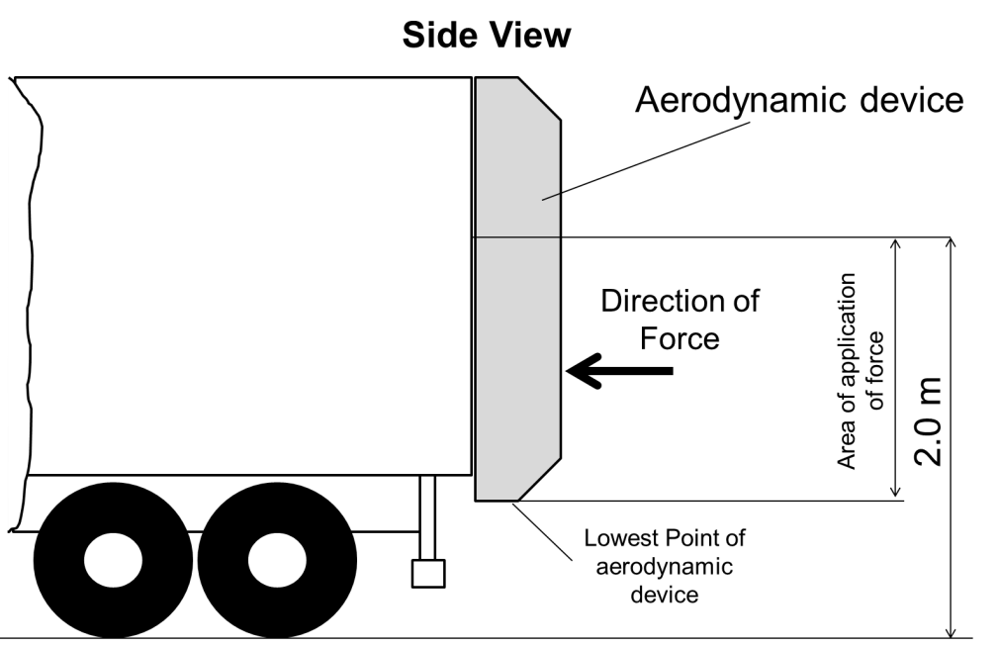
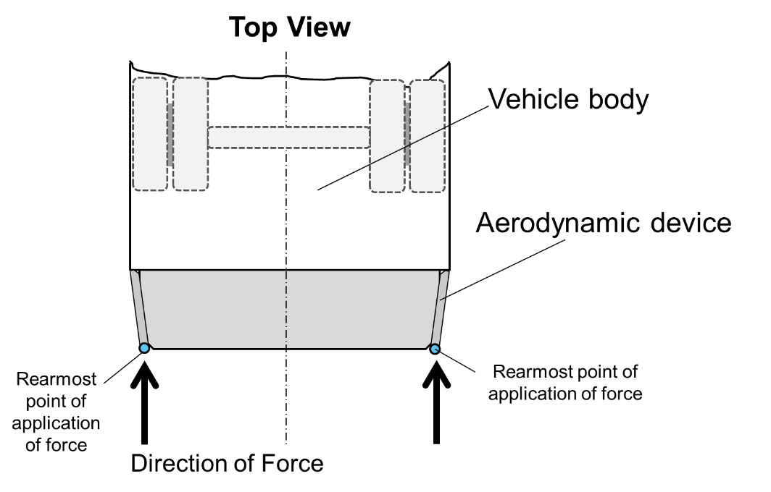
6. Requirements
6.1. The aerodynamic device shall be so fitted that during the application of the test forces as specified in paragraph 5.1.2 this aerodynamic device has at the point of application of forces an elastic and/or plastic deformation with a maximum remaining length of 200 mm in longitudinal direction of the vehicle.
This requirement is also deemed to be fulfilled if the aerodynamic device will be folded or retracted under influence of test forces as specified in paragraph 5.1.2 so that the aerodynamic device has in this folded or retracted position a maximum remaining length of 200 mm in longitudinal direction of the vehicle.
6.2. Notwithstanding the provisions in paragraph 5.1., 5.1.1., 5.1.2. and 6.1. the application of forces shall not be conducted if the aerodynamic device is made of a material of hardness not exceeding 60 shore A in the area 1 regarding figure 4. Components (fastenings, hinges, actuators, springs, cables, lamps, etc.) used to install the aerodynamic device on the body of the vehicle or that are mounted on the aerodynamic device are exempted from these provisions.
The hardness measurement shall be taken with the aerodynamic device as installed on the vehicle. Where it is impossible to carry out a hardness measurement by the Shore A procedure, comparable measurements shall be used for evaluation.

Figure 4
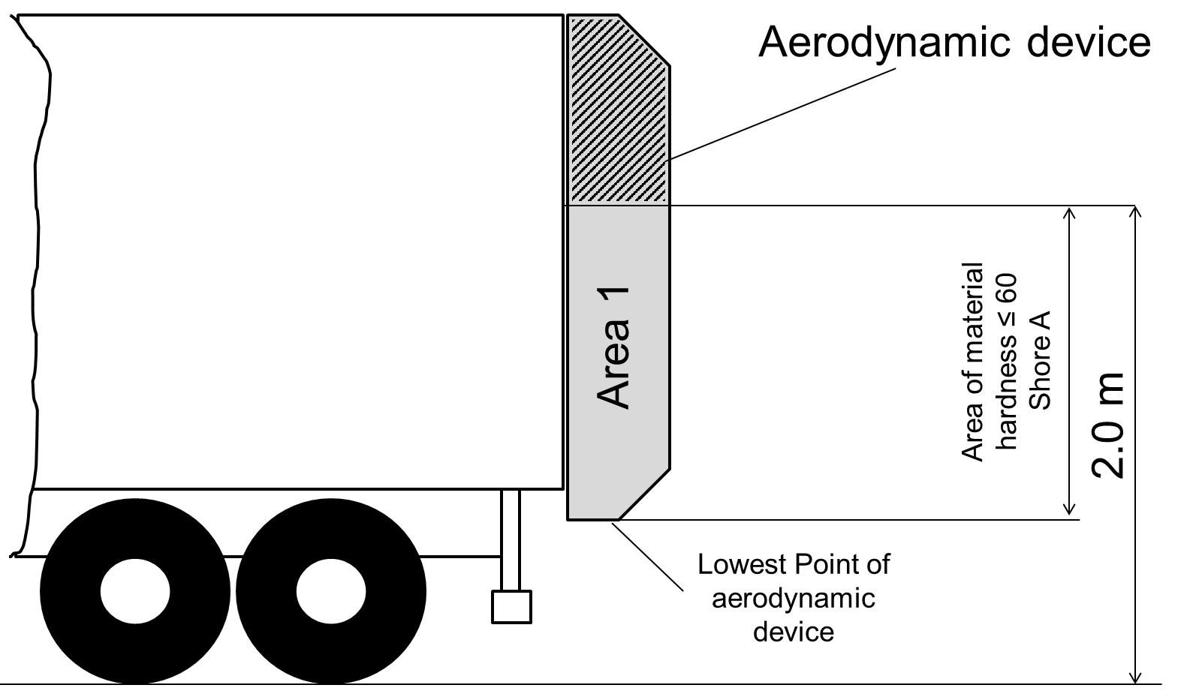
7. Marking
7.1. There shall be affixed to the aerodynamic device a clearly legible and indelible marking consisting of:
(a) A serial number;
(b) Name of device;
(c) Name of manufacturer;
(d) The marking "In accordance to UN Regulation No. 58" and year/month of conformity (e.g. 2018/01)."

* Former titles of the Agreement: Agreement concerning the Adoption of Uniform Conditions of Approval and Reciprocal Recognition of Approval for Motor Vehicle Equipment and Parts, done at Geneva on 20 March 1958 (original version); Agreement concerning the Adoption of Uniform Technical Prescriptions for Wheeled Vehicles, Equipment and Parts which can be Fitted and/or be Used on Wheeled Vehicles and the Conditions for Reciprocal Recognition of Approvals Granted on the Basis of these Prescriptions, done at Geneva on 5 October 1995 (Revision 2).

