E/ECE/324/Rev.1/Add.25/Rev.1/Amend.3−E/ECE/TRANS/505/Rev.1/Add.25/Rev.1/Amend.3
30 October 2020
Agreement
Concerning the Adoption of Harmonized Technical United Nations Regulations for Wheeled Vehicles, Equipment and Parts which can be Fitted and/or be Used on Wheeled Vehicles and the Conditions for Reciprocal Recognition of Approvals Granted on the Basis of these United Nations Regulations*
(Revision 3, including the amendments which entered into force on 14 September 2017)
_________
Addendum 25 – UN Regulation No. 26
Revision 1 - Amendment 3
04 series of amendments – Date of entry into force: 25 September 2020
Uniform provisions concerning the approval of vehicles with regard to their external projections
This document is meant purely as documentation tool. The authentic and legal binding text is: ECE/TRANS/WP.29/2020/26.
_________
UNITED NATIONS

Paragraphs 6.4. to 6.4.2., amend to read:
"6.4. Windscreen wipers
6.4.1. The windscreen wiper fittings shall be such that the wiper shaft (number 1 in Figure 0) is furnished with a protective casing (number 1.1 in Figure 0) which has a radius of curvature meeting the requirements of paragraph 5.4. above and an end surface area of not less than 150 mm². The holder (head and main part, i.e. numbers 2, 2.1 in Figure 0) are designed with a radius of curvature meeting the requirements of paragraph 5.4. above. In the case of rounded covers, these shall have a minimum projected area of 150 mm² when measured not more than 6.5 mm from the point projecting furthest. These requirements shall also be met by rear window wipers and headlamp wipers.
6.4.2. Paragraph 5.4. shall not apply to the wiper blades (number 4 in Figure 0), supporting members (number 3 in Figure 0) if present, to second holder (number 2.2 in Figure 0) if present, to the functional hinge between the holder head and the holder (number 5 in Figure 0) if present, or to the junction between the main and the second holder (number 6 in Figure 0) if present. However, these units shall be so made as to have no sharp angles or pointed or cutting parts.
Figure 0
Example of parts distribution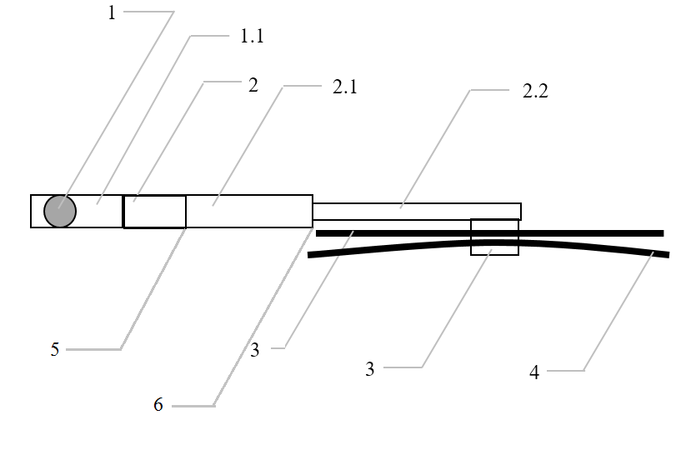
Legend:
1 Wiper shaft
1.1 Protective casing
2 Holder head
2.1 Main holder
2.2 Second holder
3 Supporting members
4 Wiper blades
5 Functional hinge
6 Junction between the main and second holder"
After paragraph 6.4.2., add a new paragraph 6.4.3., to read:
"6.4.3. Compliance with the provisions in paragraphs 6.4.1 and 6.4.2 shall be verified with the wipers in parked position."
After paragraph 12.7, insert new paragraphs 12.8. to 12.11, to read:
"12.8. As from the official date of entry into force of the 04 series of amendments, no Contracting Party applying this Regulation shall refuse to grant approval under this Regulation as amended by the 04 series of amendments.
12.9. As from 1 September 2022, Contracting Parties applying this Regulation shall not be obliged to accept type approvals to the preceding series of amendments, first issued after 1 September 2022.
12.10. Contracting Parties applying this Regulation shall continue to accept type approvals issued according to the preceding series of amendments to this Regulation first issued before 1 September 2022.
12.11. Contracting Parties applying this Regulation shall not refuse to grant type approvals according to any preceding series of amendments to this Regulation or extensions thereof."
Annex 2, amend to read
"Annex 2
Arrangements of the approval marks

Model A
(See paragraphs 4.1.4. and 4.2.4. of this Regulation)
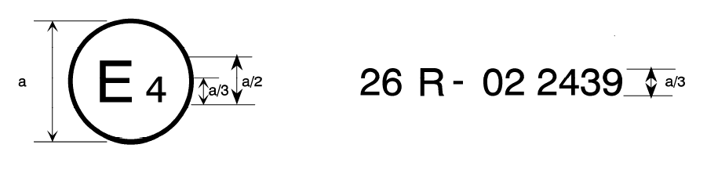
04
a= 8 mm min
The above approval mark affixed to a vehicle shows that the vehicle type concerned has been approved in the Netherlands (E 4) pursuant to UN Regulation No. 26 and under approval number 032439. The first two digits of the approval number indicate that UN Regulation No. 26 already included the 04 series of amendments when the approval was granted.

Model B

(See paragraph 4.1.5. of this Regulation)
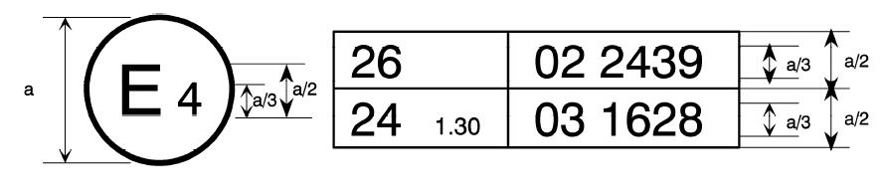
04 2439
a= 8 mm min
The above approval mark affixed to a vehicle shows that the vehicle type concerned has been approved in the Netherlands (E 4) pursuant to UN Regulation No. 26 and UN Regulation No. 24. The first two digits of the approval numbers indicate that, at the dates when the respective approvals were given, UN Regulation No. 26 included the 04 series of amendments, while UN Regulation No. 24 already included the 03 series of amendments."

* Former titles of the Agreement: Agreement concerning the Adoption of Uniform Conditions of Approval and Reciprocal Recognition of Approval for Motor Vehicle Equipment and Parts, done at Geneva on 20 March 1958 (original version); Agreement concerning the Adoption of Uniform Technical Prescriptions for Wheeled Vehicles, Equipment and Parts which can be Fitted and/or be Used on Wheeled Vehicles and the Conditions for Reciprocal Recognition of Approvals Granted on the Basis of these Prescriptions, done at Geneva on 5 October 1995 (Revision 2).
The second Regulation number is given merely as an example; the corrected absorption coefficient is 1.30 m⁻¹.

