E/ECE/324/Rev.1/Add.43/Rev.3/Amend.7−E/ECE/TRANS/505/Rev.1/Add.43/Rev.3/Amend.7
16 January 2019

Agreement
Concerning the Adoption of Harmonized Technical United Nations Regulations for Wheeled Vehicles, Equipment and Parts which can be Fitted and/or be Used on Wheeled Vehicles and the Conditions for Reciprocal Recognition of Approvals Granted on the Basis of these United Nations Regulations*
(Revision 3, including the amendments which entered into force on 14 September 2017)
_________
Addendum 43 – UN Regulation No. 44
Revision 3 - Amendment 7
Supplement 14 to the 04 series of amendments – Date of entry into force: 29 December 2018
Uniform provisions concerning the approval of restraining devices for child occupants of power-driven vehicles ("Child Restraint Systems")
This document is meant purely as documentation tool. The authentic and legal binding text is: ECE/TRANS/WP.29/2018/39.
_________

UNITED NATIONS
Paragraph 5.4.2.3., shall be deleted
Paragraph 5.2.4. (former), renumber as paragraph 5.4.2.3.
Paragraph 6.1.3., amend to read:
"6.1.3. According to the category which it belongs to, the child restraint shall be secured to the vehicle structure or to the seat structure.

Possible configurations for approval

Groups / categories table
Group category |  | Universal ⁽¹⁾ |  | Semi-universal ⁽²⁾ |  | Restricted |  | Specific vehicle
 |  | CRS | ISOFIXCRS | CRS | ISOFIXCRS | CRS | ISOFIXCRS | CRS | ISOFIXCRS
0 | Carry-cot | A | NA | A | A(3) | A | NA | A | A(3)
 | Rearward facing | A | NA | A | A (3) | A | NA | A | A(3)
0+ | Rearward facing | A | NA | A | A(3) | A | NA | A | A(3)
I | Rearward facing | A | NA | A | A(3) | A | NA | A | A(3)
 | Forward facing  (integral) | A | A (3) | A | A(3) | A | NA | A | A(3)
 | Forward facing  (non-integral) | NA | NA | NA | NA | NA | NA | NA | NA
 | Forward facing  (non-integral – see paragraph 6.1.12.) | A | NA | A | NA | A | NA | A | A(3)
II | Rearward facing | A | NA | A | NA | A | NA | A | A
 | Forward facing  (integral) | A | NA | A | NA | A | NA | A | A
 | Forward facing  (non integral) | A(4) | NA | A(4) | NA | A(4) | NA | A(4) | A(4)
III | Rearward facing | A | NA | A | NA | A | NA | A | A
 | Forward facing  (integral) | A | NA | A | NA | A | NA | A | A
 | Forward facing  (non integral) | A | NA | A | NA | A | NA | A | A
With:
CRS: Child restraint system
A: Applicable
NA: Not Applicable
______________________
⁽¹⁾ ISOFIX universal CRS means forward facing restraints for use in vehicles with positions equipped with ISOFIX anchorages system and a top tether anchorage.
⁽²⁾ ISOFIX semi universal CRS means:
- Forward facing restraints equipped with support leg or
- Rearward facing restraints equipped with a support leg or a top tether strap for use in vehicles with positions equipped with ISOFIX anchorages system and a top tether anchorage if needed
- Or rearward facing restraints, supported by the vehicle dashboard, for use in the front passenger seat equipped with ISOFIX anchorages system,
- Or lateral facing position restraint equipped if needed with an anti-rotation device for use in vehicles with positions equipped with ISOFIX anchorages system and top tether anchorage if needed.
⁽³⁾ New approvals and extensions will be granted in accordance with paragraphs 17.16. and 17.17.
⁽⁴⁾ New approvals and extensions will be granted in accordance with paragraphs 17.18. and 17.19.
"
Paragraph 6.1.8., amend to read:
"6.1.8. Integral child restraint systems of the "universal" category, except ISOFIX universal child restraint systems, shall have a main load-bearing contact point, between the child restraint and the webbing of the adult safety-belt. This point shall not be less than a radius of 150mm from the Cr axis when measured with the child restraint as indicated in figures below, on the dynamic test bench installed in accordance with Annex 21 to this Regulation without a dummy.
Non-integral child restraint systems of the "universal" category, shall have a main load-bearing contact point, between the child restraint and the webbing of the adult safety-belt. This point shall not be less than 65 mm vertically above the test bench cushion and not be less than a radius of 150mm from the Cr axis when measured with the child restraint as indicated in figures below, on the dynamic test bench installed in accordance with Annex 21 to this Regulation without a dummy.
Figures for the explanation of the measurement procedure

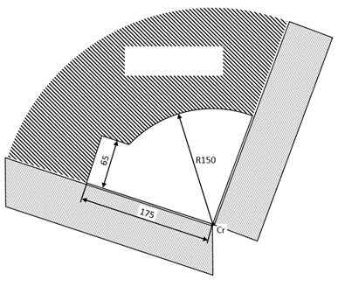
Main load bearing
contact point location
(all dimensions in millimetres)
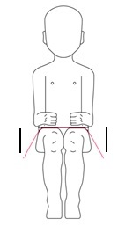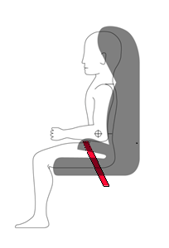
The check shall be done at both sides of the CRS and along a longitudinal plane parallel to the median plane of the CRS.
Additional alternative belt routes are allowed. Where an alternative belt route exists, the manufacturer shall make specific reference to the alternative route in the user instructions, as required in paragraph 15. When tested, using such alternative belt route(s), the restraint shall comply with all the requirements of this Regulation."
Paragraph 6.2.2., amend to read:
"6.2.2. All restraint devices utilizing a "lap strap" shall positively guide the "lap strap" equilateral on both sides to ensure that the load transmitted by the "lap strap" are transmitted through the pelvis. The assembly shall not subject weak parts of the child's body (abdomen, crotch, etc.) to excessive stresses. "
In the case of booster cushions and booster seats, the lap portion of the adult seat belt shall be positively guided equilateral on both sides to ensure that the loads are transmitted by the adult lap belt are transmitted through the pelvis. The positive guidance of loads over the pelvis shall be realised from the moment that the child is installed; the lap belt shall pass over the top of the thigh, just touching the fold with the pelvis. The angles α and β between the tangent line in which the belt touches the thighs and the horizontal shall be greater than 10°."

Figures of Strapped child

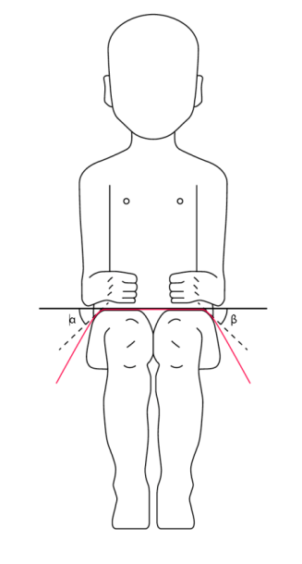
"
Paragraph 7.2.1.1., amend to read:
"7.2.1.1. The buckle shall be so designed as to preclude any possibility of incorrect manipulation. This means, inter/alia, that it shall not be possible for the buckle to be left in a partially closed position; it shall not be possible to exchange the buckle parts inadvertently when the buckle is being locked; the buckle shall only lock when all parts are engaged. Wherever the buckle and /or the tongue are in contact with the child, it shall not be narrower than the minimum width of strap as specified in paragraph 7.2.4.1.1. below. This paragraph is not applicable to belt assemblies already approved according to Regulation No. 16 or any equivalent standard in force. In the case of a "Special Needs Restraint" only the buckle on the primary means of restraint need comply with the requirements of this paragraph 7.2.1.1. to paragraph 7.2.1.9. inclusive."
Paragraph 8.2.9., amend to read:
"8.2.9. The complete seat, or the component fitted with ISOFIX attachments (e.g. ISOFIX base) if it has a release button, is attached rigidly to a test rig in such a way that ISOFIX connectors are aligned as shown in Figure 7. A 6 mm diameter bar, 350 mm long, shall be attached to the ISOFIX connectors. A force of 50 ± 1 N shall be applied to the extremities of the bar."

Figure 7, amend to read:
"Figure 7
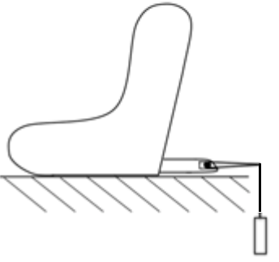
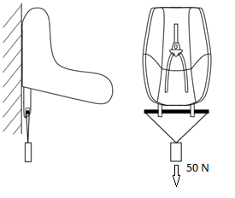
"
Paragraph 12., amend to read:
"12. Conformity of production and routine tests
The conformity of production procedures shall comply with those set out in the Agreement, Schedule 1 (E/ECE/TRANS/505/Rev.3), with the following requirements:
…"
Paragraphs 15.2.2. and 15.2., amend to read:
"15.2.2. For "restricted" and "semi-universal" category child restraints the following information, in at least a physical version, shall be clearly visible at the point of sale without removing the packing:
This Child Restraint is classified for "(Restricted/Semi-universal)" use and is suitable for fixing into the seat positions of the following cars:

CAR |  | FRONT |  | REAR
 |  | Outer |  | Centre
(Model) |  | Yes |  | Yes No

Seat positions in other cars may also be suitable to accept this child restraint. If in doubt, consult either the child restraint manufacturer or the retailer.
Paragraph 15.2.5., amend to read:
"15.2.5. The child restraint manufacturer shall provide information on the packing box as to the address in a physical or a digital version to which the customer can write to obtain further information on fitting the child restraint in specific cars."
Insert new paragraphs 17.18. and 17.19., to read:
"17.18. As from 1 September 2019, no new approvals shall be granted under this Regulation to non-integral class forward facing child restraint systems of group 2 or group 2/3, unless they form part of a multi-group child restraint system that will also be approved for group 1 and above.
17.19. As from 1 September 2023, no extensions shall be granted under this Regulation to non-integral class forward facing child restraint systems of group 2 or group 2/3, unless they form part of a multi-group child restraint system that will also be approved for group 1 and above."
Annex 2, amend to read:
"Annex 2
Arrangements of the approval marks

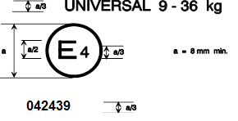

The child restraint system bearing the above approval mark is a device capable …
….
The child restraint system bearing the above approval mark is a device not capable of being fitted in every vehicle and of being used for the 9 kg-25 kg mass range (Groups I and II); it is approved in the Netherlands (E 4) under the number 042450. The approval number indicates that the approval was granted in accordance with the requirements of the Regulation concerning the approval of restraining devices for child occupants of power-driven vehicles ("child restraint system") as amended by the 04 series of amendments.
Note: The ..."

* Former titles of the Agreement: Agreement concerning the Adoption of Uniform Conditions of Approval and Reciprocal Recognition of Approval for Motor Vehicle Equipment and Parts, done at Geneva on 20 March 1958 (original version); Agreement concerning the Adoption of Uniform Technical Prescriptions for Wheeled Vehicles, Equipment and Parts which can be Fitted and/or be Used on Wheeled Vehicles and the Conditions for Reciprocal Recognition of Approvals Granted on the Basis of these Prescriptions, done at Geneva on 5 October 1995 (Revision 2).

