E/ECE/324/Rev.1/Add.16/Rev.5/Amend.3−E/ECE/TRANS/505/Rev.1/Add.16/Rev.5/Amend.3
24 June 2019
Agreement
Concerning the Adoption of Harmonized Technical United Nations Regulations for Wheeled Vehicles, Equipment and Parts which can be Fitted and/or be Used on Wheeled Vehicles and the Conditions for Reciprocal Recognition of Approvals Granted on the Basis of these United Nations Regulations*
(Revision 3, including the amendments which entered into force on 14 September 2017)
_________
Addendum 16 – UN Regulation No. 17
Revision 5 - Amendment 3
09 series of amendments – Date of entry into force: 28 May 2019
Uniform provisions concerning the approval of vehicles with regard to the seats, their anchorages and any head restraints
This document is meant purely as documentation tool. The authentic and legal binding text is: ECE/TRANS/WP.29/2018/142.

_________
UNITED NATIONS

Paragraph 4.2., amend to read:
"4.2. An approval number shall be assigned to each type approved. Its first two digits (at present 09, corresponding to the 09 series of amendments) ..."
Paragraph 5.16.1. and 5.16.2., amend to read:
"5.16.1. Seat-backs
Seat-backs and/or head restraints located such that they constitute the forward boundary of the luggage compartment, all seats being in place and in the normal position of use as indicated by the manufacturer, shall have sufficient strength to protect the occupants from displaced luggage in a frontal impact. This requirement is deemed to be met if, during and after the test described in Annex 9, the seat-backs remain in position, and the locking mechanisms remain in place. However, the deformation of the seat-backs and their fastenings during the test is permitted, provided that the forward contour of the parts of the tested seat-back and/or head restraints, that are harder than 50 Shore A, does not move forward of a transverse vertical plane which passes through:
(a) A point of 150 mm forward of the R point of the seat in question, for the parts of the head restraint;
(b) A point of 100 mm forward of the R point of the seat in question, for parts of the seat-back;
excluding the rebound phases of the test blocks.
For integrated head restraints, the limit between the head restraint and the seat-back is defined by the plane perpendicular to the reference line 540 mm from the R point.
All measurements shall be taken in the longitudinal median plane of the corresponding seat or seating position for each seating position constituting the forward boundary of the luggage compartment.
During the test described in Annex 9, the test blocks shall remain behind the seat-back(s) in question. In case of damage to a safety-belt retractor, it shall be verified that the retractor is locked as a result of the test or that it can be locked by a manual pull out of the strap.
5.16.2. Partitioning systems
At the request of the vehicle manufacturer, the test described in Annex 9 may be carried out with the partitioning systems in place, if these systems are fitted as standard equipment for the particular type of vehicle.
Partitioning systems, netting wire mesh located above the seat-backs in their normal position of use, shall be tested according to paragraph 2.2. of Annex 9.
This requirement is deemed to be met if, during the test, the partitioning systems remain in position. However, the deformation of the partitioning systems during the test is permitted, provided that the forward contour of the partitioning (including parts of the tested seat-back(s) and/or head restraint(s) that are harder than 50 Shore A does not move forward of a transverse vertical plane which passes through:
(a) A point of 150 mm forward of the R point of the seat in question, for parts of the head restraint;
(b) A point of 100 mm forward of the R point of the seat in question, for parts of the seat-back and part of the partitioning system others than the head restraint.
For integrated head restraint, the limit between the head restraint and the seat-back is the one defined in paragraph 5.16.1.
All measurements shall be taken in the longitudinal median plane of the corresponding seat or seating position for each seating position constituting the forward boundary of the luggage compartment.
After the test, no sharp or rough edges likely to increase the danger or severity of injuries of the occupants shall be present. In case of damage to a safety-belt retractor, it shall be verified that the retractor is locked already or that it can be locked by a manual pull out of the strap."
Paragraph 7, amend to read:
"7. Conformity of production
The conformity of production procedures shall comply with those set out in the Agreement, (Schedule 1, E/ECE/TRANS/505/Rev.3), with the following requirements:"
Insert new paragraphs 13.12. to 13.12.5., to read:
"13.12. As from the official date of entry into force of the 09 series of amendments, no Contracting Party applying this Regulation shall refuse to grant or refuse to accept type approvals under this Regulation as amended by the 09 series of amendments.
13.12.1. As from 1 September 2020, Contracting Parties applying this Regulation shall not be obliged to accept type approvals to the preceding series of amendments that were first issued on or after 1 September 2020.
13.12.2. Until 1 September 2022, Contracting Parties applying this Regulation shall accept type approvals to the preceding series of amendments that were first issued before 1 September 2020.
13.12.3. As from 1 September 2022, Contracting Parties applying this Regulation shall not be obliged to accept type approvals issued to the preceding series of amendments to this Regulation.
13.12.4. Notwithstanding paragraph 13.12.3., Contracting Parties applying this Regulation shall continue to accept type-approvals to the preceding series of amendments to this Regulation, for vehicles which are not affected by the changes introduced by the 09 series of amendments.
13.12.5. Contracting Parties applying this Regulation shall not refuse to grant type approvals according to any preceding series of amendments to this Regulation or extensions thereof."
Annex 2, amend to read:
"Model A

…
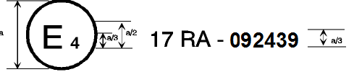
a = 8 mm min.

The above approval mark … approval number 092439. The first two digits of the approval number indicate that the Regulation already contained the 09 series of …
Model B

…
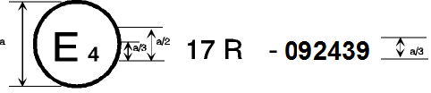
a = 8 mm min.
The above approval mark … approval number 092439. The first two digits of the approval number indicate that the Regulation already contained the 09 series of amendments at the time of approval.
Model C
…
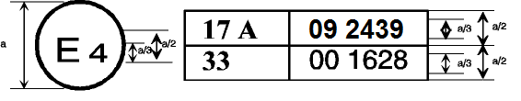
a = 8 mm min.

…
The approval numbers indicate that … included the 09 series of amendments but UN Regulation No. 33 was still in its original form. ...
Model D

…
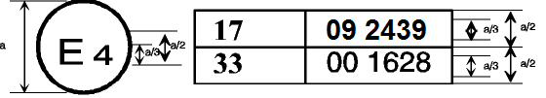
a = 8 mm min.

The above approval mark … included the 09 series of amendments but UN Regulation No. 33 was still in its original form."
Annex 9, insert a new paragraph 2.1.1.7., to read:
"2.1.1.7. All seating positions of the seat row under test shall be fitted with all components of its safety-belt providing the restraining function that are part of the seat."

* Former titles of the Agreement: Agreement concerning the Adoption of Uniform Conditions of Approval and Reciprocal Recognition of Approval for Motor Vehicle Equipment and Parts, done at Geneva on 20 March 1958 (original version); Agreement concerning the Adoption of Uniform Technical Prescriptions for Wheeled Vehicles, Equipment and Parts which can be Fitted and/or be Used on Wheeled Vehicles and the Conditions for Reciprocal Recognition of Approvals Granted on the Basis of these Prescriptions, done at Geneva on 5 October 1995 (Revision 2).

