E/ECE/324/Rev.2/Add.142−E/ECE/TRANS/505/Rev.2/Add.142
18 July 2017

Agreement
Concerning the Adoption of Uniform Technical Prescriptions for Wheeled Vehicles, Equipment and Parts which can be Fitted and/or be Used on Wheeled Vehicles and the Conditions for Reciprocal Recognition of Approvals Granted on the Basis of these Prescriptions*
(Revision 2, including the amendments which entered into force on 16 October 1995)
_________
Addendum 142 — Regulation No. 143
Date of entry into force as an annex to the 1958 Agreement: 19 June 2017
Regulation on uniform provisions concerning the approval of Heavy Duty Dual-Fuel Engine Retrofit Systems (HDDF-ERS) to be installed on heavy duty diesel engines and vehicles
This document is meant purely as documentation tool. The authentic and legal binding text is: ECE/TRANS/WP.29/2016/110.
_________

UNITED NATIONS

Regulation No. 143
Regulation on uniform provisions concerning the approval of Heavy Duty Dual-Fuel Engine Retrofit Systems (HDDF-ERS) to be installed on heavy duty diesel engines and vehicles
Contents
Page
A. Preamble and guidance to the approval of Heavy Duty vehicles equipped with a Dual-Fuel Engine Retrofit System (HDDF-ERS) 5
1. Engine dual-fuel retrofit systems 5
2. Dual-fuel engine retrofit system families and application ranges 6
3. Conformity of production requirements 8
B. Requirements and specifications 9
1. Scope 9
2. Definitions 9
3. Abbreviations 10
4. Application for approval 11
5. Approval 12
6. Actual applications 13
7. Technical requirements and tests 14
8. Engine retrofit system family and application range 15
9. Conformity of production 15
10. Penalties for non-conformity of production 16
11. Modification and extension of approvals 16
12. Production definitively discontinued 17
13. Names and addresses of Technical Services responsible for conducting approval tests and
of Type Approval Authorities 17
Annexes
1 Information document 18
Appendix 1 - Essential characteristics of the (parent) retrofit system and of the demonstration
engine 19
Appendix 2 - Essential characteristics of the engine retrofit system family and of the application
range 22
2 (Reserved) 24
3 Information document regarding the actual applications 25
Appendix 1 - List of actual applications 26
4 Arrangement of the dual-fuel engine retrofit system type approval mark 27
5 Communication 28
6 Dual-fuel engine retrofit systems intended to be fitted on road vehicles – requirements and tests 32
A. Preamble and guidance to the approval of Heavy Duty vehicles equipped with a Dual-Fuel Engine Retrofit System (HDDF-ERS)
This Regulation provides a harmonized method for the approval of a Heavy Duty Dual-Fuel Engine Retrofit System (HDDF-ERS) to comply with the level of emissions within the scope of this Regulation and as defined by the dual-fuel engine requirements in Regulation No. 49. The engine retrofit system includes the devices and components necessary to operate a vehicle in dual-fuel mode, but for the safety provisions reference is made to safety Regulations Nos. 67 (Liquefied Petroleum Gas) and 110 (Compressed Natural Gas/Liquefied Natural Gas). This Regulation provides uniform provisions to assist national vehicle approval and registration authorities to approve heavy duty vehicles (trucks and buses) with diesel engines that are retrofitted to operate as a dual-fuel vehicle.
Dual-fuel is a mode of operation, which enables the retrofitted diesel engine to operate with diesel fuel and a gaseous fuel simultaneously, both fuels being metered separately, where the consumed amount of one of the fuels relative to the other one may vary depending on the operation (see the dual-fuel engine definition in Regulation No. 49).
A complete dual-fuel retrofit system consists of:
(a) Retrofit elements that enable the operation of the engine either in diesel mode or in dual-fuel mode and constitute the engine retrofit system; and
(b) Devices and components that complete the engine retrofit system (for example gas cylinders, valves, pressure regulators, etc.) and that are necessary to permit the operation of the vehicle either in dual-fuel or in diesel mode.
This Regulation is dedicated to the type approval of dual-fuel engine retrofit systems and not to the type approval of complete retrofit systems.
1. Engine dual-fuel retrofit systems
1.1. The engine retrofit system shall only be type approved if it complies as a whole with the provisions of this Regulation.
1.2. The essence of this Regulation is to complete the elements helping the approval authority to approve the registration of diesel vehicles retrofitted into dual-fuel vehicles:
(a) By providing a worldwide recognized type approval scheme of the engine retrofit system;
(b) By requiring the manufacturer of the engine retrofit system to issue instructions regarding the devices and components that will complete the engine retrofit system, and specifications on how to verify the compliance to these instructions;
(c) By requiring the manufacturer of the engine retrofit system to issue instructions regarding the installation and use/operation of that system on the engines/vehicles intended to be retrofitted;
(d) By providing guidance for conformity of production requirements regarding the retrofit operations (manufacture of the retrofit systems as well as installation of these systems on the engines/vehicles intended to be retrofitted).

2. Dual-fuel engine retrofit system families and application ranges
2.1. The approval of an engine retrofit system according to the provisions of this Regulation takes into account the characteristics of the components of the engine retrofit system, the interface with the additional required components and the identification of the engines that can be retrofitted with the engine retrofit system.
2.2. For the initial type approval the engine retrofit system (the "parent engine retrofit system") is installed on a demonstration engine.
2.3. In general the tests for the initial type approval consist of engine performance tests (for example emission tests and the verification of dual-fuel specific requirements).
2.4. When the initial approval is granted, the demonstration engine type can be retrofitted with the parent engine retrofit system. The approval is also considered valid for similar engines which do not differ from the tested engine by relevant aspects as specified in this Regulation. This set of engines is called "application range".
2.5. In order to be mounted on all engines belonging to the application range, the engine retrofit system may require some adaptations (for example layout, dimension, etc.) and its components may vary for aspects not relevant as specified in this Regulation. This set of engine retrofit systems represents the "engine retrofit system family".
Figure 1
System family, application range and actual applications
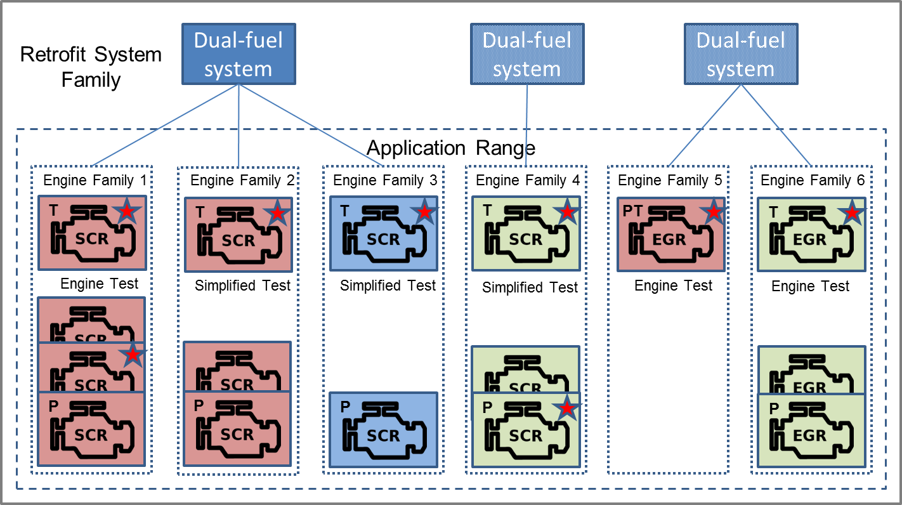
Figure 2
Legend
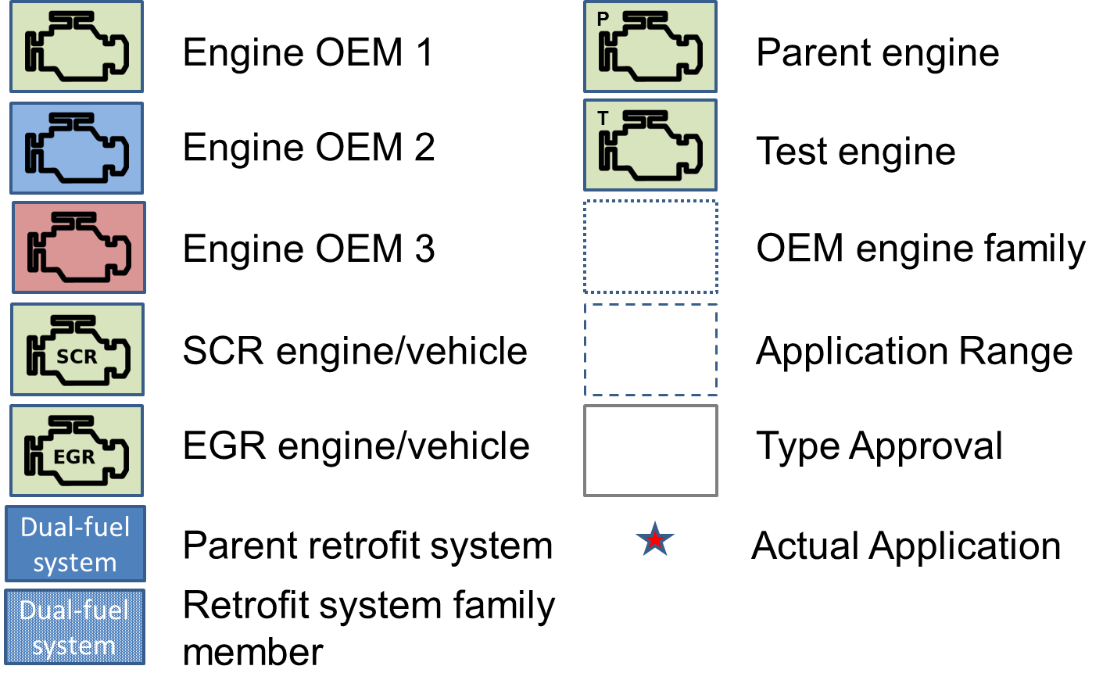
2.6. The application range may be extended to include other engines by extending the initial type approval.
Figure 3
Type approval extension
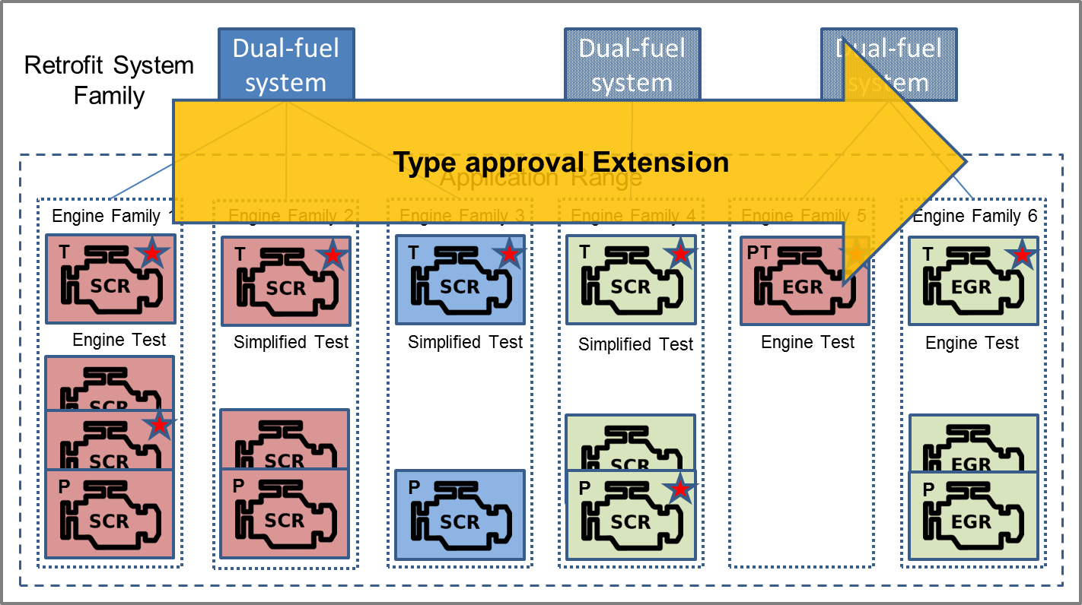
2.6.1. When applying for such an extension, the manufacturer shall submit an engine representative of the additional engines for performing additional tests. The nature of these tests depends on the desired extension.
2.6.2. A test procedure is introduced to evaluate the emission performance of the retrofitted engine by comparing the emissions in dual-fuel mode with those in diesel mode.
2.6.3. Tests may be performed on the road using portable emission measurement systems.
2.7. The manufacturer shall notify the approval authority for which engines in the application range an engine retrofit system has been developed and will be produced. This set of engine retrofit systems represents the "actual applications".

3. Conformity of production requirements
3.1. The implementation of and a schedule for conformity of production tests shall be necessary to ensure the quality of the retrofit systems and their application.
3.2. Conformity of production tests shall only be performed on actual applications.
Figure 4
Respective roles of type approval extension and conformity of production
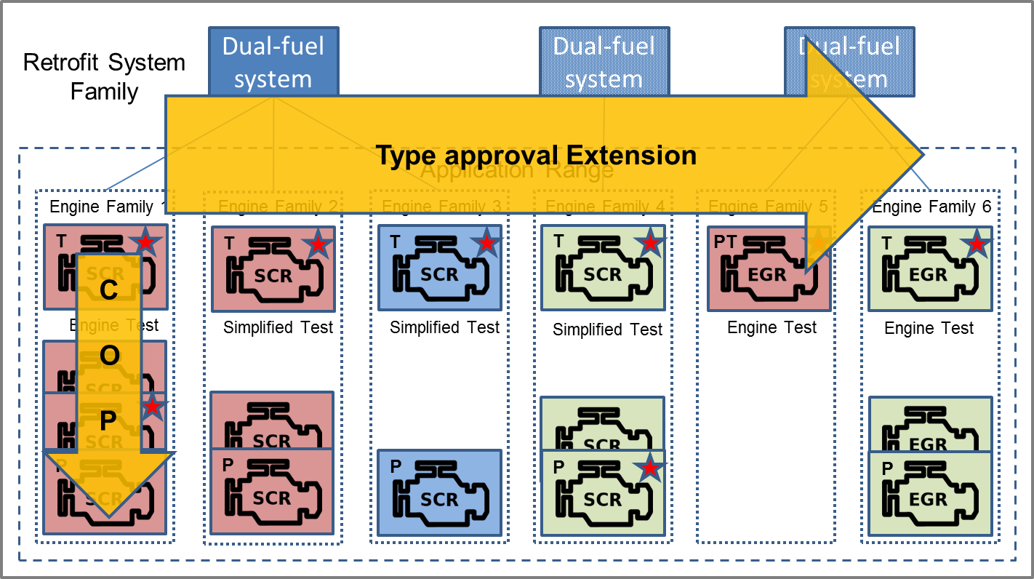
B. Requirements and specifications
1. Scope
1.1. This Regulation applies to Dual-Fuel Engine Retrofit Systems (HDDF-ERS) intended to be fitted on vehicles of categories M and N, equipped with engines approved to the requirements of rows B2 or C of Tables 1 and 2 of paragraph 5.2.1. of Regulation No. 49 as amended by the 05 series of amendments.

2. Definitions
2.1. For the purpose of this Regulation, without any further precision,
"Regulation No. 49" means Regulation No. 49 as amended by the 05 series of amendments.
2.2. For the purposes of this Regulation the definitions listed in Regulation No. 49 shall apply, unless otherwise stated by paragraph 2.3.
2.3. For the purposes of this Regulation the following definitions shall apply:
2.3.1. "Active Controller Area Network (CAN) communication" means communication via a CAN bus by actively requesting or sending CAN messages (error frames included).
2.3.2. "Actual application" means an engine system within the application range for which the engine retrofit system manufacturer supplies engine retrofit systems.
2.3.3. "Application range" means a grouping of engine systems from which engines may be selected by the engine retrofit system manufacturer to become an actual application.
2.3.4. "Demonstration engine" means the retrofitted dual-fuel engine used at type approval for demonstrating compliance with the requirements of this Regulation.
2.3.5. "EEV engine" means an engine approved to the requirements of row C of Tables 1 and 2 of paragraph 5.2.1. of Regulation No. 49.
2.3.6. "Euro V engine" means an engine approved to the requirements of row B2 of Tables 1 and 2 of paragraph 5.2.1. of Regulation No. 49.
2.3.7. "Engine retrofit system or Heavy Duty Dual-Fuel Engine Retrofit System (HDDF-ERS)" means a retrofit system for a heavy duty diesel engine which enables its operation either in diesel mode or in dual-fuel mode.
2.3.8. "Engine retrofit system family" means a retrofit system manufacturer’s grouping of engine retrofit systems which through their design, as defined in this Regulation, have similar retrofitting characteristics.
2.3.9. "Engine retrofit system manufacturer" means the person or body who is responsible to the approval authority for all aspects of the type approval of the engine retrofit system and for ensuring the conformity of production of that system.
2.3.10. "Installation manual" or "engine retrofit system installation manual" means the manual provided by the manufacturer of the engine retrofit system that includes the information, the specifications, and the tests that are necessary for installing and using the engine retrofit system in a retrofitted dual-fuel vehicle
2.3.11. "Original engine system or original engine" means the diesel engine system prior to the installation of the engine retrofit system.
2.3.12. "Original engine family" means the family of the original engine system as type approved according to Regulation No. 49.
2.3.13. "Parent engine retrofit system" means an engine retrofit system used for demonstrating compliance at type approval with the requirements of this Regulation.
2.3.14. "Passive CAN communication" means communication via a CAN bus without actively requesting or sending CAN messages ("listen-only").
2.3.15. "R49 original emission limits" means the emission limits as defined in Regulation No. 49 to which the original engine system was approved.
2.3.16. "Retrofit system or dual-fuel retrofit system" means a retrofit system for a heavy duty diesel vehicle which enables the operation of their engine either in diesel mode or in dual-fuel mode.
2.3.17. "Retrofit system installer or installer" means the person or body responsible for the installation of a type approved engine retrofit system.
2.3.18. "User manual" means the manual provided by the retrofit system manufacturer to the end-user that includes the information that is necessary in addition to the original end-user manual of the vehicle for using and maintaining the retrofitted dual-fuel vehicle.

3. Abbreviations
AR Application Range
CAN Controller Area Network
COP Conformity Of Production
ECU Electronic Control Unit
EEV Enhanced Environmentally friendly Vehicle
EMC Electro Magnetic Compatibility
EGR Exhaust Gas Recirculation
ELR European Load Response test
ESC European Steady state Cycle
ETC European Transient Cycle
HDDF-ERS Heavy Duty Dual-Fuel Engine Retrofit System
LPG Liquefied Petroleum Gas
LNG Liquefied Natural Gas
MI Malfunction Indicator
NG Natural gas
OEM Original Equipment Manufacturer
PEMS Portable Emission Measurement System
R49 Regulation No. 49
TA Type Approval
TAA Type Approval Authority

4. Application for approval
4.1. Application for approval of a dual-fuel engine retrofit system family
4.1.1. The application for approval of a dual-fuel engine retrofit system family shall be submitted by the engine retrofit system manufacturer or by his duly accredited representative.
4.2. Information package
4.2.1. The application for approval shall be accompanied by an information package describing the demonstration retrofit system and engine, the retrofit system family and the application range:
4.2.1.1. Demonstration retrofit system and engine
(a) Description of the demonstration engine retrofit system (including the list of the components);
(b) Description of the demonstration engine;
(c) Installation manual of the demonstration engine retrofit system on the demonstration engine;
(d) User manual.
The installation manual shall be provided in the English language and, upon request of the approval authority, in the language of the country of the authority.
4.2.1.2. Retrofit system family and application range
(a) Description of the engine retrofit system family (including the list of the components);
(b) Description of the application range;
(c) The elements demonstrating compliance with and required by this Regulation.
4.2.1.3. Actual application(s)
(a) Description of the actual application(s);
(b) The installation manuals of the engine retrofit systems for all the actual applications, including the description of any modification of the engine system (hardware or software) required for the installation of the engine retrofit system;
(c) The declaration of compliance and notification form in Annex 3 properly filled in.
4.2.2. The content of the information package shall comply with the requirements specified in Annex 1 and its Appendixes 1 and 2.
4.3. Engine retrofit system sample
4.3.1. The parent engine retrofit system and the demonstration engine conforming to the characteristics described in the information document shall be submitted to the Technical Service responsible for conducting the approval checks and tests defined in Annex 6.

5. Approval
5.1. Approval of a dual-fuel engine retrofit system family
5.1.1. In order to receive a type approval of an engine retrofit system family, the retrofit system manufacturer shall, in accordance with the provisions of this Regulation, demonstrate that the engine retrofit systems are subject to the tests and comply with the requirements set out in paragraph 7. and Annexes 4 and 6. The retrofit system manufacturer shall also ensure compliance with the fuel related requirements set out in paragraph 11. of Annex 6.
5.1.2. An approval number shall be assigned to each approved engine retrofit system family.
5.1.2.1 Its first two digits (at present 00 representing to the Regulation in its original form) shall indicate the series of amendments incorporating the most recent major technical amendments made to the Regulation at the time of issue of the approval.
5.1.2.2. The Contracting Party shall not assign the same type approval number to another engine retrofit system family.
5.1.3. Notice of approval or of refusal or of extension of approval of an engine retrofit system family pursuant to this Regulation shall be communicated to the Parties to the Agreement applying this Regulation, by means of a form conforming to the model in Annex 5 to this Regulation.
5.1.4. In addition to the Notice specified in paragraph 5.1.3., when applicable, the application range of the approved dual-fuel engine retrofit system family shall be communicated to the Parties to the Agreement applying this Regulation by means of a form conforming to the model in Annex 5 to this Regulation.
5.2. Markings of an approved dual-fuel engine retrofit system
5.2.1. The sample(s) of a specific dual-fuel engine retrofit system submitted to type approval shall be accompanied by a plate or its drawing with following information;
(a) The approval number;
(b) The trade name or mark of the engine retrofit system manufacturer;
(c) The type;
(d) The fuel (i.e. NG-H or NG-L or NG-HL or LNG or LNG₂₀ or LPG or a specific fuel);
(e) The contact details (i.e. telephone number or URL);
as shown in Annex 4.
5.2.2. All dual-fuel engine retrofit systems shall be identified by the plate described in 5.2.1. which shall be permanently fixed on the body of the vehicle.
5.2.3. The engine retrofit system manufacturer shall demonstrate to the type approval authority that a system is established to permit unrestricted access to the list of the components of the retrofit system through the contact details marked on the plate.
5.2.3.1. The approval number of the system, and some other easily accessible information of the engine or the vehicle (e.g. engine code, licence plate number, etc.) shall be sufficient to retrieve the correct list of the components of the retrofit system.
6. Actual applications
6.1. An approved engine retrofit system shall only be installed on an engine system belonging to its actual applications.
6.2. An engine system belongs to the actual applications when the engine retrofit system manufacturer has notified the type approval authority that this engine system is added to the actual applications.
6.2.1. The engine retrofit system manufacturer may notify the type approval authority of engine systems which are included as actual applications at type approval.
6.3. Together with the notification, the engine retrofit system manufacturer shall provide the installation manual of the system, compliant with paragraph 12. of Annex 6 and specific for each actual application, the compliance statement, as well as the updated list of actual applications in accordance with Annex 3.
6.3.1. In addition to the Notices specified in paragraphs 5.1.3. and 5.1.4., when notified, the actual applications of the approved dual-fuel engine retrofit system family shall be communicated to the Parties to the Agreement applying this Regulation by means of a form conforming to the model in Annex 3 to this Regulation.
6.4. The engine retrofit system manufacturer shall ensure that actual applications shall be compliant with the requirements of this Regulation.
6.5 The engine retrofit system manufacturer shall only supply engine retrofit systems for engine systems which belong to the actual applications.
6.6. The engine retrofit system manufacturer shall maintain records at the manufacturer's facility which contain all test data, engineering analyses, and other information which provides the basis for the compliance statement. The manufacturer shall provide such information to the type approval authority upon request.

7. Technical requirements and tests
7.1. The engine retrofit system shall fulfil the requirements specified in paragraphs 7.2. to 7.5.
7.2. Requirements for dual-fuel engine retrofit systems intended to be fitted in road vehicles
7.2.1. Engine retrofit systems shall fulfil the requirements specified in Annex 6 of this Regulation.
7.2.2. The engine retrofit system shall pass the applicable tests specified in Annex 6 whenever the engine retrofit system manufacturer applies for an initial approval or for an extension.
7.3. Additional requirements for NG dual-fuel retrofit systems
7.3.1. The specific components of the engine retrofit system shall comply with Regulation No. 110 part I, as applicable.
7.3.2. The installation of an engine retrofit system on an engine shall comply with Regulation No. 110 part II, as applicable, and with the specifications of the engine retrofit system installation manual.
7.4. Additional requirements for LPG dual-fuel retrofit systems
7.4.1. The specific components of the engine retrofit system shall comply with Regulation No. 67 part I, as applicable.
7.4.2. The installation of an engine retrofit system on an engine shall comply with Regulation No. 67 part II, as applicable, and with the specifications of the engine retrofit system installation manual.
7.5. Other additional general requirements
7.5.1. Communication within the vehicle
7.5.1.1. An engine retrofit system may make use of passive CAN communication.
7.5.1.2. Any CAN communication between the engine retrofit system and the original engine and/or vehicle shall be performed in accordance with the applicable ISO/SAE standards.
7.5.1.3. In case the engine retrofit system performs active CAN communication, it shall not increase the CAN bus load by more than 10 per cent (e.g. from 30 per cent to 40 per cent), while the total CAN bus load shall remain less than 80 per cent.
7.5.1.3.1. The CAN bus load shall be tested at rated engine power and speed and at full load at 50 per cent and 75 per cent of rated engine speed.
7.5.2. Functional safety
7.5.2.1. If CAN messages are modified in dual-fuel mode then it shall be demonstrated to the approval authority that the original safety functions of the engine or the vehicle are not inhibited.
7.5.2.2. The specifications of any modified CAN message shall be part of the documentation submitted at type approval.
7.5.3. Electrical safety
7.5.3.1. The electrical connections between the engine retrofit system and the engine/vehicle shall be designed according to the applicable ISO/SAE standards.
7.5.4. EMC
7.5.4.1. The engine retrofit system shall be compliant with Regulation No. 10.

8. Engine retrofit system family and application range
8.1. Engine retrofit system family
8.1.1. The parent engine retrofit system of an engine retrofit system family is the engine retrofit system that is used for performing the demonstration tests specified in Annex 6 during the type approval of the engine retrofit system for its initial application range.
8.1.2. Each member of the engine retrofit system family shall have the characteristics specified in paragraph 3. of Annex 6 in common with the parent engine retrofit system.
8.1.3. The engine retrofit system manufacturer shall provide the list of the engine retrofit systems belonging to the engine retrofit system family in accordance with Appendix 2 of Annex 1.
8.2. Application range of an engine retrofit system
8.2.1. Initial application range
8.2.1.1. The initial application range of an engine retrofit system shall be the original engine family to which the demonstration engine belongs.

9. Conformity of production
9.1. The Conformity Of Production (COP) procedures shall comply with those set out in the 1958 Agreement, Appendix 2 (E/ECE/324 - E/ECE/TRANS/505/Rev.2).
9.2. The measures taken to guarantee conformity of production shall fulfil the requirements of paragraph 2. of Appendix 2 to the 1958 Agreement.
9.3. Special requirements:
(a) The checks as meant in paragraph 2.2. of Appendix 2 to the 1958 Agreement include the checks on conformity with the criteria of paragraph 7. of this Regulation;
(b) For the application of paragraph 2.4.4. of Appendix 2 to the 1958 Agreement one of the test procedures described in the paragraphs 5.2. or 10.1. of Annex 6 of this Regulation shall be carried out;
(c) The approval authority shall select the test samples from the actual applications;
(d) The provisions in paragraphs 11.1 and 11.1.4. of Annex 6 shall apply.
9.4. Before type approvals can be granted the engine retrofit system manufacturer shall submit the following data on conformity of production for the purpose of the initial assessment:
(a) A completed and signed application form, in accordance with a model to be provided by the type approval authority;
(b) A description of the requested information, in accordance with the application form;
(c) A copy of the ISO 9001:2000 certificate, or any equivalent quality system, with a relevant scope.
9.5. Based on this information, manufacturers who have a certified quality system may be admitted to the type approval procedure, receiving an Initial Assessment Statement based on the appraisal of documents.
9.6. In case the engine retrofit system manufacturer does not have a certified quality system, an assessment of the company shall be carried out based on ISO 9001:2000, including conformity of production aspects.
9.7. At least the following aspects of ISO 9001:2000 are to be described and verified:
(a) Quality management system;
(b) Responsibilities of the board.

10. Penalties for non-conformity of production
10.1. The approvals granted pursuant to this Regulation may be withdrawn if the requirements laid down in Annex 6 are not complied with.
10.2. If a Party to the Agreement applying this Regulation withdraws an approval it has previously granted, it shall forthwith so notify the other Contracting Parties applying this Regulation, by means of the Communication specified in Annex 5 to this Regulation.

11. Modification and extension of approvals
11.1. Modification and extension of the approval of a dual-fuel engine retrofit system
11.1.1. The authority that granted the type approval shall be notified of any modification to the engine retrofit system. The authority will then assess whether or not the engine retrofit system still complies with the requirements for inclusion in the appropriate family.
The authority may require a further test report from the technical service responsible for conducting the tests in order to assist in its assessment.
11.1.2. Any modification or extension of the application range, as defined in paragraph 11.2., is dealt with as a modification or extension of the type approval of the dual-fuel engine retrofit system.
11.1.3. When the type approval authority approves the modification, a reference to the formal notification of that approval shall be included in the installation manual.
11.1.4. Confirmation or refusal of approval, specifying the alteration, shall be communicated by the procedure specified in paragraph 5. to the Parties to the 1958 Agreement applying this Regulation.
11.1.5. The competent authority issuing the extension of approval shall assign a series number for such an extension and inform thereof the other Parties to the 1958 Agreement applying to this Regulation of that number by means of the Communication specified in Annex 5 to this Regulation.
11.2 Extension of the application range
11.2.1. Any extension of the application range shall be subject to an extension of the type approval.
11.2.2. The technical requirements of this Regulation and the tests relative to the extension of the application range of an engine retrofit system as specified in paragraph 10. of Annex 6 shall be fulfilled.
11.2.3. If the demonstration engine meets the requirements of paragraph 10. of Annex 6, the application range is extended with the original engine family of the demonstration engine.

12. Production definitively discontinued
12.1. If the holder of the approval completely ceases to manufacture a type of engine retrofit system approved in accordance with this Regulation, he shall so inform the authority that granted the approval. Upon receiving the relevant communication, that authority shall inform thereof the other Parties to the 1958 Agreement applying this Regulation by means of the Communication specified in Annex 5 to this Regulation.

13. Names and addresses of Technical Services responsible for conducting approval tests and of Type Approval Authorities
13.1. The Contracting Parties to the Agreement applying this Regulation shall communicate to the United Nations Secretariat the names and addresses of the technical services responsible for conducting approval tests and of the administrative departments that grant approval and to which forms certifying approval, extensions, refusals or withdrawal of approval, issued in other countries, are to be sent.

Annex 1
Information document
1. Information document
1.1. General
This information document is related to the approval of Heavy Duty Dual-Fuel Engine Retrofit Systems (HDDF-ERS) in accordance with Regulation No. 143. It refers to measures to be taken against the emission of gaseous and particulate pollutants from compression-ignition engines for use in vehicles and retrofitted to dual-fuel operation with said engine retrofit system.
Parent engine retrofit system/Engine retrofit system
0. General
0.1. Make (name of undertaking):
0.2. Type and commercial description (mention any variants):
0.3. Means and location of identification of type, if marked on the vehicle:
0.4. Category of vehicle (if applicable):
0.5. Category of engine: diesel and NG-H/NG-L/NG-HL/LNG/LNG₂₀/LPG fuelled¹
0.6. Name and address of engine retrofit system manufacturer:
0.7. Location of statutory plates and inscriptions and method of affixing:
0.8. In the case of components and separate technical units, location and method of affixing of the ECE approval mark:
0.9. Address(es) of assembly plant(s):
Appendices:
1. Essential characteristics of the (parent) engine retrofit system (see Appendix 1 of this Annex).
2. Essential characteristics of the engine retrofit system family (see Appendix 2 of this Annex).
3. List further attachments, if any.
Date and place:

Annex 1 - Appendix 1
Essential characteristics of the (parent) retrofit system and of the demonstration engine
1.1. Parent¹ engine retrofit system
    - General information
1.1.1.1. Engine retrofit system manufacturer:
1.1.1.2. Fuel type (LPG, NG-H, NG-L, NG–HL, LNG, LNG₂₀, .......)
1.1.1.3. Adaptation capability for different gaseous fuel compositions:
1.1.1.4. Fuel pump: Yes/No¹
1.1.1.5. Fuel supply type (i.e. induction mixer, injector device, vapour or liquid, single or multi-point injection system):
1.1.1.6. Fuelling control strategy:
1.1.2. Components
1.1.2.1. Pressure regulator/vaporizer¹
1.1.2.1.1. Make
1.1.2.1.2. Type
1.1.2.1.3. Outlet pressure kPa
1.1.2.1.4. Certification number
1.1.2.1.5. Identification
1.1.2.1.6. Number of main adjustment points
1.1.2.1.7. Description of principle of adjustment through main adjustment points
1.1.2.1.8. Number of idle adjustment points
1.1.2.1.9. Description of principle of adjustment through idle adjustment points
1.1.2.1.10. Other adjustment possibilities: if so and which (description and drawings)
1.1.2.2. Pressure regulator²
1.1.2.2.1. Make
1.1.2.2.2. Type
1.1.2.2.3. Outlet pressure² kPa
1.1.2.2.4. Certification number
1.1.2.2.5. Identification
1.1.2.2.6. Number of main adjustment points
1.1.2.2.7. Description of principle of adjustment through main adjustment points
1.1.2.2.8. Number of idle adjustment points
1.1.2.2.9. Description of principle of adjustment through idle adjustment points
1.1.2.2.10. Other adjustment possibilities: if so and which (description and drawings)
1.1.2.3. Mixing unit: Yes/No¹
1.1.2.3.1. Number
1.1.2.3.2. Make
1.1.2.3.3. Type
1.1.2.3.4. Operating pressure(s):² kPa
1.1.2.4. Gas injection device(s) or injector(s): Yes/No¹
1.1.2.4.1. Make
1.1.2.4.2. Type
1.1.2.4.3. Identification
1.1.2.4.4. Operating pressure:² kPa
1.1.2.5. Electronic control unit
1.1.2.5.1. Make
1.1.2.5.2. Type
1.1.2.5.3. Software calibration identification
1.1.2.6. Fuel pump: Yes/No¹
1.1.2.6.1. Make
1.1.2.6.2. Type
1.1.2.6.3. Pump mounted in container: Yes/No¹
1.1.2.6.4. Operating pressure:² kPa
1.1.2.7. Shut-off valve/ non-return valve/gas tube pressure relief valve¹: Yes/No¹
1.1.2.7.1. Make(s)
1.1.2.7.2. Type(s)
1.1.2.7.3. Description
1.1.2.7.4. Operating pressure(s):² kPa
1.1.2.8. Flexible fuel hose/pipes:
1.1.2.8.1. Make(s)
1.1.2.8.2. Type(s)
1.1.2.8.3. Description
1.1.2.8.4. Operating pressure(s):² kPa
1.1.2.9. Pressure and temperature sensor:¹
1.1.2.9.1. Make(s)
1.1.2.9.2. Type(s)
1.1.2.9.3. Description
1.1.2.9.4. Operating pressure(s):² kPa
1.1.2.10. Gas filter unit:¹
1.1.2.10.1. Make(s)
1.1.2.10.2. Type(s)
1.1.2.10.3. Description
1.1.2.10.4. Operating pressure(s):² kPa
1.1.2.11. Any other emission or safety related components:¹
1.2. Demonstration engine
1.2.1. Manufacturer of the engine:
1.2.2. Manufacturer’s engine code (as marked on the engine or other means of identification):
1.2.3. Approval number (if appropriate) including fuel identification:
1.2.4. Modifications to the engine necessary to mount the retrofit system:

Annex 1 - Appendix 2
Essential characteristics of the engine retrofit system family and of the application range
1. Engine retrofit system family
1.1. General information
1.1.1. Engine retrofit system manufacturer:
1.1.2. Gaseous fuel type (LPG, NG-H, NG-L, NG-HL, LNG, LNG₂₀, .......)
1.1.3. Adaptation capability for different gaseous fuel compositions:
1.1.4. Pressure regulator/vaporizer¹ outlet pressure range: kPa
1.1.5. Fuel pump: Yes/No¹
1.1.6. Fuel supply type (i.e. induction mixer, injector device, vapour or liquid, single or multi-point injection system):
1.1.7. Fuelling control strategy:
1.1.8. GER_{ETC}: min % max %
1.1.9. GER_{ESC}: min % max %
2. Components
2.1. Provide the information as specified in paragraph 1.1.2. of Appendix 1 for all the components of the retrofit systems belonging to the family.
3. Family members
3.1. Provide the list of family members:
First approval and following extensions
Approval No.: .................................... granted on: [dd/mm/yyyy]
Extension No.: .................................... granted on: [dd/mm/yyyy]³
4. Application range
4.1. Provide the approval number of each original engine family included in the application range:
First approval and following extensions | Engines
Approval No.: .................................... granted on: [dd/mm/yyyy]³ | [Original engine family approval number]³
Extension No.: ................................... granted on: [dd/mm/yyyy]³ | [Original engine family approval number]³

Annex 2
(Reserved)

Annex 3
Information document regarding the actual applications
1. The following is the model of the required compliance statement and notification form:
"[Name of engine retrofit system manufacturer] attests that the actual application [Identification of the actual application]¹ complies with all requirements of Regulation 143. [Name of engine retrofit system manufacturer]¹ makes this statement in good faith, after having performed an appropriate engineering evaluation of the emissions performance of the actual application over the applicable range of operating and ambient conditions.
Herewith [Name of engine retrofit system manufacturer]¹ notifies the approval authority that the actual application [Identification of the actual application]¹ is added to the actual applications. The most recent list of actual applications is attached to this information document.
Appendix: List of actual applications.
Date: [Date]¹
Place: [Place]¹
[Stamp and signature of the engine retrofit system manufacturer’s representative]¹"
1.1. The information of all the actual applications together with each specific retrofit system in accordance with the table in Appendix 1 of this annex shall be attached as an appendix.

Annex 3 - Appendix 1
List of actual applications
1. This list shall be provided for each engine retrofit system family member.
Engine retrofit system: [approval (extension) number]¹
Fuel range or specific fuel: .................................
[list of components with approval numbers]
Original engine families | Actual applications
Manufacturer: .................................  Original engine family:  [approval number]¹ | Engine:  [approval number and engine code]¹  Software calibration identification number(s) and calibration verification number(s):  [Software calibration identification number(s) and calibration verification number(s)]¹  Fuel range or specific fuel: ...................................
Engine:
[approval number and engine code]¹
Software calibration identification number(s) and calibration verification number(s):
[Software calibration identification number(s) and calibration verification number(s)]¹
Fuel range or specific fuel: ...................................
 | ……..
Manufacturer: .................................  Original engine family:  [approval number]¹ | Engine:  [approval number and engine code]¹  Software calibration identification number(s) and calibration verification number(s):  [Software calibration identification number(s) and calibration verification number(s)]¹  Fuel range or specific fuel: ...................................
 | ……..
…….. | ……..

Annex 4
Arrangement of the dual-fuel engine retrofit system type approval mark
1. The approval mark shall consist of:
1.1. A circle surrounding the letter "E" followed by the distinguishing number of the country which has granted the approval;
1.2. A symbol indicating the fuel type, where the symbol "➢" indicates a CNG retrofit system, a "#" means LPG, a "%" means LNG.
1.3. The number of this Regulation, followed by the letter "R", a dash and the approval number to the right of the circle defined below. The approval number consists of the retrofit system type approval number, which appears in the communication form for this type approval (see paragraph 5.1.2. of the Regulation and Annex 5) preceded by two figures indicating the latest series of amendments to this Regulation.
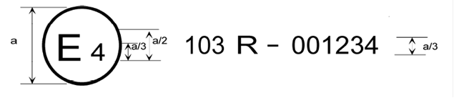 a = min. 8mm
143
2. The above approval mark affixed to the plate of a dual-fuel retrofit system, shows an approval from the Netherlands (E 4), pursuant to Regulation No. 143 under approval number 001234. The symbol "➢" indicates a CNG retrofit system. The first two digits of the approval number indicate that approval was granted in accordance to the requirement of Regulation No. 143 in its original form.
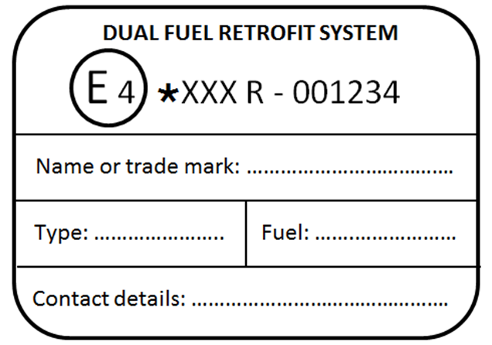
143

Annex 5
Communication
(Maximum format: A4 (210 x 297 mm))
issued by: Name of administration:
......................................
......................................
......................................
Concerning: Approval granted
Approval extended
Approval refused
Approval withdrawn
Production definitively discontinued
of a type of a Heavy Duty Dual-Fuel Engine Retrofit System (HDDF-ERS) pursuant to Regulation No. 143
Approval No.: ................................. Extension No.: ..................................................
Reason for Extension: .......................................
- Parent² engine retrofit system (approval numbers of the components):
Fuel pump:²
Vaporiser/pressure regulator:²
Pressure regulator:²
Shut-off valve:²
Non-return valve:²
Gas tube pressure relief valve:²
Flexible fuel line/hose:²
Fuel rail:²
Mixing unit:²
Gas injection device or injector:²
Electronic control unit:²
Software calibration identification number(s):
Pressure/temperature sensor:²
Gas filter unit:²
Any other emission or safety related components:
- Demonstration engine
Manufacturer of the engine:
Approval number:
Engine code:
Modifications to the engine necessary to mount the retrofit system:
- Fuel type (LPG, NG-H, NG-L, NG–HL, LNG, LNG₂₀, .......)²
Self-adaptive: Yes/No²
- GER_{ETC} test result (if applicable):
- GER_{ESC} test result (if applicable):
- Emission test results:
Engine tests - first approval or application range extension²
Gaseous test fuel(s) used:
ETC test results:
Operating modes | NMHC g/kWh | CH₄ ª  g/kWh | CO  g/kWh | NO_{x}  g/kWh | PM  g/kWh
Diesel mode before retrofit
Diesel mode after retrofit
Dual-fuel mode
ª Applicable only to NG engines

ESC test results (only diesel mode):
HC  g/kWh | CO  g/kWh | NO_{x}  g/kWh | PM  g/kWh
On-road vehicle tests - application range extension²
Gaseous test fuel used:
Operating modes |  | NMHC  g/s | CO  g/s | NO_{x}  g/s | PM  g/s
Diesel mode | urban
 | rural
 | highway
Diesel mode after retrofit | urban
 | rural
 | highway
Dual-fuel mode | urban
 | rural
 | highway
- OBD tests results:
Specify test and results:
Test description | Mode (diesel or dual-fuel) | Result
 |  | Pass/fail²
 |  | Pass/fail²
- Engine retrofit system family: (list all the components included in the family and their approval numbers):
Fuel pump:²
Vaporiser/pressure regulator:²
Pressure regulator:²
Shut-off valve:²
Non-return valve:²
Gas tube pressure relief valve:²
Flexible fuel line/hose:²
Fuel rail:²
Mixing unit:²
Gas injection device or injector:²
Electronic control unit:²
Software calibration identification number(s):
Pressure/temperature sensor:²
Gas filter unit:²
Any other emission or safety related components:
- Trade name or mark:
- Engine retrofit system manufacturer's name and address:
- Name and address of engine retrofit system manufacturer's representative, if applicable:
- Approval submission date:
- Technical Service responsible for conducting approval tests:
- Date of report issued by that Service:
- No. of report issued by that Service:
- Application range (list all the engines included in the application range with approval numbers and engine codes as in following table)
Application range:
First approval and following extensions | Engines
Approval No.: .................................... granted on: [dd/mm/yyyy] | [Original engine family approval number]³
Extension No.: .................................... granted on: [dd/mm/yyyy]³ | [Original engine family approval number]³
- The documents filed with the application or extension of approval can be obtained upon request.
- Place:
- Date:
- Signature:

Annex 6
Dual-fuel engine retrofit systems intended to be fitted on road vehicles – requirements and tests
1. Definitions
For the purpose of this Annex, the following definitions shall apply in addition to the definitions of paragraph 2. of this Regulation and to the definitions of Regulation No. 49:
1.1. Reserved
2. Determination of the diesel fuel replacement by a dual-fuel engine retrofit system
2.1 The following process is applicable for determining the diesel fuel replacement by a dual-fuel engine retrofit system.
2.1.1. The demonstration engine is submitted in dual-fuel mode to an ETC test and to an ESC test as specified in Annex 4A of Regulation No. 49.
2.1.2. The Gas Energy Ratio (GER), as defined in paragraph 2.1. of Annex 11 of Regulation No. 49, is calculated over the ETC test cycle.
2.1.3. The GER of the demonstration engine over the ETC test cycle shall be higher than 10 per cent.
2.1.4. The ETC and ESC tests referred to in paragraph 2.1.1. shall be performed consecutively, in either order.
2.1.5. The fuels used in both tests shall be the same as well as all other test conditions, including the test bench.
2.1.6. The average gas ratio over this ESC test cycle (GER_{ESC}) is calculated using the weighted average of the consumption of both fuels over this cycle.
2.1.7. The absolute difference between the average gas ratio calculated over this ETC test cycle (GER_{ETC}) and the average gas ratio calculated over this ESC test cycle (GER_{ESC}) shall not exceed 20 per cent of the GER_{ETC}.
3. Characteristics and criteria defining an engine retrofit system family
3.1. An engine retrofit system family is defined by design characteristics. These shall be common to all engine retrofit systems within the engine retrofit system family.
3.1.1. An engine retrofit system can only be a member of the same engine retrofit system family as the parent engine retrofit system when it shares with that engine retrofit system the characteristics defined in paragraph 3.2.
3.2. Characteristics defining an engine retrofit system family
3.2.1. Operational characteristics defining an engine retrofit system family:
(a) Engine retrofit system manufacturer;
(b) Fuel type (LPG, NG-H, NG-L, NG-HL, LNG, LNG₂₀,..…);
(c) Adaptation capability for different gaseous fuel compositions;
(d) Pressure regulator/vaporizer outlet pressure between 0.8 and 1.2 times that of the parent system;
(e) With or without a fuel pump;
(f) Fuel supply type (i.e. induction mixer, injector device, vapour or liquid, single or multi-point injection system);
(g) Fuelling control strategy;
(h) The difference between the highest and the lowest GER_{ETC} (i.e. the highest GER_{ETC} minus the lowest GER_{ETC}) within a dual-fuel engine retrofit system family shall not exceed 30 per cent.
4. Operating modes
Dual-fuel engine retrofit systems shall be capable of operating in both diesel mode and dual-fuel mode.
A diesel engine retrofitted with a dual-fuel engine retrofit system shall operate in diesel mode or in dual-fuel mode.
4.1. Conditions for a dual-fuel engine to idle using diesel fuel exclusively
4.1.1. Retrofitted dual-fuel engines may idle using diesel fuel exclusively.
4.2. Conditions for a dual-fuel engine to warm-up or start using diesel fuel exclusively in dual fuel mode
4.2.1. A retrofitted dual-fuel engine may warm-up or start using diesel fuel exclusively. However, in that case, it shall operate in diesel mode.
4.3. Switch back to diesel mode
A dual-fuel engine retrofit system when operating in dual-fuel mode shall switch back to diesel mode in all cases listed in this paragraph. The switch-back shall occur as soon as possible.
4.3.1. Unavailability of gaseous fuel
The unavailability of gaseous fuel when operating in dual-fuel mode can be caused by the following cases:
4.3.1.1. Empty gaseous fuel tank
When the gas quantity in the tank exceeds the level that caused the activation of the switch-back, the dual-fuel mode shall be reactivated as soon as possible.
4.3.1.2. Malfunctioning gas supply
The gas injection system electronics, fuel quantity and timing actuator(s) shall be monitored for circuit continuity (i.e. open circuit or short circuit) and functional failure when the engine operates in dual-fuel mode.
As soon as the gas diagnostic system concludes that the malfunction is no longer present or when the OBD information is erased by a scan tool, the dual-fuel mode may be reactivated.
4.3.2. Malfunction(s) detected by the OBD system of the original engine or the dual-fuel retrofit OBD system.
The dual-fuel mode may only be reactivated when the cause of the malfunction is removed and the OBD information is erased by a scan tool.
4.4. Dual-fuel indicators
4.4.1. Dual-fuel operating mode indicator:
(a) A dual-fuel engine retrofit system shall have a visual indicator indicating to the driver the mode under which the engine operates (dual-fuel mode or diesel mode);
(b) The characteristics and the location of this indicator are left to the discretion of the engine retrofit system manufacturer and may be part of an already existing visual indication system;
(c) This indicator may be completed by a message display. The system used for displaying the messages referred to in this point may be the same as the ones used for OBD, correct operation of NO_{x} control measures, or other maintenance purposes;
(d) The visual element of the dual-fuel operating mode indicator shall not be the same as the one used for the purposes of OBD (that is, the MI – Malfunction Indicator), for the purpose of ensuring the correct operation of NO_{x} control measures, or for other engine maintenance purposes;
(e) Safety alerts always have display priority over the operating mode indication.
4.4.1.1. The dual-fuel system shall warn the driver by means of the dual-fuel mode indicator or an audio signal (or both) when the engine operation is forced to diesel mode as required by paragraph 4.3.
4.4.1.2. The dual-fuel mode indicator shall be active for at least one minute on the selected mode as soon as the engine operating mode is changed from diesel to dual-fuel mode or vice-versa. This indication is also required for at least one minute at key-on, or at the request of the engine retrofit system manufacturer at engine cranking. The indication shall also be given upon the driver's request.
5. Exhaust emissions requirements
5.1. General
5.1.1. The dual-fuel engine retrofit system shall be designed and manufactured to enable the retrofitted engine or vehicle, in normal use, using that engine retrofit system and complying with the instructions of the engine retrofit system installation manual, to comply with the requirements defined in this Regulation.
5.1.1.1. The emission tests at type approval shall be performed according to the requirements specified in paragraph 5.2. of this annex.
5.1.1.2. The emission limits shall be those specified in paragraph 5.3. of this annex.
5.1.2. The engine retrofit system shall comply with the general requirements regarding emission control strategies specified in Annex 10 to Regulation No. 49, whether operating in diesel or in dual-fuel mode.
5.1.2.1. Defeat strategies or defeat devices, as defined and considered by Annex 10 to Regulation No. 49 are forbidden.
5.1.2.2. When emission related components have adjustment possibilities the OBD system shall monitor the correct adjustment of those components. When the adjusted value is not correct the ECU shall indicate that a malfunction is present.
5.2. Test requirements at type approval
5.2.1. Measurement methods
The emission performance of the demonstration engine shall be measured using the test procedures as specified in this annex and in Annex 11 to Regulation No. 49.
5.2.2. Type approval tests
5.2.2.1. The components of the engine retrofit system installed on the demonstration engine shall be aged in accordance with paragraph 9.2.
5.2.2.2. The demonstration engine shall be tested in the following configurations and operational modes:
(a) Diesel mode without the dual-fuel engine retrofit system installed (original engine);
(b) Diesel mode with the dual-fuel engine retrofit system installed;
(c) Dual-fuel mode.
5.2.3. Laboratory tests
The demonstration engine shall be tested in diesel mode and in dual-fuel mode. The ETC and ESC test cycles shall be used. The emissions to be measured are shown in Table 1.
The average gas ratios over the ESC test cycle (GER_{ESC}) and over the ETC test cycle (GER_{ETC}) shall be determined in accordance with paragraph 2.
Table 1
Laboratory tests to be performed by the demonstration engine
 | Diesel Mode | Dual-fuel Mode
ETC | NMHC; CO; NO_{X}; PM | NMHC; CH₄ ª; CO; NO_{X}; PM
ESC | HC; CO; NO_{X}; PM | GER determination only
ª For NG engines only.
5.3. Emission limits for dual-fuel engines retrofitted with an engine retrofit system:
5.3.1. Diesel mode after retrofit
The exhaust emissions of the engine operating in diesel mode shall not exceed the Regulation No. 49 original emission limits.
5.3.2. Dual-fuel mode after retrofit
The exhaust emissions of the demonstration engine operating in dual-fuel mode shall not exceed the emission limits specified in this paragraph. No deterioration factors shall be applied as the engine and components are already aged.
5.3.2.1. CO, NO_{x}, PM emissions
The CO, NO_{x} and PM emission limits applicable for type 2B dual-fuel engines as specified in Regulation No. 49 shall apply.
5.3.2.2. THC, NMHC, CH₄ emissions
5.3.2.2.1. For LPG engines the THC emission limit applicable for type 2B LPG dual-fuel engines as specified in Regulation No. 49 shall apply.
5.3.2.2.2. For NG engines and at the request of the engine retrofit system manufacturer in agreement with the type approval authority, the hydrocarbon emissions shall comply with either paragraph 5.3.2.2.3. or paragraph 5.3.2.2.4.
5.3.2.2.3. The hydrocarbon emission limit applicable for type 2B NG dual-fuel engines as specified in Regulation No. 49 shall apply.
5.3.2.2.4. The NMHC emission limit applicable for type 2B NG dual-fuel engines as specified in Regulation No. 49 and the following GER dependent CH₄ limit;
${CH}_{4}≤6.84*GER/100$ AND ${CH}_{4}≤6$ [g/kWh]
shall apply.
6. Power requirements
6.1. Demonstration engine configuration and operational modes
The demonstration engine in the configuration of paragraph 5.2.2.2., subparagraphs (a), (b) and (c), shall be submitted to the test procedures of paragraph 6.1.1.
The measured power in configuration (c) shall be within five per cent of the power measured in configuration (a).
6.1.1. The maximum power at the crankshaft is measured on an engine test bench in accordance with Regulation No. 85 (engine dynamometer method).
6.2. CAN transmitted torque test
The comparisons mentioned below are between the CAN messages present on the CAN bus.
6.2.1. The engine output torque message in dual-fuel mode shall be compared with the engine output torque message in diesel mode on an engine test bench.
6.2.2. The difference between the engine output torque message in diesel mode and the engine output torque message in dual-fuel mode shall be less than five per cent.
6.2.3. The comparison shall be performed in all modes of the ESC test, except mode 1.
7. Requirements and tests for dual-fuel engine retrofit system OBD
7.1. The dual-fuel engine retrofit system shall implement an OBD system that complies with the requirements for type 2B engines specified in paragraph 7. of Annex 11 to Regulation No. 49 and with the following restrictions:
(a) During diesel operation the diesel OBD system shall remain the only on board diagnostic system of the vehicle. The MI shall activate in case of a detected malfunction;
(b) During dual-fuel operation the diesel OBD system shall continue to monitor the original emission related components in use. The MI shall activate in case of a detected malfunction;
(c) During dual-fuel operation the dual-fuel ECU shall monitor the dual-fuel emission related components as well as their electrical connections. If the dual-fuel ECU detects a malfunction, the switch to diesel mode shall be performed as soon as possible. Operation in dual-fuel mode shall not be possible until the cause of the malfunction is removed. A clear visual or acoustic signal shall inform the driver about the situation.
7.2. The dual-fuel engine retrofit system OBD shall be submitted to the following tests carried out on the demonstration engine:
(a) In diesel mode the original Malfunction Indicator (MI) shall activate due to the electrical disconnection of any original emission-related component;
(b) In dual-fuel mode the original MI shall activate due to the electrical disconnection of any original emission-related component that is in use during dual-fuel operation. The engine retrofit system shall switch back to diesel operation as soon as the original MI is activated;
(c) In dual-fuel mode an automatic switch to diesel mode shall occur due to replacement of any dual-fuel emission-related component with a deteriorated or defective component or electronic simulation of such a failure.
7.3. Fault codes referring to malfunctions of the gas emission-related components and their electrical connections shall be stored in the dual-fuel ECU. The fault codes shall be available through the OBD bus or through a dedicated communication line.
7.4. The engine retrofit system manufacturer shall provide specific instructions and tools to read out the fault codes referred to in paragraph 7.3. of this annex in the case of a dedicated communication line.
8. Requirements to ensure the correct operation of NOX control measures
8.1. If the MI is activated the system shall automatically switch to diesel mode and stay in that mode until the issue causing the MI activation is fixed.
8.2. In this way the dual-fuel engine retrofit system enables the retrofitted engine to remain compliant with the requirements to ensure the correct operation of NO_{X} control measures specified in paragraph 5.5. of Regulation No. 49.
9. Durability requirements
9.1. The applicant shall ensure that the dual-fuel engine retrofit system when used and maintained according to the manufacturer’s instructions will comply with the applicable provisions during normal operation over a useful life of 4,000 operating hours or a service life of 6 years, whichever occurs first.
9.2. The dual-fuel engine retrofit system submitted to the durability tests as specified in Regulation No. 67 or Regulation No. 110, as applicable, shall be used to demonstrate the exhaust emission requirements as specified in paragraph 5. of this annex.
10. Requirements and tests for the extension of the application range
10.1. Tests and requirements
An engine representative of the desired extension of the application range shall be tested in accordance with the provisions set out in paragraph 5.2.2. or 10.1.1. at the choice of the dual-fuel engine retrofit system manufacturer. Engine tests in accordance with paragraph 5.2.2. are always required for the extension of an application range with an engine family equipped with EGR.
The tests in accordance with paragraph 10.1.1. shall be carried out on a representative engine equipped with a member of the dual-fuel engine retrofit system family.
The same tests shall be performed in diesel mode and in dual-fuel mode in such a way that the operating points and conditions are as similar as possible.
The NO_{X}, Non-Methane Hydrocarbons (NMHC), CO and PM emission test results in dual-fuel mode shall be lower than or equal to the results in diesel mode.
10.1.1. On-road vehicle testing using PEMS
10.1.1.1. Emission tests
10.1.1.1.1. A vehicle equipped with a representative engine and the engine retrofit system shall be tested on the road, while the emissions are measured with a Portable Emission Measurement System.
The vehicle shall be fuelled with diesel market fuel and a gaseous market fuel in accordance with paragraphs 11.1. and 11.1.2.
The same test trip(s) shall be performed in diesel mode and in dual-fuel mode with as little time as possible between the trips.
The tests shall be performed with the engine warmed-up to at least 343K or the temperature at which the system switches to dual-fuel mode.
Care shall be taken that velocities and loads of each respective diesel and dual-fuel mode trip shall be as similar as possible. The payload of the vehicle shall remain unchanged during the tests. The trip shall consist of 45 minutes of city driving followed by 30 minutes of rural driving and 30 minutes of highway driving. The emissions of city driving, rural driving and highway driving shall be evaluated separately. Alternatively separate city, rural and highway trips may be driven and evaluated separately. The durations are approximate which means durations +/- 5 minutes.
City driving is characterized by speeds between 0 and 50 km/h and an average velocity between 15 and 30 km/h. In total approximately 5 minutes of the urban driving shall be with velocity equal to zero and idling. The engine may be stopped during idling in case the engine is stopped during idling automatically by the engine control system.
Rural driving is characterized by speeds between 50 and 75 km/h and an average velocity between 45 and 70 km/h.
Highway driving is characterized by speeds above 75 km/h.
The average mass emissions expressed in g/s from each separate trip (city, rural, highway) will be compared between dual-fuel mode and diesel mode.
The test procedures shall comply with the applicable provisions of paragraph 5. and the PEMS testing procedures defined in Annex 8 and Appendix 5 of Annex 15 of the 06 series of amendments to Regulation 49 (R49r06) unless specified otherwise in this paragraph. The work and/or CO₂ based windowing approach and the use of conformity factors are not applicable.
PM or equivalent (e.g. PN) testing is not applicable until the necessary procedures are implemented in R49r06.
10.1.1.2. OBD requirements and tests
The representative engine equipped with the dual-fuel retrofit system installed in the vehicle shall comply with the provisions set out in paragraph 7. of this annex.
10.1.1.3. Power measurement
Upon agreement with the approval authority the power may be determined by performing a full load acceleration according to R49r06, Annex 8, Appendix 4 or by any other suitable method.
11. Fuels
11.1. General
The engine retrofit system manufacturer shall ensure compliance with the specifications of reference fuels set out in Annex 5 of Regulation No 49.
On request of the retrofit system manufacturer, the type approval authority may allow the use of market fuels or gaseous fuels produced with a composition representative for the market fuels to be used.
11.1.1. Type approval test
The provisions of paragraphs 4.1. and 4.2. of Regulation No. 49 regarding granting of a universal fuel approval and granting of a fuel range restricted approval shall apply.
11.1.2. Application range extension
In case of a test for an application range extension in accordance with the provisions set out in paragraph 5.2.2. or 10.1.1., the vehicle shall be fuelled with diesel market fuel and a gaseous market fuel in the range for which the engine retrofit system is approved. It is recommended to use the gaseous fuel with the lowest Methane Number rating within this fuel range.
The application range extension may be restricted to a smaller fuel range than the fuel range of the initial application range, but in that case the fuel range of the actual applications shall also be restricted.
11.1.3. Actual applications
Actual applications may be restricted to a smaller fuel range than the application range, but this shall be indicated on the notification form at the time of the notification and on the plate specified in paragraph 5.2.1. of this Regulation.
Only fuels within the range for which the engine retrofit system is compliant with this Regulation may be used.
The user manual shall clearly specify which market fuels may be used.
11.1.4. Conformity of production
The provisions in paragraphs 8.3.2.3. to 8.3.2.6. of Regulation No. 49 shall apply.
12. Installation manual
12.1. Scope
This section specifies the minimum requirements that shall be contained in the manual.
12.2. General requirements
12.2.1. The purpose of the manual is to guide the installer through the correct procedures to install and assemble the components of the dual-fuel engine retrofit system on the engine.
12.2.2. The manual shall be provided by the dual-fuel engine retrofit system manufacturer.
12.2.3. The manual is considered as part of the engine retrofit system and shall be available to the installer for each conversion kit.
12.2.4. The installation manual shall be supplied to the installer in the official language of the country where the installer operates or in the English language.
12.3. Engine retrofit system
The installation manual shall contain at least the following information:
12.3.1. Dual-fuel engine retrofit system description
12.3.2. Operational principles of the dual-fuel engine retrofit system
12.3.3. Dual-fuel engine retrofit system approval number
12.3.4. List of the components
12.3.5. Operational principles of each component of the dual-fuel engine retrofit system
12.3.6. The following information for each component:
(a) Identification number;
(b) Manufacturer's code;
(c) Type approval, if it exists.
12.4. Engine
The installation manual shall contain at least the following information:
12.4.1. Engine type and displacement
12.4.2. Approval number
12.4.3. Engine code
12.5. Installation instructions
The installation manual shall contain at least the following information:
12.5.1. Installation instructions of each component together with diagrams or photographs showing clearly the layout of the individual components.
12.5.2. Diagram or photograph showing the exact position where the installer shall place the engine retrofit system type approval plate (contained in the conversion kit).
12.5.3. Clear wiring diagram of the electrical system containing the mechanical components to which the wires shall be connected.
12.5.4. Description of any modification of the engine system (hardware and/or software) required for the installation of the engine retrofit system.
12.6. Interfaces
12.6.1. The instructions for completing the system shall include, at a minimum, the following elements:
12.6.1.1. Approvals and markings of the components and devices that are used to complete the engine retrofit system.
12.6.1.2. The technical specifications to be met by the components and devices that are used to complete the engine retrofit system:
(a) To correctly function;
(b) To comply with the provisions of this Regulation;
(c) To ensure the desired level of performance and reliability.
The technical specifications shall include the interface specifications (e.g. connection characteristics, gas pressure, communication parameters, fuel gauge or level indicator, etc.).
12.7. Proper assembly check
12.7.1. The installation manual shall contain the detailed procedures and actions to be taken by the installer to ensure that the system has been properly assembled.
12.8. Start-up procedures
12.8.1. The installation manual shall contain the start-up operations to be performed by the installer to ensure that the correct software and calibration are present.
12.9. Service instructions
12.9.1. The installation manual shall contain the maintenance schedule for single components as well as the system throughout their working life.
12.9.2. The installation manual shall specify the expertise (knowledge and training) necessary for the installation/service of the engine retrofit system.
12.9.3. The installation manual shall contain the necessary instructions to access the retrofit system parts information system referred to in paragraph 5.2.3. of this Regulation.
12.10. Engine retrofit system malfunctions
12.10.1. The installation manual shall contain the actions which shall be taken in case the engine retrofit system has a malfunction.
12.11. Diagnostics
12.11.1. The installation manual shall contain a description of the diagnostic system and the corrective actions that shall be taken in case of malfunctions.
12.12. Scrapping of the product
The manual shall give instructions to the installer about precautions to be taken when the system has to be removed from the engine.
13. User manual
13.1. Scope
To specify the minimum requirements of the user manual for operation and maintenance of the dual-fuel retrofit system.
13.2. General requirements
13.2.1. The user manual shall inform the user about the characteristics and safety features of the installed dual-fuel retrofit system.
13.2.2. The user manual shall be provided by the dual-fuel engine retrofit system manufacturer.
13.2.3. The manufacturer of the system shall include all the necessary information that is needed for correct and safe operation of the dual-fuel retrofit system.
13.2.4. The user manual shall be considered as an integral part of the system and, therefore, must be included with the delivery of the dual-fuel retrofit system hardware.
13.2.5. The user manual shall be written in the official language of the country to which the system is delivered or at least in the English language.
13.2.6. The user manual shall reference the product types, versions and production years for which it is applicable.
13.2.7. Information shall be given about relevant extreme ambient conditions.
13.3. Contents of the user manual
13.3.1. Technical specifications
The user manual shall contain at least the following information:
(a) Operating characteristics;
(b) Performance under normal operating conditions and in extreme ambient conditions.
13.3.2. Safety instructions
The user manual shall give information for dangers to health and safety categorised in the following way:
(a) SUGGESTIONS for optimal use of the system;
(b) ATTENTION for possible problems due to misuse;
(c) WARNING for damage to persons or goods when procedures are not followed.
If and when safety symbols are used, they shall be in accordance with the international system, SI and their purpose shall be clearly specified in the user manual.
13.3.2.1. The user manual shall indicate proper actions to be taken in case the vehicle is repainted and put in a hot drying cabin, or for other activities such as welding, cutting, etc.
13.3.3. Dual-fuel retrofit system description
The purpose and function of all the components of the dual-fuel retrofit systems shall be clearly described.
13.3.4. First use of the dual-fuel retrofit system
The user manual shall contain any necessary information for the user about initial running-in.
13.3.5. Operating the dual-fuel retrofit system
13.3.5.1. Filling fuel tanks of the dual-fuel retrofit system
The user manual shall indicate the sequence of operations needed to fill the gas containers. In the case of LPG, particular attention shall be paid to the maximum filling level of 80 per cent.
13.3.5.2. Switch-over procedure
The user manual shall clearly describe the method of switching back and forth between the diesel and dual-fuel mode or explain that the retrofit system switches automatically.
13.3.5.3. Opening/closing of manual valves
The user manual shall indicate the proper procedure to operate the manual valves.
13.3.5.4. Fuel level indicator
The user manual shall state the location of the fuel level indicator, for example at the dashboard or at the container. Its read-out shall be clearly explained to the user, giving particular attention to the 80 per cent filling level in case of LPG.
13.3.5.5. Maintenance
The manual shall state the frequency and type of maintenance to be carried out.
13.3.5.6. Defects and repairs
The user manual shall indicate what actions shall be taken in the case of damage to or a system defect. The user manual shall describe the diagnostic system and indicate actions to be taken in case of malfunctions.
13.3.5.7. Scrapping of the product
In case of scrapping of the system, the user manual shall require that the dual-fuel retrofit system shall be removed from the vehicle by an installer.

* Former title of the Agreement: Agreement Concerning the Adoption of Uniform Conditions of Approval and Reciprocal Recognition of Approval for Motor Vehicle Equipment and Parts, done at Geneva on 20 March 1958.
As defined in the Consolidated Resolution on the Construction of Vehicles (R.E.3.), document ECE/TRANS/WP.29/78/Rev.5, para. 2 - www.unece.org/trans/main/wp29/wp29wgs/wp29gen/wp29resolutions.html
Delete as appropriate.
Strike out what does not apply.
Specify the tolerance
Strike out what does not apply.
Specify the tolerance
Replace with the information specified between and including the square brackets
Replace the text between and including the square brackets with the specified information
Replace with the information specified between and including the square brackets
Distinguishing number of the country which has granted/extended/refused/withdrawn approval (see approval provisions in the Regulation).
Strike out what does not apply.
Replace the text between and including the square brackets with the specified information.

