E/ECE/324/Rev.2/Add.122/Rev.2/Amend.4−E/ECE/TRANS/505/Rev.2/Add.122/Rev.2/Amend.4
11 December 2017
Agreement
Concerning the Adoption of Harmonized Technical United Nations Regulations for Wheeled Vehicles, Equipment and Parts which can be Fitted and/or be Used on Wheeled Vehicles and the Conditions for Reciprocal Recognition of Approvals Granted on the Basis of these United Nations Regulations*
(Revision 3, including the amendments which entered into force on 14 September 2017)
_________
Addendum 122 – UN Regulation No. 123
Revision 2 – Amendment 4
Supplement 8 to the 01 series of amendments – Date of entry into force: 10 October 2017
Uniform provisions concerning the approval of adaptive front-lighting systems (AFS) for motor vehicles
This document is meant purely as documentation tool. The authentic and legal binding texts is: - ECE/TRANS/WP.29/2017/41 (1622506).
_________

UNITED NATIONS

Paragraph 1.16.1., amend to read:
"1.16.1. The trade name or mark(s):
(a) Lamps bearing the same trade name or mark but produced by different manufacturers shall be considered as being of different types;
(b) Lamps produced by the same manufacturer differing only by the trade name or mark shall be considered as being of the same type."
Insert new paragraphs 2.2.7. to 2.2.7.2., to read:
"2.2.7. In the case of a type of lamp differing only by the trade name or mark from a type that has already been approved it shall be sufficient to submit:
2.2.7.1. A declaration by the lamp manufacturer that the type submitted is identical (except in the trade name or mark) with and has been produced by the same manufacturer as, the type already approved, the latter being identified by its approval code;
2.2.7.2. Two samples bearing the new trade name or mark or equivalent documentation."
Paragraph 2.2.7.(former), renumber as paragraph 2.2.8.
Paragraph 5., amend to read:
"5. General specifications
The requirements contained in sections 5 "General specifications" and 6 "Individual specifications" and in the Annexes referenced in the said sections of UN Regulation No. 48, and their series of amendments in force at the time of application for the lamp type approval shall apply to this Regulation.
The requirements pertinent to each lamp and to the category/ies of vehicle on which the lamp is intended to be installed shall be applied, where its verification at the moment of lamp type approval is feasible.
5.1. …"
Paragraph 5.7.3., amend to read:
"5.7.3. In the case of failure it must be possible to obtain automatically a passing beam or a state with respect to the photometric conditions which yields values not exceeding 1,300 cd in the zone III b as defined in Annex 3 to this Regulation and at least 3,400 cd in a point of "segment I_{max}", by such means as e.g. switching off, dimming, aiming downwards, and/or functional substitution;
When performing the tests to verify compliance with these requirements, the Technical Service responsible for approval tests shall refer to the instructions supplied by the applicant."
Paragraph 6.2.4., amend to read:
"6.2.4. When emitting a specified mode of the passing beam, the system shall meet the requirements in the respective section (C, V, E, W) of part A of Table 1 (photometric values) and in Table 2 I_{max} and "cut-off" positions) of Annex 3 to this Regulation, as well as section 1 ("cut-off" requirements) of Annex 8 to this Regulation."
Paragraph 6.2.5.4., amend to read:
"6.2.5.4. If approval is sought for a category 1 bending mode, the system is designed so that, in the case of a failure affecting the lateral movement or modification of the illumination, it must be possible to obtain automatically either photometric conditions corresponding to paragraph 6.2.4. above or a state with respect to the photometric conditions which yields values not exceeding 1,300 cd in the zone IIIb, as defined in Annex 3 to this Regulation, and at least 3,400 cd in a point of "segment I_{max} ";"
Paragraph 6.4.3.1, amend to read:
"6.4.3.1. Passing beam: points B50L and 75R, or 50R if applicable;
Driving beam: I_{M} and point HV (percentage of I_{M});"
Annex 3
Figure 1, amend to read:
"Figure 1

Angular positions of passing beam photometric requirements
(indicated for right-hand traffic)
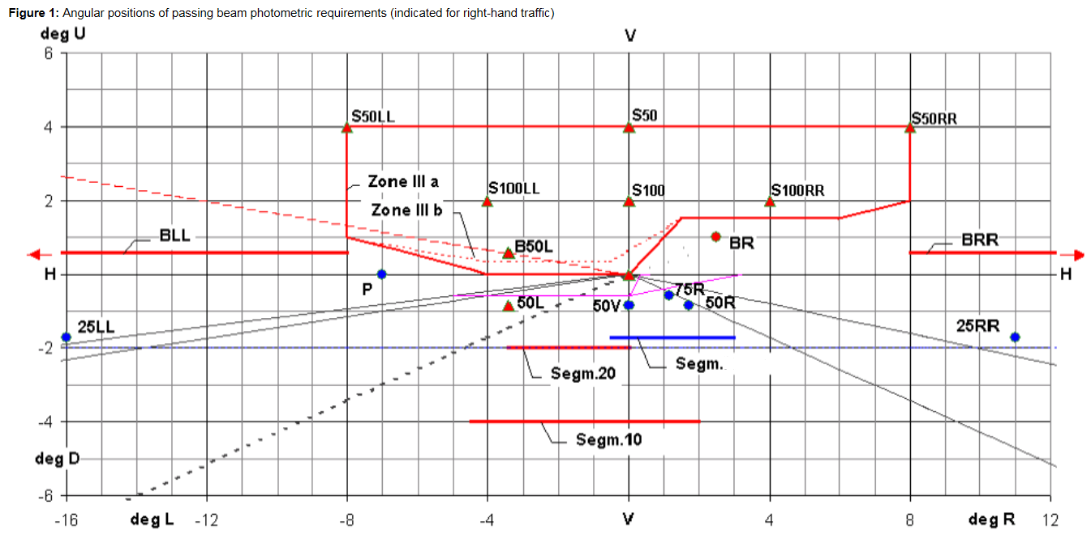
Imax
"
Table 1, Part A, line 18, replace "E_{max}" with "I_{max}".
Table 1, Part B, line 18, replace "E_{max}" with "I_{max}".
Table 1, footnote 3, amend to read:
"³ Requirements according to the provisions of Table 2 below ("Segment I_{max}") apply in addition.
Table 2, amend to read:

"Table 2
Passing beam elements angular position/extend, additional requirements
 |  | Class C passing-beam |  | Class V passing-beam |  | Class E passing-beam |  | Class W passing-beam
No. | Beam part designation and requirement | horizontal | vertical | horizontal | vertical | horizontal | vertical | horizontal | vertical
2.1. | Angular position / extend in deg  for segment I_{max}  The maximum luminous intensity in "Segment I_{max}" as indicated in this table shall be within the limits as prescribed in Table 1, Line No. 18. | 0.5L  to 3R | 0.3D  to 1.72D |  | 0.3D  to 1.72D | 0.5L  to 3R | 0.1D  to 1.72D | 0.5L  to 3R | 0.3D  to 1.72D
2.2. | The "cut-off" and part(s) of shall:  (a) comply with the requirements of paragraph 1. of Annex 8 to this Regulation and
 | (b) be positioned with its "flat horizontal part" |  | at V = 0.57 D |  | not above 0.57D  not below 1.3D |  | not above 0.23D⁸ not below 0.57D |  | not above 0.23D  not below 0.57D
⁸ | Requirements according to the provisions indicated in Table 6 below apply in addition.
"
Annex 4
Introductory part, amend to read:
"Tests for stability of photometric performance of systems in operation Tests on complete systems
Tests on complete systems
Once the photometric values have been measured according to the prescriptions of this Regulation, in the point of I_{max} for driving beam and in points 25L, 50V and B50L (or R), whichever applies for passing beam, a complete system sample shall be tested for stability of photometric performance in operation.
…"
Paragraph 1.2.1.2., amend to read:
"1.2.1.2. For a system or parts thereof with the outside lens in plastic material, the mixture of water and polluting agent to be applied to the test sample shall be composed of:
(a) 9 parts by weight of silica sand with a particle size of 0-100 μm;
(b) 1 part by weight of vegetal carbon dust produced from beech wood with a particle size of 0-100 μm;
(c) 0.2 part by weight of NaCMC⁵;
(d) 5 parts by weight of sodium chloride (pure at 99 per cent);
(e) 13 parts by weight of distilled water with a conductivity of less than ≤ 1 mS/m;
(f) 2 ± 1 drops of surfactant⁶. "
Paragraph 1.2.1.5., amend to read:
"1.2.1.5. Application of the test mixture to the test sample
The test mixture shall be uniformly applied to the entire light-emitting surface(s) of the test sample and then left to dry. This procedure shall be repeated until the illuminating value has dropped to 15-20 per cent of the values measured for each following point under the conditions described in this annex:
Point I_{max} in driving beam, under neutral state conditions;
50V for a class C passing beam, and each specified passing beam mode."
Paragraphs 2.2.1. and 2.2.2., amend to read:
"2.2.1. The result expressed in milliradians (mrad) shall be considered as acceptable for a passing beam headlamp when the absolute value Δ r₁ = ⏐ r₃ – r₆₀ ⏐ recorded on the headlamp is not more than 1.0 mrad (Δ r₁ ≤ 1.0 mrad) upward and not more than 2.0 mrad (Δ r₁ ≤ 2.0 mrad) downwards.
2.2.2. However, if this value is:
Movement
Upward | more than 1.0 mrad but not more than 1.5 mrad  (1.0 mrad < Δr_{I} < 1.5 mrad)
Downward | more than 2.0 mrad but not more than 3.0 mrad  (2.0 mrad < Δr_{I} < 3.0 mrad)
A further sample of a headlamp mounted on a test fixture representative of the correct installation on the vehicle shall be tested as described in paragraph 2.1. after being subjected three consecutive times to the cycle as described below, in order to stabilize the position of mechanical parts of the headlamp:
(a) Operation of the passing beam for one hour (the voltage shall be adjusted as specified in paragraph 1.1.1.2.);
(b) One hour period with the lamp switched off.
After these three cycles, the headlamp type shall be considered as acceptable if the absolute values Δr measured according to paragraph 2.1. above on this further sample meet the requirements in paragraph 2.2.1. above."
Annex 5
Paragraph 1.2.1.1., amend to read:
"1.2.1.1. For the following values of the passing beam and its modes, the maximum unfavourable deviation may be respectively:
- Maximum values at point B50L 170 cd equivalent 20 per cent and 255 cd equivalent 30 per cent;
- Maximum values at zone III and segment BLL: 255 cd equivalent 20 per cent and 380 cd equivalent 30 per cent;
- Maximum values at segments E, F1, F2 and F3: 170 cd equivalent 20 per cent and 255 cd equivalent 30 per cent;
- Minimum values at BR, P, at the groups S 50+ S 50LL+ S 50RR, S 100+ S 100LL+ S 100RR, and those required by footnote ⁴ of Table 1 in Annex 3 of this Regulation (B50L, BR, BRR, BLL): half of the required value equivalent 20 per cent and three quarter of the required value equivalent 30 per cent."
Paragraph 2.4., amend to read:
"2.4. Measured and recorded photometric characteristics
The sampled headlamps shall be subjected to photometric measurements at the points provided for in the Regulation, the reading being limited:
To points I_{max}, HV ¹, "HL" and "HR" ² in the case of a driving beam;
To points B50L, 50L, 50V, 75R if applicable, and 25LL in the case of the passing beam(s) (see Figure 1 in Annex 3)."
Annex 6
Paragraph 2.1.2.1., amend to read:
"2.1.2.1. Method
Photometric measurements shall be carried out on the samples before and after the test.
These measurements shall be made according to Annex 9 to this Regulation, at the following points:
B50L and 50V for the class C passing beam lighting;
I_{max} for the driving beam of a system."
Paragraph 2.6.1.2., amend to read:
"2.6.1.2. Results
After the test, the results of photometric measurements carried out on the system or part thereof in accordance with this Regulation shall not exceed by more than 30 per cent the maximum values prescribed at point B50L and not be more than 10 per cent below the minimum values prescribed at point 75R, if applicable."
Annex 7, paragraph 1.2.1.1., amend to read:
"1.2.1.1. For the following values of the passing beam and its modes, the maximum unfavourable deviation may be respectively:
- Maximum values at point B50L 170 cd equivalent 20 per cent and 255 cd equivalent 30 per cent;
- Maximum values at zone III and segment BLL: 255 cd equivalent 20 per cent and 380 cd equivalent 30 per cent;
- Maximum values at segments E, F1, F2 and F3: 170 cd equivalent 20 per cent and 255 cd equivalent 30 per cent;
- Minimum values at BR, P, at the groups S50+S50LL+S50RR, S100+S100LL+S100RR,and those required by footnote ⁴ of Table 1 in Annex 3 of this Regulation (B50L, BR, BRR, BLL): half of the required value is equivalent to 20 per cent and three quarters of the required value equivalent to 30 per cent."

* Former titles of the Agreement: Agreement concerning the Adoption of Uniform Conditions of Approval and Reciprocal Recognition of Approval for Motor Vehicle Equipment and Parts, done at Geneva on 20 March 1958 (original version); Agreement concerning the Adoption of Uniform Technical Prescriptions for Wheeled Vehicles, Equipment and Parts which can be Fitted and/or be Used on Wheeled Vehicles and the Conditions for Reciprocal Recognition of Approvals Granted on the Basis of these Prescriptions, done at Geneva on 5 October 1995 (Revision 2).

