E/ECE/324/Rev.1/Add.98/Rev.3/Amend.3−E/ECE/TRANS/505/Rev.1/Add.98/Rev.3/Amend.3
26 July 2017
Agreement
Concerning the Adoption of Uniform Technical Prescriptions for Wheeled Vehicles, Equipment and Parts which can be Fitted and/or be Used on Wheeled Vehicles and the Conditions for Reciprocal Recognition of Approvals Granted on the Basis of these Prescriptions*
(Revision 2, including the amendments which entered into force on 16 October 1995)
_________
Addendum 98 – Regulation No. 99
Revision 3 – Amendment 3
Supplement 12 to the original version of the Regulation – Date of entry into force: 22 June 2017
Uniform provisions concerning the approval of gas-discharge light sources for use in approved gas-discharge lamp units of power-driven vehicles
This document is meant purely as documentation tool. The authentic and legal binding texts is: ECE/TRANS/WP.29/2016/85.
_________

UNITED NATIONS

The title, amend to read:
"Uniform provisions concerning the approval of gas-discharge light sources for use in approved lamps of power-driven vehicles"
Paragraph 1., amend to read:
"1. Scope
This Regulation applies to gas-discharge light sources shown in Annex 1 to this Regulation and intended for use in approved lamps of power-driven vehicles."
Paragraph 2.3.4., amend to read:
"2.3.4. In case the ballast is not integrated with the light source, the ballast used for the type approval of the light source shall be marked with type and trade mark identification and with the rated voltage and wattage, as indicated on the relevant gas-discharge light source sheet."
Paragraph 3.1. and its subparagraphs, replace to read:
"3.1. Definitions
The definitions given in Resolution R.E.5 or its subsequent revisions, applicable at the time of application for type approval shall apply.
Insert a new paragraph 3.2.3., to read:
"3.2.3. The discharge arc shall be the only element of the gas-discharge light source that generates and emits light when energized."
Paragraph 3.3.3., amend to read:
"3.3.3. Gas-discharge light sources shall be equipped with standard caps complying with the cap data sheets of IEC Publication 60061, as specified on the individual data sheets of Annex 1 to this Regulation."

Annex 1, replace to read:
"Annex 1
Sheets¹ for gas-discharge light sources
The sheets of the relevant gas-discharge light source category and the group in which this category is listed with restrictions on the use of this category shall apply as incorporated in Resolution R.E.5¹ or its subsequent revisions, applicable at the time of application for type approval of the gas-discharge light source.
______________
¹ From 22 June 2017 onwards, the sheets for gas-discharge light sources, the list and group of light source categories with restrictions on the use of this category and their sheet numbers are incorporated in Resolution R.E.5 with symbol ECE/TRANS/WP.29/2016/111."
Annex 4,
Paragraph 3., amend to read:
"3. Burning position
The burning position shall be horizontal within ±10° with the lead wire down. Ageing and testing positions shall be identical. If the gas-discharge light source is accidentally operated in the wrong direction, it shall be re-aged before measurements begin. During ageing and measurements no electrically conducting objects shall be allowed within a cylinder having a diameter of 32 mm and a length of 60 mm concentric with the reference axis and symmetric to the arc. Moreover stray magnetic fields shall be avoided."
Paragraph 10., delete the figure and amend to read:
"10. Colour
The colour of the light source shall be measured in an integrating sphere using a measuring system which shows the CIE chromaticity co-ordinates of the received light with a resolution of ± 0.002."

Annex 5, amend to read:
"Annex 5
Optical setup for the measurement of the position and form
of the arc and of the position of the electrodes
The gas-discharge light source shall be positioned as shown in the main drawing of the respective category.
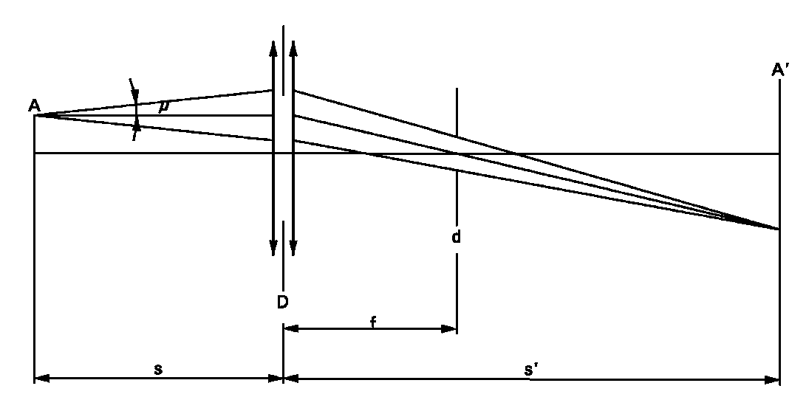
An optical system shall project a real image A' of the arc A with a magnification of preferably M = s'/s = 20 on a screen. The optical system shall be aplanatic and achromatic. In the focus-length f of the optical system a diaphragm d shall cause a projection of the arc with nearly parallel observation directions. To get the angle of the half divergence not larger than μ = 0.5°, the diameter of the focus-diaphragm with respect to the focus-length of the optical system shall be not more than d = 2f tan(μ). The active diameter of the optical system shall be not more than:
D = (1 + 1/M)d + c + (b1 + b2)/2. (c, b1 and b2 are given in the sheets prescribing the position of the electrodes).
A scale on the screen shall enable to measure the position of the electrodes. The calibration of the arrangement advantageously can be done by using a separate projector with a parallel beam in connection with a gauge whose shadow is projected to the screen. The gauge shall show the reference axis and the plane parallel to the reference plane and at distance "e" mm from it.
In the plane of the screen a receiver has to be mounted movable in a vertical direction on a line corresponding to the plane at "e" from the reference plane of the gas discharge light source.
The receiver shall have the relative spectral sensitivity of the human eye. The size of the receiver shall be not more than 0.2 M mm in the horizontal and not more than 0.025 M mm in the vertical direction (M = the magnification). The range of measurable movement shall be such that the required measures of the arc bending r and arc diffusion s can be measured. For the measurement of the stray light, the size of the receiver shall be circular with a diameter of 0.2M mm diameter."
Annex 7,
Table 1, row "Lamp voltage and wattage", amend to read:

"...
Grouping of characteristics | Grouping* of test records between gas-discharge light source types | Minimum 12 monthly sample per grouping* | Acceptable level of non-compliance per grouping of characteristics (percentage)
… | … | … | …
Gas-discharge light source voltage and wattage | All types of the same category | 200 | 1
… | … | … | …
..."
Table 3, header row, amend to read:
"
Number of gas-discharge light sources in records | Qualifying limit | Number of gas-discharge light sources in records | Qualifying limit | Number of gas-discharge light sources in records | Qualifying limit
"

* Former title of the Agreement: Agreement Concerning the Adoption of Uniform Conditions of Approval and Reciprocal Recognition of Approval for Motor Vehicle Equipment and Parts, done at Geneva on 20 March 1958.
This method is an example of a measurement method; any method with equivalent measurement accuracy may be used.

