E/ECE/324/Rev.1/Add.43/Rev.3/Amend.4−E/ECE/TRANS/505/Rev.1/Add.43/Rev.3/Amend.4
22 February 2017

Agreement
Concerning the Adoption of Uniform Technical Prescriptions for Wheeled Vehicles, Equipment and Parts which can be Fitted and/or be Used on Wheeled Vehicles and the Conditions for Reciprocal Recognition of Approvals Granted on the Basis of these Prescriptions*
(Revision 2, including the amendments which entered into force on 16 October 1995)
_________
Addendum 43 – Regulation No. 44
Revision 3 - Amendment 4
Supplement 11 to the 04 series of amendments – Date of entry into force: 9 February 2017
Uniform provisions concerning the approval of restraining devices for child occupants of power-driven vehicles ("Child Restraint Systems")
This document is meant purely as documentation tool. The authentic and legal binding text is: ECE/TRANS/WP.29/2016/37.
_________

UNITED NATIONS

Paragraph 2.8.8., amend to read:
"2.8.8. "Guide strap" means a strap or device which constrains the shoulder strap of the adult seat belt in a position to suit the child and where the effective position at which the shoulder strap changes direction can be adjusted by means of a device which can be moved up and down the strap to locate the wearer's shoulder, and then locked into that position. This guide strap is not meant to carry a significant part of the dynamic load. A guide strap is considered as a part of a child restraint system and cannot be separately approved as a child restraint system under this Regulation."
Insert a new paragraph 4.9., to read:
"4.9. Marking of a booster cushion without backrest.
If the product is a booster cushion without backrest, the following label shall be permanently visible to someone installing the restraint in a vehicle and shall be masked when the booster cushion is used with its removable backrest :

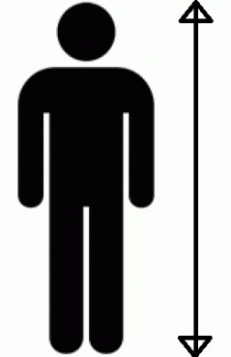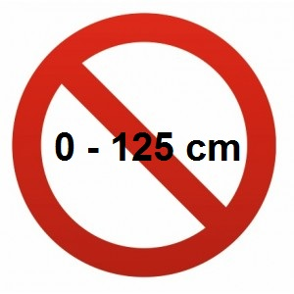
"
Insert a new paragraph 6.1.13., to read:
"6.1.13. Booster cushion without backrest shall only be type approved as Child Restraint Systems of Group III as defined in paragraph 2.1.1.5. of this Regulation. (Mass range from 22 kg to 36 kg)."

* Former title of the Agreement: Agreement Concerning the Adoption of Uniform Conditions of Approval and Reciprocal Recognition of Approval for Motor Vehicle Equipment and Parts, done at Geneva on 20 March 1958.

