E/ECE/324/Rev.2/Add.134/Amend.1−E/ECE/TRANS/505/Rev.2/Add.134/Amend.1
5 February 2016
Agreement
Concerning the Adoption of Uniform Technical Prescriptions for Wheeled Vehicles, Equipment and Parts which can be Fitted and/or be Used on Wheeled Vehicles and the Conditions for Reciprocal Recognition of Approvals Granted on the Basis of these Prescriptions*
(Revision 2, including the amendments which entered into force on 16 October 1995)
_________
Addendum 134 – Regulation No. 135
Amendment 1
Supplement 1 to the original version of the Regulation – Date of entry into force:
29 January 2016
Uniform provisions concerning the approval of vehicles with regard to their Pole Side Impact performance (PSI)
This document is meant purely as documentation tool. The authentic and legal binding text is: ECE/TRANS/WP.29/2015/54.
_________

UNITED NATIONS

Paragraph 1.1., amend to read:
"1.1. This Regulation applies to:
- Category M₁ vehicles with a gross vehicle mass of up to 3,500 kg; and
- Category N₁ vehicles where the acute angle alpha (α), measured between a horizontal plane passing through the centre of the front axle and an angular transverse plane passing through the centre of the front axle and the R-point of the driver's seat, as illustrated below, is less than 22.0 degrees; or the ratio between the distance from the driver's R-point to the centre of the rear axle (L101-L114) and the centre of the front axle and the driver's R-point (L114) is less than 1.30.2

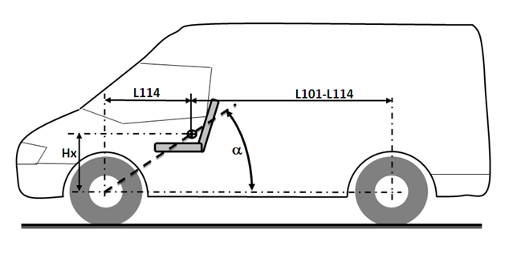"

* Former title of the Agreement: Agreement Concerning the Adoption of Uniform Conditions of Approval and Reciprocal Recognition of Approval for Motor Vehicle Equipment and Parts, done at Geneva on 20 March 1958.
2 As defined in the Consolidated Resolution on the Construction of Vehicles (R.E.3.), document ECE/TRANS/WP.29/78/Rev.3, para. 2 - www.unece.org/trans/main/wp29/wp29wgs/wp29gen/wp29resolutions.html

