E/ECE/324/Rev.2/Add.127/Amend.5−E/ECE/TRANS/505/Rev.2/Add.127/Amend.5
28 October 2016
Agreement
Concerning the Adoption of Uniform Technical Prescriptions for Wheeled Vehicles, Equipment and Parts which can be Fitted and/or be Used on Wheeled Vehicles and the Conditions for Reciprocal Recognition of Approvals Granted on the Basis of these Prescriptions*
(Revision 2, including the amendments which entered into force on 16 October 1995)
_________
Addendum 127 – Regulation No. 128
Amendment 5
Supplement 5 to the original version of the Regulation – Date of entry into force: 8 October 2016
Uniform provisions concerning the approval of light emitting diode (LED) light sources for use in approved lamp units on power-driven vehicles and their trailers
This document is meant purely as documentation tool. The authentic and legal binding text is: ECE/TRANS/WP.29/2016/25.
_________

UNITED NATIONS
Annex 1,
The list of categories of LED light sources and their sheet numbers, amend to read:
"
 | Category |  | Sheet number(s)
 | LR1 |  | LR1/1 to 5
 | LW2 |  | LW2/1 to 5
 | LR3A |  | L3/1 to 6
 | LR3B |  | L3/1 to 6
 | LW3A |  | L3/1 to 6
 | LW3B |  | L3/1 to 6
 | LY3A |  | L3/1 to 6
 | LY3B |  | L3/1 to 6
 | LR4A |  | LR4/1 to 5
 | LR4B |  | LR4/1 to 5
 | LR5A |  | L5/1 to 6
 | LR5B |  | L5/1 to 6
 | LW5A |  | L5/1 to 6
 | LW5B |  | L5/1 to 6
 | LY5A |  | L5/1 to 6
 | LY5B |  | L5/1 to 6
"
The list of sheets for LED light sources and their sequence in this annex, amend to read:
"
Sheet number(s)
LR1/1 to 5
LW2/1 to 5
L3/1 to 6
LR4/1 to 5
L5/1 to 6
"
Sheets LR3/1 to 5, replace by new sheets L3/1 to 6, to read (see following pages; one page per sheet):
Sheet LR4/1, replace by new sheet LR4/1, to read (see following pages):
Sheet LR4/4, replace by new sheet LR4/4, to read (see following pages):
After sheet LR4/5, insert new sheets L5/1 to 6, to read (see following pages; one page per sheet):
Categories LR3A, LR3B, LW3A, LW3B, LY3A and LY3B Sheet L3/1
The drawings are intended only to illustrate the essential dimensions of the LED light source.
Figure 1*
Main Drawing
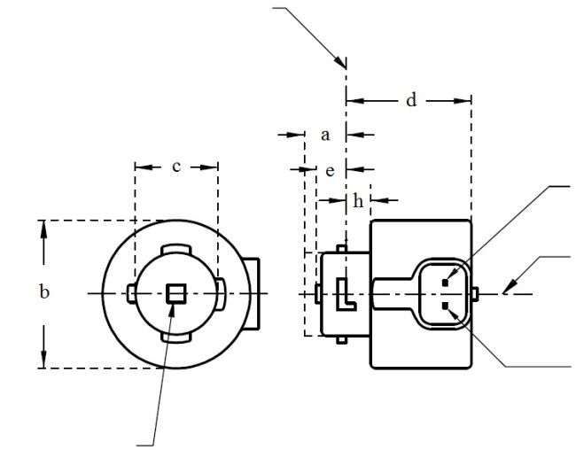
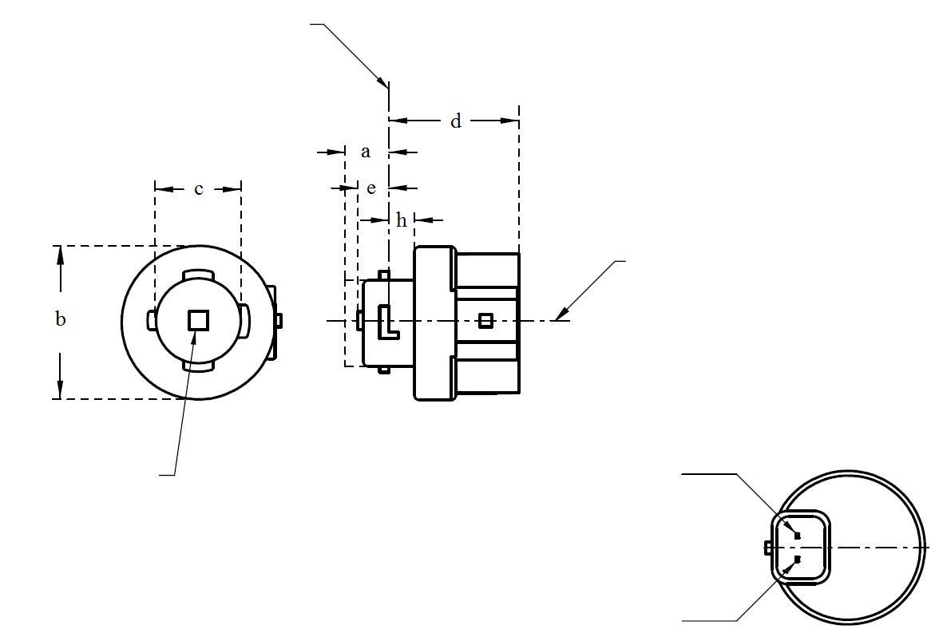
V+
Light emitting area ³
Reference axis ²
Ground
⁴
LR3A, LW3A, LY3A
V+
Light emitting area ³
Reference axis ²
Ground
Reference plane ¹
⁴
LR3B, LW3B, LY3B

For the notes see sheet L3/2.
* Projection method:
Categories LR3A, LR3B, LW3A, LW3B, LY3A and LY3B Sheet L3/2
Table 1
Essential dimensional, electrical and photometric characteristics of the LED light source

Dimensions |  |  |  |  |  | Production LED light sources | Standard LED light sources
a |  |  |  |  | mm | 6.0 max.
b |  |  |  |  | mm | c + 10.0 min.  38.0 max.
c |  |  |  |  | mm | 18.5 ± 0.1
d |  |  |  |  | mm | 28.0 max.
e |  |  |  |  | mm | 3.0 ± 0.30 | 3.0 ± 0.15
h |  |  |  |  | mm | 5.5 + 0.0/ – 0.1
Cap | LR3A, LR3B  LW3A, LW3B  LY3A, LY3B |  | PGJ18.5d-1  PGJ18.5d-24 PGJ18.5d-15 |  | in accordance with IEC Publication 60061 (sheet 7004-185-1)
Electrical and photometric characteristics
Rated values |  | Volts |  |  |  | 12
 |  | Watts |  |  | LR3A, LR3B | 3
 |  |  |  |  | LW3A, LW3B  LY3A, LY3B | 4
Objective Values⁸ |  | Watts  (at 13.5 V DC) |  |  | LR3A, LR3B | 3.5 max.
 |  |  |  |  | LW3A, LW3B | 5 max.
 |  |  |  | ¹² | LY3A, LY3B
 |  | Luminous flux  (in lm at 13.5 V DC) |  | ⁵ | LR3A, LR3B | 80 ± 20%⁹ | 80 ± 10%¹⁰
 |  |  |  | ⁶ | LW3A, LW3B | 250 ± 20% | 250 ± 10%¹¹
 |  |  |  | ^{7, 12} | LY3A, LY3B | 150 ± 20%⁹ | 150 ± 10%¹⁰
 |  | Luminous flux  (in lm at 9 V DC) |  | ⁵ | LR3A, LR3B | 19 min
 |  |  |  | ⁶ | LW3A, LW3B | 50 min.
 |  |  |  | ^{7, 12} | LY3A, LY3B | 30 min

¹ The reference plane is the plane defined by the contact points of the cap-holder fit.
² The reference axis is perpendicular to the reference plane and passing through the centre of the bayonet core.
³ Light emitting area: to be checked by means of the box system in Figure 2.
⁴ A minimum free air space of 5mm around the light source shall be respected for convection.
⁵ The emitted light shall be red.
⁶ The emitted light shall be white.
⁷ The emitted light shall be amber.
⁸ After continuous operation for 30 minutes at 23 ± 2.5° C.
⁹ The measured value shall be in between 100 per cent and 70 per cent of the value measured after 1 minute.
¹⁰ The measured value shall be in between 85 per cent and 75 per cent of the value measured after 1 minute.
¹¹ The measured value shall be in between 100 per cent and 90 per cent of the value measured after 1 minute.
¹² Operated in flashing mode for 30 minutes (frequency = 1.5 Hz, duty cycle 50 per cent ON, 50 per cent OFF). Measured in the ON-state of flashing mode after 30 minutes of operation.

Electrical characteristics

In case of LED light source failure (no light emitted) the max. electrical current draw, when operated between 12 V and 14 V, shall be less than 20 mA (open circuit condition).
Categories LR3A, LR3B, LW3A, LW3B, LY3A and LY3B Sheet L3/3

Screen projection requirements

The following test is intended to define the requirements for the apparent light emitting area of the LED light source and to determine whether the light emitting area is correctly positioned relative to the reference axis and reference plane in order to check compliance with the requirements.

The position of the light emitting area is checked by the box system defined in Figure 2, which is aligned to the planes C90 and C180 and shows the projection when viewing along direction γ=0º (C, γ as defined in Figure 3).

The proportion of the total luminous flux emitted into the viewing direction shall be as described in table 3.

Figure 2
Box definition of the light emitting area with dimensions as specified in table 2

f/3
Reference axis
perpendicular in the
centre of the light-
emitting area
f/3
f/3
f/3
f/3
f/3
A
B
B
B
B
C
C
C
C
f/2
f/2
Table 2
Dimensions of the box system in Figure 2

Dimensions in mm | f
 | LR3A, LR3B | LW3A, LW3B LY3A, LY3B
LED light sources of normal production | 3.0 | 4.5
Standard LED light sources | 3.0 | 4.5

Categories LR3A, LR3B, LW3A, LW3B, LY3A and LY3B Sheet L3/4

Table 3
Proportion of the total luminous flux emitted into the viewing direction from the areas specified in figure 2

Category | Area(s) | LED light sources of normal production | Standard LED light sources
LR3A  LR3B | A | ≤ 25% | ≤ 10%
 | Each B individually | ≥ 15% | ≥ 20%
 | Each C individually | - | ≤ 10%
 | A, all B and all C together | ≥ 90% | ≥ 90%
LW3A  LW3B  LY3A  LY3B | Each A,B individually | ≥ 6% | ≥ 8%
 | Each A, B individually | < 40% | < 30%
 | All A, B together | ≥ 55% | ≥ 60%
 | Each C individually | < 15% | < 10%
 | All A, B and C together | ≥ 90% | ≥ 90%

Categories LR3A, LR3B, LW3A, LW3B, LY3A and LY3B Sheet L3/5
Normalized luminous intensity distribution
The following test is intended to determine the normalized luminous intensity distribution of the light source in an arbitrary plane containing the reference axis. The intersection of the reference axis and the parallel plane to the reference plane in distance e is used as the coordinate system origin.
The light source is mounted on a flat plate with the corresponding mounting lug features. The plate is mounted to the goniometer table by a bracket, so that the reference axis of the light source lines up with one of the rotating axis of the goniometer. The corresponding measurement set-up is described in Figure 3.
Luminous intensity data is recorded with a standard photo-goniometer. The measurement distance should be chosen appropriately, to make sure that the detector is located in the far field of the light distribution.
The measurements shall be performed in C-planes C₀ (C₁₈₀) and C₉₀ (C₂₇₀), which contain the reference axis of the light source. The test points for each plane for multiple polar angles γ are specified in Tables 4a and 4b.
The measured luminous intensity values, normalised to the measured luminous flux of the individual light source under test, shall be converted to normalised luminous intensity values of a 1,000 lm light source. The data shall comply with the tolerance band as defined in Tables 4a and 4b.
The drawings are intended only to illustrate the essential set-up for measurement of the LED light source.
Figure 3
Set-up to measure the luminous intensity distribution
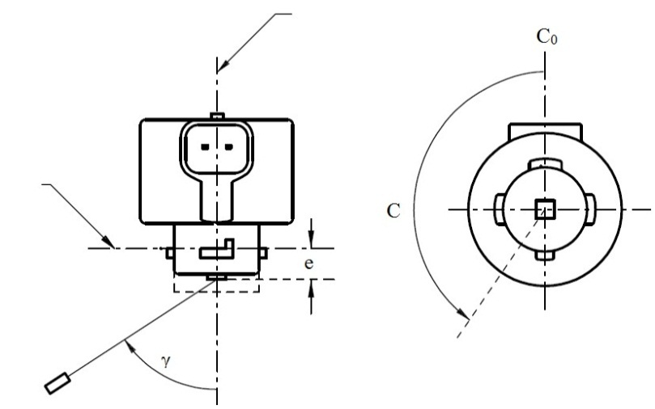
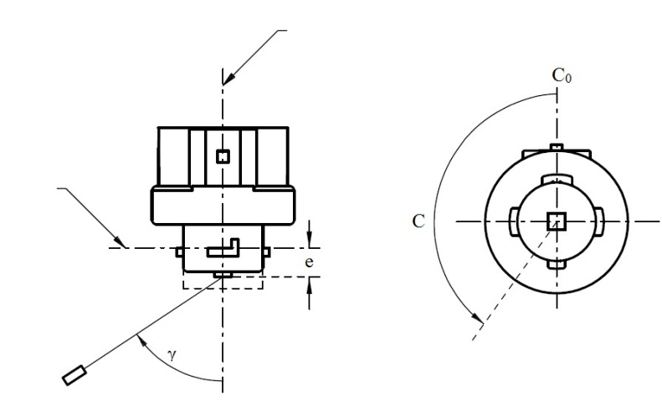
Reference axis
Reference plane
C-plane definition
Viewing direction along reference axis
Photo-Detector of Goniometer
LR3A, LW3A, LY3A
Reference axis
Reference plane
Photo-Detector of Goniometer
C-plane definition
Viewing direction along reference axis
LR3B, LW3B, LY3B

Categories LR3A, LR3B, LW3A, LW3B, LY3A and LY3B Sheet L3/6

The light pattern as described in Tables 4a and 4b shall be substantially uniform, i.e. in between two adjacent grid points the relative luminous intensity requirement is calculated by linear interpolation using the two adjacent grid points. In case of doubt this may be checked in addition to verification of the grid points given in Tables 4a and 4b.

Table 4a
Test point values of normalized intensities for categories LR3A and LR3B

 | LED light sources of normal production |  | Standard LED light sources
Angle γ | Minimum Intensity  in cd /1000 lm | Maximum Intensity  in cd/1000 lm | Minimum Intensity  in cd /1000 lm | Maximum Intensity in cd /1000 lm
-90° | 0 | 38 | 0 | 25
-75° | 0 | 160 | 0 | 140
-60° | 98 | 246 | 127 | 220
-45° | 142 | 305 | 181 | 275
-30° | 169 | 352 | 213 | 315
-15° | 192 | 389 | 239 | 340
0° | 200 | 401 | 248 | 352
15° | 192 | 389 | 239 | 340
30° | 169 | 352 | 213 | 315
45° | 142 | 305 | 181 | 275
60° | 98 | 246 | 127 | 220
75° | 0 | 160 | 0 | 140
90° | 0 | 38 | 0 | 25

Table 4b
Test point values of normalized intensities for categories LW3A, LW3B, LY3A and LY3B

 | LED light sources of normal production |  | Standard LED light sources
Angle γ | Minimum Intensity  in cd /1000 lm | Maximum Intensity  in cd/1000 lm | Minimum Intensity  in cd /1000 lm | Maximum Intensity in cd /1000 lm
-90° | 0 | 70 | 0 | 65
-75° | 0 | 160 | 0 | 150
-60° | 85 | 245 | 105 | 220
-45° | 145 | 310 | 180 | 275
-30° | 170 | 380 | 220 | 335
-15° | 190 | 415 | 240 | 370
0° | 200 | 425 | 250 | 390
15° | 190 | 415 | 240 | 370
30° | 170 | 380 | 220 | 335
45° | 145 | 310 | 180 | 275
60° | 85 | 245 | 105 | 220
75° | 0 | 160 | 0 | 150
90° | 0 | 70 | 0 | 65

Categories LR4A and LR4B Sheet LR4/1

The drawings are intended only to illustrate the essential dimensions of the LED light source.
Figure 1*
Main Drawing
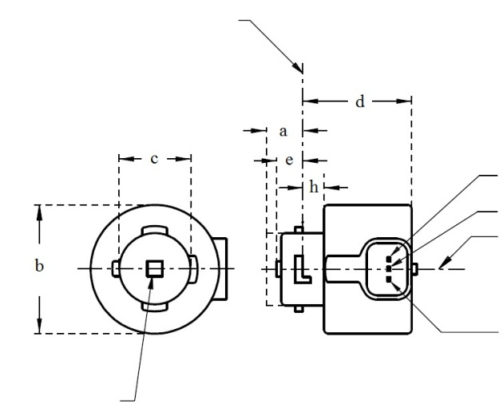
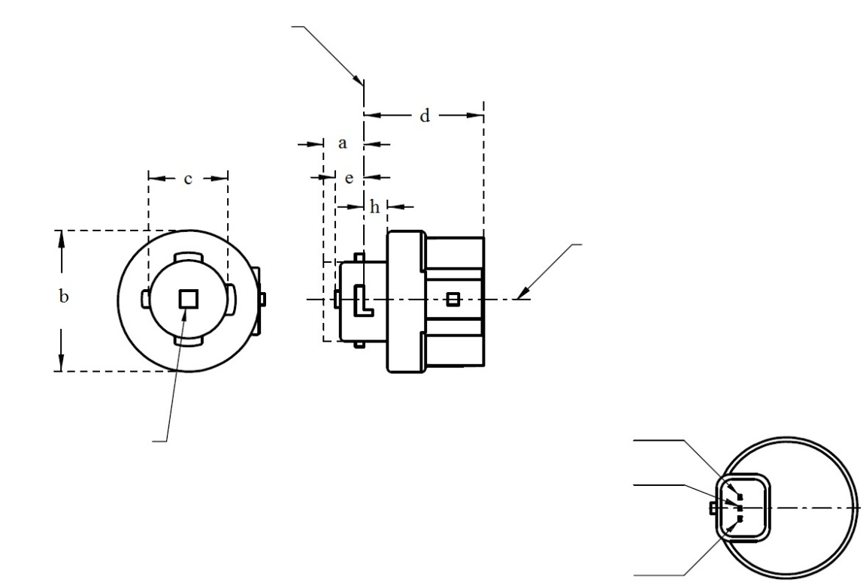
Reference plane ¹
Major Function

Light emitting area ³
Reference axis ²
Ground
Minor Function
LR4A
⁴
* Projection method:
LR4B
Major Function

Light emitting area ³
Reference axis ²
Ground
Minor Function
Reference plane ¹
⁴
For the notes see sheet LR4/2.

⁴

Categories LR4A and LR4B Sheet LR4/4

Normalized luminous intensity distribution
The following test is intended to determine the normalized luminous intensity distribution of the light source in an arbitrary plane containing the reference axis. The intersection of the reference axis and the parallel plane to the reference plane in distance e is used as the coordinate system origin.
The light source is mounted on a flat plate with the corresponding mounting lug features. The plate is mounted to the goniometer table by a bracket, so that the reference axis of the light source lines up with one of the rotating axis of the goniometer. The corresponding measurement set-up is described in Figure 3.
Luminous intensity data is recorded with a standard photo-goniometer. The measurement distance should be chosen appropriately, to make sure that the detector is located in the far field of the light distribution.
The measurements shall be performed in C-planes C₀ (C₁₈₀) and C₉₀ (C₂₇₀), which contain the reference axis of the light source. The test points for each plane for multiple polar angles γ are specified in Table 4.
After measurement the data shall be normalized to 1,000 lm according to paragraph 3.1.11 using the luminous flux of the individual light source under test. The data shall comply with the tolerance band as defined in Table 4.

The drawings are intended only to illustrate the essential set-up for measurement of the LED light source.
Figure 3*
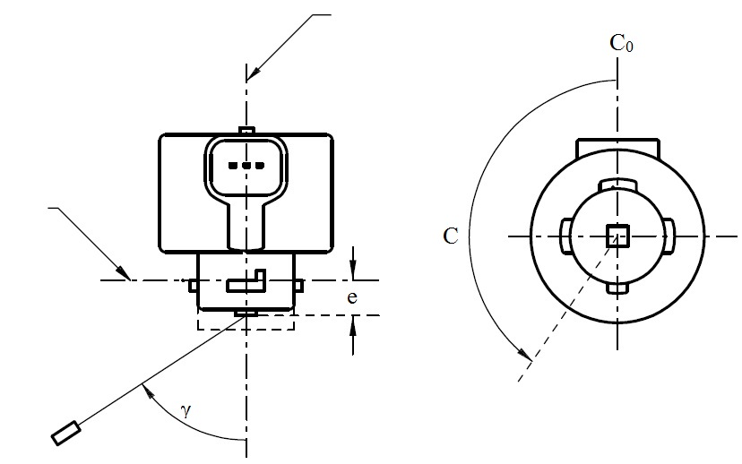
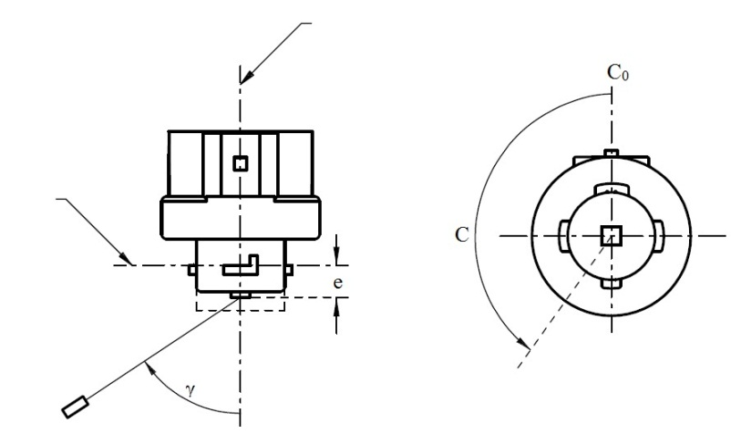
Set-up to measure the luminous intensity distribution
Reference axis
Reference plane
Photo-Detector of Goniometer
C-plane definition
Viewing direction along reference axis
LR4A
Reference axis
Reference plane
Photo-Detector of Goniometer
C-plane definition
Viewing direction along reference axis
LR4B
Categories LR5A, LR5B, LW5A, LW5B, LY5A, LY5B Sheet L5/1
The drawings are intended only to illustrate the essential dimensions of the LED light source.
Figure 1*
Main Drawing

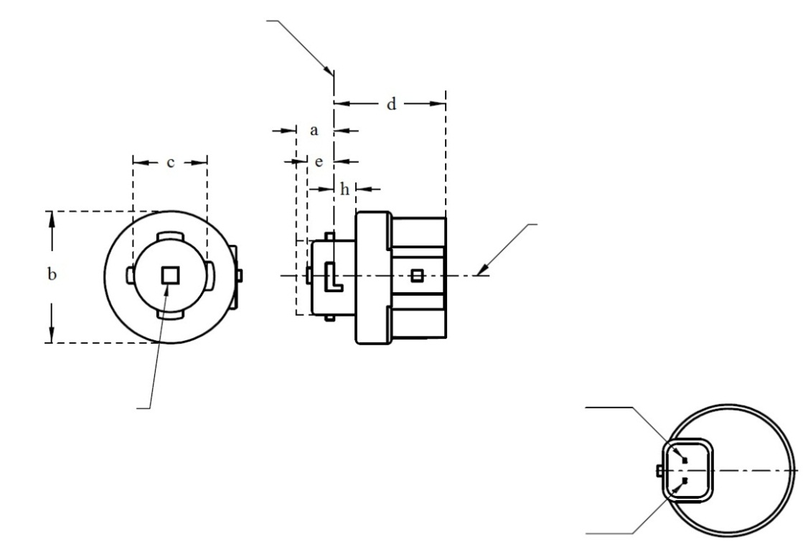
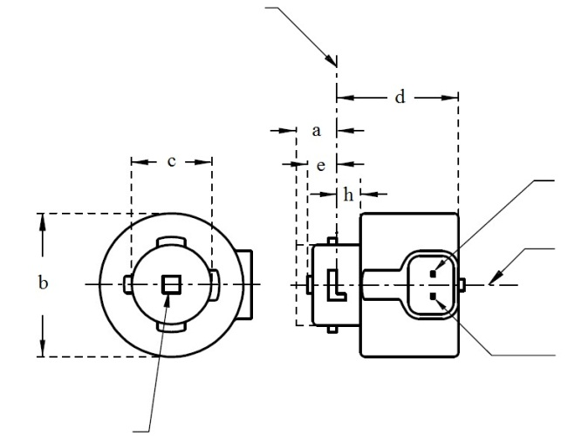
V+Reference plane ¹
Ground
Reference plane ¹
Light emitting area ³
Reference axis ²
⁴
Reference plane ¹
V+
Ground
⁴
Light emitting area ³
Reference axis ²
LR5A, LW5A, LY5A
LR5B, LW5B, LY5B
* Projection method:
For the notes see sheet L5/2
Categories LR5A, LR5B, LW5A, LW5B, LY5A, LY5B Sheet L5/2
Table 1
Essential dimensional, electrical and photometric characteristics of the LED light source

Dimensions |  |  |  |  |  | Production LED light sources | Standard LED light sources
a |  |  |  |  | mm | 6.0 max.
b |  |  |  |  | mm | c + 10.0 min.  38.0 max.
c |  |  |  |  | mm | 18.5 ± 0.1
d |  |  |  |  | mm | 28.0 max.
e |  |  |  |  | mm | 3.0 ± 0.30 | 3.0 ± 0.15
h |  |  |  |  | mm | 5.5 + 0.0/ – 0.1
Cap | LR5A, LR5B  LW5A, LW5B  LY5A, LY5B |  | PGJ18.5d-10  PGJ18.5d-28  PGJ18.5d-19 |  | in accordance with IEC Publication 60061 (sheet 7004-185-1)
Electrical and photometric characteristics
Rated values |  | Volts |  |  |  | 12
 |  | Watts |  |  | LR5A, LR5B | 3
 |  |  |  |  | LW5A, LW5B  LY5A, LY5B | 6
Objective Values⁸ |  | Watts  (at 13.5 V DC) |  |  | LR5A, LR5B | 3.5 max.
 |  |  |  |  | LW5A, LW5B | 8 max.
 |  |  |  | ¹⁰ | LY5A, LY5B
 |  | Luminous flux  (in lm at 13.5 V DC) |  | ⁵ | LR5A, LR5B | 120 ± 15% | 120 ± 5% ⁹
 |  |  |  | ⁶ | LW5A, LW5B | 350 ± 20% | 350 ± 10% ⁹
 |  |  |  | ^{7, 10} | LY5A, LY5B | 280 ± 20% | 280 ± 10% ⁹
 |  | Luminous flux  (in lm at 9 V DC) |  | ⁵ | LR5A, LR5B | 28 min.
 |  |  |  | ⁶ | LW5A, LW5B | 65 min.
 |  |  |  | ^{7, 10} | LY5A, LY5B | 55 min.

¹ The reference plane is the plane defined by the contact points of the cap-holder fit.
² The reference axis is perpendicular to the reference plane and passing through the centre of the bayonet core.
³ Light emitting area: to be checked by means of the box system in Figure 2
⁴ A minimum free air space of 5mm around the light source shall be respected for convection.
⁵ The emitted light shall be red.
⁶ The emitted light shall be white.
⁷ The emitted light shall be amber.
⁸ After continuous operation for 30 minutes at 23 ± 2.5° C.
⁹ The measured value shall be in between 100 per cent and 90 per cent of the value measured after 1 minute.
¹⁰ Operated in flashing mode for 30 minutes (frequency = 1.5 Hz, duty cycle 50 per cent ON, 50 per cent OFF). Measured in the ON-state of flashing mode after 30 minutes of operation.

Electrical characteristics

In case of LED light source failure (no light emitted) the max. electrical current draw, when operated between 12 V and 14 V, shall be less than 20 mA (open circuit condition).

Categories LR5A, LR5B, LW5A, LW5B, LY5A, LY5B Sheet L5/3

Screen projection requirements

The following test is intended to define the requirements for the apparent light emitting area of the LED light source and to determine whether the light emitting area is correctly positioned relative to the reference axis and reference plane in order to check compliance with the requirements.

The position of the light emitting area is checked by the box system defined in Figure 2, which is aligned to the planes C90 and C180 and shows the projection when viewing along direction γ=0º (C, γ as defined in Figure 3).

The proportion of the total luminous flux emitted into the viewing direction shall be as described in table 3.

Figure 2

Box definition of the light emitting area with dimensions as specified in table 2

f/3
Reference axis
perpendicular in the
centre of the light-
emitting area
f/3
f/3
f/3
f/3
f/3
A
B
B
B
B
C
C
C
C
f/2
f/2

Table 2

Dimensions of the box system in Figure 2

Dimensions in mm | f
LED light sources of normal production | 4.5
Standard LED light sources | 4.5

Categories LR5A, LR5B, LW5A, LW5B, LY5A, LY5B Sheet L5/4

Table 3

Proportion of the total luminous flux emitted into the viewing direction from the areas specified in figure 2

Category | Area(s) | LED light sources of normal production | Standard LED light sources
LR5A  LR5B | Each B individually | ≥ 10% | ≥ 15%
 | Each A, B individually | < 40% | < 30%
 | All B together | ≥ 60% | ≥ 65%
 | Each C individually | - | < 10%
 | All A, B and C together | ≥ 90% | ≥ 90%
LW5A  LW5B  LY5A  LY5B | Each A,B individually | ≥ 6% | ≥ 8%
 | Each A, B individually | < 40% | < 30%
 | All A, B together | ≥ 55% | ≥ 60%
 | Each C individually | < 15% | < 10%
 | All A, B and C together | ≥ 90% | ≥ 90%

Categories LR5A, LR5B, LW5A, LW5B, LY5A, LY5B Sheet L5/5
Normalized luminous intensity distribution
The following test is intended to determine the normalized luminous intensity distribution of the light source in an arbitrary plane containing the reference axis. The intersection of the reference axis and the parallel plane to the reference plane in distance e is used as the coordinate system origin.
The light source is mounted on a flat plate with the corresponding mounting lug features. The plate is mounted to the goniometer table by a bracket, so that the reference axis of the light source lines up with one of the rotating axis of the goniometer. The corresponding measurement set-up is described in Figure 3.
Luminous intensity data is recorded with a standard photo-goniometer. The measurement distance should be chosen appropriately, to make sure that the detector is located in the far field of the light distribution.
The measurements shall be performed in C-planes C₀ (C₁₈₀) and C₉₀ (C₂₇₀), which contain the reference axis of the light source. The test points for each plane for multiple polar angles γ are specified in Table 4.
The measured luminous intensity values, normalised to the measured luminous flux of the individual light source under test, shall be converted to normalised luminous intensity values of a 1,000 lm light source. The data shall comply with the tolerance band as defined in Table 4.

The drawings are intended only to illustrate the essential set-up for measurement of the LED light source.

Figure 3

Set-up to measure the luminous intensity distribution
Reference axis
Reference plane
Photo-Detector of Goniometer
C-plane definition
Viewing direction along reference axis
LR5A, LW5A, LY5A

Reference axis
Photo-Detector of Goniometer
Reference plane
C-plane definition
Viewing direction along reference axis
LR5B, LW5B, LY5B

Categories LR5A, LR5B, LW5A, LW5B, LY5A, LY5B Sheet L5/6

The light pattern as described in Table 4 shall be substantially uniform, i.e. in between two adjacent grid points the relative luminous intensity requirement is calculated by linear interpolation using the two adjacent grid points. In case of doubt this may be checked in addition to verification of the grid points given in Table 4.

Table 4
Test point values of normalized intensities for categories LR5A, LR5B, LW5A, LW5B, LY5A and LY5B

 | LED light sources of normal production |  | Standard LED light sources
Angle γ | Minimum Intensity  in cd /1000 lm | Maximum Intensity  in cd/1000 lm | Minimum Intensity  in cd /1000 lm | Maximum Intensity in cd /1000 lm
-90° | 0 | 70 | 0 | 65
-75° | 0 | 160 | 0 | 150
-60° | 85 | 245 | 105 | 220
-45° | 145 | 310 | 180 | 275
-30° | 170 | 380 | 220 | 335
-15° | 190 | 415 | 240 | 370
0° | 200 | 425 | 250 | 390
15° | 190 | 415 | 240 | 370
30° | 170 | 380 | 220 | 335
45° | 145 | 310 | 180 | 275
60° | 85 | 245 | 105 | 220
75° | 0 | 160 | 0 | 150
90° | 0 | 70 | 0 | 65
"

* Former title of the Agreement: Agreement Concerning the Adoption of Uniform Conditions of Approval and Reciprocal Recognition of Approval for Motor Vehicle Equipment and Parts, done at Geneva on 20 March 1958.

