|  |  |  |
| --- | --- | --- |
|  | E/ECE/324/Rev.2/Add.116/Rev.3/Amend.3−E/ECE/TRANS/505/Rev.2/Add.116/Rev.3/Amend.3 | |
|  |  | 9 November 2015 |

Agreement

Concerning the Adoption of Uniform Technical Prescriptions for Wheeled Vehicles, Equipment and Parts which can be Fitted and/or be Used on Wheeled Vehicles and the Conditions for Reciprocal Recognition of Approvals Granted on the Basis of these Prescriptions[1]*

(Revision 2, including the amendments which entered into force on 16 October 1995)

_________

Addendum 116 – Regulation No. 117

Revision 3 - Amendment 3

Supplement 7 to the 02 series of amendments – Date of entry into force: 8 October 2015

Uniform provisions concerning the approval of tyres with regard to rolling sound emissions and/or to adhesion on wet surfaces and/or to rolling resistance

This document is meant purely as documentation tool. The authentic and legal binding text is: ECE/TRANS/WP.29/2015/5.

**_________**



**UNITED NATIONS**

*Paragraph 2.16.*, amend to read:

"2.16. "*Standard reference test tyre (SRTT)*" means a tyre that is produced, controlled and stored in accordance with the ASTM (American Society for Testing and Materials) standards

(a) E1136-93 (2003) for the size P195/75R14

(b) F2872 (2011) for the size 225/75 R 16 C.

(c) F2871 (2011) for the size 245/70R19.5

(d) F2870 (2011) for the size 315/70R22.5"]

*Paragraph 6.4.1.1.*, amend to read:

"6.4.1.1. Class C1, C2 and C3 tyres

The minimum snow index value, as calculated in the procedure described in Annex 7 and compared with the SRTT shall be as follows:

|  |  |  |  |  |
| --- | --- | --- | --- | --- |
| *Class*  *of tyre* | *Snow grip index*  *(brake on snow method) (a)* | | *Snow grip index*  *(spin traction method) (b)* | *Snow grip index*  *(acceleration method) (c)* |
|  | *Ref. =  C1 – SRTT 14* | *Ref. =  C2 – SRTT 16C* | *Ref. =  C1 – SRTT 14* | *Ref. = C3N – SRTT 19.5*  *Ref. = C3W – SRTT 22.5* |
| C1 | 1.07 | No | 1.10 | No |
| C2 | No | 1.02 | 1.10 | No |
| C3 | No | No | No | 1.25 |

*(a)* See paragraph 3. of Annex 7 to this Regulation

*(b)* See paragraph 2. of Annex 7 to this Regulation

*(c)* See paragraph 4. of Annex 7 to this Regulation"

*Annex 1,*

*Paragraph 3.,* amend to read:

"3. "Tyre class" and "category of use" of the type of tyre: ……

3.1. Snow tyre for use in severe snow conditions (Yes/No)2

3.2. Traction tyre (Yes/No)2 "

*Insert a new paragraph 6.4.,* to read:

"6.4. Snow grip level of the representative tyre size, see paragraph 2.5. of Regulation No. 117, as per item 7. of the test report in the appendix to Annex 7:………………. (Snow grip index) using the brake on snow method2, spin traction method2 or acceleration method. 2"

*Annex 2,*

*Appendix 2,*

*Example 1*, correct to read:

" **a/3** **0212345 S2 0236378**"

*Example 3*, correct to read:

" **a/3** **0212345 S2 0236378**"

*Example 4*, correct to read:

" **a/3** **0212345 S2 0236378**"

*Appendix 3,*

*Example 1*, correct to read:

"« **a/3** **0236378 + 02S1**"

*Annex 4*, delete duplicated paragraphs 3.2. to 3.2.1.2.

*Annex 6,*

*Paragraph 3.5.*, amend to read:

"3.5. Duration and speed.

When the deceleration method is selected, the following requirements apply:

(a) The deceleration j shall be determined in differential dω/dt or discrete Δω/Δt form, where ω is angular velocity, t – time;

If the differential form dω/dt is used, then the recommendations of Appendix 5 to this annex are to be applied.

(b) …"

*Paragraph 5.1.5.*, amend to read:

"5.1.5. Deceleration method

…

|  |  |  |
| --- | --- | --- |
| IT |  | is the spindle, tyre and wheel inertia in rotation, in kilogram meter squared, |
| R**r** |  | is the tyre rolling radius, in metre, |
| ωT0 |  | is the tyre angular speed, unloaded tyre, in radian per second. |
| …" |  |  |

*Appendix 1,*

*Paragraph 7.*, delete the reference to the footnote 1 and footnote 1.

*Insert a new Appendix 5,* to read:

**"Annex 6 – Appendix 5**

Deceleration method: Measurements and data processing for deceleration value obtaining in differential form dω/dt.

1. Record dependency "distance-time" of rotating body decelerated from peripheral with a speed range such as 82 to 78 km/h or 62 to 58 km/h dependent on tyre class (Annex 6, paragraph 3.2., table 1) in a discrete form (figure 1) for a rotating body:



Where:

z is a number of body revolutions during deceleration;

tz is end time of revolution number z in seconds recorded with 6 digits after zero.

Figure 1



*Note 1*: The lower speed of the recording range may be reduced down to 60 km/h when test speed is 80 km/h and 40 km/h when the test speed is 60 km/h.

2. Approximate recorded dependency by continuous, monotonic, differentiable function:

2.1. Choose the value nearest to the maximum of z dividable by 4 and divide it into 4 equal parts with bounds: 0, z1(t1), z2(t2), z3(t3), z4(t4).

2.2. Work out the system for 4 equations each of the form:

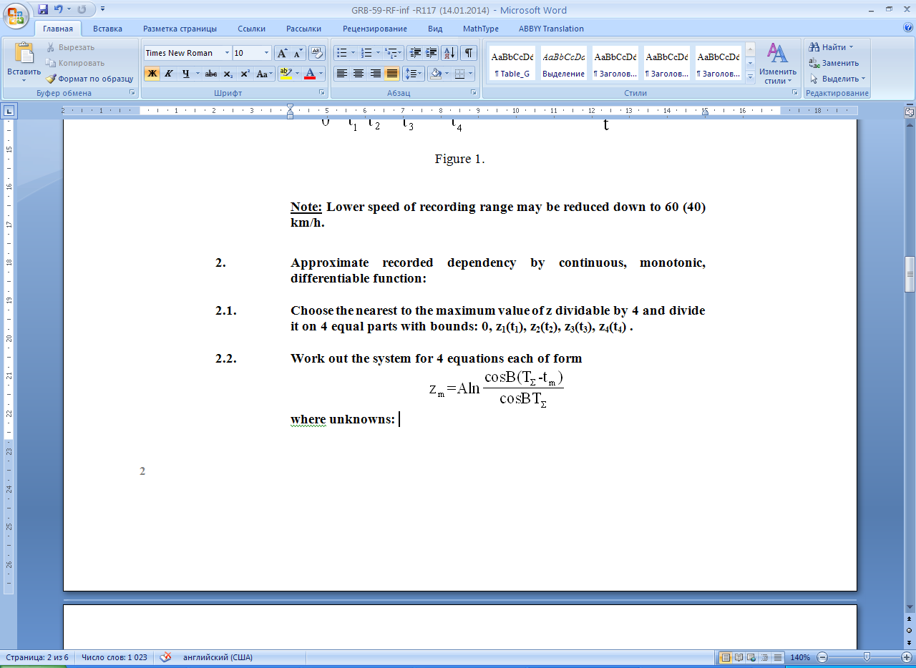

Where unknowns:

A is a dimensionless constant,

B is a constant in revolutions per second,

TΣ is a constant in seconds,

m is the number of bounds shown in figure 1.

Insert in these 4 equations the coordinates of 4-th bound above.

2.3. Take constants A, B and TΣ as the solution of the equation system of paragraph 2.2. above using iteration process and approximate measured data by formulae:

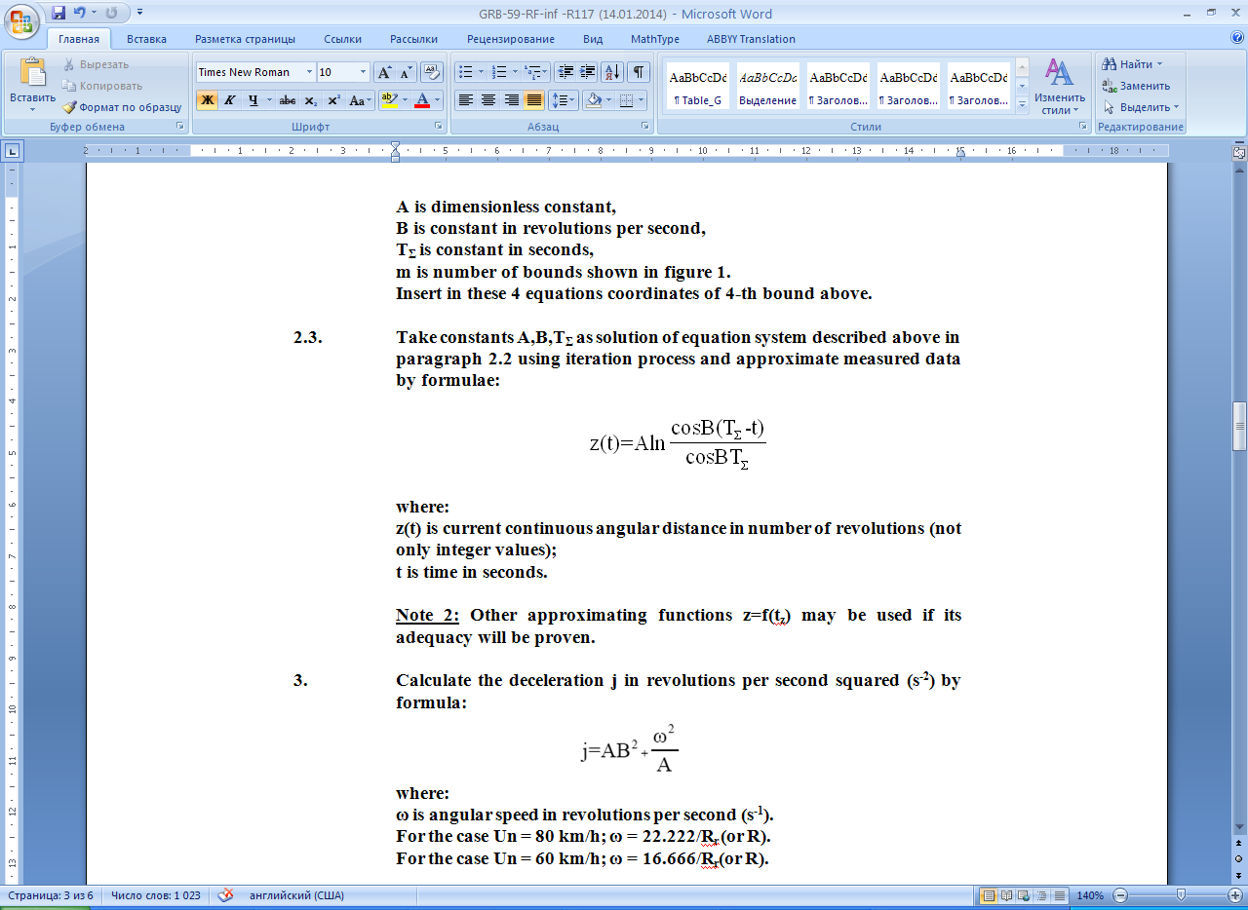

Where:

z(t) is the current continuous angular distance in number of revolutions (not only integer values);

t is time in seconds.

*Note 2*: Other approximating functions z = f(tz) may be used if their adequacy is proven.

3. Calculate the deceleration j in revolutions per second squared (s-2) by the formula:



Where:

ω is the angular speed in revolutions per second (s-1).

For the case Un = 80 km/h; ω = 22.222/Rr (or R).

For the case Un = 60 km/h; ω = 16.666/Rr (or R).

4. Estimate the quality of approximation of measured data and its accuracy by parameters:

4.1. Standard deviation in percentages:



4.2. Coefficient of determination



Where:



*Note 3*: The above calculations for this variant of the deceleration method for tyre rolling resistance measurement can be executed by the computer program "Deceleration Calculator" downloadable from the WP.29 website[2] as well as any software which allows the calculation of nonlinear regression."

*Annex 7,*

*Paragraph 3.1.4.*, amend to read:

"3.1.4. Load and pressure

3.1.4.1. For C1 tyres, the vehicle load …

…"

1. * Former title of the Agreement: Agreement Concerning the Adoption of Uniform Conditions of Approval and Reciprocal Recognition of Approval for Motor Vehicle Equipment and Parts, done at Geneva on 20 March 1958.
2. http://www.unece.org/trans/main/wp29/wp29wgs/wp29gen/deceleration_calculator.html.