E/ECE/324/Rev.1/Add.49/Rev.3/Amend.1−E/ECE/TRANS/505/Rev.1/Add.49/Rev.3/Amend.1
9 November 2015
Agreement
Concerning the Adoption of Uniform Technical Prescriptions for Wheeled Vehicles, Equipment and Parts which can be Fitted and/or be Used on Wheeled Vehicles and the Conditions for Reciprocal Recognition of Approvals Granted on the Basis of these Prescriptions*
(Revision 2, including the amendments which entered into force on 16 October 1995)
_________
Addendum 49 – Regulation No. 50
Revision 3 - Amendment 1
Supplement 17 to the original version of the Regulation – Date of entry into force: 8 October 2015
Uniform provisions concerning the approval of front position lamps, rear position lamps, stop lamps, direction indicators and rear-registration-plate illuminating devices for vehicles of category L
This document is meant purely as documentation tool. The authentic and legal binding text is:
ECE/TRANS/WP.29/2015/24 (as amended by paragraph 61 of the report ECE/TRANS/WP.29/1114).
_________
UNITED NATIONS

Paragraph 3.2.1., amend to read:
"3.2.1. Drawings, in triplicate, in sufficient detail to permit identification of the type of the device and showing the following:
(a) In what geometrical position(s) the device may be mounted on the vehicle; the axis of observation to be taken is the axis of reference in the tests (horizontal angle H = 0°, vertical angle V = 0°); and the point to be taken as the centre of reference in the said tests;
(b) The geometrical conditions of installation of the device(s) that meet(s) the requirements of paragraph 7.;
(c) In the case of an interdependent lamp system, the interdependent lamp or the combination of interdependent lamps that fulfil the requirements of paragraphs 6.7., 7.1. and of Annex 4 to this Regulation;
(d) The position intended for the approval number and the additional symbols in relation to the circle of the approval mark."
Paragraph 5.1., amend to read:
"5.1. If the two devices of a type of device which are submitted in pursuance of paragraph 3. above meet the requirements of this Regulation, approval shall be granted. All the devices of an interdependent lamp system shall be submitted for type approval by the same applicant."
Insert new paragraphs 5.5.6. and 5.5.7., to read:
"5.5.6. On devices with reduced light distribution in conformity to paragraph 2.3. in Annex 4 to this Regulation a vertical arrow starting from a horizontal segment and directed downwards."
5.5.7. On interdependent lamps, which may be used as part of an interdependent lamp system, the additional symbol shall be marked as follows:
(a) For a front position lamp "MAY";
(b) For a rear position lamp "MRY";
(c) For a stop lamp "MSY"."
Insert new paragraphs 6.6. and 6.7., to read:
"6.6. Only front and rear position lamps and stop lamps may be constructed as an interdependent lamp system.
6.7. An interdependent lamp system shall meet the requirements when all its interdependent lamps are operated together. However, if the interdependent lamp system providing the rear position lamp function is partly mounted on the fixed component and partly mounted on a movable component, the interdependent lamp(s) specified by the applicant shall meet the outboard geometric visibility, colorimetric and photometric requirement, at all fixed positions of the movable component(s). In this case, the inboard geometric visibility requirement is deemed to be satisfied if this (these) interdependent lamp(s) still conform to the photometric values prescribed in the field of light distribution for the approval of the device, at all fixed positions of the moveable component(s)."

Paragraphs 7. to 7.4.2., amend to read:
"In the reference axis, the intensity of the emitted light of each of the two devices shall be at least equal to the minimum values and not exceed the maximum values of the following table. In no direction, the maximum values indicated shall be exceeded.
 | Minimum luminous intensity in cd | Maximum luminous intensity in cd
7.1. Rear position lamps | 4 | 17
7.2. Front position lamps | 4 | 140
7.2.1. Front position lamps incorporated in a headlamp | 4 | 140
7.3. Stop-lamps | 40 | 260
7.4. Direction indicators | - | -
7.4.1. of the category 11 (see Annex 1) | 90 | 1,000
7.4.1.1. of the category 11a (see Annex 1) | 175 | 1,000
7.4.1.2. of the category 11b (see Annex 1) | 250 | 1,200
7.4.1.3. of the category 11c (see Annex 1) | 400 | 1,200
7.4.2. of the category 12 (see Annex 1) | 50 | 500
"
Paragraph 7.5.1., amend to read:
"7.5.1. In the case of a single lamp containing more than one light source:
(a) Except for a direction indicator lamp, the lamp shall comply with the minimum intensity required in the table of standard light distribution in space as shown in Annex 4 when any one light source has failed;
(b) All light sources which are connected in series are considered to be one light source"
Paragraphs 7.11. to 7.11.2., shall be deleted.
Annex 1,
Paragraphs 1. to 4., amend to read:
"1. Front position lamps
V = +15° / -10°
However, in the case where a device is intended to be installed with its H plane at a mounting height less than 750 mm above the ground, the angle of 10° below the horizontal may be reduced to 5°.
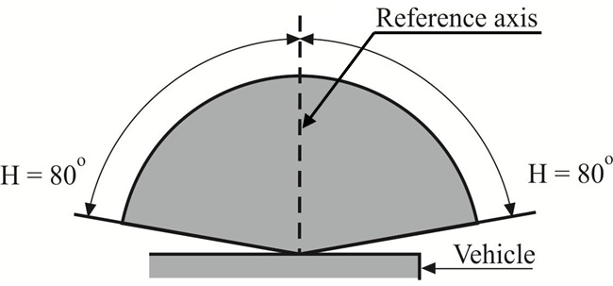
Front position lamps (for a pair of lamps)
V = +15° / -10°
However, in the case where a device is intended to be installed with its H plane at a mounting height less than 750 mm above the ground, the angle of 10° below the horizontal may be reduced to 5°.
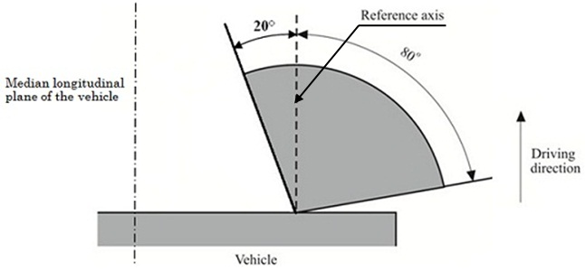
2. Rear position lamps
V = +15° / -10°
However, in the case where a device is intended to be installed with its H plane at a mounting height less than 750 mm above the ground, the angle of 10° below the horizontal may be reduced to 5°.

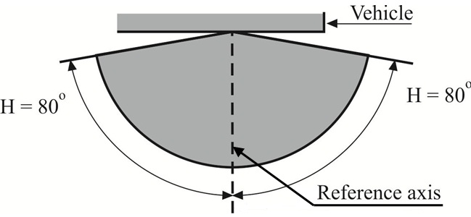
Rear position lamps (for a pair of lamps)
V = +15° / -10°
However, in the case where a device is intended to be installed with its H plane at a mounting height less than 750 mm above the ground, the angle of 10° below the horizontal may be reduced to 5°.
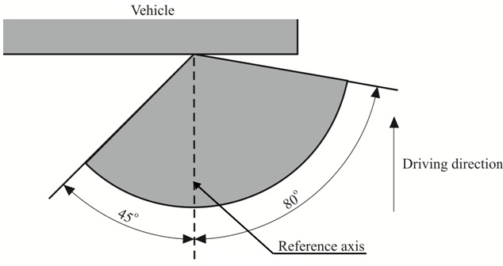
However, in the case where a device is intended to be installed with its H plane at a mounting height less than 750 mm above the ground, the inward angle of 45° may be reduced to 20° under the H plane.
3. Direction indicators of categories 11, 11a, 11b, 11c and 12
V = ±15°
However, in the case where a device is intended to be installed with its H plane at a mounting height less than 750 mm above the ground, the angle of 15° below the horizontal may be reduced to 5°.
Minimum horizontal angles of light distribution in space:
Categories 11, 11a, 11b and 11c: direction indicators for the front of the vehicle;
Category 11: for use at a distance not less than 75 mm from the passing-beam headlamp;
Category 11a: for use at a distance not less than 40 mm from the passing-beam headlamp;
Category 11b: for use at a distance not less than 20 mm from the passing-beam headlamp;
Category 11c: for use at a distance less than 20 mm from the passing-beam headlamp.
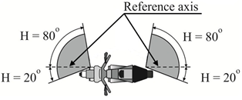
Reference axis

4. Stop lamps
V = + 15°/-10°
However, in the case where a device is intended to be installed with its H plane at a mounting height less than 750 mm above the ground, the angle of 10° below the horizontal may be reduced to 5°.
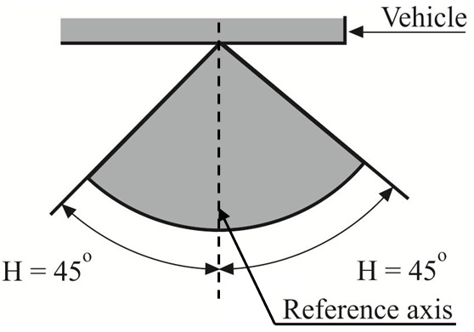
However, in the case of a pair of lamps, the inboard geometric visibility requirement is deemed to be satisfied if the lamps conform to the photometric values prescribed in the field of light distribution for the approval of the device."
Annex 2,
Item 9., amend to read:
"9. Concise description:³
…
Electronic light source control gear/variable intensity …
Only for limited mounting height of equal to or less than 750 mm above the ground: yes/no ²
Function(s) produced by an interdependent lamp forming part of an interdependent lamp system:
Front position lamp: yes/ no²
Rear position lamp: yes/ no²
Stop lamp: yes/ no ² "
Annex 3, amend to read:
"Annex 3
Examples of arrangement of the approval marks
(see paragraph 5.3. of this Regulation)

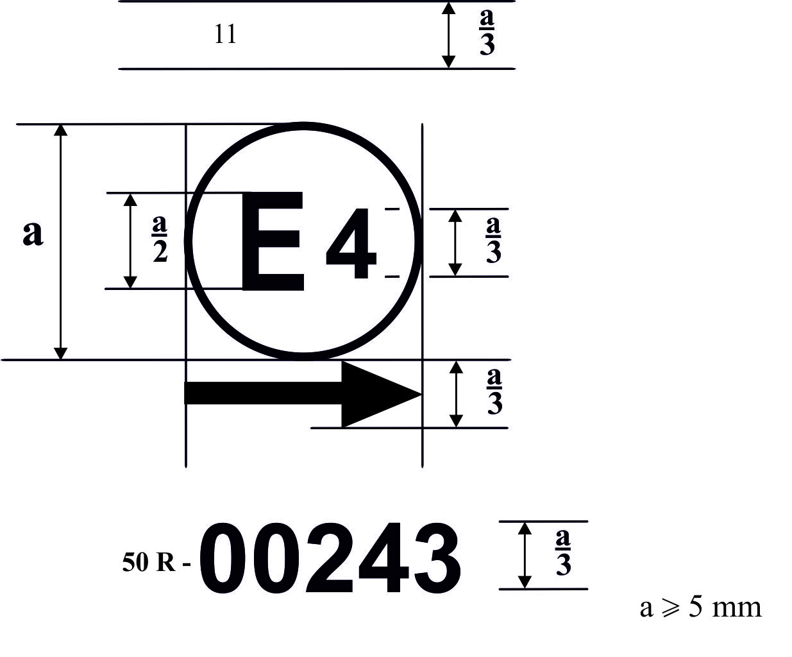
a/2
50R-00243
A device bearing the approval mark shown above is a direction indicator of the category 11 approved in the Netherlands (E 4) under the number 00243. The first two digits of the approval number indicate that the approval was granted in accordance with the requirements of Regulation No. 50 in its original form.
For a direction indicator, the arrow indicates that the luminous distribution is a symmetrical in a horizontal plane and that the photometric values required are satisfied up to an angle of 80° to the right, the device seen in the opposite sense of the light emitted.
The vertical arrow starting from a horizontal segment and directed downwards indicates a permissible mounting height of equal to or less than 750 mm from the ground for this device.
Light source modules

MD E3 17325

The light source module bearing the identification code shown above has been approved together with a lamp approved in Italy (E3) under approval number 17325.
Note: The approval number shall be placed close to the circle and either above or below the letter "E" or to the left of right of that letter the digits of the approval number shall be on the same side of the "E" and face in the same direction. The use of Roman numbers as approval numbers should be avoided so as to prevent any confusion with other symbols.
Interdependent lamps
"
Marking of an interdependent lamp comprising part of an interdependent lamp system providing:
A rear position lamp (MRY) approved as an interdependent lamp forming part of an interdependent lamp system in accordance with the requirements of Regulation No. 50;
A stop-lamp (MSY) approved as an interdependent lamp forming part of an interdependent lamp system in accordance with the requirements of Regulation No. 50.

Marking of an interdependent lamp comprising part of an interdependent lamp system providing:
A rear direction indicator lamp (category 12) approved in accordance with the requirements of Regulation No. 50;
A rear position lamp (MRY) approved as an interdependent lamp forming part of an interdependent lamp system in accordance with the requirements of Regulation No. 50;
A stop-lamp (MSY) approved as an interdependent lamp forming part of an interdependent lamp system in accordance with the requirements of Regulation No. 50.
12 MRY MSY
50 R-00113
E13
MRY MSY
50 R-00113
E13
Annex 4,
Insert a new paragraph 2.3., to read:
"2.3. However, in the case where a device is intended to be installed at a mounting height of equal to or less than 750 mm above the ground, the photometric intensity is verified only up to an angle of 5 degrees downwards."

* Former title of the Agreement: Agreement Concerning the Adoption of Uniform Conditions of Approval and Reciprocal Recognition of Approval for Motor Vehicle Equipment and Parts, done at Geneva on 20 March 1958.

