E/ECE/324/Rev.1/Add.33/Rev.2/Amend.2−E/ECE/TRANS/505/Rev.1/Add.33/Rev.2/Amend.2
22 June 2015
Agreement
Concerning the Adoption of Uniform Technical Prescriptions for Wheeled Vehicles, Equipment and Parts which can be Fitted and/or be Used on Wheeled Vehicles and the Conditions for Reciprocal Recognition of Approvals Granted on the Basis of these Prescriptions*
(Revision 2, including the amendments which entered into force on 16 October 1995)
_________
Addendum 33 – Regulation No. 34
Revision 2 - Amendment 2
03 series of amendments – Date of entry into force: 15 June 2015
Uniform provisions concerning the approval of vehicles with regard to the prevention of fire risks
This document is meant purely as documentation tool. The authentic and legal binding text is: ECE/TRANS/WP.29/2014/65 (as amended by paragraph 61 of the report ECE/TRANS/WP.29/1112).
_________
UNITED NATIONS

Paragraph 1.2., amend to read:
"1.2. Part II-1: At the request of the manufacturer, to the approval of vehicles of categories M, N and O approved to Part I or IV of this Regulation fitted with liquid fuel tank(s) with regard to the prevention of fire risks in the event of a frontal and/or lateral collision as well as to the approval of vehicles of categories M₁ and N₁, which are of a total permissible mass exceeding 2.8 tonnes, and categories M₂, M₃, N₂, N₃ and O, fitted with tank(s) for liquid fuel, which have been approved to Part I or IV of this Regulation with regard to the prevention of fire risks in the event of a rear collision.
Part II-2: To the approval of vehicles of categories M₁ and N₁, which are of a total permissible mass not exceeding 2.8 tonnes, fitted with liquid fuel tank(s) approved to Part I or IV of this Regulation with regard to the prevention of fire risks in the event of a rear collision."
Paragraph 3.1.4.2., amend to read:
"3.1.4.2. The number of this Regulation, followed by "RI", if the vehicle is approved pursuant to Part I of the Regulation, or by "RII-1" if the vehicle is approved pursuant to Parts I or IV and to Part II-1 of the Regulation, or by "RII-2" if the vehicle is approved pursuant to Parts I or IV and to Part II-2 of the Regulation, a dash and the approval number to the right of the circle prescribed in paragraph 3.1.4.1."
Insert new Part II-2, to read:
"Part II-2 - Approval of vehicle with regard to the prevention of fire risks in the event of rear collision
9.6. Definitions and test requirements
9.6.1. Paragraphs 7. to 8.2.2. of Part II-1 shall apply.
9.6.2. The vehicle test shall be performed according to the procedures described in Annex 4 of this Regulation.
9.6.3. After the collision test, the performance requirements of paragraphs 9.1. to 9.4. of Part II-1 shall be met."
Insert new paragraphs 17.7. to 17.11., to read:
"17.7. As from the official date of entry into force of the 03 series of amendments, no Contracting Party applying this Regulation shall refuse to grant or refuse to accept type approvals under this Regulation as amended by the 03 series of amendments.
17.8. As from 1 September 2018, Contracting Parties applying this Regulation shall grant type approvals only if the vehicle type to be approved meets the requirements of this Regulation as amended by the 03 series of amendments.
17.9. Contracting Parties applying this Regulation shall not refuse to grant extensions of type approvals for existing types which have been granted according to the preceding series of amendments to this Regulation.
17.10. Even after the date of entry into force of the 03 series of amendments to this Regulation, Contracting Parties applying this Regulation shall continue to accept type approvals to the preceding series of amendments to the Regulation which are not affected by the 03 series of amendments.17.11. Notwithstanding the transitional provisions above, Contracting Parties whose application of this Regulation comes into force after the date of entry into force of the most recent series of amendments are not obliged to accept type approvals which were granted in accordance with any of the preceding series of amendments to this Regulation."
Throughout Annex 2, replace the number "02" with "03".
Annex 2, Model B, amend to read:
"Model B
(See paragraph 3.1.5. of this Regulation)
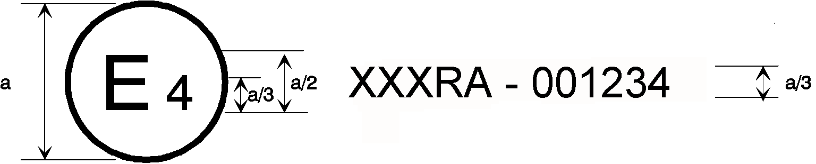
34RII-1 | 031234
33 | 001628

a = 8 mm minimum
The above approval mark affixed to a vehicle shows that the type concerned was approved in the Netherlands (E 4) pursuant to Regulations Nos. 34 Parts I or IV and II-1 and 33*. The approval numbers indicated that, at the date when the respective approvals were given, Regulation No. 34 included the 03 series of amendments and Regulation No. 33 was still in its original form.

34RII-2 | 031234
33 | 001628

The above approval mark affixed to a vehicle shows that the type concerned was approved in the Netherlands (E 4) pursuant to Regulations Nos. 34 Parts I or IV and II-2 and 33*. The approval numbers indicated that, at the date when the respective approvals were given, Regulation No. 34 included the 03 series of amendments and Regulation No. 33 was still in its original form."
Annex 4
Paragraph 2.1., amend to read:
"2.1. Testing ground
The test area shall be large enough to accommodate the impactor (striker) propulsion system and to permit after-collision displacement of the vehicle struck and installation of the test equipment. The part in which vehicle collision and displacement occur shall be horizontal, flat and uncontaminated, and representative of a normal, dry, uncontaminated road surface."
Paragraph 2.2.2., amend to read:
"2.2.2. The impacting surface shall be flat, not less than 2,500 mm wide, and 800 mm high, and its edges shall be rounded to a radius of curvature of between 40 and 50 mm. It shall be clad with a layer of plywood 20 +/- 2 mm thick, in good condition."
Paragraph 2.4.2., amend to read:
"2.4.2. The velocity of collision shall be between 48 km/h and 52 km/h."

* Former title of the Agreement: Agreement Concerning the Adoption of Uniform Conditions of Approval and Reciprocal Recognition of Approval for Motor Vehicle Equipment and Parts, done at Geneva on 20 March 1958.

