In the context of software update regulation and its first referencing in the ALKS regulation, GRVA agreed to let the opportunity to the OEM to use an alternative software identification system instead of the proposed RXSWIN format. In this case of application, the proposal below targets to introduce the same level of specifications whatever the identification solution is chosen for the approval process.

On this basis, France propose to open the discussion and to introduce such additional details to clarify technical application for Type Approval Authorities and Technical Services in case of alternative software identification system is chosen.

The additions and deletions are shown in bold text to facilitate identification of these proposed changes within the existing Regulations.

Suggestion for amendments of UN Regulation No. [156] (Software update and software updates management system) & UN Regulation No. [157] (Automated Lane Keeping System)

I. Proposal on UN Regulation No. [156]

Add a new paragraph 2.12., to read :
« 2.12 "Alternative software identification system » means a dedicated system, defined by the vehicle manufacturer, identifying the version and representing information about the type approval relevant software of the Electronic Control System contributing to the regulated type approval relevant characteristics of the vehicle.»

Paragraph 7.1.1.3., amend to read:
« 7.1.1.3. A process whereby, for a vehicle type that has an RXSWIN or an alternative software identification system, information regarding the RXSWIN or the alternative software identification system of the vehicle type before and after an update can be accessed and updated. This shall include the ability to update information regarding the software versions and their integrity validation data of all relevant software for each RXSWIN or an alternative software identification system. »

Paragraph 7.1.1.4., amend to read:
« 7.1.1.4. A process whereby, for a vehicle type that has an RXSWIN or an alternative software identification system, the vehicle manufacturer can verify that the software version(s) present on a component of a type approved system are consistent with those defined by the relevant RXSWIN or an alternative software identification system; »

Paragraph 7.1.2.3., amend to read:
« 7.1.2.3. For every RXSWIN or alternative software identification system, there shall be an auditable register describing all the software relevant to the RXSWIN or to the alternative software identification system of the vehicle type before and after an update. This shall include information of the software versions and their integrity validation data for all relevant software for each RXSWIN or an alternative software identification system.»

Add a new paragraph 7.2.3., to read :
« 7.1.2.3. If the manufacturer implements an alternative software identification system, the manufacturer shall demonstrate that the requirements of paragraphs 7.2.1.2.1. to 7.2.1.2.3. are met. »

II. Proposal on UN Regulation No. [157]

Add a new paragraph 9.3.3., to read :
« 9.3.3. If the manufacturer implements an alternative software identification system, the manufacturer shall demonstrate that the requirements of paragraphs 9.3.2.1. and 9.3.2.3. are met. »

Add a new paragraph 9.3.3.1., to read :
« 9.3.3.1. The vehicle manufacturer shall provide the following information in the communication form of this Regulation :
- The reference of the alternative software identification system
- The process to access software versions identification related data »

Renumber current paragraph 9.3.3. to paragraph 9.3.4.

Annex 1, add a new paragraph 20., to read :
« 20. Alternative software identification system :
20.1. Reference of the alternative software identification system
20.2 The process to access software versions identification related data
20.2. If applicable, list the relevant parameters that will allow the identification of those vehicles that can be updated with the software represented by the alternative software identification system under item 20.1. »

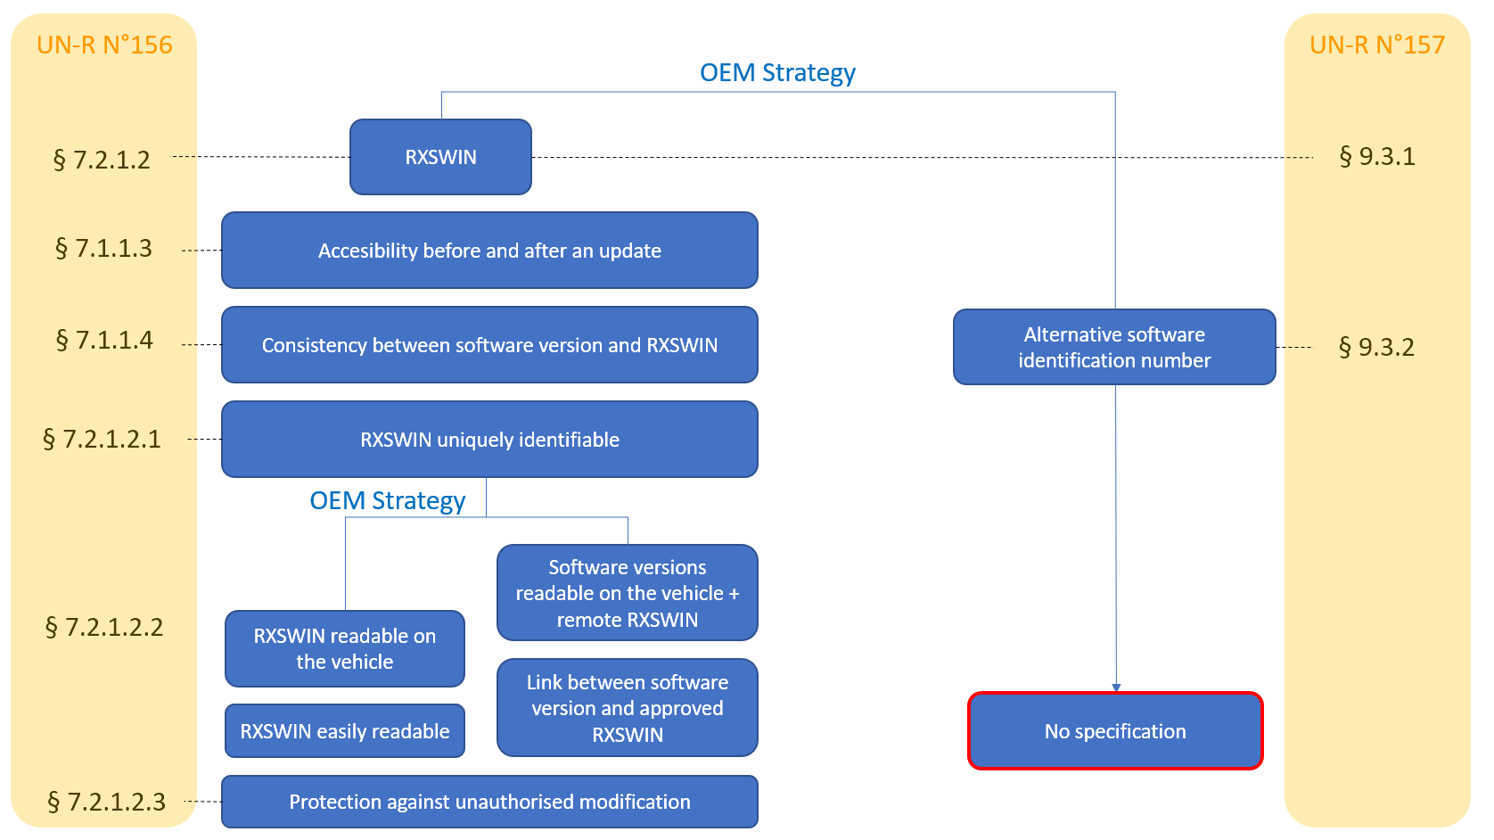
II. Justification

______________

