Proposal for amendments to ECE/TRANS/WP.29/GRVA/2020/22
This document aims to provide an overview of all working and informal documents aiming to amend UN-R79 ACSF of category C.

Black 03 series of amendments of UN-R79 (incl. amendments by FR already in force)
Blue Amendments for 2-Step HMI and automatic deactivation already adopted by GRVA but not yet in force.
Red Amendments proposed by OICA/CLEPA in GRVA-05-30 /GRVA-2020-22
Blue Amendments proposed by AVERE in GRVA-07-xx
Green Amendments proposed by CITA in GRVA-05-50/GRVA-2020-23
Purple Amendments proposed by Germany in GRVA-05-53/GRVA-2020-24

Proposed amendments to GRVA-2020-22 are marked in bold for new text, and strikethrough for deleted text.
Proposed amendments to GRVA-07-xx (AVERE) are marked in bold for new text, and strikethrough for deleted text.

- Proposal
5.6.4. Special Provisions for ACSF of Category C
Vehicles equipped with an ACSF system of Category C shall fulfil the following requirements.
5.6.4.1. General
5.6.4.1.1. A vehicle equipped with an ACSF of Category C shall also be equipped with an ACSF of Category B1 complying with the requirements of this Regulation.
5.6.4.1.2. When the ACSF of Category C is activated (standby) the ACSF of Category B1 shall aim to center the vehicle in the lane, unless a different position in lane is deemed reasonable due to the situation or resulting from driver input (e.g. when another vehicle is driving close beside).
This shall be demonstrated by the vehicle manufacturer to the Technical Service during type approval.
5.6.4.2. Activation/deactivation of the ACSF of Category C system
5.6.4.2.1. The default status of the system shall be off at the initiation of each new engine start/run cycle.
This requirement does not apply when a new engine start/run cycle is performed automatically, e.g. the operation of a stop/start system.
5.6.4.2.2. The vehicle shall be equipped with a means for the driver to activate (standby mode) and deactivate (off mode) the system. The same means as for an ACSF of Category B1 may be used.
5.6.4.2.3. The system shall only be activated (standby mode) after a deliberate action by the driver.
Activation by the driver shall only be possible on roads where pedestrians and cyclists are prohibited and which, by design, are equipped with a physical separation that divides the traffic moving in opposite directions and which have at least two lanes in the direction the vehicles are driving. The confirmation that the road is permitting the activation of an ACSF category C These conditions shall be based on ensured by the use of at least two independent means.
In the case of a transition from a road type with a classification permitting an ACSF of Category C, to a type of road where an ACSF of Category C is not permitted, the system shall be deactivated automatically (off mode), unless a temporarily missing second lane in driving direction is the only condition not fulfilled from the above (e.g. a connector between two highways).
5.6.4.2.4. It shall be possible to deactivate the system (off mode) at any time by a single action of the driver. Following this action, the system shall only be able to be reactivated (standby mode) by a deliberate action of the driver.
5.6.4.2.5. Notwithstanding the requirements above it shall be possible to perform the corresponding tests in Annex 8 of this Regulation on a test track.
5.6.4.3. Overriding
A steering input by the driver shall override the steering action of the system. The steering control effort necessary to override the directional control provided by the system shall not exceed 50 N.
The system may remain activated (standby mode) (active mode) provided that priority is given to the driver during the overriding period.
5.6.4.4. Lateral acceleration
The lateral acceleration induced by the system during the lane change manoeuvre:
(a) Shall not exceed 1 m/s² in addition to the lateral acceleration generated by the lane curvature, and
(b) Shall not cause the total vehicle lateral acceleration to exceed the maximum values indicated in tables of paragraph 5.6.2.1.3. above.
The moving average over half a second of the lateral jerk generated by the system shall not exceed 5 m/s³.
5.6.4.5. Human Machine Interface (HMI)
5.6.4.5.1. Unless otherwise specified, the optical signals identified in paragraph 5.6.4.5. shall be easily distinguishable from each other (e.g. different symbol, colour, blinking, text).
5.6.4.5.2. When the system is in standby mode (i.e. ready to intervene), an optical signal shall be provided to the driver.
5.6.4.5.2.1. When the initiation of the lane change procedure is actually anticipated to be possible, this may be indicated to the driver.
5.6.4.5.3. When the lane change procedure is ongoing an optical signal shall be provided to the driver.
5.6.4.5.4. When the lane change procedure is suppressed, in accordance with paragraph 5.6.4.6.8., the system shall clearly inform the driver about this system status by an optical warning signal and additionally by an acoustic or haptic warning signal. In case the suppression is initiated by the driver or in case of automatic suppression while the lane change procedure hasn’t commenced for more than 1s, an optical warning is sufficient.
5.6.4.5.5. A system failure shall be signalled immediately to the driver by an optical warning signal. However, when the system is manually deactivated by the driver, the indication of failure mode may be suppressed.
If a system failure occurs during a lane change manoeuvre, the failure shall be signalled to the driver by an optical, and an acoustic or haptic warning.
5.6.4.5.6. The system shall provide a means of detecting that the driver is holding the steering control and shall warn the driver in accordance with the warning strategy below:
If, after a period of no longer than 3s after the initiation of the lane change procedure and before the start of the lane change manoeuvre, the driver is not holding the steering control, an optical warning signal shall be provided. This signal shall be the same as the signal specified in paragraph 5.6.2.2.5. above.
The warning signal shall be active until the driver is holding the steering control, or until the system is deactivated, either manually or automatically according to 5.6.4.6.8.
5.6.4.6. Lane Change Procedure
5.6.4.6.1. The initiation of a lane change procedure of an ACSF of Category C shall only be possible if an ACSF of Category B1 is already active.
5.6.4.6.2. The lane change procedure requires, and shall start immediately after, a manual activation by the driver of the direction indicator to the intended side for the lane change.
5.6.4.6.3. When the lane change procedure starts, the ACSF of Category B1 shall be suspended and the ACSF of Category C shall carry on the lane keeping function of ACSF of category B1, until the lane change manoeuvre starts.
5.6.4.6.4. The lateral movement of the vehicle towards the intended lane shall not start earlier than 1 second after the start of the lane change procedure. Additionally, the lateral movement to approach the lane marking and the lateral movement necessary to complete the lane change manoeuvre, shall be completed as one continuous movement.
The lane change manoeuvre shall be initiated either automatically or by a second deliberate action of the driver. A vehicle shall not be equipped with both these means of initiation.
5.6.4.6.4.1. Automatic initiation of the lane change manoeuvre
In case of an automatic initiation the lane change manoeuvre shall commence between 3.0 seconds and 7.0 5.0 seconds after the manual activation of the procedure as described in paragraph 5.6.4.6.2. and shown in the Figure below. The manoeuvre shall commence at the earliest opportunity without undue delay when the situation is not deemed critical as defined in 5.6.4.7.

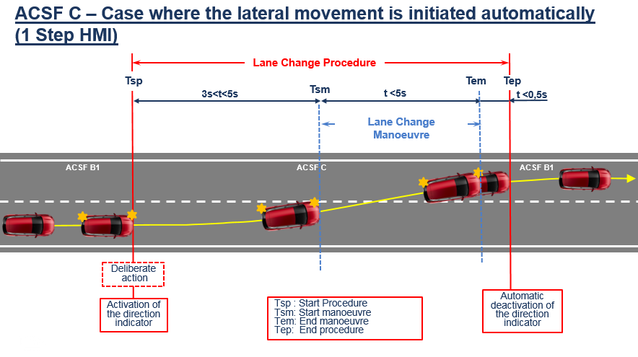
5.6.4.6.4.2. Initiation of the lane change manoeuvre by a second deliberate action
In case of an initiation by a second deliberate action the lane change manoeuvre shall commence between 3.0 and 7.0 seconds after the manual activation of the procedure as described in paragraph 5.6.4.6.2.
Additionally, the lane change manoeuvre shall commence at the latest 3.0 seconds after the second deliberate action as shown in the Figure below.
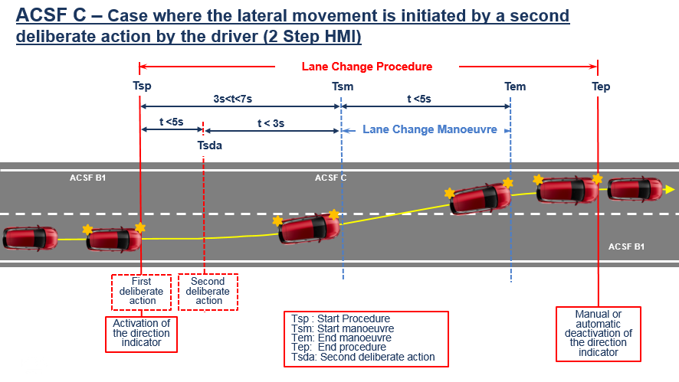
The control to operate the second deliberate action shall be located in the steering control area."

5.6.4.6.5. The lane change manoeuvre shall be completed in less than:
(a) 5 seconds for M₁, N₁ vehicle categories;
(b) 10 seconds for M₂, M₃, N₂, N₃ vehicle categories.
5.6.4.6.6. Once the lane change manoeuvre has completed, ACSF of Category B1 lane keeping function shall resume automatically in a timely manner.
5.6.4.6.7. The direction indicator shall remain active throughout the whole period of the lane change manoeuvre and shall be automatically deactivated by the system no later than 0.5 seconds after the resumption of ACSF of Category B1 lane keeping function as described in paragraph 5.6.4.6.6. above. Automatic deactivation by the system of the direction indicator is required only if the lane change manoeuvre is initiated automatically, and if the direction indicator control is not fully engaged (latched position) during the lane change manoeuvre.

5.6.4.6.8. Suppression of the Lane Change Procedure
5.6.4.6.8.1. The lane change procedure shall be suppressed automatically by the system when at least one of the following situations occurs before or when the lane change manoeuvre has starteds:
(a) The system detects a critical situation (as defined in paragraph 5.6.4.7.) later than 1s after the initiation of the lane change procedure but before the start of the lane change manoeuvre;
A critical situation (as defined in paragraph 5.6.4.7.) has been detected by the system when the lane change manoeuvre starts;
(b) The system is overridden or switched off by the driver;
(c) The system reaches its boundaries (e.g. lane markings are no longer detected);
(d) The system has detected that the driver is not holding the steering control at the start of when the lane change manoeuvre is about to starts;
(e) The direction indicator lamps are manually deactivated by the driver;
(f) Following the deliberate action of the driver to start the procedure described in paragraph 5.6.4.6.2., the lane change manoeuvre has not commenced:
(i) At the latest after 7.0 5.0 seconds, in the case of an automatic initiation,
(ii) At the latest after 7.0 seconds, in the case of an initiation by a second deliberate action,
(iii) At the latest after 3.0 seconds after the second deliberate action, in the case of an initiation by a second deliberate action,
whatever is appropriate
(g) The system, with an initiation of the lane change manoeuvre by a second deliberate action, has not detected the second deliberate action at the latest 5.0 7.0 5.0 seconds after the start of the lane change procedure.
(h) The lateral movement described in paragraph 5.6.4.6.4. is not continuous.
5.6.4.6.8.2. Manual deactivation of the lane change procedure, using the manual control of the direction indicator, shall be possible for the driver at any time.
5.6.4.7. Critical situation
A situation is deemed to be critical when, at the time a lane change manoeuvre starts, an approaching vehicle in the target lane would have to decelerate at a higher level than 3m/s², 0.4 seconds after the lane change manoeuvre has started, to ensure the distance between the two vehicles is never less than that which the lane change vehicle travels in 1 second.
The resulting critical distance at the start of the lane change manoeuvre shall be calculated using the following formula:
S_{critical} = (v_{rear} - v_{ACSF}) * t_{B} + (v_{rear} - v_{ACSF})² / (2 * a) + v_{ACSF} * t_{G}
Where:
v_{rear} is The actual speed of the approaching vehicle or 130 km/h whatever value is lower
v_{ACSF} is The actual speed of the ACSF vehicle
a = 3 m/s² (Deceleration of the approaching vehicle)
t_{B} = 0.4 s (Time after the start of the lane change manoeuvre at which the deceleration of the approaching vehicle starts)
t_{G} = 1 s (Remaining gap of the vehicles after the deceleration of the approaching vehicle).
If the manufacturer considers additional influencing parameters when identifying the critical situation (e.g. acceleration of the ego-vehicle and/or deceleration of the approaching vehicle), the formula may be modified and the modification shall be declared to and assessed by the Technical Service. It shall remain ensured that an approaching vehicle would not have to decelerate at a higher level than 3m/s², 0.4 seconds after the lane change manoeuvre has started, to ensure the distance between the two vehicles is never less than that which the lane change vehicle travels in 1 second. The modified formula used by the manufacturer to identify the critical situation shall be part of the type approval documentation.
A tolerance of 10%, by which the distance between the two vehicles at the time the lane change manoeuvre starts is permitted to be lower than the critical distance resulting from the formula above shall be permitted.
5.6.4.8. Minimum distance and minimum operation speed
5.6.4.8.1. The ACSF of Category C shall be able to detect vehicles approaching from the rear in an adjacent lane up to a distance S_{rear} as specified below:
The minimum distance S_{rear} shall be declared by the vehicle manufacturer. The declared value shall not be less than 55 m.
The declared distance shall be tested according to the relevant test in Annex 8 using a two-wheeled motor vehicle of Category L₃¹ as the approaching vehicle.
The minimum operation speed V_{smin} , down to which the ACSF of Category C is permitted to perform a lane change manoeuvre, shall be calculated with minimum distance S_{rear} using the following formula:
$$V_{Smin}= a*\left(t_{B}-t_{G}\right)+v_{app}-\sqrt{a^{2}*{(t_{B}-t_{G})}^{2}- 2*a*(v_{app}*t_{G}-S_{rear})}$$
Where:
S_{rear} is The minimum distance declared by the manufacturer in [m];
V_{app} = 36.1 m/s (The speed of the approaching vehicle is
130 km/h i.e. 36.1 m/s);
a = 3 m/s² (Deceleration of the approaching vehicle);
t_{B} = 0.4 s (Time after the start of the manoeuvre at which the deceleration of the approaching vehicle starts);
t_{G} = 1 s (Remaining gap of the vehicles after the deceleration of the approaching vehicle);
V_{smin} in [m/s] is The resulting minimum activation speed of the ACSF of Category C.
If the vehicle is operated in a country with a general maximum speed limit below 130 km/h, this speed limit may be used as an alternative for V_{app} in the above formula to calculate the minimum operation speed V_{smin}. In this case the vehicle shall be equipped with a means to detect the country of the operation and shall have information available on the general maximum speed limit of this country.
Notwithstanding the requirements above in this paragraph, the ACSF of Category C is permitted to perform a lane change manoeuvre at speeds lower than the calculated V_{smin} provided that the following conditions are met:
(a) The system has detected another vehicle in the adjacent lane into which the lane change is planned at a distance lower than S_{rear} ; and
(b) The situation is not deemed to be critical according to paragraph 5.6.4.7. (e.g. at low speed differences and V_{app}< 130 km/h);
(c) The declared value S_{rear} is greater than the calculated value S_{critical} from paragraph 5.6.4.7. above.
5.6.4.8.2. The vehicle system detection area on ground level shall be at minimum as shown in the figure below.
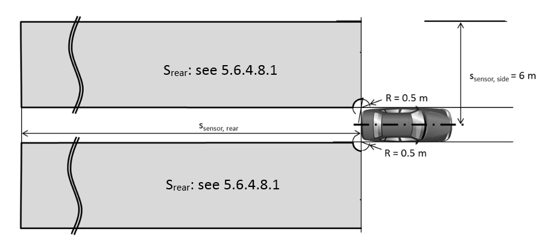
5.6.4.8.3. After each vehicle new engine start/run cycle (other than when performed automatically, e.g. the operation of a stop/start systems), the ACSF of Category C function shall be prevented from performing a lane change manoeuvre until the system has detected, at least once, an moving object at a distance greater than the minimum distance S_{rear} declared by the manufacturer in paragraph 5.6.4.8.1. above.
If, in addition to moving objects, the system uses the detection of stationary objects, this shall be demonstrated by the manufacturer to and assessed by the Technical Service.
5.6.4.8.4. The ACSF of Category C shall be able to detect blindness of the sensor (e.g. due to accumulation of dirt, ice or snow). The ACSF of Category C shall be prevented, upon detection of blindness, from performing the lane change manoeuvre. The status of the system shall be signalled to the driver no later than on the initiation of the lane change procedure. The same warning as the one specified in paragraph 5.6.4.5.5. (system failure warning) may be used.
5.6.4.9. System information data
5.6.4.9.1. The following data shall be provided, together with the documentation package required in Annex 6 of this Regulation, to the Technical Service at the time of type approval.
5.6.4.9.1.1. The conditions under which the system can be activated and the boundaries for operation (boundary conditions). The vehicle manufacturer shall provide values for V_{smax} , V_{smin} and ay_{smax} for every speed range as mentioned in the table of paragraph 5.6.2.1.3. of this Regulation.
5.6.4.9.1.2. Information about how the system detects that the driver is holding the steering control.
5.6.4.9.1.3. The means to override and to suppress or cancel.
5.6.4.9.1.4. Information about how the failure warning signal status and the confirmation of the valid software version related ACSF performance can be checked via the use of an electronic communication interface.
5.6.4.9.1.5. Documentation about which system software version related ACSF performance is valid. This documentation shall be updated whenever a software version was amended. ⁶
5.6.4.9.1.6. Information on the sensor range over lifetime. The sensor range shall be specified in such way that any influence on deterioration of the sensor shall not affect the fulfilment of paragraphs 5.6.4.8.3. and 5.6.4.8.4. of this Regulation.
5.6.4.10. The vehicle with ACSF of Category C shall be tested in accordance with relevant vehicle test(s) specified in Annex 8 to this Regulation. For driving situations not covered by the tests of Annex 8, the safe operation of the ACSF shall be demonstrated by the vehicle manufacturer on the base of Annex 6 of this Regulation.

Annex 8
[…]
2. Testing conditions
The tests shall be performed on a flat, dry asphalt or concrete surface affording good adhesion. The ambient temperature shall be between 0 °C and 45 °C.
At the request of the manufacturer and with the agreement of the Technical Service, tests may be performed under deviating conditions, if the correct function of the system under the prescribed test conditions can be assumed.
[…]
3.5. Tests for ACSF of Category C Systems
If not specified otherwise all vehicle test speeds shall be based on V_{app} = 130 km/h.
If not specified otherwise, the approaching vehicle shall be a type-approved high volume series production vehicle.
The vehicle manufacturer shall demonstrate to the satisfaction of the Technical Service that the requirements are fulfilled for the whole speed range. This may be achieved on the basis of appropriate documentation appended to the test report.
3.5.1. Lane change functional test
3.5.1.1. The test vehicle shall be driven in a lane of a straight test track, which has at least two lanes in the same direction of travel, with road markings on each side of the lanes. The vehicle speed shall be: V_{smin} + 10km/h.
The ACSF of Category C shall be activated (standby mode) and, unless the system is already enabled according to paragraph 5.6.4.8.3., another vehicle shall approach from the rear in order to enable the system as specified in paragraph 5.6.4.8.3. above.
The approaching vehicle shall then pass the vehicle under test entirely.
A lane change into the adjacent lane shall then be initiated by the driver.
The lateral acceleration and the lateral jerk shall be recorded during the test.
3.5.1.2. The requirements of the test are fulfilled if:
(a) The lateral movement towards the marking does not start earlier than 1 second after the lane change procedure was initiated,
(b) The lateral movement to approach the lane marking and the lateral movement necessary to complete the lane change manoeuvre are completed as one continuous movement,
(c) The recorded lateral acceleration does not exceed 1 m/s²,
(d) The moving average over half a second of the lateral jerk does not exceed 5 m/s³,
(e) The measured time between the start of the lane change procedure and the start of the lane change manoeuvre is not less than 3.0 s and not more than 7.0 seconds.:
(i) 5.0 seconds in the case of an automatic initiation,
(ii) 7.0 seconds in the case of an initiation by a second deliberate action
whatever is appropriate.
(f) For systems with an initiation of the lane change manoeuvre by a second deliberate action,
- The measured time between the start of the lane change procedure and the second deliberate action is not more than 5.0 7.0 5.0 seconds, and
- The measured time between the second deliberate action and the start of the lane change manoeuvre is not more than 3.0 seconds.
(g) The system provides information to the driver to indicate that the lane change procedure is ongoing,
(h) The lane change manoeuver is completed in less than 5 seconds for M₁, N₁ vehicle categories and less than 10 s for M₂, M₃, N₂, N₃ vehicle categories,
(i) ACSF of Category B1 automatically resumes after the lane change manoeuvre is completed, and
(j) The direction indicator is deactivated not before the end of the lane change manoeuvre and no later than 0.5 seconds after ACSF of Category B1 has resumed, in case the lateral movement is initiated automatically and the direction indicator control was not fully engaged (latched position) during the lane change manoeuvre.
3.5.1.3. The test according to paragraph 3.5.1.1. shall be repeated with a lane change in the opposite direction.
3.5.2. Minimum activation speed test V_{smin.}
3.5.2.1. Minimum activation speed test V_{smin} based on V_{app} = 130 km/h.
The test vehicle shall be driven within a lane of a straight track which has at least two lanes in the same direction of travel and road markings on each side of the lane.
The vehicle speed shall be: V_{smin} - 10km/h.
The ACSF of Category C shall be activated (standby mode) and, unless the system is already enabled according to paragraph 5.6.4.8.3., another vehicle shall approach from the rear in order to enable the system as specified in paragraph 5.6.4.8.3. above.
The approaching vehicle shall then pass the vehicle under test entirely.
A lane change procedure shall then be initiated by the driver.
The requirements of the test are fulfilled if the lane change manoeuvre is not performed.
3.5.2.2. Minimum activation speed test V_{smin} based on country specific general maximum speed limit below 130 km/h.
In case V_{smin} is calculated, based on a country specific general maximum speed limit instead of V_{app} =130 km/h as specified in paragraph 5.6.4.8.1., the tests described below shall be performed. For this purpose it is allowed to simulate the country of operation in agreement between the vehicle manufacturer and the Technical Service.
3.5.2.2.1. The test vehicle shall be driven within a lane of a straight track which has at least two lanes in the same direction of travel and road markings on each side of the lane.
The vehicle speed shall be: V_{smin} - 10km/h.
The ACSF of Category C shall be activated (standby mode) and, unless the system is already enabled according to paragraph 5.6.4.8.3., another vehicle shall approach from the rear in order to enable the system as specified in paragraph 5.6.4.8.3. above.
The approaching vehicle shall then pass the vehicle under test entirely.
A lane change procedure shall then be initiated by the driver.
The requirements of the test are fulfilled if the lane change manoeuvre is not performed.
3.5.2.2.2. The test vehicle shall be driven within a lane of a straight track which has at least two lanes in the same direction of travel and road markings oneach side of the lane.
The vehicle speed shall be: V_{smin} + 10km/h.
The ACSF of Category C shall be activated (standby mode) and, unless the system is already enabled according to paragraph 5.6.4.8.3., another vehicle shall approach from the rear in order to enable the system as specified in paragraph 5.6.4.8.3. above.
The approaching vehicle shall then pass the vehicle under test entirely.
A lane change procedure shall then be initiated by the driver.
The requirements of the test are fulfilled if the lane change manoeuvre is performed.
3.5.2.2.3. The manufacturer shall demonstrate to the satisfaction of the Technical Service that the vehicle is able to detect the country of operation and that the general maximum speed limit of this country is known.
3.5.3. Overriding test
3.5.3.1. The test vehicle shall be driven in a lane of a straight test track, which has at least two lanes in the same direction of travel, with road markings on each side of the lanes.
The vehicle speed shall be: V_{smin} + 10km/h.
The ACSF of Category C shall be activated (standby mode) and, unless the system is already enabled according to paragraph 5.6.4.8.3., another vehicle shall approach from the rear in order to enable the system as specified in paragraph 5.6.4.8.3. above.
The approaching vehicle shall then pass the vehicle under test entirely.
A lane change into the adjacent lane shall then be initiated by the driver.
The steering control shall be firmly controlled by the driver to maintain the vehicle in the straight direction.
The force applied by the driver on the steering control during the overriding manoeuver shall be recorded.
3.5.3.2. The test requirements are fulfilled if the measured overriding force does not exceed 50 N, as specified in paragraph 5.6.4.3. above.
3.5.3.3. The test according to paragraph 3.5.3.1. shall be repeated with a lane change in the opposite direction.
3.5.4. Lane Change Procedure suppression test
3.5.4.1. The test vehicle shall be driven in a lane of a straight test track, which has at least two lanes in the same direction of travel, with road markings on each side of the lanes.
The vehicle speed shall be: V_{smin} + 10km/h.
The ACSF of Category C shall be activated (standby mode) and, unless the system is already enabled according to paragraph 5.6.4.8.3., another vehicle shall approach from the rear in order to enable the system as specified in paragraph 5.6.4.8.3. above.
The approaching vehicle shall then pass the vehicle under test entirely.
A Lane Change Procedure shall then be initiated by the driver.
The test shall be repeated for each of the following conditions, which shall occur before the lane change manoeuvre has started:
(a) The system is overridden by the driver;
(b) The system is switched off by the driver;
(c) The vehicle speed is reduced to: V_{smin}-10 km/h;
(d) The driver has removed his hands from the steering control and the hands-off warning has been initiated;
(e) The direction indicator lamps are manually deactivated by the driver;
(f) The lane change manoeuvre has not commenced within 7.0 5.0 seconds following the initiation of the lane change procedure. (e.g. another vehicle is driving in the adjacent lane in a critical situation as described in paragraph 5.6.4.7.) or 7.0 seconds if initiated by a second deliberate action.
(g) The second deliberate action for an appropriate system is performed later than 5.0 seconds after the initiation of the lane change procedure.
3.5.4.2. The requirements of the test are fulfilled if the lane change procedure is suppressed, for each of the test cases above.
3.5.5. Sensor performance test
3.5.5.1. The test vehicle shall be driven in a lane of a straight test track, which has at least two lanes in the same direction of travel, with road markings on each side of the lanes.
The vehicle speed shall be: V_{smin} + 10km/h.
The ACSF of Category C shall be activated (standby mode).
Another vehicle shall approach from the rear on the adjacent lane, with a speed of 120 km/h.
The approaching vehicle shall be a type approved high volume series production motorcycle of category L₃¹ with an engine capacity not exceeding 600 cm3 without front fairing or windshield and shall aim to drive in the middle of the lane.
The distance between the rear end of the test vehicle and the front end of the approaching vehicle shall be measured (e.g. with a Differential Global Positioning System), and the value when the system detects the approaching vehicle shall be recorded.
3.5.5.2. The requirements of the test are fulfilled if the system detects the approaching vehicle no later than at the distance declared by the vehicle manufacturer (S_{rear}), as specified in 5.6.4.8.1. above.
3.5.6. Sensor blindness test
3.5.6.1. The test vehicle shall be driven in a lane of a straight test track, which has at least two lanes in the same direction of travel, with road markings on each side of the lanes.
The vehicle speed shall be: V_{smin} + 10km/h.
The ACSF of Category C shall be activated (standby mode) and, unless the system is already enabled according to paragraph 5.6.4.8.3., another vehicle shall approach from the rear in order to enable the system as specified in paragraph 5.6.4.8.3. above.
The approaching vehicle shall then pass the vehicle under test entirely.
The rear sensor(s) shall be made blind, with means agreed between the vehicle manufacturer and the Technical Service, which shall be recorded in the test report. This operation may be carried out at standstill, provided no new engine start /run cycle is performed.
The vehicle shall be driven to a speed of V_{smin} + 10km/h, and a lane change procedure shall be initiated by the driver.
3.5.6.2. The requirements of the test are fulfilled if the system:
(a) Detects the sensor blindness,
(b) Provides a warning to the driver as defined in para. 5.6.4.8.4., and
(c) Is prevented from performing the lane change manoeuvre.
In addition to the above mentioned test, the manufacturer shall demonstrate to the satisfaction of the Technical Service that the requirements defined in paragraph 5.6.4.8.4. are also fulfilled under different driving scenarios. This may be achieved on the basis of appropriate documentation appended to the test report.
3.5.7. Engine start/run cycle test
The test is divided in 3 consecutive phases as specified below.
The vehicle speed shall be: V_{smin} + 10km/h.
3.5.7.1. Phase 1 – Default-off test
3.5.7.1.1. Following a new engine start /run cycle performed by the driver, the test vehicle shall be driven in a lane of a straight test track, which has at least two lanes in the same direction of travel, with road markings on each side of the lanes.
The ACSF of Category C shall not be activated (off mode) and another vehicle shall approach from the rear and the approaching vehicle shall pass the vehicle entirely.
A lane change procedure shall then be initiated by the driver with the appropriate deliberate action(s).
3.5.7.1.2. The requirements of the test phase 1 are fulfilled if the lane change manoeuvre is not initiated.
3.5.7.2. Phase 2
The objective of the test is to check that the lane change manoeuvre is prevented if the system has not detected any moving object at a distance equal or greater than the distance Srear (as specified in paragraph 5.6.4.8.3.).
3.5.7.2.1. Following a new engine start / run cycle performed by the driver, the test vehicle shall be driven in a lane of a straight test track, which has at least two lanes in the same direction of travel, with road markings on each side of the lanes.
The ACSF of Category C shall be manually activated (standby mode).
A lane change procedure shall then be initiated by the driver with the appropriate deliberate action(s).
3.5.7.2.2. The requirements of the test phase 2 are fulfilled if the lane change manoeuvre has not started (as the pre-condition specified in 5.6.4.8.3. is not fulfilled).
3.5.7.3. Phase 3 – Lane change enabling conditions test
The objective of the test is to check that the lane change manoeuvre is only possible once the system has detected a moving object at a distance equal or greater than the distance S_{rear} (as specified in paragraph 5.6.4.8.3.).
3.5.7.3.1. Following the completion of the test phase 2, another vehicle shall approach from the rear on the adjacent lane in order to enable the system as specified in paragraph 5.6.4.8.3. above.
The distance between the rear end of the test vehicle and the front end of the approaching vehicle shall be measured (e.g. with a differential Global Positioning System), and the value when the system detects the approaching vehicle be recorded.
After the rear coming vehicle has entirely passed the vehicle under test, a lane change procedure and manoeuvre shall be initiated by the driver with the appropriate deliberate action(s).
3.5.7.3.2. The requirements of the test phase 3 are fulfilled if:
(a) The lane change manoeuver is executed;
(b) The approaching vehicle is detected no later than at the distance declared by the vehicle manufacturer (S_{rear}).

- Justification
Justifications for the amendments to GRVA/2020/22 can be found in the informal document submitted to GRVA-07 amending GRVA/2020/22.

