Proposal for amendments to GRVA/2020/22
This document proposes minor improvements to the amendments proposed by OICA/CLEPA in document GRVA/2020/22. Proposed changes to the current proposal of GRVA-2020-22 are marked in red bold for new text, and red strikethrough for deleted text.

- Proposal
Paragraph 5.6.4.1.2, amend to read:
5.6.4.1.2. When the ACSF of Category C is activated (standby) the ACSF of Category B1 shall aim to center the vehicle in the lane, unless a different position in lane is deemed reasonable due to the situation or resulting from driver input (e.g. when another vehicle is driving close beside).
This shall be demonstrated by the vehicle manufacturer to the Technical Service during type approval.
Paragraph 5.6.4.2.3., amend to read:
5.6.4.2.3. The system shall only be activated (standby mode) after a deliberate action by the driver.
Activation by the driver shall only be possible on roads where pedestrians and cyclists are prohibited and which, by design, are equipped with a physical separation that divides the traffic moving in opposite directions and which have at least two lanes in the direction the vehicles are driving. The confirmation that the road is permitting the activation of an ACSF category C These conditions shall be based on ensured by the use of at least two independent means.
In the case of a transition from a road type with a classification permitting an ACSF of Category C, to a type of road where an ACSF of Category C is not permitted, the system shall be deactivated automatically (off mode), unless a temporarily missing second lane in driving direction is the only condition not fulfilled from the above (e.g. a connector between two highways).
Paragraph 5.6.4.3., amend to read:
5.6.4.3. Overriding
A steering input by the driver shall override the steering action of the system. The steering control effort necessary to override the directional control provided by the system shall not exceed 50 N.
The system may remain activated (standby mode) (active mode) provided that priority is given to the driver during the overriding period.
Paragraph 5.6.4.5.2., amend to read:
5.6.4.5.2. When the system is in standby mode (i.e. ready to intervene), an optical signal shall be provided to the driver.
Paragraph 5.6.4.5.2.1. include new provision to read
5.6.4.5.2.1. When the initiation of the lane change procedure is actually anticipated to be possible, this may be indicated to the driver.
Paragraph 5.6.4.5.4., amend to read:
5.6.4.5.4. When the lane change procedure is suppressed, in accordance with paragraph 5.6.4.6.8., the system shall clearly inform the driver about this system status by an optical warning signal and additionally by an acoustic or haptic warning signal. In case the suppression is initiated by the driver or in case of automatic suppression while the lane change procedure hasn’t commenced for more than 1s, an optical warning is sufficient.
Paragraph 5.6.4.6.6., amend to read:
5.6.4.6.6. Once the lane change manoeuvre has completed, ACSF of Category B1 lane keeping function shall resume automatically in a timely manner.
Paragraph 5.6.4.6.8.1., amend to read:
5.6.4.6.8. Suppression of the Lane Change Procedure
5.6.4.6.8.1. The lane change procedure shall be suppressed automatically by the system when at least one of the following situations occurs before or when the lane change manoeuvre has started starts:
(a) The system detects a critical situation (as defined in paragraph 5.6.4.7.) later than 1s after the initiation of the lane change procedure but before the start of the lane change manoeuvre;
A critical situation (as defined in paragraph 5.6.4.7.) has been detected by the system when the lane change manoeuvre starts;
(b) The system is overridden or switched off by the driver;
(c) The system reaches its boundaries (e.g. lane markings are no longer detected);
(d) The system has detected that the driver is not holding the steering control at the start of when the lane change manoeuvre is about to starts;
(e) The direction indicator lamps are manually deactivated by the driver;
(f) The lane change manoeuvre has not commenced within 5.0 seconds following the deliberate action of the driver described in paragraph 5.6.4.6.2.;
(g) The lateral movement described in paragraph 5.6.4.6.4. is not continuous.
Paragraph 5.6.4.7., amend to read:
5.6.4.7. Critical situation
A situation is deemed to be critical when, at the time a lane change manoeuvre starts, an approaching vehicle in the target lane would have to decelerate at a higher level than 3m/s², 0.4 seconds after the lane change manoeuvre has started, to ensure the distance between the two vehicles is never less than that which the lane change vehicle travels in 1 second.
The resulting critical distance at the start of the lane change manoeuvre shall be calculated using the following formula:
S_{critical} = (v_{rear} - v_{ACSF}) * t_{B} + (v_{rear} - v_{ACSF})² / (2 * a) + v_{ACSF} * t_{G}
Where:
v_{rear} is The actual speed of the approaching vehicle or 130 km/h whatever value is lower
v_{ACSF} is The actual speed of the ACSF vehicle
a = 3 m/s² (Deceleration of the approaching vehicle)
t_{B} = 0.4 s (Time after the start of the lane change manoeuvre at which the deceleration of the approaching vehicle starts)
t_{G} = 1 s (Remaining gap of the vehicles after the deceleration of the approaching vehicle).
A tolerance of 10%, by which the distance between the two vehicles at the time the lane change manoeuvre starts is permitted to be lower than the critical distance resulting from the formula above shall be permitted.
Paragraph 5.6.4.8.3., amend to read:
5.6.4.8.3. After each vehicle new engine start/run cycle (other than when performed automatically, e.g. the operation of a stop/start systems), the ACSF of Category C function shall be prevented from performing a lane change manoeuvre until the system has detected, at least once, an moving object at a distance greater than the minimum distance S_{rear} declared by the manufacturer in paragraph 5.6.4.8.1. above.
If, in addition to moving objects, the system uses the detection of stationary objects, this shall be demonstrated by the manufacturer to and assessed by the Technical Service.
Annex 8, Paragraph 2., amend to read:
2. Testing conditions
The tests shall be performed on a flat, dry asphalt or concrete surface affording good adhesion. The ambient temperature shall be between 0 °C and 45 °C.
At the request of the manufacturer and with the agreement of the Technical Service, tests may be performed under deviating conditions, if the correct function of the system under the prescribed test conditions can be assumed.
Annex 8, Paragraph 3.5.1.2., amend to read:
3.5.1.2. The requirements of the test are fulfilled if:
(a) The lateral movement towards the marking does not start earlier than 1 second after the lane change procedure was initiated,
(b) The lateral movement to approach the lane marking and the lateral movement necessary to complete the lane change manoeuvre are completed as one continuous movement,
[…]
(j) The direction indicator is deactivated not before the end of the lane change manoeuvre and no later than 0.5 seconds after ACSF of Category B1 has resumed, in case the lateral movement is initiated automatically and the direction indicator control was not fully engaged (latched position) during the lane change manoeuvre.
- Justification
- Paragraph 5.6.4.2.3., delete “temporarily”
The proposed amendment aims to clarify the original proposal. The main principle of the proposal is that while only a second lane is missing, the system may remain in standby mode. For how long this condition will be the case is irrelevant to the proposal.
- Paragraph 5.6.4.5.2.1., replace “actually” by “anticipated to be”
The proposed amendment aims to clarify the wording in that regard, that the assessment of the situation is always based on the currently available information. Therefore there is no guarantee, that the lane change procedure can really be initiated, but based on the current information it is anticipated to be possible.
- Paragraph 5.6.4.6.6., B1 shall resume “in a timely manner”
The proposed amendment aims clarify that the exact point in time when B1 resumes and is indicated accordingly is slightly affected by latencies and the circumstances of the driving situation. Therefor instead of requiring that B1 resumes at the exact point in time when the rear-wheel crosses the lane marking, it should do so in a timely manner.
- Paragraph 5.6.4.6.8.1., suppression criteria
The original proposal aims to clarify which of the conditions will lead to suppression as soon as they occur, and which of them lead to suppression latest when the lane change maneuver starts. The new amendments aim to simplify the originally proposed wording by harmonizing that of the introductory sentence with the wording of items (a) and (d).
- Paragraph 5.6.4.7., Tolerance for the Critical Situation
The amendment aims to recognized that the distance between the lane change vehicle and a vehicle from the rear is predicted as the lane change vehicle approaches the lane marking. A change in dynamic behaviour (e.g. acceleration, deceleration) of the lane change vehicle or the vehicle approaching from the rear as well as tolerances in speed detection can result in the real distance deviating slightly from the prediction. If a tolerance was permitted, the ACSF C would not need to leave as large a safety margin in order to ensure to never fall below the minimum value, which would permit finding suitable gaps more easily.
The following calculations show, that the proposed tolerance does not significantly increase the criticality of the scenario.
- Critical Distance [m] according to the formula of par. 5.6.4.7.:
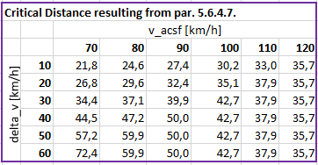
- Comparison of the minimum distance [m] resulting from applying 10% tolerance to the critical distance (yellow, left) or permitting 10% tolerance to the remaining distance tg (red, right)

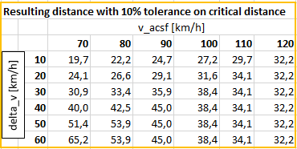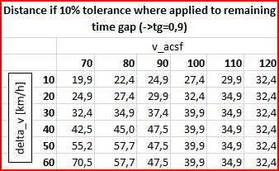

- Even if the critical distance is cut short by 10%, the required deceleration [m/s2] of an approaching vehicle in order to ensure a remaining distance to 0,9s doesn’t significantly change.

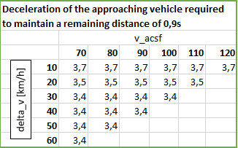

- And at all times, even if the critical distance is cut short by 10%, collision avoidance can be ensure by very light braking of the approaching vehicle

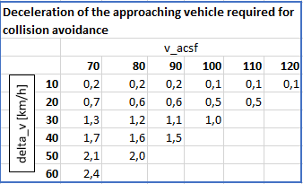
- Annex 8, Paragraph 2., Other test conditions
This amendment aims to carry over the amendment to UN-R79 ACSF B1 already adopted by GRVA-04, which read “At the manufacturer's discretion and with the agreement of the Technical Service, a lane with a width of less than 3.5 m may be used, if the correct function of the system on roads with wider lanes can be demonstrated.”, to the other test conditions as well.
In order to ensure type approval testing also during the winter months it should be possible to test vehicles also on wet surfaces or at lower temperatures.
- Annex 8, Paragraph 3.5.1.2. (j), Pass condition with regard to direction indicator deactivation
This amendment aims to amend the pass condition with regard to direction indicator deactivation according to the amended provisions on direction indicator deactivation as adopted at GRVA-05, where automatic deactivation is only required when the LCM is initiated automatically and the direction indicator wasn’t fully latched.

