|  |  |  |  |
| --- | --- | --- | --- |
|  | United Nations | ECE/TRANS/WP.29/GRVA/2021/11 | |
| _unlogo | **Economic and Social Council** | | Distr.: General  20 November 2020  Original: English |

**Economic Commission for Europe**

Inland Transport Committee

**World Forum for Harmonization of Vehicle Regulations**

**Working Party on Automated/Autonomous and Connected Vehicles**

**Ninth session**

Item 6 (a) of the provisional agenda

**UN Regulation No. 79 (Steering equipment):**

**Automatically Commanded Steering Function**

Proposal for a Supplement to the 03 series of amendments to UN Regulation No. 79 (Steering equipment)

Submitted by the experts from the International Organization of Motor Vehicle Manufacturers and the European Association of Automotive Suppliers[[1]](#footnote-2)\*

The text reproduced below was prepared by the experts from the International Organization of Motor Vehicle Manufacturers (OICA) and the European Association of Automotive Suppliers (CLEPA). It is based on informal document GRVA-07-43. The changes to the current text of the Regulation are marked in bold for new or strikethrough for deleted characters.

I. Proposal

*Paragraph 2.4.17.,* amend to read:

2.4.17. A "*Lane Change Manoeuvre*" is part of the Lane Change Procedure and,

(a) Starts when the outside edge of the tyre tread of the **power-driven** vehicle’s front wheel closest to the lane markings touches the inside edge of the lane marking to which the vehicle is being manoeuvred,

(b) Ends when the rear wheels of the **power-driven** vehicle have fully crossed the lane marking.

*Paragraph 2.7.,* amend to read:

2.7. "*Electric control line*" means the electrical connection **between two vehicles** which provides the steering control function to **a towed vehicle within a combination** **~~the trailer~~**. It comprises the electrical wiring and connector and includes the parts for data communication and the electrical energy supply for the trailer control transmission.

*Insert new paragraphs 2.8. and 2.9.* to read:

**2.8. "*Data communication*" means the transfer of digital data under the rules of a protocol.**

**2.9. "*Point-to-point*" means a topology of a communication network with only two units. Each unit has an integrated termination resistor for the communication line.**

*Paragraph 5.6.4. and 5.6.4.1.1.* amend to read:

5.6.4. Special Provisions for ACSF of Category C

**Power-driven** Vehicles **~~or vehicle combinations~~** equipped with an ACSF system of Category C **and trailers supporting lane change function(s)** shall fulfil the **relevant** following requirements.

5.6.4.1.1. A **power-driven** vehicle equipped with an ACSF of Category C shall also be equipped with an ACSF of Category B1 complying with the requirements of this UN Regulation.

*Insert a new paragraph 5.6.4.5.5.1.,* to read:

**5.6.4.5.5.1. In case the vehicle is coupled to a trailer supporting lane change function(s), the system failure signal transmitted from the trailer via the electric control line shall trigger the aforementioned warning signal accordingly.**

*Insert a new paragraph 5.6.4.8.2.1.,* to read:

**5.6.4.8.2.1. In case the vehicle is coupled to trailer(s), the defined detection area shall be applied to the whole length of the vehicle combination. In case of a trailer supporting lane change function(s), the detection area defined above applies to the rearmost point of the trailer.**

*Paragraph 5.6.4.8.4.,* amend to read:

5.6.4.8.4. The ACSF of Category C shall be able to detect blindness of the sensor (e.g. due to accumulation of dirt, ice or snow). The ACSF of Category C shall be prevented, upon detection of blindness **on the power-driven vehicle or on the trailer, as relevant,** from performing the lane change manoeuvre. The status of the system shall be signalled to the driver no later than on the initiation of the lane change procedure. The same warning as the one specified in paragraph 5.6.4.5.5. (system failure warning) may be used.

*Insert new paragraphs 5.6.4.8.5., 5.6.4.8.5.1. and 5.6.4.8.5.2.,* to read:

**5.6.4.8.5. The requirements of paragraphs 5.6.4.8.1. to 5.6.4.8.4. apply to trailers supporting lane change function(s), and to power-driven vehicles. However, the following exceptions apply:**

**5.6.4.8.5.1. In case the ACSF of Category C of the power-driven vehicle is only able to operate when connected via the electric control line to a trailer supporting lane change function(s), the requirements of paragraphs 5.6.4.8.2. to 5.6.4.8.4 shall not apply; only the relevant requirements of 5.6.4.8.1. applies.**

**5.6.4.8.5.2. In case the ACSF of Category C of the power-driven vehicle (Categories N2 and N3) is able to operate with a trailer not supporting lane change functions, the declared value Srear shall not be less than 55 m plus the total length of the trailer. The power-driven vehicle shall use the relevant information transmitted from the trailer via the electric control line to assess the length of the trailer (conform to ISO 11992-2 or ISO 11992-3). If the power-driven vehicle cannot receive the information to assess the length of the trailer, then the max. length of a trailer ([X] m) shall be used.**

**The relevant tests of Annex 8 shall be performed with a trailer not supporting lane change function(s).**

*Insert new paragraphs 5.6.4.9., 5.6.4.9.1., 5.6.4.9.1.1., 5.6.4.9.1.2., 5.6.4.9.1.3. and 5.6.4.9.1.4.,* to read:

**5.6.4.9. Connections, for ACSF between power-driven vehicle and trailer**

**The following paragraphs applies to vehicles implementing lane change functions based on trailers supporting lane change function(s).**

**5.6.4.9.1. The data communication line shall conform to ISO 11992-1:2019 and 11992-3:2020 and be a point-to-point type using:**

**(a) The fifteen-pin connector according to ISO 12098 or,**

**(b) In the case of systems where the connection of the electric control line is automated, the automated connector shall, as a minimum, provide the same number of pins as the abovementioned ISO 12098 connector.**

**5.6.4.9.1.1. The support of messages defined within ISO 11992-3:2020 is specified within Annex 9 to this Regulation for the towing vehicle and trailer as appropriate.**

**5.6.4.9.1.2. The functional compatibility of towing and towed vehicles equipped with electric control lines as defined above shall be assessed at the time of type approval by checking that the relevant provisions of ISO 11992-1:2019 and ISO 11992-3:2020 are fulfilled. Annex 10 of this Regulation provides an example of tests that may be used to perform this assessment.**

**5.6.4.9.1.3. When a power-driven vehicle is equipped with an electric control line connected to a trailer equipped with an electric control line, a continuous failure (> 40 ms) within the electric control line shall be detected in the power-driven vehicle and shall be signalled to the driver by the warning signal specified in paragraph 5.6.4.5.5., when such vehicles are connected via the electric control line.**

**5.6.4.9.1.4. Power-driven vehicles able to use the data transmitted from a trailer to perform the functionality and the performance of an ACSF of Category C shall send the GPM 11 message to the trailer and receive the GPM 21 message prior to the enabling the ACSF-functionality of the motor vehicle if a trailer is coupled.**

*Insert new paragraphs 5.6.4.10., 5.6.4.10.1., 5.6.4.10.2. and 5.6.4.10.3., to read:*

**5.6.4.10. Special provisions for trailers supporting lane change function(s).**

**5.6.4.10.1. The functionality shall be enabled only if GPM 11 message is received and GPM 21 messages is sent as defined in ISO 11992-3:2020.**

**5.6.4.10.2. If a trailer provides data communication via the electric control line and is equipped with ACSF-sensors it shall be in conformance to ISO 11992-3:2020. Failure warning signals required from the trailer by this Regulation shall be activated via the above connector. The requirement to be applied to trailers with respect to the transmission of failure warning signals shall be those, as appropriate, which are prescribed for motor vehicles in paragraph 5.6.4.5.5.**

**5.6.4.10.3. A system failure in the trailer shall be transmitted to the motor vehicle.**

*Insert new items 7 and 8. in Annex 1,* to read:

**7.[x]. The towing vehicle is/is not1 equipped with an ACSF of Category C fulfilling the relevant requirements and the Annex 9.**

**8.[x]. The trailer is/is not1 equipped with an ACSF of Category C fulfilling the relevant requirements and the Annex 9.**

*Paragraph 3.5., in Annex 8,* amend to read:

3.5. Tests for ACSF of Category C Systems

If not specified otherwise all vehicle test speeds shall be based on   
Vapp = 130 km/h

If not specified otherwise, the approaching vehicle shall be a type-approved high volume series production vehicle.

**A “vehicle under test” or “a test vehicle” normally driven as single vehicle/unit may be a part of a combination [, that means one motor vehicle is towing at least one trailer.]**

The vehicle manufacturer shall demonstrate to the satisfaction of the Technical Service that the requirements are fulfilled for the whole speed range. This may be achieved on the basis of appropriate documentation appended to the test report.

*Insert new paragraphs 3.5.8., 3.5.9., 3.5.9.1., 3.5.9.2. and 3.5.9.3., in Annex 8,* to read:

**3.5.8. Lane change suppression test**

**The test vehicle shall be driven in a lane of a straight test track, which has at least two lanes in the same direction of travel, with road markings on each side of the lanes.**

**The vehicle speed shall be: Vsmin + 10km/h.**

**The ACSF of Category C shall be activated (standby mode).**

**A Lane Change Procedure shall then be initiated by the driver.**

**The requirements of the test are fulfilled if the system inhibits any lane change procedures if:**

**(a) The towing vehicle is not equipped with means able to detect areas on ground level specified in paragraph 5.6.4.8.2. and tested individually;**

**(b) The trailer is not equipped with means able to detect areas on ground level in general; [or]**

**(c) The towing vehicle and the trailer are not able to perform detection of areas specified in paragraph 5.6.4.8.2.; [or]**

**(d) The trailer is not equipped with means able to detect side areas on ground level between the end of detection fields of the towing vehicle and areas specified in paragraph 5.6.4.8.2., if necessary ;**

**(e) The trailer is not equipped with means able to detect rear areas within its own lane fulfilling at least requirements for srear;**

**(f) A warning to the driver specified in paragraph 5.6.4.5.4. is provided.**

**Provisions of ISO11992-3:2020 shall be respected.**

**The manufacturer shall demonstrate to the satisfaction of the Technical Service dimensions of areas on ground level those permit lane change procedures executed singularly or in combination with at least one trailer.**

**3.5.9. Trailer object detection test**

**3.5.9.1. Detection of stationary targets**

**The test vehicle shall be stationary within a lane of a straight track which has at least two lanes and road markings on each side of the lane.**

**Stationary vehicles / [objects] with a Radio Cross Section (RCS) not greater than a type approved high volume series production motorcycle of Category L31 with an engine capacity not exceeding 600 cm3 without front fairing or windshield shall be placed as follows:**

**(a) Two at the leading edge left and right at a distance of 0.5 to 4.0 m [from vehicle under test];**

**(b) Two at the rear edge left and right at a distance of 0.5 to 4.0 m [from vehicle under test];**

**(c) Two at the rear at a distance of 5 m and 55 m.**

**The requirements of the test are fulfilled if the trailer system detects all of the six vehicles/[objects] simultaneously.**

**3.5.9.2. Detection of moving targets in adjacent lanes**

**The test vehicle shall be stationary within a lane of a straight track which has at least two lanes and road markings on each side of the lane.**

**Another vehicle shall approach from the rear on the adjacent lane, with a speed of 120 km/h.**

**The approaching vehicle shall be a type approved high volume series production motorcycle of Category L3 with an engine capacity not exceeding 600 cm3 without front fairing or windshield and shall aim to drive in the middle of the lane.**

**The distance between the rear end of the test vehicle and the front end of the approaching vehicle shall be measured (e.g. with a Differential Global Positioning System), and the value when the system detects the approaching vehicle shall be recorded.**

**The test shall be repeated with the approaching vehicle in the opposite adjacent lane.**

**The requirements of the test are fulfilled if the system detects the approaching vehicle no later than 55 m from the rear edge of the vehicle.**

**3.5.9.3. [Rear] Detection of moving targets [behind of its own lane]**

**The test vehicle shall be stationary within a lane of a straight track which has at least two lanes and road markings on each side of the lane.**

**Another vehicle shall approach from the rear on the adjacent lane, with a speed of [120/50] km/h.**

**The approaching vehicle shall be a type approved high volume series production motorcycle of Category L3 with an engine capacity not exceeding 600 cm3 without front fairing or windshield and shall aim to drive in the middle of the lane.**

**The distance between the rear end of the test vehicle and the front end of the approaching vehicle shall be measured (e.g. with a Differential Global Positioning System), and the value when the system detects the approaching vehicle shall be recorded.**

**The requirements of the test are fulfilled if the system detects the approaching vehicle no later than 55 m from the rear edge of the vehicle.**

*Insert a new Annex 9,* to read:

Annex 9

Compatibility between towing vehicles and trailers with regard to data transmission according to ISO 11992 for environmental monitoring

1. General

1.1. The requirements of this annex shall only apply to towing vehicles and trailers equipped with an electric control line as defined in paragraph 2.7 of the Regulation.

1.2. The ISO 12098:2004 connector provides a power supply for the ACSF/environmental monitoring function of the trailer via pins 4 and 9. In the case of vehicles equipped with an electric control line as defined in paragraph 2.7 of the Regulation this connector also provides a data communication interface via pins 13, 14 and 15 — see paragraph [5.6.4.x.x. of the Regulation].

1.3. This annex defines requirements applicable to the towing vehicle and trailer with respect to the support of ACSF/environmental monitoring messages defined within ISO [11992-3:2020].

2. The parameters defined within ISO [11992-3:2020] that are transmitted by the electric control line shall be supported as follows:

2.1. The following functions and associated messages are those specified within this Regulation that shall be supported by the towing vehicle or trailer as appropriate:

|  |  |  |  |  |  |  |  |  |  |  |  |  |  |  |  |  |  |  |  |  |  |  |  |  |  |  |  |  |  |  |  |  |  |  |  |  |  |  |  |  |  |  |
| --- | --- | --- | --- | --- | --- | --- | --- | --- | --- | --- | --- | --- | --- | --- | --- | --- | --- | --- | --- | --- | --- | --- | --- | --- | --- | --- | --- | --- | --- | --- | --- | --- | --- | --- | --- | --- | --- | --- | --- | --- | --- | --- |
| Messages transmitted from the towing vehicle to the trailer:  SP mapping of GPM11   | *Byte pos.* | *Bit pos.* | *Parameter ISO 11992-03:2020* | *Reference in UN Regulation No. 79* | | --- | --- | --- | --- | |  |  |  |  | | 1 | 1 to 2 | Vehicle type | Paragraph 5.6.4.9.1.4. | | 3 to 8 | Detailed Vehicle Type | Paragraph 5.6.4.9.1.4. | | 2 | 5 to 8 | ODM version request | Paragraph 5.6.4.9.1.4. |   Object Detection Message (ODM11)  With this message, relevant information for the automated steering function is sent from the towing vehicle to the towed vehicle.  ODM11 message definition   | *Byte pos.* | *Bit pos.* | *Parameter ISO 11992-03:2020* | | --- | --- | --- | |  |  |  | | 1 | --- | CRC | | 2 | 1 to 4 | sequence counter | | 5 to 8 | ODM input | | 3 to 4 | --- | longitudinal speed | | 5 to 6 | --- | lateral speed | | 7 to 8 | --- | yaw rate | |

2.1.2. Messages transmitted from the trailer to the towing vehicle:

GPM21 message definition

| *Byte pos.* | *Bit pos.* | *Parameter ISO 11992-03:2020* | *Reference in UN Regulation No. 79* |
| --- | --- | --- | --- |
|  |  |  |  |
| 1 | 1 to 2 | Vehicle Type | Paragraph 5.6.4.10.1. |
| 3 to 8 | Detailed Vehicle Type | Paragraph 5.6.4.10.1. |
| 2 | 5 to 8 | ODM Version Information | Paragraph 5.6.4.10.1. |
| 7 | 1 to 8 | Identification Data Index | Paragraph 5.6.4.10.1. |
| 8 | 1 to 8 | Identification Data Content | Paragraph 5.6.4.10.1. |

ODM 21, ODM 23, ODM 25, ODM 27, ODM 29, ODM 211, ODM 213, ODM 215 message definition

| *Byte pos.* | *Bit pos.* | *Parameter ISO 11992-03:2020* |
| --- | --- | --- |
|  |  |  |
| 1 | --- | Cyclic Redundancy Check (CRC-8) |
| 2 | 1 to 4 | Sequence Counter |
| 2 | 5 to 8 | Status Indicator |
| 3 to 4 | --- | AS Longitudinal Distance Object |
| 5 to 6 | --- | AS Lateral Distance Object |
| 7 | 1 to 4 | AS Standard Deviation of Longitudinal and Lateral Distance |
| 7 | 5 to 8 | reserved by this document |
| 8 | 1 to 8 | Track ID |

ODM 22, ODM 24, ODM 26, ODM 28, ODM210, ODM 212, ODM 214, ODM 216 message definition

| *Byte pos.* | *Bit pos.* | *Parameter ISO 11992-03:2020* |
| --- | --- | --- |
|  |  |  |
| 1 | --- | Cyclic Redundancy Check (CRC-8) |
| 2 | 1 to 4 | Sequence Counter |
| 2 | 5 to 8 | Status Indicator |
| 3 to 4 | --- | AS Absolute Longitudinal Speed Object |
| 5 to 6 | --- | AS Absolute Lateral Speed Object |
| 7 | 1 to 4 | AS Normal Deviation of Longitudinal and Lateral Speed |
| 7 | 5 to 7 | reserved by this document |

2.1.2.1. General

IMPORTANT — If ISO 11992-1 is used as a data link and physical layer only one trailer (towed vehicle) can be supported due to bandwidth overload of the CAN bus between towing and towed vehicles.

The towing vehicle shall not rely on any sorting of the objects communicated by the towed vehicle.

2.1.2.2. Objects to the side of the towed vehicle

The following rule shall be applied for left-hand and right-hand side separately:

If any object is next to the towed vehicle, the one with minimum lateral distance to the towed vehicle shall be selected.

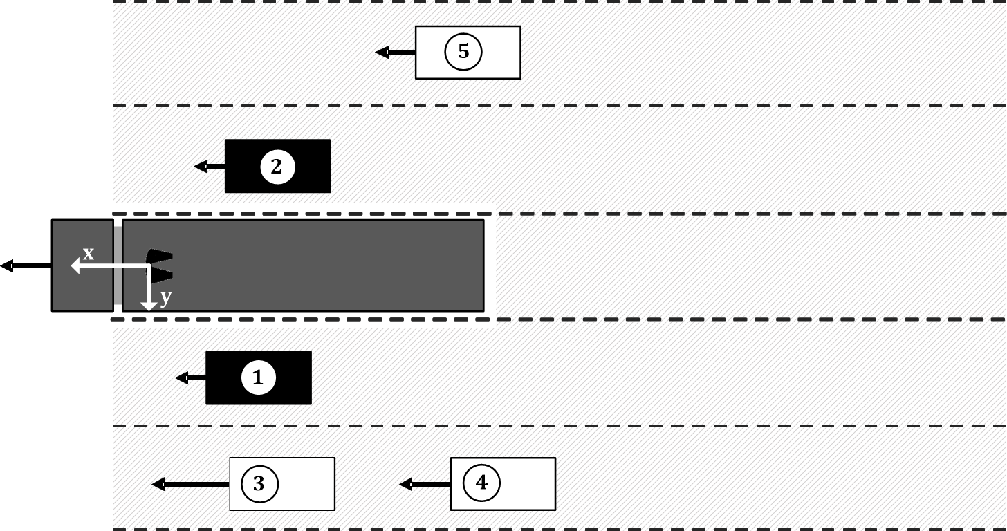

2.1.2.3. Objects behind the towed vehicle

The area behind the towed vehicle is split into five ranges. From each range an object shall be selected, if present. If the absolute velocity of the towed vehicle > 10 km/h only moving objects shall be selected. An object is moving if its absolute velocity is not zero. The five ranges are specified by the lateral position relatively to the towed vehicle:

(a) –0.5 × w – 7 m ≤ y < –0.5 × w – 3.5 m

(b) –0.5 × w – 3.5 m ≤ y < – 0.5 × w

(c) behind the towed vehicle

(d) 0.5 × w < y ≤ 0.5 × w + 3.5 m

(e) 0.5 × w + 3.5 m < y ≤ 0.5 × w + 7 m

Where y is the lateral position [m] and w is the width [m] of the towed vehicle.

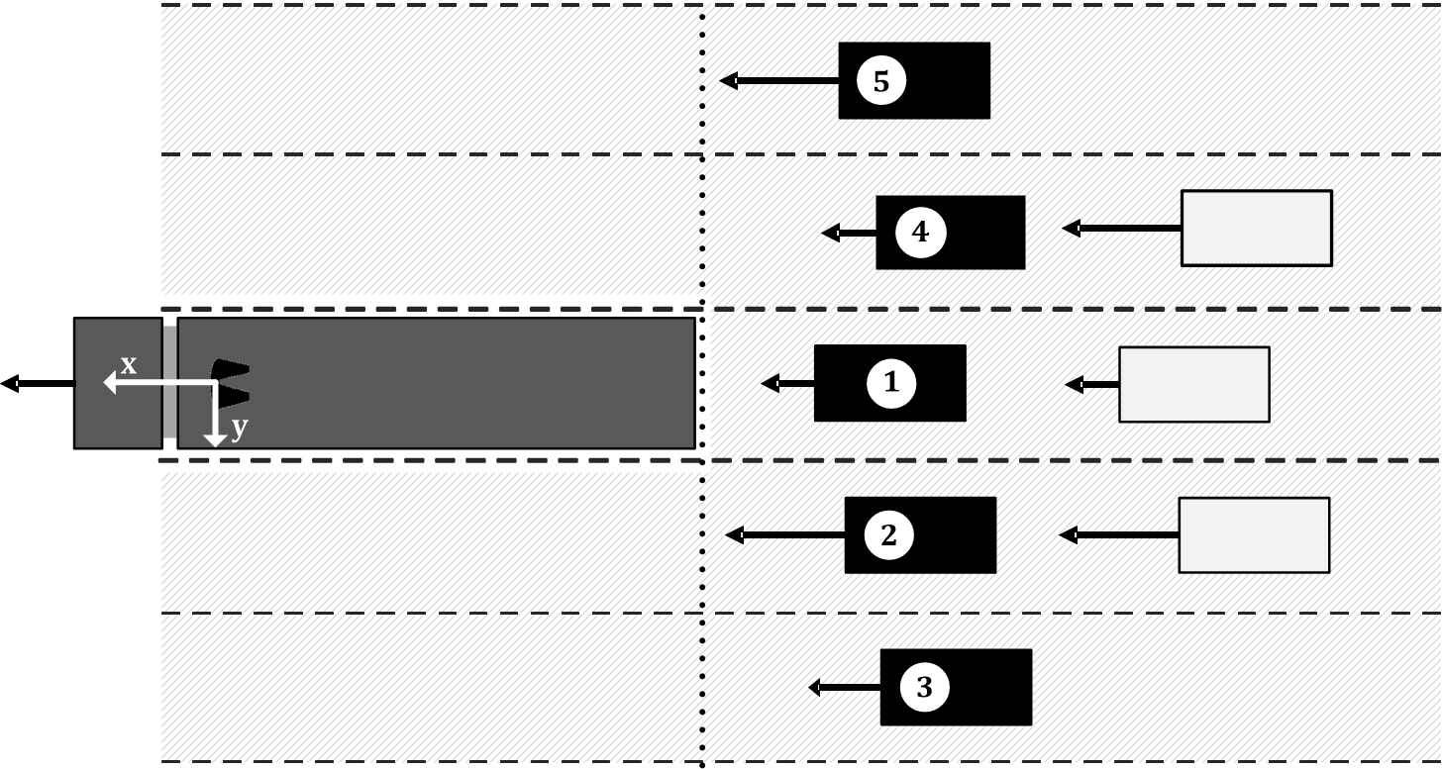

No objects are detected, sensor system not ready:

In case no objects are detected or the sensor system is not ready all object values shall be set to System Not Available (SNA).

2.2. Under the following conditions the towed vehicle shall transmit the status indicator according to the ODM messages defined in paragraph 2.1.2. above:

2.2.1. Communication error:

If a communication persistent error is reported by an underlying layer (e.g. bus-off by the CAN controller), the application shall perform a reset. After the reset, the same initialisation procedure as on power-up shall be performed. The delay between the persistent error is reported and the reset executed shall be at least 100 ms.

2.2.2. Sensor error:

The sensors providing ODM information shall be equipped with mechanisms for sensor failure detection (e.g. blockage, malfunction). A detected sensor error shall be reported by the ODM status indicator. Different states. If the sensors are equipped with integrated recovery mechanism, these should be supported.

2.3. The following messages defined in ISO 11992-3:2020 shall be supported by the towing vehicle or trailer if available:

2.3.1. Messages transmitted from the trailer to the towing vehicle:

ODM217 message definition

| *Byte pos.* | *Bit pos.* | *Parameter ISO 11992-03:2020* |
| --- | --- | --- |
|  |  |  |
| 1 | --- | Cyclic Redundancy Check (CRC-8) |
| 2 | 1 to 4 | Sequence Counter |
| 2 | 5 to 8 | Status Indicator |
| 3 to 4 | --- | Geometric Item #1 |
| 5 to 6 | --- | Geometric Item #2 |
| 7 to 8 | --- | Geometric Item #3 |

Multiplexing rules for geometric distances

| *Sequence counter* | *Item* | *Parameter ISO 11992-03:2020* |
| --- | --- | --- |
|  |  |  |
| 1 or 9 | #1 | distance to rear coupling point |
| 1 or 9 | #2 | distance to centre of rotation |

2.4. The following messages shall be supported by the towing vehicle or trailer as appropriate when the vehicle is installed with a function associated with that parameter:

2.4.1. Messages transmitted from the towing vehicle to the trailer:

SP mapping of GPM11

| *Byte pos.* | *Bit pos.* | *Parameter ISO 11992-03:2020* |
| --- | --- | --- |
|  |  |  |
| 3 to 4 | 1 to 16 | Articulation Angle between towing and towed vehicle |
| 5 to 6 | 1 to 16 | Angle between towing vehicle and drawbar |
| 7 to 8 | 1 to 16 | Angle between drawbar and towed vehicle |

2.4.2. Messages transmitted from the trailer to the towing vehicle:

GPM21 message definition

| *Byte pos.* | *Bit pos.* | *Parameter ISO 11992-03:2020* |
| --- | --- | --- |
|  |  |  |
| 3 to 4 | 1 to 16 | Articulation Angle between towing and towed vehicle |
| 5 to 6 | 1 to 16 | Articulation Angle drawbar and towed vehicle |

The support of all other messages defined within ISO [11992-3:2020] is optional for the towing vehicle and trailer.

*Insert a new Annex 10,* to read:

Annex 10

Test procedure to assess the functional compatibility of vehicles equipped with ACSF control lines

1. General

1.1. This annex defines a procedure that may be used to check towing and towed vehicles equipped with an electric control line against the functional and performance requirements referred to in paragraph [5.6.4.] of this regulation. Alternative procedures may be used at the discretion of the technical service if an equivalent level of checking integrity can be established.

1.2. The references to ISO 12098:2004 within this annex apply to ISO 12098 for 24 V applications [and ISO 12098 for 12 V applications.]

2. Information document

2.1. The vehicle manufacturer [/system supplier] shall supply to the technical service an information document that contains at least the following:

2.1.1. A schematic of the vehicle ACSF system;

2.1.2. Evidence that the interface, including the physical layer, data link layer and the application layer and the respective position of supported messages and parameters, complies with ISO 11992;

2.1.3. A list of supported messages and parameters; and

3. Towing vehicles

3.1. ISO 11992 trailer simulator

The simulator shall:

3.1.1. Have a connector meeting ISO 12098:2004 (15 pin) to connect to the vehicle under test. Pins [13,] 14 and 15 of the connector shall be used to transmit and receive messages complying with ISO [11992-3:2020].

3.1.2. Be capable of receiving all of the messages transmitted by the motor vehicle to be type approved and be capable of transmitting all trailer messages defined within ISO [11992-3:2020].

3.1.3. Provide a direct or indirect readout of messages, with the parameters in the data field shown in the correct order relative to time; and

3.2. Checking procedure

3.2.1. Confirm that the manufacturer's[/supplier's] information document demonstrates compliance with the provisions of ISO 11992 with respect to the physical layer, data link layer and application layer.

3.2.2. Check the following, with the simulator connected to the motor vehicle via the ISO 12098:2004 interface and whilst all trailer messages relevant to the interface are being transmitted:

3.2.2.1. Control line signalling:

3.2.2.1.1. The parameters defined in GPM 11 byte 1 bit 5 -8 and byte 3-8 bit 1 – 16 of ISO 11992-3:2019 shall be checked against the specification of the vehicle as follows: [Table 78 of the ISO standard].

3.2.2.2. Failure warning:

3.2.2.2.1. Simulate a permanent failure in the communication line to pin 14 of the ISO 12098 connector and check that the warning signal of the ACSF specified in paragraph 5.6.4.5.5. of this Regulation is displayed.

3.2.2.2.2. Simulate a permanent failure in the communication line to pin 15 of the ISO 12098 connector and check that the warning signal of the ACSF specified in paragraph 5.6.4.5.5. of this Regulation is displayed.

3.2.2.2.x. [Requirements for failure warning signals]

3.2.3. Additional checks

3.2.3.1. [At the discretion of the Technical Service the checking procedures defined above may be repeated with the non-ACSF functions relevant to the interface in different states or switched off.]

3.2.3.2. Paragraph 2.4.1 of Annex 9 defines additional messages that shall under specific circumstances be supported by the towing vehicle. Additional checks may be carried out to verify the status of supported messages to ensure the requirements of paragraph [5.x.x.x.x] of the Regulation are fulfilled.

4. Trailers

4.1. ISO 11992 towing vehicle simulator

The simulator shall:

4.1.1. Have a connector meeting ISO 12098:2004 (15 pin) to connect to the vehicle under test. Pins [13,] 14 and 15 of the connector shall be used to transmit and receive messages complying with ISO [11992-3:2020].

4.1.2. Have a failure warning display and an electrical power supply for the trailer;

4.1.3. Shall be capable of receiving all of the messages transmitted by the trailer to be type approved and be capable of transmitting all motor vehicle messages defined within ISO [11992-3:2020].

4.1.4. Provide a direct or indirect readout of messages with the parameters in the data field shown in the correct order relative to time; and

4.2. Checking procedure

4.2.1. Confirm that the manufacturer's[/supplier's] information document demonstrates compliance with the provisions of ISO 11992 with respect to the physical layer, data link layer and application layer.

4.2.2. Check the following, with the simulator connected to the trailer via the [ISO 12098] interface and whilst all towing vehicle messages relevant to the interface are being transmitted:

4.2.2.1. Control line signalling:

4.2.2.2. Failure warning:

4.2.2.2.1. Simulate a permanent failure in the communication line to pin 14 of the ISO 12098 connector and check that the warning signal of the ACSF System specified in paragraph 5.6.4.5.5. Of this regulation is displayed.

4.2.2.2.2. Simulate a permanent failure in the communication line to pin 15 of the ISO 12098 connector and check that the warning signal of the ACSF specified in paragraph [x.x.x.x.x] of this Regulation is displayed.

4.2.2.2.3. [Requirements for failure warning signals]

4.2.3. Additional checks

4.2.3.1. [At the discretion of the Technical Service the checking procedures defined above may be repeated with the non-ACSF functions relevant to the interface in different states or switched off.]

4.2.3.2. Paragraph 2.4.1.2. of Annex 9 defines additional messages that shall under specific circumstances be supported by the towing/towed vehicle. Additional checks may be carried out to verify the status of supported messages to ensure the requirements of paragraph [5.x.x.x.x. of the Regulation] are fulfilled.

II. Justification

This document proposes amendments to the provisions of ACSF of Category C in UN Regulation No. 79, with the main aim to include a truck – trailer data transmission.

1. \* In accordance with the programme of work of the Inland Transport Committee for 2021 as outlined in proposed programme budget for 2021 (A/75/6 (Sect.20), para 20.51), the World Forum will develop, harmonize and update UN Regulations in order to enhance the performance of vehicles. The present document is submitted in conformity with that mandate. [↑](#footnote-ref-2)