Draft Mutual Resolution Addendum 1

This is a working document representing the development of MR1 Addendum 1 and concerning the BIORID-II UN dummy for use in rear impact assessment. It should be read together with informal document GRSP -54-05.

Comments on this document, and on GRSP-54-05 are welcome before 31 January 2021 for consideration in the final document to be submitted to the 69th session of GRSP.

It contains:

An edited version of sections 1 (Introduction) and 2 (Physical Properties),

A new section 3 (Certification procedures)

In addition
Annex 1 of the document is being reviewed for consistency, to remove proprietary references and replace manufacturer’s drawing numbers with UN Drawing numbers.
Annex 2, Appendix 1 to Appendix 9: All engineering drawings have new title blocks with the description:
“UN: Mutual Resolution (M.R.1)”, and

UN Drawing numbers with the style:

“ECE/TRANS/WP.29/1101/Add.1/Annex2/App.*/Dwg.***”

There are 247 engineering drawings,

Appendix 1 contains 7 engineering drawings
Appendix 2 contains 12 engineering drawings
Appendix 3 contains 26 engineering drawings
Appendix 4 contains 44 engineering drawings
Appendix 5 contains 29 engineering drawings
Appendix 6 contains 23 engineering drawings
Appendix 7 contains 31 engineering drawings
Appendix 8 contains 55 engineering drawings
Appendix 9 contains 20 engineering drawings

Annex 2, Appendix 2 to be replaced with a methodology for the development of test data to determine the compression value for the dummy jacket and the lower torso. This is under development.

Annex 2, Appendix 3 – Details required to be included in the dummy certification document.

1. Introduction
This document, addendum 1 to the Mutual Resolution, aims to set out a standard specification for build and certification of the Biofidelic Rear Impact Dummy (BioRID-II UN).
BioRID-II UN is a 50th percentile male dummy, developed to mimic occupant behaviour in automotive rear impact collisions of low severity.
BioRID-II UN has a fully articulated spine, providing a more anthropomorphic response in a collision while still maintaining the level of repeatability and reproducibility established by previous dummies used in automotive impact testing.
BioRID-II UN is equipped to record many measurements, including thorax loading and head acceleration and rotation, which can be correlated to the risk of whiplash associated disorders and other injuries.
1.1. General Design
For the purposes of application in the context of UN ECE Regulations, the BioRID-II UN anthropometric test dummy is defined by compliance with the build and calibration requirements set out in this document and accompanying engineering drawings (Annex 2 Appendix 1 to 9). The generic build level, e.g. BioRID-IIg, is not sufficient to determine the status of the dummy and it is necessary to establish that the individual components that comprise the dummy are manufactured to the particular level of drawing revision that are tabled in Annex II.
BioRID-II UN incorporates a fully articulated two-dimensional spine with 24 vertebrae. The spine consists of seven cervical (C1-C7), twelve thoracic (T1-T12) and five lumbar (L1-L5) vertebrae.
The head assembly and the top cervical vertebra (C1) are connected using an occipital interface plate. This interface plate provides for the mounting of a 6-channel or 3-channel upper neck load cell, or if no load cell is used, a load cell structural replacement. The superior thoracic vertebra (T1) is contoured as a cervical vertebra on the upper side and as a thoracic vertebra on the lower side to mate the cervical and thoracic regions. Similarly, the upper surface of the superior lumbar vertebra (L1) is shaped like the thoracic vertebrae and the underside shaped like the lumbar vertebrae to mate the thoracic and lumbar regions. The lowest lumbar vertebra (L5) connects the spine to the pelvis through a sacrum lumbar and pelvis interface plate.
The vertebrae for the BioRID II UN are made of durable plastic connected with pins at each joint that allow for angular motion in the sagittal plane only. The occipital and pelvis interfaces are made of aluminium. There are elastomeric blocks glued to the top of each vertebra to simulate the compression resistance of the muscles and discs between each human vertebra.
To increase the biofidelity of the neck motion response, tensioning cables are incorporated into the neck region of the spine. The three cables originating at the top of the neck have threaded adjustments for controlling cable tension. One cable goes through the cervical vertebrae, around a damper assembly at the T4 vertebra and back through the vertebrae to the top of the neck. The two other cables also start at the top of the neck but terminate at two spring-loaded cable-tensioning devices mounted on the right side of the torso.
The upper torso flesh is made of moulded silicone. Included in the flesh mould are the left and right arm attachment yokes with reinforcement plates, the abdomen interface attachment, the abdomen cavity, the abdomen valve and the spine-torso interface. The flesh material and/or external surface characteristics enable positive attachment of adhesive targets.
The arms are Hybrid III 50th percentile dummy assemblies and the head and pelvis are modified Hybrid III 50th percentile dummy assemblies. The legs are Hybrid III 50th percentile dummy legs with the knee sliders replaced with pedestrian blocks.
1.2. Instrumentation
1.2.1. Available Instrumentation
Table 1 lists the available instrumentation for the BioRID II UN Dummy. Section 2.4 of Annex 1 describes cable installation requirements. It shall be ensured that any changes of instrumentation do not alter the mass or centre of mass of components.
Note: table 1 and figure 1 will need amending once injury criteria are finalised!!!!
Table 1.
BioRID UN Instrumentation
Location | Type | Measurement | Number of Channels
Head | Accelerometer | AX, AY, AZ | 3
Head | Angular Rate Sensor (ARS) | AVX, AVY, AVZ | 1 - 3
Head | Skull Cap Contact Switch | Event | 1
Head | Tilt Sensor | Angle | 1
Upper Neck | Load Cell | FX, FY, FZ, MX,MY,MZ | 6
Thorax (T1) | Load Cell | FX, FZ, MY | 3
Thorax (T1) | Accelerometer | AX, AZ | 2
Thorax (T1) | ARS | AVX, AVY, AVZ | [1 - 3]
Thorax (T1) | Tilt Sensor | Angle | 1
Thorax (T8) | Accelerometer | AX, AZ | 2
Thorax (T8) | ARS | AVX, AVY, AVZ | [1 - 3]
Lumbar (L1) | Accelerometer | AX, AZ | 2
Lumbar (L1) | ARS | Angular | [1 - 3]
Lumbar Load Cell | Load Cell | FX, FX, FZ, MX, MY, MZ | 6
Muscle Tension (2) | Load Cell | Force | 2
Pelvis | Accelerometer | AX, AY, AZ | 3
Pelvis | Gyro | AVX, AVY, AVZ | 1 - 3
Pelvis | Tilt Sensor | Angle | 1

1.2.2. Instrumentation Location
The location of the instrumentation shall be as illustrated in figure 1.
Figure 1.
Instrumentation layout

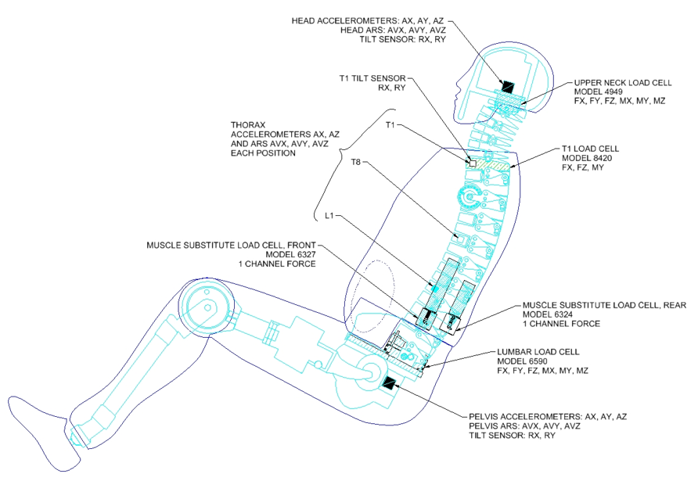

1.3. Required Tools
The following special tools will allow assembly, disassembly and calibration of the BioRID-II UN Rear Impact Dummy.
Hex spanner, Ball end (0.05" – 3/8" and 1.5 mm – 10 mm)
Hex spanner, ‘T’-handle (3/32" - 3/8" and 2 mm – 10 mm)
Screwdriver, standard tip (2.5 mm tip width)
Pin punch (6 mm dia.)
Brass mallet
Thread locking adhesive (e.g. cyanoacrylate)
Open-end spanner (13 mm)
Synthetic gear oil of ISO viscosity grade 680
1.4. Abbreviations of Screw Types Used
The abbreviations listed in table 2 shall be used within this addendum
Table 2. Abbreviations of screw types
Screw Type | Abbreviation
Socket Head Cap Screw | SHCS
Button Head Cap Screw | BHCS
Flat Head Cap Screw | FHCS
Socket Set Cup Point | SSCP
Socket Head Shoulder Screw | SHSS

2. Physical Properties
2.1. Dimensions
Table 3 specifies key dimensions that are checked when the dummy is seated in the dummy measurement chair. These measurements enable dimensional conformity to be checked without having to inspect every component and allow the level of compression in the flesh to be monitored. These checks shall be performed whenever the dummy is certified.
The dummy measurement chair shall feature a flat, rigid, smooth, clean, dry, horizontal surface. The seating surface shall be at least 406 mm wide and 406 mm deep, with a vertical section at least 406 mm wide and 914 mm high attached to the rear of the seating fixture. It shall feature an adjustable head strap capable of supporting the dummy’s head against forward movement. A suitable chair is shown in figure 2.
Table 3
Dimensions of BioRID UN
 | Metric (mm)
Feature | Lower | Upper
H-Point above seat | 84 | 89
H-Point from Seat Rear | 135 | 140
Seated Height | 879 | 889
Thigh Clearance | 140 | 155
Buttock to Knee Length | 579 | 605
Knee Pivot Height | 485 | 500
Foot Length | 251 | 267
Foot Width | 91 | 107
Figure 2.
Seating the dummy in the measurement chair
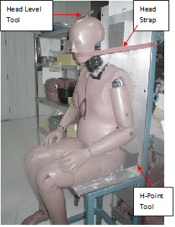

Dimensional Conformity Check
Level the seat of the dummy measurement chair such that it lies parallel to the X-Y plane in the coordinate reference system. Zero a digital inclinometer on the seat surface with it oriented in the X-coordinate direction.
Position the dummy on the measurement chair such that the dummy’s midsagittal plane is vertical and centred upon the test surface. Position the head strap of the chair so it runs around the front of the head, directly under the nose (figure 2). Insert the head levelling tool on the top of the skull, then insert the H-Point tool through the pelvis into the H-Point reference square hole mounted at the base of the spine. The dimensions of the H-Point tool are shown in figure 3.
Figure 3.
Dimensions for the H-Point Tool
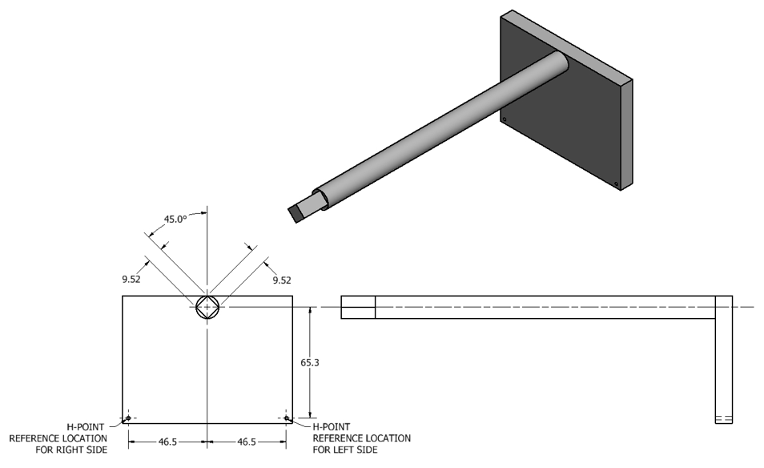

Position the lower torso so the H-Point reference hole on the H-point tool is between 135 - 140mm from the seat back on both sides of the dummy when measured in the X coordinate direction (figure 4). Measure the height (Z coordinate direction) from the seat to the H-Point reference hole (figure 5) and compare to the tolerance band specified in table 2. Place the inclinometer on the top of the H-Point tool (figure 6) and confirm the angle is 0 +/-2 degrees. If necessary, adjust the dummy position and repeat the measurements of the H-point positions (X and Z directions) and angles until all are within tolerance.

Figure 4.
Setting the longitudinal position of the lower torso
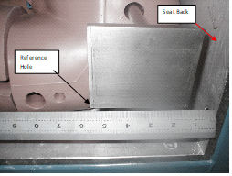
Figure 5.
Measuring the H-Point height (left side)
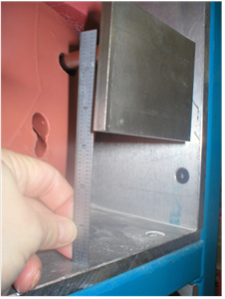
Figure 6.
Measuring the H-point tool angle
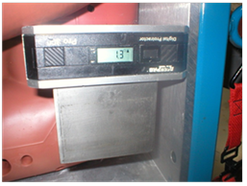

Place the inclinometer on the top of the head levelling tool (figure 7). The head angle shall be 26.5 +/- 2 degrees. The head strap may be adjusted to allow slump on the spine to attain the correct angle.
Measure the thigh clearance by placing a straight edge across the highest point on the thighs and measuring the vertical distance (Z coordinate direction) from the seat to the bottom of the straight edge on each side of the dummy (figure 8). Hold the measuring rule in a vertical orientation such that it touches the outer thigh.
Figure 7.
Measuring the angle of the head levelling tool

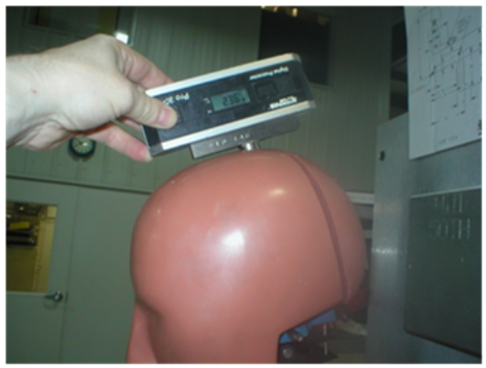 | Figure 8.  Measuring the thigh clearance  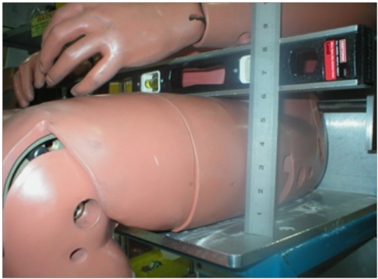

To find the buttock to knee length, place a straight edge across the furthest forward point of both the knees and measure the distance (X coordinate direction) between the straight edge to the seat back. Measurements shall be taken on either side such that the tape or rule is oriented in the X direction and touches the side of the dummy (figure 9).
Place a spirit level on the top of the head and centre the bubble. Measure the dimension from the seat to the underside of the level (Z coordinate direction) to find the seated height (figure 10).
Level the feet front to back by holding a digital inclinometer to the soles of the feet. Place a straight edge transversely under the balls of the feet, such that it contacts both feet, and measure the vertical distance between the straight edge and the knee pivot to find the knee pivot height on both sides of the dummy, as shown in figure 11. The measuring device shall be vertical and shall touch the dummy. Measure the length and width of each foot using a rule at the longest and widest points of the foot respectively.

Figure 10
Measuring the seated height of the dummy
Figure 9.  Measuring the knee to buttock length  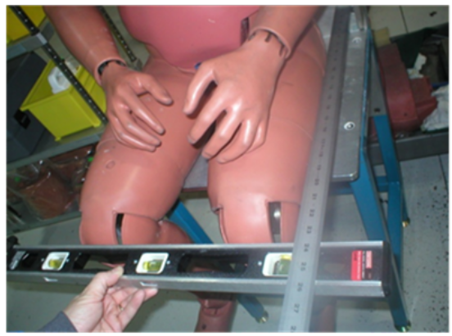 |  | 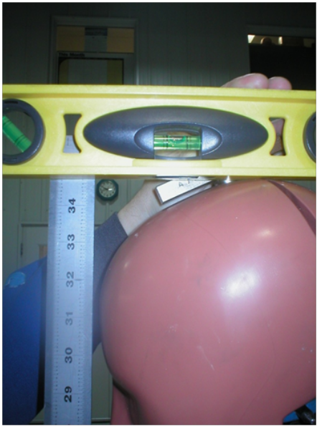

Figure 11
Measuring the left knee pivot height
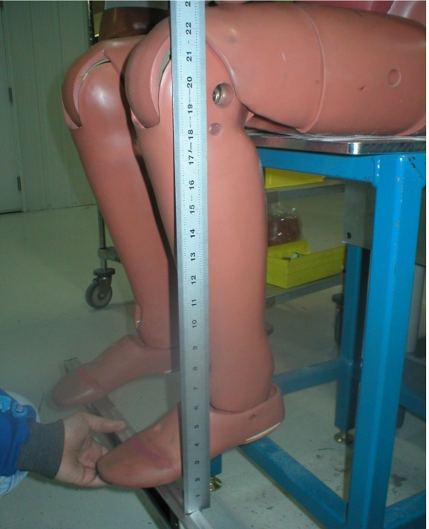

2.2. Masses
The mass of the BioRID-II UN dummy segments shall conform to the specifications in table 4. After replacing parts, including instrumentation, the mass of the segment containing the replaced part shall be rechecked.
Table 4
Masses of BioRID-II UN components

 | Mass (kg))
Assembly | Lower Corridor | Upper Corridor
Head | 4.49 | 4.58
Torso | 41.96 | 42.86
Arm | 3.57 | 3.84
Hand | 0.52 | 0.61
Leg | 10.12 | 10.43
Foot | 1.09 | 1.22
3. Certification
3.1. Introduction
The BioRID-II UN Dummy Certification Procedures are to insure proper performance of, and consistent results between, dummies. The procedures include tests to verify the test equipment system response to inputs and tests to verify dummy and dummy component performance.
These include:
Test Equipment System Validation
This test gives confidence the energy transfer device (ETD), test equipment system, and impactor are going to provide consistent test inputs to the validation and certification procedures.
Jacket Validation Test
This test verifies the stiffness of the jacket material remains within the specified limits. The jacket used in the certification procedure shall be validated in accordance with paragraph 3.5.
Lower Torso Validation Test
This test verifies the material inside the pelvis remains within the specified limits. The lower torso is not used during the dummy certification test, but its validation is necessary before the whole dummy assembly can be certified. The procedures for validation of the lower torso are detailed in paragraph 3.6.
Dummy Certification Test (without headrest)
This test insures the dummy’s neck will provide reliable test results. The test also provides evidence the damper, neck bumpers, muscle substitute springs and cable, are working correctly as a system. The procedures for certification of the dummy are detailed in paragraph 3.4.
Validation of the test equipment system shall be ensured prior to the validation tests for jacket and lower torso and for the certification test of the dummy. In advance of the certification tests it shall be ensured that:
- the dummy components have been checked to ensure that they comply with the BioRID-II UN dummy specification (Appendix 1 - BioRID-II UN Design Checklist)
- the front neck bumpers (C1 – C7) and the front thoracic bumper (T1) are less than 12-months old, and,
- all other spinal bumpers are less than 24-months old.
The dummy certification shall be valid for a period no greater than 12-months. In the case where the spinal bumpers will exceed the age specified above, the dummy certification shall only be valid until the first age threshold is reached.
If the dummy experiences a severe impact, a further dummy certification test shall be required to validate continued compliance.

3.2. Required Test Equipment and Specifications
3.2.1. Sled System
The sled system shall comprise a sled assembly that is free to move on linear bearings along a machined and guided track. The sled shall be designed to allow the BioRID-II UN upper torso and head to be mounted to its forward structure, and with an impact face plate to the rear. It shall be possible separately to mount the BioRID-II UN jacket assembly and the lower torso to the impact face to allow for their individual validation.
The essential dimensions to establish the relative position of the essential mounting points of the sled assembly, in respect to the impactor, are shown in Figure 12. The centre point of the impact face plate shall lie 138.5mm above the centre point of the lower mounting hole on the top surface of the torso assembly attachment plate.

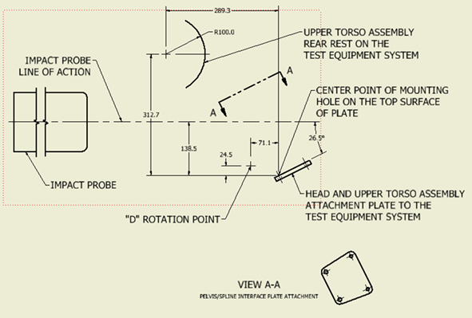
Figure 12. Essential dimensions for the sled assembly

The mass of all the components that move with the system (excluding the energy transfer device and its mounting screws) shall be 44.25 kg +/- .05 kg.
The impact face plate shall provide for the attachment of an energy transfer device and, separately, for the attachment of the dummy jacket and the lower torso.
3.2.2. Impactors
Pendulum type impactors are described in this section; however, alternative arrangements may be used providing that they satisfy the essential performance criteria.
The suspension system for the impactor shall be designed to ensure that, under the dynamic conditions of use, the centreline of the impactor remains vertically within +/- 2mm of its at rest position.
3.2.2.1. Upper Torso Impactor
The upper torso impactor shall comprise two parts which shall be of rigid metallic construction and concentric about their longitudinal axis.
The primary part of the impactor shall be designed to allow it to be suspended such that, in an at rest position, its longitudinal centreline is level in the horizontal plane.
The impactor shall have a mass of 33.55 kg +/- 0.1 kg. This mass includes 33% of the mass of the suspension cables and their attachment fittings to the impactor.
A separate, detachable, impact face shall have a mass of 4.05 kg +/- 0.01 kg. The impacting face of the impactor shall be perpendicular and concentric with the longitudinal axis of the impactor, and have a flat, continuous, and non-deformable 254 +/- 0.25 mm diameter surface with a 1mm - 2 mm thick polytetrafluoroethylene (PTFE) covering, extending rearward a minimum of 12.7 mm.
3.2.2.2. Jacket/Lower Torso Impactor
The jacket / lower torso impactor shall be of rigid metallic construction and concentric about its longitudinal axis.
It shall have a mass of 13.97 +/- 0.02 kg which includes all attached hardware, including 33% of the mass of the suspension cables. The combined mass of 33% of the impactor support cables and all hardware attached to the impactor must not exceed 5% of the total impactor mass.
The impacting end of the test impactor is to be perpendicular and concentric with the longitudinal axis of the impactor, having a flat, continuous, and non-deformable 152.4 +/- 0.25 mm diameter impact face, extending rearward a minimum of 25 mm, with an edge radius of 7.6 mm - 12.7 mm.
3.2.3. Dummy Equivalent Fixed Mass Package
The dummy equivalent fixed mass package provides equivalent inertia for the sled assembly to that provided by the BioRID-II UN upper torso and head assembly. Its mass, including attachment hardware, shall be 25.50 kg +/- 0.02 kg
3.2.4. Instrumentation
3.2.4.1. The data acquisition system used for the certification procedure shall conform to ISO 6487: 2015 or SAE J211.
3.2.4.2. The impactor, section 2.1 or 2.2, acceleration is to be collected and filtered using a Channel Class 180 phaseless filter.
3.2.4.3. The test equipment system, section 2.5, acceleration is to be collected and filtered using a Channel Class 60 phaseless filter.
3.2.4.4. The accelerometers for the sled system, the dummy impactor and the jacket / pelvis impactor shall, as a minimum, satisfy the following criteria:
Range  Mounted resonance frequency  Damping ratio  Transverse sensitivity  Non-linearity & hysteresis | +/- 2000g  22,000 Hz MIN  Undamped (0.005)  +/- 1% MAX  +/- 2% MAX
Table 5
Accelerometer Criteria

3.2.5. Energy Transfer Device (ETD)
An impact block device, mounted to the impact face of the sled system. The ETD modulates the energy transferred from the impactor to the sled and influences the sled acceleration profile. The mass of the ETD (and its attachment bolts) shall be 2.90 kg +/- 0.01 kg

3.3. BioRID-II UN Sled and Track System (without headrest) Validation
The sled and track system to be used to certify the BioRID-II UN dummy, and to validate the dummy jacket and lower torso shall itself be validated. The validation ensures that the rails, sled and energy transfer device are correctly installed and functioning. This validation shall be completed according to the following procedures and prior to performing any of the certification tests.
The sled and track system shall be validated for BioRID-II UN certification if the results of the tests set out below satisfy the following limits:
- The peak impactor force when the energy transfer device is impacted shall be 9200 N +/- 600 N. The force shall be calculated by the product of the impactor mass and the impactor deceleration,
- The peak sled acceleration shall be 127 m/s² +/- 9 m/s²,
- The peak sled velocity shall be 2.8 m/s +/- 1.5 m/s, and
- The sled velocity decay in the time interval between 50 ms and 150 ms shall be not more than -1.5 ms⁻².

3.3.1. Pre-Test Preparation
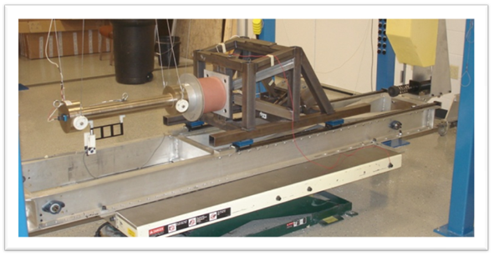
Figure 13: Example of a test equipment system with impactor and energy transfer device
3.3.1.1. Suspend the dummy impactor so that its longitudinal centreline is parallel +/- 0.5 degrees to the impactor’s line of action plane. Mount the impactor accelerometer on the end of impactor opposite to the impact face and with its sensitive axis in line with its longitudinal centreline.
3.3.1.2. Position the sled system so that the linear guide rails are parallel to the longitudinal centreline of the impactor and attach the sled fixed mass package to the dummy mounting on the sled. Mount the sled accelerometer to the sled with its sensitive axis parallel to the longitudinal centreline of the impactor.
3.3.1.3. With the impactor hanging freely, ensure that its centreline is aligned to the alignment hole on the sled impact plate. In the example in Figure 14 a detachable alignment shaft is attached to the front of the impactor. The line of action centreline shall be 0mm +/- 2mm horizontally and vertically with the impactor centreline at the point of impact when mounted to the test equipment system.

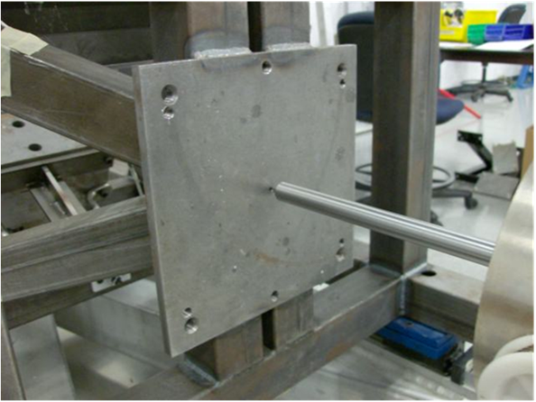
Figure 14: Impact Probe Alignment
3.3.1.4. Attach the energy transfer device to sled impact plate. The ETD side to side centreline plane shall be parallel +/- 0.5 degrees to the line of action plane of the impactor.
3.3.1.5. With the impactor hanging freely, slide the sled toward it until the energy transfer device is just touching the impactor face. Ensure the sled has at least 500 mm of unrestricted travel in the direction of flight of the impactor.
3.3.1.6. Soak all hardware in a controlled environment at any temperature between 19.0°C – 25.0°C and a relative humidity between 10 and 70 percent for not less than 4 hours prior to testing.
3.3.2. Test Equipment System Validation Test Procedure
3.3.2.1. The dummy impactor and impactor face assembly shall be released from a position to achieve a velocity, at impact with the energy transfer device, of between 4.7 m/s and 4.8 m/s. It shall be ensured that, at the instant of contact with the energy transfer device, the longitudinal plane of the impactor is +/- 0.5 degrees relative to the vertical and horizontal planes.
3.3.2.2. Determine the,
- impactor velocity,
- the impactor acceleration,
- the sled system velocity, and
- the sled system acceleration.
3.3.2.3. Wait at least 30 minutes between successive impacts on the ETD.

3.4. BioRID-II UN Dummy Certification (without Headrest)
3.4.1. The dummy certification establishes that, when conducting tests in accordance with UN Global Technical Regulation No. 7, the outputs from the dummy instrumentation are within specification.
The BioRID-II UN dummy shall be certified for use when testing for compliance with the performance values established in UNECE Global Technical Regulation No. 7 if the test conditions and the dummy response satisfy the following limits:
3.4.1.1. Test Conditions
  - The peak impactor force shall be not less than 8000 N and no more than 9700 N. The force shall be calculated by the product of the impactor mass and the impactor deceleration.
  - The peak sled acceleration shall be shall be not less than 137 m/s2 and not more than 170 m/s2.
  - The first peak sled velocity shall be not less than 2.25 m/s and no more than 2.50 m/s between 20 ms and 30 ms.
  - The sled velocity shall be no less than 2.1 m/s at 135 ms to 2.0 m/s at 140 ms and no more than 2.5 m/s at 135 ms to 2.4 m/s at 140 ms.

3.4.1.2. Dummy Response
  - The peak T1 X axis acceleration shall be 225 m/s2, +/- 42 m/s2.
  - The peak head rotation about the occipital condyle (potentiometer A) [shall be not less than 11.5 degrees and not more than 16.50 degrees] [shall be 12.6 degrees, +/- 2.5 degrees (12.1 / 15.1)], occurring between 25 ms and 70 ms.
  - The peak head rotation must also be between 2 degrees and -9 degrees between 125 ms and 135 ms.
  - The peak neck link rotation (potentiometer B) shall be not less than 4.00 degrees and no more than 6.5 degrees between 18.5 ms and 28.5 ms.
  - The peak neck link rotation (potentiometer B) must also be no less than -30.0 degrees between 98 ms and 108 ms, no less than -29.0 degrees between 165 ms and 175 ms and at no time should the data be more than -36.0 degrees.
  - The T1 rotation (potentiometer C) must be no less than -16.5 degrees between 73 ms and 78 ms and at no time be more than -19.0 degrees.
  - The total head rotation, the sum of head rotation (potentiometer A) and neck link rotation (potentiometer B), shall be not less than -25.0 degrees between 100 ms and 110 ms and between 170 ms and 190 ms and shall be not more than -41.0 degrees between 100 ms and 190 ms.
  - The total thoracic rotation, the sum of T1 rotation (potentiometer C) and lower spine rotation (Pot D), shall be not less than -10.0 degrees between 125 ms and 135 ms and shall be not more than -21.0 degrees.
  - The maximum upper neck moment (My) shall less than 17.8 Nm and more than 7.7 Nm between 20 ms and 35 ms.
  - • The minimum upper neck moment (My) shall less than -23.5 Nm and more than -15.0 Nm between 66.0 ms and 83.0 ms.
3.4.2. Pre-Test preparation
3.4.2.1. Ensure that:

3.4.2.1.1. There is no accelerometer block mounted at the C4 location – this is not to be fitted in the BioRID-II UN dummy,

3.4.2.1.2. The spinal bumpers are within the serviceable age limits (paragraph 3.1.)

3.4.2.1.3. The dummy assembly and its components have been verified as BioRID-II UN compliant (Appendix 1)

3.4.2.1.4. The dummy jacket has been validated within the last year prior to performing this test.

3.2.4.4.5. The dummy has no damage, loose or missing screws, loose or missing bumpers, etc.
3.4.2.2. Remove the arms and the lower torso assembly and attach the torso to the dummy mounting plate on the sled.
3.4.2.3. Remove the head and, using the machined sled track rail as a zero reference, verify the lateral angle of the occipital condyle plate is less than +/-0.5 degrees. Adjust dummy position if necessary.
3.4.2.4. Install upper neck load cell (if not already in the dummy) and reattach the head with the long occipital condyle pin to attach potentiometer A. Attach potentiometer A and potentiometer B to the dummy between T1 and the occipital condyle pin (Figure 15). Attach potentiometer C to opposite side of the T1 pin (Figure 16). Tighten the nut against the potentiometer collets to keep them from rotating during the test.

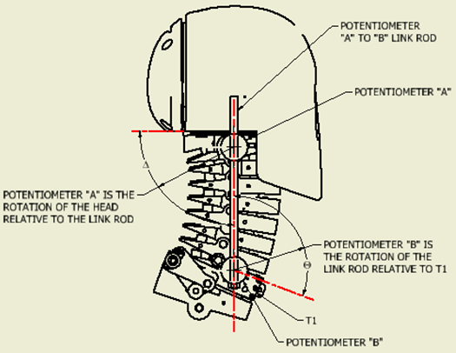
Figure 15: Potentiometer A and B locations.
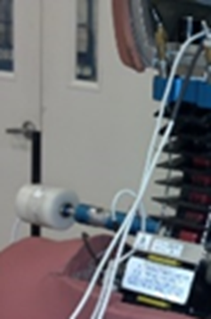
Figure 16: Potentiometer C location.

3.4.2.5. Install an “X” axis accelerometer to the T1 load cell shown in Figure 17
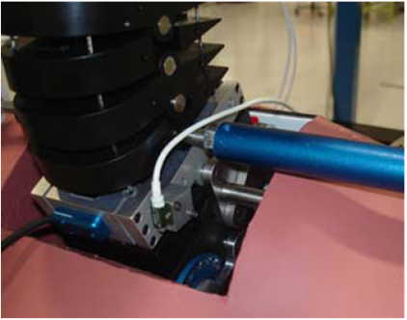
Figure 17: X-axis accelerometer attachment

3.4.2.6. Prepare the sled system and dummy impactor as described in paragraph 3.3.1. above.
3.4.2.7. Level the fore and aft inclination of the head to less than +/- 0.5 degrees (Figure 18).

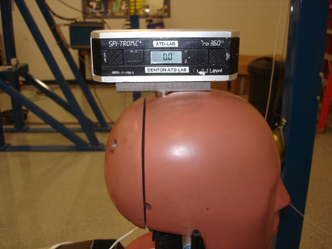

Figure 1: Head Setup Angle
3.4.2.8. Soak all hardware in a controlled environment at any temperature between 20.6°C - 22.2°C and a relative humidity between 10 and 70 percent for not less than 4 hours prior to testing.

3.4.3. BioRID-II UN Certification Test Procedure
3.4.3.1. The sled system shall be impacted as described in paragraph 3.3.2. above.
3.4.3.2. Determine the,
- impactor acceleration,
- sled system acceleration,
- T1 acceleration,
- Location A, B, D and D potentiometer values, and
- Upper neck My values
3.4.3.3. Time zero of the test is defined as the time of contact between the impactor, and the ETD.
3.4.3.4. Wait at least 30 minutes between successive impacts on the same dummy or ETD.

3.5. Jacket Validation Procedures
3.5.1. The jacket validation test shall be completed annually and establishes that the material stiffness of the torso remains within specification.
The jacket validation is intended for monitoring purposes only. The test shall be valid if, when the anterior surface of the jacket is impacted,
  - The peak impactor acceleration is not less than 1110N and not more than 1360N. The force shall be calculated by the product of the impactor mass and the impactor deceleration.
  - The peak sled system acceleration is not less than 15.0 m/s² and not more than 18.6 m/s².
  - The peak sled system velocity is not less than 0.375 m/s and not more than 0.411 m/s.
While the jacket validation test is for monitoring purposes only, consideration should be given to replacing the jacket if the peak jacket compression is less than 18.3mm or more than 20.3mm.
3.5.2. Pre-Test Preparation
3.5.2.1. Suspend the jacket/pelvis impactor so that its longitudinal centreline is parallel, +/- 0.5 degrees, to its line of action plane. Mount the impactor accelerometer on the end of impactor opposite to the impact face and with its sensitive axis in line with its longitudinal centreline.
3.5.2.2. Position the sled system so that the linear guide rails are parallel to the longitudinal centreline of the impactor. Mount the sled accelerometer to the sled with its sensitive axis parallel to the longitudinal centreline of the impactor.
3.5.2.3. With the impactor hanging freely, ensure that its centreline is aligned to the alignment hole on the sled impact plate. In the example in Figure 14 a detachable alignment shaft is attached to the front of the impactor. The line of action centreline shall be 0mm +/- 2mm horizontally and vertically with the impactor centreline at the point of impact
3.5.2.4. The dummy and the test hardware shall have been in a controlled environment at a temperature of 22.0°C +/- 3.0°C, and a relative humidity between 10 and 70 percent, for not less than 4 hours prior to testing.
3.5.2.5. Remove the jacket from the dummy. The mass of the jacket, including the 15 torso attachment pins, arm pivot screws and water, shall be 21.87 kg +/- 0.26 kg.
3.5.2.6. Install the jacket onto the jacket core (Figure 19) and, using an attachment plate, attach the jacket and jacket core assembly to the impact plate of the sled. The jacket shall be mounted upside down with its posterior surface facing the sled, as shown in Figure 20.
Figure 19: Jacket Core Assembly
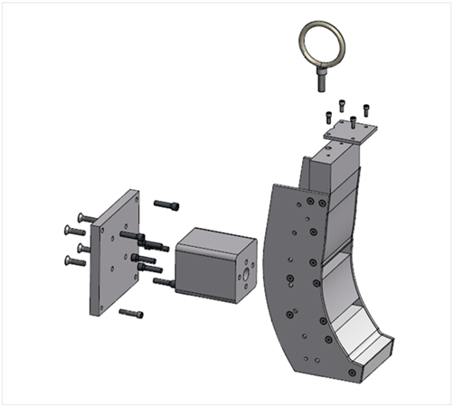

Figure 20: BioRID Jacket Test Setup
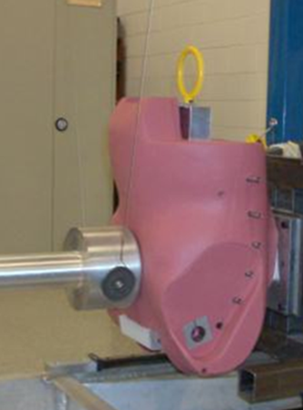

3.5.2.6.1. The jacket side to side centreline plane shall be parallel +/- 0.5 degrees to the line of action plane of the impactor and shall be within +/- 3mm horizontally from the line of action plane of the impactor.
3.5.2.6.2. The jacket pelvis interface abdomen attachment surface shall be 300mm +/- 3mm above the impactor centreline (with the impactor hanging freely).
3.5.6.2.3. The spine-torso interface pins at location T2 shall be present in the jacket for weight purposes but not used to mount the jacket to the sled.
3.5.2.7. With the impactor hanging freely, slide the sled toward the impactor until the jacket is just touching the impactor face, Figure 20. Ensure that, at this position, the sled shall have a minimum of 500mm of unrestricted forward travel.
3.5.3. Jacket Validation Test Procedure

3.5.3.1. The jacket/pelvis impactor shall be released from a position to achieve an impact velocity of between 1.50 – 1.55 m/s. It shall be ensured that the impactor is horizontal +/- 0.5 degrees at the instant of contact between itself and the jacket. The centre of the impactor face shall be within 2mm of the impact site.

3.5.3.2. Determine the:
- The impactor velocity,
- the impactor acceleration,
- the sled system velocity,
- the sled system acceleration, and
- the jacket compression.

3.5.3.3. A time interval of at least 30 minutes shall be provided between successive impacts on the same jacket.

3.6. Lower Torso Validation
3.6.1. The lower torso validation test shall be completed annually and establishes that the material stiffness of the pelvis remains within specification.
The jacket validation is intended for monitoring purposes only. The test shall be valid if, when the anterior surface of the jacket is impacted,
  - The peak impactor force is not less than 3250N and not more than 4620N. The force shall be calculated by the product of the impactor mass and the impactor deceleration.
  - The peak sled system acceleration is not less than 36 m/s² and not more than 48.9m/s²

While the lower torso validation test is for monitoring purposes only, consideration should be given to replacing the lower torso if the peak jacket compression is less 17.8 mm or more than 19.5mm.

3.6.2. Pre-Test Preparation
3.6.2.1. Prepare the sled system and lower torso impactor as described in paragraphs 3.5.2.1. to 3.5.2.3. above.
3.6.2.2. The dummy and the test hardware shall have been in a controlled environment at a temperature of 22.0°C +/- 3.0°C, and a relative humidity between 10 and 70 percent, for not less than 4 hours prior to testing.
[Should it be filled with water during the soak?]
3.6.2.3. Remove the lower torso from the dummy. The mass of the pelvis assembly, including the femurs, shall be 7.995 kg +/- 0.045 kg. - TBD
3.6.2.4. Using the lower torso test fixture (Figure 21), attach the assembly to the sled impact plate with the posterior surface uppermost (Figure 22). The assembly includes all the components shown in Figure 23.

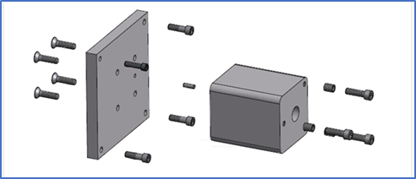
Figure 21: Lower torso Fixture Assembly

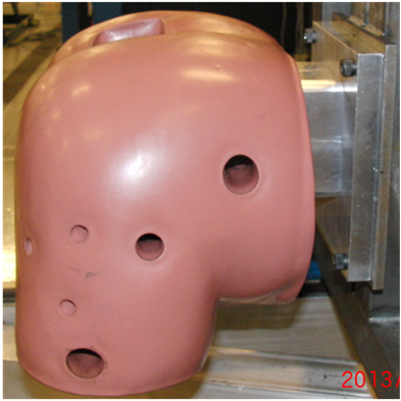
Figure 22: Lower torso orientation on the sled.

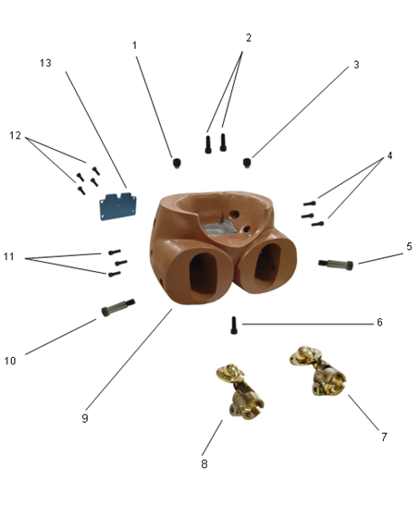
1 | 78051-259  Set Screw Assembly | 2 | 9010283  Screw, SHCS M10-1.5 x 45 | 3 | 78051-259  Set Screw Assembly
4 | 9000009  Screw, SHCS 1/4-20 x 3/4 | 5 | 9000063  Screw, SHSS 5/8 x 1-3/4 | 6 | 9010283  Screw, SHCS M10-1.5 x 45
7 | 78051-110  Femur Assembly,  Left, w/o bumper | 8 | 78051-111  Femur Assembly,  Right, w/o bumper | 9 | ARA-514  Pelvis, Moulded, RID
10 | 9000063  Screw, SHSS 5/8 x 1-3/4 | 11 | 9000009  Screw, SHCS 1/4-20 x 3/4 | 12 | 9000624  Screw, SHCS 10-24x 1/2
13 | 78051-13  Pelvic Cavity Cover
Figure 23: Lower torso assembly components

3.6.2.4.1. The lower torso side to side centreline plane shall be within +/- 3mm horizontally from the line of action plane of the impactor.
3.6.2.4.2. The front spine interface plate attachment hole centreline (figure 24) shall be positioned 23 mm +/- 3mm below the impactor centreline (with the impactor hanging freely).
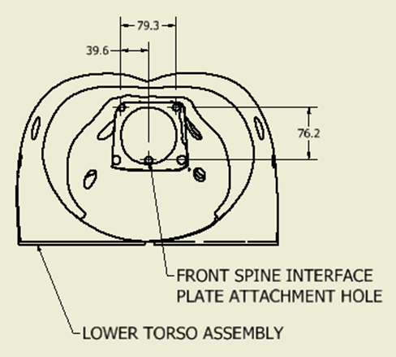
Figure 24. Lower torso assembly
3.6.2.5. With the impactor hanging freely, position the test equipment system so the lower torso is just touching the impactor face. Ensure that, at this position the sled has a minimum of 500mm of unrestricted forward travel.

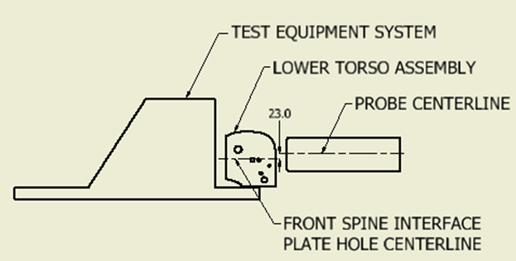
Figure 25. Lower torso test set-up.

3.6.3. Lower torso Validation Test Procedure.
3.6.3.1. The lower torso test procedure shall be as described for the jacket validation test in paragraph 3.5.3.1. above.
3.6.3.2. Determine the:
• The impactor velocity,
• the impactor acceleration,
• the sled system velocity,
• the sled system acceleration, and
• the lower torso compression.
3.6.2.3. A time interval of at least 30 minutes shall be provided between successive impacts on the same lower torso assembly.

Annex 1
This section is being reviewed for consistency, to remove proprietary references and replace manufacturer’s drawing numbers with UN Drawing numbers.
Annex 2, Appendix 1 to Appendix 9.
All engineering drawings have new title blocks with the description:
“UN: Mutual Resolution (M.R.1)”, and

UN Drawing numbers with the style:

ECE/TRANS/WP.29/1101/Add.1/Annex2/App.*/Dwg.***

There are 247 engineering drawings,

Appendix 1 contains 7 engineering drawings
Appendix 2 contains 12 engineering drawings
Appendix 3 contains 26 engineering drawings
Appendix 4 contains 44 engineering drawings
Appendix 5 contains 29 engineering drawings
Appendix 6 contains 23 engineering drawings
Appendix 7 contains 31 engineering drawings
Appendix 8 contains 55 engineering drawings
Appendix 9 contains 20 engineering drawings

New Appendix

Appendix 1 - BioRID-II UN Design Checklist

 |  | 
  BioRID-II UN Design Checklist
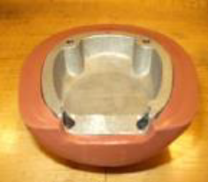
  VERIFY THE SKULL CAP IS FOR BIORID, AND THAT IT HAS THE CORRECT SIZE CABLE
  CLEARANCE SLOT.
  REFER TO GTR DWG # ARA-104, ARA-106
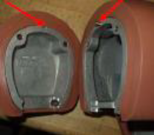 | VERIFY SKULL AND CAP CONTAINS ERROR PROOFING PIN-HOLE COMBINATION.  REFER TO GTR DWG # ARA-108, ARA-104, ARA 106
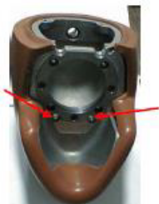 | VERIFY THE CORRECT SIZE HOLES IN THE HEAD TO CLEAR THE FRONT CABLE ADJUSTERS  (12.7 MM).  REFER TO GTR DWG # ARA-104
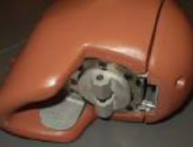 | VERIFY THE CORRECT HEAD IS INSTALLED (NON-SKULL CAP LOAD CELL VERSION).  REFER TO GTR DWG # ARA-103
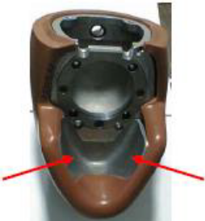 | VERIFY THE HEAD SKIN IS CUT OUT UNDER THE CHIN (NOT A H-III50M HEAD SKIN).  REFER TO GTR DWG # ARA-108 G11
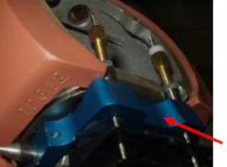 | VERIFY THAT THE OC PLATE HAS CLEARANCE FOR INSTRUMENTATION CABLES.  REFER TO GTR DWG # ARA-100 J6,G2
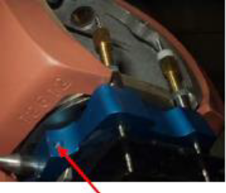 | VERIFY THE PRESENCE OF OC PIN SET SCREWS.  REFER TO GTR DWG # ARA-100 J6,G2
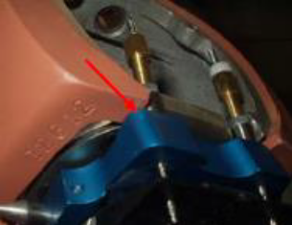 | VERIFY HEAD SKIN IS TRIMMED TO AVOID MECHANICAL LOAD PATH AROUND UPPER NECK LOAD CELL.
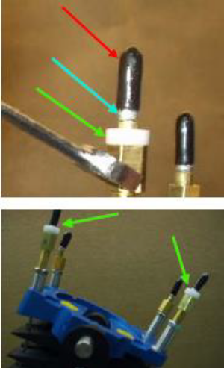 | VERIFY THAT PLASTIC CAPS AND ALUMINUM CRIMPS ARE STILL IN PLACE ON TOP OF ALL FOUR CABLES ABOVE THE ADJUSTERS IN THE HEAD, AND THAT BOTH DELRIN SLEEVES ARE IN PLACE ON BOTH MUSCLE SUBSTITUTE CABLE ADJUSTERS.  REFER TO GTR DWG # ARA-200 B5  PADI SECTION 10.1.1
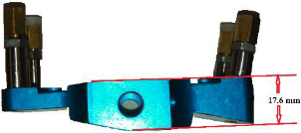 | VERIFY PROPER OC PLATE IS INSTALLED. THE THICKNESS SHOULD BE 17.6 MM. IF IS LESS THAN 17 MM, IT SHOULD BE REPLACED.  REFER TO GTR DWG # ARA-100
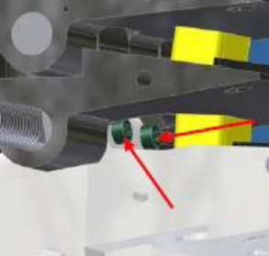 | VERIFY THAT PRESENCE OF THE M2.5 SHCS THAT LOCK THE T1 PIN IN PLACE, AND THAT THEY ARE TIGHT.  REFER TO GTR DWG # ARA-200 C8
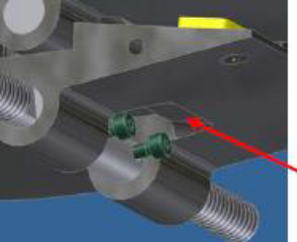 | VERIFY THAT BOTTOM OF C7 VERTABRA HAS CLEARANCE FOR T1 LOCKING SCREWS.  REFER TO GTR DWG # ARA-200 C8, ARA-208 F5, J5
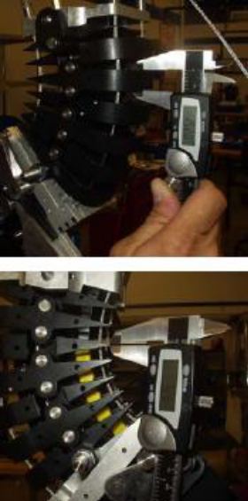 | CHECK CERVICAL VERTABRAE DIMENSIONAL  THICKNESSES FRONT (15.3 +/- 0.25mm) AND BACK (1.2 +/- 0.25mm) AND VERIFY WITH DRAWINGS  REFER TO GTR DWG # ARA-201 J5  REFER TO GTR DWG # ARA-203 J2, J6  REFER TO GTR DWG # ARA-206 J2, J6  REFER TO GTR DWG # ARA-207 J2, J6  REFER TO GTR DWG # ARA-208 J2, J6
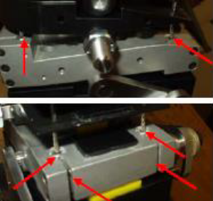 | VERIFY T1 LOAD CELL OR STRUCTURAL REPLACEMENT DESIGN WITH REMOVABLE BUSHINGS AND SLOTS TO ALLOW REMOVAL WITHOUT CUTTING CABLES  REFER TO GTR DWG # ARA-301 GLOBAL, AND  PADI SECTION 5.2.3
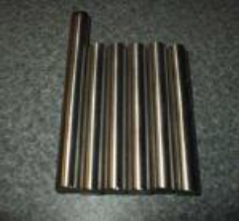 | VERIFY USE OF STAINLESS STEEL NECK PINS (WILL NOT RUST)  REFER TO GTR DWG # ARA-209, ARA-212 GLOBAL
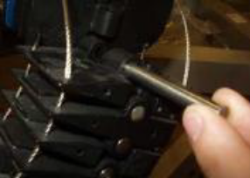 | CHECK CERVICAL VERTEBRAE HOLES WITH GAUGE PINS:  8.0000 +.0010/-.0000 mm DIA. SHOULD GO IN USING LIGHT SINGLE FINGER FORCE.  8.0300 + .0010/-.0000 mm DIA. SHOULD NOT  GO IN USING LIGHT SINGLE FINGER  FORCE.  REFER TO GTR DWG # ARA-201 H5  REFER TO GTR DWG # ARA-203 H5  REFER TO GTR DWG # ARA-206 H5  REFER TO GTR DWG # ARA-207 H5  REFER TO GTR DWG # ARA-208 H3
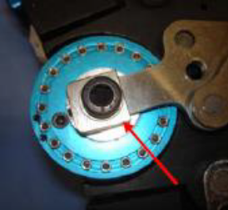 | VERIFY DAMPER (ARA-375) IS  INSTALLED, IDENTIFIED BY PRESENCE OF CLAMPING BLOCK  REFER TO GTR DWG # ARA-375 GLOBAL,  REFER TO GTR DWG # ARA-377  GLOBAL
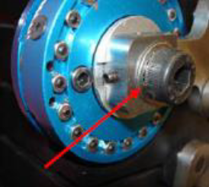 | VERIFY PRESENCE OF LOCK WASHER UNDER THE M8 DAMPER ATTACHMENT SCREW.  REFER TO GTR DWG # ARA-375 A3
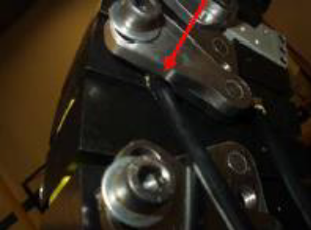 | VERIFY PRESENCE OF SLOT IN T3 TORSION PLATE FOR MUSCLE SUBSTITUTE CABLE SHEATH CLEARANCE.  REFER TO GTR DWG # ARA-319 A2  REFER TO GTR DWG # ARA-200 D3
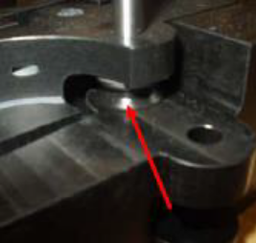 | VERIFY THE DAMPER CABLE GUIDE WHEEL IS THE CORRECT SIZE/DESIGN/REVISION.  REFER TO GTR DWG # ARA-343 GLOBAL
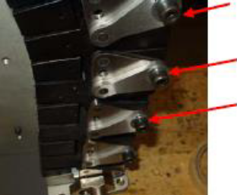 | VERIFY THE TORSION PLATE FASTENERS ARE SHCS WITH WASHERS INSTEAD OF BHCS.  REFER TO GTR DWG # ARA-200 GLOBAL, AND  PADI SECTION 5.2.4
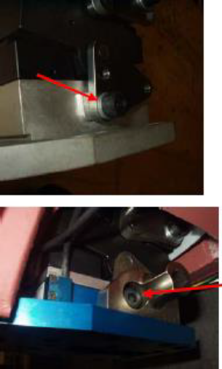 | VERIFY THAT THE S1 SCREW INCLUDES THE TENSION WASHER AND THAT THE SCREW IS TORQUED TO THE PROPER SPECIFICATION.  REFER TO GTR DWG # ARA-200 J15, AND  PADI SECTION 5.2.4
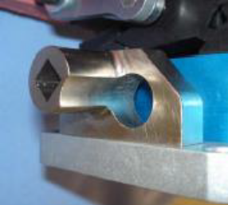 | VERIFY THE NEW DESIGN H POINT LOCATORS ARE INSTALLED  REFER TO GTR DWG # ARA-933 GLOBAL  REFER TO GTR DWG # ARA-934 GLOBAL  REFER TO GTR DWG # ARA-200 J15
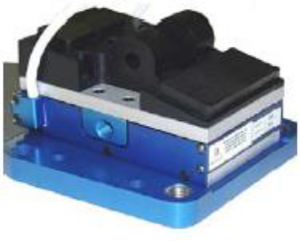 | VERIFY S1 IS PRESENT, WHICH USES A LUMBAR LOAD  CELL OR STRUCTURAL REPLACEMENT TO IMPROVE`  DURABILITY AND INTERCHANGABILITY.  REFER TO GTR DWG # ARA-562 GLOBAL,  REFER TO GTR DWG # ARA-564 GLOBAL  REFER TO GTR DWG # ARA-200 K10, AND  PADI SECTION 5.2.4
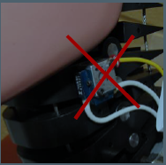 | Remove C4 Accelerometer and mount. This will cause a  load path around upper neck load cell and produce  erroneous results.
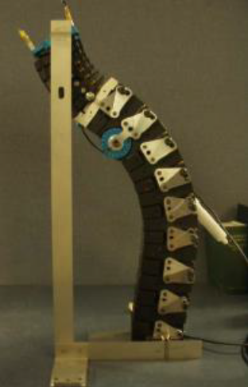 | SETUP SPINE BY CAREFULLY FOLLOWING THE SETUP  PROCEDURE.  REFER TO PADI SECTION 10.2.5
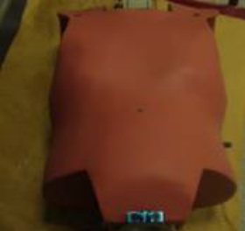 | VERIFY CORRECT JACKET VERSION (ARMS WILL HANG  STRAIGHT DOWN).  REFER TO GTR DWG # ARA-395 GLOBAL  REFER TO GTR DWG # ARA-002 GLOBAL
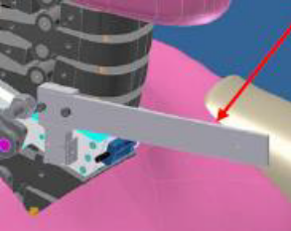 | VERIFY USE OF NEW T1 ANGLE INDICATOR ATTACHED TO ACCEL. MOUNT LOCATION  REFER TO GTR DWG # ARA-930 GLOBAL
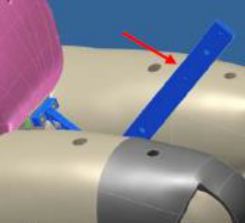 | VERIFY USE OF NEW PELVIS ANGLE INDICATOR UPDATED TO CLEAR BELT  REFER TO GTR DWG # ARA-915 GLOBAL
Appendix 2 - BioRID II Maintenance Checklist
APPENDIX 2 - BioRID II Maintenance Checklist |  | 
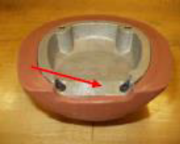
  VERIFY THE SKULL CAP IS FOR BIORID, AND THAT IT HAS THE CORRECT SIZE CABLE
  CLEARANCE SLOT.
  REFER TO GTR DWG # ARA-104, ARA-106
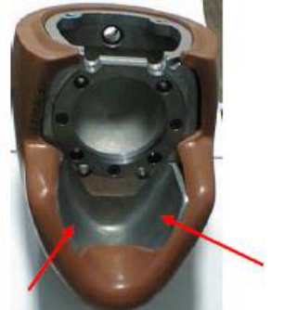
  VERIFY THE HEAD SKIN IS CUT OUT UNDER THE CHIN, UNLIKE THE HIII 50TH HEAD SKIN.
  REFER TO GTR DWG # ARA-103 GLOBAL
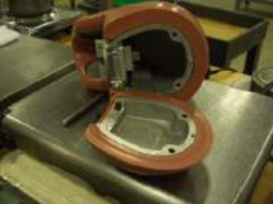
  VERIFY THE HEAD MASS ASSEMBLY WITH ACCELEROMETERS IS 4.540 +/- 0.045KB (10.000+/- 0.10LB)
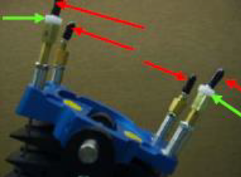
  VERIFY THAT PLASTIC CAPS ARE STILL IN PLACE ON TOP OF ALL FOUR CABLES ABOVE THE ADJUSTERS IN THE HEAD, AND THAT BOTH DELRIN SLEEVES ARE IN PLACE ON BOTH MUSCLE SUBSTITUTE CABLE ADJUSTERS.
  REFER TO GTR DWG # ARA-200 GLOBAL
  PADI SECTION 10.1.1
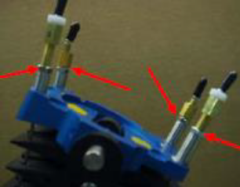
  VERIFY THAT THE 4 LOCKNUTS ON THE O.C PLATE CABLE ADJUSTERS ARE TIGHT.
  REFER TO PADI SECTION 10.1.1
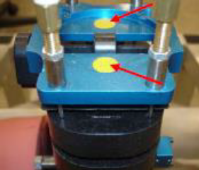
  VERIFY THE PRESENCE AND GOOD CONDITION OF LOAD CELL/O.C. PLATE BUMPERS. IF THE YELLOW O.C BUMBERS ARE COMPRESSED THE HEAD WILL ROCK. VERIFY THAT THERE IS NO PLAY BETWEEN THE O.C PLATE AND THE HEAD WHEN THE PIN IS INSTALLED. REPLACE IF
  NECESSARY.
  REFER TO GTR DWG # ARA-105 GLOBAL
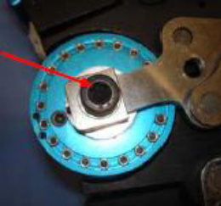
  VERIFY THAT THE M8 DAMPER MOUNTING SCREW IS TIGHT AND TORQUED TO 5 ft/lbs
  REFER TO PADI SECTION 11.5
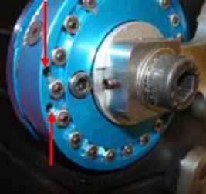
  VERIFY THAT THE DAMPER CABLE IS SECURE IN THE SLOT OF THE DAMPER BODY AND THE TWO CLAMPING SCREWS ARE TIGHTENED
  REFER TO PADI SECTION 11.5
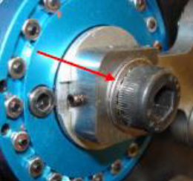
  VERIFY THAT THE SERRATED LOCK WASHER IS UNDER THE M8 DAMPER ATTACHMENT SCREW
  REFER TO GTR DWG # ARA-375 A3
  PADI SECTION 11.5
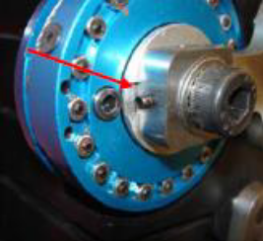
  VERIFY THAT THE DAMPER CLAMP TONGUE POSITIONED CORRECTLY IN THE SLOT
  REFER TO GTR DWG # ARA-375 GLOBAL
  PADI SECTION 11.5
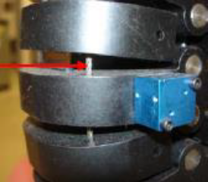
  VERIFY THAT THERE ARE NO KINKS, BENDS OR DAMAGE IN ANY OF THE CABLE ASSEMBLIES. AVOID TWISTING THE CABLES DURING THE DUMMY SETUP
  REFER TO PADI SECTION 10.1.1
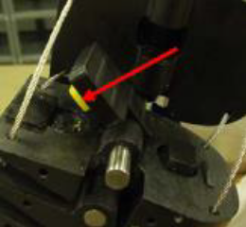
  FRONT NECK BUMPERS MUST BE REPLACED EVERY 12 MONTHS.
  REFER TO GTR DWG # TRA-086 GLOBAL
  REFER TO GTR DWG # TRA-087 GLOBAL
  REFER TO GTR DWG # TRA-088 GLOBAL
  PADI SECTION 11.1
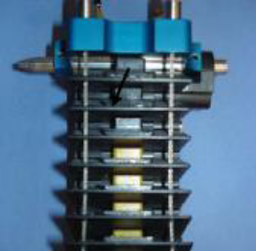
  VERIFY THE PRESENCE AND CORRECT POSITION OF ALL CERVICAL BUMPERS IN THE NECK ASSEMBLY. CHECK BOTH FRONT AND BACK.
  REFER TO GTR DWG # ARA-200 GLOBAL
  PADI SECTION 11.1
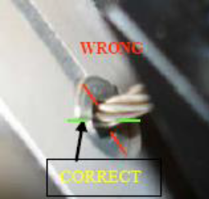
  VERIFY THAT THE T1 CABLE BUSHINGS ARE NOT CLAMPED SO THAT SPLIT BETWEEN HALVES IS PARALLEL TO SIDES OF T1, OR CABLE CAN RIDE ON THE SPLIT RESULTING IN DRAG
  REFER TO GTR DWG # ARA-301 GLOBAL
  PADI SECTION 10.2.2
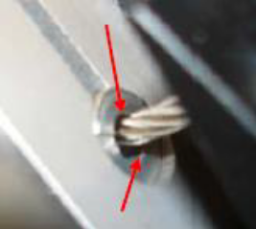
  CHECK TO SEE IF THERE IS EXCESSIVE WEAR ON THE T1 CABLE BUSHINGS RESULTING IN AN OVAL APPEARANCE
  REFER TO PADI SECTION 10.2.2
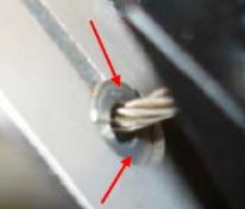
  VERIFY THAT THE SPLIT BUSHINGS ARE TIGHT IN THE REPLACABLE T1 LOAD CELL
  REFER TO PADI SECTION 10.2.2
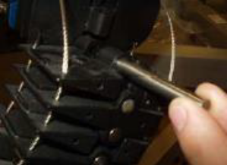
  CHECK CERVICAL VERTEBRAE HOLES WITH GAUGE PINS:
  8.0000 +.0010/-.0000 mm DIA. SHOULD GO IN USING LIGHT SINGLE FINGER FORCE.
  8.0300 + .0010/-.0000 mm DIA. SHOULD NOT
  GO IN USING LIGHT SINGLE FINGER FORCE.
  REFER TO GTR DWG # ARA-201 H5
  REFER TO GTR DWG # ARA-203 H5
  REFER TO GTR DWG # ARA-206 H5
  REFER TO GTR DWG # ARA-207 H5
  REFER TO GTR DWG # ARA-208 H3
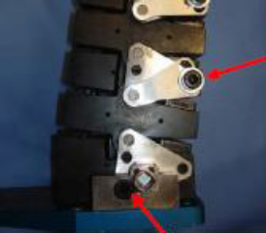
  VERIFY THAT ALL TORSION PLATE FASTENERS ARE TIGHT, BOTH SIDES OF THE DUMMY.
  INCLUDING THE LOWEST LUMBAR SCREW NOTED WITH AN ARROW.
  REFER TO GTR DWG # ARA-200 GLOBAL
  PADI SECTION 10.2
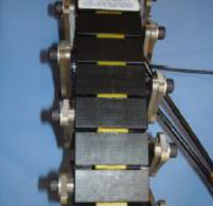
  VERIFY THE PRESENCE AND CORRECT POSITION OF ALL BUMPERS IN THE THORACIC AND LUMBAR AREA. CHECK BOTH FRONT AND BACK OF SPINE.
  REFER TO GTR DWG # ARA-200 GLOBAL
  PADI SECTION 5.2.4.1
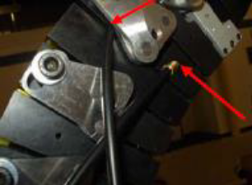
  VERIFY THAT THE MUSCLE SUBSTITUTE CABLE FERRULES ARE GLUED INTO THE T3 VERTEBRA AND NOT LOOSE.
  REFER TO GTR DWG # ARA-200 GLOBAL
  PADI SECTION 5.2.2
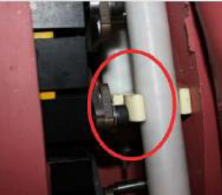
  VERIFY THAT THE SPRING HOUSING HOLDER DOES NOT RIDE UP OVER THE END OF THE ADJACENT SHCS.
  REFER TO PADI SECTION 5.2.2
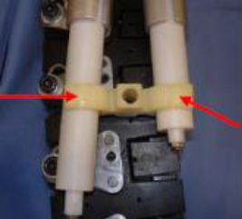
  CHECK TO SEE IF THE SPRING HOUSING
  COUPLING IS DEFORMED ALLOWING THE HOUSINGS TO SNAP OUT
  REFER TO PADI SECTION 5.2.2
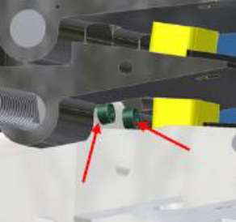
  VERIFY THAT THE M2.5 SHCS THAT LOCK THE T1 PIN IN PLACE ARE TIGHT.
  REFER TO GTR DWG # ARA-200 C8
  PADI SECTION 5.2.3.1
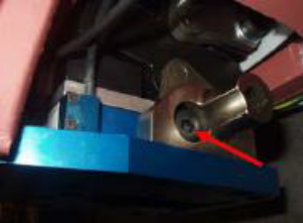
  VERIFY THAT THE S1 SCREW INCLUDES THE TENSION WASHER AND IS TORQUED TO THE PROPER SPECIFICATION.
  REFER TO GTR DWG # ARA-200 J15
  PADI SECTION 5.2.4
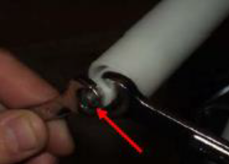
  VERIFY THAT THE 2 NUTS ON THE SPRING CABLE THREADED STUDS ARE INSTALLED AND TIGHT.
  REFER TO GTR DWG # ARA-200 GLOBAL
  PADI SECTION 10.1
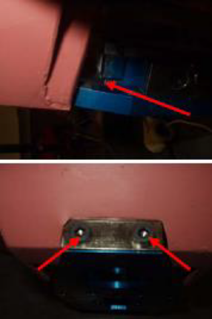
  VERIFY THAT JACKET LUMBAR PLATE IS ENGAGED IN SLOT AT BOTTOM OF S1, AND THAT M6 SCREWS ARE TIGHT.
  REFER TO GTR DWG # ARA-002
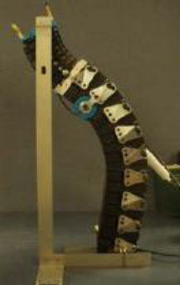
  SETUP SPINE BY CAREFULLY FOLLOWING THE SETUP PROCEDURE.
  REFER TO PADI SECTION 10.2.5
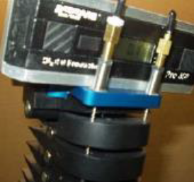
  VERIFY THAT THE LATERAL TILT OF THE O.C. PLATE IS ADJUSTED TO ZERO +/- 0.2 DEGREES RELATIVE TO THE LUMBAR PLATE, WHEN ADJUSTING THE DAMPER CABLE TENSION. VERIFY THAT THIS ADJUSTMENT WAS THE FINAL CABLE ADJUSTMENT.
  REFER TO PADI SECTION 10.2
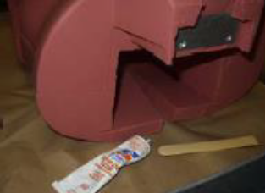
  INSPECT THE JACKET FOR ANY TEARS. MINOR REPAIRS CAN BE ACCOMPLISHED WITH RTV. FOR MAJOR TEARS THE JACKET SHOULD BE REPLACED.
  REFER TO PADI SECTION Appendix B
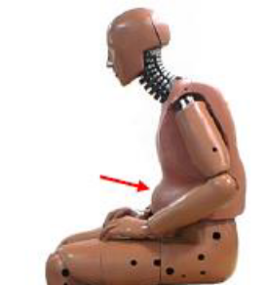
  VERIFY THE ABDOMEN CONTAINS THE CORRECT AMOUNT OF WATER, WHICH IS 2.06 LITRES (4.35 LB). WEIGHT OF JACKET, PINS, AND WATER SHOULD BE 21.87+/- .30 KG.
  REFER TO GTR DWG # ARA-395 GLOBAL
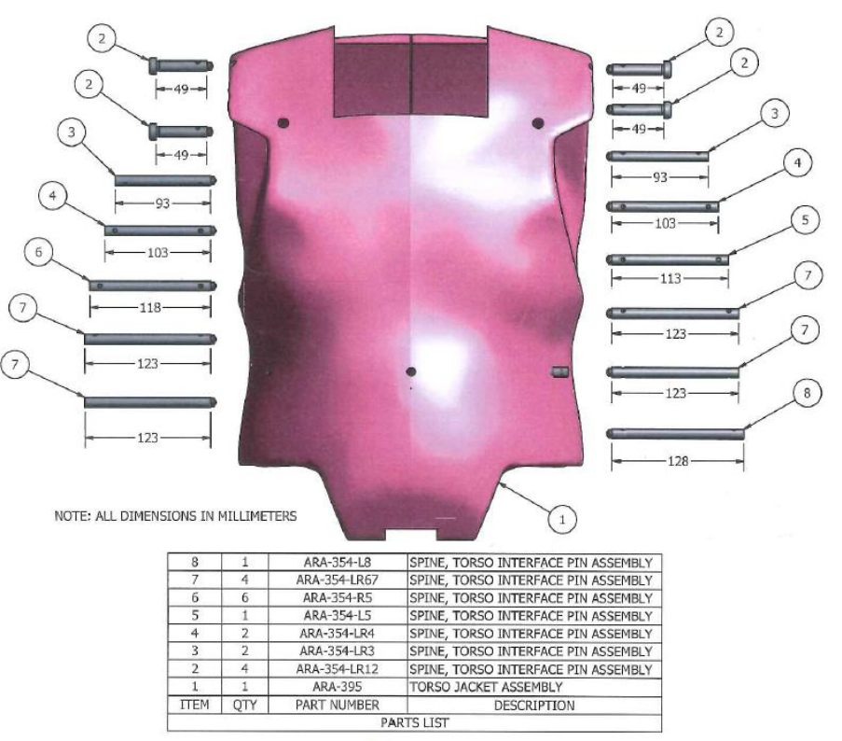

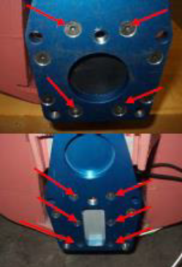
  VERIFY THE SCREWS AT THE BASE OF THE SPINE ARE TIGHTENED AFTER REINSTALLING JACKET ONTO THE SPINE.
  REFER TO GTR DWG # ARA-200 GLOBAL
  AND PADI SECTION 5.2.4
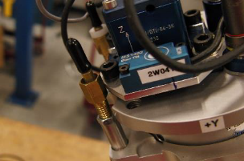
  PRIOR TO HEAD BEING INSTALLED, CHECK THE TILT SENSOR MOUNT TO ENSURE IT WILL NOT TOUCH THE CABLE ADJUSTER. THIS CAUSES A LOAD PATH AROUND THE LOAD CELL AND PRODUCES INCORRECT LOAD CELL READINGS DURING TEST. THE PICTURE TO THE LEFT SHOWS AN INCORRECT MOUNT WHICH IS TOUCHING THE CABLE ADJUSTER.
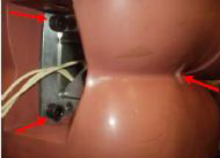
  VERIFY THE SCREWS AT THE BASE OF THE SPINE ARE TIGHTENED AFTER REINSTALLING SPINE INTO THE PELVIS.
  REFER TO GTR DWG # ARA-002 GLOBAL
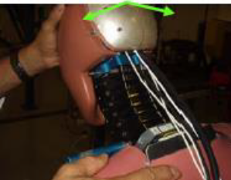
  VERIFY THAT THERE IS NO LATERAL PLAY IN THE NECK.
  REFER TO PADI SECTION 10.2.4
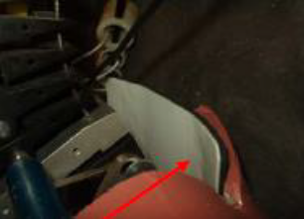
  VERIFY THE TEFLON PAD BEHIND THE DUMMY IS INSTALLED CORRECTLY AND IN THE
  CORRECT POSITION, WITH TEFLON AGAINST
  VERTEBRAE.
  REFER TO GTR DWG # ARA-002 GLOBAL
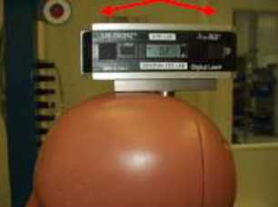
  VERIFY THAT THE SPINE ADJUSTMENT IS BALANCED SO THAT IT CAN HOLD THE HEAD AT +4 DEGREES AND
  –4 DEGREES ON THE CERTIFICATION SLED.
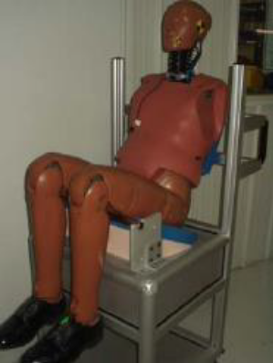
  STORE THE DUMMY WITH THE PELVIS AN JACKET SUPPORTED IN A SLIGHTLY RECLINED POSITION
  REFER TO PADI SECTION 3.1
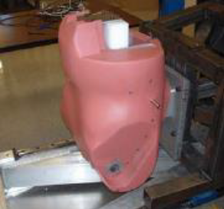
  CHECK JACKET STIFFNESS ANNUALLY WITH DYNAMIC IMPACT TEST
  REFER TO BioRID Jacket Certification Procedures
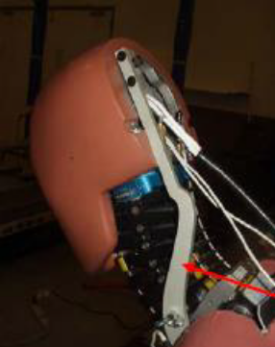
  VERIFY THAT THE NECK STABILIZING BRACKET IS BEING USED WHEN THE DUMMY IS NOT IN USE.
  REFER TO PADI SECTION 3.0
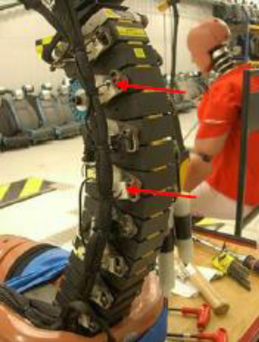
  VERIFY THAT THE INSTRUMENTATION CABLE STRAIN RELIEFS HAVE LOOPS AS CALLED OUT IN THE PADI p.14
  REFER TO PADI SECTION 7.3
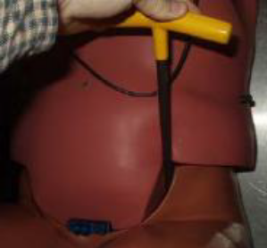
  VERIFY THAT FEMUR PLUNGERS ARE SET TO 1-2 G.
  REFER TO PADI SECTION 9.1.2
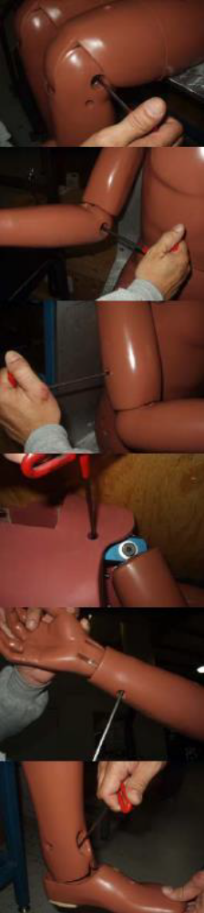
  VERIFY THAT ALL ARM AND LEG JOINTS ARE SET AT 1-2 G.
  REFER TO PADI SECTION 9.1.2
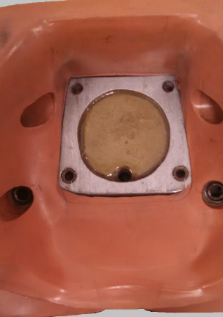
  VERIFY THAT THE PELVIS FLESH IS NOT PULLING AWAY FROM THE FRONT OF THE BONE, IF THE FLESH IS PULLING AWAY, IT IS POSSIBLE FOR THE BONE TO ROTATE WITH IN THE FLESH. THE PELVIS IS IN THE PICTURE IS OF A NORMAL PELVIS.

– Schematic and General Arrangement of Equipment

Appendix 2 – Jacket / Lower torso Compression data manipulation
TO BE ADDED

Appendix 3 – Certification Document Detail
The following detail represent the minimum information to be provided with the certification of a BioRID-II UN dummy:

- The name of the company / organisation certifying the dummy.
- The location of the facility where the certification tests were completed.
- The manufacturer’s identification number of the dummy
- The date that the certification test was completed.
- The age of the front neck bumpers (C1 – C7) and the front thoracic bumper (T1)
- The age of the remaining spinal bumpers
- The date at which the dummy requires further certification

- The peak T1 X axis acceleration
- The peak head rotation about the occipital condyle between 25 ms and 70 ms
- •The peak head rotation between 125 ms and 135 ms
- The peak neck link rotation between 18.5 ms and 28.5 ms, 98 ms and 108 ms, and between 165 ms and 175 ms
- The T1 rotation between 73 ms and 78 ms
- The total head rotation between 100 ms and 110 ms and between 170 ms and 190 ms
- The total thoracic rotation between 125 ms and 135 ms
- The maximum upper neck moment (My) between 20 ms and 35 ms.
- The minimum upper neck moment (My) between 66.0 ms and 83.0 ms.

Additionally, for monitoring purposes, the following information is required
- The peak compression of the jacket during initial validation
- The peak compression of the replacement jacket (if applicable)
- The peak compression of the lower torso assembly during initial validation, and
- The peak compression of the replacement lower torso assembly (if applicable.

