Proposal to amend document ECE/TRANS/WP.29/GRSP/2020/8
(Proposal for the 10 series of amendments to UN Regulation No. 17 (Strength of seats))
Submitted by the expert from the International Organization of Motor Vehicle Manufacturers
The text reproduced below was prepared by the expert from the International Organization of Motor Vehicle Manufacturers (OICA). The proposal aims to modify ECE/TRANS/WP.29/GRSP/2020/8 in order to clarify the test procedure for the height of head restraints in the case of vehicles having a low roof construction.
I. Proposal
Paragraph 5.6.2.3, amend to read:

"5.6.2.3. Exception

If the interior surface of the vehicle roofline, including the headliner, physically prevents a head restraint, located in the front designated seating position, from attaining the height required by paragraph 5.6.2.1. or 5.6.2.2. of this Regulation as applicable, the gap between the head restraint and the interior surface of the roofline, including the headliner, when measured in accordance with Annex 10. paragraph 2.3.3.1., shall not exceed 50 mm when the head restraint adjusted to its highest position intended for occupant use.
In case of seats fitted with integrated head restraints that cannot be adjusted in height and the head restraint would interfere with the roofline in at least one seat adjustment intended for normal occupant use, the clearance in this seat adjustment shall not exceed [10] mm. If this leads to a gap of more than 50 mm when measured in accordance with Annex 10. paragraph 2.3.3.1., then the head restraint shall conform to the requirements of paragraph 5.6.1.1.2.
However, in no instance shall the height of a head restraint located in a front designated seating position be less than 700 mm when the head restraint is adjusted to its lowest position intended for occupant use."

II. Justification
In the current proposal to transpose GTR 7 Phase 2 into UN R17, the exception rule for low roof vehicles considers only the design position (based on R-point).

It is assumed that smaller people (e.g. 5th percentile woman) will use the highest seat adjustment position with a more upright backrest on the driver seating position. In some vehicles with specific rooflines and seats fitted with integrated not height adjustable head restraints this can lead to a contact with the roof.

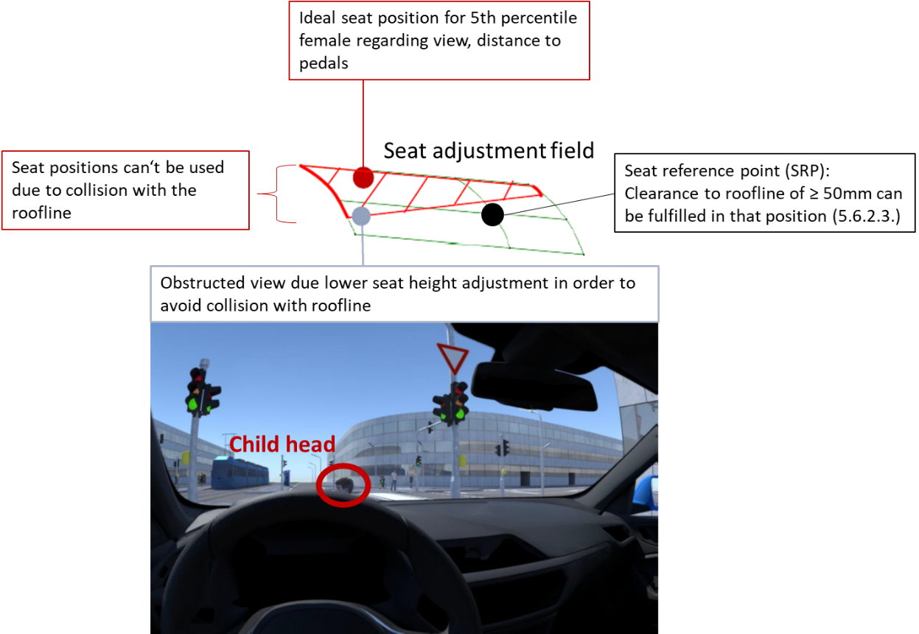

Furthermore a collision with the roof may have an impact to the easy-entry function for 2-doors vehicles with more than one seat row and to the curtain airbag deployment.

For these reasons, OICA suggests that in case of low roofline and seats fitted with integrated not height adjustable head restraints the exception rule shall be applied if there is at least one seat position affected.

