Submitted by the expert from the Netherlands | Informal document GRSP-67-05  (67th GRSP, 20-24 July 2020  agenda item 17(b))
Type Approval E20 44R 04 4013 – Braxx Smart Kid Belt
Submitted by the expert from the Netherlands
The text reproduced below has been prepared by the expert from the Netherlands referring to the procedure in the 1958 Agreement Rev. 3 Articles 4.2, 10.4 and Schedule 6 Paragraphs 2 and 3.
I. Subject
Guide strap approved as Child Restraint System under the provisions of ECE R44.04 supplement 11.

II. Introduction
Poland issued a Type Approval for the Braxx Smart Kid Belt according to ECE R44.04.
Approval number : E20 44R 04 4013
Issue date approval : 11 July 2017
Test report number : BLB.015.17H (by TS PIMOT)
Issue date test report : 27 January 2017
Supplement applicable at the time of approval : supplement 11
Date of entry into force suppl. 11 : 9 February 2017

The Netherlands have the opinion, that the Smart Kid Belt does not meet the requirements of ECE R44.04 supplement 11 and therefore approval was wrongly issued and should be withdrawn.
Poland presented informal document GRSP-66-19 during the 66th GRSP held from 10-13 December 2019 and also presented similar documents during the TCMV of 30 April 2020 and EU Forum Meeting held on 10 June 2020 to show compliance. The EU Commission held a presentation in the Forum meeting held on 10 June 2020 to indicate its position and to state that JRC is carrying out further investigation.
With this informal document, the Netherlands is seeking consensus among Contracting Parties about this approval and depending on the outcome of the discussion, will submit a request to WP.29 for arbitration under Article 10.2 and Schedule 6 Chapter 3 of the 1958 Agreement Rev. 3.

III. Summary
- The approved guide strap is out of scope of this Regulation. It is particularly stated that a guide strap cannot be approved as a Child Restraint System
- Apart from point 1, the Braxx Smart Kid Belt doesn’t meet a number of specific requirements in the Regulation
- Because there is NO positive guidance of the lap belt, the influence of the car design (location of seat belt anchorage points, the seat shape, structure and material) plays a major role in the behaviour in real life. (In comparison: a booster cushion does have positive guidance of the lap belt, which makes the location of the lower anchorage points in the vehicle less critical and effectively consistent with different car designs).
Therefore this can never be designated as UNIVERSAL.

IV. Detailed evaluation
Box with content when you order the Braxx Smart Kid Belt:
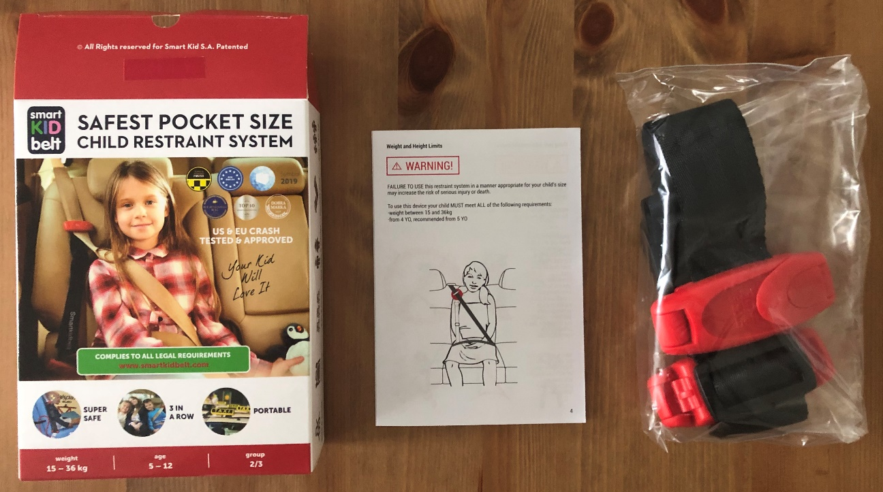
Picture 1
+ separate instruction leaflet from the Dutch importer:
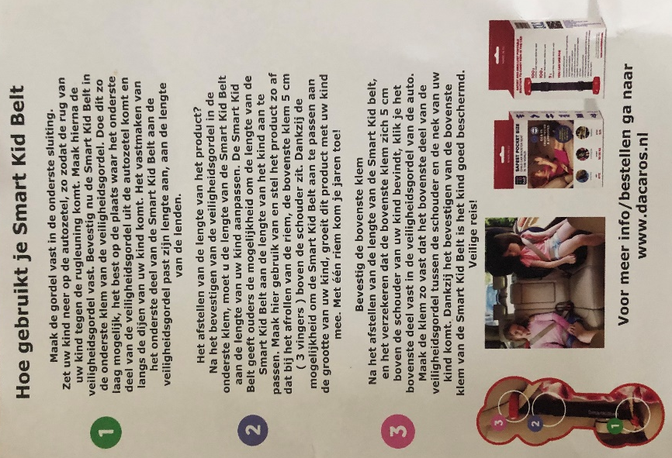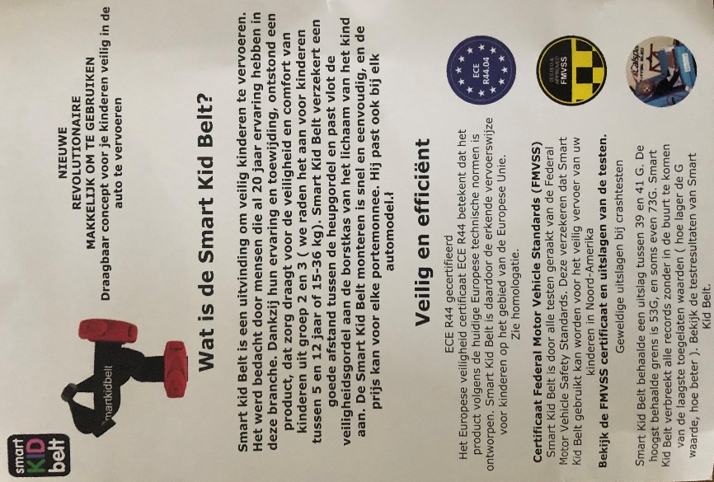
Picture 2 Picture 3

ECE R44.04 supplement 11:
2.8.8. "Guide strap" means a strap […] This guide strap is considered as a part of a child restraint system and cannot be separately approved as a child restraint system under this Regulation
Position NL: supplement 11 was in force at the time of approval and it was already obvious since December 2015 that approving of a guide strap as Child Restraint System would not be legal nor supported by Contracting Parties.
(On the agenda in WP29 (ECE/TRANS/WP.29/2016/37): June 2016 (minutes ECE/TRANS/WP.29/1123 voting 35/0/0)
Working document 2015/33 (Russian Federation) discussed in GRSP-58 (December 2015) and sent to WP.29).
Poland indicates that the approval was issued according to supplement 10. In our opinion, this is not in line with the transitional provisions that apply for supplements (see ECE/TRANS/WP.29/1044/Rev.1 applicable at the time of approval). It is clearly indicated that the supplement becomes applicable for all procedures for new approvals started after the date of its entry into force. A supplement is not an introduction of new requirements, rather a clarification of existing requirements or extension of the scope of a Regulation.

4. Markings
4.2. One of the parts made of plastics of the child restraint device (such as shell, impact shield, booster cushion, etc.), except the belt(s) or harness, shall be marked clearly (and indelibly) with the year of production.
Position NL: This design does NOT meet the requirements. On both plastic clips that are on the product as well as the regulators, there is none of the marking as mentioned in the paragraph above. The label states a LOT number LOT 19M09 on the used sample, but it is not clear to a customer that this might refer to a production year whereas at the same time, the manufacturer recommends in the owner’s manual that the product has a life span of 8 years.
4.3. If the restraint is to be used in combination with an adult safety belt the correct routing of the webbing shall be clearly indicated by means of a drawing permanently attached to the restraint. If the restraint is held in place by the adult safety-belt, the routes of the webbing shall be clearly marked on the product by colour coding. The colours for the safety-belt route to be used when the device is installed forward facing shall be red and when installed rear-facing shall be blue. Devices that can be installed rearward and forward facing without changing the belt routing (e.g. turnable system) shall use both colours. The same colours shall also be used on the labels on the device that illustrate the methods of use. […]
Position NL: This design does NOT meet the requirements. The label provided on the product is in black and white. The colour red is not present on the label. See Picture 4.
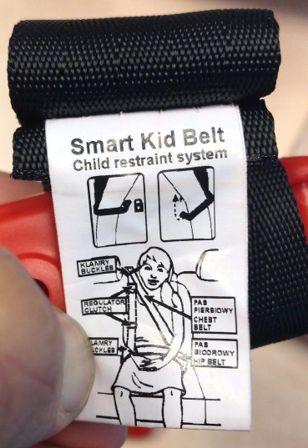
Picture 4. Instruction label as found on actual product

5. Approval
5.1. Each sample submitted in conformity with paragraphs 3.2.2. and 3.2.3. above shall meet the specifications set forth in paragraphs 6. to 8. of this Regulation in every respects before approval can be granted.
Position NL: this device only conforms to some of the requirements and is specifically out of scope of the Regulation. Therefore approval should not have been granted.
6. General Specifications
6.1.8. Child restraint systems of the "universal" category […] shall have a main load-bearing contact point, between the child restraint and the adult safety-belt. This point shall not be less than 150 mm from the Cr axis when measured with the child restraint on the dynamic test bench installed in accordance with Annex 21 to this Regulation, without a dummy. This shall apply to all adjustment configurations.
Position NL: this design does NOT meet the requirements.
On the side of the shoulder belt anchorage, the guide strap is attached to the lap portion of the belt. This could be done at any distance between Cr and the anchorage point; it is not a fixed dimension determined by the Child Seat manufacturer like in the case of a booster seat. In case of the R44 dynamic test bench this distance is 200 mm. In the instructions, the manufacturer indicates to “attach this device’s lower clip as close as possible to the car seatbelt’s anchor” so on this side 200 mm would be feasible.
But, as a main load bearing contact point, it is assumed to carry load, whereas the guide strap is not supposed to do so according to paragraph 2.8.8.
2.8.8. "Guide strap" […] This guide strap is not meant to carry a significant part of the dynamic load
On the opposite site, there is NO main load bearing contact point at all; the load bearing contact point only depends on the specific vehicle design (seat structure, material, location of lower anchorage points and length of the buckle). One should realise that the distance between lower anchorages in vehicle designs may vary from a minimum of 240 mm in a rear centre location to well over 500 mm in case of a front bucket seat.

6.2.2. […] all restraint devices utilizing a "lap strap" shall positively guide the "lap strap" to ensure that the loads transmitted by the "lap strap" are transmitted through the pelvis. The assembly shall not subject weak parts of the child's body (abdomen, crotch, etc.) to excessive stresses.
Position NL: the system uses the lap belt of the vehicle as lap strap. There is NO positive guidance of the loads by the Child Restraint System. Actually, there is negative guidance due to the connection between the lap belt and the shoulder belt. During impact the lap portion is pulled up increasing the chance of getting in the abdominal region of the child.
In real life, the location of the lap strap mainly depends on the vehicle design and therefore the weak parts of the child’s body are potentially vulnerable to excessive stresses. This is not tested, because testing is limited to a dynamic test bench which was never designed to cover all vehicle designs.

7.1.4. Testing (see test report BLB.015.17H)
Dynamic testing of the 22 kg P6 dummy
Variant 1 has been tested with a dummy that weighs 22 kg. The test pictures on page 12 show a different dummy from the P6 as described in annex 8 of UN Regulation no. 44. The joints on the hands, the back of the head and joint of its feet suggest that an older version of a six-year-old Hybrid III dummy has been used.
The six-year-old Hybrid III dummy is completely different from the P6 and will give different test results. Furthermore it does not use abdomen clay so we wonder how the assessment can be done as mentioned in the report on page 7 since it cannot be assessed on damage.
Dynamic testing of the 32 kg P10 dummy
The after-test photo on page 13 shows the P10 dummy with its feet touching the floor. This could indicate that the high floor position has been chosen instead of the low floor position. The high floor support is only to be used for test child restraint systems that use a support leg or such. Having the feet of the dummy on the floor could mean that the positioning of the dummy is compromised. Behaviour of the dummy during the dynamic test will be different.
Position NL: requests explanation of used test dummies and floor position during the tests.

Reporting (see test report BLB.015.17H)
9. Test report of type approval and production qualification.
Position NL: Test report is incomplete, does not state the minimum required data as specified under points 9.1a ~ i. e.g. the amount of head excursion per sample and the time at which point the maximum head excursion has been reached. Also the Chest Z value for production qualification testing is not given.

15. Instructions.
15.1. Each child restraint shall be accompanied by instructions in the language of the country where the device is sold with the following content:
15.2. Instructions on installation shall include the following points:
15.2.1. For "universal" category child restraints the following label shall be clearly visible at the point of sale without removing the packing:
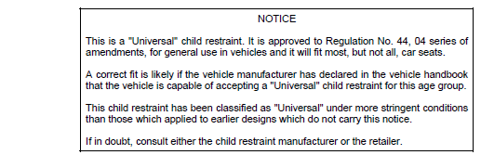
Picture 5; snap shot from UN Reg. 44

15.2.4. If the device requires an adult safety-belt, the following wording should also be clearly visible at the point of sale without removing the packing: "Only suitable if the approved vehicles are fitted with lap/3 point/static/with retractor safety-belts, approved to UN/ECE Regulation No. 16 or other equivalent standards."
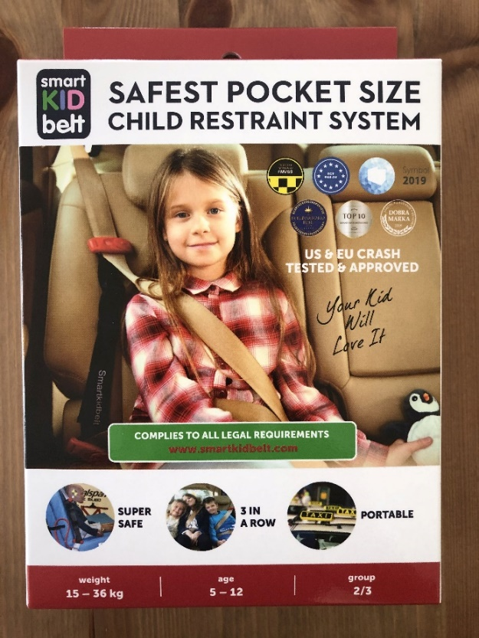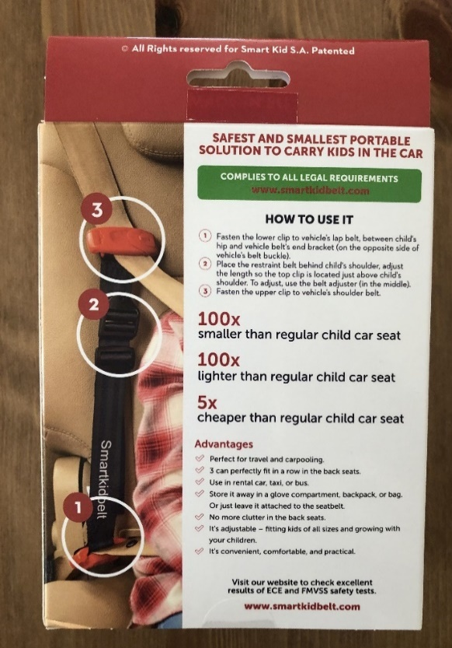
Picture 6; packing front Picture 7; packing rear
Picture 8; packing left side
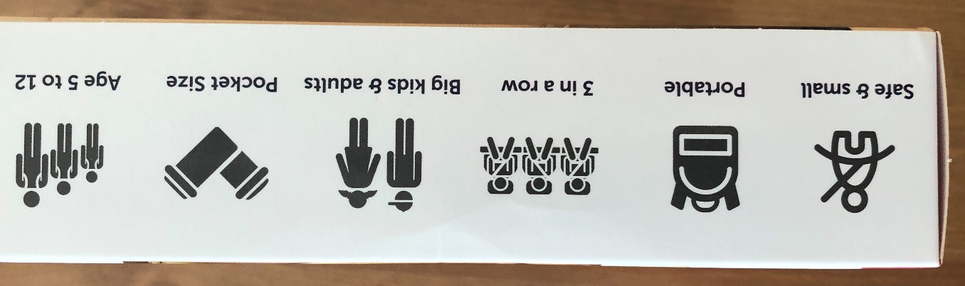
Picture 9; packing right side

Position NL: The product does NOT comply, the required label and wording are not present in the packing, and the information that is given instead is not in the language of the country where the device is sold.

V. Conclusions

- This device is out of scope of ECE R44 and therefore approval should not have been granted
- This device does not meet a number of requirements, both technical and with regard to instructions for users and therefore approval should not have been granted
- The manufacturer suggests that this device offers a level of protection similar to a child restraint and indicates it can be used for each and every type of vehicle (universal). The car design determines the level of protection for a great deal and might result in submarining and injuries in the abdominal area, since the device sold as a child restraint does not offer any protection or guidance in this area. At best, this device offers better protection than the adult belt itself, but lacks the additional protection of a child restraint system.
- Since approval of this device was issued erroneously, it shall be withdrawn and Market Surveillance Authorities shall be informed.
- The Netherlands are seeking support from other Contracting Parties and would appreciate cooperation from Contracting Party Poland to avoid having to start the arbitration process in WP.29
__________

