|  |  |  |  |
| --- | --- | --- | --- |
|  | United Nations | ECE/TRANS/WP.29/GRSP/2020/9 | |
| _unlogo | **Economic and Social Council** | | Distr.: General  20 February 2020  Original: English |

**Economic Commission for Europe**

Inland Transport Committee

**World Forum for Harmonization of Vehicle Regulations**

**Working Party on Passive Safety**

**Sixty-seventh session**

Geneva, 11-15 May 2020

Item 12 of the provisional agenda

**UN Regulation No. 127 (Pedestrian safety)**

**Proposal for the 03 series of amendments to UN Regulation No. 127 (Pedestrian Safety)**

Submitted by the expert from the European Commission on behalf of the Drafting Task Force [[1]](#footnote-2)\*

The text reproduced below was prepared by the experts of the Drafting Task Force to align the UN Regulation with the revised General Safety Regulation of the European Union – appropriate transitional provisions, and minor adaptations and clarifications to the existing requirements. The modifications to the current text of the UN Regulation are marked in bold for new or strikethrough for deleted characters.

**I. Proposal**

*Paragraph 2.1.*,amend to read:

"2.1. "*Adult headform* **bonnet** *top test area*" is an area on the outer surfaces of the front structure. The area is bounded:

(a) In the front, by a wrap around distance (WAD) of 1,700 or a line 82.5 mm rearward of the bonnet leading edge reference line, whichever is most rearward at a given lateral position;

(b) At the rear, by a WAD 2,100 or [~~a line 82.5 mm forward]~~ of the bonnet rear reference line, whichever is most forward at a given lateral position, and

(c) At each side, by a line 82.5 mm inside the side reference line.

The distance of 82.5 mm is to be set with a flexible tape held tautly along the outer surface of the vehicle."

*Paragraph 2.10.*,amend to read:

"2.10. "*Bonnet top test area*" is composed of the child headform **bonnet top** test area and the adult headform **bonnet top** test area as defined in paragraphs 2.1. and 2.16. respectively."

*Paragraph 2.16.*,amend to read:

"2.16. "*Child headform* **bonnet top** *test area*" is an area on the outer surfaces of the front structure. The area is bounded:

(a) In the front, by a WAD 1,000 or a line 82.5 mm rearward of the bonnet leading edge reference line, whichever is most rearward at a given lateral position,

(b) At the rear, by a WAD 1,700 or [~~a line 82.5 mm forward]~~ of the bonnet rear reference line, whichever is most forward at a given lateral position, and

(c) At each side, by a line 82.5 mm inside the side reference line.

The distance of 82.5 mm is to be set with a flexible tape held tautly along the outer surface of the vehicle."

*Insert new paragraphs 2.44. to 2.47.*, to read:

"**2.44. "*Windscreen test area*" is an area on the outer surface of the windscreen. It is bounded as follows:**

**(a) In the front, by a line [100] mm rearward to the opaque obscuration of the windscreen. In case of absence of the opaque obscuration, the line is measured from the front edge of the windscreen;**

**(b) In the rear, by a WAD 2,500 or a line [130] mm forward to the windscreen rear reference line (i.e. rear edge of the windscreen), whichever is more forward at a given lateral position;**

**(c) At each side, by a line [100] mm inside the opaque obscuration of the windscreen. In case of absence of the opaque obscuration, the line is measured from the side edge of the windscreen.**

**For (a) and (c), the distances of [100] mm are to be measured with a flexible tape held tautly along the outer surface of the vehicle at an angle of 90° to the tangent line to the opaque obscuration limit.**

**For (b), the distance of [130] mm is to be measured with a flexible tape held tautly along the outer surface of the vehicle at an angle of 90° to the tangent line to the rear edge of the windscreen.**

**Tests to any measuring points located in the windscreen area forward of WAD 1,700 shall be performed with the child headform impactor. Tests to any measuring points located in the windscreen area rearward of WAD 1,700 shall be performed with the adult headform impactor. For tests to any measuring points located in the windscreen area on WAD 1,700, either of the headform impactors may be used at the choice of the technical service.**

**2.45. "*Opaque obscuration*" means any area of the glazing preventing light transmission, including any solid black windscreen-printed area, but excluding any shade band, dot-printed area, text or graphics.**

**2.46. "*Shade band*" means any area of the glazing with a reduced light transmittance, excluding any opaque obscuration.**

**2.47. “*Untypical windscreen fracture behaviour*” is the situation that upon impact by the headform, the integrity of the windscreen remains for more than [1] millisecond~~s~~ without fracture, as a visual criteria of high speed videos, or which appears as an untypically lengthy peak with more than [500] m.s-2, or combination of peaks, in the time/acceleration plot for more than [3] milliseconds (examples are shown in graphs 1 and 2 of figure 12).**

**Figure 12**

**Typical and untypical fracture behaviour of mineralic glass**

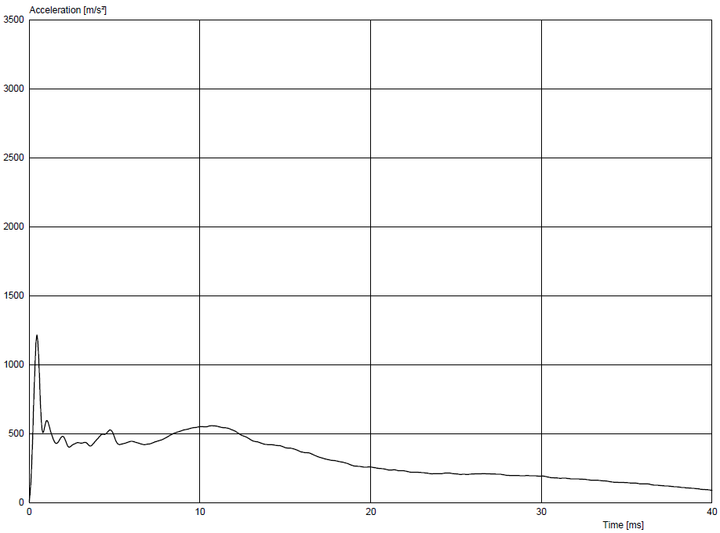

Graph 1: Example of typical behaviour with instantaneous fracturing

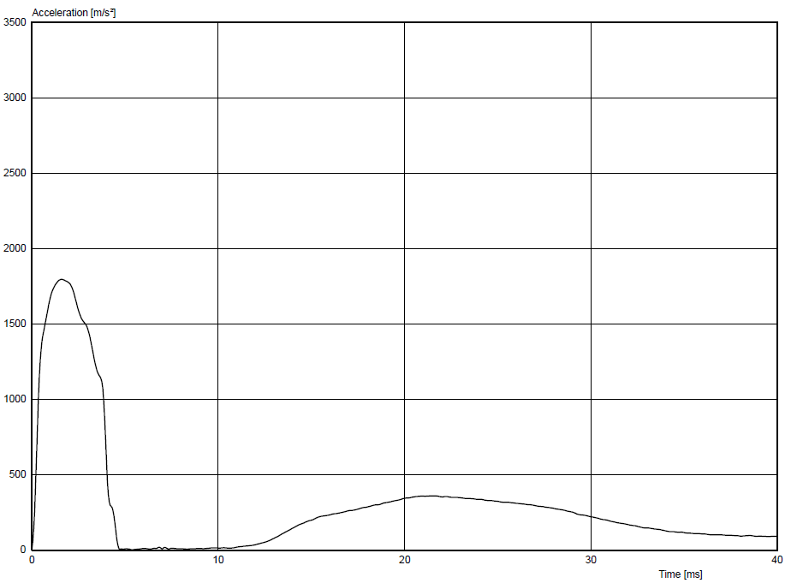

Graph 2: Example of untypical behaviour with delayed fracturing"

*Paragraph 5.2.1.*,amend to read:

"5.2.1. Child and adult headform tests:

When tested in accordance with Annex 5, paragraphs 3., 4., and 5., the HIC recorded shall not exceed 1,000 over two thirds of the **combined** bonnet top test area **and the windscreen test area. Furthermore, the recorded HIC shall not exceed 1,000 over two thirds of the bonnet top test area.** The HIC for the remaining areas shall not exceed 1,700 for both headforms.

In case there is only a child headform test area, the HIC recorded shall not exceed 1,000 over two thirds of the test area. For the remaining area the HIC shall not exceed 1,700."

*Insert new paragraphs 11.5. to 11.10.*, to read:

"**11.5. As from the official date of entry into force of the 03 series of amendments, no Contracting Party applying this Regulation shall refuse to grant or refuse to accept type approvals under this Regulation as amended by the 03 series of amendments.**

**11.6. As from 7 July 2024, Contracting Parties applying this Regulation shall not be obliged to accept type approvals to the preceding series of amendments, first issued after 7 July 2024.**

**11.7. Until 7 July 2026, Contracting Parties applying this Regulation shall accept type approvals to the preceding series of amendments, first issued before 7 July 2024.**

**11.8. As from 7 July 2026, Contracting Parties applying this Regulation shall not be obliged to accept type approvals issued to the preceding series of amendments to this Regulation.**

**11.9. As from 1 September 2028, Contracting Parties shall no longer permit the specific provisions related to untypical windscreen fracture behaviour (see Annex 5, paragraphs 4.8. and 5.8.) for the purpose of granting type-approval.**

**11.10. Contracting Parties applying this Regulation shall not refuse to grant type approvals according to any preceding series of amendments to this Regulation or extensions thereof.**"

*Annex 5, paragraphs 3.4.1. to 3.4.4.*,amend to read:

"3.4.1. The manufacturer shall identify the zones of the bonnet top test area **and of the windscreen test area** where the HIC shall not exceed 1,000 (HIC1000 zone) or 1,700 (HIC1700 zone) (see Figure 5).

3.4.2. Marking of the "bonnet top" test area**, marking of the windscreen test area** as well as "HIC1000 zone" and "HIC1700 zone" will be based on a drawing supplied by the manufacturer, when viewed from a horizontal plane above the vehicle that is parallel to the vehicle horizontal zero plane. A sufficient number of x and y co-ordinates shall be supplied by the manufacturer to mark up the areas on the actual vehicle while considering the vehicle outer contour in the z direction.

3.4.3. The areas of "HIC1000 zone" and "HIC1700 zone" may consist of several parts, with the number of these parts not being limited. The determination of the impacted zone is done by the measuring point.

3.4.4. The calculation of the surface of the bonnet top testarea **and the calculation of the surface of the windscreen test area** as well as the surface areas of "HIC1000 zone" and "HIC1700 zone" shall be done on the basis of a projected bonnet **and windscreen** when viewed from a horizontal plane parallel to the horizontal zero plane above the vehicle, on the basis of the drawing data supplied by the manufacturer."

*Annex 5, paragraphs 4.1. to 4.3.*,amend to read:

"4.1. Tests shall be made to the front structure within the boundaries as defined in paragraph 2.16. of this Regulation. **Test shall also be made to the windscreen within the boundaries as defined in paragraph 2.44.** For tests on the rear area of the bonnet top, the headform impactor shall not contact the windscreen or A-pillar before impacting the bonnet top. **For tests on the windscreen, the headform impactor shall not directly contact the A-pillars, windscreen header and cowl, except in the case of monitoring testing.**

4.2. A minimum of nine tests shall be carried out with the child headform impactor **together** to the bonnet top test area **and on the windscreen test area**, three tests each to the middle and the outer thirds of the child/small adult **~~bonnet top~~** test areas, at positions judged to be the most likely to cause injury. **Where possible, at least three of these nine tests shall be carried out on the windscreen test area.**

**For each test on the windscreen, an undamaged and untested windscreen shall be used.**

Tests shall be to different types of structure, where these vary throughout the area to be assessed and at positions judged to be the most likely to cause injury.

4.3. The selected measuring points for the child/small adult headform impactor shall be a minimum of 165 mm apart and within the child headform test area**s** as defined in paragraph**s** 2.16. **and 2.44** of this Regulation."

*Annex 5, paragraph 4.5.*,amend to read:

"4.5. For the child headform testing, a longitudinal and transversal impact tolerance of ±10 mm shall apply. This tolerance is measured along the surface of the bonnet **or the windscreen.** The test laboratory may verify at a sufficient number of measuring points that this condition can be met and the tests are thus being conducted with the necessary accuracy."

*Insert a new paragraph 4.8.*, to read:

"**4.8. In case of untypical windscreen fracture, which shall only be considered where there is no direct or indirect local headform contact with any interior fittings or other structural components and where the HIC value exceeds the respective zone’s limit, the technical service shall repeat the test upon the manufacturer’s request. The test(s) with untypical windscreen fracture shall also be duly recorded in the test report**."

*Annex 5, paragraphs 5.1. to 5.3.*,amend to read:

"5.1. Tests shall be made to the front structure within the boundaries as defined in paragraph 2.1. of this Regulation. **Test shall also be made to the windscreen within the boundaries as defined in paragraph 2.44.** For tests at the rear of the bonnet top, the headform impactor shall not contact the windscreen or A-pillar before impacting the bonnet top. **For the tests on the windscreen, the head form impactor shall not directly contact the A-pillars, windscreen header and cowl, except in the case of monitoring testing.**

5.2. A minimum of nine tests shall be carried out with the adult headform impactor **together** to the bonnet top test area **and on the windscreen test area**, three tests each to the middle and the outer thirds of the adult **~~bonnet top~~** test areas, at positions judged to be the most likely to cause injury. **Where possible, at least three of these nine tests shall be carried out on the windscreen test area.**

**For each test on the windscreen, an undamaged and untested windscreen shall be used.**

Tests shall be to different types of structure, where these vary throughout the area to be assessed and at positions judged to be the most likely to cause injury.

5.3. The selected measuring points for the adult headform impactor shall be a minimum of 165 mm apart and within the adult headform test area**s** defined in paragraph**s** 2.1. **and 2.44** of this Regulation."

*Annex 5, paragraph 5.5.*,amend to read:

25.5. For the adult headform testing, a longitudinal and transversal impact tolerance of ±10 mm shall apply. This tolerance is measured along the surface of the bonnet **or the windscreen**. The test laboratory may verify at a sufficient number of measuring points that this condition can be met and the tests are thus being conducted with the necessary accuracy."

*Insert a new paragraph 5.8.*, to read:

"**5.8. In case of untypical windscreen fracture, which shall only be considered where there is no direct or indirect local headform contact with any interior fittings or other structural components and where the HIC value exceeds the respective zone’s limit, the technical service shall repeat the test upon the manufacturer’s request. The test(s) with untypical windscreen fracture shall also be duly recorded in the test report.**"

*Insert a new paragraph 5.9.*, to read:

"**5.9. Where, in case of a collision with a pedestrian or bicyclist, the A-pillars, windscreen header and/or cowl are physically covered (partly or wholly, optionally or as standard equipment) by any form of active protection (e.g. external airbag, deployable structure), monitoring tests shall be carried out.**

**In this case the measuring points on the A-pillars, windscreen header and/or cowl shall be selected as agreed between the technical service and the manufacturer so that the effectiveness of the protection can be scientifically assessed. For that purpose it is not required to observe the prescribed clearance distances or exclusion areas.**

**The vehicle manufacturer may also voluntarily request for monitoring tests to be carried out in case of any other innovative solutions that reduce head injury levels in case of head contact with A-pillars, windscreen header and/or cowl.**

**A detailed description of the protective system, the selected measuring points and the results of the assessment shall be included in the information document.**"

II. Justification

1. This proposal will allow contracting parties to apply an enlarged head impact zone for regulatory compliance testing.
2. The extended head impact zone is requested due to the entry into force of the revised General Safety Regulation (EU) 2019/2144 that will apply as from 7 July 2024 for new types of vehicle and 7 July 2026 for all new vehicles.
3. Various Task Force meetings, attended by interested stakeholders and contracting parties, were organized to discuss the proposal. In addition, workshops to validate and support the proposal were arranged as in addition to face to face and web meetings.
4. Following the above meetings and the obligations laid down in the revised General Safety Regulation, a methodology was agreed that would enlarge the head impact zone, while excluding headform contact with the A-pillars, windscreen header and cowl.
5. The issue of untypical breakage of mineral glass with late fracturing and (very) high deceleration values has been addressed by a temporary provision allowing retesting and providing the respective industries with sufficient lead time to improve these properties of windscreen glazing.
6. Special provisions have been added to require monitoring of the tests of any areas currently not covered by the defined enlarged headform test zone, e.g. external airbags.
7. The proposal also makes minor adaptations and clarifications to the existing requirements.

1. \* In accordance with the programme of work of the Inland Transport Committee for 2020 as outlined in proposed programme budget for 2020 (A/74/6 (part V sect. 20) para 20.37), the World Forum will develop, harmonize and update UN Regulations in order to enhance the performance of vehicles. The present document is submitted in conformity with that mandate. [↑](#footnote-ref-2)