|  |  |  |  |
| --- | --- | --- | --- |
|  | United Nations | ECE/TRANS/WP.29/GRSG/2020/31 | |
| _unlogo | **Economic and Social Council** | | Distr.: General  27 July 2020  Original: English |

**Economic Commission for Europe**

Inland Transport Committee

**World Forum for Harmonization of Vehicle Regulations**

**Working Party on General Safety Provisions**

**119th session**

Geneva, 6-9 October 2020

Item 10 of the provisional agenda

**UN Regulation No. 125 (Forward field of Vision for Drivers)**

Proposal for Supplement 2 to the 01 series of amendments to UN Regulation No. 125 (Forward field of vision of drivers)

Submitted by the expert from the International Organization of Motor Vehicle Manufacturers[[1]](#footnote-2)\*

The text reproduced below was prepared by the expert from International Organization of Motor Vehicle Manufacturers (OICA) to amend ECE/TRANS/WP.29/GRSG/2020/11 to exempt foldable/adjustable partitioning systems. It is based on document GRSG-118-26. The modifications to the current text of the UN Regulations are marked **in bold**.

I. Proposal

*Paragraph 1.1.,* amend to read:

“1.1. This Regulation applies to the 180° forward field of vision of drivers of category M1 **and N1** vehicles.[[2]](#footnote-3)”

*Paragraph 1.3.,* amend to read:

“1.3. The requirements of this Regulation are so worded as to apply to category M1 **and N1** vehicles in which the driver is on the left. In category M1 **and N1** vehicles in which the driver is on the right these requirements shall be applied by inverting the criteria, when appropriate.”

*Insert a new Paragraph 2.19.,* to read:

“**2.19. "*Partitioning System*" means parts or devices which in addition to the seat backs, are intended to protect occupants from displaced luggage.**”

*Paragraph 5.1.3.,* amend to read:

“5.1.3.  Except as provided in paragraph 5.1.3.3. or 5.1.3.4. **or 5.1.3.5.** below, other than the obstructions created by the "A" pillars, the fixed or movable vent or side window division bars, outside radio aerials, devices for indirect vision, covering the mandatory field of indirect vision, and windscreen wipers, there shall be no obstruction in the driver’s 180° forward direct field of vision below a horizontal plane passing through V1, and above three planes through V2, one being perpendicular to the plane X‑Z and declining forward 4° below the horizontal, and the other two being perpendicular to the plane Y‑Z and declining 4° below the horizontal (see Annex 4, appendix, figure 4).

…”

*Insert a new Paragraph 5.1.3.5.,* to read:

“**5.1.3.5.  An obstruction created by a partitioning system towards the passenger side will be tolerated if the partitioning system is adjustable and if, in its normal position of use as declared by the manufacturer, no obstruction in the driver’s 180° forward direct field of vision is present. The vehicle owner’s manual shall indicate the normal position of use.**”

II. Justification

1. EU Regulation (EU) 2018/858 Annex I Part A, Section 3 “Criteria for the categorization of vehicles in category N” includes specific requirements in paragraphs 3.2. to 3.4. on securing of load. In small N1 vehicles these requirements are met by foldable/adjustable partitioning systems. The full application of UN Regulation No. 125 to this vehicle category will remove the possibility of such systems. A prohibition of such systems may lead some users to switch to larger vehicles.

2. The above proposal adds the definition of partitioning system as it is defined in UN Regulation No. 126 and an allowance for foldable/adjustable partitioning systems to partially obstruct the driver’s field of view.

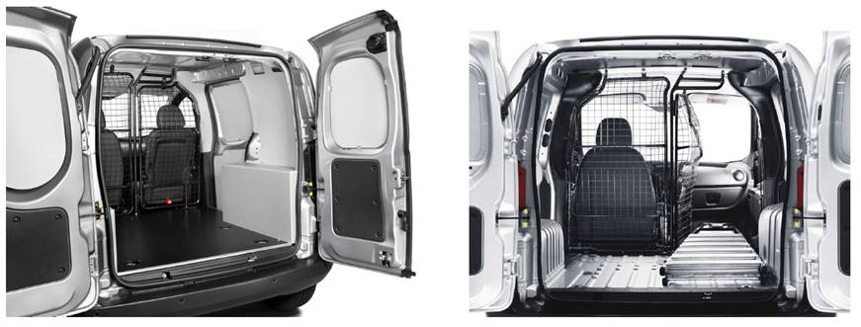

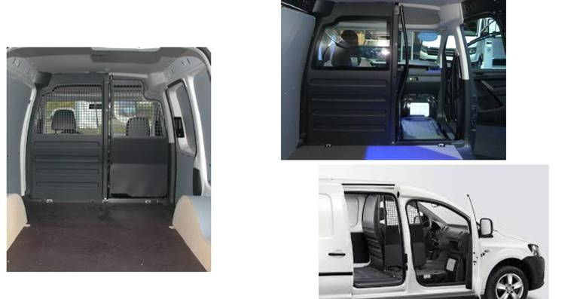

1. \* In accordance with the programme of work of the Inland Transport Committee for 2020 as outlined in proposed programme budget for 2020 (A/74/6 (part V sect. 20) para 20.37), the World Forum will develop, harmonize and update UN Regulations in order to enhance the performance of vehicles. The present document is submitted in conformity with that mandate. [↑](#footnote-ref-2)
2. As defined in the Consolidated Resolution on the Construction of Vehicles (R.E.3.), document ECE/TRANS/WP.29/78/Rev.6, para. 2. - www.unece.org/trans/main/wp29/wp29wgs/wp29gen/wp29resolutions.html [↑](#footnote-ref-3)