EQUIVALENCE CRITERIA

GUIDE FOR SPECIFYING LED REPLACEMENT LIGHT SOURCE CATEGORIES  
AS EQUIVALENTS FOR CORRESPONDING FILAMENT LIGHT SOURCE CATEGORIES

# **1. INTRODUCTION**

At their seventy-eight session GRE decided to establish a task force (TF S/R) addressing the topics of LED Substitute light sources and LED “Retrofit” light sources.

In the subsequent GRE sessions TF S/R had presented proposals for the LED Substitute light sources – type-approved according to Regulation No. 128 – accompanied by amendments to the device and installation regulations, which are enforced in the meantime.

In a second step TF S/R addressed “Retrofits” as LED Replacement light sources to be type-approved according to Regulation No. 37 for administrative reasons. As LED Replacement light sources are intended to replace the corresponding filament versions in vehicles-in-use they have additional equivalence requirements compared to the LED Substitute light sources. This document describes the full set of equivalence criteria and gives guidance for the specification of new LED replacement light source categories in Regulation No. 37.

This document is submitted to the eighty-third session of GRE for adoption as GRE reference document.

# **2. COMPARING FILAMENT LAMPS AND LED LIGHT SOURCES**

Several electrical, geometrical, photometrical and thermal parameters should be specified to describe equivalence between the LED Replacement light sources and the filament light sources of the corresponding categories in Regulation No. 37.

2.1. Parameters, which are not inherently linked to the light generation technology, should be the same, for example test voltage, luminous flux, colour and light centre length. The maximum outline dimension is linked to the incandescent technology and should remain the same, too.

2.2. In filament light sources densely coiled tungsten wires form the light emitting area, whereof the shape (≈ cylindrical) and the radiation pattern show limited variations in practice. In LED based solutions the light emitting area can be quite diverse in terms of size and homogeneity; as well the radiation characteristics can significantly vary depending on the individual design. Therefore, this type of parameters of LED Replacement light sources should be similar to the behaviour of corresponding filament light sources.

2.3. In comparison to filament light sources certain parameters of LED light sources are different due to the distinct principle of light generation. With LED technology the same amount of light is usually generated with significantly less energy compared to incandescent technology, and the spectral composition (infrared versus visible radiation, but also within the visible range) differs between both technologies.

2.4. Further, the different technology of light generation makes it necessary to consider additional requirements. In case of LED solutions the photometrical values are usually quantified under initial “cold” and stabilized “hot” conditions in order to control the emission behaviour in changing thermal situations.

Based on these facts the parameters to which these equivalence criteria apply are grouped into four sets of criteria (“same”, “similar”, “different” and “additional”) and described in the following section.

# **3. REQUIREMENTS FOR EACH RELEVANT PARAMETER**

3.1. Parameters with the same values

The following parameters of an LED replacement light source category should be the same as in the data sheet of the corresponding filament light source category, including the tolerances:

3.1.1. Cap

Geometric cap dimensions relevant for interchangeability, e.g. for connecting to the electrical supply, and mechanically retaining the source in the holder, should be the same.

Geometric cap dimensions – not relevant for interchangeability – may have a deviating specification. The maximum allowed deviation(s) should be specified in the corresponding data sheet.

3.1.2. Maximum lamp outline dimensions

3.1.3. Electrical connector

3.1.4. Test voltage

3.1.5. Objective luminous flux

In case different luminous flux values are given for 12V- and 24V-version of the counterpart filament light source, the 12V-value should be applied to both versions of the LED replacement light source.

*Note: The 24V-version of filament light sources have usually a larger filament (longer filament wire), which is compensated by a higher luminous flux value to achieve same beam performance. This is also reflected by the fact that type-approvals of 24V devices are done with 12V standard light sources.*

3.1.6. Colour of emitted light

Note: The definitions of the colours are given Regulation No. 48.

Restrictions apply for certain white LED replacement light source categories (see section 3.3.5.)

3.1.7. Light centre length

3.1.8. Distortion free zone (if any)

In case a distortion free zone is specified for a filament light source category, this should be reflected in the specifications of the normalized luminous intensity distribution (see section 3.2.1.) of the corresponding LED replacement light source category.

3.2. Parameters with similar values

The normalized luminous intensity distribution (“far field”) as well as the emission behaviour, the homogeneity of the light-emitting-area and – in case of application in road illumination devices – the contrast (“near field”) of the LED replacement light source should be similar to the characteristic of the filament light source of the corresponding category.

3.2.1. Normalized luminous intensity distribution

The normalized luminous intensity distribution of LED Replacement light sources should be specified in directions which are relevant for the light emission of filament light sources of the corresponding category.  
Therefore, minimum and maximum intensity values (in cd/1000 lm) should be given in the category sheet, typically in representative C-planes* and in representative angular steps , excluding the following distorted areas of filament light sources of the corresponding category:

* transition region of the cap;
* proximity of the filament axis;
* area of strong glass distortions (tips);
* shading area of lead-in wires.

All values (intensity limits, relevant directions) should be derived from measurements of homologated filament light source samples of the corresponding category (see Annex 1A for categories used in light signalling devices only and Annex 1B for categories also used in road-illumination devices). The selection of samples should include various possible designs of different manufacturers.

*\* C-planes: see CIE publication 70-1987, "The measurement of absolute intensity distributions".*

3.2.2. Size and position of the light-emitting-area

A box definition including the relevant viewing direction(s) of the corresponding filament light source data sheet, if any, should apply for the size and position of the (apparent) light-emitting-area of the LED replacement light source. Depending on the geometrical circumstances ~~[~~under which the box is defined in the corresponding filament light source data sheet~~]~~ additional viewing directions(s) may need to be introduced.

In case different box dimensions are given for 12V- and 24V-version of the counterpart filament light source, the 12V-dimensions should be applied to both versions of the LED replacement light source (see also note under 3.1.5.). In addition, a minimum percentage value of the luminous flux emitted from this box into the given viewing direction(s) should be specified in the data sheet (see parameter DFR in Annex 2). This value should be derived from measurements of homologated filament light source samples of the corresponding category (see Annex 2). The selection of samples should include various possible designs of different manufacturers.

3.2.3. Homogeneity of the light-emitting-area

The box defined under 3.2.2. should be split in representative sections and limits for the luminous flux emitted from each section into the given viewing direction(s) should be specified to achieve a level of homogeneity comparable to the filament case, where usually minimum and maximum limits of filament dimension and position per category exist (see Annex 3A for categories used in light signalling devices only and Annex 3B for categories also used in road-illumination devices).

3.2.4. Contrast of the light-emitting area (only for categories also used in road-illumination devices)

The minimum contrast, specified as the ratio of the luminous flux emitted from the box defined under 3.2.2. and the luminous flux emitted from a representative area at a specified distance should be derived from measurements of homologated filament light source samples of the corresponding category (see Annex 4). The selection of samples should include various possible designs of different manufacturers.

3.3. Parameters with different values

The following properties are inherently different between filament and LED Replacement light sources. The equivalence criteria have to be described appropriately:

3.3.1. Electrical power consumption

The typical electrical power consumption (and electrical current draw) of LED light sources is significantly lower compared to filament light sources (e.g. at a level of about 30 percent or less) due to the highly-efficient way of light generation.

As the typical level of power consumption of filament light sources – even if not regulated – is used to detect failures in some functions/vehicles, the benefit of high-efficiency (i.e. low power consumption) could create issues (see section 4.x.). For this reason additional power consumption (i.e. higher power consumption level) should be required in cases where failure detection systems (or OBD systems) make it necessary.

As a consequence, LED Replacement light sources should be specified in two “versions” with respect to electrical power consumption and electrical current draw:

* a default version with a minimum power consumption of 40-50% - typically larger than the maximum power consumption of the high-efficiency version – to serve failure detection systems of vehicles-in-use.
* a so-called high-efficiency version with a maximum power consumption of about 30% – or even less – compared to the corresponding filament light source

As a consequence, the default version requires:

* the specification of a maximum cap temperature, which corresponds to the maximum cap temperature of the corresponding filament light source (see 3.3.4.)
* the optional use of non-integrated electronics (AE device) due to the impact of increased thermal load and/or required space

3.3.2. Dependency of the luminous flux on the applied voltage

The luminous flux of filament light sources depends significantly on the applied voltage; no electronics is integrated to cope with voltage variations. Due to their technology LED light sources are always driven by electronics, which can be used to limit the luminous flux – voltage dependency.

The minimum voltage range and the corresponding luminous flux tolerances given in Annex 6 of Regulation No. 37 should be used as a default for electrical and photometrical tests of LED replacement light sources.

3.3.3. Dependency of the luminous flux on elevated ambient temperatures

While for filament light sources the luminous flux is usually independent on the ambient temperature, LED light sources have a technology-inherent dependency, which can be compensated – within limits – by additional cooling efforts and/or additional electronic measures.

This drawback of LED technology should be evaluated in conjunction with the voltage-dependency (3.3.2.) to achieve equivalent “real-world criteria”. The total (combined) effect of both types of dependency should be similar for filament light sources and the corresponding LED replacement light sources.

In Annex 5 an consideration is given for the situation of light sources used in passing and driving beam applications. Corresponding estimations should be carried out for other relevant applications. Representative requirements per application are given in Table 1:

|  |  |  |
| --- | --- | --- |
| LED replacement light source categories used in … | Luminous flux requirement | |
| Elevated ambient temperature | Minimum required luminous flux (relative to flux measured at 23°C) |
| Passing and driving beam | 60°C | ≥ 75% * |
| Rear lighting | 50°C | (≥ 75%) ** |
| Front Direction Indicator | 80°C | (≥ 75%) ** |
| … |  |  |

**Table 1: temperature test requirement for the luminous flux of LED replacement light sources**

* in combination with a flux-voltage dependency of ±10% at 12V (see Annex 5)

** given an appropriate voltage dependency (t.b.d.)

3.3.4. Cap temperature

Even the LED technology is typically more efficient than the filament technology it should be ensured that the cap temperature of the LED replacement light source is not exceeding the level of the corresponding filament light source at the relevant location as indicated per category. Therefore, a maximum value should be specified for the default version. Due to the low limit for the maximum power consumption (see 3.3.1.) the high-efficiency version can be excluded from this requirement.

3.3.5. The spectral content

Uncoloured filament light sources have a balanced spectral distribution corresponding to correlated colour temperature values in the range of 2,500 – 3,500 K. Red or amber lenses of certain light-signalling devices have spectral transparencies, which are adapted to this inherent filament light source property.

Therefore, LED replacement light source categories emitting white light and possibly being operated behind red or amber cover lenses should have a correlated colour temperature specification of maximum 3,000 K.

3.4. Additional parameters

As there are special properties of LED light sources due to the way the light is generated, LED replacement light sources should be subject to additional criteria.

3.4.1. Thermal run-up behaviour

The thermal behaviour of the emitted luminous flux after one minute of operation and after 30 minutes of operation should be in accordance with Regulation No. 37, annex 6.

3.4.2. PWM operation

3.4.2.1. PWM operation to stabilize the applied voltage

In some light functions/vehicles Pulse-Width-Modulation (PWM) of the applied voltage is used to stabilize (i.e. to slightly reduce) the voltage at the terminal of the light source at the level of the test voltage. As investigations on popular [European] vehicle models show, PWM frequencies of 100 Hz or higher (below 200 Hz) are used and the typically duty cycle is 90 percent or higher (corresponding to typical board net fluctuations).

While the light output of filament light sources is hardly modulated (due to the thermal inertia of the filament) under the relevant PWM frequencies, the light output of LED light sources can easily follow even higher frequencies. From the CIE investigation on “Visual Aspects of Time-Modulated Lighting Systems” (CIE TN 006:2016) it can be estimated that under the above mentioned PWM operation conditions no significant visible effects are expected for LEDs.

Nonetheless, interferences between the PWM signal and inappropriate light source electronics might lead to disturbing visible effects or malfunction of LED Replacement light sources. Therefore, the light output of LED replacement light sources should not exhibit critical frequency components (i.e. lower than the applied PWM frequency) when the worst-case PWM parameters (i.e. frequency of 100 Hz, duty cycle of 90 percent) are applied (see R37 proposal, section 3.4.7.5.).

3.4.2.2. PWM operation to dim light sources

There are two applications known where single filament light sources are used to address two functions, one at nominal light output level and another one at dimmed light output level:

* combination of DRL and front position lamp
* combination of stop lamp and rear position lamp

Thereby, dimming of filament light sources is usually realized by a PWM voltage signal with a duty-cycle of 55% to 65% leading to an output ratio of 5:1 to 10:1 needed for the above mentioned combination of functions.

As filament light sources show a different luminous flux - voltage dependency than LED light sources, there should be a requirement added to the data sheet of the relevant LED light source categories (e.g. P21W, W16W) to guarantee a comparable light output under the relevant PWM conditions. Based on the above mentioned filament behaviour, the light output of LED replacement light sources should be 15% ± 5% of the luminous flux measured at DC test voltage when a PWM signal of 60% duty cycle is applied.

3.4.3. Polarity

Different to filament technology LED technology is sensitive to the polarity of the applied voltage. Basically, additional electronics integrated in the LED light source cap could solve this issue. However, there are some categories where either the limited cap size does not allow additional electronic components and/or the cap-connector design enables the reversed insertion (i.e. an easy circumvent of the issue).

Therefore, the polarity requirement should be chosen category by category and the data sheet of the corresponding LED replacement light source category should unambiguously specify the polarity conditions. For example, a one-way-polarity would be sufficient for categories like C5W and W5W, while categories like P21W or R5W require proper functioning in both polarity situations.

# **4. REQUIREMENTS REGARDING FAILURE**

It should be noted that failure detection systems are mandatory for direction indicator lamps in all vehicles-in-use, while such systems are equipped in other functions to some extent on a voluntary base. Further, failure detection systems and on-board diagnostic systems are not or hardly specified by regulations or by standards from officially recognised international standardisation organisations. In particular the electrical detection threshold is not publicly known or standardized.

Due to significantly reduced power consumption of LED technology, some failure detection systems of vehicles-in-use will give a false failure indication. In case the detection threshold for the electrical current draw (and hence for the power consumption) is too high the vehicle would indicate a failed LED replacement light source even though it is working normally.

Relevant information for vehicles-in-use with respect to electrical power consumption (ref. to 3.3.1.), but also with respect to applied PWM signals (ref. to 3.4.2.1.) can be achieved by vehicle studies (see Annex 6).

4.1. Failure detection

All LED replacement light source categories should have a default setting with a minimum power consumption being able to serve the vehicles-in-use having high detection thresholds, e.g. for light source categories used in low-beams a value of 27 W respectively 2000 mA.

Due to the significant number of vehicles-in-use having no failure detection systems (excluding direction indicators) or having a sufficiently low detection threshold, most of the LED replacement light source categories should implement an option for a high-efficiency (= low power) version with a specified maximum power.

4.2. Failure behaviour

A criterion per category should reflect the situation that a LED replacement light source may consist of more than one light emitting element and a clear detection of malfunction is possible. Example: “Either the LED replacement light source complies with luminous flux and intensity requirements, or it stops emitting light and the electrical current drops below a specified limit”.

# **5. DOCUMENTATION**

The proposal for LED replacement category sheet(s) should be accompanied by information showing the equivalence with the corresponding filament light source category. Measurements of anonymised samples of filament light source to derive equivalent performance should be included. See also Annex 7.

# **ANNEXES**

**Annex 1A**

**Clarification of the requirements to the normalized luminous intensity distribution (categories used light-signalling devices)**

The normalized luminous intensity distribution of homologated filament light source samples typically exhibits bulb-to-bulb variations due to the specific design, i.e. due to non-regulated parameters (glass thickness variations, shape of glass bulb, coiling structure of filament, etc.) and/or tolerances (filament position, lead-in wire position). Further, “distorted” areas (design of lead-in wires and their relative position to the filament, proximity of filament axis, transition region of the cap, glass tips) lead to extreme variations in specific angular regions.

However, straight filaments generate quite similar emission patterns in the directions of major light emission, i.e. more or less perpendicular to the filament axis (e.g. +/- 30°).

Therefore, the specification of equivalent radiation characteristics of LED Replacement light sources is limited to the directions of relevant light emission of the corresponding filament light source excluding “distorted” areas.

Depending on the specific filament light source category, the excluded areas are different. Figure 1 shows representative examples of transversal and axial filament positions and limitations of the directions where light emission of the LED replacement light source should be specified.

|  |  |  |
| --- | --- | --- |
|  | *Orientation of C-planes* | *Angular limitation of  in C0-plane* |
| *Example P21W* | *top view* |  |
| *Example H21W* | *top view* |  |

**Figure 1: representative examples of filament positions and limitations of the directions where light emission of the LED replacement light source should be specified**

**Annex 1B**

**Clarification of the requirements to the normalized luminous intensity distribution (categories used in road-illumination devices)**

The normalized luminous intensity distribution of homologated filament light source samples typically exhibits bulb-to-bulb variations due to the specific design, i.e. due to non-regulated parameters (glass thickness variations, shape of glass bulb, coiling structure of filament, etc.) and/or tolerances (filament position, lead-in wire position). Further, “distorted” areas (design of lead-in wires and their relative position to the filament, proximity of filament axis, transition region of the cap, glass tips) lead to extreme variations in specific angular regions.

However, straight filaments generate quite similar emission patterns in the directions of major light emission, e.g. +/- 45° around the vertical line to the filament axis.

Therefore, the specification of equivalent radiation characteristics of LED Replacement light sources is limited to the directions of relevant light emission of the corresponding filament light source excluding “distorted” areas.

Depending on the specific filament light source category (e.g. axial versus transversal filament alignment or single versus dual filament with or without shield), the excluded areas are different. 

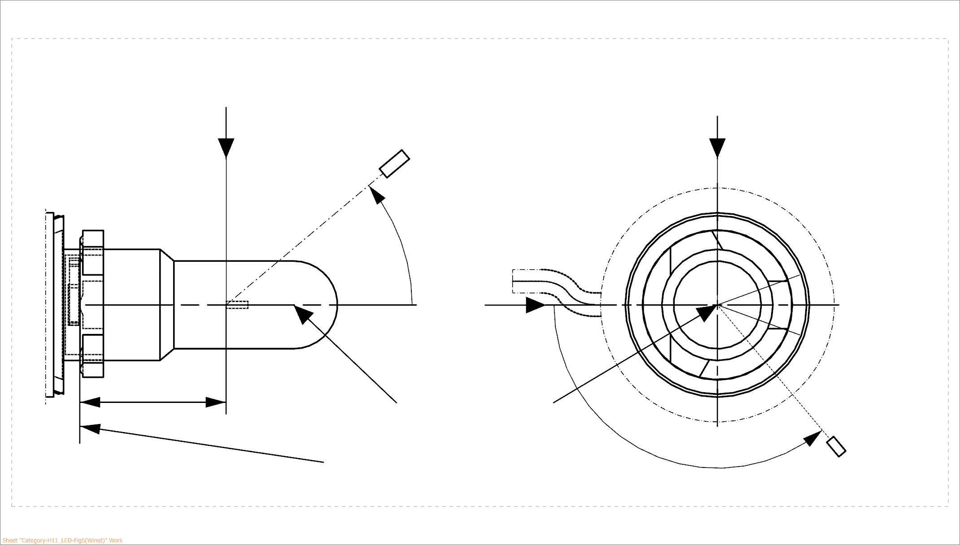

25,0

***View from B***

***View from C***

Reference plane

Reference axis

**B**

**A**

C = 270°

C = 90°

C = 180°

**C**

C = 0°

****

**A**

Photo-Detector of Goniometer

**Figure 2 – Definition of C-Planes and angle  for an example of a** **single filament light source with axial filament alignment**

Figure 2 shows an example of a single filament light source with axial filament alignment. The normalized luminous intensity distribution is specified in three C-planes (C = 0°, C = 90°, C = 270°) in an angular range covering the distortion free area, which is typically given in the category sheet of the corresponding filament light source by the angles 1 and 2 (note: the C-plane oriented to the lead-in wire (C = 180°) is excluded).

Additionally, the normalized luminous intensity distribution is specified at  = 90° in several C-planes separated by e.g. 30° (C = 0°, C = 30°, C = 60°, …) excluding the shading region due to the lead-in wire (C = 180°), which extends typically over a range of +/-30°, when various possible designs of different manufacturers are taken into account.

In case a black top is specified for the corresponding filament light source (typically given by the angle 3 in the category sheet of the corresponding filament light source) an upper limit on the normalized luminous intensity distribution applies, e.g. in the corresponding angular range ( = 0° … 3) of the four C-planes (C = 0°, C = 90°, C = 180°, C = 270°).

If a selection of samples including various possible designs of different manufacturers is measured the values of the normalized luminous intensity typically varies between [80] and [130] cd/1000 lm, due to glass tubular thickness variations and the coiling structure of the corresponding filament light sources. In the same way the normalized luminous intensity in the range of the black-top is typically below [10] cd/1000 lm for the selection of samples.

**Annex 2**

**Clarification of the definition of a minimum light emission of the defined box**

The luminous flux emitted from a filament light source is not solely emitted from the filament. Scattered and reflected light from coatings, lead-in wires, etc. contribute to the emission characteristics.

Therefore, the definition of an equivalent minimum percentage is defined for LED Replacement light sources on the basis of measurements of homologated filament light source samples of the corresponding category.

In figure 3 two examples of an amber filament light source (PY21W) are shown. One sample made of amber glass has a high percentage of direct light emission (~ 90%; i.e. only minor reflections due to the lead-in structure and the ghost images) whereas the second sample using an amber coating has a lower percentage of direct light emission (~70%; due to additional haze from the coating material). Hence, based on given examples of PY21W filament light sources in figure 3 the minimum percentage value of the luminous flux emitted from the box into the given viewing direction(s), the so-called Direct-Flux-Ratio DFR, could be set to 80%.

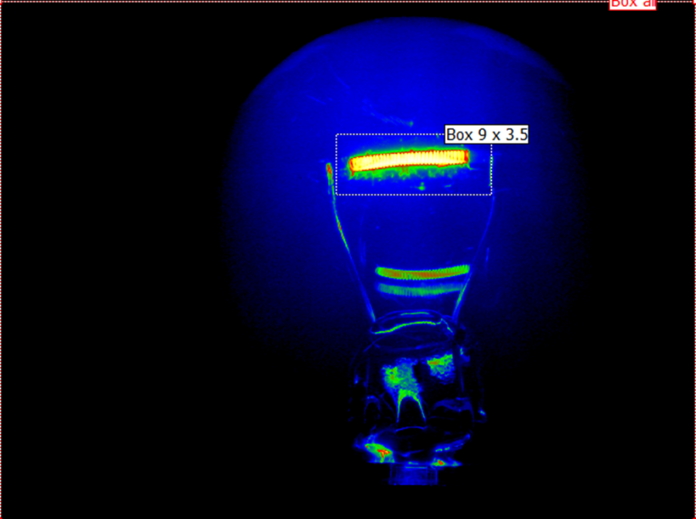

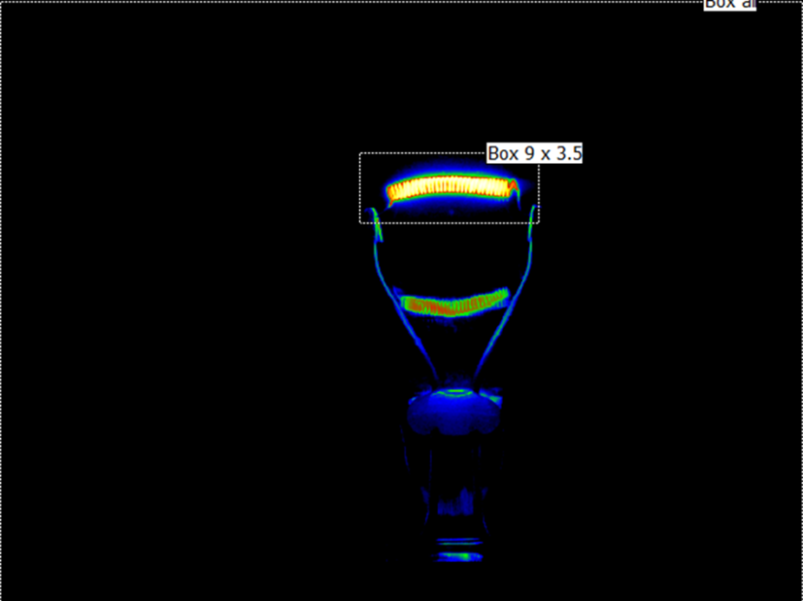

**Figure 3: PY21W-samples with amber glass (left) and with amber coating (right)**

Figure 4 shows an H11 as an example of a single filament Halogen light source with axial filament alignment. Measurements of samples of different manufacturers show that this kind of light sources has high percentage of direct light emission showing only little variations (typical between 85% and 90% for uncoated versions).

Hence, the Direct-Flux-Ratio DFR of LED Replacement light sources being the counterpart light sources of Halogen light sources with an axially aligned, single filament could be set to 90%, in general.

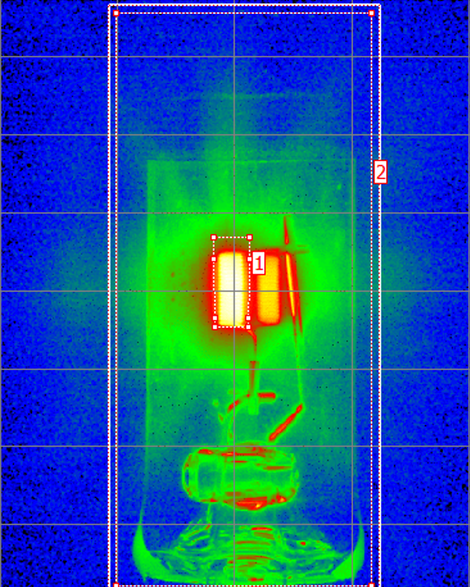

**“A+B+C”**

**“all”**

**Figure 4: H11-sample showing typical situation of a filament light source with axial filament alignment**

**Annex 3A**

**Clarification of the requirements to the homogeneity of the light-emitting-area (categories used in light-signalling devices)**

The explanations in this annex are based on the example of PY21W.

Figure 5 shows that in Regulation No. 37 the box from the front elevation is already defined in three sections. The projection of the filament should lie entirely within the rectangle and the centre of the filament should stay within the inner section of the box.



**Figure 5: Front elevation of the box specification of filament light source category PY21W in Regulation No. 37**

The percentages of the minimum luminous flux emitted from each section into the given viewing direction(s) should be specified based on considerations done with samples of filament light sources of the corresponding category, i.e. including tolerances of typical filament dimensions and filament position and taking into account that part of the light is emitted from outside the box (ref. value of DFR).

Figure 6 describes the outcome for the example of a PY21W LED replacement light source. The lower limit for each section is derived from extreme values of the filament length (f = 5.5 and 7.0 mm), of the filament position (shift of centre k = -1.0 and +1.0 mm) according to the PY21W filament lamp category and the share of direct light emission from the box (“DRF” = 80%, see Annex 2):

* Section B: 2*k/f *DFR= 2.0/7.0*0.8 = 22.9%,  
  rounding up at multiples of 5% to 25% min.
* 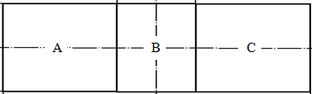Sections A and C: (0.5*f-2*k)/f*DFR = (2.75-2.0)/5.5*0.8 = 10.9%,  
  rounding up at multiples of 5% to 15% min.

*The proportion of the total luminous flux emitted into the viewing direction from the area(s):*

* *A, B and C together should be 80 per cent or more;*
* *B should be 25 per cent or more;*
* *A and C should each be 15 per cent or more.*

**Figure 6: Front elevation of the box specification of LED replacement light source category P21W**

**Annex 3B**

**Clarification of the requirements to the homogeneity of the light-emitting-area (categories used in road-illumination devices)**

The explanations in this annex are based on the example of H11.

Figure 7 shows that in Regulation No. 37 the box, checked from two perpendicular viewing directions, is already defined in three sections. The filament shall lie entirely within the limits shown, while the ends of the filament as defined on sheet shall lie between lines Z1 and Z2 and between Z3 and Z4.

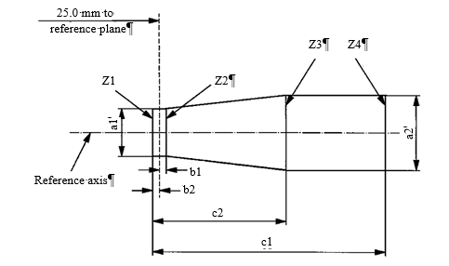

**Figure 7: Box specification of filament light source category H11 in Regulation No. 37**

The size and position of the light emitting area of the LED Replacement light source is based on the specifications of the filament box in the viewing direction(s) specified for the corresponding filament light source.

The homogeneity requirements of the light emitting area of the LED Replacement light source are based on the requirements for the minimum and maximum dimension and the position of the filament specified for the corresponding filament light source. To emphasize the relevance of the central part of the box and typical maximum filament diameter (e.g. 1.4mm given in a footnote of H11 category sheet), the central part is divided in three sub-parts for more equivalent homogeneity specification.

Figure 8 shows the example of the section definition for a trapezoidal box definition as given in the H11, while Table 2 summarizes the resulting requirements to the different luminous flux ratios.

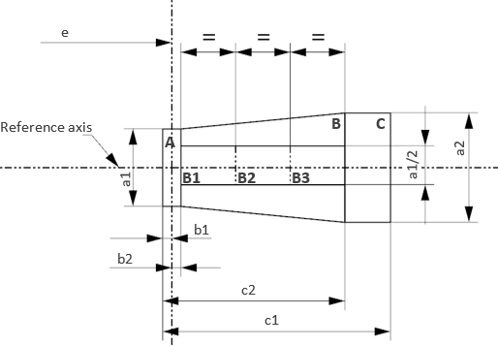

**Figure 8: Box specification of LED Replacement light source category, example H11/LED**

**Table 2: homogeneity requirements of LED Replacement light source category H11/LED**

|  |  |  |  |
| --- | --- | --- | --- |
| Section | Luminous flux ratio limit | Spec. for H11/LED* | Comment |
| A | $$\frac{A}{A+B+C}=\frac{b1+b2}{c2}$$ | <= 10% | Max. value based on shortest filament covering whole A |
| B | $$\frac{B}{A+B+C}=\frac{c2-b1-b2}{c1}$$ | >= 72% | Min. value based longest possible filament |
| C | $$\frac{C}{A+B+C}=\frac{c1-c2}{c1-b1-b2}$$ | <= 22% | Max. value based on shortest filament covering whole C |
| B1, B2, B3 | $$\frac{Bi}{B}=1/3∙\frac{0.5∙a1}{d}∙0.75$$ | >= 15% | Total of B1+B2+B3 is split in three, allowing a certain tolerance (“-25%”) |

* The tighter specification of the filament length of standard H11 filament light sources (4.5 ± 0.1 mm) translates into tighter restriction of certain sections, e.g. a minimum and a maximum limit apply for section B.

**Annex 4**

**Clarification of the requirements to the contrast of the light-emitting-area**

In the case of a filament light source with axial filament alignment (e.g. H11) the contrast is determined from the ratio of the luminous flux emitted from the following areas:

* the area represented by the box “A+B+C”
* the rectangular area D (“glare zone”) positioned parallel to the reference axis with size 1.5 times the length and 1.5 times the largest diameter of box A+B+C

The distance between both areas (d = 0.4mm) is derived from the optical magnification of typical Halogen headlamps, where a minimum contrast in the beam must be achieved between 75R and HV. The location of the area D is diametrically opposite of the lead wire and symmetrically arranged to the box “A+B+C”.

Figure 9 shows the illustration of the box arrangement.

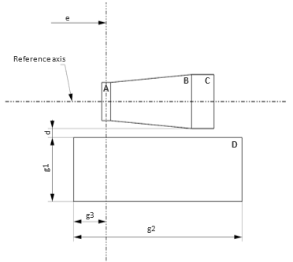

**Figure 9: Box arrangement used for definition and determination of contrast**

In the case of a single-filament light source with axial filament alignment measurements of samples of different manufacturers show contrast values of typically [100]:1 for uncoated versions.

Hence, the minimum contrast of LED Replacement light sources being the counterpart light sources of Halogen light sources with an axially aligned, single filament could be set to [100]:1, in general.

**Annex 5**

**Total/combined effect of voltage and temperature on the luminous flux (“Real-World Comparison”)**

Filament light sources

There are no dedicated requirements to R37 filament light sources with respect to variations of the applied input voltage (i.e. type-approval testing only at the specified test voltage). Nevertheless, the light output of filament light sources significantly depends on the exact voltage applied to its terminals. The luminous flux ** of automotive filament light sources in relation to the applied voltage *U* is approximately described by the following formula (flux *0* at test voltage *Uo*)

$$\frac{Φ}{Φ_{0}}=const.∙{(\frac{U}{U_{0}})}^{\sim 3.5}$$

On the other side the light output of filament light sources is nearly independent on the ambient temperature, especially under automotive typical conditions.

LED light sources

In general the light output of LED light sources depends on the applied voltage and the ambient temperature. Regulated LED light sources are subject to a default limitation of the flux-voltage dependency, e.g. ± 30% at 12 V and ±15% at 14 V deviation from the value measured at test voltage is allowed (ref. R128 Annex 4). Further, there is the option to apply stricter requirements per category (data sheets).

The light output of LED light sources also depends on the level of the ambient temperature. While type-approval testing of regulated LED light sources is limited by default (and of lamps with non-regulated LED solutions in general) to testing at room temperature (i.e. 23°C), LED Substitute light sources were the first of their kind being subject to additional testing at elevated ambient temperature given in the corresponding data sheet. LED Replacement light sources should follow this practice.

Comprehensive evaluation under real-world conditions

Under real-world conditions the temperature drawback of LED technology could be set off by the voltage drawback of filament technology when the requirements for the LED replacement light sources are properly set. Thereby, a typical voltage range (e.g. 12 - 14 V for a 12 V architecture) and a typical temperature range should apply. For the latter, state-of-the-art statistical thermal profiles applied by OEMs could be used.

In the following example the situation of light sources used in passing- and driving-beam cavities is elaborated in detail:

* Apply a typical OEM temperature profile *Ttp* used “for components that are installed in the engine compartment, but not on the engine itself”, e.g.:

|  |  |
| --- | --- |
| Temperature *Ttp* | Distribution |
| -40°C | 6 % |
| 23°C | 20 % |
| 65°C | 65 % |
| 115°C | 8 % |
| 120°C | 1 % |

* Take into account that headlamps have one side facing the engine compartment and one side facing the car environment (“outside air”)
* Note that low- and high-beam functions are safety critical when driving at night, i.e. no sun load, typical outside air *Tout* of 15°C or less
* Assuming the more critical case that the major part of the headlamp (2/3 of outer surface) faces the hot engine compartment and the rest (1/3 of outer surface) faces the colder outside air, values for a representative test temperature *Ttest* can be derived: $$T_{test}≈2/3T_{tp}+1/3T_{out}$$

| Applied temperature profile | | 🡪 *Ttest* (°C) | Conclusion |
| --- | --- | --- | --- |
| -40°C | 6 % | ~ -22°C |  |
| 23°C (nom.) | 20 % | ~ 20°C | Test at 20°C covers 26% of cases |
| 65°C | 65 % | ~ 48°C | Test at 50°C covers 91% of cases |
| 115°C | 8 % | ~ 82°C | Test at 80°C covers 99% of cases |
| 120°C | 1 % | ~ 85°C |  |

A light source test at 50°C ambient temperature would cover 91% of the thermal situations of headlamps, while a test at 80°C would cover 99% of all situations. For practical reasons it could be considered to replace two test points by a single representative one, e.g. at 60°C with the appropriate minimum luminous flux requirement.

In order to achieve equivalent light output performance of a LED replacement light source in passing and driving beam applications a combination of reasonable requirements with respect to the voltage and temperature dependencies should be prescribed. For example, a flux-voltage requirement of ±10% at 12 V combined with a flux-temperature requirement of ≥ 75% at 60°C leads to equivalent performance of the filament light source and its corresponding LED replacement light source. The Figure 10, which is true-to-scale for easy comparison, is based on a filament typical voltage dependency of 72% at 12V compared to the value at test voltage of 13.2V.

*Note: this figures takes into account the impact of aged light sources (bars given in light colours) as another factor, which is not type-approval relevant but which matters in real-world as well. While filament light sources used in headlamps have a lumen maintenance factor of about 80% (20% drop) after a few hundred hours, the corresponding LED light sources show no significant drop of light output (e.g. maintenance factor of ~98%).*

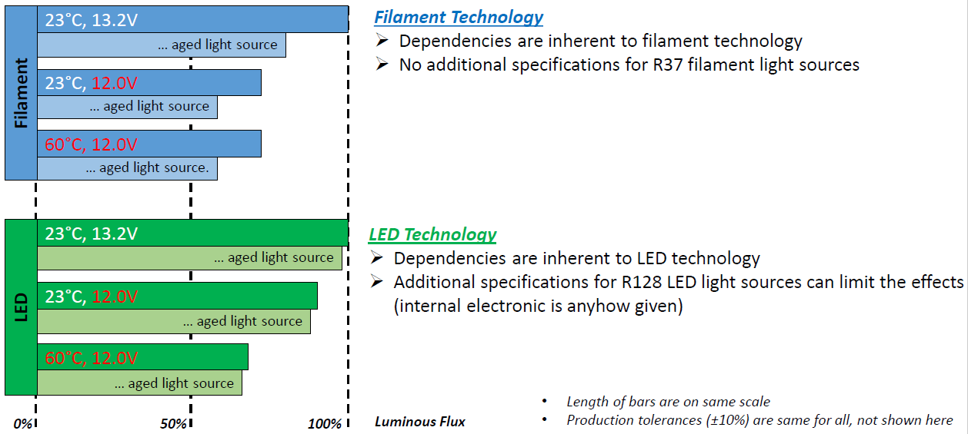

**Figure 10: Comparison of filament and LED technology with respect to the voltage- and temperature-dependency of the luminous flux** (incl. ageing)

**Annex 6**

**Supporting vehicle investigations**

Vehicle investigations can be carried out to support specific requirements for LED replacement light sources, e.g.:

* the minimum level of power consumption or electrical current draw needed for the proper functioning of failure detection systems (see 3.3.1.).
* the PWM test parameters used to stabilize board net fluctuations

The following information is taken from a study based on the top-selling vehicle models in Europe from the registration years 2011-2015.

Failure detection of front and rear direction indicators

* + 100% equipped with failure detection systems (mandatory)
  + detection levels between 100 mA and 800 mA
  + Set minimum current draw for the default version of e.g. PY21W category to 1000 mA

Failure detection of passing beams

* + system present in about 50% of the number of vehicles-in-use, while half of them have sufficiently low threshold, i.e. about 75% of the number of vehicles-in-use work well with a high-efficiency version
  + detection level between 450 mA and 1700 mA
  + Set minimum current draw for the default version of e.g. H11 category to 2000 mA

PWM parameters used to stabilize board net fluctuations

* + PWM applied e.g. in many vehicles
  + PWM frequency in most cases 100 Hz, sometimes 150 Hz
  + PWM duty cycle always in the range of 90 – 100%
  + Set minimum test requirement for worst-case parameters 100 Hz / 90%

**Annex 7**

**Checklist for equivalence of parameters**

Parameters as in paragraphs described above Check

3.1. Parameters with the same values

3.1.1. Cap O

3.1.2. Maximum lamp outline dimensions O

3.1.3. Electrical connector O

3.1.4. Test voltage O

3.1.5. Objective luminous flux O

3.1.6. Colour of emitted light O

3.1.7. Light centre length O

3.1.8. Distortion free zone (if any) O

3.2. Parameters with similar values

3.2.1. Normalized luminous intensity distribution O

3.2.2. Size and position of the light-emitting-area O

3.2.3. Homogeneity of the light-emitting-area O

3.2.4. Contrast of the light-emitting area (only for categories also used in  
road-illumination devices) O

3.3. Parameters with different values

3.3.1. Electrical power consumption O

3.3.2. Dependency of the luminous flux on the applied voltage O

3.3.3. Dependency of the luminous flux on elevated ambient temperatures O

3.3.4. Cap temperature O

3.3.5. The spectral content O

3.4. Additional parameters

3.4.1. Thermal run-up behaviour O

3.4.2. PWM operation

3.4.2.1. PWM operation to stabilize the applied voltage O

3.4.2.2. PWM operation to dim light sources O

3.4.3. Polarity O

4. Requirements regarding failure O

4.1. Failure detection O

4.2. Failure behaviour O