|  |  |  |  |
| --- | --- | --- | --- |
|  | United Nations | ECE/TRANS/WP.29/GRE/2020/23 | |
| Description: _unlogo | **Economic and Social Council** | | Distr.: General  5 August 2020  Original: English |

**Economic Commission for Europe**

Inland Transport Committee

**World Forum for Harmonization of Vehicle Regulations**

**Working Party on Lighting and Light-Signalling**

**Eighty-third session**

Geneva, 19–23 October 2020

Item 6 (b) of the provisional agenda

**UN Regulation No. 48 (Installation of lighting and light-signalling devices):**

**Proposals for new series of amendments to UN Regulation No. 48**

Proposal for a Supplement to the 06 and 07 series of amendments to UN Regulation No. 48

Submitted by the expert from the International Organization of Motor Vehicle Manufacturers[[1]](#footnote-2)\*

The text reproduced below was prepared by the expert from the International Organization of Motor Vehicle Manufacturers (OICA). This proposal intends to improve the requirements linked to the manual levelling device. The modifications to the existing text are marked in bold for new or strikethrough for deleted characters.

I. Proposal

*Paragraph 6.2.6.2.2.,* amend to read:

**“6.2.6.2.2.** However, devices, which are adjusted manually, ~~either continuously or non‑continuously,~~ shall only be permitted~~,~~ ~~provided they have a stop position at which the lamps can be returned to the initial inclination defined in paragraph 6.2.6.1.1. by means of the usual adjusting screws or similar means, provided they have a stop position at which the lamps can be returned to the initial inclination defined in paragraph 6.2.6.1.1. by means of the usual adjusting screws or similar means.~~ **where these systems also incorporate:**

**(a) a warning signal or message to the driver requesting that the vertical inclination of the dipped-beam headlamps shall be checked. The characteristics of this warning signal or message is defined in paragraph 6.2.6.2.2.1. below.**

**(b) in addition, a visual status to the driver indicating the current setting of the vertical inclination of the cut-off of the dipped-beam is shown. The characteristics of this visual status are defined in paragraph 6.2.6.2.2.2. below.**

**6.2.6.2.2.1.** **The warning signal or message shall be shown when the device which starts or stops the engine (propulsionsystem) is in a position which makes it possible to start the propulsion system and when the dipped-beam headlamps are switched ON (manually or automatically relative to the ambient light conditions according to the requirements of Annex 13).**

**The warning signal or message shall be shown until one of the following conditions is met:**

**(a) it is manually confirmed or whenever the inclination status is changed by the driver;**

**(b) it has been shown for at least 10 seconds;**

**(c) the vehicle speed has reached at least 15 km/h.**

**6.2.6.2.2~~.1~~.2. The inclination status shall be shown every time the engine (propulsion system) is started.**

**Furthermore, the inclination status shall be shown:**

**(a) at each switching ON of dipped-beam headlamp;**

**and**

**(b) whenever the inclination status is changed by the driver.**

**The inclination status shall be shown unless:**

1. **it is manually confirmed by the driver or**
2. **it has been shown for at least 10 seconds.**

**6.2.6.2.2.3. Automatic stop-starts of the propulsion system initiated by a vehicle control system, do not need to show the warning signal and the inclination status as specified in paragraphs 6.2.6.2.2.1. and 6.2.6.2.2.2. above.**

**6.2.6.2.2.~~2~~4.** These manually adjustable devices shall be **easily visible, reachable and identifiable by the driver in accordance with the requirements of UN Regulation No. 121.**

~~Continually adjustable devices shall have reference marks indicating the loading conditions that require adjustment of the dipped-beam.~~

The number of positions on devices ~~which are not continuously adjustable~~ to **adjust the dipped-beam headlamps** shall be such as to ensure compliance with the range of values prescribed in paragraph 6.2.6.1.2. in all the loading conditions defined in Annex 5.

~~For these devices also, the loading conditions of Annex 5 that require adjustment of the dipped-beam shall be clearly marked near the control of the device (Annex 8).~~

**Requirements ~~and examples~~ of controls for the headlamps leveling devices are specified in Annex 8.**

**6.2.6.2.2.5. The different positions to adjust the dipped-beam headlamps shall be explained in the owner's handbook.”**

*Annex 8,* amend to read:

**“Annex 8**

**The controls for the headlamp-levelling devices referred to in paragraph 6.2.6.2.2. of this Regulation**

1. Specifications

1.1. ~~Downward~~ Inclination of the dipped-beam shall in all cases be produced **by a simple control, the operation of which is clearly described in the owner’s handbook.** ~~in one of the following ways:~~

1. ~~by moving a control downwards or to the left;~~
2. ~~by rotating a control in a counter clockwise direction;~~
3. ~~by depressing a button (push-pull control).~~

~~If several buttons are used to adjust the beam, the button which gives the greatest downward inclination shall be installed to the left or below the button(s) for other dipped-beam positions.~~

~~A rotary control that is installed edge-on, or with only the edge visible, should follow the operating principles of control of types (a) or (c).~~

1.1.1. This control shall carry symbol**(**s**)** indicating clearly the movements corresponding to the downward and upward inclination of the dipped beam.

1.2. The "0" position corresponds to the initial inclination according to paragraph 6.2.6.1.1. of this Regulation.

~~1.3.~~ [~~The marks used on control shall be explained in the owner's handbook~~.]

~~1.4.~~ ~~Only the following symbols may be used to identify the controls:~~

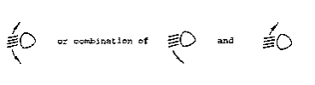

~~Symbols employing five lines instead of four may also be used~~

**~~Example 1:~~**

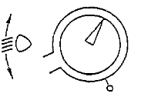

**~~Example 2:~~**

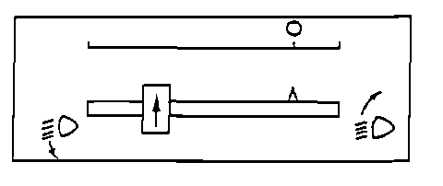

**~~Example 3:~~**

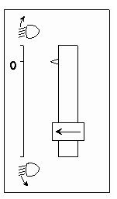

**”**

II. Justification

A. General

1. ECE/TRANS/WP.29/GRE/2020/8 currently proposes to delete paragraph 6.2.6.2.2. which describes the conditions where a manual levelling device may be used as an alternative to automatic levelling.
2. However, the report of the Informal Working Group "Simplification of the Lighting and Light-Signalling Regulations" (IWG SLR) at its thirty-fifth session ( informal document SLR-35-22) keeps the possibility of manual levelling open, provided that improvements are made to the human machine interface (HMI) and ergonomics of the control:

"Concerning the manual option for levelling device (paragraph 6.2.6.2.2.), France recommended to keep both possibilities (automatic and manual) because it is important to stay within the “box” regardless of the specific technological solution. France added that, in case of manual levelling the HMI/ergonomics of the device shall be improved (e.g. more visible location of the levelling control) as well as the communication to the driver (e.g. information on the dashboard similar to the “Gear Shift Indicator”)".

1. Vehicle manufacturers believe that manual adjustment of the dipped beam should continue to be permitted for a number of reasons, as outlined below:

* For all classes of vehicles, a manual levelling device is a highly reliable and cost-effective solution.
* Failure analysis indicates manual levelling is a very robust solution with a negligible number of customer complaints.
* Manual levelling has a high accuracy to provide light on the road independent of the engine type, body work and use conditions.
* The cost of calibration is also lower when compared with an automatic levelling system.

1. For vehicles of сategories N2 and N3:

* On and off-road vehicles used for special purposes are usually equipped with a steel suspension at the front and rear axles.
* Placement of the sensor in the suitablelocation on the vehicle is critical for the operation of the system, this position is difficult to protect against mud and spray water (see the pictures below).

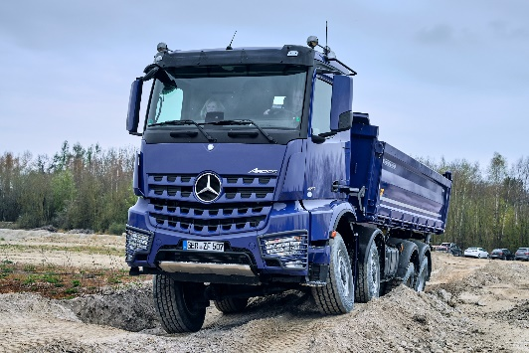

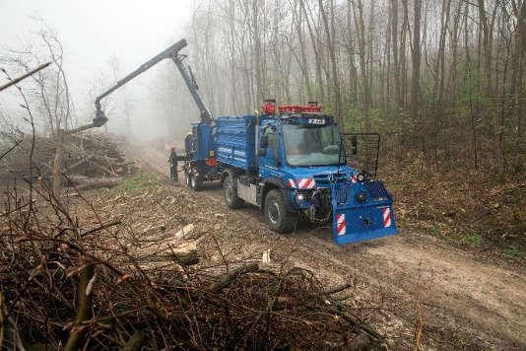

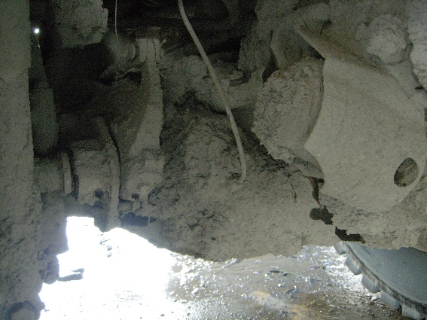

**Figure**

Examples where the position of the sensor may be affected by mud and water

* For vehicles are operating in a very harsh environment adding sensors for automatic levelling systems is a reliability risk. Finding usable positions for the sensors with the different vehicle configurations is not always possible.
* There are factors contributing to a large tolerance span for automatic levelling systems for trucks (frame bending, tire compression etc). The influences of those factors are difficult to calculate, in particular since many vehicles are finalized by body builders who may provide the vehicle with additional frame members, different axles and wheels. An automatic levelling system will in those cases not provide an accurate headlamp aim.

B. Improvements to HMI/ergonomics

1. In 6.2.6.2.2.(a) a warning signal or message is proposed in order to ask the driver to check the aim of their headlights. The conditions for activating the warning signal are given in 6.2.6.2.2.1.
2. In 6.2.6.2.2.(b) a visual status of the vertical inclination will be provided to the driver shown every time the engine (propulsion system) is started, at each switching ON of dipped-beam headlamp and whenever the inclination status is changed by the driver.
3. To improve the ergonomics / accessibility of controls, paragraph 6.2.6.2.2.4. introduces requirements that manually adjustable devices shall be easily visible, reachable and identifiable by the driver in accordance with the requirements of UN Regulation No. 121.

C. Justification of the changes to Annex 8

1. ‘Downward’ should be deleted. In the old text it referring to the direction of the control device. For trucks we are adjusting the dipped beam both upwards and downwards due to different loading characteristics of different vehicle configurations.
2. In order for the requirements to be technology neutral, the prescription of control methods (downwards, rotary, push-pull) have been deleted.
3. Requirement 1.3 referring to the owner’s handbook has been moved into the main regulatory text (see paragraph 6.2.6.2.2.5.) and therefore can be deleted.
4. Requirement 1.4. specifying the symbols, which can be used, has been deleted as these are already prescribed in UN Regulation No. 121.
5. Examples of controls 1, 2 and 3 have been deleted as the illustrations are considered outdated.

1. \* In accordance with the programme of work of the Inland Transport Committee for 2020 as outlined in proposed programme budget for 2020 (A/74/6 (part V sect. 20) para 20.37), the World Forum will develop, harmonize and update UN Regulations in order to enhance the performance of vehicles. The present document is submitted in conformity with that mandate. [↑](#footnote-ref-2)