|  |  |  |  |
| --- | --- | --- | --- |
|  | United Nations | ECE/TRANS/WP.29/2020/46 | |
| _unlogo | **Economic and Social Council** | | Distr.: General  19 December 2019  Original: English |

**Economic Commission for Europe**

Inland Transport Committee

**World Forum for Harmonization of Vehicle Regulations**

**180th session**

Geneva, 10–12 March 2020

Item 14.2.3 of the provisional agenda

**Consideration and vote by AC.3 of draft UN GTRs  
and/or draft amendments to established UN GTRs  
Proposal for Amendments to a UN GTR, if any**

Technical Report on the development of Amendment 2 to UN Global Technical Regulation (UN GTR) No. 6   
(Safety glazing))

Submitted by the representative from Republic of Korea[[1]](#footnote-1)\*

The text reproduced below was prepared by the representative from Republic of Korea. This is the technical report submitted together with the proposal for Amendment to UN GTR No. 6 (ECE/TRANS/WP.29/2020/45). It was adopted by the Working Party on General Safety (ECE/TRANS/WP.29/GRSG/96, para. 23). It is submitted to the World Forum for Harmonization of Vehicle Regulations (WP.29) and to the Executive Committee (AC.3) of the 1998 Agreement for consideration at their March 2020 sessions.

Technical report on the development of the amendment to global technical regulation No. 6 (Safety Glazing)

I. Introduction

1. The expert from Republic of Korea proposed to amend GTR.6 on safety glazing to exempt in Zone I the possible opaque obscuration in the test area on the windscreen of Category 1-2 and 2 vehicles which is used for installation of those devices such as rain-drop sensor, inside mirror or autonomous vehicle sensors, etc.

II. Objective

2. As the technical advanced, there is the inside room mirror having a sensor, such as weather rain sensors, lane detection sensors, and highway electronic toll sensors. These functions were integrated into the room mirror. It affected to Zone I of Category 1-2 and 2 vehicles.

3. However, Category 1-2 and 2 vehicles have no opaque obscuration. On the other hand, Passenger cars have the opaque obscuration. This proposal is to allow additional opaque obscuration in relation to the optical distortion test and secondary image separation test in GTR 6.

III. Meeting held by GRSG

4. In the 116th session of GRSG (1-5 April 2019), the expert from Republic of Korea introduced GRSG-116-30 and GRSG-116-31 on the need to exempt in Zone I the possible opaque obscuration which is defined in paragraph 7.1.3.2.4. of the annexes 7.1. The expert from Germany principally agreed the proposed amendments, adding that the opaque obscuration had to be clearly defined. The expert from Finland affirmed the necessity for similar amendments in UN Regulation No. 43.

5. In the 117th session of GRSG (8-11 October 2019), The expert from the Republic of Korea presented ECE/TRANS/WP.29/GRSG/2019/33 as amended by GRSG-117-43 and GRSG-117-49 on the need to exempt in Zone I the possible opaque obscuration which is defined in paragraph 7.1.3.2.4. of the annexes on installing laminated-glass panes. The expert from Germany clarified that there was no real difference between UN GTR No.6 and UN Regulation No.43 as the UNGTR would provide for two options while the UN Regulation would use only one of the options which was in accordance with the agreements.

6. GRSG adopted ECE/TRANS/WP.29/GRSG/2019/33 as amended by GRSG-117-49 and requested the secretariat to submit it to AC.3 as draft amendment to UN GTR No. 6 for consideration at its March 2020 sessions.

IV. Main resolutions agreed by GRSG

7. Various safety and convenience options (Lane Departure Warning Systems (LDWS), Autonomous sensors, etc.) for trucks are being installed or under development. If these options are fitted on the underside dashboard-top of the windshield glass, it may limit the driver’s direct front of vision.

8. For the optimization of installation, the above options may be integrated with the interior mirror. However, it is difficult for some models to install the interior mirror, since Zone I may be intruded. Therefore, the opaque obscuration which can be used for installation of the above safety and convenience options must be permitted additionally. For this reason, some new planes such as P5, P6, and P7 shall be added. On the other hand, the new opaque obscuration for Category 1-2 and 2 Vehicles has to be equal level with the one for Category 1-1 vehicles using the “V” points in order not to violate safety.

V. Development of the UN GTR

9. The objective of the proposal is to develop, in the framework of the 1998 Agreement, an amendment to UN GTR No. 6 on Safety Glazing to adapt the provisions to technical progress to enable the approval of windscreens with extended areas of opaque obscuration providing for the installation of safety and convenience elements (e.g. LDWS).

10. The development of the draft language for updating the GTR involved consideration of the differences between the respective 1998 Agreement and 1958 Agreement. Specific solutions for the different technical items were developed whereby GRSG experts were requested to support and contribute in the process.

The Amendment 2 to UN GTR No. 6 incorporates:

Determination of the opaque obscuration by defining planes P5, P6, and P7

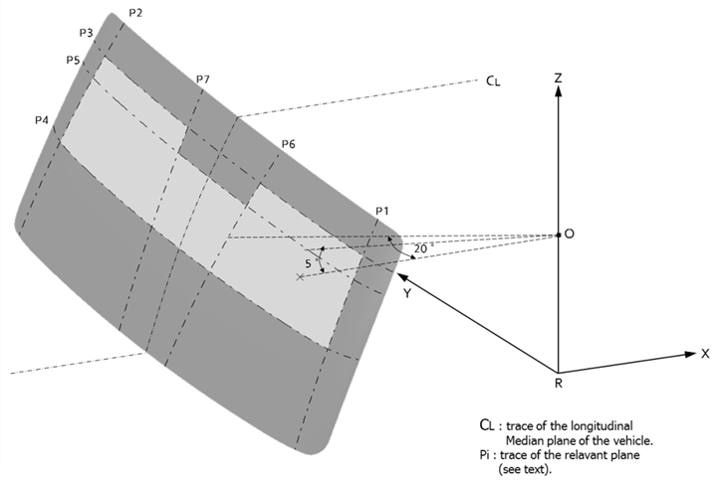

VI. Conclusion

11. Following the adoption of the draft Amendment 3 to UN GTR No. 6 at its 117th session, GRSG requests AC.3 voting for establishing this Amendment 3 (as proposed in ECE/TRANS/GRSG/2019/33) in the Global Registry.

1. \* In accordance with the programme of work of the Inland Transport Committee for 2020 as outlined in proposed programme budget for 2020 (A/74/6 (part V sect. 20) para 20.37), the World Forum will develop, harmonize and update UN Regulations in order to enhance the performance of vehicles. The present document is submitted in conformity with that mandate. [↑](#footnote-ref-1)