|  |  |  |  |
| --- | --- | --- | --- |
|  | United Nations | ECE/TRANS/WP.29/2020/26 | |
| _unlogo | **Economic and Social Council** | | Distr.: General  20 December 2019  Original: English |

**Economic Commission for Europe**

Inland Transport Committee

**World Forum for Harmonization of Vehicle Regulations**

**180th session**

Geneva, 10–12 March 2020

Item 4.8.15 of the provisional agenda

**1958 Agreement:  
Consideration of draft amendments to existing   
UN Regulations submitted by GRSG**

Proposal for the 04 series of amendments to UN Regulation No. 26 (External projections of passenger cars)

Submitted by the experts from the Working Party on General Safety[[1]](#footnote-1)\*

The text reproduced below was adopted by the Working Party on General Safety (GRSG) at its 117th session (ECE/TRANS/WP.29/GRSG/96, para. 12). It is based on ECE/TRANS/WP.29/GRSG/2019/34 as amended by GRSG-117-45. It is submitted to the World Forum for Harmonization of Vehicle Regulations (WP.29) and to the Administrative Committee (AC.1) for consideration at their March 2020 sessions.

**04 series of amendments to UN Regulation No 26 (External projections of passenger cars)**

*Paragraphs 6.4. to 6.4.2.,* amend to read:

"6.4. Windscreen wipers

6.4.1. The windscreen wiper fittings shall be such that the wiper shaft (number 1 in Figure 0) is furnished with a protective casing (number 1.1 in Figure 0) which has a radius of curvature meeting the requirements of paragraph [5.4.](https://raceonline.utac.com/fr/document/show/document_id/4022#A0_S5_4_) above and an end surface area of not less than 150 mm². The holder (head and main part, i.e. numbers 2, 2.1 in Figure 0) are designed with a radius of curvature meeting the requirements of paragraph 5.4. above. In the case of rounded covers, these shall have a minimum projected area of 150 mm² when measured not more than 6.5 mm from the point projecting furthest. These requirements shall also be met by rear window wipers and headlamp wipers.

6.4.2. Paragraph [5.4.](https://raceonline.utac.com/fr/document/show/document_id/4022#A0_S5_4_) shall not apply to the wiper blades (number 4 in Figure 0), supporting members (number 3 in Figure 0) if present, to second holder (number 2.2 in Figure 0) if present, to the functional hinge between the holder head and the holder (number 5 in Figure 0) if present, or to the junction between the main and the second holder (number 6 in Figure 0) if present. However, these units shall be so made as to have no sharp angles or pointed or cutting parts.

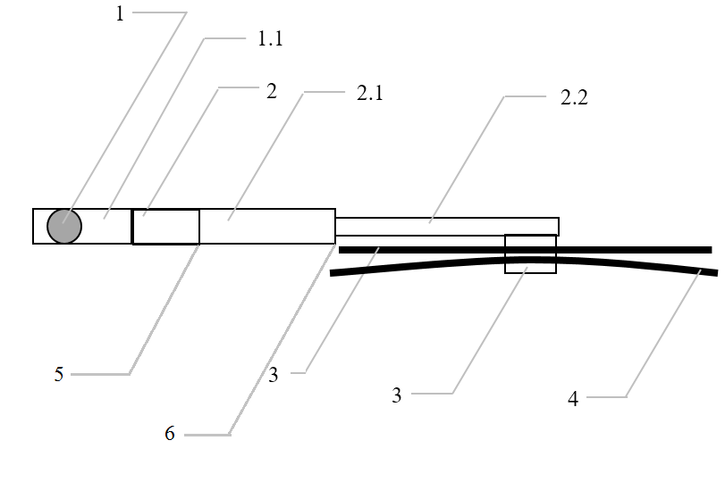Figure 0: Example of parts distribution

Legend:

1 Wiper shaft

1.1 Protective casing

2 Holder head

2.1 Main holder

2.2 Second holder

3 Supporting members

4 Wiper blades

5 Functional hinge  
6 Junction between the main and second holder"

*After paragraph 6.4.2.,* add a new paragraph 6.4.3., to read:

"6.4.3. Compliance with the provisions in paragraphs 6.4.1 and 6.4.2 shall be verified with the wipers in parked position."

*After paragraph 12.7,* insert new paragraphs 12.8. to 12.11,to read:

"12.8. As from the official date of entry into force of the 04 series of amendments, no Contracting Party applying this Regulation shall refuse to grant approval under this Regulation as amended by the 04 series of amendments.

12.9. As from 1 September 2022, Contracting Parties applying this Regulation shall not be obliged to accept type approvals to the preceding series of amendments, first issued after 1 September 2022.

12.10. Contracting Parties applying this Regulation shall continue to accept type approvals issued according to the preceding series of amendments to this Regulation first issued before 1 September 2022.

12.11. Contracting Parties applying this Regulation shall not refuse to grant type approvals according to any preceding series of amendments to this Regulation or extensions thereof."

*Annex 2*, amend to read

"Annex 2

Arrangements of the approval marks

# Model A

(See paragraphs 4.1.4. and 4.2.4. of this Regulation)

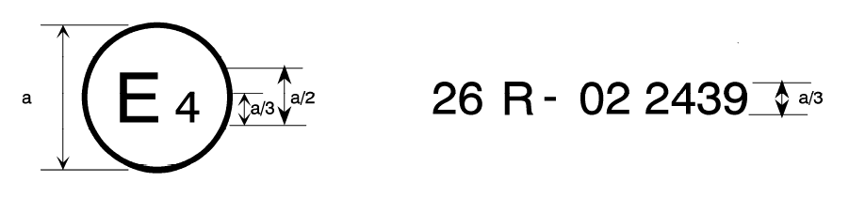

04

a= 8 mm min

The above approval mark affixed to a vehicle shows that the vehicle type concerned has been approved in the Netherlands (E 4) pursuant to UN Regulation No. 26 and under approval number 032439. The first two digits of the approval number indicate that UN Regulation No. 26 already included the 04 series of amendments when the approval was granted.

# Model B

# (See paragraph 4.1.5. of this Regulation)

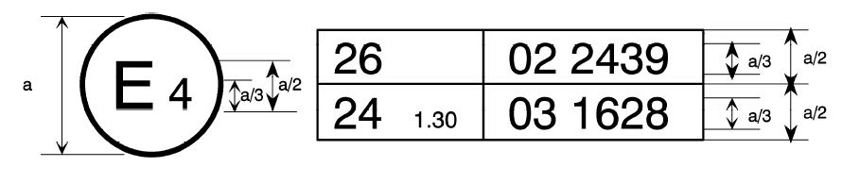

04 2439

a= 8 mm min

The above approval mark affixed to a vehicle shows that the vehicle type concerned has been approved in the Netherlands (E 4) pursuant to UN Regulation No. 26 and UN Regulation No. 24.[[2]](#footnote-2) The first two digits of the approval numbers indicate that, at the dates when the respective approvals were given, UN Regulation No. 26 included the 04 series of amendments, while UN Regulation No. 24 already included the 03 series of amendments."

1. \* In accordance with the programme of work of the Inland Transport Committee for 2020 as outlined in proposed programme budget for 2020 (A/74/6 (part V sect. 20) para 20.37), the World Forum will develop, harmonize and update UN Regulations in order to enhance the performance of vehicles. The present document is submitted in conformity with that mandate.. [↑](#footnote-ref-1)
2. The second Regulation number is given merely as an example; the corrected absorption coefficient is 1.30 m-1. [↑](#footnote-ref-2)