|  |  |  |  |
| --- | --- | --- | --- |
|  | United Nations | ECE/TRANS/WP.29/2020/13 | |
| _unlogo | **Economic and Social Council** | | Distr.: General  18 December 2019  Original: English |

**Economic Commission for Europe**

Inland Transport Committee

**World Forum for Harmonization of Vehicle Regulations**

**180th session**

Geneva, 10–12 March 2020

Item 4.8.2 of the provisional agenda

**1958 Agreement:  
Consideration of draft amendments to existing   
UN Regulations submitted by GRSG**

Proposal for Supplement 4 to the 07 series of amendments to UN Regulation No. 107 (M2 and M3 vehicles)

Submitted by the experts from the Working Party on General Safety[[1]](#footnote-1)\*

The text reproduced below was adopted by the Working Party on General Safety (GRSG) at its 117th session (ECE/TRANS/WP.29/GRSG/96, para. 8). It is based on ECE/TRANS/WP.29/GRSG/2019/30 as amended by GRSG-117-54. It is submitted to the World Forum for Harmonization of Vehicle Regulations (WP.29) and to the Administrative Committee (AC.1) for consideration at their March 2020 sessions.

Supplement 4 to the 07 series of amendments to UN Regulation No. 107 (M2 and M3 vehicles)

*Annex 3**Paragraph 7.6.2.8.,* amend to read:

"7.6.2.8. For vehicles of classes I, II and III,required escape hatches shall be positioned as follows:

(a) If there is only one hatch, it shall be situated in the middle third of the passenger compartment; or

(b) If there are two hatches, they shall be separated by a distance of at least 2 m measured between the nearest edges of the apertures in a line parallel to the longitudinal axis of the vehicle."

*Insert a new Paragraph 7.6.2.9.* to read:

"7.6.2.9. For vehicles of classes A and B, required escape hatches shall be positioned as follows:

(a) If there is only one hatch, it shall be situated in the middle third of the passenger compartment. As an alternative, on vehicles with a very short passenger compartment length, the hatch may be located in the mid-section of this compartment, and this mid-section shall be equally spaced longitudinally each side of the transverse centre line of the passenger compartment, with a length of no greater than 1.6m as shown in Annex 4 Figure 31;

(b) If there are two hatches, they shall be separated by a distance of at least 2 m measured between the nearest edges of the apertures in a line parallel to the longitudinal axis of the vehicle."

*Annex 4,* after Figure 30 insert:

"Figure 31

**Alternative placement of escape hatch for very short passenger compartment length having a middle third smaller than 1600 mm**

(See Annex 3, paragraph 7.6.2.9.)

**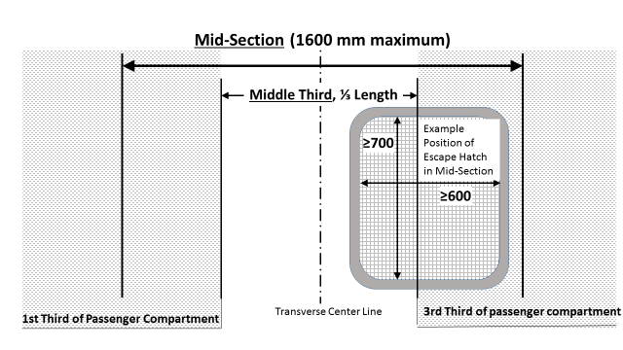**

(All dimensions in mm)"

1. \* In accordance with the programme of work of the Inland Transport Committee for 2020 as outlined in proposed programme budget for 2020 (A/74/6 (part V sect. 20) para 20.37), the World Forum will develop, harmonize and update UN Regulations in order to enhance the performance of vehicles. The present document is submitted in conformity with that mandate. [↑](#footnote-ref-1)