|  |  |  |  |
| --- | --- | --- | --- |
|  | United Nations | ECE/TRANS/WP.29/2020/102 | |
| _unlogo | **Economic and Social Council** | | Distr.: General  21 August 2020  Original: English |

**Economic Commission for Europe**

Inland Transport Committee

**World Forum for Harmonization of Vehicle Regulations**

**182nd session**

Geneva, 10-12 November 2020

Item 4.7.1. of the provisional agenda

**1958 Agreement:  
Consideration of draft amendments to existing   
UN Regulations submitted by GRSG**

Proposal for the 01 series of amendments to UN Regulation No. 35 (Foot controls)

Submitted by the Working Party on General Safety [[1]](#footnote-2)\*, [[2]](#footnote-3)\*\*

The text reproduced below was adopted by the Working Party on General Safety at its 118th session, held in July 2020 (see ECE/TRANS/WP.29/GRSG/97). It is based on ECE/TRANS/WP.29/GRSG/2020/15. It is submitted to World Forum for Harmonization of Vehicle Regulations (WP.29) and the Administrative Committee of the 1958 Agreement (AC.1) for consideration and vote at their November 2020 sessions.

*Paragraph 1, footnote 1,* amend to read:

"1 As defined in the Consolidated Resolution on the Construction of Vehicles (R.E.3), document ECE/TRANS/WP.29/78/Rev.6, para. 2 - [www.unece.org/trans/main/wp29/wp29wgs/wp29gen/wp29resolutions.html](http://www.unece.org/trans/main/wp29/wp29wgs/wp29gen/wp29resolutions.html)**"**

*Paragraph 4.2.*, amend to read:

"4.2. An approval number shall be assigned to each type approved. Its first two digits (at present 01) shall indicate the series of amendments incorporating the most recent major technical amendments made to the UN Regulation at the time of issue of the approval. The same Contracting Party shall not assign the same number to another vehicle type."

*Paragraph 4.4.1., footnote 2*, amend to read:

"2 The distinguishing numbers of the Contracting Parties to the 1958 Agreement are reproduced in Annex 3 to the Consolidated Resolution on the Construction of Vehicles (R.E.3), document ECE/TRANS/WP.29/78/Rev.6, Annex 3 - [www.unece.org/trans/main/wp29/wp29wgs/wp29gen/wp29resolutions.html](http://www.unece.org/trans/main/wp29/wp29wgs/wp29gen/wp29resolutions.html)"

*Paragraph 5.5.*, amend to read:

"5.5. The distance**,** shown at "F" in [annex 4](https://raceonline.utac.com/fr/document/show/document_id/1197#A4_), between the orthogonal projections of the service-brake-pedal and the clutch-pedal bearing surfaces on to the reference plane "P" shall be ≥ 50 mm."

*Paragraph 5.6.*, amend to read:

"5.6. The distance**,** shown at "G" in [annex 4](https://raceonline.utac.com/fr/document/show/document_id/1197#A4_),between the contour points of the projection of the clutch pedal on to plane "P" and the intersection of the nearest wall with plane "P" shall be ≥ 50 mm."

*Paragraph 5.7.*, amend to read:

"5.7. The distances, respectively shown as "H" and "J" in Annex 4, between the projection of the service-brake pedal on to the reference plane "P" and the intersection of each of the walls with that plane shall be ≥ 130 mm to the right and ≥ 160 mm to the left for vehicles with three pedals, and ≥ 130 mm to the right and ≥ 120 mm to the left for vehicles with two pedals.

In the case of a foot rest as declared by the manufacturer, installed for the driver's left foot, the measurements for "J" and "G" in Annex 4 shall ignore the foot rest. The distance, shown at "K" in [annex 4](https://raceonline.utac.com/fr/document/show/document_id/1197#A4_), between the contour points of the projection of the left most pedal on to plane "P" and the intersection of the footrest with plane "P" shall be ≥ 50 mm."

Paragraph 7, *amend to read:*

"7. Conformity of production

The conformity of production procedures shall comply with those set out in the Agreement, Schedule 1 (E/ECE/TRANS/505/Rev.3), with the following requirements:

…"

*Insert new paragraphs 10. to 10.4.*, to read:

"10. Transitional provisions

10.1. As from the official date of entry into force of the 01 series of amendments, no Contracting Party applying this Regulation shall refuse to grant or refuse to accept type approvals under this Regulation as amended by the 01 series of amendments.

10.2. As from 1 September 2022, Contracting Parties applying this Regulation shall not be obliged to accept type approvals to the preceding series of amendments, first issued after 1 September 2022.

10.3. Contracting Parties applying this Regulation shall continue to accept type approvals issued according to the preceding series of amendments to this Regulation first issued before 1 September 2022.

10.4. Contracting Parties applying this Regulation shall not refuse to grant type approvals according to any preceding series of amendments to this Regulation or extensions thereof."

*Paragraph 10. (former),* renumber as paragraph 11.

*Annex 1, item 5,* amend to read:

"5. Brief description of the vehicle type as regards the arrangement of foot controls and foot rest..........................................................................................................."

*Annex 2,* amend to read:

"**Arrangements of approval marks**

**Model A**  
(See paragraph 4.4. of this Regulation)

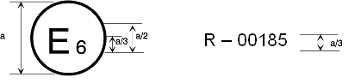  
a = 8 mm min

41 R - 0**4** 2439

**4**

41 R - 0**4** 2439

41 R - 0**4** 2439

41 R - 0**4** 2439

35 R - 01 2439

The above approval mark affixed to a vehicle shows that the vehicle type concerned has, with regard to the arrangement of foot controls, been approved in the Netherlands (E 4) under approval number 012439. The first two digits of the approval number indicate that the approval was granted in accordance with the requirements of UN Regulation No. 35, as amended by the 01 series of amendments.

**Model B**

(See paragraph 4.5. of this UN Regulation)

a

a

3

35 01 2439

24 \* 1.30 03 1628

a

3

a

2

a

2

a

2

a = 8 mm min.

The above approval mark affixed to a vehicle shows that the vehicle type concerned has been approved in the Netherlands (E 4) pursuant to UN Regulation Nos. 35 and 24.1 (In the case of the latter UN Regulation the corrected absorption co-efficient is 1.30 m-1). The first two digits of the approval numbers indicate that, at the date on which the respective approvals were granted, UN Regulation No. 35 included the 01 series of amendments and UN Regulation No. 24 included the 03 series of amendments.

\_\_\_\_\_\_\_\_\_\_\_\_\_

1 The second number is given merely as an example."

*Annex 3,* shall be deleted

*Insert a new Annex 3,* to read:

"Annex 3

Procedure for determining the "H" point and the actual   
torso angle for seating positions in motor vehicles1

Appendix 1 - Description of the three dimensional "H" point machine1

Appendix 2 - Three-dimensional reference system1

Appendix 3 - Reference data concerning seating positions1

\_\_\_\_\_\_\_\_\_\_\_\_\_

1 The procedure is described in Annex 1 and its Appendices 1, 2 and 3 to the Consolidated Resolution on the Construction of Vehicles (R.E.3) (document ECE/TRANS/WP.29/78/Rev.6 - [www.unece.org/trans/main/wp29/wp29wgs/wp29gen/wp29resolutions.html](http://www.unece.org/trans/main/wp29/wp29wgs/wp29gen/wp29resolutions.html)"

*Annex 4,* amend to read:

"Annex 4

Arrangement of foot controls

Figure 1a

Two pedals – Automatic transmission without footrest

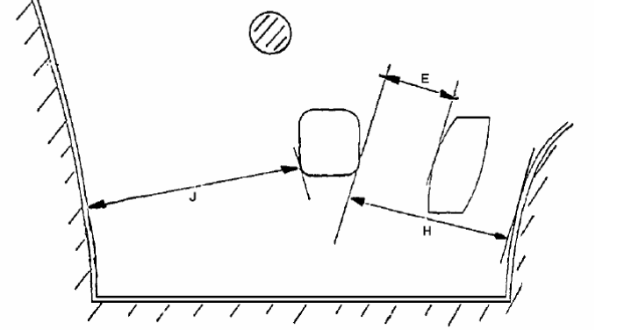

Figure 1b

**Two pedals – Automatic transmission with footrest**

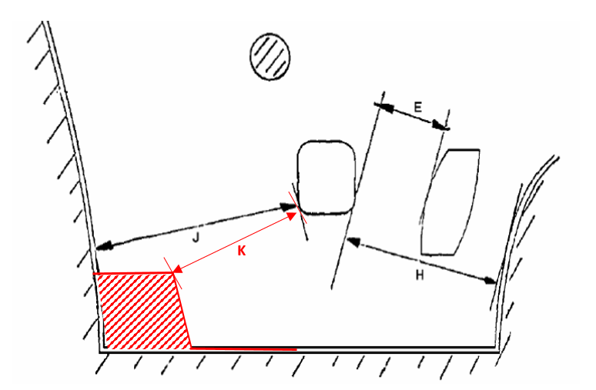

|  | *max.* | *min.* |
| --- | --- | --- |
| E | 100 | 50 |
| H | - | 130 |
| J | - | 120 |
| K | **-** | 50 |

# Figure 2a

# **Three-pedals – Conventional transmission without Footrest**



# Figure 2b

# **Three-pedals - Conventional transmission with Footrest**

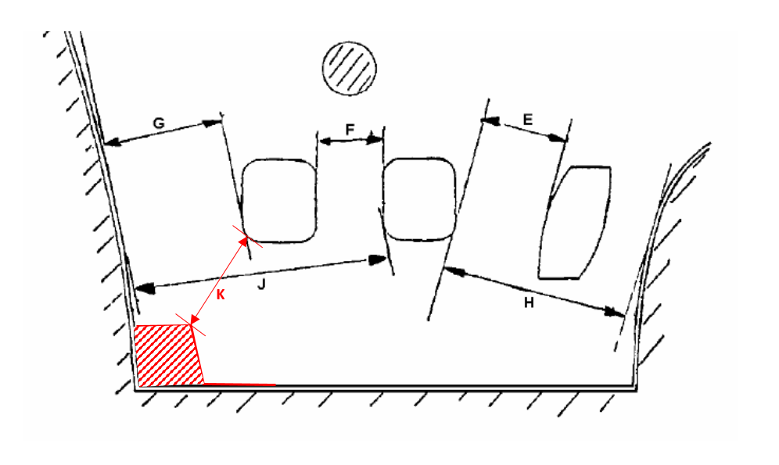

|  | *max.* | *min.* |
| --- | --- | --- |
| E | 100 | 50 |
| F | - | 50 |
| G | - | 50 |
| H | - | 130 |
| J | - | 160 |
| K | - | 50 |

1. \* In accordance with the programme of work of the Inland Transport Committee for 2020 as outlined in proposed programme budget for 2020 (A/74/6 (part V sect. 20) para 20.37), the World Forum will develop, harmonize and update UN Regulations in order to enhance the performance of vehicles. The present document is submitted in conformity with that mandate. [↑](#footnote-ref-2)
2. \*\* This document was scheduled for publication after the standard publication date owing to circumstances beyond the submitter's control. [↑](#footnote-ref-3)