INF.11
Economic Commission for Europe  Inland Transport Committee  Working Party on the Transport of Perishable Foodstuffs  Seventy-sixth session  Geneva, 13-16 October 2020  Item 8 of the provisional agenda  Reports of informal working groups | 12 October 2020  English

Report of the Informal Working group on the improvement of the approval system for ATP equipment and thermal appliances
Transmitted by the Government of the Netherlands on behalf of the working group.
1. The mandate of the informal working group is to identify and propose amendments to remove obstructions in approval system for ATP equipment, thermal appliances and other items.
2. The Informal working group met virtually on May 11th, May 25th, June 8th, June 22nd and 7 July 2020. In total of 16 experts were included in the list of participants representing 6 countries and 2 NGO’s.
Progress in WP.11
3. Besides topics covered by the mandate the informal working group also provides an informal meeting place to discuss other issues and ideas concerning ATP and WP.11.
4. In such, the limited progress was discussed and the benefits of changing the voting system (unanimity rule). It was stressed that contracting parties and NGO’s made considerable efforts to produce proposals while they were not adopted and without a clear motivation. It was recognized that it would be important for the authors to know the arguments but that it was not possible to oblige contracting parties to express their reasons for refusal. The best possible option would be that the Chair would ask for motivation on refusal. It was also said that in some cases the purpose of a proposal was not specific enough leading to misinterpretation and refusal at the session, in such documents could be improved.
Discussions on the outcome of document ECE/TRANS/2019/16 (report of the 1e and 2nd sessions of the informal working group).
5. Two proposals were not adopted in October 2019 by WP.11:
6. Proposal 1 proposed a modification of model report No 12 where in the English version “Self-contained/not self -contained was to be changed in “independent/dependent/mains operated”. It was decided in WP.11 to postpone discussion until definitions were developed.
7. For Model test report No 12 it was decided to align this wording with other test reports such as model reports 4, 5, 6 and 7 to make it consistent. Regarding definitions of independent and dependent it was recognized that there would be two different issues, the possibility to maintain the temperature even when the vehicle was not moving or vehicles engine was not functioning and the minimum time this continuation of function should be possible. Reference was made to the French document in 2019/8 and it was decided not to pursue this subject further in light of future developments.
8. Proposal 4 of 2019/16 suggested a modification of model report No. 12 for “Date of Manufacture” to “Year of manufacture”. Date of manufacture would lead to discussions among competent authorities if day, month and year should be given or month/year of just year. During discussion in WP.11 it was said that the manufacturers plate already requested notification of month and year, and that “year” alone was insufficient. It was also said that there were more inconsistencies in the other model reports.
It was agreed that Date of manufacture to be added by (Month/year) as used in model report No 13 was the most appropriate.
9. The consequential amendments to the test reports can be found as proposal 1 and 2 in document ECE/TRANS/WP.11/2020/14.
Discussion on document ECE/TRANS/WP.11/2019/2 and ECE/TRANS/WP.11/2019/3.
10. In the document’s definitions were proposed. Concerning document 2019/2 it was reported by WP.11 that the definition needed redrafting and in document 2019/3 the term of “Unit” was not supported by consensus.
11. It was discussed that the term “appliance” in itself appeared in many places in the Annexes of the ATP and that it was not always used for “thermal appliance”. It was also said that the application of “thermal appliance” in the regulation was also not consistently used for thermal appliances, for example in “refrigerating appliance” and “mechanically refrigerating appliance”. It was recognized that modifying the regulation for consistent use would be very labor intensive and that first there should be agreement on the correct wording. It was also expected that in a future revision these terms would be revisited anyway and that it would be helpful if definitions would be developed to help the understanding of the provisions. It was felt that more than a definition for “thermal appliance” was needed for full understanding.
12. The proposals for definitions are reproduced in Proposal 3 of document UNECE/TRANS/WP.11/2020/14.
Discussions on the declaration of conformity of Multi -compartment, multi temperature equipment (MTMC) and the markings.
13. Issues with the new requirements for MTMC’s coming into force op 6 July 2020 (declaration) and the 1ste of October 2020 (markings) were tabled.
14. It was said that marking could already be applied from 6 July voluntary and that this should be separated subject from the declaration issue.
15. For the declaration it was said that it was not clear who had to prepare the declaration and how this declaration should look like. In addition, no certainty existed in the application of a particular calculation tool that is the basis for the declaration.
16. After some discussion on who would have to prepare and issue the declaration it was decided that the equipment manufacturer, backed up by the appliance manufacturer or testing station, should prepare the declaration that then would be stamped and signed by the competent authority issuing the ATP certificate of compliance. It was also stated that the declaration was intended for the user and control authority and that is should remain free from unnecessary information. A Format was agreed upon that is reproduced in Annex 1 to document ECE/TRANS/2020/14. Also, in this document under proposal 4 included are several textual proposals to improve the requirements.
17. It was recognized that more than one calculation tool, or calculation spreadsheet were in existence. It was also questioned if a unique reference could be made to the IT tool that was developed at significant cost of the industry. It was said that it was unknown how these calculation spread sheets or calculation tools compared to each other and whether the outcome would be comparable. Examples with dimensions for calculation were submitted by participants and accepted. Comparison calculations were made in 4 different systems. The result was that for a simple 2 compartment situation identical outcomes would be achieved, however for a more complex 3 compartment equipment with a fixed separation wall in the longitudinal direction and movable end walls to form a third compartment at the rear of the equipment showed some differences in outcome. It was discovered that some this was due to determination of the worst-case situation.
18. It was discussed if this very limited deviation was really necessary. In the end it was said that the given fixed values for the internal walls would make it an estimation of demanded energy and that this was covered by a significant safety factor of 1.75 that would also cover this differences in determination of the worst-case conditions. It was also stated that MTMC already in use had less capacity than calculated and performed well in practice.
19. It was discussed that until the new requirements would come into force a guidance document, how to deal with the declaration of conformity and calculation tools (validation), present on the UN website would be helpful. See Annex 1 to this document. Concerning the form of validation of tools and calculation sheets it should be decided by WP.11 to validate against the TI tool or give detailed validation samples. For this reason, this section is kept in square brackets.

Annex 1
Guidance document
1. It is proposed to place a separate guidance document on the website of the UNECE. As this is a temporarily document to help the issue of the declaration of conformity until it is included in the regulation, it would be easier to deleted once it is redundant than when included in the ATP Handbook.
Guidance on the issue of the declaration of conformity (Annex 1, Appendix 2 paragraph 7.3.6) and the dimensioning of Multi-Compartment, Multi-Temperature equipment (MTMC).
Introduction:
2. The new provisions coming into force on 6 July 2020, which require a declaration of conformity for MTMC to be supplied, leaves room for interpretation. Although actions to change the ATP have been taken, they take time to implement. For the interim period, the explanation in this guidance document is intended to help with a harmonized procedure to improve acceptance of equipment in the country of registration.
3. For all equipment, the heat transfer through the wall shall be determined and the refrigerating and/or heating capacity matched, including the applicable safety factor, to guarantee safe transport of perishable foodstuffs. Additionally Multi compartment equipment that are is intended to maintain different temperatures in the individual compartments the heat transfer of each compartment shall be determined, the refrigerating capacity of the individual evaporator be matched, and the total capacity of the host unit for all individual evaporators operating at different temperatures.
4. Modifications to the ATP as described in 7.3.6 (06 July 2020), coming into force in October 2020, dictated that a declaration of conformity is to be issued to accompany the ATP certificate (Certificate of compliance). The declaration is intended to give information to carriers, consignors and control authorities if a particular equipment is suitable for a particular transport operation. In this it should be noted that based on article 4 of the ATP Treaty the selection of the equipment lies with the consignor and in some cases with the carrier.
Declaration of conformity
5. The declaration of conformity shall be prepared by the manufacturer of the insulated equipment or the equipment manufacturer placing the vehicle into service. The calculation shall be based on the temperature conditions as required by the owner or operator. If the temperature conditions for each compartment will be limited (not all -20<-> +12) this shall be stated in the declaration.
6. The declaration shall be based on a dimensioning calculation either by the thermal appliance manufacturer, the insulated equipment manufacturer or an appointed testing station. The Competent authority issuing the vehicle ATP certificate may after checking the calculation stamp and sign the declaration.
7. The certificate of conformity shall be appended to the ATP certificate and carried in the vehicle during carriage.
8. The declaration shall follow the Lay-out given in Annex 1 as far as possible.
Dimensioning:
Calculation:
9. For each compartment the (heat) energy required, and evaporator capacity available, shall be checked in the worst-case position of the dividing walls. In this worst-case situation, the energy requirement and availability for all compartments serviced by the host unit shall be checked as well.
10. Calculation shall be based on the given insulation factors in Annex1. Appendix 2 paragraph 7.3.7.
Use and validation of calculation tools.
11. [ To perform the calculation a calculation tool is recommended. A tool is available free of charge from Transfrigo-route International (further TI). However other tools or calculation sheets may be used to perform the calculation. The version of the tool valid at time of initial approval shall be used.
12. The competent authority that need to stamp and sign the declaration may request proof of validation of the other tools or spread sheets than the TI tool. The validation may be done by comparing results coming from the TI tool and the other tool or calculation sheets where the results may not exceed more than [2%] from the TI tool.
13. To receive the TI tool in its latest version contact TI via the website http://www.transfrigoroute.eu ]

Annex 1.
Model No. 14
Declaration of conformity for Multi Temperature – Multi compartment equipment
Supplementary document to the Certificate of Compliance as per Annex 1, appendix 2 paragraph 7.3.6
Top view sketch of the lay-out of the equipment:
Indicating:
-front and rear, numbering of compartments
-lay-out of the compartments with fixed and movable bulkheads and the following dimensions in centimeters: inside dimensions of the body, thickness and lengths of the bulkheads.
-most extreme position of movable dividing walls
- Position of the host unit(s) and evaporators
-material of the floor .
(Example of top view sketch)
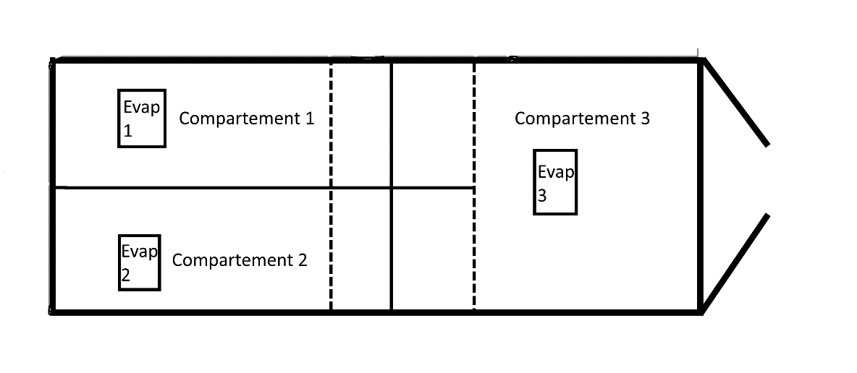

Insulated body:
ATP test report number:
Make:
Serial number:

Host unit:
ATP Test report number:
Make:
Serial Number:
Evaporators:
ATP test report number:
Make:
Type:

Remarks:
(for example, limitations in compartment temperatures or dimensions, use of particular accessories as curtains etc.)

Authentication
Name of competent authority:
Address:
Telephone number:
E-mail address:
Date and Place of signature Stamps signature, and name signing officer.

