INF.5
Economic Commission for Europe  Inland Transport Committee  Working Party on the Transport of Perishable Foodstuffs  Seventy-sixth session  Geneva, 13-16 October 2020  Item 5 (f) of the provisional agenda  Status and implementation of the Agreement  on the International Carriage of Perishable Foodstuffs  and on the Special Equipment to be Used for such Carriage (ATP)  Interpretation of ATP | 25 September 2020  English

Clarifications regarding filling the form of the ATP certificate issued to insulated equipment, refrigerated equipment, mechanically refrigerated equipment, heated equipment, mechanically refrigerated and heated equipment for carriage perishable foodstuffs
Submitted by the Russian Federation
1. In the appendix 3 to annex 1 to the ATP presented the reference of filling the form of the ATP certificate. In accordance with the Clarifications, the name of the vehicle for which this ATP certificate is issued must be left uncrossed in the upper part of the certificate, and all other names must be crossed out.
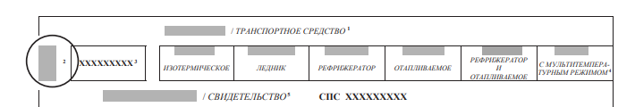
2. Having studied the experience of the contracting parties, it can be concluded that there is a lack of uniformity in filling out forms of ATP certificates.
3. Some countries, when issuing certificates for refrigerated vehicles, do not cross out the name "refrigerator" and leave "insulated" uncrossed, for example, Germany, Lithuania, Finland:
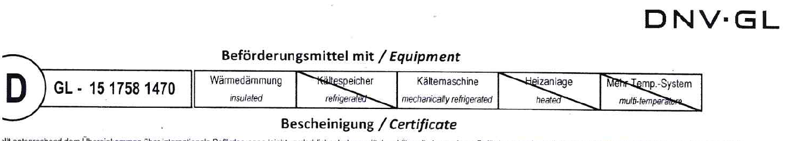

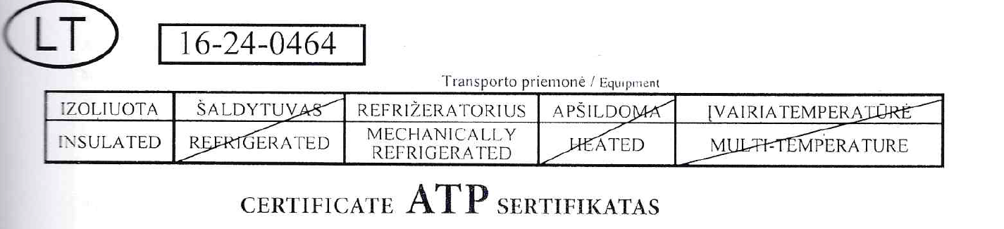

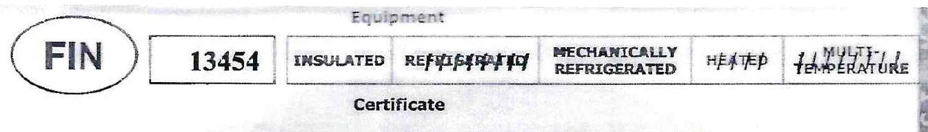
4. Poland, Latvia and the Russian Federation, if an ATP certificate is issued for a refrigerated vehicle, the name "insulated" is crossed out:
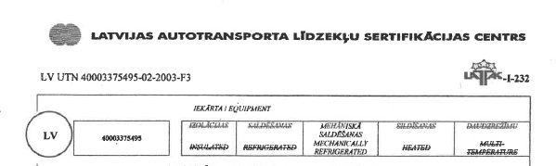
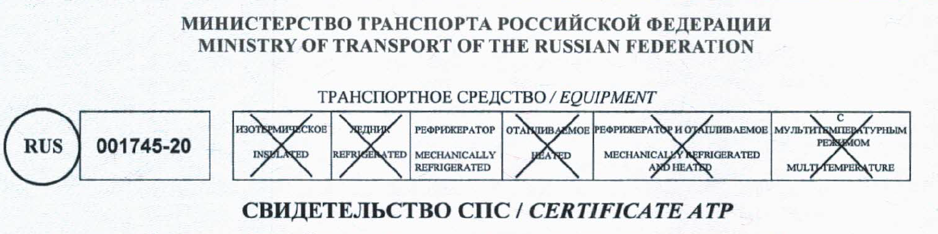
5. The lack of uniformity in the methods of filling the forms of ATP certificates may lead to problems for international carriers.
6. In goal of harmonization of requirements to filling the forms of ATP certificates Russian Federation propose to define the necessity of crossing out the type “Insulated” in the case when the ATP certificate issue to insulated equipment with the thermal appliance.
7. The Russian Federation believes that it is possible to leave the name "insulated" unchecked only if an ATP certificate is issued for an isothermal vehicle that is not equipped with any source of cold and /or heat, in which case all other names should be crossed out, since in accordance with the definitions and standards for special vehicles for the transport of perishable foodstuffs, vehicles: glaciers, refrigerators, heated, refrigerated and heated are a priori isothermal.
8. To mark in the ATP certificate the equipment is not only for example “mechanically refrigerator” also is the insulated equipment is incorrect, because the case when the mechanically refrigerator isn’t insulated is impossible.
9. Definitions of special equipment from ATP:
