Informal document No.10
Distr.: General
2 March 2020

Original: English
Economic Commission for Europe
Inland Transport Committee
Global Forum for Road Traffic Safety
Eightieth session
Geneva, 9-13 March 2020
Item 4 of the provisional agenda
Convention on Road Signs and Signals (1968):
Group of Experts on Road Signs and Signals

Proposal for amendments to Annex 1 and 3
Submitted by the Chair of Group of Experts on Road Signs and Signals and secretariat
This document contains the comments by Lithuania, Norway, Slovakia, Sweden, and Switzerland on ECE/TRANS/WP.1/2019/5 (amendment proposals to the 1968 Convention on Road Signs and Signals) and the responses proposed by the Chair of the Group of Experts on Road Signs and Signals and secretariat. WP.1 will be invited to discuss this document, and possibly adopt it.

This document contains the Group’s proposed amendments to Annex 1 and 3.

Section A
DANGER WARNING SIGNS
I. Models and general characteristics and symbols
1. The "A" DANGER WARNING signs shall be of two models model Aa or model Ab both described here and reproduced in Annex 3, except signs to be placed in the immediate vicinity of level-crossings and additional signs at approaches to level-crossings or opening bridges. A, 28 and A, 29 described in paragraphs 28 and 29 below respectively. Model Aa one is an equilateral triangle having one side horizontal and the opposite vertex above it; the ground is white or yellow and the border red. Model Ab two is a square with one diagonal vertical; the ground is yellow and the border, which is only a rim, is black or dark blue. Unless the description specifies otherwise, the symbols displayed on these signs shall be black or dark blue.
2. The size of the normal sized sign of model Aa one shall measure approximately 0.90 m; that of the small sized sign of model Aa one shall measure not less than 0.60 m. The size of the normal sized sign of model Ab two shall measure approximately 0.60 m; that of the small sign of model Ab two shall measure not less than 0.40 m.
3. As regards the choice between models Aa and Ab, see Article 5, paragraph 2, and Article 9, paragraph 1, of this Convention. The choice between the models shall be made in accordance with Article 5, paragraph 2, and Article 9, paragraph 1, of this Convention.
II. Symbols and instructions for the use of signs Definitions and images
1. Dangerous bend or bends
Warning of a dangerous bend or succession of dangerous bends shall be given by one of
the following symbols, whichever is appropriate:
(a) A, 1a: left bend
(b) A, 1b: right bend
(c) A, 1c: double bend, or succession of more than two bends, the first to the left
(d) A, 1d: double bend, or succession of more than two bends, the first to the right.
LEFT BEND
A, 1 a (A-01.1) gives warning of a dangerous left bend.
Images of permitted variants of A, 1 a (A-01.1) sign:
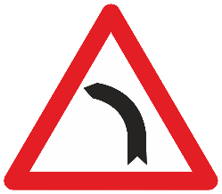 | 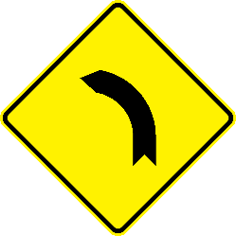
RIGHT BEND
A, 1 b (A-01.2) gives warning of a dangerous right bend.
Images of permitted variants of A, 1 b (A-01.2) sign:
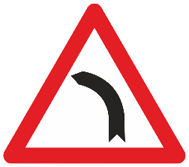 | 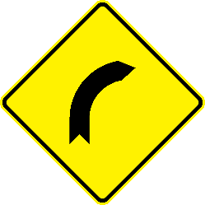
DOUBLE BEND OR SUCCESSION OF MORE THAN TWO BENDS, THE FIRST TO THE LEFT
A, 1 c (A-01.3) gives warning of a dangerous double bend, or succession of more than two bends, the first to the left.
Images of permitted variants of A, 1 c (A-01.3) sign:
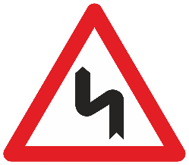
DOUBLE BEND OR SUCCESSION OF MORE THAN TWO BENDS, THE FIRST TO THE RIGHT
A, 1 d (A-01.4) gives warning of a dangerous double bend, or succession of more than two bends, the first to the right.
Images of permitted variants of A, 1 d (A-01.4) sign:
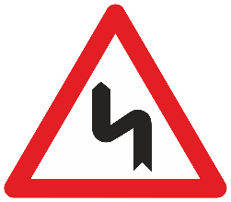
2. Dangerous descent³¹
DANGEROUS DESCENT
(a) To give warning of a steep descent symbol A, 2a shall be used with the sign of model Aa, or symbol A, 2b with the sign of model Ab.
(b) The left-hand part of symbol A, 2a shall occupy the left-hand corner of the sign panel and its base shall extend over the whole width of the panel. The figure in symbols A, 2a and A, 2b shows the gradient as a percentage; it may be replaced by a ratio (1:10). It shall, however, be open to Contracting Parties taking into account as far as possible the provisions of Article 5, paragraph 2 (b) of this Convention, to use, instead of symbol A, 2a or A, 2b, symbol A, 2c if they have adopted the sign of model Aa and symbol A, 2d if they have adopted the sign of model Ab.
A, 2 (A-02.0) gives warning of a dangerous descent. The symbol of either a car or a percentage or both, may be used. An arrow in the ground colour of the sign may be embedded into the black triangular part of the symbol when the percentage symbol is used.
Images of permitted variants of an example of A, 2 (A-02.0) sign:
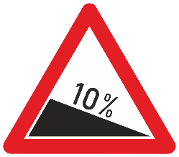  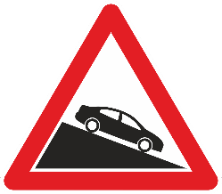 | 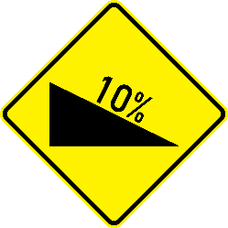  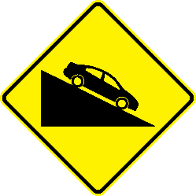
3. Steep ascent³²
STEEP ASCENT
(a) To give warning of a steep ascent, symbol A, 3a shall be used with the sign of model Aa , or symbol A, 3b with the sign of model Ab.
(b) The right-hand part of symbol A, 3a shall occupy the right-hand corner of the sign panel and its base shall extend over the whole width of the panel. The figure in symbols A, 3a and A, 3b shows the gradient as a percentage; it may be replaced by a ratio (1:10). It shall, however, be open to Contracting Parties which have chosen symbol A, 2c as the symbol for a dangerous descent to use symbol A, 3c instead of A, 3a, and to Contracting Parties which have chosen symbol A, 2d to use symbol A, 3d instead of A, 3b.
A, 3 (A-03.0) gives warning of a steep ascent. The symbol of either a car or a percentage or both, may be used. An arrow in the ground colour of the sign may be embedded into the black triangular part of the symbol when the percentage symbol is used.
Images of permitted variants of an example of A, 3 (A-03.0) sign:
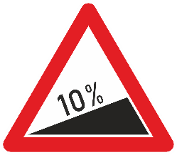  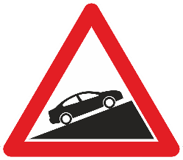 | 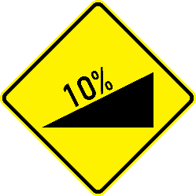  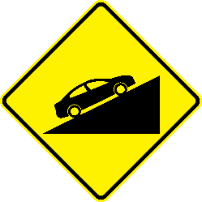
4. Carriageway narrows
CARRIAGEWAY NARROWS
Warning that the carriageway ahead is narrower shall be given by the symbol A, 4a or by a symbol showing the outline of the road more clearly, such as A, 4b .
A, 4 a (A-04.1) gives warning that the carriageway ahead is narrower. This sign shall not be used for indicating lane reduction ahead.
Images of permitted variants of A, 4 a (A-04.1) sign:
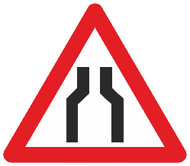 | 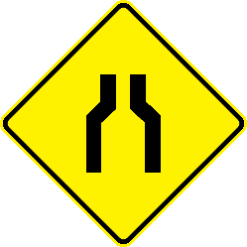
CARRIAGEWAY NARROWS LEFT
A, 4 b (A-04.2) gives warning that the carriageway ahead is narrower on the left-hand side. This sign shall not be used for indicating lane reduction ahead.
Images of permitted variants of A, 4 b (A-04.2) sign:
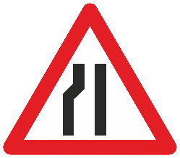 | 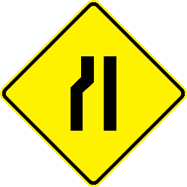
CARRIAGEWAY NARROWS RIGHT
A, 4 c (A-04.3) gives warning that the carriageway ahead is narrower on the right-hand side. This sign shall not be used for indicating lane reduction ahead.
Images of permitted variants of A, 4 c (A-04.3) sign:
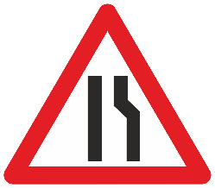 | 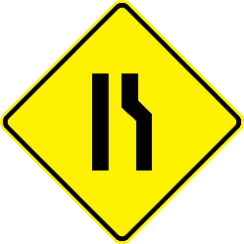
5. Opening bridge
OPENING BRIDGE
(a) Warning of a opening bridge shall be given by the symbol A, 5.
A, 5 (A-05.0) gives warning of an opening bridge.
(b) A rectangular panel of model The sign A, 29a (A-26.1) described in paragraph 29 below may be placed below this signthe danger warning sign bearing symbol A, 5 provided that panels of model signs A, 29b and A, 29c (A-26.2 and A-26.3) described in that paragraph are set up at approximately one third and two thirds of the distance between the the sign A29a bearing symbol A, 5 and the opening bridge.
Images of permitted variants of A, 5 (A-05.0) sign:
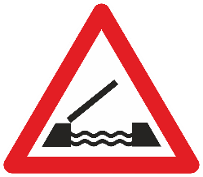 | 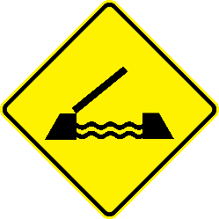
6. Road leads on to quay or river bank
QUAY OR RIVER BANK
Warning that the road is about to lead on to a quay or river bank shall be given by symbol A,6.
A, 6 (A-06.0) gives warning that the road is about to lead on to a quay or river bank.
Images of permitted variants of A, 6 (A-06.0) sign:
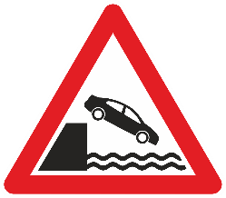 | 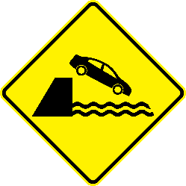
7. Uneven road
UNEVEN ROAD
(a) Warning of dips, hump bridges or ridges, or of sections where the carriageway is in bad condition shall be given by symbol A, 7a.
(b) To give warning of a hump bridge or ridge, symbol A, 7a may be replaced by symbol A, 7b.
(c) To give warning of a dip, symbol A, 7a may be replaced by symbol A,7c.
A, 7a (A-07.1) gives warning of dips, hump bridges or ridges, or of sections where the carriageway is in bad condition.
Images of permitted variants of A, 7 a (A-07.1) sign:
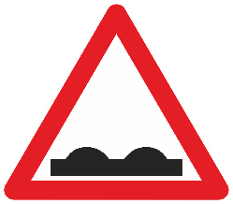
SPEED HUMP
A, 7 b (A-07.2) gives warning of a speed hump.
Images of permitted variants of A, 7 b (A-07.2) sign:
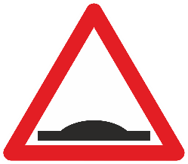
DIP
A, 7 c (A-07.3) gives warning of a dip.
Images of permitted variants of A, 7 c (A-07.3) sign:
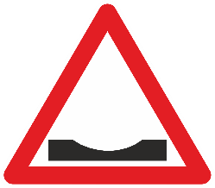
8. Dangerous shoulders
DANGEROUS SHOULDERS
(a) Warning of a section of road where the shoulders are particularly dangerous shall be given by symbol A, 8.
(b) The symbol may be reversed.
A, 8 (A-08.0) gives warning of a section of road where the shoulders are particularly dangerous. The symbol on this sign may be reversed.
Images of permitted variants of A, 8 (A-08.0) sign:
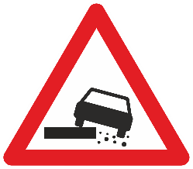  reversed symbol:  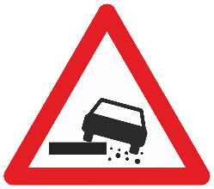 | 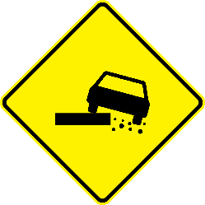  reversed symbol:  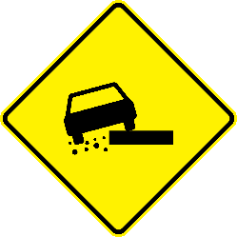
9. Slippery road
SLIPPERY ROAD
Warning that the section of road ahead may be particularly slippery shall be given by symbol A, 9
A, 9 (A-09.0) gives warning that the section of road ahead may be particularly slippery.
Images of permitted variants of A, 9 (A-09.0) sign:
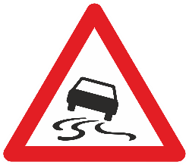 | 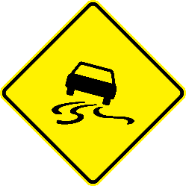
10. Loose gravel
LOOSE GRAVEL
Warning of a section of road on which gravel may be thrown up shall be given by symbol A, 10a used with the sign of model Aa or by symbol A, 10b with the sign of model Ab .
A, 10 a (A-10.0) gives warning of a section of road on which gravel may be thrown up. The symbol on this sign may be reversed.
Images of permitted variants of A, 10 a (A-10.0) sign:
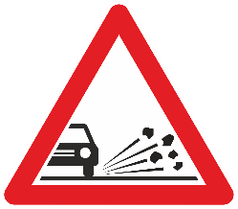  reversed symbol:  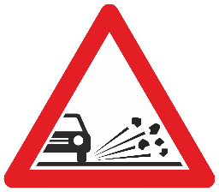 | 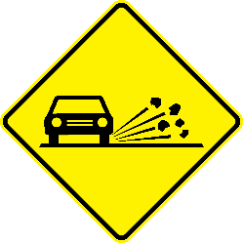  reversed symbol:  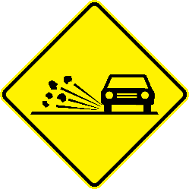
11. Falling rocks
FALLING ROCKS
(a) Warning of a section of road on which there is danger from falling rocks and the consequent presence of rocks on the carriageway shall be given by symbol A, 11a used with the sign of model Aa or by symbol A, 11b with the sign of model Ab .
(b) The right-hand part of the symbol shall occupy the right-hand corner of the sign panel in both cases.
(c) The symbol may be reversed.
A, 11 a (A-11.0) gives warning of a section of road on which there is danger from falling rocks and the consequent presence of rocks on the carriageway. The symbol on this sign may be reversed.
Images of permitted variants of A, 11 a (A-11.0) sign:
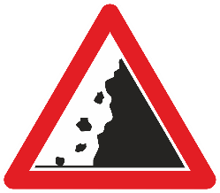  reversed symbol:  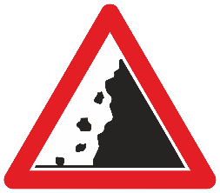 | 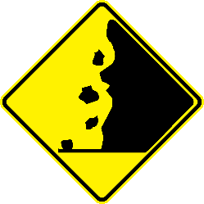  reversed symbol:  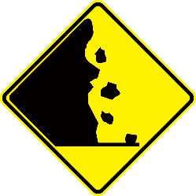
12. Pedestrians crossing³³
(a) Warning of a pedestrian crossing indicated either by road markings, or by signs E, 12 shall be given by symbol A, 12 of which there are two models: A, 12a and A, 12b .
{³³ See also point 17 of the Annex of the European Agreement[deleted]}
(b) The symbol may be reversed.
PEDESTRIAN CROSSING
A, 12 a (A-12.1) gives warning of a pedestrian crossing indicated either by road markings of broad stripes parallel to the axis of the carriageway, or by sign E, 12 (E-10.0). The symbol on this sign may be reversed.
Images of permitted variants of A, 12 a (A-12.1) sign:
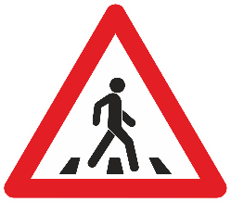  reversed symbol: | 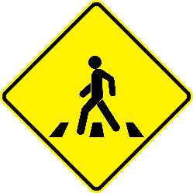  reversed symbol:  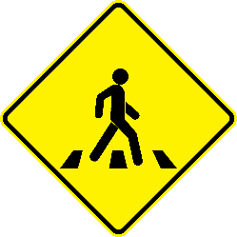
PEDESTRIAN
A, 12 b (A-12.2) gives warning of a section of road frequented by pedestrians. The symbol on this sign may be reversed.
Images of permitted variants of A, 12 b (A-12.2) sign:
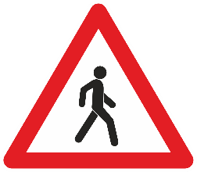  reversed symbol:  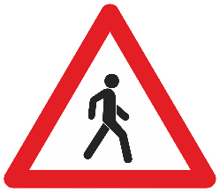 | 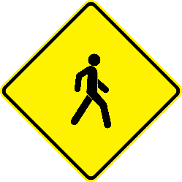  reversed symbol:  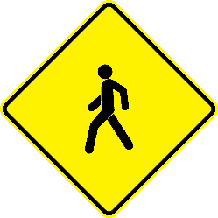
13. Children
(a) Warning of a section of road frequented by children, such as the exit from a school or playground shall be given by symbol A, 13.
(b) The symbol may be reversed.
CHILDREN
A, 13 (A-13.0) gives warning of a section of road frequented by children, such as within the proximity of a school or playground. The symbol on this sign may be reversed.
Images of permitted variants of A, 13 (A-13.0) sign:
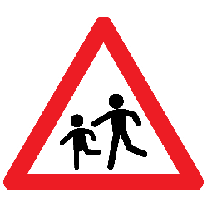  reversed symbol:  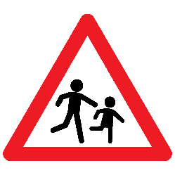 | 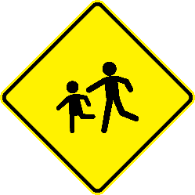  reversed symbol:  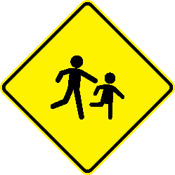
14. Cyclists entering or crossing
CYCLISTS ENTERING OR CROSSING
(a) Warning of a point at which cyclists frequently enter or cross the road shall be given by symbol A, 14.
(b) The symbol may be reversed.
A, 14 (A-14.0) gives warning of a point at which cyclists frequently enter or cross the road. The symbol on this sign may be reversed.
Images of permitted variants of A, 14 (A-14.0) sign:
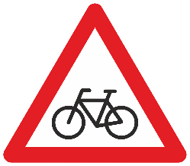  reversed symbol:  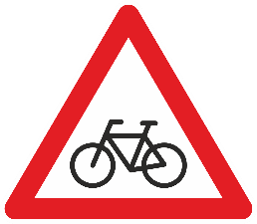 | 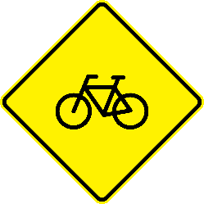  reversed symbol:  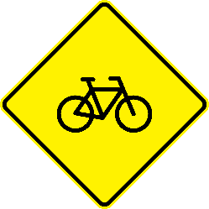
15. Cattle or other animals crossing
DOMESTIC ANIMALS CROSSING
(a) Warning of a section of road on which there is a particular danger of animals crossing shall be given by a symbol representing the silhouette of the animal, domestic or wild, most frequently encountered, such as symbol A, 15a for a domestic animal and symbol A, 15b for a wild animal.
(b) The symbol may be reversed.
A, 15 a (A-15.1) gives warning of a section of road on which there is a particular danger of domestic animals crossing. The symbol shall represent the silhouette of the domestic animal most frequently encountered. The symbol on this sign may be reversed.
Images of permitted variants of an example of A, 15 a (A-15.1) sign:
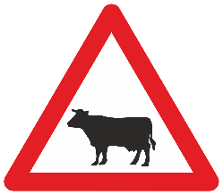  reversed symbol:  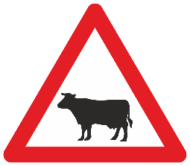 | 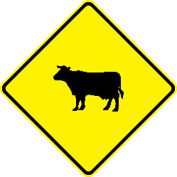  reversed symbol:  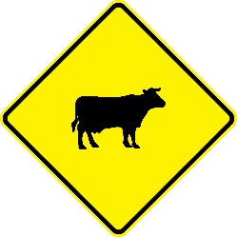
WILD ANIMALS CROSSING
A, 15 b (A-15.2) gives warning of a section of road on which there is a particular danger of wild animals crossing. The symbol shall represent the silhouette of the wild animal most frequently encountered. The symbol on this sign may be reversed.
Images of permitted variants of an example of A, 15 b (A-15.2) sign:
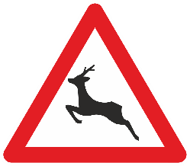  reversed symbol:  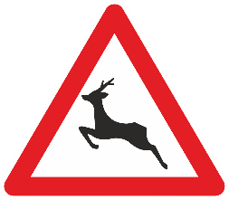 | 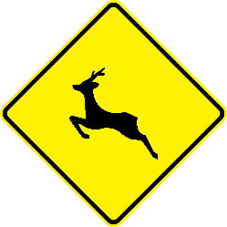  reversed symbol:  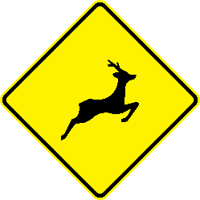
16. Road works
ROAD WORKS
Warning that work is in progress on the section of the road ahead shall be given by symbol A, 16.
A, 16 (A-16.0) gives warning that work is in progress on the section of the road ahead.
Images of permitted variants of A, 16 (A-16.0) sign:
17. Traffic light signals
TRAFFIC LIGHT SIGNALS
(a) If it is considered essential to give warning of a section of road on which traffic is regulated by three-colour light signals, because road users would not expect such a section, symbol A, 17 shall be used. There are three models of symbol A, 17: A, 17a ; A, 17b ; and A, 17c , which correspond to the arrangements of lights in the three-colour system described in Article 23, paragraphs 4 to 6 of this Convention.
(b) This symbol shall be in the three colours of the lights of which it gives warning.
A, 17 (A-17.0) gives warning of a section of road on which traffic is regulated by three-colour traffic light signals. The symbol of traffic light signals shall be surrounded by a dark colour narrow strip.
This sign shall only be used on road sections on which road users would not expect traffic light signals. The symbol shall be in the three colours of the traffic lights of which it gives warning.
This sign may be set up to supplement or replace the signs described in paragraphs 18 to 21 if traffic at the intersection is regulated by a traffic light signal.
Images of permitted variants of A, 17 a (A-17.0) sign:
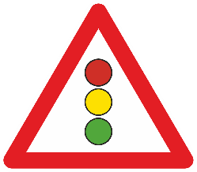 | 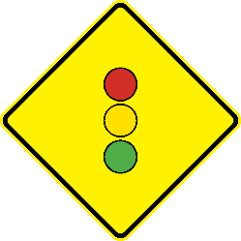
18. Intersection where the priority is prescribed by the general priority rule³⁴
{³⁴ See also point 17 of the Annex of the European Agreement[deleted]}
INTERSECTION WITH GENERAL PRIORITY RULE
(a) Warning of an intersection where the priority is that prescribed by the general priority rule in force in the country shall be given by symbol A, 18a used with sign Aa or by symbol A, 18b used with sign Ab .
A, 18 a (A-18.1) gives warning of an intersection where the priority is that prescribed by the general priority rule in force in the country.
Images of permitted variants of A, 18 a (A-18.1) sign:
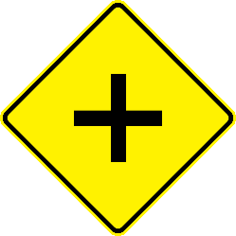
(b) Symbols A, 18a and A, 18b may be replaced by symbols which show the nature of the intersection more clearly, such as A, 18c ; A, 18d ; A, 18e ; A, 18f and A, 18g .
INTERSECTION WITH GENERAL PRIORITY RULE
A, 18 b (A-18.2) gives warning of an intersection where the priority is that prescribed by the general priority rule in force in the country and shows an example of a specific nature of the intersection.
Images of permitted variants of an example of A, 18 b (A-18.2) sign:
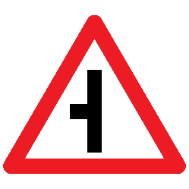 | 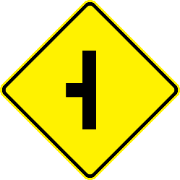

19. Intersection with a road the users of which must give way
(a) Warning of an intersection with a road the users of which must give way shall be given by symbol A, 19a .
INTERSECTION WITH A GIVE WAY ROAD
A, 19 a (A-19.1) gives warning of an intersection with a road the users of which must give way.
Images of permitted variants of A, 19 a (A-19.1) sign:
(b) Symbol A, 19a may be replaced by symbols which show the nature of the intersection more clearly, such as A, 19b and A, 19c .
INTERSECTION WITH A GIVE WAY ROAD
A, 19 b (A-19.2) gives warning of an intersection with a road the users of which must give way and shows an example of a specific nature of the intersection.
Images of permitted variants of an example of A, 19 b (A-19.2) sign:
(c) These symbols The signs A, 19 a and A, 19 b (A-19.1 and A-19.2) may be used on a road only if sign B, 1 or sign B, 2 (B-01.0 or sign B-02.0) is placed on the road or roads with which it forms the intersection of which warning is given, or if these roads are such (for example, paths or earth-tracks) that, under domestic legislation, drivers using them are required to give way at the intersection even in the absence of such signs. The use of these symbols on roads on which sign B, 3 (B-03.0) is set up shall be confined to certain exceptional cases.
20. Intersection with a road to whose users drivers must give way³⁵
{³⁵ See also point 17 of the Annex of the European Agreement[deleted]}
(a) If the "GIVE WAY" sign B, 1 is placed at the intersection, the symbol A, 20 shall be used at the approach.
(b) If the "STOP" sign B, 2 is placed at the intersection, the symbol used at the approach shall be A, 21a or A, 21b whichever corresponds to the model of sign B, 2 set up. (c) However, instead of sign Aa with these symbols, sign B, 1 or sign B, 2 may be used in conformity with Article 10, paragraph 6, of this Convention.
[deleted]
21. Roundabout
ROUNDABOUT
Warning of a roundabout shall be given by symbol A, 22.
A, 22 (A-20.0) gives warning of a roundabout. The symbol on this sign shall be reversed for traffic keeping to the left.
Images of permitted variants of A, 22 (A-20.0) sign:
reversed symbol: | reversed symbol:
22. Intersection where traffic is regulated by a light signal³⁶
{³⁶ See also point 17 of the Annex of the European Agreement[deleted]}
If traffic at the intersection is regulated by a light signal, a sign Aa or Ab , bearing symbol A, 17 described in paragraph 17 above may be set up to supplement or replace the signs described in paragraphs 18 to 21 above.
[deleted]
23. Two-way traffic
TWO-WAY TRAFFIC
(a) Warning of a section of road temporarily or permanently carrying two-way traffic on the same carriageway when, on the previous section, traffic was carried on a one-way road or on a road comprising several one-way traffic carriageways, shall be given by the symbol A, 23.
(b) The sign bearing this symbol shall be repeated at the beginning of the section and along the section as frequently as may be necessary.
A, 23 (A-21.0) gives warning of a section of road temporarily or permanently carrying two-way traffic on the same carriageway when, on the previous section, traffic was carried on a one-way road or on a road comprising several one-way traffic carriageways. This sign shall be repeated at the beginning of the section and along the section as frequently as may be necessary. The symbol on this sign shall be reversed for traffic keeping to the left.
Images of permitted variants of A, 23 (A-21.0) sign:
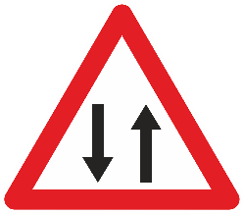  reversed symbol:  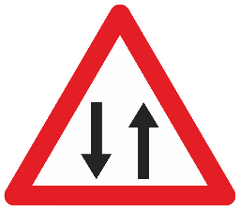 | 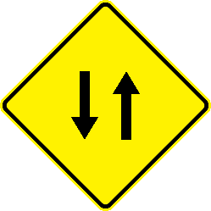  reversed symbol:  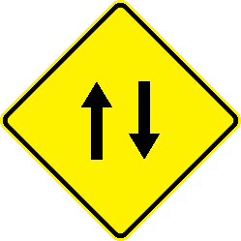
24. Traffic congestion
TRAFFIC CONGESTION
(a) Warning that there may be traffic congestion on the section of road ahead shall be given by symbol A, 24.
(b) The symbol may be reversed.
A, 24 (A-22.0) gives warning that there may be traffic congestion on the section of road ahead. The symbol on this sign may be reversed for traffic keeping to the left.
Images of permitted variants of A, 24 (A-22.0) sign:
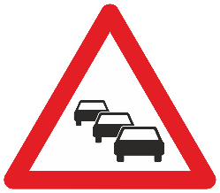  reversed symbol:  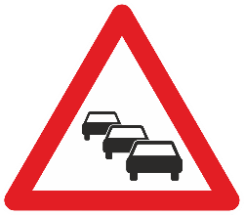 | 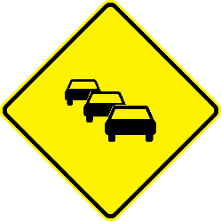  reversed symbol:  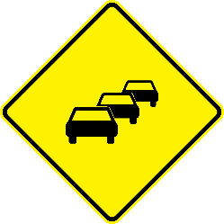
25. Level-crossings with gates
LEVEL-CROSSINGS WITH GATES
Warning of level-crossings with gates or staggered half-gates on either side of the railway line, shall be given by symbol A, 25.
A, 25 (A-23.1) gives warning of level-crossings with gates or staggered half-gates on either side of the railway. The symbol on this sign may be reversed. The barrier shown on the sign may be of colours applied by a State concerned in accordance with Article 35, paragraph 1 of this Convention.
Images of permitted variants of A, 25 (A-23.1) sign:
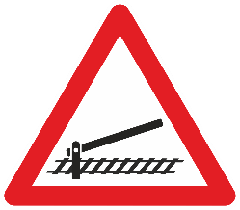  reversed symbol:  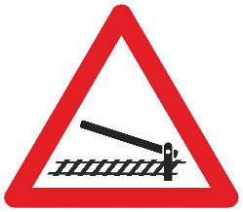 | 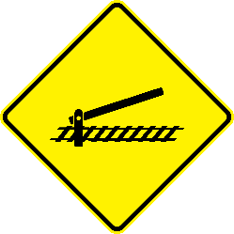  reversed symbol:  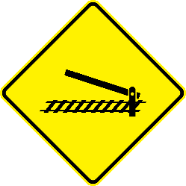
26. Other level-crossings³⁷
OTHER LEVEL-CROSSINGS
Warning of other level-crossings shall be given by symbol A, 26 a or A, 26 b , or by symbol A, 27 as appropriate.
A, 26 a (A-23.2) gives warning of level-crossings without gates or staggered half-gates on either side of the railway. It may be replaced by sign A, 26 b (A-23.3) or A, 27 (A-24.0). The symbol on this sign may be reversed for traffic keeping to the left.
Images of permitted variants of A, 26 a (A-23.2) sign:
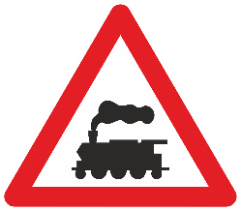  reversed symbol:  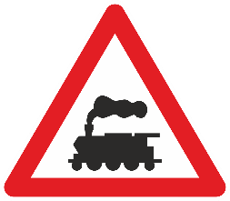 | 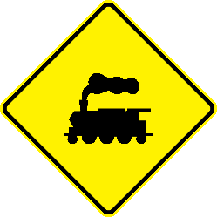  reversed symbol:  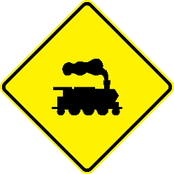
OTHER LEVEL-CROSSINGS
A, 26 b (A-23.3) gives warning of level-crossings without gates or staggered half-gates on either side of the railway. It may be replaced by sign A, 26 a (A-23.2) or A, 27 (A.24.0).
Images of permitted variants of A, 26 b (A-23.3) sign:
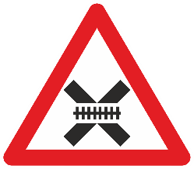 | 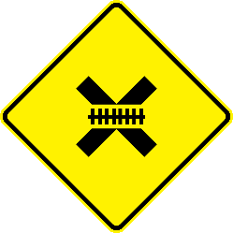
27. Intersection with a tramway line
INTERSECTION WITH A TRAMWAY
To give warning of an intersection with a tramway line, unless such intersection is a levelcrossing as defined in Article 1 of the Convention, symbol A, 27 may be used.
A, 27 (A-24.0) gives warning of an intersection with a tramway, unless such intersection is a level crossing as defined in Article 1 of the Convention. The symbol on this sign may be reversed for traffic keeping to the left. If such intersection is considered as level crossing, this sign may be replaced by A, 26 a (A-23.2) or A, 26 b (A.23.3).
NOTE - If it is considered necessary to give warning of intersections between a road and a railway track at which rail traffic proceeds very slowly and road traffic is regulated by a railwayman accompanying the railway vehicles and making the necessary hand signals, sign A, 32 described in paragraph 32 below shall be used. [comment: already available in para 32]
Images of permitted variants of A, 27 (A-24.0) sign:
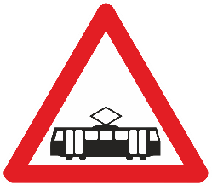 | 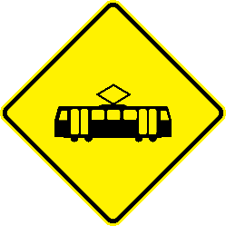
28. Signs to be placed in the immediate vicinity of level-crossings³⁸
LEVEL-CROSSINGS
(a) There are three four models of sign A, 28 referred to in Article 35, paragraph 2 of this Convention: A, 28 a, A, 28 b, and A, 28 c and A, 28 d.
(b) Models A, 28 a and A, 28 b c shall have a white or yellow ground and a red or black border or may show red stripes (with or without a red or black border) on condition that neither the general appearance nor the effectiveness of the signs is impaired thereby; model A, 28 c b and A, 28 d shall have a white or yellow ground and a black border; the inscription on model A, 28 c b and A, 28 d shall be in black letters. Models A, 28 c b and A, 28 d shall be used only if the railway line comprises at least two tracks; with model A, 28 c d the additional panel shall be affixed to indicate the number of tracks.
A, 28 a (A-25.1) gives warning of immediate vicinity of a level-crossing with one track. It is of an X-shaped cross with a white or yellow ground and a red or black border or may show red stripes (with or without a red or black border). It may be replaced by sign A, 28 b (A-25.2).
Image of a permitted variant of A, 28 a (A-25.1) sign:
LEVEL-CROSSINGS
A, 28 b (A-25.2) gives warning of immediate vicinity of a level-crossing with one track. It is of an X-shaped cross with a white or yellow ground and a black border and black inscription. It may be replaced by sign A, 28 a (A-25.1).
Images of a permitted variant of an example of A, 28 b (A-25.2) sign:
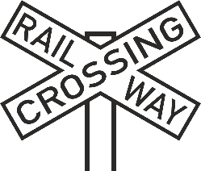
LEVEL-CROSSINGS
A, 28 c (A-25.3) gives warning of immediate vicinity of a level-crossing with at least two tracks. It is identical to the sign A, 28 a (A-25.1) except that it is supplemented by half of an X-shaped cross affixed below. It may be replaced by sign A, 28 d (A-25.4).
Image of a permitted variant of A, 28 c (A-25.3) sign:
LEVEL-CROSSINGS
A, 28 d (A-25.4) gives warning of immediate vicinity of a level-crossing with at least two tracks. It is identical to the sign A, 28 b (A-25.2) except that it is supplemented by an additional panel affixed below indicating the number of tracks. It may be replaced by sign A, 28 c (A-25.3).
Image of a permitted variant of an example of A, 28 d (A-25.4) sign:
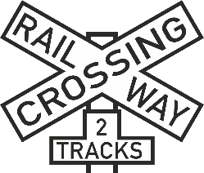
If a Contracting Party decides to use the sign A, 28 a (A-25.1) at a level-crossing with one track it shall use the sign A, 28 c (A-25.3) at a level-crossing with at least two tracks, or alternatively use signs A, 28 b (A-25.2) and A, 28 d (A-25.4).
29. Additional signs at approaches to level-crossings or opening bridges
APPROACHES TO LEVEL-CROSSINGS OR OPENING BRIDGES
(a) Signs A, 29a, A, 29b and A, 29c may be used to give warning of and distance at approaches to level-crossings and swing bridges. These signs are rectangular having its longer sides vertical and bear respectively three, two and one oblique red stripes on a white or yellow ground, with the latter two signs set up at about two thirds and one third of the distance between the sign A, 29a and the railway line or swing bridge. These signs may be repeated on the opposite side of the carriageway. The stripes shall slope downwards towards the carriageway.
(b) The danger warning sign for the level-crossing or swing bridge may be placed above signs A, 29b and A, 29c in the same way as it shall be placed above sign A, 29a.
A, 29 a (A-26.1) gives warning of and distance at approaches to level-crossings and opening bridges. It shall be placed under the signs A, 25, A, 26 a, A, 26 b, A, 27 or A, 5 (A-23.1, A-23.2, A-23.3, A-24.0 and A-05.0). It is a rectangle having its longer sides vertical and bears, preferably centered, three oblique red stripes on a white or yellow ground. It may be repeated on the opposite side of the carriageway. The stripes shall slope downwards towards the carriageway.
Images of permitted variants of A, 29 a (A-26.1) sign:
reversed stripes:

APPROACHES TO LEVEL-CROSSINGS OR OPENING BRIDGES
A, 29 b (A-26.2) gives warning of and distance at approaches to level-crossings and opening bridges. It may be placed under the signs A, 25, A, 26 a, A, 26 b, A, 27 or A, 5 (A-23.1, A-23.2, A-23.3, A-24.0 and A-05.0). It is a rectangle having its longer sides vertical and bears, preferably centered, two oblique red stripes on a white or yellow ground. It is set up at about two thirds of the distance between the railway or opening bridge and the sign A, 29 a (A-26.1). It may be repeated on the opposite side of the carriageway. The stripes shall slope downwards towards the carriageway.
Images of permitted variants of A, 29 b (A-26.2) sign:
reversed stripes:
APPROACHES TO LEVEL-CROSSINGS OR OPENING BRIDGES
A, 29 c (A-26.3) gives warning of and distance at approaches to level-crossings and opening bridges. It may be placed under the signs A, 25, A, 26 a, A, 26 b, A, 27 or A, 5 (A-23.1, A-23.2, A-23.3, A-24.0 and A-05.0). It is a rectangle having its longer sides vertical and bears, preferably centered, one oblique red stripe on a white or yellow ground and it is set up at about one third of the distance between the railway or opening bridge and the sign A, 29 a (A-26.1). It may be repeated on the opposite side of the carriageway. The stripe shall slope downwards towards the carriageway.
Images of permitted variants of A, 29 c (A-26.3) sign:
reversed stripe:
30. Airfield
(a) Warning of a section of road likely to be flown over at low altitude by aircraft taking off from or landing on an airfield shall be given by symbol A, 30.
(b) The symbol may be reversed.
AIRFIELD
A, 30 (A-27.0) gives warning of a section of road likely to be flown over at low altitude by aircraft taking off from or landing on an airfield.
Images of permitted variants of A, 30 (A-27.0) sign:
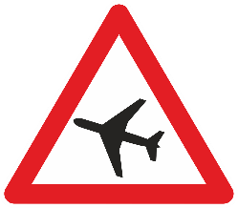

31. Cross-wind
CROSS-WIND
(a) Warning of a section of road on which there is often a strong cross-wind shall be given by symbol A, 31.
(b) The symbol may be reversed.
A, 31 (A-28.0) gives warning of a section of road on which there is often a strong cross-wind. The symbol on this sign may be reversed.
Images of permitted variants of A, 31 (A-28.0) sign:
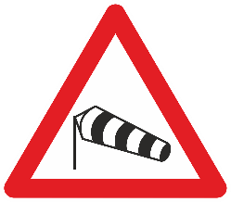  reversed symbol:  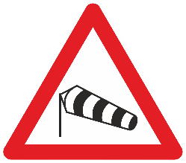 | 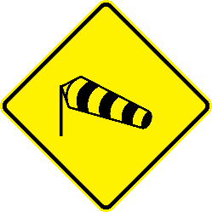  reversed symbol:
32. Other dangers
OTHER DANGERS
(a) Warning of a section of road on which there is a danger other than those enumerated in paragraphs 1 to 31 above or in section B of this annex may be given by symbol A, 32.
A, 32 (A-29.0) gives warning of a section of road on which there is a danger other than those enumerated in paragraphs 1 to 31 above or in section B of this annex. Sign A, 32 may be used, for example, to give warning of intersections with railway tracks at which rail traffic proceeds very slowly and road traffic is regulated by a railwayman accompanying the railway vehicles and making the necessary hand signals.
(b) It shall, however, be open to Contracting Parties to adopt graphic symbols in conformity with the provisions of Article 3, paragraph 1 (a) (ii) of this Convention.
(c) Sign A, 32 may be used, in particular, to give warning of intersections with railway tracks at which rail traffic proceeds very slowly and road traffic is regulated by a railwayman accompanying the railway vehicles and making the necessary hand signals.
Images of permitted variants of A, 32 (A-29.0) sign:
Section B
PRIORITY SIGNS
NOTE - At an intersection comprising a priority road in which there is a bend, an additional panel H, 8 bearing a diagram of the intersection which shows the outline of the priority road may be placed below danger signs giving warning of the intersection or below priority signs, whether they are set up at the intersection or not.
Definitions, images and characteristics
1. "GIVE WAY" sign³⁹
(a) The "GIVE WAY" sign shall be sign B, 1. It shall be used to notify drivers that, at the intersection where the sign is placed, they must give way to vehicles on the road they are approaching. It shall consist of an equilateral triangle having one side horizontal and the opposite vertex below it. The ground shall be white or yellow and the border red. The sign shall bear no symbol.
GIVE WAY
B, 1 (B-01.0) notifies drivers that, at the intersection where the sign is placed, they must give way to vehicles of the road they are approaching. It shall consist of an equilateral triangle having one side horizontal and the opposite vertex below it. The ground shall be white or yellow and the border red. The sign shall bear no symbol.
(b) The side of the normal sized sign shall measure approximately 0.90 m; the side of the small sign shall measure not less than 0.60 m.
(c) B, 1 (B-01.0) may be used in conjunction with an additional panel H, 8 (H-08.0) described in section H, paragraph 6 subsection II, paragraph 5 of this Annex, in order to indicate to drivers the outline of the priority road.
To give warning of sign B, 1 (B-01.0) placed at intersection, sign B, 1 (B-01.0) supplemented by an additional panel H, 1 (H-01.0), described in section H, paragraph 2 (a) paragraph 1 of this Annex shall be used at the approach by Contracting Parties using model one for danger warning signs. If a Contracting Party uses model two (square with one vertical diagonal) for danger warning signs, the sign B, 1 (B-01.0) shall be depicted on the panel of model two for danger warning signs.
Image of a permitted variant of B, 1 (B-01.0) sign:
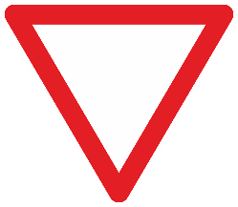
Images of permitted variants of a warning to give way:
2. "STOP" sign⁴⁰
{⁴⁰ See also point 18 of the Annex of the European Agreement[deleted]}
(a) The "STOP" sign shall be sign B, 2, which shall be used to notify drivers that, at the intersection where the sign is placed, they shall stop before entering the intersection and give way to vehicles on the road they are approaching. of which tThere are two models of this sign:
(i) Model B, 2a is octagonal with a red ground surrounded by white rim and bearing the word “STOP” inscription in white in English or in the language of the State concerned; the height of the word shall be no less than one third of the height of the panel;
(ii) Model B, 2b is circular with a white or yellow ground and a red yellow border; it bears within it sign B, 1 without any inscription, and near the top, in large letters, the word “STOP” inscription in black or dark blue, in English or in the language of the State concerned.
STOP
B, 2 (B-02.0) notifies drivers that, at the intersection where the sign is placed, they must stop before entering the intersection and give way to vehicles on the road they are approaching. It is an octagon with a red ground surrounded by a white rim and bears the “STOP” inscription in white in English or in the language of the State concerned. The height of the inscription shall be no less than one third of the height of the panel.
(b) The height of the normal sized sign B, 2 a (B-02.0) and the diameter of the normal sized sign B, 2b shall be approximately 0.90 m; the same dimensions of the small signs and shall be not less than 0.60 m for a small sized sign.
(c) As regards the choice between models B, 2a and B, 2b, see Article 5, paragraph 2, and Article 10, paragraph 3, of this Convention.
(d) B, 2 (B-02.0) and B, 2 b may be used in conjunction with an additional panel H, 8 (H-08.0) described in section H, paragraph 6 subsection II, paragraph 5 of this Annex, in order to indicate to drivers the outline of the priority road.
To give warning of sign B, 2 (B-02.0) placed at intersection, sign B, 1 (B-01.0) supplemented by an additional panel bearing the "STOP" inscription, or its equivalent in national language and a figure indicating the distance to the sign B, 2 (B-02.0) shall be used at the approach by Contracting Parties using model one for danger warning signs. Shall a Contracting Party use model two (square with one vertical diagonal) for danger warning signs, the sign B, 2 (B-02.0) shall be depicted on the panel of model two for danger warning signs.
Image of B, 2 (B-02.0) sign:
Images of permitted variants of a warning to stop:

3. "PRIORITY ROAD" sign
PRIORITY ROAD
(a) The "PRIORITY ROAD" sign shall be sign B, 3 (B-03.1) which shall be used to notifies drivers that, at intersections of that road with other roads, they have priority for passage over vehicles moving along or coming from such the other roads are required to give way to vehicles moving along that road. It shall consist of a square with one diagonal vertical. The rim of the sign shall be black; the sign shall have in its centre a yellow or orange square with a black rim; the space between the two squares shall be white.
(b) The side of the normal sized sign shall measure approximately 0.50 m; the side of the small sign shall measure not less than 0.35 m.
(c) B, 3 (B-03.1) may be used in conjunction with an additional panel H, 8 (H-08.0) described in section H, paragraph 6 subsection II, paragraph 5 of this Annex, in order to indicate to drivers the outline of the priority road.
Image of B, 3 (B-03.1) sign:
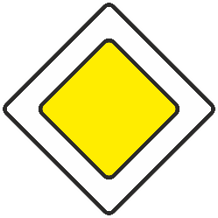
4. "END OF PRIORITY" sign
END OF PRIORITY ROAD
(a) The "END OF PRIORITY" sign shall be sign B, 4 (B-03.2) which shall be used to notifies y drivers that the road along which they are moving ceases to have priority over other roads. It shall consist of sign B, 3 (B-03.1) above with the addition of a black or grey median band perpendicular to the lower left and upper right sides of the square or, preferably, of grey black parallel lines forming such a band.
(b) B, 4 (B-03.2) may be used in conjunction with an additional panel H, 8 (H-08.0) described in section H, paragraph 6 subsection II, paragraph 5 of this Annex, in order to indicate to drivers the outline of the priority road.
Image a permitted variant of B, 4 (B-03.2) sign:
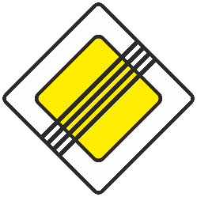
5. Sign indicating priority for oncoming traffic
PRIORITY FOR ONCOMING TRAFFIC
B, 5 a (B-04.1) notifies drivers that entry into the narrow section is prohibited so long as it is not possible to pass through that section without obliging oncoming vehicles to stop. It shall be used on a narrow section of road where passing is difficult or impossible, traffic is regulated and, because where drivers can see the whole length of the section clearly both at night and by day, and no traffic light signals are installed. The sign shall be set up facing the traffic on the side which does not have priority. The symbol on this sign shall be reversed for traffic keeping to the left.
(a) If, on a narrow section of road where passing is difficult or impossible, traffic is regulated and if, because drivers can see the whole length of the section clearly both at night and by day, such regulation is carried out by giving priority to traffic moving in one direction and not by installing traffic light signals, sign B, 5 "PRIORITY FOR ONCOMING TRAFFIC" shall be set up facing the traffic on the side which does not have priority. This sign shall mean that entry into the narrow section is prohibited so long as it is not possible to pass through that section without obliging oncoming vehicles to stop.
(b) This sign shall be round, with a white or yellow ground and a red border; the arrow indicating the direction having priority shall be black and that indicating the other direction red. The arrows shall be parallel.
Image of a permitted variant of B, 5 a (B-04.1) sign:
reversed symbol:
PRIORITY FOR ONCOMING TRAFFIC
B, 5 b (B-04.2) notifies drivers that entry into the narrow section is prohibited so long as it is not possible to pass through that section without obliging oncoming vehicles to stop. It shall be used on a narrow section of road where passing is difficult or impossible, traffic is regulated and, because where drivers can see the whole length of the section clearly both at night and by day, and no traffic light signals are installed. The sign shall be set up facing the traffic on the side which does not have priority. The symbol on this sign shall be reversed for traffic keeping to the left.
This sign shall be round, with a white or yellow ground and a red border; the arrow indicating the direction having priority shall be black and that indicating the other direction red. The arrowheads shall be joining one another at the centre of this sign. This sign may be used instead of sign B, 5 a (B-04.1) taking into account as far as possible the provisions of Article 5, paragraph 2 (b) of this Convention.
Image of a permitted variant of B, 5 b (B-04.2) sign:
reversed symbol:

6. Sign indicating priority over oncoming traffic
PRIORITY OVER ONCOMING TRAFFIC
B, 6 a (B-05.1) notifies drivers when entering into the narrow section that they have priority over oncoming vehicles. It shall be used on a narrow section of road where passing is difficult or impossible and where drivers can see the whole length of the section clearly both at night and by day, and no traffic light signals are installed. The sign shall be set up facing the traffic on the side which has priority. The symbol on this sign shall be reversed for traffic keeping to the left.
This sign shall be rectangular with a blue ground; the arrow pointing upwards shall be white and the other arrow red. The arrows shall be parallel. When the sign B, 6 a (B-05.1) is used, the sign B, 5 a (B-04.1) shall be placed on the road, at the other end of the narrow section, for traffic moving in the opposite direction.
Image of a permitted variant of B, 6 a (B-05.1) sign:
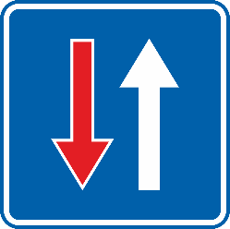
reversed symbol:
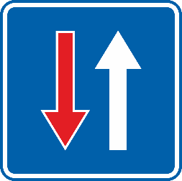

PRIORITY OVER ONCOMING TRAFFIC
B, 6 b (B-05.2) notifies drivers when entering into the narrow section that they have priority over oncoming vehicles. It shall be used on a narrow section of road where passing is difficult or impossible and where drivers can see the whole length of the section clearly both at night and by day, and no traffic light signals are installed. The sign shall be set up facing the traffic on the side which has priority. The symbol on this sign shall be reversed for traffic keeping to the left.
This sign shall be rectangular with a blue ground; the arrow pointing upwards shall be white and the other arrow red. The arrows shall be shall be joining one another at the centre. When the sign B, 6 b (B-05.2) is used, the sign B, 5 b (B-04.2) shall be placed on the road, at the other end of the narrow section, for traffic moving in the opposite direction. This sign may be used instead of sign B, 6 a (B-05.1) taking into account as far as possible the provisions of Article 5, paragraph 2 (b) of this Convention.
Image of a permitted variant of B, 6 b (B-05.2) sign:
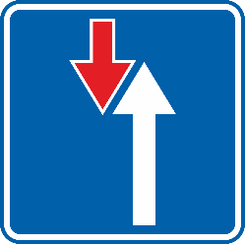
reversed symbol:
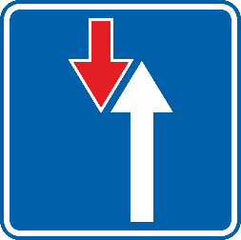
Section C
PROHIBITORY OR RESTRICTIVE SIGNS
I. General characteristics and symbols
1. Prohibitory and restrictive signs shall be circular; their diameter shall be not less than 0.60 m outside built-up areas and not less than 0.40 m or 0.20 m for signs prohibiting or restricting standing and parking in built-up areas.
2. Unless otherwise specified where the signs in question are described, prohibitory or restrictive signs shall have a white or yellow ground or blue ground for signs prohibiting or restricting standing and parking with a wide red border; the symbols and the inscriptions, if any, shall be black or dark blue and the oblique bars, if any, shall be red and shall slope downwards from left to right regardless of the direction of traffic . Conversely, bands used to end a regulation shall slope downwards from right to left regardless of the direction of driving in the country.
3. Contracting Parties may omit the red oblique bar from signs C, 3a to C, 3ln and C, 4 a and C, 4 b (C-03.1 to C-03.14 and C-04.1 and C-04.2)⁴¹.
{⁴¹ See also point 19 of the Annex of the European Agreement}
II. Description Definitions and images
1. Prohibition and restriction of entry^{41bis}
{^{41bis} See also point 19 of the Annex of the European Agreement}
(a) Notification that entry is prohibited for all vehicles shall be given by sign C, 1, "NO ENTRY", of which there are two models: C, 1a , and C, 1b .
NO ENTRY
C, 1 a (C-01.1) notifies that entry is prohibited for all vehicles. It may be replaced by sign C, 1 b (C-01.2). The choice between the C, 1 a and C, 1 b shall be made in accordance with Article 5, paragraph 2 of this Convention.

Image of a permitted variant of C, 1 a (C-01.1) sign:
NO ENTRY
C, 1 b (C-01.2) notifies that entry is prohibited for all vehicles. It may be replaced by sign C, 1 a (C-01.1). The choice between the C, 1 a and C, 1 b shall be made in accordance with Article 5, paragraph 2 of this Convention.
Image of a permitted variant of C, 1 b (C-01.2) sign:
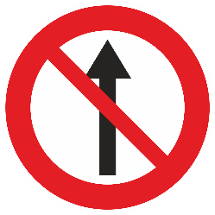
CLOSED TO ALL VEHICLES IN BOTH DIRECTIONS
(b) Notification that all vehicular traffic is prohibited in both directions shall be given by sign C, 2, "CLOSED TO ALL VEHICLES IN BOTH DIRECTIONS".
C, 2 (C-02.0) notifies that all vehicular traffic is prohibited in both directions.
Image of a permitted variant of C, 2 (C-02.0) sign:
(c) Notification that entry is prohibited for a certain category of vehicle or road-user only, shall be given by a sign bearing as a symbol the silhouette of the vehicles or road-users whose entry is prohibited. Sign C, 3a; C, 3b; C, 3c; C, 3d; C, 3e; C, 3f; C, 3g; C, 3h; C, 3i; C 3j; C, 3k; and C, 3l shall have the following meanings:
NO ENTRY FOR ANY POWER DRIVEN VEHICLE EXCEPT TWO-WHEELED MOTOR CYCLES WITHOUT SIDE-CAR
C, 3 a (C-03.1) notifies that entry is prohibited for any power driven with more than two wheels.
Image of a permitted variant of C, 3 a (C-03.1) sign:
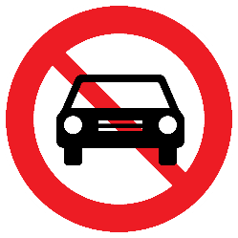
C, 3b "NO ENTRY FOR MOTOR CYCLES"
C, 3 b (C-03.2) notifies that entry is prohibited for motor cycles.
Image of a permitted variant of C, 3 b (C-03.2) sign:
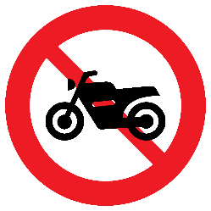
NO ENTRY FOR CYCLES
C, 3 c (C-03.3) notifies that entry is prohibited for cycles "NO ENTRY FOR CYCLES"
Image of a permitted variant of C, 3 c (C-03.3) sign:
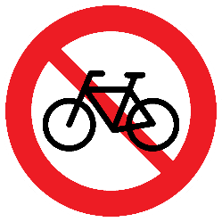
NO ENTRY FOR MOPEDS
C, 3 d (C-03.4) notifies that entry is prohibited for mopeds "NO ENTRY FOR MOPEDS"
Image of a permitted variant of C, 3 d (C-03.4) sign:
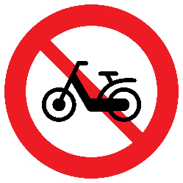
NO ENTRY FOR GOODS VEHICLES
C, 3 e (C-03.5) notifies that entry is prohibited for goods vehicles "NO ENTRY FOR GOODS VEHICLES"
The inscription of a tonnage figure, either in a light colour on the silhouette of the vehicle or, in accordance with Article 8, paragraph 4 of this Convention, on an additional panel placed below this sign C, 3e, shall mean that the prohibition applies only if the permissible maximum mass of the vehicle or combination of vehicles exceeds that figure.
Image of a permitted variant of an example of C, 3 e (C-03.5) sign:
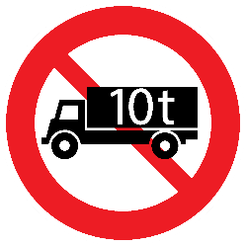
NO ENTRY FOR ANY POWER-DRIVEN VEHICLE DRAWING A TRAILER OTHER THAN A SEMI-TRAILER OR A SINGLE AXLE TRAILER
C, 3 f (C-03.6) notifies that entry is prohibited for "NO ENTRY FOR any power-driven vehicle drawing a trailer other than a semi-trailer or a single axle trailer"
The inscription of a tonnage figure, either in a light colour on the silhouette of the trailer or, in accordance with Article 8, paragraph 4, of this Convention, on an additional panel placed below this sign C, 3f , shall mean that the prohibition applies only if the permissible maximum mass of the trailer exceeds that figure. It shall be open to Contracting Parties, in cases where they see fit to do so, to replace, in the symbol, the silhouette of the rear end of a lorry by that of the rear end of a private car, and the trailer silhouette by that of a trailer which can be attached to a private car.
Image of a permitted variant of an example of C, 3 f (C-03.6) sign:
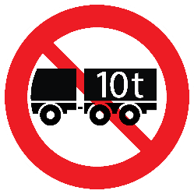
NO ENTRY FOR ANY POWER-DRIVEN VEHICLE DRAWING A TRAILER
C, 3 g (C-03.7) notifies that entry is prohibited for "NO ENTRY FOR any power-driven vehicle drawing a trailer"
The inscription of a tonnage figure, either in a light colour on the silhouette of the trailer or, in accordance with article 8, paragraph 4 of this Convention, on an additional panel placed below this sign C, 3g , shall mean that the prohibition applies only if the permissible maximum mass of the trailer exceeds that figure.
Image of a permitted variant of an example of C, 3 g (C-03.7) sign:
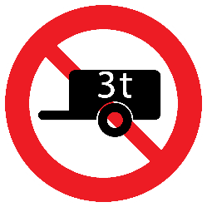
NO ENTRY FOR VEHICLES CARRYING DANGEROUS GOODS FOR WHICH SPECIAL SIGN PLATING IS PRESCRIBED
C, 3 h (C-03.8) notifies that entry is prohibited for "NO ENTRY FOR vehicles carrying dangerous goods for which special sign plating is prescribed".
To indicate no entry for vehicles carrying certain types of dangerous goods, this sign C, 3 h may be used in conjunction, if necessary, with an additional panel. The information given on this additional panel specifies that this prohibition applies only to the carriage of dangerous goods as defined by domestic legislation.
Image of a permitted variant of C, 3 h (C-03.8) sign:
NO ENTRY FOR PEDESTRIANS
C, 3 i (C-03.9) notifies that entry is prohibited for "NO ENTRY FOR pedestrians".
Image of a permitted variant of C, 3 i (C-03.9) sign:
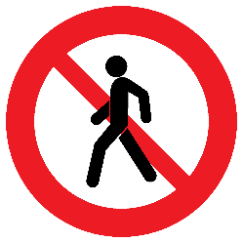
NO ENTRY FOR ANIMAL-DRAWN VEHICLES
C, 3 j (C-03.10) notifies that entry is prohibited for "NO ENTRY FOR animal-drawn vehicles"
Image of a permitted variant of C, 3 j (C-03.10) sign:
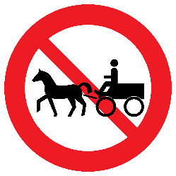
NO ENTRY FOR HANDCARTS
C, 3 k (C-03.11) notifies that entry is prohibited for "NO ENTRY FOR handcarts".
Image of a permitted variant of C, 3 k (C-03.11) sign:
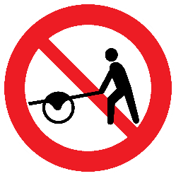
NO ENTRY FOR POWER-DRIVEN AGRICULTURAL VEHICLES
C, 3 l (C-03.12) notifies that entry is prohibited for "NO ENTRY FOR power-driven agricultural vehicles".
Image of a permitted variant of C, 3 l (C-03.12) sign:
NO ENTRY FOR VEHICLES CARRYING MORE THAN A CERTAIN QUANTITY OF EXPLOSIVES OR READILY INFLAMMABLE SUBSTANCES
C, 3 m (C-03.13) notifies that entry is prohibited for vehicles carrying more than a certain quantity of explosives or readily inflammable substances.
Image of a permitted variant of C, 3 m (C-03.13) sign:
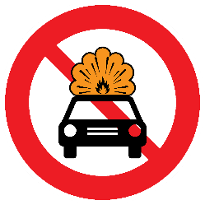
NO ENTRY FOR VEHICLES CARRYING MORE THAN A CERTAIN QUANTITY OF SUBSTANCES LIABLE TO CAUSE WATER POLLUTION
C, 3 n (C-03.14) notifies that entry is prohibited for vehicles carrying more than a certain quantity of substances liable to cause water pollution.
Image of a permitted variant of C, 3 n (C-03.14) sign:
NOTE - It shall be open to Contracting Parties to omit from signs C, 3a to C, 3l the red oblique bar joining the upper left quadrant and the lower right quadrant or, provided that this does not make the symbol less easy to see and understand, not to interrupt the bar where it crosses the symbol.
(d) Notification that entry is prohibited for several categories of vehicle or road user, may be given either by displaying as many prohibitory signs as there are prohibited classes, or by a single prohibitory sign which shows the silhouettes of the various vehicles or road-users whose entry is prohibited. Signs C, 4a "NO ENTRY FOR POWER DRIVEN VEHICLES"; and C, 4b "NO ENTRY FOR POWER DRIVEN VEHICLES OR ANIMAL-DRAWN VEHICLES" are examples of such signs.
NO ENTRY FOR TWO CATEGORIES OF VEHICLES OR ROAD USERS
C, 4 a (C-04.1) notifies that entry is prohibited for categories of vehicle or road user depicted on the sign. The example presented below would mean “No entry for power driven vehicles”
Signs showing more than two silhouettes may not be set up outside built-up areas.
Contracting Parties may use instead two signs each depicting the specific category of vehicle or road user.
Image of a permitted variant of an example of C, 4 a (C-04.1) sign:
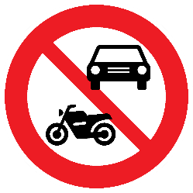
NO ENTRY FOR THREE CATEGORIES OF VEHICLES OR ROAD USERS
C, 4 b (C-04.2) notifies that entry is prohibited for categories of vehicle or road user depicted on the sign.
Signs showing more than two silhouettes may not be set up outside built-up areas. And signs showing more than three silhouettes may not be set up in built-up areas.
Contracting Parties may use instead three signs each depicting the specific category of vehicle or road user.
Image of a permitted variant of an example of C, 4 b (C-04.2) sign:
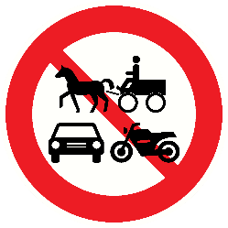
(e) Notification that entry is prohibited for vehicles whose mass or dimensions exceed certain limits shall be given by the signs:
NO ENTRY FOR TOO WIDE VEHICLES
C, 5 a (C-05.1) notifies that entry is prohibited for "NO ENTRY FOR vehicles having an overall width exceeding the indicated figure (in metres) on the sign. ... metres"
Image of a permitted variant of an example of C, 5 a (C-05.1) sign:
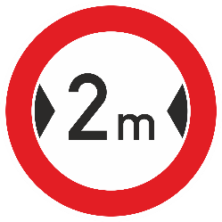
NO ENTRY FOR TOO WIDE VEHICLES
C, 5 b (C-05.2) notifies that entry is prohibited for vehicles having an overall width exceeding the indicated figure (in metres) with a decimal fraction on the sign. The decimal fraction shall be depicted as “comma” or “dot” depending on the indication of decimal fractions in the State concerned.
Image of a permitted variant of an example of C, 5 b (C-05.2) sign:
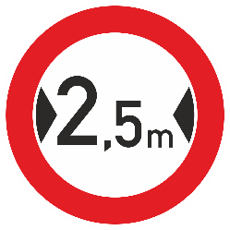
NO ENTRY FOR TOO HIGH VEHICLES
C, 6 a (C-06.1) notifies that entry is prohibited for "NO ENTRY FOR VEHICLES HAVING AN OVERALL HEIGHT EXCEEDING ... METRES" vehicles having an overall height exceeding the indicated figure (in metres) on the sign.
Image of a permitted variant of an example of C, 6 a (C-06.1) sign:
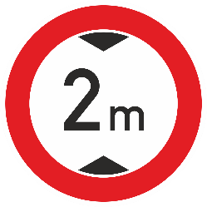
NO ENTRY FOR TOO HIGH VEHICLES
C, 6 b (C-06.2) notifies that entry is prohibited for vehicles having an overall height exceeding the indicated figure (in metres) with a decimal fraction on the sign. The decimal fraction shall be depicted as “comma” or “dot” depending on the indication of decimal fractions in the State concerned.
Image of a permitted variant of an example of C, 6 b (C-06.2) sign:
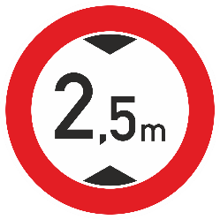
NO ENTRY FOR TOO HEAVY VEHICLES
C, 7 a (C-07.1) notifies that entry is prohibited for "NO ENTRY FOR VEHICLES ECEEDING…TONNES LADEN MASS” vehicles having a laden mass exceeding the indicated figure (in tonnes) on the sign.
Image of a permitted variant of an example of C, 7 a (C-07.1) sign:
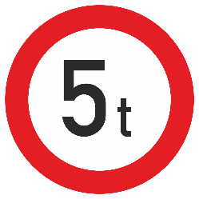
NO ENTRY FOR TOO HEAVY VEHICLES
C, 7 b (C-07.2) notifies that entry is prohibited for vehicles having a laden mass exceeding the indicated figure (in tonnes) with a decimal fraction on the sign. The decimal fraction shall be depicted as “comma” or “dot” depending on the indication of decimal fractions in the State concerned.
Image of a permitted variant of an example of C, 7 b (C-07.2) sign:
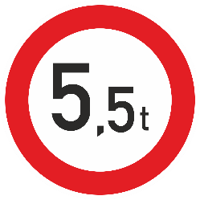
NO ENTRY FOR TOO HEAVY VEHICLES
C, 8 a (C-08.1) notifies that entry is prohibited for "NO ENTRY FOR VEHICLES Having a mass exceeding …tonnes on one axle” vehicles having a mass (in tonnes) on one axle exceeding the indicated figure on the sign.
Image of a permitted variant of an example of C, 8 a (C-08.1) sign:
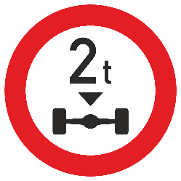
NO ENTRY FOR TOO HEAVY VEHICLES
C, 8 b (C-08.2) notifies that entry is prohibited for vehicles having a mass (in tonnes), with a decimal fraction, on one axle exceeding the indicated figure on the sign. The decimal fraction shall be depicted as “comma” or “dot” depending on the indication of decimal fractions in the State concerned.
Image of a permitted variant of an example of C, 8 b (C-08.2) sign:
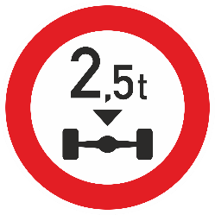
NO ENTRY FOR TOO LONG VEHICLES
C, 9 a (C-09.0) notifies that entry is prohibited for "NO ENTRY FOR VEHICLES OR COMBINATIONS OF VEHICLES EXCEEDING … METRES IN LENGTH” vehicles or combinations of vehicles having a length exceeding the indicated figure (in metres) on the sign.
Image of a permitted variant of an example of C, 9 (C-09.0) sign:
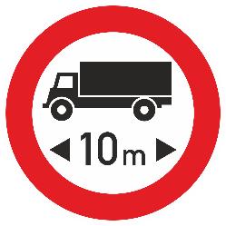
2. Prohibition of a too close driving
PROHIBITION OF TOO CLOSE DRIVING
(f) Notification that vehicles shall not be driven closer together than the distance indicated on the sign shall be given by sign C, 10 (C-10.0) notifies that vehicles shall not be driven closer together than the figure indicating the distance in meters on the sign. “DRIVING OF VEHICLES LESS THAN ... METRES APART PROHIBITED".

Image of a permitted variant of an example of C, 10 (C-10.0) sign:
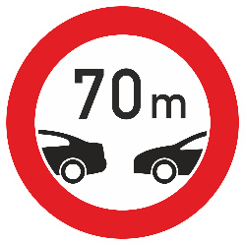
23. Prohibition of turning
NO LEFT TURN
C, 11 a (C-11.1) notifies that turning to the left is prohibited
Notification that turning is prohibited (to the right or to the left according to the direction of the arrow) shall be given by sign C, 11a "NO LEFT TURN" or sign C, 11b "NO RIGHT TURN".
Image of a permitted variant of C, 11 a (C-11.1) sign:
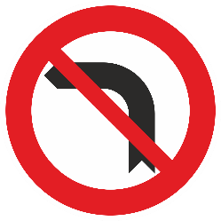
NO RIGHT TURN
C, 11 b (C-11.2) notifies that turning to the right is prohibited.
Image of a permitted variant of C, 11 b (C-11.2) sign:
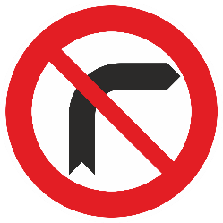
34. Prohibition of U-turns
NO U-TURN
C, 12 (C-12.0) notifies that U-turn is prohibited. The symbol on this sign shall be revered for traffic keeping to the left.
(a) Notification that U-turns are prohibited shall be given by sign C, 12 "NO UTURNS".
Image of a permitted variant of C, 12 (C-12.0) sign:
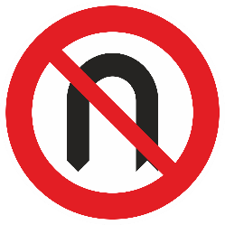
reversed symbol:
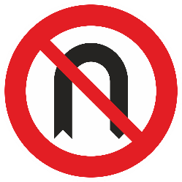
45. Prohibition of overtaking⁴²
PROHIBITION OF OVERTAKING
C, 13 aa (C-13.1) notifies (a) Notification that, in addition to the general rules on overtaking laid down by the regulations in force, the overtaking of power-driven vehicles other than two-wheeled mopeds and two-wheeled motor cycles without side-car travelling on a road is prohibited., shall be given by sign C, 13a "OVERTAKING PROHIBITED". The symbol on this sign shall be reversed, if necessary, for traffic keeping to the left. Contracting Parties shall select a variant of this sign with or without the red oblique bar.
There are two models of this sign: C, 13aa and C, 13ab.
Image of permitted variants of C, 13 aa (C-13.1) sign:
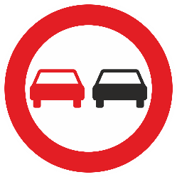  reversed symbol:  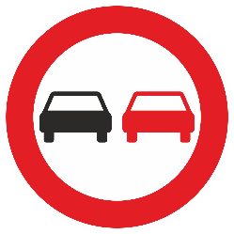 | 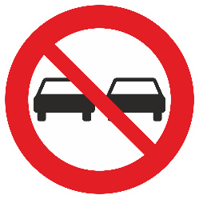
END OF PROHIBITION OF OVERTAKING
C, 17 c (C-13.2) notifies that prohibition of overtaking indicated by sign C, 13 aa (C-13.1) ceases to apply.
This sign shall be circular and have a white or yellow ground; it shall have no border or only have preferably a black rim, it shall show in light grey the symbol of the prohibition of overtaking which has ceased; and shall bear an oblique diagonal black band or preferably, black parallel lines forming such a band, sloping downward from right to left, which may be black or dark grey or, preferably, consist of black or grey parallel lines forming such a band. The diagonal oblique band can may be interrupted when crossing the grey symbol. If not interrupted, the diagonal band shall be placed over the grey symbol.
Notwithstanding the provisions of Article 6, paragraph 1 of this Convention, this sign may be placed on the reverse side of the prohibition of overtaking sign for traffic coming in the opposite direction.

Image of a permitted variant of C, 17 c (C-13.2) sign:
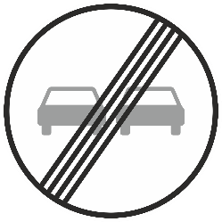
PROHIBITION OF OVERTAKING BY GOODS VEHICLES
C, 13ba (C-13.3) notifies (b) Notification that overtaking is prohibited only for goods vehicles having a permissible maximum mass exceeding 3.5 tonnes shall be given by sign C, 13b "OVERTAKING BY GOODS VEHICLES PROHIBITED". The symbol on this sign shall be reversed for traffic keeping to the left. Contracting Parties shall select a variant of this sign with or without the red oblique bar.
There are two models of this sign: C, 13ba and C, 13bb.
An inscription on an additional panel placed below the sign in accordance with Article 8, paragraph 4 of this Convention may change the permissible maximum mass above which the prohibitions applyies.
Image of permitted variants of C, 13 ba (C-13.3) sign:
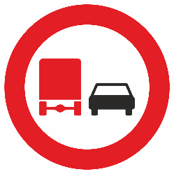  reversed symbol:  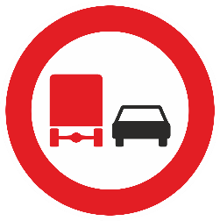 | 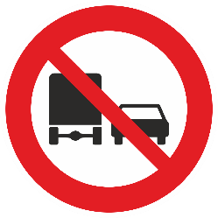  reversed symbol:  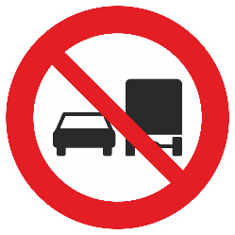
END OF PROHIBITION OF OVERTAKING FOR GOODS VEHICLES
C, 17 d (C-13.4) notifies that prohibition of overtaking for goods vehicles indicated by sign C, 13 ba (C-13.3) ceases to apply. The symbol on this sign shall be reversed for traffic keeping to the left.
This sign shall be circular and have a white or yellow ground; it shall have no border or only have preferably a black rim, it shall show in light grey the symbol of the prohibition of overtaking which has ceased; and shall bear an oblique diagonal black band or preferably, black parallel lines forming such a band, sloping downward from right to left, which may be black or dark grey or, preferably, consist of black or grey parallel lines forming such a band. The diagonal oblique band can may be interrupted when crossing the grey symbol. If not interrupted, the diagonal band shall be placed over the grey symbol.
Notwithstanding the provisions of Article 6, paragraph 1 of this Convention, this sign may be placed on the reverse side of the prohibition of overtaking for goods vehicles sign for traffic coming in the opposite direction.

Image of a permitted variant of C, 17 d (C-13.4) sign:
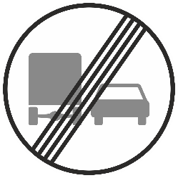
reversed symbol:
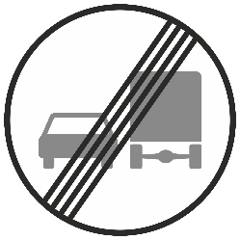

56. Speed limit
MAXIMUM SPEED LIMITED
C, 14 (C-14.1) notifies, with the figure indicated on the sign, the permitted maximum speed limit. (a) Notification of a speed limit shall be given by sign C, 14, "MAXIMUM SPEED LIMITED TO THE FIGURE INDICATED". The figure appearing on the sign shall indicate the maximum speed The figure shall be provided in the unit of measurement most commonly used to express the speed of vehicles in the country concerned. That unit of measurement may be shown on the sign after or below the figure. If shown, “km” (for Kilometres) or "m" (for Miles) shall be used as appropriate. After or below the figure expressing the speed may be added, for instance, "Km" (Kilometres) or "m" (Miles).
(b) To indicate a speed limit applicable only to vehicles of a permissible maximum mass exceeding a given figure, an inscription comprising that figure shall be placed on an additional panel below the sign in accordance with Article 8, paragraph 4 of this Convention.
Image of a permitted variant of an example of C, 14 (C-14.1) sign:
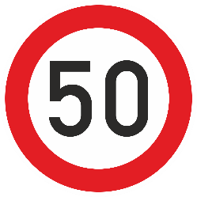
END OF SPEED LIMITED
C, 17 b (C-14.2) notifies that the speed limit indicated by sign C, 14 (C-14.1) ceases to apply.
This sign shall be circular and have a white or yellow ground; it shall have no border or only have preferably a black rim, it shall show in light grey the speed limit inscription which has ceased; and shall bear an oblique diagonal black band or preferably, black parallel lines forming such a band, sloping downward from right to left, which may be black or dark grey or, preferably, consist of black or grey parallel lines forming such a band. The diagonal oblique band can may be interrupted when crossing the grey inscription If not interrupted, the diagonal band shall be placed over the grey symbol.
Notwithstanding the provisions of Article 6, paragraph 1 of this Convention, this sign may be placed on the reverse side of the maximum speed sign for traffic coming in the opposite direction.

Image of a permitted variant of an example of C, 17 b (C-14.2) sign:
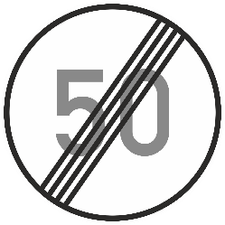
67. Prohibition of the use of audible warning devices
PROHIBITION OF THE USE OF AUDIBLE WARNING DEVICES
C, 15 (C-15.0) notifies Notification that the use of audible warning devices is prohibited, except to avoid an accident, shall be given by sign C, 15 "USE OF AUDIBLE WARNING DEVICES PROHIBITED".
This sign, if not placed at the beginning of a built-up area beside or shortly after the sign identifying the built-up area, shall be accompanied by an additional panel H, 2 (H-02.0) described in section H, subsection II, paragraph 1 of this annex, showing the distance over which the prohibition applies. It is recommended that this sign should not be placed at the beginning of built-up areas when the prohibition applies in all built-up areas and that it be provided that the sign identifying a built-up area placed at the beginning of that area shall notify road users that the traffic regulations applicable to built-up areas in that country apply from that point onwards.
Image of a permitted variant of C, 15 (C-15.0) sign:
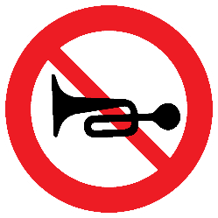
78. Prohibition of passing without stopping
PROHIBITION OF PASSING WITHOUT STOPPING
C, 16 (C-16.0) notifies that passing without stopping is prohibited. When used in
(a) Notification of the proximity of a Custom-house at which a stop is compulsory, Nnotwithstanding Article 8 of this Convention, the symbol of this sign shall include the word inscription "Customs", preferably in two languages. Contracting Parties using C, 16 this signs shall endeavour to reach a regional agreement to the effect that this word inscription shall appear in the same language(s) on all the signs they set up.
(b) This sign may also be used to notify drivers that passing without stopping is prohibited for When used for other reasons; in this case the inscription word "Customs" shall be replaced by another very brief inscription indicating the reason for the stop.
Image of a permitted variant of an example of C, 16 (C-16.0) sign:
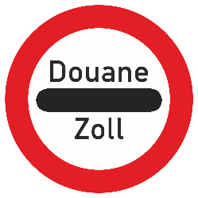
89. End of prohibition or restriction
END OF PROHIBITION OR RESTRICTION
C, 17 a (C-17.0) notifies that (a) The point at which all prohibitions or restrictions notified indicated by prohibitory or restrictive signs for moving vehicles cease to apply. shall be indicated by sign C, 17a "END OF ALL LOCAL PROHIBITIONS IMPOSED ON MOVING VEHICLES". This sign shall be circular and have a white or yellow ground; it shall have no border or only a black rim, and shall bear a diagonal band, sloping downward from right to left, which may be black or dark grey or consist of black or grey parallel lines. This sign shall be circular and have a white or yellow ground; it shall have no border or only have preferably a black rim, and shall bear an oblique diagonal black band or preferably, black parallel lines forming such a band, sloping downward from right to left, which may be black or dark grey or, preferably, consist of black or grey parallel lines forming such a band.
(b) The point at which a particular prohibition or restriction notified to moving vehicles by a prohibitory or restrictive sign ceases to apply shall be indicated by sign C, 17b "END OF SPEED LIMIT" or sign C, 17c "END OF PROHIBITION OF OVERTAKING", OR SIGN C, 17d "END OF PROHIBITION OF OVERTAKING FOR GOODS VEHICLES". These signs shall be similar to sign C, 17a , but shall show, in addition, in light grey the symbol of the prohibition or restriction which has ceased.
(c) Notwithstanding the provisions of Article 6, paragraph 1 of this Convention, the signs referred to in this paragraph 8 this sign may be placed on the reverse side of the prohibitory or restrictive sign intended for traffic coming in the opposite direction.
Image of a permitted variant of C, 17 a (C-17.0) sign:
910. Prohibition or restriction of standing and parking
(a) (i) Places where parking is prohibited shall be indicated by sign C, 18, "PARKING PROHIBITED"; places where standing and parking are prohibited shall be indicated by sign C, 19, "STANDING AND PARKING PROHIBITED".
PROHIBITION OF PARKING
C, 18 (C-18.0) notifies of places where parking is prohibited. Sign C, 18 Parking may also be prohibited by a circular sign with a red border and a red transverse oblique bar sloping downwards from left to right, bearing the letter or ideogram used in the State concerned to denote "Parking", in black or dark blue on a white or yellow ground⁴³.
Image of a permitted variant of C, 18 (C-18.0) sign:
PROHIBITION OF STANDING AND PARKING
C.19 (C-19.0) notifies of places where standing and parking are prohibited
Image of a permitted variant of C, 19 (C-19.0) sign:
(ii) Sign C, 18 may be replaced by a circular sign with a red border and a red transverse bar, bearing the letter or ideogram used in the State concerned to denote "Parking", in black on a white or yellow ground.43
(iii) The scope of the prohibition notified by signs C, 18 and C, 19 (C-18.0 and C-19.0) may be restricted by inscriptions on an additional plate panel below the sign specifying, as the case may be,:
(i) The days of the week or month or the times of day during which the prohibition applies;
(ii) The time in excess of which parking is prohibited by sign C, 18 or standing and parking is prohibited by sign C, 19;
(iii) The exceptions granted for certain classes of road user.
(iv) The time in excess of which parking or standing is prohibited may also be inscribed on the lower part of the red circle of the sign instead of appearing on an additional plate panel.
ALTERNATE PARKING
(b) (i) Where parking is authorized on opposite sides of the road alternately, signs C, 20a and C, 20b , "ALTERNATE PARKING", shall be used instead of sign C, 18;
C, 20 a (C-20.1) notifies of places where parking is authorized on opposite sides of the road alternately with the prohibition of parking applying to the side of placement of this sign on odd number dates. The time at which the side changes shall be prescribed by domestic legislation and need not necessarily be midnight. The bar on the sign shall be white.
Image of a permitted variant of C, 20 a (C-20.1) sign:
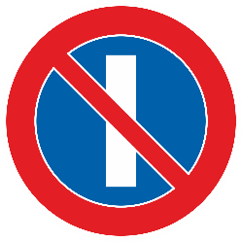
ALTERNATE PARKING
C, 20 b (C-20.2) notifies of places where parking is authorized on opposite sides of the road alternately with the prohibition of parking applying to the side of placement of this sign on even number dates. The time at which the side changes shall be prescribed by domestic legislation and need not necessarily be midnight. The two bars on the sign shall be white.
(ii) The prohibition of parking shall apply to the sign C, 20a side on odd number dates and to the sign C, 20b side on even number dates; the time at which the side changes shall be prescribed by domestic legislation and need not necessarily be midnight.
Image of a permitted variant of C, 20 b (C-20.2) sign:
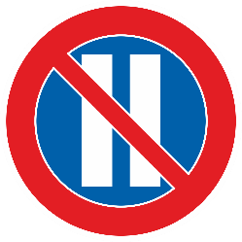
ALTERNATE PARKING
C, 20 c (C-20.3) notifies of places where parking is authorized on opposite sides of the road alternately in case when the Ddomestic legislation may also prescribes an alternation other than a daily alternation for parking; the numerals I and II shall in that case be replaced on the signs by This sign may contain the period of alternation, e.g., 1-15 and 16-31 for an alternation on the first and sixteenth day of each month.
Image of a permitted variant of an example of C, 20 c (C-20.3) sign:
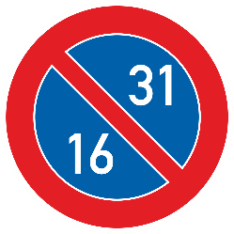
Additional Provisions applying to prohibition or restriction of standing and parking
Contracting Parties (iii) Sign C, 18 may be used by States which do not adopt sign C, 19; C, 20 a and C, 20b, and C, 20c (C-19.0, C-20.1, C-20.2, C-20.3), may use instead the sign C, 18 (C-18.0) supplemented by additional inscriptions, as provided in Article 8, paragraph 4 of this Convention.⁴⁴
(c) (i) Except in special cases, The signs that notify parking prohibitions and restrictions signs, except in special cases, shall be so placed that their disc they are is perpendicular to the axis of the road, or at a slight angle to the plane perpendicular to that axis. In special cases, the signs may be placed parallel to the axis of the road. When additional panels are used in those cases, they shall be of models H, 3 (H-03.1, H-03.2 and H-03.3) described in Section H, subsection II, paragraph 2.
(ii) All the prohibitions and restrictions of parking shall apply only on the side of the carriageway on which the signs are placed.
(iii) Except as may be otherwise indicated:
On an additional panel H, 2 of section H of this annex and showing the distance over which the prohibition applies; or In conformity with subparagraph (c) (v) of this paragraph, tThe prohibitions and restrictions of parking shall apply from a point level with the sign to the next point of entry of a road unless indicated otherwise.
(iv) If the prohibition and restrictions of parking cease to apply before the next point of entry of a road, the sign supplemented by aAn additional panel H, 3a or H, 4a (H-03.1 or H-04.1) described in Section H, subsection II, paragraph 2 depicted in section H of this annex may be placed below the sign used at the point where the parking prohibition begins. An additional panel H, 3b or H, 4b (H-03.2 or H-04.2) described in Section H, subsection II, paragraph 2 depicted in section H of this annex may be used for repeating the prohibition provided that respectively additional panels H, 3 a and H, 4 a (H-03.1 or H-04.1) are used to indicate the beginning of the prohibition. may be placed below signs repeating the prohibition. A further prohibition sign supplemented by an An additional panel H, 3c or H, 4c (H-03.3 or H-04.3) described in Section H, subsection II, paragraph 2 DEPICTED IN SECTION H OF THIS ANNEX shall be used where the prohibition ceases to apply provided that respectively additional panels H, 3 a and H, 4 a (H-03.1 or H-04.1) are used to indicate the beginning of the prohibition, except when another parking regulation applies. may be placed at the point where the prohibition ceases to apply. Panels H, 3 (H-03.1, H-03.2 and H-03.3) shall be placed parallel to the axis of the road, and panels H, 4 (H-04.1, H-04.2 and H-04.3) perpendicular to that axis. The distances, if any, shown by these panels H, 3 or H, 4 shall be those over which the prohibition applies in the direction of the arrow.
(v)⁴⁵ If the prohibition ceases to apply before the next point of entry of a road, the sign bearing the additional end-of prohibition panel described in subparagraph (c) (iv) above shall be set up. However, where If the prohibition applies only over a short distance⁴⁵, it shall be permissible to set up only one sign:
- Showing in the red circle border the distance on which it applies, or
- Bearing an additional panel H, 2 (H-02.0) described in Section H, subsection II, paragraph 1, H, 3, H, 3 a or H, 4 a (H-03.1 or H-04.1) showing the short distance.
(vi) Where parking-meters are installed, their presence shall signify that parking is subject to payment and is limited to the period for which the meter operates.
Section D
MANDATORY SIGNS
I. General characteristics and symbols
1. Mandatory signs shall be circular, except signs D, 10 (D-08.0) described in subsection II, paragraph 10 of this section which shall be rectangular; their diameter shall be not less than 0.60 m outside built-up areas and not less than 0.40 m in built-up areas. However, signs having a diameter of not less than 0.30 m may be used in conjunction with traffic light signals or on bollards on traffic islands.
2. Unless provided otherwise, the signs shall be blue and the symbols shall be white or of a light colour, or, alternatively, the signs shall be white with a red rim and the symbols shall be black.⁴⁶
{⁴⁶ See also point 20 of the Annex of the European Agreement[deleted]}
II. Descriptions Definitions and images
1. Direction to be followed⁴⁷
DIRECTION LEFT TO BE FOLLOWED
D, 1 a (D-01.1) notifies that the only direction in which vehicles are obliged to proceed is to the left.
The direction in which vehicles are obliged to proceed, or the only directions in which they are permitted to proceed, shall be indicated by model D, 1a of sign D, 1, "DIRECTION TO BE FOLLOWED" on which the arrow or arrows shall point in the appropriate direction or directions. However, instead of using sign D, 1a, sign D, 1b may to be used notwithstanding the provisions of subsection I of this section. Sign D, 1b shall to be black with a white rim and a white symbol.
Image of a permitted variant of D, 1 a (D-01.1) sign:

D, 1 a (D-01.2)
Image of D, 1 a (D-01.2) sign:
DIRECTION LEFT OR STRAIGHT TO BE FOLLOWED
D, 1 a (D-01.3) notifies that the only directions in which vehicles are obliged to proceed are forward left or straight.
Image of D, 1 a (D-01.3) sign:
DIRECTION STRAIGHT TO BE FOLLOWED
D, 1 a (D-01.4) notifies that the only direction in which vehicles are obliged to proceed is straight.
Image of D, 1 a (D-01.4) sign:
DIRECTION RIGHT TO BE FOLLOWED
D, 1 a (D-01.5) notifies that the only direction in which vehicles are obliged to proceed is to the right.
Image of a permitted variant of D, 1 a (D-01.5) sign:

Image of D, 1 a (D-01.6) sign:
DIRECTION RIGHT OR STRAIGHT TO BE FOLLOWED
D, 1 a (D-01.7) notifies that the only directions in which vehicles are obliged to proceed are forward right or straight.
Image of D, 1 a (D-01.7) sign:
DIRECTION LEFT OR RIGHT TO BE FOLLOWED
D, 1 a (D-01.8) notifies that the only directions in which vehicles are obliged to proceed are to the left or to the right.
Image of a permitted variant of D, 1 a (D-01.8) sign:
2. Pass this side
PASS LEFT
Sign D, 2 "PASS THIS SIDE", placed, notwithstanding the provisions of Article 6, paragraph 1 of this Convention, on an island or before an obstacle on the carriageway, shall mean that vehicles must pass on the side of the island or obstacle indicated by the arrow.
D, 2 a (D-02.1) notifies that vehicles must pass the island or obstacle on the left side. Notwithstanding the provisions of Article 6, paragraph 1 of this Convention, this sign is placed on the island or before the obstacle on the carriageway.
Image of D, 2 a (D-02.1) sign:
PASS RIGHT
D, 2 b (D-02.2) notifies that vehicles must pass the island or obstacle on the right side. Notwithstanding the provisions of Article 6, paragraph 1 of this Convention, this sign is placed on the island or before the obstacle on the carriageway.
Image of D, 2 b (D-02.2) sign:
PASS LEFT OR RIGHT
D, 2 c (D-02.3) notifies that vehicles must pass the island or obstacle on the left or on the right side. Notwithstanding the provisions of Article 6, paragraph 1 of this Convention, this sign is placed on the island or before the obstacle on the carriageway.
Image of D, 2 c (D-02.3) sign:
3. Compulsory roundabout
COMPULSORY ROUNDABOUT’
3. Sign D, 3 (D-03.0) ‘COMPULSORY ROUNDABOUT’, shall notifiesy that vehicles must follow the direction at the roundabout indicated by the arrows. If the compulsory roundabout is indicated by the sign D, 3 (D-03.0) together with the sign B, 1 (B-01.0) or B, 2 (B-02.0), the driver vehicle in the roundabout has priority. The symbol on this sign shall be reversed for traffic keeping to the left.
Image of D, 3 (D-03.0) sign:
reversed symbol:
4. Compulsory cycle track
COMPULSORY CYCLE TRACK
Sign D, 4 a (D-04.1) "COMPULSORY CYCLE TRACK" shall notifiesy cyclists that the track at the entrance to which it is placed is reserved for them, and shall notifiesy the drivers of other vehicles that they are not entitled to use that track. Cyclists shall be required to use the track if the track is running along a carriageway, footpath or track for riders on horseback and leading into the same direction. However, drivers of mopeds shall also be required, in the same conditions, to use the cycle track if domestic legislation so provides or if notification of this requirement is given by an additional panel bearing an inscription or the symbol of sign C, 3 d (C-03.4).
Image of D, 4 a (D-04.1) sign:
END OF COMPULSORY CYCLE TRACK
D, 4 b (D-04.2) notifies cyclists of the end of the compulsory cycle track. This sign shall be identical to sign D, 4 a (D-04.1), except that it shall be crossed by an oblique red band or, preferably, red parallel lines forming such a band sloping down from right to left. The band can be interrupted when crossing the symbol. If not interrupted, the red band shall be placed over the symbol.
Notwithstanding the provisions of Article 6, paragraph 1 of this Convention, this sign may be placed on the reverse side of the sign D 4 a (D-04.1) for cyclists coming in the opposite direction.
Image of a permitted variant of D, 4 b (D-04.2) sign:
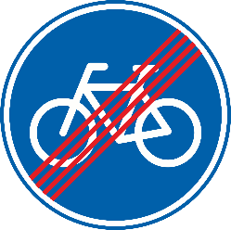
5. Compulsory footpath
COMPULSORY FOOTPATH
Sign D, 5 a (D-04.3) "COMPULSORY FOOTPATH" shall notifiesy pedestrians that the path at the entrance to which it is placed is reserved for them, and shall notify notifies other road users that they are not entitled to use that path. Pedestrians shall be required to use the path if the path is running along a carriageway, cycle track or track for riders on horseback and leading into the same direction.
Image of D, 5 a (D-04.3) sign:
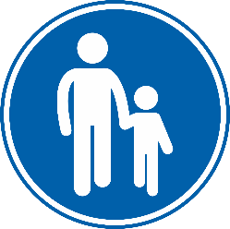
END OF COMPULSORY FOOTPATH
D, 5 b (D-04.4) notifies pedestrians of the end of the compulsory footpath. This sign shall be identical to sign D, 5 a (D-04.3), except that it shall be crossed by an oblique red band or, preferably, red parallel lines forming such a band sloping down from right to left. The band can be interrupted when crossing the symbol. If not interrupted, the red band shall be placed over the symbol.
Notwithstanding the provisions of Article 6, paragraph 1 of this Convention, this sign may be placed on the reverse side of the sign D 5 a (D-04.3) for pedestrians coming in the opposite direction.
Image of a permitted variant of D, 5 b (D-04.4) sign:
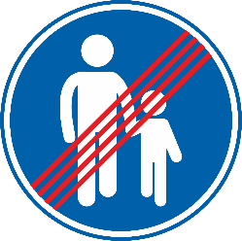
6. Compulsory track for riders on horseback
COMPULSORY TRACK FOR RIDERS ON HORSEBACK
Sign D, 6 a (D-04.5) "COMPULSORY TRACK FOR RIDERS ON HORSEBACK" shall notifiesy riders on horseback that the track at the entrance of which it is placed is reserved for them and shall notify notifies other road users that they are not entitled to use that track. Riders on horseback shall be required to use the track if the track is running along a carriageway, cycle track or footpath and leading into the same direction.
Image of D, 6 a (D-04.5) sign:
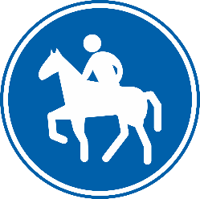
END OF COMPULSORY TRACK FOR RIDERS ON HORSEBACK
D, 6 b (D-04.6) notifies riders on horseback of the end of the compulsory track for them. This sign shall be identical to sign D, 6 a (D-04.5), except that it shall be crossed by an oblique red band or, preferably, red parallel lines forming such a band sloping down from right to left. The band can be interrupted when crossing the symbol. If not interrupted, the red band shall be placed over the symbol.
Notwithstanding the provisions of Article 6, paragraph 1 of this Convention, this sign may be placed on the reverse side of the sign D 6 a (D-04.5) for riders on horseback coming in the opposite direction.
Image of a permitted variant of D, 6 b (D-04.6) sign:
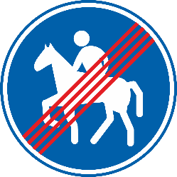
7. Compulsory path or track for two categories of road users
COMPULSORY PATH OR TRACK FOR TWO CATEGORIES OF ROAD USERS
D, 11 a (D-05.1) notifies the two categories of road users depicted by symbols on this sign that the path or track, at the entrance of which the sign is placed, is reserved for them; and notifies other road users that they are not entitled to use that path or track. The road users depicted by symbols on this sign shall be required to use that path or track.
When The symbols are placed side by side of the road users shall be placed side by side on this sign and separated by a vertical line through its centre. Each symbol shall be understood to mean that the relevant category must use the side of the path or track reserved for that category and shall notify other road users that they are not entitled to use that side. The two sides of the path or track shall be clearly separated, by physical means or road markings.
Image of an example of D, 11 a (D-05.1) sign:
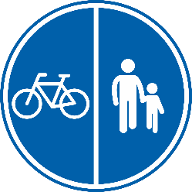
END OF COMPULSORY PATH OR TRACK FOR TWO CATEGORIES OF ROAD USERS
D, 11 (D-05.2) notifies the two categories of road users depicted by symbols on this sign of the end of the compulsory path or track for them. This sign shall be identical to sign D, 11 a (D-05.1), except that it shall be crossed by an oblique red band or, preferably, red parallel lines forming such a band sloping down from right to left. The band can be interrupted when crossing the symbols. If not interrupted, the red band shall be placed over the symbols.
Notwithstanding the provisions of Article 6, paragraph 1 of this Convention, this sign may be placed on the reverse side of the sign D 11 a (D-05.1) for the same road users coming in the opposite direction.

Image of a permitted variant of an example of D, 11 (D-05.2) sign:
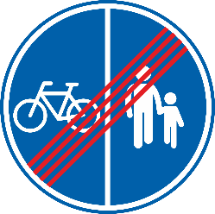
COMPULSORY SHARED PATH OR TRACK FOR TWO CATEGORIES OF ROAD USERS
D, 11 b (D-05.3) notifies the two categories of road users depicted by symbols on this sign that the path or track, at the entrance of which it is placed, is reserved for their shared use; and notifies other road users that they are not entitled to use that path or track. The road users depicted by symbols on this sign shall be required to use that path or track.
When The symbols are placed side by side of the road users shall be placed one above the other on this sign. The order in which the symbols are placed shall be optional. Where necessary the precautions to be taken by both categories of users shall be laid down in domestic legislation.

Image of an example of D, 11 b (D-05.3) sign:
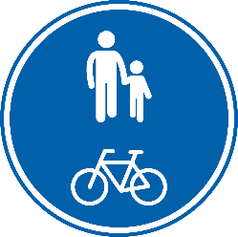
END OF COMPULSORY SHARED PATH OR TRACK FOR TWO CATEGORIES OF ROAD USERS
D, 11 (D-05.4) notifies the two categories of road users depicted by symbols on this sign of the end of the compulsory shared path or track for them. This sign shall be identical to sign D, 11 b (D-05.3), except that it shall be crossed by an oblique red band or, preferably, red parallel lines forming such a band sloping down from right to left. The band can be interrupted when crossing the symbols. If not interrupted, the red band shall be placed over the symbols.
Notwithstanding the provisions of Article 6, paragraph 1 of this Convention, this sign may be placed on the reverse side of the sign D 11 b (D-05.3) for the same road users coming in the opposite direction.
Image of a permitted variant of an example of D, 11 (D-05.4) sign:
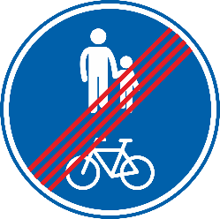

78. Compulsory minimum speed
COMPULSORY MINIMUM SPEED
Sign D, 7 (D-06.1) "COMPULSORY MINIMUM SPEED", shall mean notifies drivers that vehicles using the road at the entrance to which it is placed they shall travel at not less than the speed specified. Tthe figure shown on the sign shall express this speed in the unit of measurement most commonly used to express the speed of vehicles in the country concerned. After the figure specifying the speed, for instance, "Km" (Kilometres) or "m" (Miles) may be added. That unit of measurement may be shown on the sign after or below the digit.
Image of an example of D, 7 (D-06.1) sign:
8. End of compulsory minimum speed
END OF COMPULSORY MINIMUM SPEED
Sign D, 8 (D-06.2) "END OF COMPULSORY MINIMUM SPEED", shall mean notifies drivers that the compulsory minimum speed imposed by sign D, 7 (D-06.1) is no longer in effect. Sign D, 8 This sign shall to be identical to sign D, 7 (D-06.1), except that it shall be crossed by an oblique diagonal red bar band or, preferably, red parallel lines forming such a band running from the upper right edge to the lower left edge sloping down from right to left. The band can be interrupted when crossing the figure shown on the sign. If not interrupted, the red band shall be placed over the figure.
Notwithstanding the provisions of Article 6, paragraph 1 of this Convention, this sign may be placed on the reverse side of the sign D 7 (D-06.1) for drivers coming in the opposite direction.
Image of a permitted variant of an example of D, 8 (D-06.2) sign:
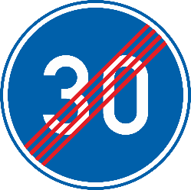
9. Snow chains compulsory
COMPULSORY SNOW CHAINS
Sign D, 9 a (D-07.1), "SNOW CHAINS COMPULSORY" shall mean notifies drivers that their vehicles travelling on the road at the entrance to which it is placed shall have snow chains fitted to not less than two of their driving wheels in situations when the carriageway is covered by snow and/or ice.
Image of D, 9 a (D-07.1) sign:
END OF COMPULSORY SNOW CHAINS
D, 9 b (D-07.2), notifies drivers that the use of compulsory snow chains imposed by sign D, 9 (D-07.1) is no longer in effect. This sign shall be identical to sign D, 9 a (D-07.1), except that it shall be crossed by an oblique red band or, preferably, red parallel lines forming such a band sloping down from right to left. The band can be interrupted when crossing the symbol. If not interrupted, the red band shall be placed over the symbol.
Notwithstanding the provisions of Article 6, paragraph 1 of this Convention, this sign may be placed on the reverse side of the sign D 9 a (D-07.1) for drivers coming in the opposite direction.
Image of a permitted variant of D, 9 b (D-07.2) sign:
10. Compulsory direction for vehicles carrying dangerous goods
COMPULSORY DIRECTION FOR VEHICLES CARRYING DANGEROUS GOODS
D, 10a (D-08.0) notifies drivers of vehicles carrying dangerous goods of the direction in which they shall proceed. This sign shall depict one of the symbols used on signs C, 3 h (C-03.8), C, 3 m (C-03.13) or C, 3 n (C-03.14) to specify the type of dangerous goods carried and one of the signs D, 1 a (D-01.1, D-01.2, D-01.4, D-01.5, D-01.6) to specify the direction to follow.
The ground of this sign shall be white.
Image of a permitted variant of an example of D, 10 (D-08.0) sign:
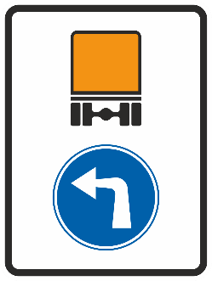
Sign D, 10a ; D, 10b and D, 10c shall indicate the direction in which vehicles carrying dangerous goods shall proceed.
11. Remarks concerning the combination of signs D, 4; D, 5 and D, 6
(a) Notification that a path or track is reserved to two categories of road users and prohibited to other users shall be indicated by a mandatory sign bearing the two symbols for the categories of users entitled to use the path or track at the entrance to which it is placed.
(b) When the symbols are placed side by side on the sign and separated by a vertical line through the centre of the sign, each symbol shall be understood to mean that the relevant category must use the side of the path or track reserved for that category and shall notify other road users that they are not entitled to use that side. The two sides of the path or track shall be clearly separated, by physical means or road markings.
(c) When the symbols are placed one above the other, the sign shall notify the relevant categories of users that they may jointly use the path or track. The order in which the symbols are placed shall be optional. Where necessary the precautions to be taken by both categories of users shall be laid down in domestic legislation.
Sign D, 11a and D, 11b are examples of the combination of signs D, 4 and D, 5.
Section E
SPECIAL REGULATION SIGNS
I. General characteristics and symbols
Special regulation signs are square or rectangular, usually with a blue ground and a light-coloured symbol or inscription, or with a light coloured ground and a dark coloured symbol or inscription.
II. Descriptions Definitions and images
1. Signs indicating a regulation or danger warning applying to one or more traffic lanes.
Signs such as those given below shall mean that a regulation or danger warning applies only to one or more lanes, defined by longitudinal lane markings, on a multi-lane carriageway for traffic moving in the same direction. They may also indicate lanes allocated to oncoming traffic. The sign relating to the regulation or danger warning shall be shown on each of the arrows concerned:
REGULATION OR DANGER WARNING APPLYING TO A LANE
E, 1 (E-01.0) notifies about a regulation or danger warning applying to a lane, defined by longitudinal lane markings, on a multi-lanes carriage way for traffic moving in the same direction. This sign may also indicate a lane allocated to oncoming traffic. The sign relating to the regulation or danger warning shall be shown on each of the arrows concerned.
Image of a permitted variant of an example of E, 1 (E-01.0) sign:
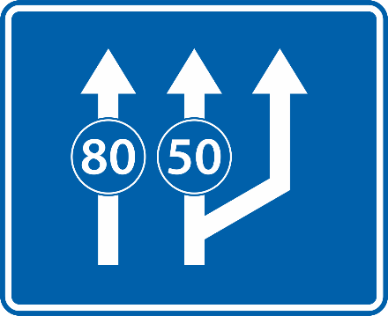
(i) E, 1a "COMPULSORY MINIMUM SPEED APPLYING TO DIFFERENT LANES".
(ii) E, 1b "COMPULSORY MINIMUM SPEED APPLYING TO ONE LANE". This sign may be used as way of creating a "slow lane".
(iii) E, 1c "SPEED LIMITS APPLYING TO DIFFERENT LANES". Borders of the circles shall be red and letters black.
2. Signs indicating lanes reserved for buses or other categories of vehicles
LANE RESERVED FOR BUSES
Signs such as E, 2a and E, 2b are examples of signs showing the position of the E, 2 a (E-02.1) notifies road users about the position of the lane, on a multi-lane carriageway with longitudinal lane markings, reserved for buses in accordance with Article 26 bis, paragraph 2. This sign may also indicate a lane allocated to oncoming traffic. Additional panel H, 5 (H-05.0) depicting the symbol of a bus or only the symbol of a bus shall be shown on the arrow concerned.
Image of a permitted variant of an example of E, 2 a (E-02.1) sign:
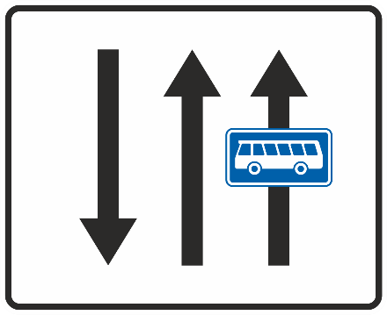
LANE RESERVED FOR SPECIFIC CATEGORIES OF VEHICLES
E, 2 b (E-02.2) notifies road users about the position of the lane, , on a multi-lane carriageway with longitudinal lane markings, reserved for specific categories of vehicles in accordance with Article 26bis, paragraph 1. Additional panel H, 5 (H-05.0) depicting the symbol of that type of vehicle category , or only the symbol of that vehicle category , shall be shown on the arrow concerned.
Image of a permitted variant of an example of E, 2 b (E-02.2) sign:
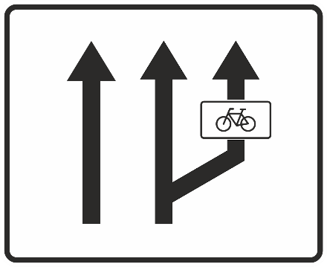
43. Preselection sign
Example of sign for preselection at intersections on roads with several lanes: E, 4.
PRESELECTION OF LANES
E, 4 (E-03.0) notifies road users about directions to follow for each lane of a multi-lane carriageway at the intersection in order for them to preselect the required lane before the intersection. Lane markings may be included.
Image of a permitted variant of an example of E, 4 (E-03.0) sign:
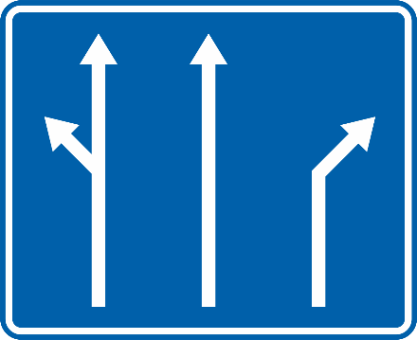
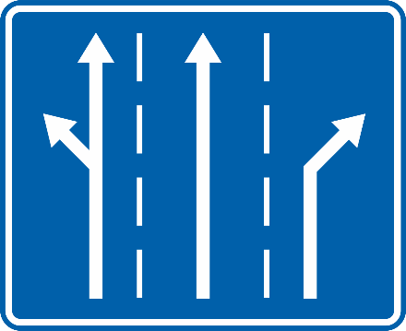
34. "ONE-WAY" sign
(a) Two different "ONE-WAY" signs may be set up where it is necessary to indicate a road or carriageway which is one-way:
(i) Sign E, 3a placed approximately perpendicular to the axis of the carriageway; its panel shall be square.
(ii) Sign E, 3b placed approximately parallel to the axis of the carriageway; its panel shall be an elongated rectangle the long side of which is horizontal. The words "one way" may be inscribed on the arrow of sign E, 3b in the national language or one of the national languages of the country concerned.⁴⁸
ONE-WAY
E, 3 a (E-04.1) notifies road users that a carriageway is one-way. This sign shall be placed perpendicular to the axis of the carriageway. It shall be square or rectangular, the ground shall be blue and the symbol white.
Image of E, 3 a (E-04.1) sign:
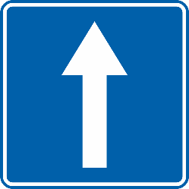
ONE-WAY
E, 3 b (E-04.2) notifies road users that a carriageway is one-way. This sign shall be placed parallel to the axis of the carriageway; it shall be an elongated rectangle, the long side of which is horizontal, the ground shall be blue and the symbol white. The inscription "One way" may be placed on the arrow of this sign in the national language or one of the national languages of the State concerned.⁴⁸ The symbol on this sign may be reversed.
Image of an example of E, 3 b (E-04.2) sign:
reversed symbol:
(b) Signs E, 3a (E-04.1) and E, 3b (E-04.2) may be set up irrespective of whether prohibitory or mandatory signs are set up at the entrance to the road in question.
5. Signs notifying an entry to or an exit from a motorway
(a) Sign E, 5a , "MOTORWAY", shall be placed at the point where the special rules to be observed on a motorway begin to apply.
MOTORWAY
E, 5 a (E-05.1) notifies drivers of vehicles about an entry to a motorway where the special rules to be observed on a motorway begin to apply. It shall be placed at the entry to a motorway. It shall have blue or green ground and a white symbol.
⁴⁹ See footnote
Image of E, 5 a (E-05.1) sign:
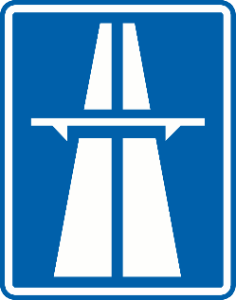
END OF MOTORWAY
(b) Sign E, 5b , "END OF MOTORWAY", shall be placed at the point where those rules cease to apply.
E, 5 b (E-05.2) notifies drivers of motor vehicles that the special rules imposed by sign E, 5 a (E-05.1) cease to apply from the point of its placement. This sign shall be identical to the sign E, 5 a, (E-05.1) except that it shall be crossed by a diagonal red band or, preferably, red parallel lines forming such a band running from the upper right edge to the lower left edge. The diagonal band may be interrupted when crossing the symbol. If not interrupted, the diagonal band shall be placed over the symbol.
(c) Sign E, 5b This sign may also be used and repeated to give warning of the ending of a motorway; the distance between each sign set up for this purpose and the end of the motorway shall be inscribed on the lower part of the sign or the additional panel H, 1 (H-01.0) described in section H, subsection II, paragraph 1 shall be used for this purpose.
(d) These signs shall have blue or green ground.
Image of a permitted variant of E, 5 b (E-05.2) sign:
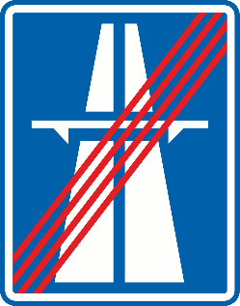
6. Signs notifying an entry to or exit from a road on which the traffic rules are the same as on a motorway
ROAD FOR MOTOR VEHICLES
(a) Sign E, 6a (E-06.1), "ROAD FOR MOTOR VEHICLES", notifies drivers of vehicles about an entry to a road for motor vehicles shall be placed at the point where special traffic rules, on roads other than motorways, begin to apply on roads other than motorways and which are reserved for motor vehicle traffic and do not serve properties bordering on the road. An additional panel may be placed under this sign E, 6a to show that, by way of exception, the access of motor vehicles to properties bordering on the road is permitted. This sign shall have blue or green ground, and a white symbol.
⁵⁰ See footnote
Image of E, 6 a (E-06.1) sign:
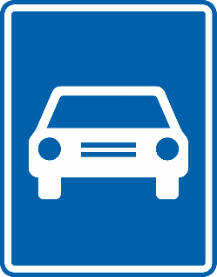
END OF ROAD FOR MOTOR VEHICLES
E, 6 b (E-06.2) notifies drivers of motor vehicles that the special rules imposed by sign E, 6 a (E-06.1) cease to apply from the point of its placement. This sign shall be identical to the sign E, 6 a (E-06.1), except that it shall be crossed by a diagonal red band or, preferably, red parallel lines forming such a band running from the upper right edge to the lower left edge. The diagonal band may be interrupted when crossing the symbol. If not interrupted, the diagonal band shall be placed over the symbol.
(b) Sign E, 6b , "END OF ROAD FOR MOTOR VEHICLES", This sign may also be used and repeated to give warning of the ending of the road; the distance between each sign set up for this purpose and the end of the road shall be inscribed on the lower part of the sign or on the additional panel H, 1 (H-01.0) described in section H, subsection II, paragraph 1.
(c) These signs shall have blue or green ground.
Image of a permitted variant of E, 6 b (E-06.2) sign:
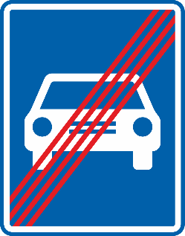
7. Signs indicating the beginning and the end of a built-up area⁵¹
BEGINNING OF A BUILT-UP AREA
(a) The sign to indicate the beginning of a built-up area shall bear the name of the built-up area or the symbol showing the silhouette of a built-up area or the two combined. Signs E, 7 a ; E, 7b ; E, 7c and E, 7d are examples of signs showing the beginning of a built-up area.
E, 7 a (E-07.1) notifies road users about the beginning of a built-up area where general regulations governing traffic in built-up areas in the territory of the State apply. This sign shall bear the name of the built-up area. It may be replaced by signs E, 7 b or E, 7 c (E-07.3 or E-07.5).
Image of a permitted variant of an example of E, 7 a (E-07.1) sign:
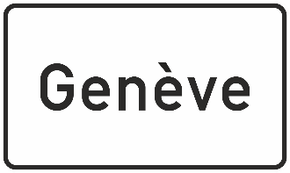
END OF A BUILT-UP AREA
E, 8 a (E-07.2) notifies road users about the end of a built-up area and that the rules imposed by the sign E, 7 a (E-07.1) cease to apply. This sign shall be identical to E, 7 a (E-07.1) except that it shall be crossed by an oblique a diagonal red bar band coloured red or, preferably, red parallel lines forming such a bandor consisting of parallel lines coloured red running from the upper right edge to the lower left edge. The diagonal band may be interrupted when crossing the name of the built-up area. If not interrupted, the diagonal band shall be placed over the name of the built-up area.
Image of a permitted variant of an example of E, 8 a (E-07.2) sign:
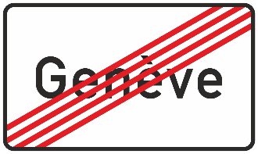
BEGINNING OF A BUILT-UP AREA
E, 7 b (E-07.3) notifies road users about the beginning of a built-up area where general regulations governing traffic in built-up areas in the territory of the State apply. This sign shall bear the symbol of the built-up area. It may be replaced by signs E, 7 a or E, 7 c (E-07.1 or E-07.5).
Image of a permitted variant of E, 7 b (E-07.3) sign:
END OF A BUILT-UP AREA
E, 8 b (E-07.4) notifies road users about the end of a built-up area and that the rules imposed by the sign E, 7 b (E-07.3) cease to apply. This sign shall be identical to E, 7 b (E-07.3) except that it shall be crossed by an oblique a diagonal red bar band coloured red or, preferably, red parallel lines forming such a bandor consisting of parallel lines coloured red running from the upper right edge to the lower left edge. The diagonal band may be interrupted when crossing the symbol of the built-up area. If not interrupted, the diagonal band shall be placed over the symbol of the built up area.
Image of a permitted variant of E, 8 b (E-07.4) sign:
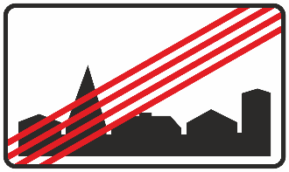
BEGINNING OF A BUILT-UP AREA
E, 7 c (E-07.5) notifies road users about the beginning of a built-up area where general regulations governing traffic in built-up areas in the territory of the State apply. This sign shall bear the name and the symbol of the built-up area. It may be replaced by signs E, 7 a or E, 7 b (E-07.1 or E-07.3).
Image of a permitted variant of an example of E, 7 c (E-07.5) sign:
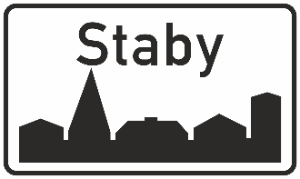
END OF A BUILT-UP AREA
E, 8 c (E-07.6) notifies road users about the end of a built-up area and that the rules imposed by the sign E, 7 c (E-07.5) cease to apply. This sign shall be identical to E, 7 c (E-07.5) except that it shall be crossed by an oblique a diagonal red bar band coloured red or, preferably, red parallel lines forming such a bandor consisting of parallel lines coloured red running from the upper right edge to the lower left edge. The diagonal band may be interrupted when crossing the name and the symbol of the built-up area. If not interrupted, the diagonal band shall be placed over them.
Image of a permitted variant of an example of E, 8 c (E-07.6) sign:
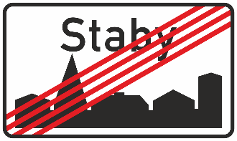
(b) The sign showing the end of a built-up area shall be identical except that it shall be crossed by an oblique bar coloured red or consisting of parallel lines coloured red running from the upper right edge to the lower left edge. Signs E, 8a ; E, 8b ; E, 8c and E, 8d are examples of signs indicating the end of a built-up area. Notwithstanding the provisions of Article 6, paragraph 1 of this Convention these signs indicating the end of a built-up area may be placed on the reverse side of signs identifying a built-up area.
(c) The signs covered by this paragraph shall be used in conformity with the provisions of the Convention, Article 13 bis, paragraph 2.
The general regulations governing traffic in built-up areas may be supplemented by different regulations notified by other signs on certain sections of road in the built-up area. However, sign B, 4 (B-03.2) shall always be placed on a priority road marked with sign B, 3 (B-03.1) if that road ceases to have priority where it passes through the built-up area.
The provisions of Section G, subsection I, paragraphs 4, 5 and 6 and 7 apply to signs indicating the beginning and the end of a built-up area.¹²
8. Signs having zonal validity
(a) Beginning of a zone
BEGINNING OF A ZONE
E, 9 (E-08.1) notifies road users of a beginning of a zone where restrictions, prohibitions or obligations indicated by the regulatory sign displayed on this sign applies to all interconnecting roads (at least two) in the zone.
(i) To indicate that a sign applies to all roads in a zone (zonal validity), the This sign shall be displayed on a rectangle ular panel with a light-coloured ground. It preferably should bear Tthe word inscription "ZONE" or its equivalent in the national language may be displayed above or below the sign on the panel. Specific details of the restrictions, prohibitions or obligations indicated by the sign may be given below the sign on the panel inscribed in the lower part of the sign or on an additional panel. The inscriptions shall be black or dark blue.
Signs applying to all roads in a zone (zonal validity) This sign shall be set up at all roads giving access to the zone concerned. The zone preferably should only include roads which have similar characteristics.
(ii) Signs E, 9a ; E, 9b ; E, 9c and E, 9d are examples of signs applying to all roads in a zone (zonal validity):
E, 9a - Zone in which parking is prohibited;
E, 9b - Zone in which parking is prohibited at certain times;
E, 9c - Parking zone;
E, 9d - Maximum speed zone.
(b) Exit from a zone
Images of permitted variants of examples of E, 9 (E-08.1) sign:
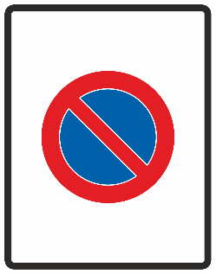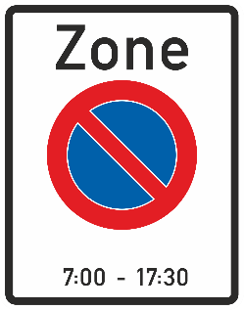
EXIT FROM A ZONE
E, 10 (E-08.2) notifies road users of the exit from a zone in which a sign has zonal validity E, 9 (E-08.1). This sign shall be similar to E, 9 (E-08.1) sign except that the regulatory sign displayed on E, 9 (E-08.1) shall be of grey colour and a A black or dark grey diagonal band or, preferably, parallel grey or black lines forming such a band running from the upper right edge to the lower left edge. The diagonal band may be interrupted when crossing the displayed grey regulatory sign. If not interrupted, the diagonal band shall be placed over it.
(i) To indicate the exit from a zone in which a sign has zonal validity, the same sign displayed on a rectangular panel shall be set up as that placed at the entry to the zone but it shall be grey on a rectangular panel with a light coloured ground. A black or dark grey diagonal band or parallel grey or black lines forming such a band shall slope downwards across the sign from right to left.
Signs indicating the exit from a zone It shall be set up on all roads which may be used to leave that zone.
(ii) Signs E, 10a ; E, 10c and E, 10d are examples of signs indicating the exit from a zone in which a sign applies to all roads (zonal validity):
E, 10a - End of zone in which parking is prohibited;
E, 10b - End of zone in which parking is prohibited at certain times;
E, 10c - End of parking zone;
E, 10d - End of maximum speed zone.
Images of permitted variants of examples of E, 10 (E-08.2) sign:
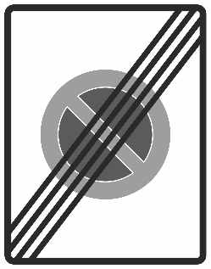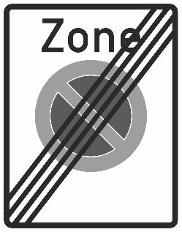
9. Signs notifying the entry to or exit from a tunnel where special rules apply
TUNNEL
(a) Sign E, 11a (E-09.1) ‘TUNNEL’ notifies of indicates a section of road passing through a tunnel and on which special traffic rules apply. It is placed at the point from which these rules apply. It shall be used for tunnels of 1,000 m or more and in cases provided for by domestic legislation. The length of such tunnel shall be included either in the lower part of the sign or on an additional panel H, 2 (H-02.0) as described in section H, subsection II paragraph 1. The name of the tunnel may be placed on an additional panel or on the sign itself.
The sign shall have a blue or green ground and the symbol shall be white and black or dark blue.
(b) In order to warn road users in advance, sign E, 11a (E-09.1) may be placed in addition, at a suitable distance before the point where the special rules apply; such sign shall show, either in its lower part, or on an additional panel H, 1 (H-01.0), as described in section H, subsection II paragraph 1 paragraph 2 (a) of this Annex, the distance between the point at which it is set up and the point from which these special rules apply.
Image of a permitted variant of E, 11 a (E-09.1) sign:
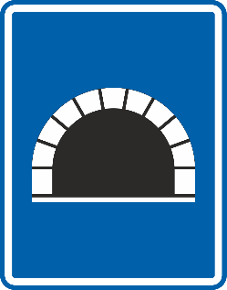
END OF TUNNEL
(c) Sign E, 11b (E-09.2) ‘END OF TUNNEL’ notifies that the special traffic rules imposed by sign E, 11 a (E-09.1) may be placed at the point from which the special rules no longer cease to apply from the point of its placement. This sign shall be identical to E, 11 a (E-09.1) except that it shall be crossed by a diagonal red band or, preferably, of red parallel lines forming such a band running from the upper right edge to the lower left edge. The diagonal band may be interrupted when crossing the symbol. If not interrupted, the diagonal band shall be placed over the symbol.
Image of a permitted variant of E, 11 b (E-09.2) sign:
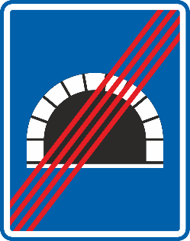
10. "PEDESTRIAN CROSSING" sign⁵²
{⁵² See also point 22 of the Annex of the European Agreement[deleted]}
PEDESTRIAN CROSSING
((a) Sign E, 12 (E-10.0), "PEDESTRIAN CROSSING", notifies road users of is used to show pedestrians and drivers the position of a pedestrian crossing. The ground of the panel this sign shall be blue or black with the triangle a white or yellow triangle. and tThe symbol shall be black or dark blue.; the This symbol shall symbol displayed shall be a pedestrian on a crossing marked by broad stripes. symbol as A, 12 a (A-12.1). The symbol on this sign may be reversed.

Image of a permitted variant of E, 12 (E-10.0) sign:
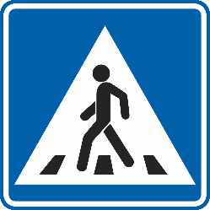
reversed symbol:
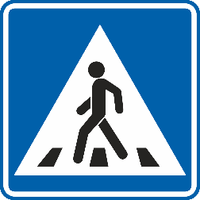
(b) However, the sign E, 12b, having the shape of an irregular pentagon, a blue ground and a white symbol or the sign E, 12c, having a dark ground and white symbol may also be used.
The pedestrian crossing signs shall be placed at pedestrian crossings when the competent authorities consider it advisable.
11. "HOSPITAL" sign
HOSPITAL
(a) This sign shall be used to notify drivers of vehicles that they should take the precautions required near medical establishments; in particular, that they should not make any unnecessary noise. There are two models of this sign: E, 13a and E, 13b .
E, 13 a (E-11.1) notifies road users that a medical establishment is located nearby where they need to take the precautions required and where they shall not make any unnecessary noise. It shall have a blue ground and the symbol shall be white. It may be replaced by E, 13 b (E-11.2).
Image of E, 13 a (E-11.1) sign:
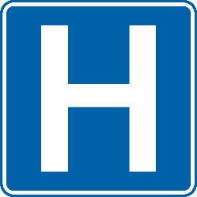
HOSPITAL
E, 13 b (E-11.2) notifies road users that a medical establishment is located nearby where they need to take the precautions required and where they shall not make any unnecessary noise. It shall have a blue ground and the symbols shall be white and red. It may be replaced by E, 13 a (E-11.1). (b) The red cross on this sign E, 13b may be replaced by one of the symbols referred to in section F, subsection II, paragraph 1 a red symbol depicting first-aid stations in the States concerned.
Image of a permitted variant of E, 13 b (E-11.2) sign:
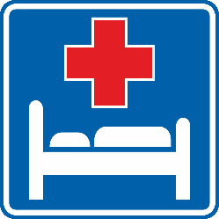
12. "PARKING" sign
PARKING
(a) Sign E, 14 a (E-12.1) , "PARKING", notifies of places which may be set up parallel to the axis of the road, shall indicate places where the parking of vehicles is authorized. The panel It shall be square or rectangular ⁵³ with a blue ground and Iit shall bear the letter in white or ideogram used in the State concerned to denote "Parking". The ground of this sign shall be blue. This sign may be set up parallel to the axis of the road.
(b) The direction in which the parking place lies or the categories of vehicle for which it is reserved may be shown on the sign itself or on an additional panel below the sign. Such inscriptions may also limit the period for which parking is permitted.
Image of an example of E, 14 a (E-12.1) sign:
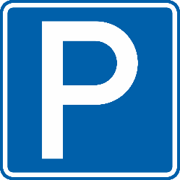
PARK AND RIDE
E, 14 b (E-12.2) notifies of places where the parking is authorized with an option to change to other transport means. The sign shall have a blue ground and shall bear a white coloured symbol “P + R” with one horizontal line placed below and one above “P + R”.
In the “P + R” symbol, the letters P and R may be replaced by the letters or ideograms used in the State concerned to denote "Parking" and “availability of other transport means”. This sign may be replaced by E, 14 c or E, 14 d (E-12.3 or E-12.4).
Image of an example of E, 14 b (E-12.2) sign:
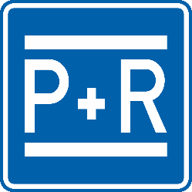
PARK AND RIDE
E, 14 c (E-12.3)^{53bis} notifies of places where the parking is authorized with an option to change to a specific means of public transport. or indicate that public transport is accessible from the parking place by means of The sign shall have a blue ground and shall bear a white coloured symbol “P +” sign followed by an inscription indicating the type of public transport, in word or symbol form by its name.
{^{53bis} See also point 22 of the Annex of the European Agreement}
In the “P +” symbol, the letter P may be replaced by the letter used in the State concerned to denote "Parking". This sign may be replaced by E, 14 b or E, 14 d (E-12.2 or E-12.4).
Image of an example of E, 14 c (E-12.3) sign:
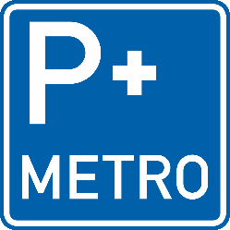
PARK AND RIDE
E, 14 d (E-12.4)^{53ter} notifies of places where the parking is authorized with an option to change to a specific means of public transport. The sign shall have a blue ground and shall bear a white coloured symbol “P +” followed by a symbol indicating the type of public transport. or indicate that public transport is accessible from the parking place by means of bear a "+ sign"
{^{53ter} See also point 22 of the Annex of the European Agreement}
In the “P +” symbol, the letter P may be replaced by the letter used in the State concerned to denote "Parking". This sign may be replaced by E, 14 b or E, 14 c (E-12.2 or E-12.3).
Signs E, 14b and E, 14c are examples of the signs which may be used to indicate a car park more particularly intended for vehicles whose drivers wish to use a means of public transport.
Image of an example of E, 14 d (E-12.4) sign:
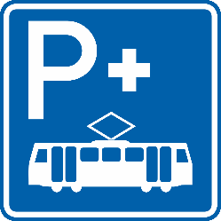
13. Signs notifying a bus or tramway stop
BUS STOP
E, 15 (E-13.1)"BUS. STOP" notifies of a location of a bus stop where special regulations in the territories of the State concerned may apply. The symbol on this sign may be reversed.
Image of a permitted variant of an example of E, 15 (E-13.1) sign:
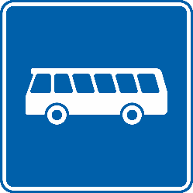
reversed symbol:
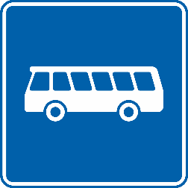
TRAMWAY STOP
and E, 16 (E-13.2)"TRAMWAY STOP" notifies of a location of a tramway stop where special regulations in the territories of the State concerned may apply. The symbol on this sign may be reversed.
Image of a permitted variant of an example of E, 16 (E-13.2) sign:
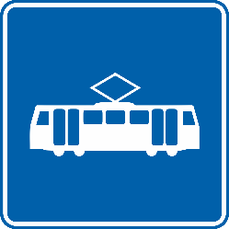

⁵⁴ See footnote
{⁵⁴ Additional paragraph introduced in the annex of the European Agreement (see point 22). [deleted]}
14. Signs notifying an entry to or an exit from a residential area where special traffic rules apply
RESIDENTIAL AREA
E, 17 a (E-14.1) notifies road users about the beginning of a residential area where special regulations governing traffic in residential areas in the territory of the state apply.
This sign shall have a blue ground and white symbols.
Image of E, 17 a (E-14.1) sign:
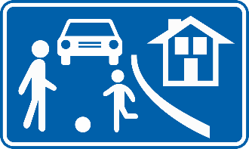
END OF RESIDENTIAL AREA
Sign E, 17 b (E-14.2) notifies of the exit from a residential area where the special regulations imposed by E, 17 a (E-14.1) cease to apply. This sign shall be identical to the sign E, 17 a (E-14.1) except that it shall be crossed by a diagonal red band or, preferably, red parallel lines forming such a band running from the upper right edge to the lower left edge. The diagonal band shall be placed over the symbols.
Image of a permitted variant of E, 17 b (E-14.2) sign:
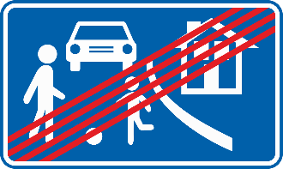
145. Signs indicating a stopping place in case of emergency or danger
EMERGENCY STOPPING PLACE
Sign E, 18⁵⁵ “EMERGENCY STOPPING PLACE” (E-15.0) notifies of indicates a place which shall only be used by drivers for stopping or parking in case of emergency or danger. If this stopping place is equipped with an emergency telephone and/or an extinguisher, the sign shall bear the symbols F, 14 17 (F-10.0) and/or F, 15⁵⁶ F, 18 (F-11.0) either in its lower part or on a rectangular an additional panel placed below the sign. This sign has two models, E, 18 a ⁵⁷ and E, 18 b ⁵⁸. The symbol on this sign shall be reversed for traffic keeping to the left.
{⁵⁶ See footnote 65 and 66 [deleted]}
{⁵⁷ See corrigendum TRANS/WP.1/2003/3/rev.4/Corr.1.1 The number previously attributed was E, 17 a [deleted]}
{⁵⁸ See corrigendum TRANS/WP.1/2003/3/rev.4/Corr.1.1 The number previously attributed was E, 17 b [deleted]}

Image of a permitted variant of E, 18 (E-15.0) sign:
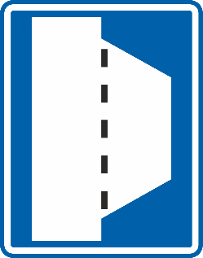
reversed symbol:
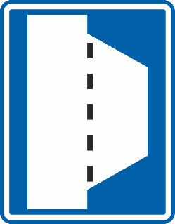

Section F
INFORMATION, FACILITIES OR SERVICE SIGNS
I. General characteristics and symbols
1. “F” signs with inscriptions shall have a blue or green ground; they shall bear a white or yellow rectangle be blue or green rectangles with a white square placed in the centre on which the symbol shall be displayed.
2. “F” signs without inscriptions shall be blue or green squares or rectangles with a white square placed in the centre. The area of the white square shall not be greater than two-thirds of the area of the blue or green ground.
23. On the blue or green band ground at the bottom On the lower part of the “F” sign with inscription, the distance to the facility indicated, or to the entry to the road leading to it, may be inscribed in white; on the sign bearing symbol F, 5 the word “HOTEL” or “MOTEL” may be inscribed in the same way. The signs may also be set up along main roads or at the entry to the road leading to the facility and may then bear a white advance directional or directional arrow on the blue or green part at the bottom on the lower part of the sign, respectively.
4. The symbol shall be black or dark blue, unless otherwise indicated. symbols F, 1 a, F, 1 b, F, 1 c and F, 18⁵⁹, which shall be red. The symbol F, 17⁶⁰ may be red.
{⁵⁹ See footnote 66 [deleted]}
{⁶⁰ See footnote 65 [deleted]}
II. Descriptions Definitions and images
1. "FIRST-AID STATION" symbol sign⁶¹
FIRST-AID STATION
F, 1 (F-01.0) notifies of a location of a first aid station. The symbols depicting first-aid stations in the States concerned shall be used. These symbols shall be red. Examples of these symbols are F, 1a , F, 1b and F, 1c .
Images of permitted variants of examples of F, 1 (F-01.0) sign:
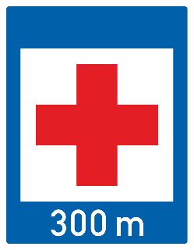
2. Miscellaneous symbols Other signs
BREAKDOWN SERVICE
F, 2 (F-02.0) "BREAKDOWN SERVICE" ) notifies of a location of a breakdown service.
Images of permitted variants of F, 2 (F-02.0) sign:
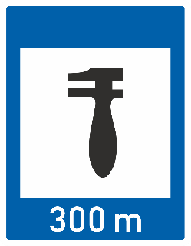
TELEPHONE
F, 3 (F-03.0)"TELEPHONE" notifies of a location of a telephone.
Images of permitted variants of F, 3 (F-03.0) sign:
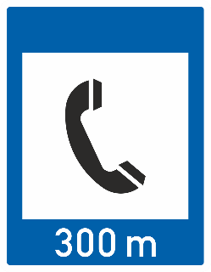
FILLING STATION
F, 4 (F-04.0) "FILLING STATION" notifies of a location of a filling station
Images of permitted variants of F, 4 (F-04.0) sign:
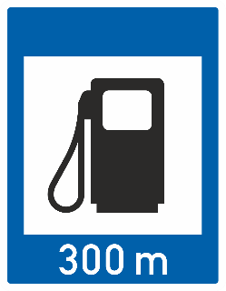
HOTEL OR MOTEL
F, 5 (F-05.1) "HOTEL or MOTEL" notifies of a location of a hotel or motel. This sign - the variant with inscription – may contain the inscription “HOTEL” or “MOTEL” on the lower part of the sign.
Images of permitted variants of F, 5 (F-05.1) sign:
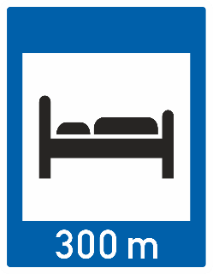
YOUTH HOSTEL
F, 13 (F-05.2) "YOUTH HOSTEL" notifies of a location of a youth hostel.
Images of permitted variants of examples of F, 13 (F-05.2) sign:
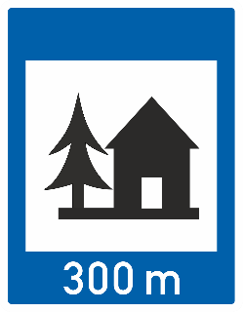
RESTAURANT
F, 6 (F-06.1) "RESTAURANT" notifies of a location of a restaurant.
Images of permitted variants of examples of F, 6 (F-06.1) sign:
REFRESHMENTS OR CAFETERIA
F, 7 (F-06.2) "REFRESHMENTS OR CAFETERIA" notifies of the availability of refreshments or location of a cafeteria.
Images of permitted variants of F, 7 (F-06.2) sign:
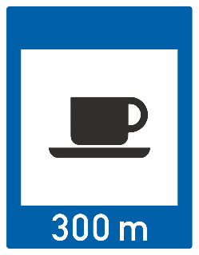
PICNIC SITE OR REST AREA
F, 8 (F-07.1) "PICNIC SITE" notifies of a location of a picnic site or rest area.
Images of permitted variants of examples of F, 8 (F-07.1) sign:
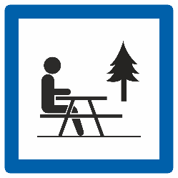 | 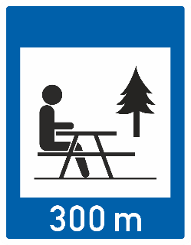
F, 9 "STARTING-POINT FOR WALKS
CAMPING SITE
F, 10 (F-07.2) "CAMPING SITE" notifies of a location of a camping site.
Images of permitted variants of F, 10 (F-07.2) sign:
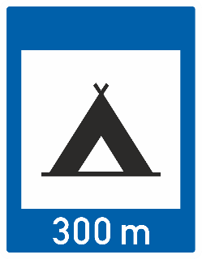
CARAVAN SITE
F, 11 (F-07.3) "CARAVAN SITE" notifies of a location of a caravan site.
Images of permitted variants of F, 11 (F-07.3) sign:
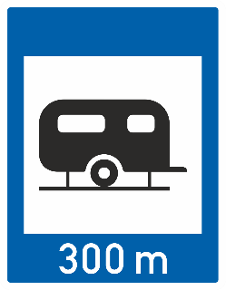
F, 12 "CAMPING AND CARAVAN SITE"
RADIO STATIONS PROVIDING TRAFFIC INFORMATION
F, 14⁶² See footnote (F-08.0) notifies of the frequency for the radio station providing traffic information. The sign shall display an inscription “Radio” in the white square, which may also be supplemented by the name or the code of the radio station. The word inscription “Radio” may be repeated in the national language.
{⁶² See also point 23 of the Annex of the European Agreement [deleted]}
This sign - the variant with inscription – shall display the inscription of the frequency and, if necessary, the wavelength of the local radio station in white on the lower part of the signs. For the variant of this sign without inscription, the frequency information shall be displayed on an additional panel.
It is left to the discretion of the State concerned to add in the case of VHF stations the indication “MHz” or the regional code, and in the case of medium-frequency or long-frequency stations the indication “kc/s”
The wavelength may be given in figures with the letter m (e.g. 1500m).
Images of permitted variants of examples of F, 14 (F-08.0) sign:
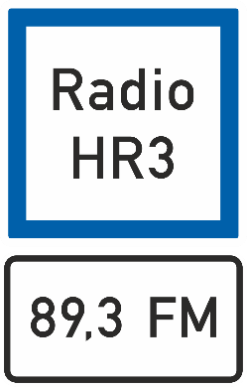 | 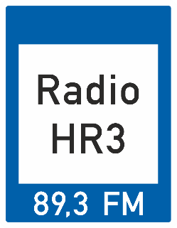
PUBLIC LAVATORY
F, 15⁶³ See footnote (F-09.0) notifies of a location of a public lavatory.
{⁶³ See also point 23 of the Annex of the European Agreement [deleted]}
Images of permitted variants of F, 15 (F-09.0) sign:
F, 16⁶⁴ See footnote
{⁶⁴ See also point 23 of the Annex of the European Agreement [deleted]}
EMERGENCY TELEPHONE
F, 17 (F-10.0)⁶⁵ "EMERGENCY TELEPHONE" notifies of a location of a telephone for emergency calls. The symbol may also be red.
Images of permitted variants of F, 17 (F-10.0) sign:
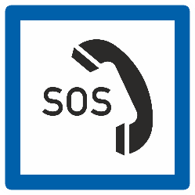 | 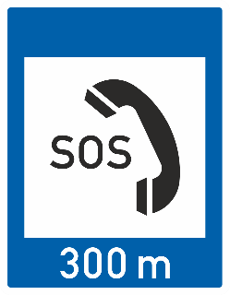
EXTINGUISHER
F, 18 (F-11.0)⁶⁶ "EXTINGUISHER" See footnote “notifies of a location of an extinguisher. The symbol shall be red.
Images of permitted variants of F, 18 (F-11.0) sign:
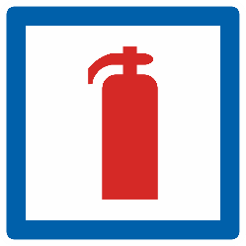 | 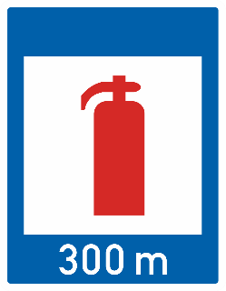
⁶⁷ See footnote
{⁶⁷ Additional text introduced in the Annex of the European Agreement (see point 23) [deleted]}
3. Multiple facilities or service signs
MULTIPLE FACILITIES OR SERVICE SIGNS
F, 19 a (F-12.1) notifies of a location of two different types of facilities or services.
Images of permitted variants of examples of F, 19 a (F-12.1) sign:
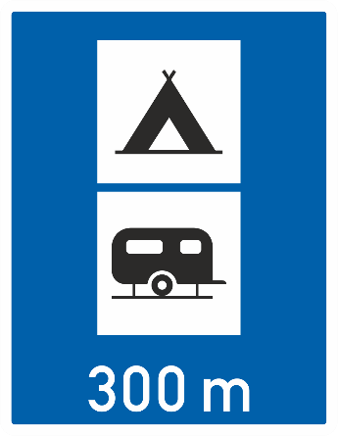
MULTIPLE FACILITIES OR SERVICE SIGN
F, 19 b (F-12.2) notifies of a location of three different types of facilities or services.
Images of permitted variants of examples of F, 19 b (F-12.2) sign:
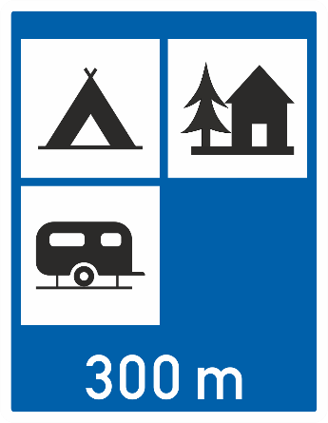
MULTIPLE FACILITIES OR SERVICE SIGN
F, 19 c (F-12.3) notifies of a location of four different types of facilities or services.
Images of permitted variants of examples of F, 19 c (F-12.3) sign:
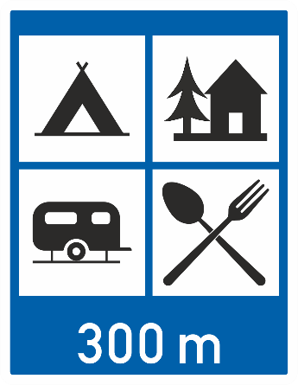
Section G
DIRECTION, POSITION OR INDICATION OTHER INFORMATION SIGNS
I. General characteristics and symbols
1. Informative Other information signs are usually rectangular; however, direction signs, and signs notifying the direction and distance of the nearest emergency exit and signs indicating temporary conditions due to road works or detours may be in the shape of an elongated rectangle with have the longer side horizontal, terminating in an arrowhead.
2. Informative Other information signs shall bear either white or light-coloured symbols or inscriptions on a dark ground with a white light-coloured rim, or dark-coloured symbols or inscriptions on a white or light-coloured ground with a black dark-coloured rim; the colour red may be used only exceptionally and must never predominate with the exception of the road identification signs, which may have a red ground with a light-coloured rim.
3. Advance direction signs or direction signs relating to motorways or roads treated as motorways shall bear white symbols or inscriptions on a blue or green ground. On such signs the symbols used on signs E, 5a and E, 6a may be reproduced on reduced scale. Other information signs, except the indication signs and the sign G,4a (G-04.1), may have different colours of ground and symbols if placed on roads of different classification or, for advance direction signs and direction signs, if pointing to different locations such as facilities or services.
4. Signs indicating temporary conditions such as road works, diversions or detours may have orange or yellow ground with black symbols and inscriptions.
4. On signs G, 1; G, 4; G, 5; G, 6 and G, 10 The names of localities should preferably be displayed ecommended to show place names in the language of the country, or subdivision thereof, where they are localities referred to are situated.
5. The inscriptions on other information signs in countries not using the Latin alphabet shall be displayed in both the national language and transliterated into the Latin alphabet reproducing as closely as possible the pronunciation in the national language.
6. In countries not using the Latin alphabet, the inscriptions transliterated in Latin characters may be displayed on the same sign as the inscriptions in the national language or, in addition, displayed on an identical sign.
7. A sign shall not bear inscriptions in more than two languages.
II. Advance direction signs Definitions and images
1. Advance direction signs
1. General case
Examples of advance direction signs: G, 1a; G, 1b and G, 1c.
2. Special cases
(a) Examples of advance direction signs for "NO THROUGH ROAD": G, 2a and G,
2b^{.68}
{⁶⁸ See also point 24 of the Annex of the European Agreement [deleted]}
(b) Example of advance direction sign for route to be followed in order to turn left, where a left turn at the next intersection is prohibited: G, 3.
NOTE: Advance direction signs G, 1 may bear the symbols used on other signs informing road users of the characteristics of the route or of traffic conditions (for example: signs A, 2; A, 5;C, 3e; C, 6; E, 5a; F, 2).
Signs such as those given below are examples of advance direction signs:
ADVANCE DIRECTION
G, 1 a (G-01.1) notifies of advance directions. This sign is an example of a stacked advance direction sign (two localities).
Image of a permitted variant of an example of G, 1 a (G-01.1) sign:
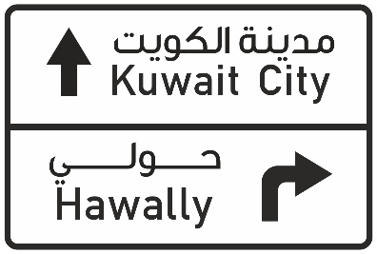
ADVANCE DIRECTION
G, 1 b (G-01.2) notifies of advance directions. This sign is an example of a stacked advance direction sign (three localities).
Image of a permitted variant of an example of G, 1 b (G-01.2) sign:
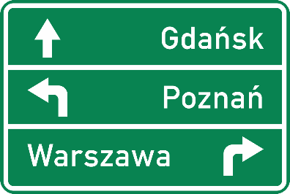
ADVANCE DIRECTION ON ROUNDABOUT
G, 1 c (G-01.3) notifies of advance directions. This sign is an example of a stacked advance direction sign (roundabout). The roundabout arrows shall be reversed for traffic keeping to the left.
Image of a permitted variant of an example of G, 1 c (G-01.3) sign:
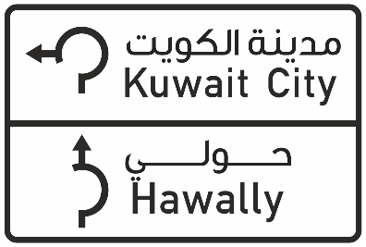
DIAGRAMMATIC ADVANCE DIRECTION FOR INTERSECTION
G, 2 a (G-02.1) notifies of advance directions. This sign is an example of an advance direction sign (intersection).
Image of a permitted variant of an example of G, 2 a (G-02.1) sign:
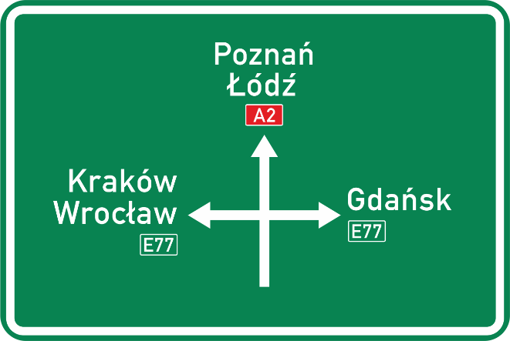
DIAGRAMMATIC ADVANCE DIRECTION FOR ROUNDABOUT
G, 2 b (G-02.2) notifies of advance directions. This sign is an example of an advance direction sign (roundabout). The symbol of the roundabout on this sign shall be reversed for traffic keeping to the left.
Image of a permitted variant of an example of G, 2 b (G-02.2) sign:
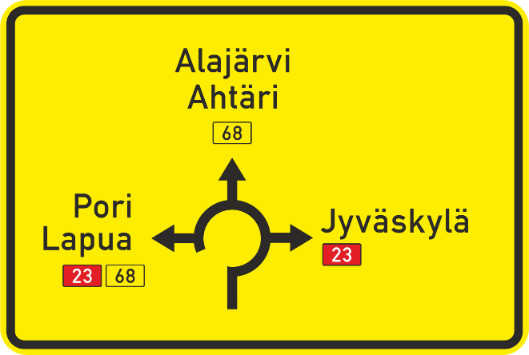
reversed symbol:
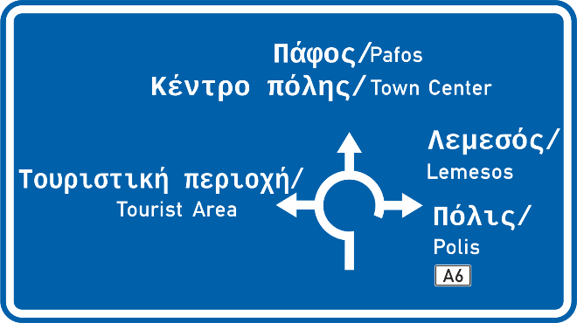
DIAGRAMMATIC ADVANCE DIRECTION FOR LANES
G, 2 c (G-02.3) notifies of advance directions. This sign is an example of an advance direction sign (lanes).
Image of a permitted variant of an example of G, 2 c (G-02.3) sign:
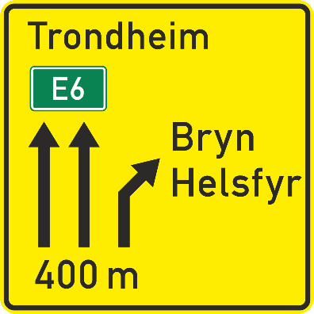
ADVANCE DIRECTION SIGN OVER A LANE
G, 3 a (G-03.1) notifies of advance directions. This sign is an example of an advance direction sign for placing over a lane and may also indicate advance direction for an exit from a motorway.
Image of a permitted variant of an example of G, 3 a (G-03.1) sign:
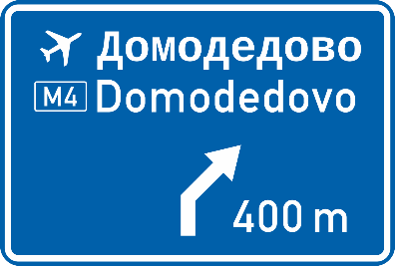
ADVANCE DIRECTION SIGN OVER LANES
G, 3 b (G-03.2) notifies of advance directions. This sign is an example of an advance direction sign for placing over a carriageway with two lanes.
Image of a permitted variant of an example of G, 3 b (G-03.2) sign:
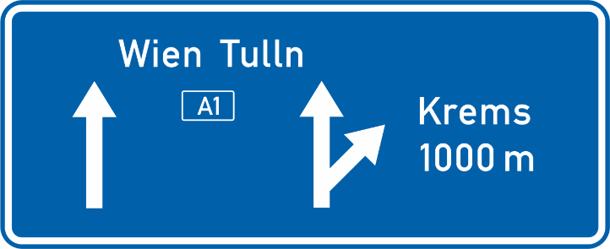
ADVANCE DIRECTION SIGN OVER LANES
G, 3 c (G-03.3) notifies of advance directions. This sign is an example of an advance direction sign for placing over a carriageway with three lanes.
Image of a permitted variant of an example of G, 3 c (G-03.3) sign:
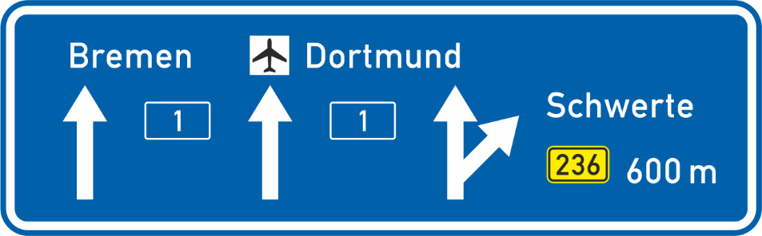
ADVANCE DIRECTION SIGN FOR NO THROUGH ROAD
G, 4 a (G-04.1) notifies in advance of a no through road. This sign shall have a blue ground and the symbol shall be white and red.
Image of a permitted variant of an example of G, 4 a (G-04.1) sign:
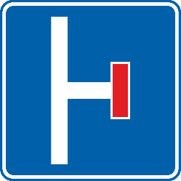
ADVANCE DIRECTION SIGN FOR PROHIBITION TO TURN
G, 4 b (G-04.2) notifies in advance a route to be followed in order to turn left, where a left turn at the next intersection is prohibited. The symbol shall be reversed for traffic keeping to the left.
Image of a permitted variant of an example of G, 4 b (G-04.2) sign:
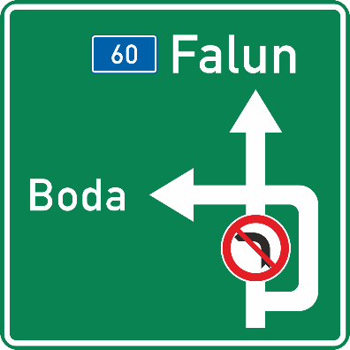
reversed symbol:
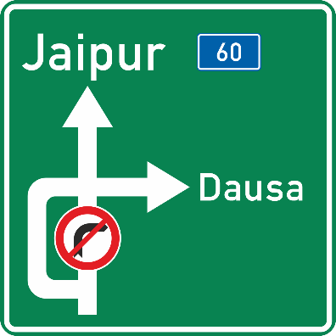
Sign G, 4 c is an example of advance direction sign for “EXIT”.
All advance direction signs may indicate the distance between the sign and the intersection or exit from a motorway on their lower parts. This distance may also be shown on an additional panel placed.
NOTE: All advance direction signs G, 1, G, 1, G, 2 and G, 3 except G, 4 a and G, 4 b (G-04.1 and G-04.2) may bear the symbols used on other signs or display other signs in a reduced scale notifying road users of the characteristics of the route or , traffic conditions, facilities and services, parking or road identification (for example: signs A, 2; A, 5; C;3e ; C, 6; E, 5a ; E, 6 a; E, 14; F, 2; G, 13 (A-02.1, A-02.1, A-05.0, C-03.5, C-06.1, C-06.2, E-05.1, E-06.1, E-12.1, F-02.0, G-13.0)). Advance direction sign G, 4 a (G-04.1) display the sign G, 13 (G-13.0) while G, 4 b (G-04.2) may display the sign C, 11 a or C, 11 b (C-11.1 or C-11.2) on a reduced scale.
III2. Direction signs
1. Examples of signs showing the direction of a place: G, 4a ; G, 4b ; G, 4c and G, 5.⁶⁹
2. Examples of signs showing the direction of an airfield: G, 6a ; G, 6b and G, 6c . ⁷⁰
3. Sign G, 7 shows the direction of a camping site.
4. Sign G, 8 shows the direction of a youth hostel.
5. Examples of signs showing the direction of a car parking more particularly intended for vehicles whose drivers wish to use means of public transport: G, 9a and G, 9b . The type of public transport may be indicated on the sign by an inscription or symbol.
Signs such as those given below are examples of direction signs:
DIRECTION SIGN
G, 5 a (G-05.1) notifies of a left direction. This sign is an example of a direction sign showing one direction with the sign panel terminating in an arrowhead to the left.
Image of a permitted variant of an example of G, 5 a (G-05.1) sign:
DIRECTION SIGN
G, 5 b (G-05.2) notifies of right direction. This sign is an example of a direction sign showing one direction with the sign panel terminating in an arrowhead to the right.
Image of a permitted variant of an example of G, 5 b (G-05.2) sign:
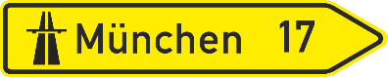
DIRECTION SIGN
G, 5 c, (G-05.3) notifies of a direction. This sign is an example of a direction sign showing one direction with an arrow⁶⁹.
Image of a permitted variant of an example of G, 5 c (G-05.3) sign:
DIRECTION SIGN (LEFT)
G, 5 d, (G-05.4) notifies of left direction. This sign is an example of a direction sign showing one direction with the sign panel terminating in an arrowhead to the left.
Image of a permitted variant of an example of G, 5 d (G-05.4) sign:
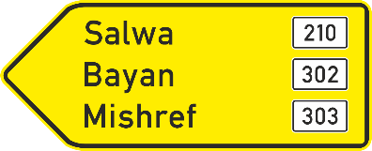
DIRECTION SIGN (RIGHT)
G, 5 e, (G-05.5) notifies of right direction. This sign is an example of a direction sign showing one direction with the sign panel terminating in an arrowhead to the right.
Image of a permitted variant of an example of G, 5 e (G-05.5) sign:
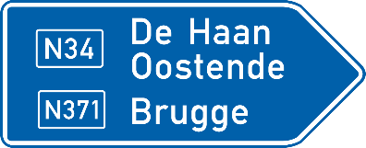
DIRECTION SIGN
G, 5 f (G-05.6) notifies of a direction. This sign is an example of a direction sign showing one direction with an arrow.^{69bis}
{^{69bis} See also point 25 of the Annex of the European Agreement}
Image of a permitted variant of an example of G, 5 f (G-05.6) sign:
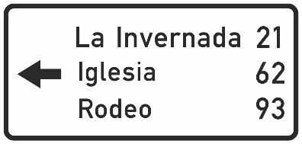
G, 5 g is an example of a direction sign for exit.
DIRECTION SIGN
G, 6 a (G-06.1) notifies of directions. This sign is an example of a direction sign showing directions with arrows.
Image of a permitted variant of an example of G, 6 a (G-06.1) sign:
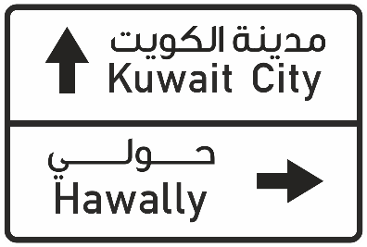
DIRECTION SIGN FOR THREE DIRECTIONS
G, 6 b (G-06.2) notifies of directions. This sign is an example of a direction sign showing directions with arrows.
Image of a permitted variant of an example of G, 6 b (G-06.2) sign:
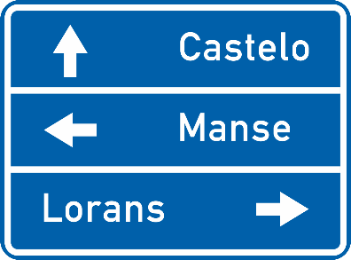
DIRECTION SIGN OVER LANE
G, 7 (G-07.0) notifies a direction. This sign is an example of a direction sign for placing over a lane.
Image of a permitted variant of an example of G, 7 (G-07.0) sign:
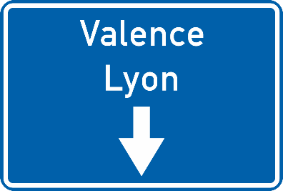

Any direction sign bearing the names of several places shall show them one below the other. The size of letters used for one place may be larger than those used for the others, only if the place in question is the largest.
When distances are displayed, the figures expressing them should preferably be inscribed at the same height as the place-name. On direction signs which are arrow-shaped, these figures should preferably be placed between the place-name and the point of the arrow; on rectangular-shaped signs, they should preferably be placed after the place-name.
Direction signs G, 4; G, 5 and G, 6 may bear the symbols used on other signs or display other signs in a reduced scale notifying road users of the characteristics of the route or, traffic conditions, facilities and services, parking or road identification (for example: signs A, 2; A, 5; C, 3e ; C, 6; E, 5a ; E, 6 a; E, 14; F,2 (A-02.1, A-02.2, A-05.0, C-03.5, C-06.1, C-06.2, E-05.1, E-06.1, E-12.1, F-02.0)). The signs may also indicate the categories of vehicles to which they apply.
When other symbols or signs on a reduced scale are displayed, they shall be placed at the sign end opposite to where the direction is shown.
IV3. Road identification signs
ROAD IDENTIFICATION
G, 8 (G-08.0) identifies the road by its number or name. This sign is an example of a road identification sign having a rectangular shape bearing a road number.
Image of a permitted variant of an example of G, 8 a (G-08.1) sign:
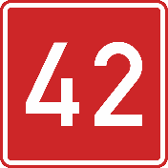
V4. Place identification signs
PLACE IDENTIFICATION
Sign G, 9 (G-09.0) identifies a place, other than a built-up area, by its name. It may additionally bear a symbol for the place. It shall indicate on-site point without the need to specify its end.⁷⁰
{⁷⁰ See also point 25 of the Annex of the European Agreement}
Image of a permitted variant of an example of G, 9 (G-09.0) sign:
IVI5. Confirmatory signs
PLACE CONFIRMATION
Sign G, 10 a (G-10.1) confirms the direction to places. This sign is an example that displays the names of places and distances.
Image of a permitted variant of an example of G, 10 a (G-10.1) sign:
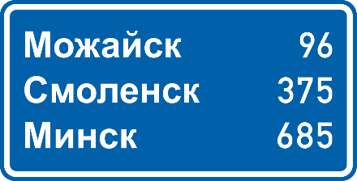
PLACE CONFIRMATION
G, 10 b (G-10.2) confirms the direction to places. This sign is an example that displays the names of places and distances.
Image of a permitted variant of an example of G, 10 b (G-10.2) sign:
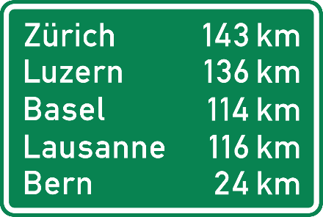
Confirmatory signs shall display the name of one or more places. Confirmatory signs displaying names of several places shall show them one below the other. The size of letters used for one place may be larger than those used for the others, only if the place in question is the largest.
Where distances are shown, the figures expressing them shall be indicated after the names of the places.
Confirmatory signs may bear the symbols used on other signs or display other signs on a reduced scale, for example road identification signs.
Notwithstanding the provisions of Article 6, paragraph 1, of this Convention, this sign may be placed on the reverse side of another sign intended for traffic proceeding in the opposite direction.
VII6. Indication signs
Indication signs, unless specified otherwise, shall have a blue ground and white symbols or inscriptions. When rims at the edge are used, they shall be white.
1A. Signs indicating the number and direction of traffic lanes
DIRECTION OF LANES
Signs such as G, 11a; and G, 11 b (G-11.1) and G, 11c shall be used to notify notifies drivers about the number and direction of lanes. This sign is an example of a sign indicating the direction of lanes showing an incoming lane.
Image of a permitted variant of an example of G, 11 a (G-11.1) sign:
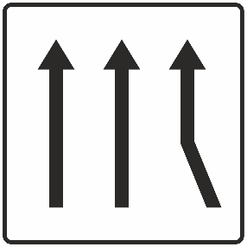
DIRECTION OF LANES
Signs such as G, 11a; and G, 11 b (G-11.2) and G, 11c shall be used to notify notifies drivers about the number and direction of lanes. This sign is an example of a sign indicating the direction of lanes showing a lane which continuous on the left side of an island or road divider.
Image of a permitted variant of an example of G, 11 b (G-11.2) sign:
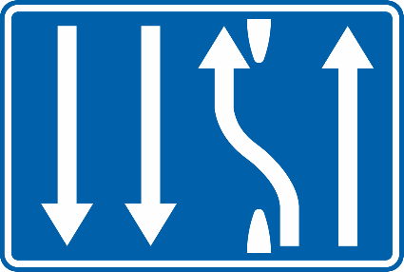
Theyse signs for direction of lanes shall comprise the same number of arrows as the number of lanes allocated to traffic in the same direction; they may also indicate lanes allocated to oncoming traffic. These signs shall bear either light-coloured symbols on a dark ground, or dark-coloured symbols on a light-coloured ground.
2B. Signs indicating the end or closure of a lane
END OR CLOSURE OF A LANE
Signs such as G, 12a (G-12.1), and G, 12b and G, 12 c shall notifies drivers about the end or the closure of a lane. Road markings may be included. This sign is an example of a sign indicating the end or closure of a lane showing the end or closure of a lane with a curved arrow.
Image of a permitted variant of an example of G, 12 a (G-12.1) sign:
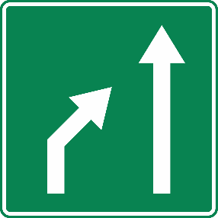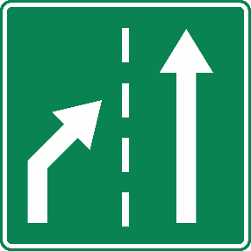
reversed symbol:
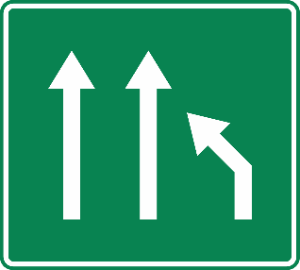
END OR CLOSURE OF A LANE
Signs such as G, 12a, and G, 12b (G-12.2) and G, 12 c shall notifies drivers about the end or closure of a lane. This sign is an example of sign indicating the end or closure of a lane sign showing the end or closure of a lane with a curved line.
Image of a permitted variant of an example of G, 12 b (G-12.2) sign:
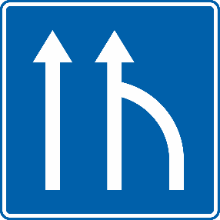
END OR CLOSURE OF A LANE
Signs such as G, 12a, and G, 12b G, 12 c (G-12.3) shall notifies drivers about the end or closure of a lane. Road markings may be included. This sign is an example of a sign indicating the end or closure of a lane showing the end or closure of a lane with a bar placed instead of an arrowhead.
Image of a permitted variant of an example of G, 12 b (G-12.2) sign:
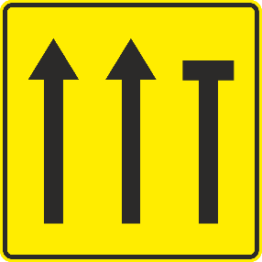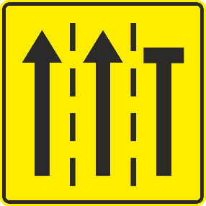
These signs for end or closure of lanes must comprise the same number of arrows as the number of lanes allocated to traffic in the same direction; they may also indicate lanes allocated to oncoming traffic. These signs for end or closure of a lane shall bear either light-coloured symbols on a dark ground, or dark-coloured symbols on a light-coloured ground. Road markings may be included.
3C. "NO THROUGH ROAD" sign⁷¹
{⁷¹ See also point 26 of the Annex of the European Agreement [deleted]}
NO THROUGH ROAD
Sign G, 13 (G-13.0) indicates a no through road. "NO THROUGH ROAD", It shall be placed at the entry to that a road, shall mean that there is no throughway. The symbol shall be white and red.
Image of G, 13 (G-13.0) sign:
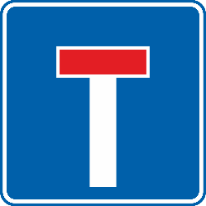
4D. “GENERAL SPEED LIMITS” sign
GENERAL SPEED LIMITS
Sign G, 14 (G-14.0) “GENERAL SPEED LIMITS”, shall be used, especially near national frontiers, to notify notifies road users about the general speed limits in force in a country or in a subdivision of that country. It shall be used, in particular at national borders. The name or distinguishing sign of the country, possibly accompanied by the national emblem, shall be placed at the top of the sign. On the sign, the general speed limits in force in a country will be displayed in the following order: (1) in built-up areas; (2) outside built-up areas; (3) on motorways. If appropriate, the symbol of sign E, 6 a (E-06.1), “Road for motor vehicles”, may be used to indicate the general speed limit on roads for motor vehicles.
The border ground of the sign and its upper part shall be blue; the country name and the ground of the three squares rectangles within the sign, preferably not more than four, shall be in white. The symbols used in the upper and central squares rectangles shall be in black and the symbol in the central square shall have an oblique red line across it display the sign E, 7 b (E-07.3) or its symbol, and the sign E, 8 b (E-07.4), or its symbol, respectively.
Image of an example of G, 14 (G-14.0) sign:
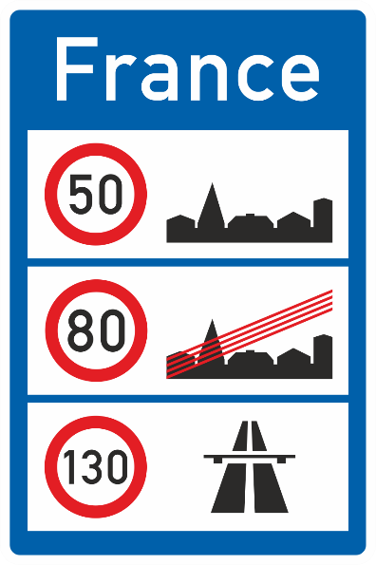
5E “ROAD OPEN OR CLOSED” sign
ROAD OPEN OR CLOSED
(a) Sign G, 15 (G-15.0) “ROAD OPEN OR CLOSED”, shall be used to notifies drivers whether a mountain road, particularly a section leading over a pass, is open or closed; the sign shall be placed at the entry to the road or roads leading to the section in question.
The name of the section of road (or pass) shall be inscribed in white, for example “Furka”.
Rectangles 1, 2 and 3 shall be removable.
(b) If the section of the road is closed, panel rectangle 1 shall be red and shall bear the inscription “CLOSED”; if the section is open, panel rectangle 1 shall be green and shall bear the inscription “OPEN”. The inscriptions shall be white.
(c) Panels Rectangles 2 and 3 shall have a white ground with black inscriptions and symbols.
If the section of road is open, panel rectangle 3 shall remain blank and panel rectangle 2, according to the condition of the road, shall either be blank, or display sign D, 9 (D-07.1), “SNOW CHAINS COMPULSORY”, and/or display symbol sign G, 16 (G-16.0)., “CHAINS OR SNOW TYRES RECOMMENDED”. This symbol shall be black.
If the section of road is closed, panel rectangle 3 shall show the name of the place up to which the road is open and panel rectangle 2 shall display, according to the condition of the road, either the inscription “OPEN AS FAR AS” or symbol G, 16, or signs D, 9 (D-07.1) and/or G, 16 (G-16.0). Rectangle 3 may also display other danger warning signs.”
Image of an example of G, 15 (G-15.0) sign:
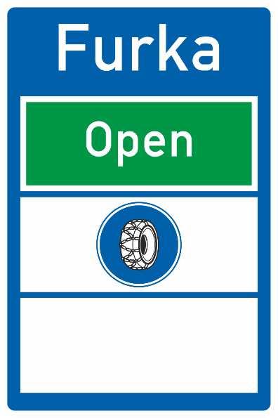
F. “ADVISORY SNOW TYRES OR SNOW CHAINS” sign
ADVISORY SNOW TYRES OR SNOW CHAINS
G, 16 (G-16.0) notifies drivers that their vehicles should have snow tyres fitted to all wheels or to have snow chains fitted to at least two of their driving wheels. The snow tyres are recommended to be used in snow conditions.
Image of G, 16 (G-16.0) sign:
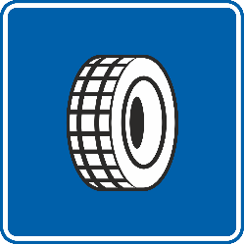
6G. "ADVISORY SPEED" sign
ADVISORY SPEED
Sign G, 17 (G-17.0) "ADVISORY SPEED" shall be used to show notifies drivers of the speed at which it is advisable to drive if circumstances permit and if the driver is not required to comply with a lower limit specific to his category of vehicle. The figure or range of figures appearing on the sign shall indicate the speed in the unit of measurement most commonly used to express the speed of vehicles in the country concerned. That unit of measurement may be shown on the sign after or below the digit. This unit may be specified on the sign.
Image of an example of G, 17 (G-17.0) sign:
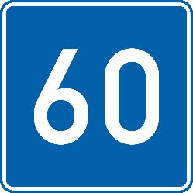

7H. Sign notifying advised itinerary
ADVISED ITINERARY
G, 18 (G-18.0) "ADVISED ITINERARY FOR HEAVY VEHICLES" notifies drivers of an advised itinerary for the type of road user indicated by the symbol displayed on the sign.
Image of G, 18 (G-18.0) sign:
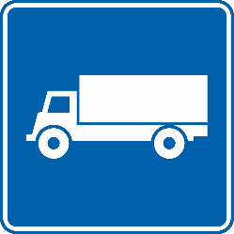
8I. Sign notifying an escape lane
ESCAPE LANE
Sign G, 19 (G-19.0) "ESCAPE LANE" shall be used to notifies drivers of an escape lane on a steep descent. This sign, with an additional panel plate displaying the distance to the escape lane, should be placed in conjunction with sign A, 2 (A-02.1 or A-02.2) at the top of the descent, where the danger zone begins and at the entry to the escape lane. Depending on the length of the descent the sign should be repeated as necessary, again with an additional panel distance plate displaying the distance to the escape lane. The symbol shall be white and red. The symbol It may be varied depending on the location of the escape lane in relation to the road concerned. It shall be reversed for traffic keeping to the left.
Image of an example of G, 19 (G-19.0) sign:
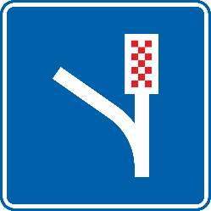
reversed symbol:
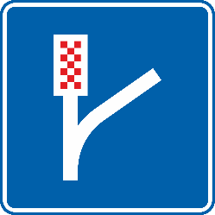
9J. Signs notifying a pedestrian overpass or underpass
OVERPASS
(a) Sign G, 20 a and G, 20 b (G-20.1) is are used to notifies of a location of respectively a pedestrian overpass or underpass.
Image of G, 20 a (G-20.1) sign:
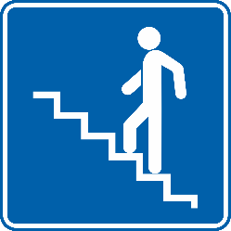
UNDERPASS
G, 20 a and G, 20 b (G-20.2) is are used to indicates respectively notifies of a location of a pedestrian overpass or underpass.
Image of G, 20 b (G-20.2) sign:
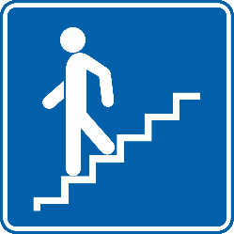
OVERPASS WITHOUT STEPS
(b) Sign G, 21 a and G, 21 a (G-21.1) is are used to respectively an overpass or notifies of a location of a pedestrian overpass without steps. The symbol of handicapped a person displayed on the additional panel H,7 may also be used on this sign.
Image of an example of G, 21 a (G-21.1) sign:
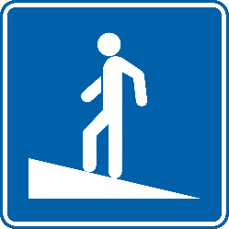
UNDERPASS WITHOUT STEPS
(b) Sign G, 21 a and G, 21 b (G-21.2) is are used to indicates respectively an overpass or notifies of a location of a pedestrian underpass without steps. The symbol of a person displayed on the additional panel H,7 may also be used on this sign.
Image of an example of G, 21 b (G-21.2) sign:
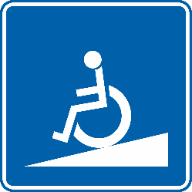
10K. Signs notifying an exit from a motorway

EXIT FROM A MOTORWAY
Signs G, 22 a (G-22.1); G, 22 b and G, 22 c are examples of advance signs for notifying notifies drivers of a distance to an exit from a motorway. It shall bear three oblique stripes sloping downwards towards the carriageway and it may bear a distance inscription. These signs shall bear the indication of a distance to the exit from a motorway, as determined by It shall be set up provided that signs bearing respectively one and two oblique bars stripes are set up at one third and two thirds of the distance between the this sign bearing three oblique bars stripes and the exit from a motorway. These signs It shall have a blue or green ground; the oblique bars stripes and inscriptions shall be white.
Image of a permitted variant of an example of G, 22 a (G-22.1) sign:
reversed stripes:
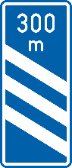
EXIT FROM A MOTORWAY
Signs G, 22 a; G, 22 b (G-22.2) and G, 22 c are examples of advance signs for notifying notifies drivers of a distance to an exit from a motorway. It shall bear two oblique stripes sloping downwards towards the carriageway and it may bear a distance inscription. These signs shall bear the indication of a distance to the exit from a motorway, as determined by It shall be set up at two thirds of a given distance, provided that signs bearing respectively one and two three oblique bars stripes are also set up. at one third and two thirds of the given distance between the sign bearing three oblique bars stripes and to the exit from a motorway. These signs It shall have a blue or green ground; the oblique bars stripes and inscriptions shall be white.
Image of a permitted variant of an example of G, 22 b (G-22.2) sign:
reversed stripes:
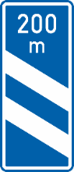

EXIT FROM A MOTORWAY
Signs G, 22 a; G, 22 b and G, 22 c (G-22.3) are examples of advance signs for notifying notifies drivers of a distance to an exit from a motorway. It shall bear one oblique stripe sloping downwards towards the carriageway and it may bear a distance inscription. These signs shall bear the indication of a distance to the exit from a motorway, as determined by It shall be set up at one third of a given distance, provided that signs bearing respectively one and two and three oblique bars stripes are also set up. at one two thirds and two thirds of the given distance between the sign bearing three oblique bars stripes and to the exit from a motorway. These signs It shall have a blue or green ground; the oblique bars stripes and inscriptions shall be white.
Image of a permitted variant of an example of G, 22 c (G-22.3) sign:
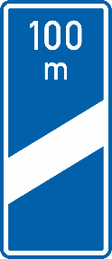
reversed stripe:
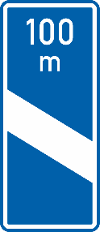
1L Signs indicating emergency exits
EMERGENCY EXIT
(a) The signs G, 23 (G-23.0) a and G, 23 b notifies of a location of an emergency exits. The symbol on this sign may be reversed.
Image of G, 23 (G-23.0) sign:
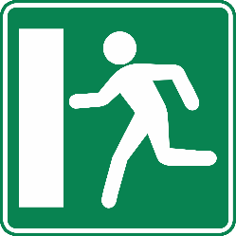
Reversed symbol
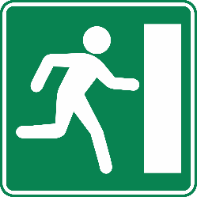
DIRECTION TO THE NEAREST EMERGENCY EXIT (LEFT)
(b) The signs G, 24 a (G-24.1), G, 24b and G, 24c are examples of signs to notifies of the direction and distance to the nearest emergency exits to the left. In tunnels, they shall be placed at a maximum distance of 50 m apart and at a height of 1 to 1.5 m on the sidewalls.
Image of an example of G, 24 a (G-24.1) sign:
DIRECTION TO THE NEAREST EMERGENCY EXIT (RIGHT)
(b) The signs G, 24 a, G, 24b (G-24.2) and G, 24c are examples of signs to notifies of the direction and distance to the nearest emergency exits to the right. In tunnels, they shall be placed at a maximum distance of 50 apart and at a height of 1 to 1.5 m on the sidewalls.
Image of an example of G, 24 b (G-24.2) sign:
DIRECTIONS TO THE NEAREST EMERGENCY EXIT
(b) The signs G, 24 a, G, 24b and G, 24 c (G-24.3) are examples of signs to notifies of the direction and distance to the nearest emergency exits to both the left and right. In tunnels, they shall be placed at a maximum distance of 50 m apart and at a height of 1 to 1.5 m on the sidewalls.
Image of an example of G, 24 c (G-24.3) sign:
(c) The All the emergency exit signs G, 23 and G, 24 shall have a green ground and the symbols, arrows and distance indications are shall be white or of a light colour.
12M. Sign indicating crash through gates
CRASH THROUGH GATES
G, 25 (G-25.0) notifies drivers to crash through the level crossing gate when trapped between closed gates. This sign shall be placed on the inside of the second gate in the direction of traffic.
The sign shall have a green ground. The symbol of a vehicle shall be green and the ‘crash symbol’ shall be white. The gate shown on the sign may be of colours applied by the State concerned in accordance with Article 35, paragraph 1 of this Convention.
This sign may be used with an additional panel bearing an inscription “if trapped, crash through gate” in a national language. Such a panel, if used, shall be placed on the gate next to the sign. The symbol on this sign may be reversed.
Image of an example of G, 25 (G-25.0) sign:
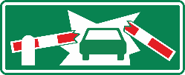
Reversed symbol:
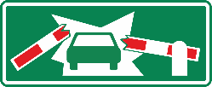
N. Signs indicating temporary conditions due to road works or detours
These signs shall have a yellow or orange ground; symbols and inscriptions shall be black. When rims at the edge are used, they shall be black.
These signs may bear the symbols used on other signs or display other signs notifying road users of the characteristics of the route or traffic conditions.
SCHEME OF DIVERSION
Signs G, 26 (G-26.0), G, 25 b, G, 25 c, G, 25, d are examples of signs showing displays a diagram for a diversion. It may bear the name of a place to which the diversion applies or the inscription “Diversion” in the national language. The symbol on this sign may be reversed.
Image of a permitted variant of an example of G, 26 a (G-26.1) sign:
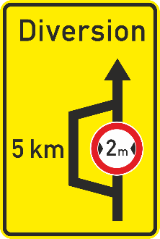
reversed symbol:
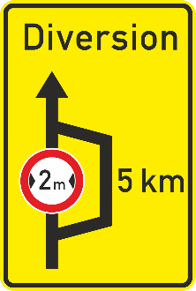
DIVERSION DIRECTION (LEFT)
G, 27 a (G-27.1) notifies of the direction of diversion to the left., G, 26 b and G, 26 c are example of signs showing directions for detours. These signs It shall differ conspicuously from the direction sign G, 5 a (G-05.1). It may bear the name of a place to which the diversion applies or the inscription “Diversion” in the national language.
Image of a permitted variant of an example of G, 27 a (G-27.1) sign:
DIVERSION DIRECTION (RIGHT)
G, 27 b (G-27.2) notifies of the direction of diversion to the right. , G, 26 b and G, 26 c are example of signs showing directions for detours. These signs It shall differ conspicuously from the direction sign G, 5 b (G-05.2). It may bear the name of a place to which the diversion applies or the inscription “Diversion” in the national language.
Image of a permitted variant of an example of G, 27 b (G-27.2) sign:
DIRECTION OF DIVERSION
G, 27 c (G-27.3) notifies of the direction of diversion. This sign is an example of a diversion direction sign showing the direction of the diversion with an arrow. It shall differ conspicuously from the direction sign G, 5 c (G-05.3). It may bear the name of a place to which the diversion applies or the inscription “Diversion” in the national language.
Image of an example of G, 27 c (G-27.3) sign:
DIRECTION OF LANES DURING ROAD WORKS
G, 28 (G-28.0) a and G, 27 b are examples of signs showing notifies of the direction of lanes during road works. This sign shall display the same number of arrows as the number of lanes allocated to traffic in the same direction.
Image of a permitted variant of an example of G, 28 (G-28.0) sign:
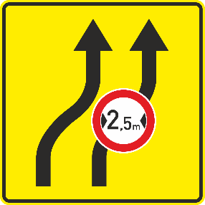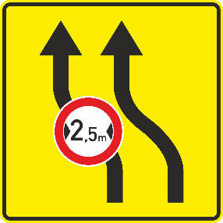
TEMPORARY LANE CLOSURE
G, 29 (G-29.0) is an example showing notifies of a temporary closure of a lane. This sign shall display the same number of arrows as the number of lanes allocated to traffic in the same direction. Road markings may be included.
Image of a permitted variant of an example of G, 29 (G-29.0) sign:
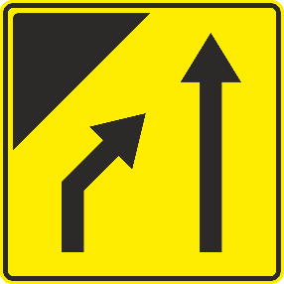
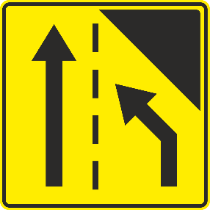
Section H
ADDITIONAL PANELS
I. General characteristics and symbols
1. These panels shall have either a white or yellow ground and a black, dark blue or red rim, in which case the distance or length or symbol shall be inscribed in black or dark blue; or a black or dark blue ground and a white, yellow or red rim, in which case the distance or length or symbol shall be inscribed in white or yellow.
Additional panels, used with danger warning, priority and prohibitory or restrictive signs, shall have a white or yellow ground and a black or a dark blue symbol or inscription. Additional panels, used with mandatory, special regulations, and informative signs, shall have either a white or yellow ground and a black or a dark blue symbol or inscription; or they shall have a green or blue ground and a white symbol or inscription. Additional panels are always placed under the signs except the additional panel used with signs E,2a, E,2b and G, 25.
⁷² See footnote
{⁷² Additional paragraph introduced in the Annex of the European Agreement (see point 27) [deleted]}
II. Definitions and images
1. Additional panels indicating the distance to or a length of a section of road.
DISTANCE PANEL
2. (a) Additional panels H, 1 (H-01.0)show notifies of the distance from the sign to the beginning of the dangerous section of road or of the zone to which the regulation or information applies.
Image of a permitted variant of an example of H, 1 (H-01.0) sign:
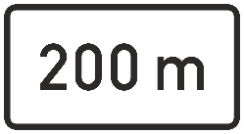
LENGTH INDICATION PANEL
(b) Additional panels H, 2 (H-02.0) show notifies of the length of the dangerous section of road or of the zone to which the regulation applies.
Image of a permitted variant of an example of H, 2 (H-02.0) sign:
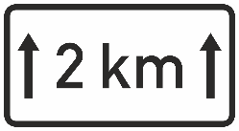
(c) Additional panels are placed under the signs. However, The distance information given on the additional panels H, 1 (H-01.0) and H, 2 (H-02.0) may instead be inscribed on the lower part of the sign in the case of danger warning signs of model two (square with one vertical diagonal) Ab, and elsewhere if allowed. selected prohibitory or restriction signs, selected special regulation signs, and advance direction signs, the information to be given on the additional panels may be inscribed on the lower part of the sign.
2. Additional panels concerning parking, parking prohibition or restriction
3. The additional panels H, 3 and H, 4 concerning parking prohibitions or restrictions are of models H, 3a; H, 3b and H, 3c and H, 4a; H, 4b and H, 4c respectively. (See: section C, para. 9 (c) of this annex). These additional panels used in conjunction with the sign E, 14 (E-12.1) show the direction in which parking places lie. When used with signs notifying parking prohibition or restriction, they notify about the beginning, continuation or the end of the prohibition or restriction. The use of the additional panels concerning parking prohibition or restriction is detailed in Section C, paragraph 10, Additional Provisions, applying to prohibition or restriction of standing and parking.
PANEL INDICATING THE BEGINNING OF PARKING, PARKING PROHIBITION OR RESTRICTION OR THE DIRECTION IN WHICH PARKING PLACES LIE
H, 3 a (H-03.1) notifies of the point from which the parking, parking prohibition or restriction begins when used in conjunction with signs notifying parking prohibition or restriction. It notifies of parking places to the left from E,14 (E-12.1) sign. This panel shall be placed parallel to the axis of the road
Images of a permitted variants of an example of H, 3 a (H-03.1) sign:
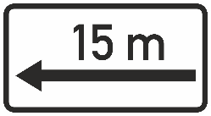
PANEL INDICATING THE REPETITION OF PARKING PROHIBITION OR RESTRICTION OR THE DIRECTION IN WHICH PARKING PLACES LIE
H, 3 b (H-03.2) notifies that the parking prohibition or restriction continues when used in conjunction with signs notifying parking prohibition or restriction. It notifies of parking places to the left and right from E,14 (E-12.1) sign. This panel shall be placed parallel to the axis of the road.
Images of a permitted variants of an example of H, 3 b (H-03.2) sign:
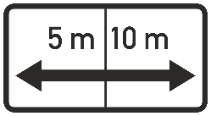
PANEL INDICATING THE END OF PARKING PROHIBITION OR RESTRICTION OR THE DIRECTION IN WHICH PARKING PLACES LIE
H, 3 c (H-03.3) notifies of the point at which the parking prohibition or restriction ends when used in conjunction with signs notifying parking prohibition or restriction. It notifies of parking places to the right from E,14 (E-12.1) sign. This panel shall be placed parallel to the axis of the road.
Images of a permitted variants of an example of H, 3 c (H-03.3) sign:
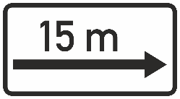
PANEL INDICATING THE BEGINNING OF PARKING PROHIBITION OR RESTRICTION OR THE DIRECTION IN WHICH PARKING PLACES LIE
H, 4 a (H-04.1) notifies of the point from which the parking prohibition or restriction begins when used in conjunction with signs notifying parking prohibition or restriction. It notifies of parking places onward from the E,14 (E-12.1) sign. This panel shall be placed perpendicular to the axis of the road.
Image of a permitted variant of an example of H, 4 a (H-04.1) sign:
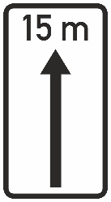
PANEL INDICATING THE REPETITION OF PARKING PROHIBITION OR RESTRICTION OR THE DIRECTION IN WHICH PARKING PLACES LIE
H, 4 b (H-04.2) notifies that the parking prohibition or restriction continues when used in conjunction with signs notifying parking prohibition or restriction. It notifies of parking places onward and backward from the E,14 (E-12.1) sign. This panel shall be placed perpendicular to the axis of the road.
Image of a permitted variant of an example of H, 4 b (H-04.2) sign:
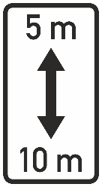
PANEL INDICATING THE END OF PARKING PROHIBITION OR RESTRICTION OR THE DIRECTION IN WHICH PARKING PLACES LIE
H, 4 c (H-04.3) notifies of the point at which the parking prohibition or restriction ends when used in conjunction with signs notifying parking prohibition or restriction. It notifies of parking places backward from the E,14 (E-12.1) sign. This panel shall be placed perpendicular to the axis of the road.
Image of a permitted variant of an example of H, 4 c (H-04.3) sign:
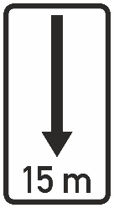
3. Additional panels displaying symbols of road users
ROAD USER PANEL
4. Additional panel H, 5 (H-05.0) displays the symbol of a particular road user category to whom the Rregulatory signs applies. to particular road users by displaying the symbol for their category. For example: H, 5a, and H, 5. All symbols from signs C, 3, E, 15, E, 16 and F, 11 may be used on H, 5 panel. If necessary the symbol may be replaced by an inscription in the national language of the State concerned.
Image of a permitted variant of an example of H, 5 (H-05.0) sign:
ROAD USER PANEL
Additional panel H, 6 (H-06.0) displays the symbol of a particular road user category to whom shall be used iIn cases where the regulatory sign does not applyis .. a certain category of road users. this is indicated by the symbol for their category and by the term "except" in the language of the particular country. For example: H, 6. If necessary the symbol may be replaced by an inscription in that language. PThis panel H, 6 shall be similar to panel H, 5 (H-05.0) but except that it shall display, in addition, the inscription “except” in the national language of the State concerned. If necessary the symbol may be replaced by an inscription in the national language of the State concerned.
Image of a permitted variant of an example of H, 6 (H-06.0) sign:
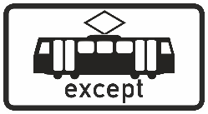
4. Additional panel indicating persons with disabilities
PERSON WITH DISABILITIES PANEL
5. ToH, 7 a (H-07.1) indicates, when used in conjunction with E, 14 a (E-12.1), that parking space is reserved for handicapped persons with disabilities., panel H, 7 a should be used with signs C, 18 or E, 14.
Image of a permitted variant of H, 7 a (H-07.1) sign:
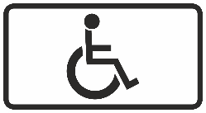
PERSON WITH DISABILITIES PANEL
H, 7 b (H-07.2) indicates, when used in conjunction with C, 18 (C-18.0), To indicate that parking is not prohibited for persons with disabilities panel H, 7 b should be used with signs C, 18. PThis panel H, 7 b shall be similar to panel H, 7 a (H-07.1) but except that it shall display, in addition, the inscription “except” in the national language of the State concerned.
Image of a permitted variant of H, 7 b (H-07.2) sign:
5. Additional panels for use at intersections
INTERSECTION PANEL
6. The additional panel H, 8 (H-08.0) displays a diagram of the intersection in which broad strokes indicate priority roads and thin strokes indicate the roads with no priority. This panel may only be used with B, 1, B, 2, B, 3 or B, 4 (B-01.0, B-02.0, B-03.1 and B-03.2) signs.
Image of a permitted variant of an example of H, 8 (H-08.0) sign:
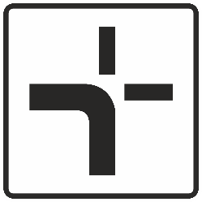
6. Additional panel to indicate ice or snow
ICE OR SNOW PANEL
7. To H, 9 (H-09.0) indicates that the section of road ahead is slippery because of ice or snow the additional panel H, 9 should be used. This panel may only be used with A, 9 (A-09.0) or A, 32 (A-29.0) signs.
Image of a permitted variant of H, 9 (H-09.0) sign:
NOTE APPROPRIATE TO THE WHOLE OF ANNEX I: In countries where traffic keepsto the left, signs and/or symbols shall be reversed as appropriate.

7. Additional panel to indicate distance to a STOP sign
DISTANCE TO A STOP SIGN
H, 10 (H-10.0) indicates the distance to a STOP sign. It shall be used in accordance with Section B, paragraph 2 of this Annex.
Image of a permitted variant of an example of H, 10 (H-10.0) sign:
