|  |  |  |  |
| --- | --- | --- | --- |
|  | United Nations | ECE/TRANS/WP.15/AC.1/2020/54 | |
| _unlogo | **Economic and Social Council** | | Distr.: General  25 June 2020  English  Original: French |

**Economic Commission for Europe**

Inland Transport Committee

**Working Party on the Transport of Dangerous Goods**

**Joint Meeting of the RID Committee of Experts and the   
Working Party on the Transport of Dangerous Goods**

Bern, 10–11 September 2020, and Geneva, 14–18 September 2020

Item 4 of the provisional agenda

**Interpretation of RID/ADR/ADN**

Placarding of removable skips

**Transmitted by the Government of France**[[1]](#footnote-1)\*,[[2]](#footnote-2)\*\*

|  |
| --- |
| *Summary* |
| **Executive summary**: Clarify the status of removable skips in relation to the definition of containers and their placarding, particularly in the context of road transport of bulk waste. |
|  |

Introduction

1. RID/ADR permits the carriage in bulk of certain wastes (as long as their classification permits) under 7.3.3 according to the special provisions of type BK or VC that are indicated in column (17) of Table A.

2. In most cases, waste transport operators use dumper trucks (vehicles for carriage in bulk). However, in some cases, to facilitate operations, some vehicles are equipped with removable skips.

3. Such skips do not meet the definition of containers and are never used as such, but simply facilitate loading at waste collection points.

4. The “bulk container” is only reserved for containers meeting the requirements of Chapter 6.11, which are therefore approved by the competent authority and used in multimodal transport. Removable “waste skips” are therefore not bulk containers within the meaning of RID/ADR. What could be confusing is that, in the definition of bulk containers in Chapter 1.2, it is mentioned that bulk containers may be, for example, “offshore bulk containers, skips, bulk bins, swap bodies, trough-shaped containers, roller containers, load compartments of vehicles”.

5. Because of the use of the word “skip” in the definition of “bulk container”, the question arose as to whether such skips should be placarded in accordance with the placarding of containers as indicated in 5.3.1.2 or rather in accordance with vehicles as indicated in 5.3.1.4.1, even though the skip is removable.

6. Placarding according to 5.3.1.2 would lead to placing placards on all 4 sides of the body, including the one in front just behind the vehicle cab, despite the fact that this placard would never be visible when the skip is in use.

These skips, although removable, are never used for transhipment from one mode to another and are always positioned on the road transport vehicle in the same direction.

7. By way of example, below are some photos illustrating such removable skips:

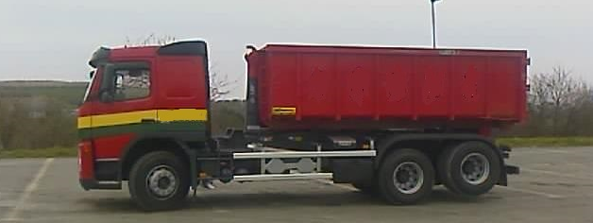

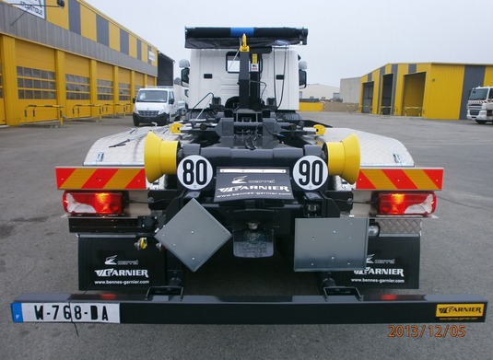

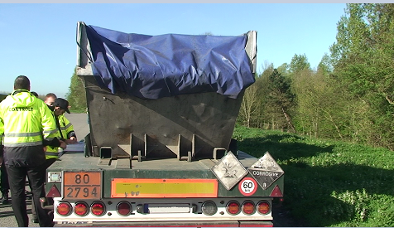

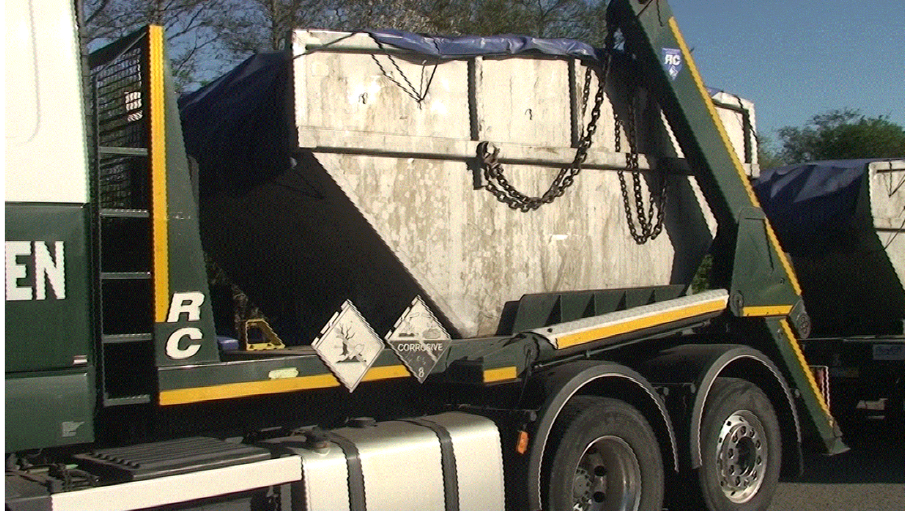

Questions

8. Question 1:

Do the skips described in the introduction have to be placarded in accordance with 5.3.1.2 or 5.3.1.4.1?

9. Question 2:

Is there a need for amendments to clarify the regulations on this point?

If that is the case, France could make a proposal at the next session.

1. \* Subprogramme 2 of programme budget for 2020 (A/74/6 (Sect.20) and supplementary information). [↑](#footnote-ref-1)
2. \*\* Circulated by the Intergovernmental Organisation for International Carriage by Rail (OTIF) under the symbol OTIF/RID/RC/2020/54. [↑](#footnote-ref-2)