|  |  |  |  |
| --- | --- | --- | --- |
|  | United Nations | ECE/TRANS/WP.15/AC.1/2020/27 | |
| _unlogo | **Economic and Social Council** | | Distr.: General  6 January 2020  Original: English |

**Economic Commission for Europe**

Inland Transport Committee

**Working Party on the Transport of Dangerous Goods**

**Joint Meeting of the RID Committee of Experts and the  
Working Party on the Transport of Dangerous Goods**

Bern, 16-20 March 2020

Item 4 of the provisional agenda

**Interpretation of RID/ADR/ADN**

Request for interpretation of the provision of 3.4.7.1.

Transmitted by the Government of Poland**[[1]](#footnote-2)\*, [[2]](#footnote-3)\*\***

Introduction

1. Pursuant to 3.4.7.1 of ADR “The centre area shall be white or a suitable contrasting background.”

2. With what should the central area be contrasted? With the black surrounding line or with the background colour?

3. Commonly used marking of packaging consists in an overprint of black surrounding line on a grey carton. The centre of mark is also grey. The grey centre contrasts with the black surrounding line however is not contrasting with the grey background. The provision is ambiguous since it stipulates that the centre should be white or contrasting however fails to specify with what it should be contrasted. If we assume that it should contrast with the surface on which it was place, the line overprint on the carton fails to meet this requirement (see annex). It should be stated here that impreciseness of the provision results also in interpretational differences related to the LQ mark.

Annex

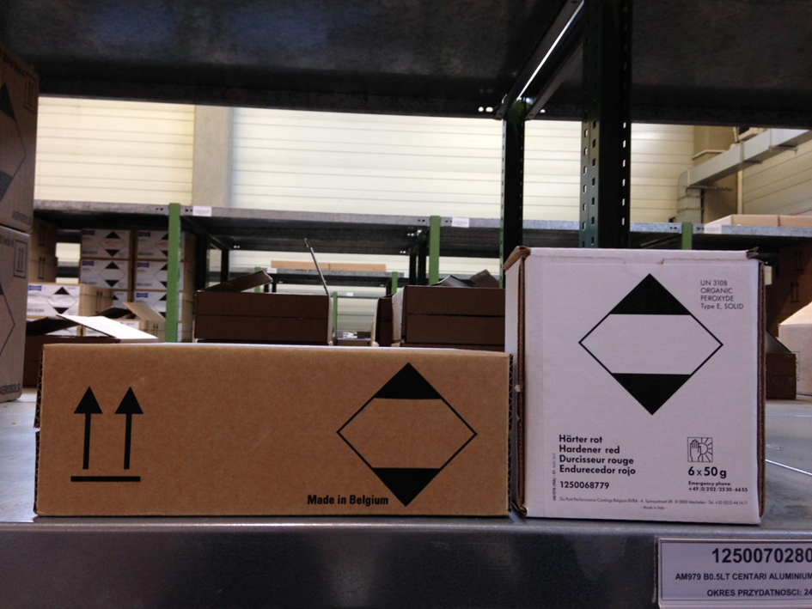

1. \* 2020 (A/74/6 (Sect.20) and Supplementary, Subprogramme 2).§ [↑](#footnote-ref-2)
2. \*\* Circulated by the Intergovernmental Organisation for International Carriage by Rail (OTIF) under the symbol OTIF/RID/RC/2020/27. [↑](#footnote-ref-3)